Marketing plan written for Travelodge

Student Name:

__________________EGLA BERISHA_______________________________

Student ID number:
______2210202_____________

Marketing Essentials BMIH4005

Lecturer’s Name:

__________LUCIANA SUARDI______________________

Table of Contents
Introduction 3
Situation Analysis- 5 C's 4
-Company: SWOT analysis (Microanalysis) 4
-Customers: Segmentation and Targeting/ Customer profiles 5
-Competitors: Porter's five forces, Perceptual positioning maps 5
-Collaborators: B2B Relationships, Partnerships, Franchises 6
-Climate: PESTLE (Macro analysis) 6
Objectives 7
-SMART target 7
Strategy 8
Tactics 9
Marketing mix 9
Action 10
Control 11
Identify USP, Features and Benefits 11
How we will measure success? 11
Conclusion 12
References: 13
Appendix 15
Component B 15

Introduction
Redefining the marketing with specific campaigns is one of the most important things that make a company run after the customers of the industry. So, the firms that have been cornered in the pandemic should run the project of bouncing back on track. From the standpoint of this industry, the other variables are also favourable to a certain degree. As a result, the companies often choose a low-cost approach or a premium service plan. So, here the actions have been performed for Travelodge (Alghizzawi, 2019).

Figure: Travelodge (Gupta, 2019).

Situation Analysis- 5 C's

-Company: SWOT analysis (Microanalysis)

SWOT analysis of “Travelodge”
Strengths | Travelodge is a business that offers low-cost packages that makes them very strong. Travelodge can welcome everyone. Travelodge also have the service for the premium customer as well under, the “Travelodge Business Account Card” (Sousa, and Alves, 2019).
Weaknesses | As a budget-friendly organization, Travelodge can not offer a wide range of opportunities and customization in their service as Travelodge charge less. That’s why Travelodge are sometimes presented as boring hotels in the market (Ivasciuc, 2020).
Opportunities | Adopting the pace and trend of ecotourism is a major opportunity for them. If Travelodge can embrace it, Travelodge will be in a situation where Travelodge should be one of the most customer-attracting firms in this industry (Mkwizu, 2019).
Threats | In this saturated industry, the sellers are many. Travelodge all try to offer the service at a low price. The competitive war among them is too much. In such a situation, the firms are struggling to survive in the market (Femenia-Serra, and Gretzel, 2020)

-Customers: Segmentation and Targeting/ Customer profiles
Segmentation
Travelodge is a firm that tries to attract economy buyers in the country. Travelodge offer a low-price product to the market and then base this feature to target the customers. In the tourism and leisure industry, the segmentation factor is mainly the income or wealth of a person. So, the firms generally either go for a low-cost strategy or a premium service strategy. That’s why it can be concluded that the organization segments them with the factor income. Travelodge mainly attract people with low income, students and so on (Gupta, 2019).

-Competitors: Porter's five forces, Perceptual positioning maps
Porter’s five forces
Porter’s five forces model is one of the best frameworks to judge an industry's attractiveness. So, people should be attracting the need to understand the current situation of the industry so that Travelodge become successful in their actions. In this industry, the threat of new entrants is low as the industry is saturated. The threat of substitutes is also low as the industry alternatives are not viable or feasible yet except for Airbnb. The other factors are also favourable to some extent from this industry perspective. That’s why Travelodge will get some advantage from the industry (Lim, et al. 2021).
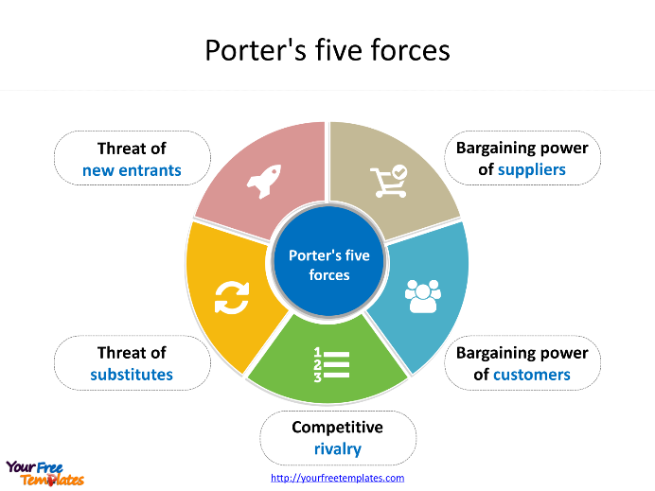
Figure: Porter’s five forces model (Lim, et al. 2021).

-Collaborators: B2B Relationships, Partnerships, Franchises
Advertising has benefits other than money. Travelodge are creative because Travelodge can come up with new ideas and use technology well. As marketing managers move up in their careers, Travelodge can choose to focus on social media or data analytics (Ivasciuc, 2020)
For example, advertising plays a significant role for these types of companies. Utilising customer data with the things should be made it easy for firms to get more customers. Thus, the company can develop relationships with different stakeholders (Alghizzawi, 2019).

-Climate: PESTLE (Macro analysis)
Political: The political issue of the UK is being practised and being a hot cake to the UK and beyond because the practices that have happened are not healthy. So, the procedure should be problematic for Travelodge (Mkwizu, 2019).
Economic: The less purchasing power of the buyers, high inflation rate, high price and high-interest rate are affecting the country negatively. Thus, Travelodge is also failing to get the expected amount of customers as well (Ntounis, et al. 2022).
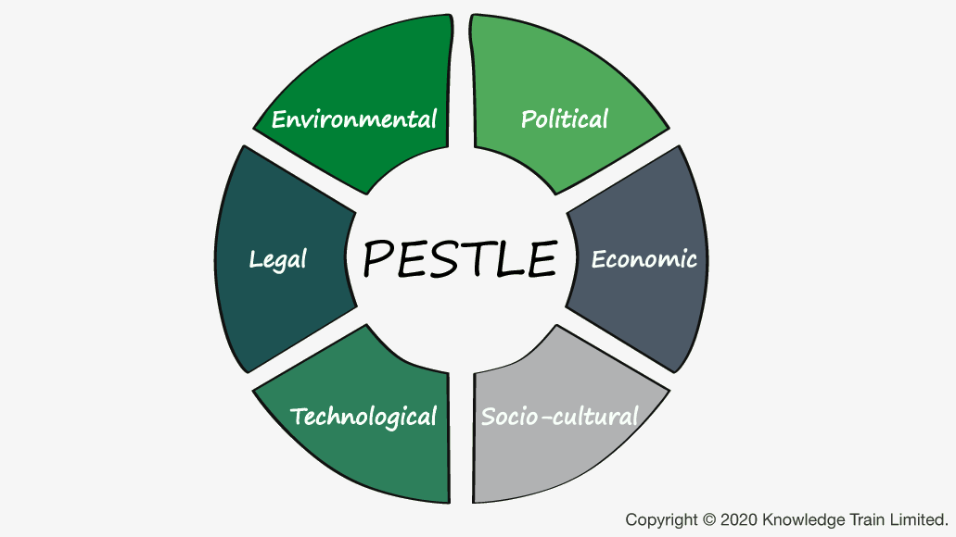
Figure: PESTLE (Femenia-Serra, and Gretzel, 2020).
Social: The social impact in the tourism and leisure industry is very dominant. So, Travelodge should patronise society with CSR and other social activities. Thus, this environment will be favourable to them as well (Ivasciuc, 2020).
Technological: Technology has been embedded in all the actions since the pandemic. Travelodge has adopted the technology as well. Due to this thing this environment can be perceived that Travelodge are favourable to the Travelodge (Femenia-Serra, and Gretzel, 2020)
Legal: The legal aspect is also favourable to them as the legal factors help them to get some fringe benefits. As Travelodge are registered companies, Travelodge get many extra facilities. Thus, Travelodge become consistent with their work (Sousa, and Alves, 2019).
Environmental: Travelodge can adopt the environmental advantages to have the things to make positives for them. Those things have been new trends. Such ways things will work with a highly extensive environmental factor (Lim, et al. 2021).

Objectives

-SMART target
Specific- The lost customers due to the pandemic will get back to the firm.
Measurable- The achievement of equal sales or the visit of the guest will indicate the measure.
Achievable- Getting back the lost customer is affordable.
Relevant- Offering and capturing value from the market.
Time-Bound- Within 6 months.

Strategy
Organisations value proposition: The organization provides a feature-packed valuable offering to the market. Travelodge look for a low-cost customer to capture the market share in the long run (Deb et al. 2022). The tourist and leisure sector has a significant social influence. Travelodge should thus support society by engaging in CSR and other charitable endeavours. Consequently, Travelodge will benefit from this environment as well (Ivasciuc, 2020).
How the organisation differentiates: The organization definite itself with value and the cost-benefit ratio. Because of the unhealthy practises that have occurred, the political problem of the UK is being practised and is becoming a hot cake to the UK and beyond. Therefore, Travelodge should have trouble with the process (Mkwizu, 2019).
The link value proposition to our customer segments: Those feature-packed values are very linked to the segments Travelodge have targeted for their business as Travelodge target low-income people and Travelodge get them as well (Mkwizu, 2019). Travelodge also gain from the legal element since it enables them to get certain ancillary advantages. Travelodge get numerous more amenities since Travelodge are registered businesses. As a result, individuals become reliable in their employment (Sousa, and Alves, 2019).

Tactics

Marketing mix
Product: This organization provides the service of a hotel room in their different locations those are specifically solid products that have sufficient demand. Those are also good products that attract buyers (Labanauskaitė, et al. 2020).
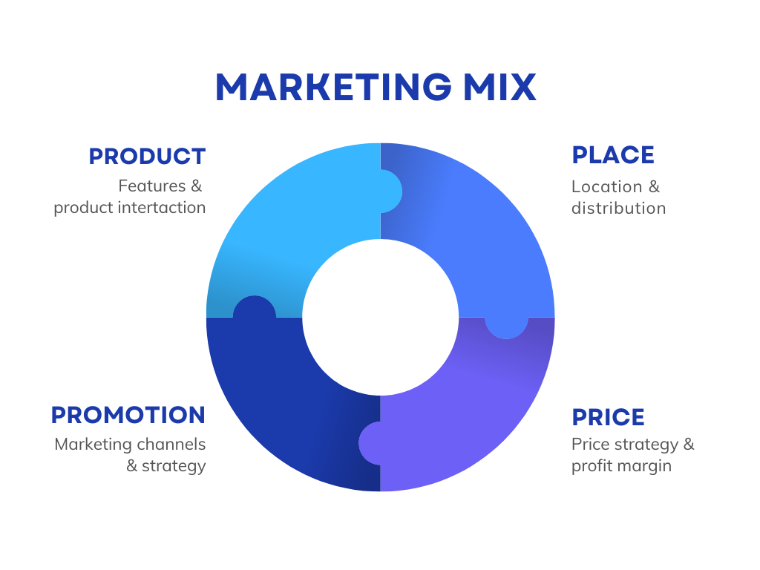
Figure: Marketing Mix (Femenia-Serra, and Gretzel, 2020).
Place: Travelodge offer these services to over 600 locations all over the world. All the customers use their product in many different locations and then Travelodge are satisfied to receive the same standard benefits from the customers (Le, et al. 2019).
Promotion: Travelodge run digital marketing, social media marketing and so on. Travelodge try to attract customers uniquely. Most of their customers come from the search as well. That’s why Travelodge do SEO regularly (Sousa, and Alves, 2019).
Price: The pricing of the firms is tolerable. Travelodge keep their price affordable to all the customers. Travelodge try to make this thing easy for all the people. Travelodge want more tourists in the tourist spots in the UK (Lim, et al. 2021).

Action
Particulars | Feb  2023 | Mar  2023 | Apr  2023 | May  2023 | June  2023 | July  2023 | Aug  2023
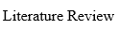
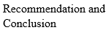

Control

Identify USP, Features and Benefits
From the perspective of digital marketing, Travelodge should be developing their information for the organizations and then Travelodge should also redefine their goals that are to be achieved in the long run. So, Travelodge need to look at their strengths and weaknesses and then take action according to them (Femenia-Serra, and Gretzel, 2020). The nation is suffering from lower consumer buying power, high inflation, high prices, and high interest rates. As a result, Travelodge is likewise struggling to attract the anticipated number of guests (Ntounis, et al. 2022). Advertising has advantages beyond financial gain. Travelodge are inventive because Travelodge can think of fresh concepts and effectively utilise technology. Marketing managers might opt to concentrate on social media or data analytics as their careers advance (Ivasciuc, 2020)

How we will measure success?
When the data traffic of their website will go high and 65% of the old customers will back to them and get their service, we will understand that the campaign was successful. Another parameter of success is the successful visit of the customers to all the stores in all the locations all over their hotel brunches (Mkwizu, 2019). Travelodge may use the benefits of the environment to their advantage. Those have been recent tendencies. Things will operate in such ways when a significant environmental element is present (Lim, et al. 2021). For these kinds of businesses, advertising, for instance, is crucial. It should be simple for businesses to use client data with the items to increase their consumer base. Consequently, the business may establish connections with many stakeholders (Alghizzawi, 2019).

Conclusion
This is a paper that tries to investigate the marketing endeavours of Travelodge. In this paper, situational analysis with 4C, Smart objectives, Strategy, tactics, Marketing mix, Control and actions has been investigated from the perspective of Travelodge (Lim, et al. 2021). Since the epidemic, technology has been a part of every activity. The technology has also been embraced by Travelodge. This makes it seem as if the environment is favourable to the Travelodge (Femenia-Serra, and Gretzel, 2020)

References:
Alghizzawi, M., 2019. The role of digital marketing in consumer behavior: A survey. Int. J. Inf. Technol. Lang. Stud, 3(1), pp.24-31.
Deb, S.K., Nafi, S.M. and Valeri, M., 2022. Promoting tourism business through digital marketing in the new normal era: a sustainable approach. European Journal of Innovation Management, (ahead-of-print).
Femenia-Serra, F. and Gretzel, U., 2020. Influencer marketing for tourism destinations: lessons from a mature destination. In Information and Communication Technologies in tourism 2020 (pp. 65-78). Springer, Cham.
Gupta, G., 2019. Inclusive use of digital marketing in tourism industry. In information systems design and intelligent applications (pp. 411-419). Springer, Singapore.
Ivasciuc, I.S., 2020. Augmented reality and facial recognition technologies. Building bridges between the hospitality industry and tourists during pandemic. Bulletin of theáTransilvaniaáUniversity of Brasov. Series V: Economic Sciences, pp.75-92.
Labanauskaitė, D., Fiore, M. and Stašys, R., 2020. Use of E-marketing tools as communication management in the tourism industry. Tourism Management Perspectives, 34, p.100652.
Le, D., Scott, N. and Lohmann, G., 2019. Applying experiential marketing in selling tourism dreams. Journal of Travel & Tourism Marketing, 36(2), pp.220-235. F.zaman
Lim, W.M., Yap, S.F. and Makkar, M., 2021. Home sharing in marketing and tourism at a tipping point: What do we know, how do we know, and where should we be heading?. Journal of business research, 122, pp.534-566.
Mkwizu, K.H., 2019. Digital marketing and tourism: opportunities for Africa. International Hospitality Review.
Ntounis, N., Parker, C., Skinner, H., Steadman, C. and Warnaby, G., 2022. Tourism and Hospitality industry resilience during the Covid-19 pandemic: Evidence from England. Current Issues in Tourism, 25(1), pp.46-59.
Sousa, B.M. and Alves, G.M., 2019. The role of relationship marketing in behavioural intentions of medical tourism services and guest experiences. Journal of Hospitality and Tourism Insights.

Appendix

Component B


