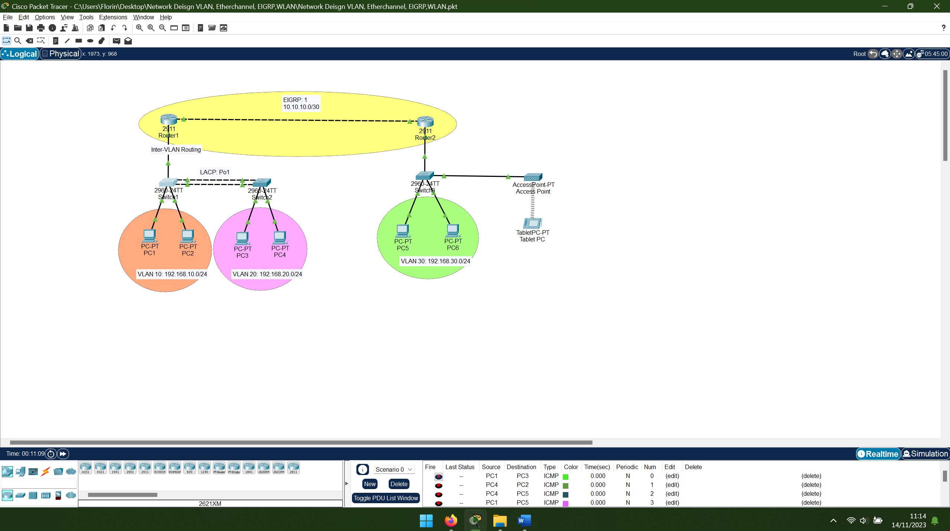
Tue Nov 14 10:25:00 Router1 Router>enable
Tue Nov 14 10:25:10 Router1 Router#configure terminal
Tue Nov 14 10:25:21 Router1 Router(config)#hostname Router1
Tue Nov 14 10:25:32 Router1 Router1(config)#interface gigabitEthernet 0/0
Tue Nov 14 10:25:43 Router1 Router1(config-if)#no sh
Tue Nov 14 10:25:54 Router1 Router1(config-if)#exit
Tue Nov 14 10:26:05 Router1 Router1(config)#interface gigabitEthernet 0/0.10
Tue Nov 14 10:26:16 Router1 Router1(config-subif)#encapsulation dot1Q 10
Tue Nov 14 10:26:27 Router1 Router1(config-subif)#description ***VLAN 10***
Tue Nov 14 10:26:38 Router1 Router1(config-subif)#ip address 192.168.10.1 255.255.255.0
Tue Nov 14 10:26:49 Router1 Router1(config-subif)#exit
Tue Nov 14 10:27:00 Router1 Router1(config)#interface gigabitEthernet 0/0.20
Tue Nov 14 10:27:11 Router1 Router1(config-subif)#encapsulation dot1Q 20
Tue Nov 14 10:27:22 Router1 Router1(config-subif)#ip address 192.168.20.1 255.255.255.0
Tue Nov 14 10:27:33 Router1 Router1(config-subif)#description ***VLAN 20***
Tue Nov 14 10:27:44 Router1 Router1(config-subif)#exit
Tue Nov 14 10:27:55 Router1 Router1(config)#interface gigabitEthernet 0/1
Tue Nov 14 10:28:06 Router1 Router1(config-if)#no shutdown
Tue Nov 14 10:28:17 Switch1 Switch>en
Tue Nov 14 10:28:28 Switch1 Switch#conf t
Tue Nov 14 10:28:39 Switch1 Switch(config)#v
Tue Nov 14 10:28:50 Switch1 Switch(config)#hostname Switch1
Tue Nov 14 10:29:01 Switch1 Switch1(config)#vlan 10
Tue Nov 14 10:29:12 Switch1 Switch1(config-vlan)#name V10
Tue Nov 14 10:29:23 Switch1 Switch1(config-vlan)#vlan 20
Tue Nov 14 10:29:34 Switch1 Switch1(config-vlan)#name V20
Tue Nov 14 10:29:45 Switch1 Switch1(config-vlan)#exit
Tue Nov 14 10:29:56 Switch1 Switch1(config)#interface range fastEthernet 0/23
Tue Nov 14 10:30:07 Switch1 Switch1(config-if-range)#shutdown
Tue Nov 14 10:30:18 Switch1 Switch1(config-if-range)#no shutdown
Tue Nov 14 10:30:28 Switch1 Switch1(config-if-range)#exi
Tue Nov 14 10:30:39 Switch1 Switch1(config)#interface range fastEthernet 0/23-24
Tue Nov 14 10:30:50 Switch1 Switch1(config-if-range)#switchport mode trunk
Tue Nov 14 10:31:01 Switch1 Switch1(config-if-range)#exi
Tue Nov 14 10:31:12 Switch1 Switch1(config)#interface gigabitEthernet 0/1
Tue Nov 14 10:31:23 Switch1 Switch1(config-if)#switchport mode trunk
Tue Nov 14 10:31:34 Switch1 Switch1(config-if)#exit
Tue Nov 14 10:31:45 Switch1 Switch1(config)#interface range fastEthernet 0/23-24
Tue Nov 14 10:31:56 Switch1 Switch1(config-if-range)#channel-group 1 mode active
Tue Nov 14 10:32:07 Switch1 Switch1(config-if-range)#exi
Tue Nov 14 10:32:18 Switch1 Switch1(config)#interface range fastEthernet 0/1-22
Tue Nov 14 10:32:29 Switch1 Switch1(config-if-range)#switchport mode access
Tue Nov 14 10:32:40 Switch1 Switch1(config-if-range)#switchport access vlan 10
Tue Nov 14 10:32:51 Switch1 Switch1(config-if-range)#exit
Tue Nov 14 10:33:02 Switch1 Switch1#wr
Tue Nov 14 10:33:13 Switch2 Switch>enable
Tue Nov 14 10:33:24 Switch2 Switch#configure terminal
Tue Nov 14 10:33:35 Switch2 Switch(config)#hostname Switch2
Tue Nov 14 10:33:46 Router2 Router>enable
Tue Nov 14 10:33:57 Router2 Router#configure terminal
Tue Nov 14 10:34:08 Router2 Router(config)#hostname Router2
Tue Nov 14 10:34:19 Router2 Router2(config)#interface gigabitEthernet 0/0
Tue Nov 14 10:34:30 Router2 Router2(config-if)#no shutdown
Tue Nov 14 10:34:41 Router2 Router2(config-if)#ip address 192.168.30.1 255.255.255.0
Tue Nov 14 10:34:52 Router2 Router2(config-if)#description ***VLAN 30***
Tue Nov 14 10:35:03 Router2 Router2(config-if)#exit
Tue Nov 14 10:35:14 Router2 Router2(config)#interface gigabitEthernet 0/1
Tue Nov 14 10:35:25 Router2 Router2(config-if)#no shutdown
Tue Nov 14 10:35:36 Router2 Router2(config-if)#ip address 10.10.10.2 255.255.255.252
Tue Nov 14 10:35:46 Router2 Router2(config-if)#description ***Connection with Router1***
Tue Nov 14 10:35:57 Router2 Router2(config-if)#exit
Tue Nov 14 10:36:08 Router1 Router1(config-if)#ip address
Tue Nov 14 10:36:19 Router1 Router1(config-if)#ip address 10.10.10.1 255.255.255.252
Tue Nov 14 10:36:30 Router1 Router1(config-if)#description ***Connection with Router***
Tue Nov 14 10:36:41 Router1 Router1(config-if)#exit
Tue Nov 14 10:36:52 Router1 Router1(config)#do sh ip rou c
Tue Nov 14 10:37:03 Router1 Router1(config)#router eigrp 1
Tue Nov 14 10:37:14 Router1 Router1(config-router)#no auto-summary
Tue Nov 14 10:37:25 Router1 Router1(config-router)#network 192.168.10.0 0.0.0.255
Tue Nov 14 10:37:36 Router1 Router1(config-router)#network 192.168.20.0 0.0.0.255
Tue Nov 14 10:37:47 Router1 Router1(config-router)#network 10.10.10.0 0.0.0.3
Tue Nov 14 10:37:58 Router1 Router1(config-router)#passive-interface gigabitEthernet 0/0.10
Tue Nov 14 10:38:09 Router1 Router1(config-router)#passive-interface gigabitEthernet 0/0.20
Tue Nov 14 10:38:20 Router1 Router1(config-router)#end
Tue Nov 14 10:38:31 Router1 Router1#write
Tue Nov 14 10:38:42 Router2 Router2(config)#do sh ip rou c
Tue Nov 14 10:38:53 Router2 Router2(config)#router eigrp 1
Tue Nov 14 10:39:04 Router2 Router2(config-router)#no auto-summary
Tue Nov 14 10:39:15 Router2 Router2(config-router)#network 192.168.30.0 0.0.0.255
Tue Nov 14 10:39:26 Router2 Router2(config-router)#network 10.10.10.0 0.0.0.3
Tue Nov 14 10:39:37 Router2 Router2(config-router)#passive-interface gigabitEthernet 0/0
Tue Nov 14 10:39:48 Router2 Router2(config-router)#end
Tue Nov 14 10:39:59 Router2 Router2#write
Tue Nov 14 10:40:10 Router2 Router2#show ip route
Tue Nov 14 10:40:21 Router2 Router2#wr
Tue Nov 14 10:40:32 Router1 Router1#conf t
Tue Nov 14 10:40:43 Router1 Router1(config)#ip dhcp pool VLAN_10
Tue Nov 14 10:40:54 Router1 Router1(dhcp-config)#no ip dhcp pool VLAN_10
Tue Nov 14 10:41:05 Router1 Router1#wr
Tue Nov 14 10:41:15 Switch3 Switch>enable
Tue Nov 14 10:41:26 Switch3 Switch#configure terminal
Tue Nov 14 10:41:37 Switch3 Switch(config)#hostname Switch3
Tue Nov 14 10:41:48 Switch3 Switch3(config)#interface range fastEthernet 0/1-24, gi0/1-2
Tue Nov 14 10:41:59 Switch3 Switch3(config-if-range)#switchport mode access
Tue Nov 14 10:42:10 Switch3 Switch3(config-if-range)#switchport access vlan 30
Tue Nov 14 10:42:21 Switch3 Switch3(config-if-range)#exit
Tue Nov 14 10:42:32 Switch3 Switch3(config)#vlan 30
Tue Nov 14 10:42:43 Switch3 Switch3(config-vlan)#name V30
Tue Nov 14 10:42:54 Switch3 Switch3(config-vlan)#exit
Tue Nov 14 10:43:05 Switch3 Switch3(config)#end
Tue Nov 14 10:43:16 Switch3 Switch3#copy running-config startup-config
Tue Nov 14 10:43:27 Switch2 Switch2#show vlan brief
Tue Nov 14 10:43:38 Switch2 Switch2#conf t
Tue Nov 14 10:43:49 Switch2 Switch2(config)#vlan 10
Tue Nov 14 10:44:00 Switch2 Switch2(config-vlan)#name v10
Tue Nov 14 10:44:11 Switch2 Switch2(config-vlan)#name V10
Tue Nov 14 10:44:22 Switch2 Switch2(config-vlan)#vlan 20
Tue Nov 14 10:44:33 Switch2 Switch2(config-vlan)#name V20
Tue Nov 14 10:44:44 Switch2 Switch2(config-vlan)#exit
Tue Nov 14 10:44:55 Switch2 Switch2(config)#interface range fastEthernet 0/23-24
Tue Nov 14 10:45:06 Switch2 Switch2(config-if-range)#switchport mode trunk
Tue Nov 14 10:45:17 Switch2 Switch2(config-if-range)#channel-group 1 mode passive
Tue Nov 14 10:45:28 Switch2 Switch2#show etherchannel summary
Tue Nov 14 10:45:39 Switch1 Switch1>en
Tue Nov 14 10:45:50 Switch1 Switch1#show etherchannel summary
Tue Nov 14 10:46:01 Switch1 Switch1#write
Tue Nov 14 10:46:12 Switch2 Switch2#show etherchannel summary
Tue Nov 14 10:46:23 Switch2 Switch2#write
Tue Nov 14 10:46:33 Switch2 Switch2#show vlan brief
Tue Nov 14 10:46:44 Switch2 Switch2#conf t
Tue Nov 14 10:46:55 Switch2 Switch2(config)#interface range fastEthernet 0/1-22
Tue Nov 14 10:47:06 Switch2 Switch2(config-if-range)#switchport mode access
Tue Nov 14 10:47:17 Switch2 Switch2(config-if-range)#switchport access vlan 20
Tue Nov 14 10:47:28 Switch2 Switch2#show etherchannel summary
Tue Nov 14 10:47:39 Switch2 Switch2#show vlan brief
Tue Nov 14 10:47:50 Switch2 Switch2#write
Tue Nov 14 10:48:01 Switch2 Switch2#write
Tue Nov 14 10:48:12 Router1 Router1>en
Tue Nov 14 10:48:23 Router1 Router1#wr
Tue Nov 14 10:48:34 Router2 Router2>en
Tue Nov 14 10:48:45 Router2 Router2#wr
Tue Nov 14 10:48:56 Switch1 Switch1#write
Tue Nov 14 10:49:07 Switch2 Switch2#we
Tue Nov 14 10:49:18 Switch2 Switch2#write
Tue Nov 14 10:49:29 Switch3 Switch3#write
Tue Nov 14 10:49:40 Router2 Router2>en
Tue Nov 14 10:49:51 Router2 Router2#conf t
Tue Nov 14 10:50:02 Router2 Router2(config)#ip dhcp pool VLAN30
Tue Nov 14 10:50:13 Router2 Router2(dhcp-config)#network 192.168.30.0 255.255.255.0
Tue Nov 14 10:50:24 Router2 Router2(dhcp-config)#default-router 192.168.30.1
Tue Nov 14 10:50:35 Router2 Router2(dhcp-config)#exit
Tue Nov 14 10:50:46 Router2 Router2(config)#ip dhcp excluded-address 192.168.30.1
Tue Nov 14 10:50:57 Router2 Router2#write
Tue Nov 14 10:51:08 Router2 Router2#conf t
Tue Nov 14 10:51:19 Router2 Router2(config)#ip dhcp excluded-address 192.168.30.1 192.168.30.10
Tue Nov 14 10:51:30 Router2 Router2(config)#noip dhcp excluded-address 192.168.30.1
Tue Nov 14 10:51:41 Router2 Router2#cponf t
Tue Nov 14 10:51:52 Router2 Router2#conf t
Tue Nov 14 10:52:02 Router2 Router2(config)#no ip dhcp excluded-address 192.168.30.1
Tue Nov 14 10:52:13 Router2 Router2#wr
Tue Nov 14 10:52:24 Switch1 Switch1>show running-confing
Tue Nov 14 10:52:35 Switch1 Switch1>show
Tue Nov 14 10:52:46 Switch1 Switch1>show config

