

Professional Career Development (BMSW4005_LON)

  - Reflective writing about my career development

Ysmael Abigail Ramirez Asencio 1912612

Hossein Shokri

04/01/2021
Table of Contents
1-Introduction 2
2-Career Research 2
3-Career Evaluation 2
4-Reflection on my role play 3
5-Self-motivation 3
6-Learning styles Honey and Mumford 3
7-Smart Objectives 4
8-Swot analysis 4
9-Personal Development Plan 5
10-Johari Window 6
11-Career Ambitions and Aspirations 7
12-Conclusion 7
13-Appendix 7
Appendix A 7
Appendix B 8
Appendix C 8
Appendix D 9
14-References 9

1-Introduction
After a few years without knowing what I want to do in my professional life, I decide to do a training course in Payroll without knowing anything about this subject, but I just started and, in the process, I realize that I enjoy enough working in this area. After that, I just did some research about what types of degrees I can do to be able to work in this environment, and that is the reason why I am now doing this course, to be in the right way to my future. (Appendix A)

2-Career Research
After an exhaustive investigation about degrees, universities, and colleges, I figure out that my goal career is Accounting, then I just started to look at what I need to become an Accountant.
“An accountant is a person who records business transactions on behalf of an organization, reports on company performance to management, and issues financial statements.” (Bragg, 2020)
During my research, I realize that an accountant has a large number of responsibilities and duties such as preparing accounts and Tax refunds, analyzing accounts and business plans, Prepper payroll, auditing financial information, Manage financial systems, and many more. (targetjobs, 2020). And of course, to you be able to do all this task you should have some key skills such as critical thinking, numerical skills, analytical skills, general business knowledge, communication, and customers service. (Accountantwritingstaff, 2020).
3-Career Evaluation
With this long research, I evaluated the accountant career in three important steps, first the love of what you are doing. Second, working market and third salary.
An important point is to find what you love to do, something that you enjoy enough. That is why I spend a long time to find what I truly love and enjoy, because before I realize that I want to be an accountant I was thinking in study something that is totally the opposite, and thanks to god I notice on time that I do not like those others subjects at all.
The working market, for me it is an important point when you decide which career you want to do because I personally do not want to spend a lot of time study something for at the end do not find any job. That is why I think accountancy is a good career because every single business has a financial task that has to be done at the end of the month or end of the fiscal year.
For me the salary is important, many people say that is not all about money and is “ok” that can be true but at the same time if you already spent three or four years of your life preparing yourself and taking knowledge in a determinate subject to be competitive and with the capacities to do a specific job, the least you can expect is a good salary. That is why I look for a career that at the end of the day I receive good compensation.

4-Reflection on my role play
The role-play exercise was about creating a five-question for an interview in your dream job position. I chose a challenging question because that can help me in the future. I enjoy it extremely during I was doing this role-play, I have to say that I felt that moment very mine, as if it were real. And to be honest I cannot wait for this moment to become real. The feedback that I receive from my lecture was; we did a good team working, and he said that I have good knowledge about the position that I wish to be in the future. (Appendix B)

5-Self-motivation
Since always I knew that I am a very ambitious person, always I want more but not in a bad way. I started to work when I was very young because I love money, and this is good motivation. when I grow and I started a proper job was there when I realize that if I have a degree, I will have more possibilities and will be more easily find a job with a good salary.
Also, my daughter is my biggest inspiration to try to be better every single day, because I know that she will follow my steps, and I want her to be proud of me and that she knows that I decide to continue with my career to bring her a better life.
Additionally, I have to say that I do not want to have a degree just because of “job opportunities” because a degree is not a guaranty that you will have a job, but it is good to help. One of the reasons that help me to keep on is because I want to learn I want to get new knowledge and new skills; I want to be more “intellectual”.
6-Learning styles Honey and Mumford
According to Peter Honey and Alan Mumford, we have four different learning styles those are the following reflector is the person that needs to watch and think about what is happening to understand the situation. Activists are those ones who learn by doing and involving with the explanations. Pragmatists are those people who need to put into practice what they see, and theorists those ones who learn with a concept, modules, and fact. (UniversityofLeicester, 2020)
After the explanation that I receive in class, I decided to do my own investigation to know what is my learning style, I found a questionary about Honey and Mumford and I did it and was there when a realized that I am a pragmatist person and, to be honest, it is totally right. (Appendix C)

7-Smart Objectives

According to (WayneStateUniversity, 2020) our smart objectives have to be Specific, Measurable, Archivable, Relevant, and Time-oriented if we follow this acronymous we will be able to find my smart objectives.
One of my smart objectives is to finish this course successfully I mean passing all the subjects, to be able to start my degree in accounting. My second objective is by next year (2021) start to work in an office environment as an assistant at an entry-level or even as a volunteer, because I have to be realistic and I know that I do not have any office background experience, but at the same time, I know that I have to start at some point, and I want to be in the direction of my goal as soon as possible. And my third objective is to finish my accounting degree by twenty twenty-four.

8-Swot analysis
Swot Analysis apply to become an accountant. Create this swot analysis help me to understand what I have to improve, and also, help me to identify all those skills in where I am good.
Strength  - Good time management  - Good attention to detail  - Excellent planning and organizing skill  - Math’s and numeracy skills | Weaknesses  - Communication writing and verbal  - Lack of personal confidence  - Missing professional qualification  - Lack of English language
Opportunities  - Many universities course in London  - Free online courses  - Internships in an accounting firm  - With UK qualification I will be able to work in different countries | Threat  - Work in a different environment  - Not experiences  - Combinate work and studies

9-Personal Development Plan

 | My goal | Skills and knowledge to be learns | What obstacles might get in my way | What I have to do to meet my goal | What support and resource will I need | Time schedule
Short time  (Three months) | Finish the course in skills for the workplaces to get my national certificate. | Problem-solving and decision making.  Knowledge such as prepper a report and how-to prepper a good assessment | Have a newborn baby and prepper assessment at the same time is difficult. | Be on time with the assessment.  Attend the online classes | Lectures support to be able to finish my assessment successfully | I expect to finish by February of twenty twenty-one
Long time  (three years) | Get a degree in Accounting. | How to prepper a Tax refund.  How handling with auditing.  How to analyzing accounts and many more. | Motherhood, work, and study at the same time can be truly difficult, and stressful. | Go to the university.  Do my homework.  Do the assessment. | Financial support such as student finance.  Any university in London with Accounting program | I hope that I can be finished by twenty twenty-four

10-Johari Window

Johari window is a tool that we can use to have better communication between two people or between a group, also, is good to understand yourself from a different point of view.
The Johari Window has 4 different areas, and they are separated into two different groups. One is about what you know and what you do not know about yourself. And the other groups are about what others know about you and what they do not know about yourself. According to that, we have an open area: this is what you and others know about you. The hidden area is about the thing that you know about you but others do not know. The blind, thing that is unknown by you but knows by others. And the unknown area is the thing that is unknown to you and also by others. (Lyon, 2020)

 | Know to self | Not know to self
Know to other | Open area  - Enthusiastic  - Happy  - Confident  - Sentimental  - Dedicate  - I get angry easily | Blind area  - Independent  - Intelligent  - Friendly  - Brave  - Idealistic  - Organized  - Spontaneous  - Responsive  - Proud
Not know to other | Hidden area  - Sensible | Unknown area

During I was doing my own Johari window I realize a couple of things that I did not know about myself, I ask a few people to fill up the Johari window that I have created, and when I check the feedback surprisingly, they agree on several things. (Appendix D)

11-Career Ambitions and Aspirations
Ones I finish my degree in accounting I want to start to work as an accountant as soon as possible, I know that when I just go out of university, I will not have the required experience that needs to work on my own as an “individual accountant” and have an especially good salary, and according to (Higginbotham, 2019) during own investigation about what qualification and experience you will need I find out that most of the job ask for a degree or ATT, ACCA, ACA. And also, the year of experience that you need to earn between 28k and 38k annul will be around three to five years (Reed, 2020). And I just have to say that I aspire to become an accounting manager in a good firm, I know that for this dream became real I have to work truly hard on my weaknesses and also to develop all the skills that are necessary to work as an accountant.

12-Conclusion
To finish I have to say that do this reflective report was truly helpful for me because I could realize that accounting is an occupation extremely important for any business, also, I have to say thanks to my lecture because during all the session classes I learn enormously about how to prepare myself of a determinate job position interview. to be honest I enjoy those classes. And one of the most important things is, that create this report helps me to learn about what are my weaknesses and what I have to work on to become a good professional.

13-Appendix

Appendix A
Lifetime exercise
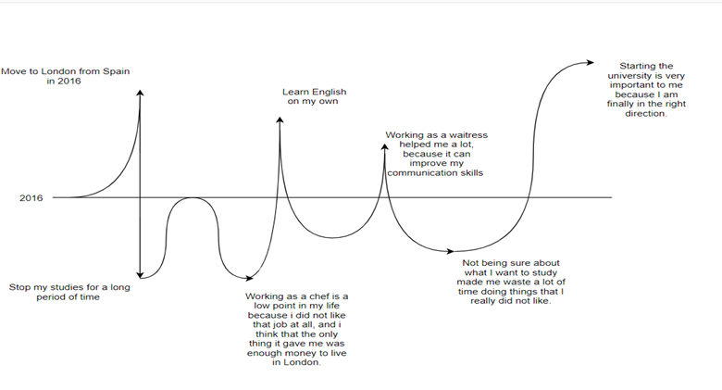

Appendix B
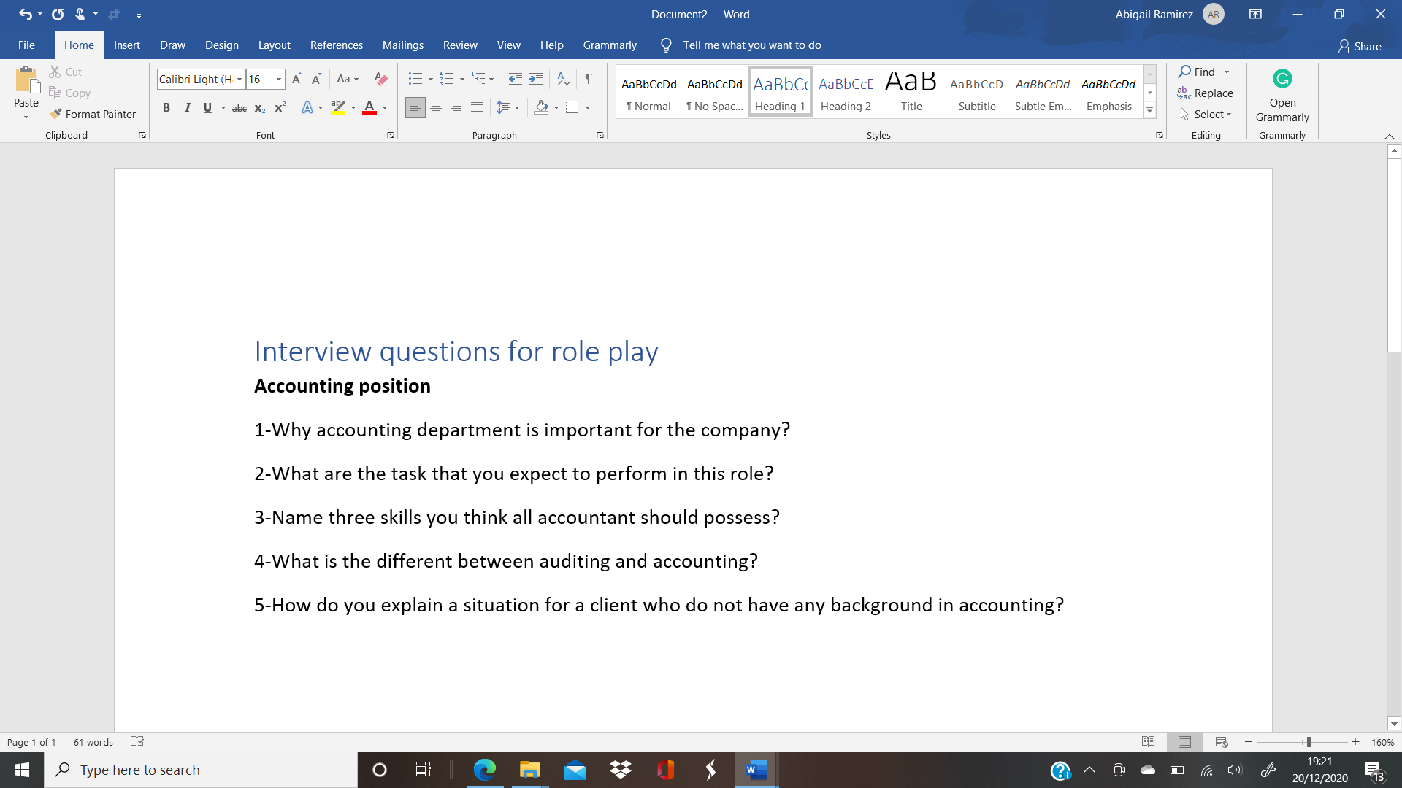

Appendix C
Test about learning styles Honey and Mumford
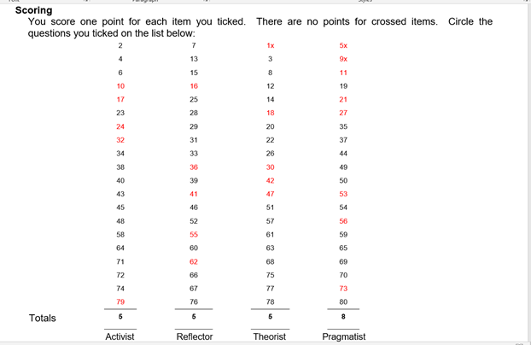

Appendix D
Johari Window
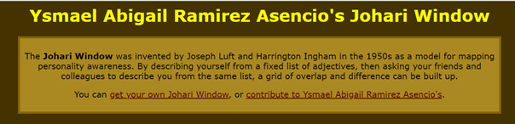
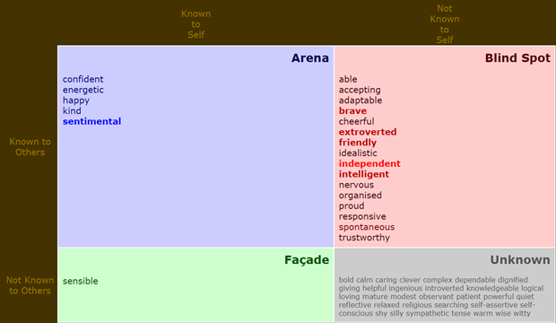
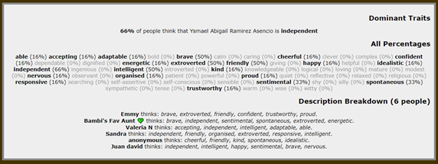 (Kevan, 2006)

14-References
References
Accountantwritingstaff, 2020. Top Accounting Skills. [Online]
Available at: https://www.accounting.com/resources/top-skills-for-accountants/
[Accessed 16 November 2020].
Bragg, S., 2020. AccountingTools. [Online]
Available at: https://www.accountingtools.com/articles/what-is-an-accountant.html
[Accessed 12 November 2020].
GovernorsWestermUniversity, 2019. Accounting skills to list on your resume. [Online]
Available at: https://www.wgu.edu/blog/accounting-skills-list-on-resume1911.html
[Accessed 12 November 2020].
Heatley, S., 2018. The ultimate personal development plan guide. [Online]
Available at: https://www.perkbox.com/uk/resources/blog/the-ultimate-personal-development-plan-guide-free-templates
[Accessed 17 November 2020].
Higginbotham, D., 2019. How to become an accountant. [Online]
Available at: https://www.prospects.ac.uk/jobs-and-work-experience/job-sectors/accountancy-banking-and-finance/how-to-become-an-accountant
[Accessed 16 November 2020].
Kevan, 2006. Johari Window. [Online]
Available at: https://kevan.org/johari?view=ysmael+abigail+ramirez+asencio
[Accessed 08 December 2020].
Lyon, A., 2020. Johari Window Model. [Online]
Available at: https://youtu.be/Zi4SvpAFRmY
[Accessed 17 November 2020].
Reed, 2020. Accountant Jobs. [Online]
Available at: https://www.reed.co.uk/jobs/accountant-jobs
[Accessed 16 November 2020].
targetjobs, 2020. ACCOUNTANT: JOB DESCRIPTION. [Online]
Available at: https://targetjobs.co.uk/careers-advice/job-descriptions/276909-accountant-job-description
[Accessed 12 November 2020].
UniversityofLeicester, 2020. Honey and Mumford. [Online]
Available at: https://www2.le.ac.uk/departments/doctoralcollege/training/eresources/teaching/theories/honey-mumford#:~:text=Learning%20styles%20were%20developed%20by,%2C%20Theorist%3B%20Pragmatist%20and%20Reflector.&text=seek%20out%20opportunities%20to%20learn%20using%
[Accessed 14 November 2020].
WayneStateUniversity, 2020. S.M.A.R.T. Objectives. [Online]
Available at: https://hr.wayne.edu/leads/phase1/smart-objectives
[Accessed 16 November 2020].

