A Child’s Experience Between The age of 0-5 Years Can Affect the Rest of Their Lives.

Name: Karen Ruddock
Student Number: 2015942
Module Code: BMHP4019_BIRM
Lecturer’s Name: Rebecca Kavanagh

Mathias Sager (2017) Lifetime Stability & Changeability of Personality (Developmental Psychology)
Link: Lifetime Stability & Changeability of Personality (Developmental Psychology) - mathias sager - Psychology & Art (mathias-sager.com)

According to the Author Mathias Sager has suggested that Genetic and environmental factors can influence on your personality. Mathias Sager has mentioned that Freud explains after looking at the brain structures and the functionality to the personality it’s more emphasizing the longer influence of theories, such as adaptions within the family environment. With the similarity which ties in with Bandura’s social experiment a both look at the brain structures for their personalities. This can comparatively be consistent as time goes on, growing up and change in early stages. Though our personability’s of the progresses within our lifespan. Personality’s need to have further research to understand the better of our understanding of interplay, our genetics and factors which is related to the child influence on psychological development. Experiences in childhood of a traumatic experience can trigger the personalities of a child which can also change how they act with their personality when they grow into adulthood, this can either be good thing so they are aware of what could be avoided in the future, as could manifest later in life with psychology effects. The link above will give you all the details needed and is credible. This information can be found on the 3rd slide of my presentation.

Denise Boyd Helen Bee (2019) Lifespan Development [Book] 8th ed.
Link: Lifespan development - University of Wales Trinity Saint David (uwtsd.ac.uk)

Stated by the Lifespan development book, this book will give you all the information you need to learn all the fact’s on Erikson’s Psychosocial Theories of development on a child’s study of growing from childhood all the way through adulthood. This book also gives much more information on learning to realise of how a child’s mind develops and grows and how the child’s mind can be influenced and how it can be emotionally affected. There are different stages which is the Erickson stages which is stated below:
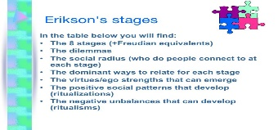

This shows you on the picture above of different and stages of a child’s development. This book taught me a lot of information on a child and their development. This helps understand child’s developmental of growing. This can be seen on the 4th slide on page 34.

Rachel Gillibrand, Virginia Lam and Victoria L. O’Donnell (2011) Developmental Psychology [Book] (Accessed on 19th October 2021).

The book of developmental psychology shows you in the book of how a child’s mind works, develops and facts of when a child grows. It’s explaining behaviours during childhood. This talks about the depths of different stages from prenatal to the last attention deficit hyperactivity of ADHD. Bandura explains in the book that children had learnt a lot from synthetic of others, for example if it was a behaviour or a playful aggression when playing with the bobo doll. This book can be found on amazon or the library of UWTSD site. This can be seen on page 39 and on 5th slide.
Chaise Williams (2014) Albert Bandura, Bobo Doll experiment [Online] Available at: Albert Bandura, Bobo Doll experiment (thinglink.com) (Accessed on: 19th October 2021).

This picture shows you what a child is doing and what he’s thinking. This shows a child (boy) can be aggressive towards the bobo doll. The personalities from this experiment could change in the future. Whereas a girl, shows less interest in the doll. This results on their judgement towards the doll. It’s a blow-up doll and has a printed body on it and inflatable. It has been used for the child’s reaction towards it. Albert Bandura explains the issues and actions of the child of how they are towards the doll and explains why. This will be found on the 5th slide.
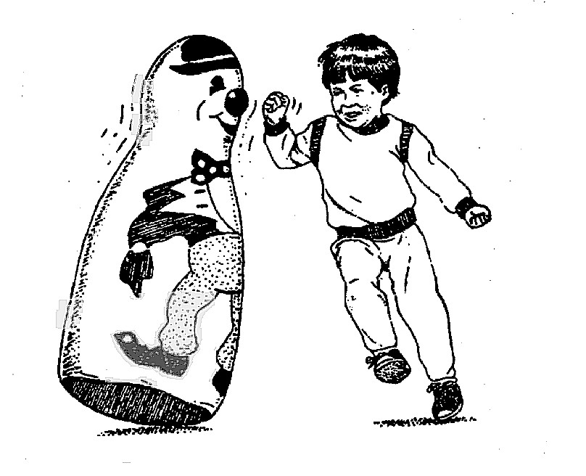

Michelle Manno (2013) The Benefits of Puzzles in Early Childhood Development [Online] Available at: https://teach.com/blog/the-benefits-of-puzzles-in-early-childhood-development/

With this practical learning for children its showing and learning a child how to use different puzzles by size, shape, and pictures. This teaching a child practice learning using a puzzle learns children to use their brains to focus on what they have in front of them and learning them to focus on how to learn to use a puzzle and memorise where the shapes go, and what they are. This is good to learn as when next learning to use a puzzle they will remember where they are supposed to be. A child learning before school is very important so they are ready to learn colours, numbers and shape’s This can be found on the website above and on 5th slide.
Janice Davis (2012) Why Puzzles Are So Important for Kids to Learn? [Online] Available at: https://www.learning4kids.net/2012/02/21/why-are-puzzles-so-good-for-kids-learning/ (Picture below)

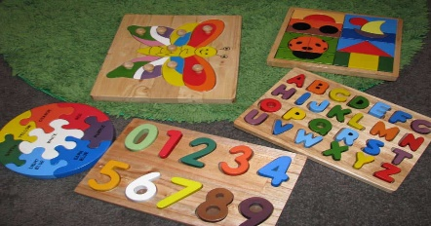

Katie (2018) Why Learning Colours and shapes is so Important For Young Children [Online] Available at: https://www.giftofcuriosity.com/why-learning-colors-and-shapes-is-so-important-for-young-children/ (Accessed On 19th October 2021).
https://www.giftofcuriosity.com/why-learning-colors-and-shapes-is-so-important-for-young-children/ (Picture).

Learning a child to use colours and shapes is so important for the young as it helps them to recognize different colours and shapes ready for when they go pre-school. These colours and shapes help children to learn to be verbal in communication which teaches a child to be vocabulary for describing different colours or shapes. This is also good for a child to learn colours for even health and safety, for example we use the colour red which indicates danger or stop. This is a complex task for young children, partly because of learning lots of different colours and learning to remembering. This website will show you all the different colours to identify how a child learns and the meaning of them. You will find the website very entertaining as it open’s your eyes of how a child learns fast by learning different colours. You will find this website above and on my 7th slide.



