Module Name: Independent Project
Module Code: BMTP6015
Element: Element 3
Student Name: Charlie Macdonald
Student Number: 2304849
Lecturer: Scott James

Content Page

Page 3-5 - Critical Evaluation and Impact Assessment
Page 5-6 – Project Limitations
Page 6 – Conclusions and recommendations
Page 7 – Appendix
Page 8 – Reference List

Independent Project Element Three

Critical Evaluation and Impact Assessment
The event was a big success. It was a record-breaking ITT Future You with a record number of guest and exhibitors. Overall the event had 670 guests and 55 exhibitors in the careers fair, which was a new record for the most exhibitors in any Institute of Travel and Tourism event. The ITT Future You Instagram page has been very engaging with 214 followers with 67 posts. This shows that the page has been popular, with many people visiting the page to read the posts to get more information about ITT. The most popular video we had this year was myself and Simon acting out a conversation about ITT Future You. This video had over 1,300 views on Instagram which shows that the video reached a wider audience and promoted the event to many different people. The social media engagement worked really well overall as there were posts almost every day leading up to the event, as well as countdowns from a month out. This really helped boost our ticket sales which then led to a record-breaking number of guests (Favorido, 2026).
During the event the audience reactions were really good with lots of engagement. After the conference was over many people said it had inspired them and were very impressed with the achievements of the current and former students. During the event people were constantly engaging with the exhibitors asking questions about their companies and potential careers in those sectors. The exhibitors were also engaging with each other during the day as they saw it as a good opportunity to network with new people. We also had guests come up to us organisers during the event praising how the event was run and the content during the conference (BCD Meetings & Events, 2025).
Participation levels during the event were very high as well, especially in the exhibition and the workshops. The mocktail workshop in particular was very busy and popular as the guests enjoyed watching the mocktails being made and the variety of different options available to them. Another workshop we had that worked well was the waiter obstacle course which was a challenge for the guests to carry a tray with plastic cups through the course in the quickest time without dropping anything. This workshop was popular with the schools and colleges as it was a competition to see who could get the fastest time and they enjoyed the challenge.
At the end of the event we sent out a survey to the guests and the exhibitors to get their thoughts on the event and what could be improved in the future (Cam.ac.uk, 2026). We got a lot of responses from the survey and lots of good ways the event could improve even more in the future. Some of the exhibitors mentioned that the music was slightly loud on the stage and they occasionally struggled to hear the guests. Some other stall holders mentioned that they would have liked food to be provided and were disappointed that the arena café was closed. Some of the companies did not like the fact that they had to leave the exhibition area when the conference was ongoing, but that was not our decision as the arena would not allow people to be in the lower auditorium due to safety risks. However, from the guest’s point of view the majority of the feedback indicated that they enjoyed the live music and thought it gave a good atmosphere to the event and really enjoyed the conference and the fact that it was split up into two different sessions. Overall the feedback from the survey was very positive with only a few people saying they did not enjoy some aspects of the event and that is equally important for us to know, so that we know what to improve for future events. (Appendix A-B)
After review, the event did meet the original aims set out during the first phase of planning. The main aims were to inspire students and graduates to pursue a career in the tourism, events and hospitality sector and based on the feedback from the guests this aim was achieved. Another aim we had for the event was to reinforce Wales as a launchpad for world class talent, innovation and ideas. This event focused mainly on the current students and alumni of UWTSD to showcase the talent that comes out of the university and to promote how inspiring the course is.
Many aspects of the event worked really well including the teamwork between the organisers, the exhibition and the conference. The teamwork was crucial to this event being a success as we all worked really hard to make sure everything went well and there were no disagreements in the team we all just got on with the job at hand and helped each other out. Another aspect that worked well was the exhibition, as we had a variety of different companies in the exhibition, and the guests enjoyed talking to all the companies to find out more information about them and potential career opportunities within the industry. Finally, the conference was a big success, with the content and speakers being very inspirational in sharing their stories about their careers. There was a good mixture of live speakers and videos of speakers with plenty of footage to keep the guests entertained throughout the conference.
Not many aspects of the event underperformed however there were a few things to improve on such as the tickets not fully working and also some of the timings of the conference. The main issue with the tickets was with the schools and colleges, as the tutors registered for all of the tickets under their name and when they arrived we had to take the name of all the students for safety reasons. This took some time to sort out but was not too big a problem.
In some instances, people did not receive their tickets after registering, but we had the list of names so instead of scanning the QR codes we had to search for their names. This took a bit longer and held up the check-in slightly, but again was not a major problem. Also with the timings of the exhibition some of the exhibitors did not like the fact that the exhibition had to close during the conference and felt like most people left after the last conference finished. They would have liked more time at the end of the conference, however we felt that it was best to end the event at three o’clock, as the schools and colleges had to get back and most people had finished in the exhibition at that point.
The event mostly achieved the success benchmarks we set up before the event. We wanted to create the most successful ITT event and we succeeded in that aspect, however the stakeholders originally set out the goal of 1,000 guests. We understood that it would be hard to reach that goal and ended up with 670 guests which is still a really good number and the stakeholders came to realise that 1,000 was a bit unrealistic and were very happy with the outcome of the event. We also succeeded in running the conference in two different parts, as previously it has always been one longer session. The new format, however, was a success and people were more engaging and found it better than a longer session.
Project Limitations
Whilst planning and running the event we did come across some challenges that affected the event and we had to work around those challenges. For example, we had some last-minute changes before the event as the DJ had to pull out the week before, and we had some exhibitors drop out during the week and a few days before the event which meant we had to rearrange the exhibition and look for a new DJ or singer to perform. As we had a few of the exhibitors pull out the day before the event it gave us a very short window to change the plans but we managed to fill in all the gaps in the exhibit with different companies and other companies expanding their stalls. As for the DJ he was unable to get his equipment on time which led to us having to look for a replacement a few days before the event. Fortunately, we found a replacement singer who was really good and everyone was praising.
We also had some scheduling issues, as not everyone was available for some meetings, but we tried to find a time when everyone was available and if someone could not make it we would just pass on any information they missed. As we had to wait for companies and stakeholders to get back to us with information sometimes scheduling the meetings was difficult as we had to wait for their reply, however most of the time the whole team were available for the meetings.
Other limitations we faced were staffing and resources as some of the volunteers couldn’t make it on the set-up day and some were running late on the actual day of the event. On the day of set-up some of the sub teams did not arrive, which led to the people who were there doing more work in different areas. Also, on the day some people had emergencies and couldn’t make it which led to us having to reassign the job roles and move people around to different locations to fill in the gaps. We also had small issues with technology as none of the organisers are experts in technology and there were a few issues we had to resolve, but as a team we managed to get around those issues.
During the event we had a slight issue with the venue as they did not have enough tables for the exhibition, which meant we had to bring tables over from the university. Also, as it was a nice day some of the students from the schools and colleges went outside after the first conference and not back down to the exhibition, but as the arena had to keep the doors open there was nothing we were able to do about that issue. We had to encourage them to head back down to the exhibition, which most of them did.
These issues did not greatly affect the event as we mostly found solutions to all of the problems. The main issue was people going outside instead of staying in the exhibition and in future events, we would have to tell the schools and colleges that they have to stay inside and engage with the stalls. We did try to find a solution by asking our volunteers to encourage them to go back inside but in the future we would ask the tutors to keep an eye on their students. As for the issue of people dropping out we found solutions with other companies and next time we might ask for a small deposit so that they feel more inclined to commit to coming to the event.
Conclusion and Recommendations
Whilst planning and running this event we have learnt valuable and practical skills about the industry and about planning such events, however there are still aspects that could be improved in the future. One of the recommendations for future events is to create a detailed event plan for the set-up day to ensure that everyone knows their exact roles. This would lead to the process running more smoothly and quickly, and being less stressful for us organisers, as people would not need to ask so many questions on the day. Another recommendation I have for this event in the future is to ask for the exhibitors to pay a small deposit which they will get back when they arrive at the event to ensure that they do not drop out last minute. Some companies might think that as it is a free event they have nothing to lose if they do not attend but if they have to pay a deposit it will be more of an incentive not to drop out. The final recommendation I have is to ask the tutors of the schools and colleges to tell the students to stay inside the arena and engage with the exhibition instead of going outside after the first conference has finished.
It is also important to have contingency plans in place in case things go wrong close to the event, like with the DJ dropping out. Fortunately, we knew someone who would be willing to step in last minute and the problem was solved. However, overall this event was a big success and the whole team of organisers worked tirelessly to ensure that it was a success and there were only a few minor issues which needed ironing out before the event. In the future if we had the event plan in place for the set-up day it would have been much smoother and even more of a success. Planning and organising this event has given the whole team much more confidence in pursuing careers in this industry and the teamwork skills we learnt will be valuable for any job we have in the future.

Appendix
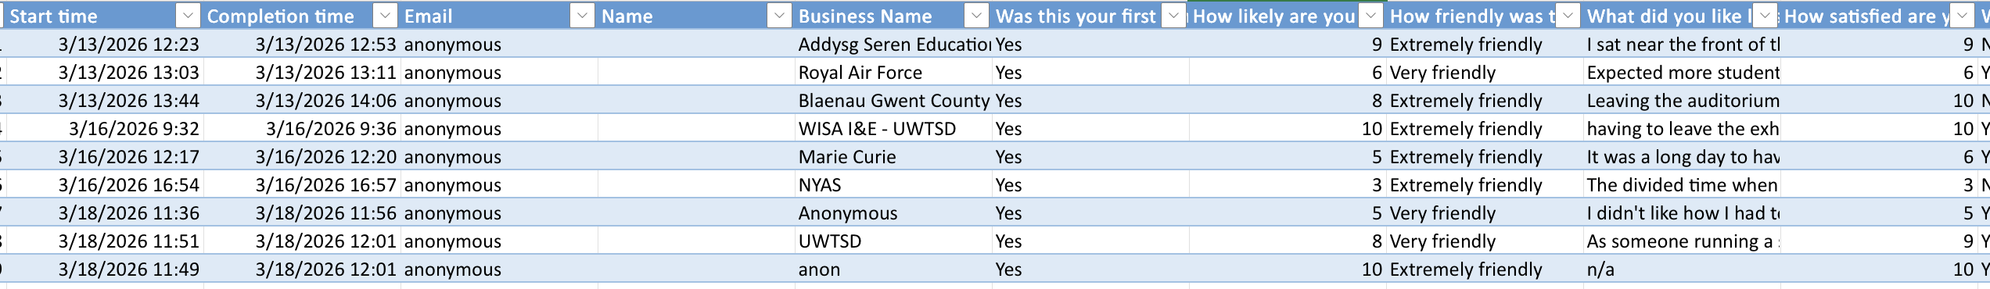
A.

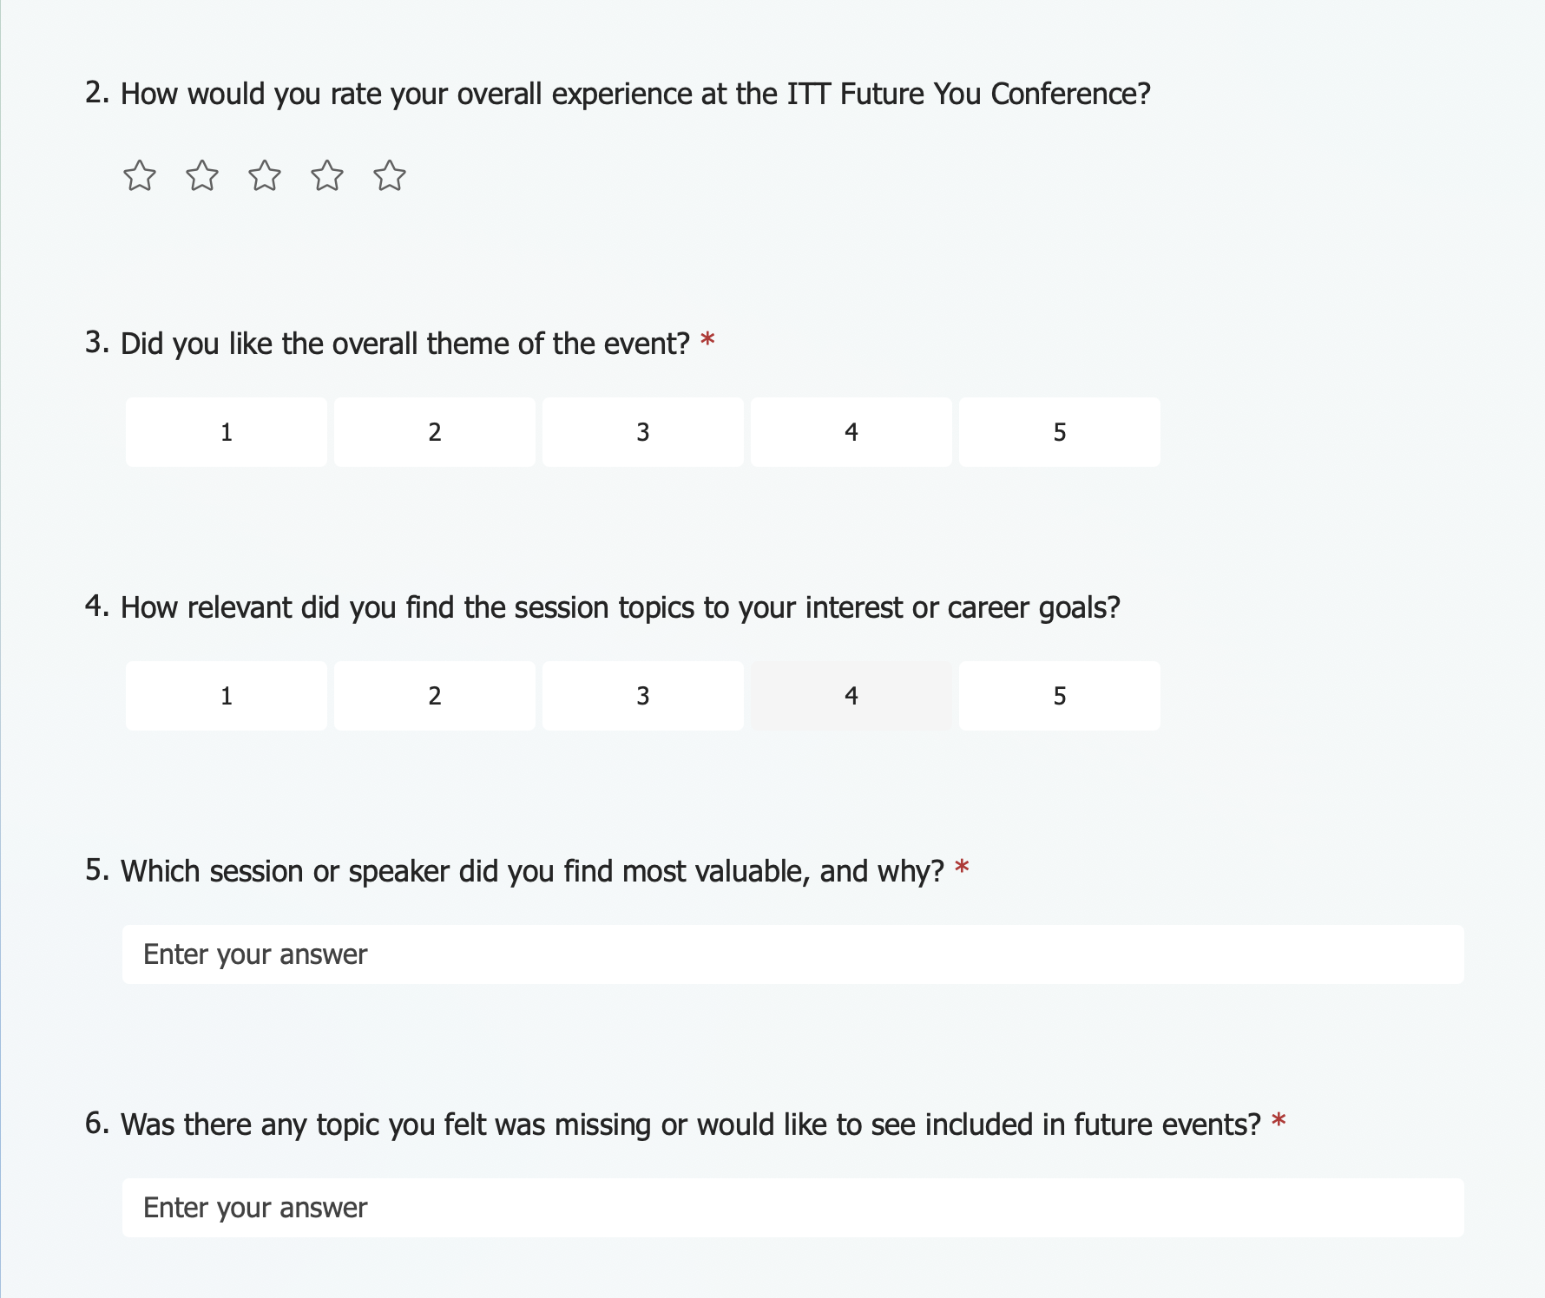
B.

Reference List
BCD Meetings & Events. (2025). What Is A Successful Event And How Can Success Be Measured? - BCD M&E UK. [online] Available at: https://bcdme.com/en-gb/blog/what-is-a-successful-event-and-how-can-success-be-measured/.
Cam.ac.uk. (2026). Survey Methods | School of Technology. [online] Available at: https://www.tech.cam.ac.uk/survey-methods.
Favorido, N. (2026). UWTSD students deliver record-breaking ‘Future You Wales’ Tourism and Events conference - Herald.Wales. [online] Herald.Wales. Available at: https://herald.wales/west-wales/uwtsd-students-deliver-record-breaking-future-you-wales-tourism-and-events-conference/?fbclid=IwZnRzaAQmRk1leHRuA2FlbQIxMQBzcnRjBmFwcF9pZAo2NjI4NTY4Mzc5AAEeFpFyINCIqAk6N0BzRTa8IyCPYBQ97cWJF147F9MDxcKlcNyHIfZzvX9vWnI_aem_H2Xq43ZfohswurGyxt-uzA.

