UNIVERSITY OF WALES
TRINITY SAINT DAVID

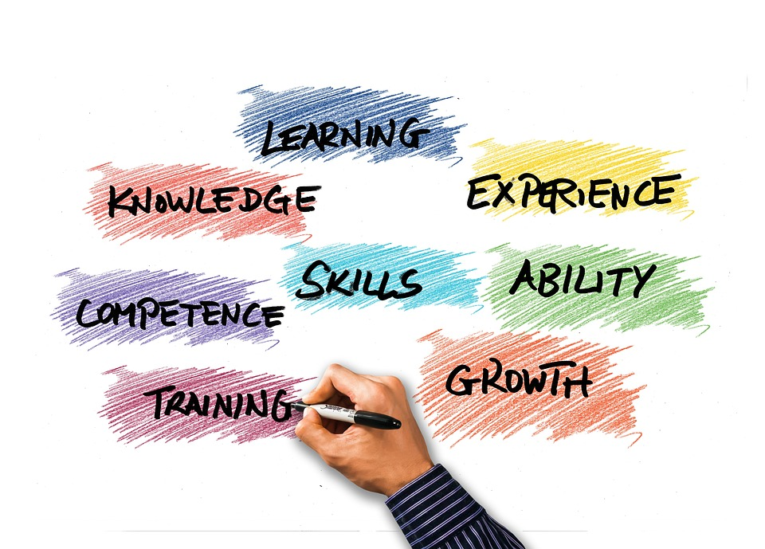

Business skills for the International Hotel Industry: M4X01917 – L4
Assignment 1

Student: Aneliya Dimitrova ID : 1816842
Lecturer: Dale Clarke
06/11/2019
Content

- Introduction-brief explanation of the topic.

- SWOT.

- Personal development plan-PDP.

- Skills required to find employment in Hospitality Industry.

- Conclusion.

- Reference list.

1.Introduction
I have been assigned to write a report about my current Academic and employability skills. In order to do it I am going to use SWOT and PDP.
I am doing to analyse my personal qualities and skills, and what I need to improve so I could impress employers in the hospitality industry.
The report will allow me to discover myself deeply, to clarify my goals and the way I could achieve them. I could see clearly the opportunities and threats I will face. I am going to make a plan and I need to consider the time on the way of my development.
To work in the hospitality industry, we need to own diversity of skills-academic and employability. Some of them we own by birth, they depend on character and intuition, and we call them soft skills. Hard skills are specific and teachable abilities, we have learnt at school and gained from our work experience.
Phelan, Kelly Virginia & Mills, Julinet (2001) point five important skills for hospitality industry -professionalism, work ethic, personality traits and self-management.
On the other hand Dixon,Jami; Belnap et all ( 2001), have focused on five different skills. These are team work, decision making, communication skills, working under pressure and problem solving.
To find my skills appropriate to work in hospitality industry I am going to do SWOT analyse.
- SWOT
SWOT analyse is an effective way to look at an organization from every single corner, to analyse its good and bad sides, to discover opportunities and avoid threats or decrease them if it is possible. Using SWOT helps growing, increases turnover, assistances stability of the organization.
SWOT
Internal factors | External factors
Strengths | Opportunities
Weaknesses | Threats

“SWOT Analysis is a simple but powerful tool for sizing up an organization’s resource capabilities and deficiencies, its market opportunities, and the external threats to its future” (Thompson et al., 2007: 97).
We can apply SWOT not only for an organization. It could be utilizing in many cases, including analysing ourselves.
I am proud with myself and my strengths. I am fully dedicated and loyal in everything what I do. Everyone notice it and people always ask me how I do it, where I take the energy from. My positive attitude and professional approach astonish people around me. I have an influence above them and unite them. I am exceptional team player but at the same time I like working independently. Time management is very important for me, that is why I am absolutely punctual. Whole my work experience is under pressure but I am capable to make right decisions in critical situations, still stay calm.
I am detail oriented, even pedantic. In many cases this is one of my strengths but sometimes could be weakness. I have worked as a supervisor in Housekeeping department in Hilton hotel. One of my responsibility was checking rooms and give them to the reception, when they are ready to meet new guests. For me five stars standard means absolutely spotless and sparkling cleaning everywhere. I trained and helped my team daily but I had to call back housekeepers many times and some girls were upset. I know people are different and everyone is unique, I really respect this. I need to find a balance between my expectations and what people can do, to find a way to make them to do better, what they do not do good enough. Otherwise I will scare people not only on my work place but in my personal life as well.
My biggest weaknesses are my IT skills. I am not quick in typing and I am not familiar with many computer programs and applications. I have to learn many things on the topic, especially those ones related to hospitality industry.
As English is not my native language, I put extraordinary efforts to make myself more confident. Language knowledge is vital in hospitality. I live and study in United Kingdom so to speak fluent English is a must.
I have learnt Russian. I knew it very well but I have not spoken for a long time. I need to recall it. Knowing Russian will give me an advantage when I am looking for a job.
As many of us I am not very confident in public speaking. I need to work on it.
To work for big International company is my dream since I was a child. The opportunity that I have now is unbelievable. I study in well-known with quality education University. On the other hand, I could apply my knowledge in practice in Marriott hotel. This is the best choice I have ever made.
3.Personal development plan(PDP).
Personal Development Planning (PDP) is “a structured and supported process undertaken by an individual to reflect upon their own learning, performance and/or achievement and to plan for their personal, educational and career development”. (QAA definition of PDP from Policy Statement on a Progress File for Students, May 2000)
PDP is an impetus for moving forward because we know where we are and where we want to be, and when and how things are going to happen. Sometimes we have to do what we do not want to do in order to achieve our goals. Then PDP keeps us aware are we on the right way.
Engaging in PDP gives many benefits for every person:
- to become fully motivated
- to identify his potential and be able to fulfil it
- to check his progress
- to be more employable
To create PDP we need to answer few questions:
- Where am I now?
- Where do I wish to be?
- How am I going to get there?
- Do I need any support?
- What have / have not I achieved already?
- How have I done it?

 | Short-term time frame  What do I want to achieve in the next three to six months? | Mid-term time frame  What do I want to achieve in the next six months to two years? | Long-term time frame  What do I want to achieve in the next two to three years?
Section 1 – What are my goals? | 1.Speed my typing  skills.  2.Speek confidently in front of public. | 1.Speek fluently English and Russian.  2.Start learning new language. | 1.Go to another country for apprenticeship.  2.Become a manager in one of Marriott hotels.
Section 2 – What skills and knowledge do I need to learn? | 1.IT  2.Speaking in English in academic style. | 2.Speeking  2.Listening  3.Reading  4.Understanding | 1.Middle level IT skills.  2.Developing leadership.
Section 3 – What are my next steps? | 1.Start typing daily minimum 3 pages.  2.Start practising in front of a mirror. | 1.Learning gramma rules daily –minimum one rule per day.  2.Reading books in English and Russian minimum 60 pages per week. | 1.Reading about history, traditions, daily life of the country.  2.Reading books about Hotel management and Leadership.
Section 4 – What resources do I need? | 1.Time. | 1.Time  2.internet  3.Books  4.A native speaker to speak with. | 1.Time  2.Internet  3.Books  4.A place to practice and a person to guide me in the beginning.
Section 5 –What is my time schedule? | 1.I started on 01/11/19  2.01/12/19 | 1.15/12/19  2.15/12/19 | 1.2021  2.2021
Section 6 – When have I completed each step? | 1.Continuously improvement. | 1. Continuously improvement. | 1.2022  2.2022

4.Skills required to find employment in Hospitality Industry.
Whether we work as a manager, we will grow and find success through experience and constant learning. With that in mind we should aim to acquire and develop hospitality skills in our career. Burton (2018) identify top 8 skills:
1. Communication
2. Resilience
3. Initiative
4. Multitasking
5. Adaptability
6. Attention to details
7.Cultural awareness
8. Compliance training
I agree with this statement but I could add: negotiation and persuasion skills, problem solving ability, leadership, honesty, perseverance and motivation.
For me is all about to love people, to love helping them and making them happy. J. Willard Marriott`s words express my opinion: ’’ Employees must instinctively know to place customer need above their own and never be too busy to help.’’
5. Conclusion:
This report is useful and necessary. It helps me to set up my goals, I analysed my good and bad skills, I know where I am and where I want to be and I have a plan how to achieve my goals. I appreciate the possibility to study in the University of Wales Trinity Saint David and to work in Marriott hotel chain.

1. Burton, Liz Top 8 Skills for a Successful Career in Hospitality, September 19, 2018, www.highspeedtraining.co.uk
2. Dixon, Jami; Belnap, Cody; Albrecht,Chad ; Lee, Konrad May/Jun 2001, “Theimportance of soft skills”, . CorporateFinance Review 14.6 p35-38.
3.. J. Willard Marriott January 20, 1964 The Marriott Management Philosophy.A living traditionof values and beliefs.
4. Phelan, Kelly Virginia&Mills, Julinet;“An Exploratory Study of Knowledge,Skills and Abilities (KSAs) Needed inUndergraduate Hospitality Curriculums inthe Convention Industry”,Journal ofHuman Resources in Hospitality andTourism,Vol.10, issue 1, ’Jan Mar 2011p96-116, 21p.
5. THOMPSON, A. A., STRICKLAND, A. J. & GAMBLE, J. E. (2007). Crafting and Executing Strategy-Concepts and Cases, (15th Edition), USA: McGraw-Hill/Irwin.
6. QAA definition of PDP from Policy Statement on a Progress File for Students, May 2000http://www.qaa.ac.uk/academicinfrastructure/progressFiles/archive/policystatement/default.asp

