

Academic Discipline of Social Justice and Inclusion
MArts/BA Humanistic Counselling Practice

Module: Practicum

Assessment Component: 2

Assignment Title: Reflexive account of Client at Supervision

Student Number: P150911

Overview
A reflexive account of a client at supervision, which will evidence therapist ability at competently working ethically and safely within an agency. This aims to demonstrate self-awareness, appropriate management of relationship with client and identify issues that may need addressing when working as a counsellor. It will highlight the essential existence of contractual boundaries, confidentiality and anonymizing client identity. The client discussed in this essay is receiving counselling support from a domestic abuse agency.
Reflexive account of a client at supervision
Good practice in action requires clinical supervision. According to the BACP, student members who require client hours to be counted towards accreditation need a minimum of 1.5 hours of supervision for every eight hours of client work a month. Group supervision for student members the rule varies according to size of the group and frequency of supervision (BACP,2019). A qualitative research study explored counsellors’ experiences and views of how clinical supervision had helpful and non-helpful effects on their client work; counselling relationship dynamics, self-awareness, professional development and emotional support. Congruence and confidence were highlighted as having the greatest impact on supervision and client work (Vallance, 2007). It is important that the supervisor has adequate qualification, background experience and knowledge in the subject field of the organization from which the client is seeking a talking therapy, to be able to work with the supervisee competently.
Due to the nature of the work that the agency undertakes, who are providing counselling support for this client, an initial assessment process is carried out prior to the client being allocated to an agency counsellor. Client was identified as KD to the supervisor to maintain client anonymity. The client discussed at supervision presented with depression, anxiety and feeling ‘not herself’ and ‘unable to move forward’ following the breakdown of her marriage, and difficulties that have arisen with her ex-husband post-divorce.
Contracting and boundaries were put into place during the first client session. During the initial session, KD was informed of the confidentiality of the therapy sessions, the length of each session and the duration of therapy. A reassessment would be performed after 6 weeks into therapy to allow client and therapist to work collaboratively on length of further sessions required up to a total of 12, this creates time for the therapist to establish a positive ending to treatment. It also informed of the circumstances at which confidentiality may be compromised. Notes made following each session would be of minimal content and anonymized but may be accessed by local authorities if deemed necessary. The core 10 assessment completed during the first session gave an insight into the level of distress KD had experienced during that past week. It is a good reference as discussion, and reflection of progression made. The use of this was agreed by supervisor.
Establishing a good therapeutic relationship is paramount to the success of therapy between client and therapist. The core conditions of Person-Centered counselling were present throughout, this was displayed by KD being open in her disclosures of her current situation, even though this was upsetting and distressing for her.
The aims of therapy were discussed which included KD being able to sit in her own company, to better interact with her ex-husband for contact of their children, and to have an acceptance of her new circumstances.
This client was taken to supervision following her 3rd session. During which time a good therapeutic alliance had been achieved. Whilst actively listening to what was going on for KD at that moment, it became apparent that KD was feeling shame of being a single parent, allowing stigma to impact her psychologically and emotionally and was seeing herself in a bad light. Evenings were becoming more and more of a dreadful thought as KD’s anxiety at sitting in her own company whilst children were in bed was allowing a build-up of negative thoughts becoming unbearable, preventing her from concentrating on anything from what is on TV to reading. Settling down to sleep was worsening to the point that her sleep pattern was interrupted, leaving her feeling exhausted by the morning when her daily routine began again.
The interventions used in these counselling sessions are ‘emotion focused’ and ‘reframing’ to promote self-efﬁcacy, using the client–therapist alliance, and actively listening to the client’s disclosures in the here and now, and shifting the outlook of her newfound circumstances. Using the appropriate use of therapist self-disclosure, the stigma and stereotyping of being a single mum not only lifted but a deeper level of the therapeutic relationship was achieved. By the following session the therapist noticed a change in the way in which KD presented. Phenomenological noticing of therapist that her facial expressions were softer, and happier, her body language was more relaxed, and she was less emotional. Her narrative had shifted from being ‘stuck’ and ‘unaccepting’ to embracing her single status, thus realizing she could make decisions that pleased herself without the negative input of her ex-husband.
The fifth session witnessed KD’s progression of therapy. Paying reference to the Core 10 to visually display to KD how she had worked so hard to make the changes she was wishing for, by not ‘sweating the small stuff’ approach, KD has realized that as she focuses more at being at peace where she is at this moment in time, rather than putting all her attention on where she would rather be, she has begun to find peace right now, in the present. This is evidenced by her change in presentation, tone of voice and speed of speech. KD seems less anxious and more relaxed with her new thought process.
The supervisor has discussed the use of disclosure and pointed out that this was exactly the correct approach for this client at that moment, and significant improvement has been made as a result of it. The huge impact this has had on KD and how the change really manifested in the client’s whole demeanor, attitude and increasing energy and motivation. Being honest about the work with the client with themselves and supervisor is the key to becoming a competent counsellor, adapting an attitude of withholding interventions can only prove to cause harm to themselves, client, supervisor and agency. Trust and confidence are the two main ingredients of a good therapist.
The duties and responsibilities of the supervisee are expected to work in accordance with the ethical guidelines and professional standards of the organization and counselling framework and be prepared to openly discuss all client cases with their nominated clinical supervisor. Failure to be congruent during supervision could potentially cause harm to both client and supervisee and be deemed as their work being unethical. The duties and responsibilities of the supervisor are to examine interventions, and treatment plans made by the therapist, and to challenge appropriately to interventions, boundaries and ethical decisions, to provide education and management support.
The supervisor works from Peter Hawkins and Robin Shohet ‘Seven Eyed Supervision Model’ 2014, that integrates the ‘relational and systemic’ values of supervision in one theoretical model. It concentrates on relationships between client, therapist and supervisor, and how each relationship interlinks. The seven aspects of the therapeutic process give it its name.

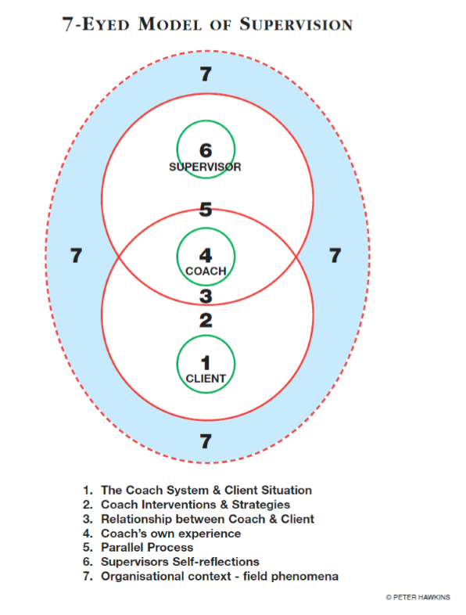
Supervision has three key elements; normative which is to meet with the ethical/organisanonal standards, and quality control. Formative for developing skills and an understanding. Restorative for support, as the client is the key focus.

During the third session therapist discloses that she had recently suffered a bereavement of a close friend. The supervisor advised that in this situation the therapist would usually take some time off from client work to ensure therapist is working ethically within the current organizational and BACP guidelines. Failure to take time off for self-care could potentially cause harm should the therapist not fully ‘be present’ during client work, something important could be missed or the client may sense that therapist is not fully listening to them which could impact the therapeutic relationship of trust. An agreed length of time from client work was agreed by organization, supervisor and supervisee, and client informed that the therapist would be taking annual leave. Sessions recommenced following this time, after supervisor and management at organization being satisfied the therapist is fit to return to client work.
Supervisor feedback has been positive, complimenting supervisee for always being honest and candid, bringing her clients in a very distinct way by talking about them clearly, and the interventions she has used. Discussion regarding appropriate use of self-disclosure and its impact on KD. Appraisal for honestly discussing the sudden passing of a close friend, and her vulnerability following her death, and how this would impact on both client and therapist. This demonstrated a willingness to adhere to a counsellor’s recognition for self-care and how poor self-care has a direct impact on clients by putting clients first by taking a short break from client work, working to professional standards.

Conclusion
This reflexive account has given an example of appropriate use of taking a client to supervision. It encompasses the integration of ethics, professionalism, client management, the use and importance of clinical supervision. Supervision is required to obtain accreditation of client work. It ensures the quality of the therapists work with client within the organisation. It supports personal and professional development. It constantly is educating the supervisee in their client work and can support supervisee if exposed to vicarious trauma. The experience and knowledge the supervisor has in the agencies subject field are the main requirements of the supervisee and supervisor relationship. It supports supervisee resilience and helps to reduce burnout and improve client outcome.
Supervisor feedback and challenges of interventions used is the learning process for the supervisee. Being honest and open about client work can be daunting for the supervisee as there are elements of fear that the intervention used maybe inaccurate or innocent harm may have been caused. Congruence and confidence in the allocated supervisor by the supervisee need to be present if any assistance, support or guidance can be from the supervisor. The therapist needs to be at all times honest with themselves, client and supervisor to maintain safety for all concerned. If the supervisee is fearful of sharing their client work then it would put them and client at risk which could do harm to client and agency reputation. Accepting criticism is part of personal development which is ongoing in the role of a counsellor.

Reference List

BACP. (2019). Supervision. Available: https://www.bacp.co.uk/membership/supervision/. Last accessed 9th May 2019.

Brady, t. (2005). coaching, supervision and the organizational system. Available: file:///C:/Users/pc/AppData/Local/Packages/Microsoft.MicrosoftEdge_8wekyb3d8bbwe/TempState/Downloads/Supervision%20Masterclass%20NH%20NHS%20FT%20%20(3).pdf. Last accessed 9th May 2019.

Vallance, Kate. (2007). Exploring counsellor perceptions of the impact of counselling supervision on clients. counselling and psychotherapy research. 5 (2), 107-110.

