Engineering Design & Materials

Dry sump

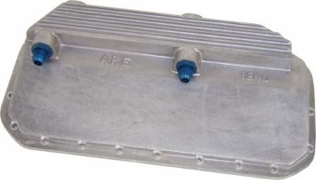

(DrySump)

BSc/HND Motorsport Automotive

Callum Evans
1702660

Problem Investigation

The use of a wet or dry sump is based on the level of competition and a racers budget. A wet sump system is based off the original oil system that came stock with the car, this can be upgraded with aftermarket parts such as different shaped sumps and oil pumps that can pump a larger volume of oil. (DrySumpInfo)
A dry sump system is mainly used for top levels of racing such as the world rally championship and forms of road racing such as Ginetta race cars.

1.1 Dry sump
A dry sump system stores the oil in a separate tank and pumps the pan with next to no oil in the pan. Advantages include more power because of the extra crankcase vacuum with the dry sump pump. This then improves the ring seal. (DrySumpInfo) The system also has increased capacity, adjustable and consistent oil pressure and remote coolers. Better weight distribution and a lower centre of gravity is also an advantage because of the lack of oil in the pan allowing it to be shallower. Therefore, the engine can be mounted lower to the ground.

1.2 Wet sump
A wet sump offers a simple and cheap design as there in no external oil pump. As there is only one internal pump then there is no need for external pipes and hoses which take up more room in the engine bay. There is also a larger chance of leaks. However a race car in fast corners can cause the oil in the sump to slosh to one side starving the oil pick up pipe and therefore losing oil pressure to the head of the engine causing damage to the cams and tappets.

Contents
1. Problem Investigation 2
2. List of Figures 3
3. QFD Competing Product research 5
4. Design Feature ratings 6
5. The Resulting Scores for Each Design 6
6. Design Feature ratings 7
7. Product Design Specification 7
8. Detailed Design Specification 8
9. Dry Sump Design A 9
10. Dry Sump Design B 10
11. Dry Sump Design C/Final Design 12
12. References 15
13. Appendix 16

List of Figures

Figure 1 = Table showing design feature ratings
Figure 2 = Table showing the resulting scores for each design
Figure 3 = Table showing design feature ratings
Figure 4 = Table showing product design specification
Figure 5 = Table showing detailed design specification
Figure 6 = Solid works technical drawing showing Design A
Figure 7 = Solid works technical drawing showing Design b
Figure 8 = Solid works technical drawing showing the final design
Figure 8 = Table showing customer research

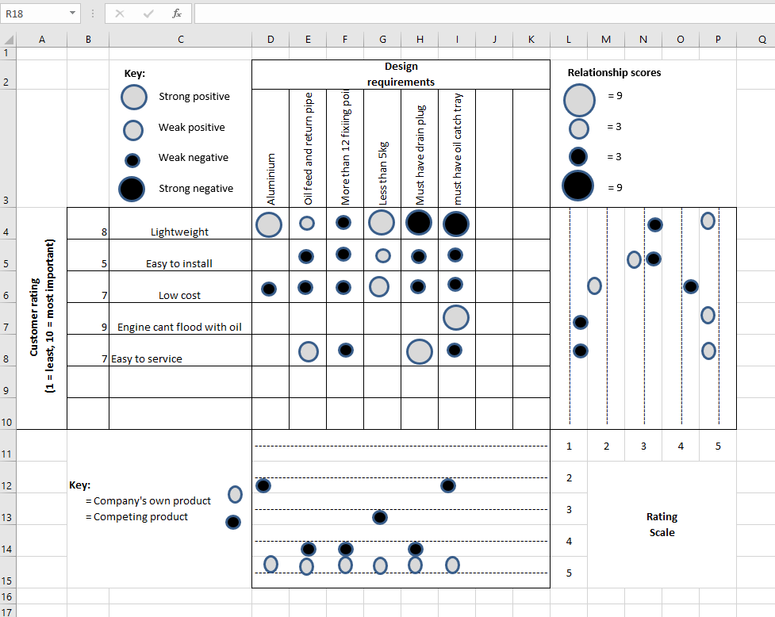
QFD Competing Product research

The QFD above is an example of a comparison with a similar dry sump on the market. My dry sump out scored the competitors dry sump due to the QFD being bias towards company own dry sump.

Design Feature ratings

Feature | Design A | Design B | Design C
Fulfilment of function | Low | Medium | High
Reliability | High | Medium | Medium
Serviceability | Low | High | High
Life | High | High | Low
Ease of maintenance | Low | High | High
Ease of manufacture | High | Medium | Low
Efficiency of operation | Low | Medium | High
Figure 1

The Resulting Scores for Each Design

 | Design A | Design B | Design C
High | 2 | 3 | 4
Medium | 0 | 4 | 1
Low | 4 | 0 | 2
Cost | Cheap | Moderate | Expensive
Figure 2

Design Feature ratings

Feature | Design A | Design B | Design C | Importance
Fulfilment of function | 5 | 8 | 10 | 3
Reliability | 10 | 8 | 8 | 2
Serviceability | 1 | 10 | 10 | 2
Life | 8 | 8 | 6 | 1
Ease of maintenance | 1 | 10 | 10 | 3
Ease of manufacture | 10 | 8 | 5 | 1
Efficiency of operation | 2 | 6 | 10 | 3
Design total Weighted ratings | 56 | 124 | 173
Figure 3

Product Design Specification

Performance Requirements | Design requirements | Design specification
Lower centre of gravity | Must have enough room for the crank shaft to pass without making contact | Less than 10mm of clearance between crank shaft and sump
Must be able to run with a high capacity of oil so the engine runs cooler | Must have a main feed and return oil pipe connectors | 2 pre-cut, 8mm threaded holes for oil pip connectors
Improve power to weight ratio of vehicle and improve performance | Must be lightweight | Less than 5kg
Must be able to adjust the oil flow rate to the engine | Must have an oil feed and return pipe to a pump that can be adjusted | Must have 2 holes pre-cut and threaded into the bottom of the sump.
Must be secure to engine block | Suitable number of bolts to be used | Must use more than 12 fixing bolts
Figure 4

Detailed Design Specification
Market Requirements | Life in service requirements | Production requirements | Conformance Requirements
Sump must be light weight | Must be able to withstand knocks from debris from the road surface | Must be less than 5kg | The design must be tested on a engine dyno before sale to ensure no leaks or fractures
Must be affordable | Must be able to outlive the life of the engine as long as not damaged | The sump can be manufactured overseas where the cost will be cheaper | The sump must not have any sharp edges that could be dangerous to user
Must need a magnetic drain plug | Must be able to be serviced easily (drain plug) | Must be made out of cast aluminium | The product will only be able to fit ford zetec engine and won’t be compatible with anything else
Must be easy to fit to the engine | At the end of the sumps functional life the material used can be recycled | Must be made as light as possible | The design of the sump must be checked for copy rights before manufacturing
Must have quick oil pipe connections for quick removal and refitting | The Sump me be able to endure weathering and corrosion. | Must be all 1 piece to reduce weak points and ensure a structurally strong product
Figure 5

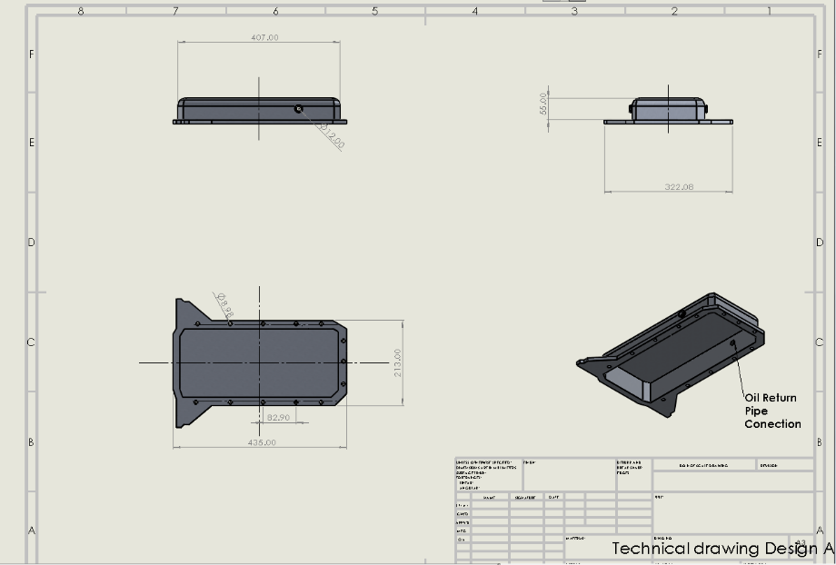
Dry Sump Design A

Figure 6

Figure 6 Shows the first initial design of the dry sump.
Advantages:
- Lightweight, weighs less than 3 kilos because it is made form aluminium
- Easy to manufacture because of the simple shape and design
- Good contact with engine block ensuring a good seal preventing leaks
- Sump pan is only 55mm deep allowing the engine to be mounted lower
Disadvantages:
- No where for the sump to mount to the gearbox this means the flywheel is exposed when operating
- No baffle/catch tray is fitted, so if the vehicle roles then all oil would go into the engine and the external pump will be sucking air. This will restrict oil to the head of the engine causing damage to cams and valves.

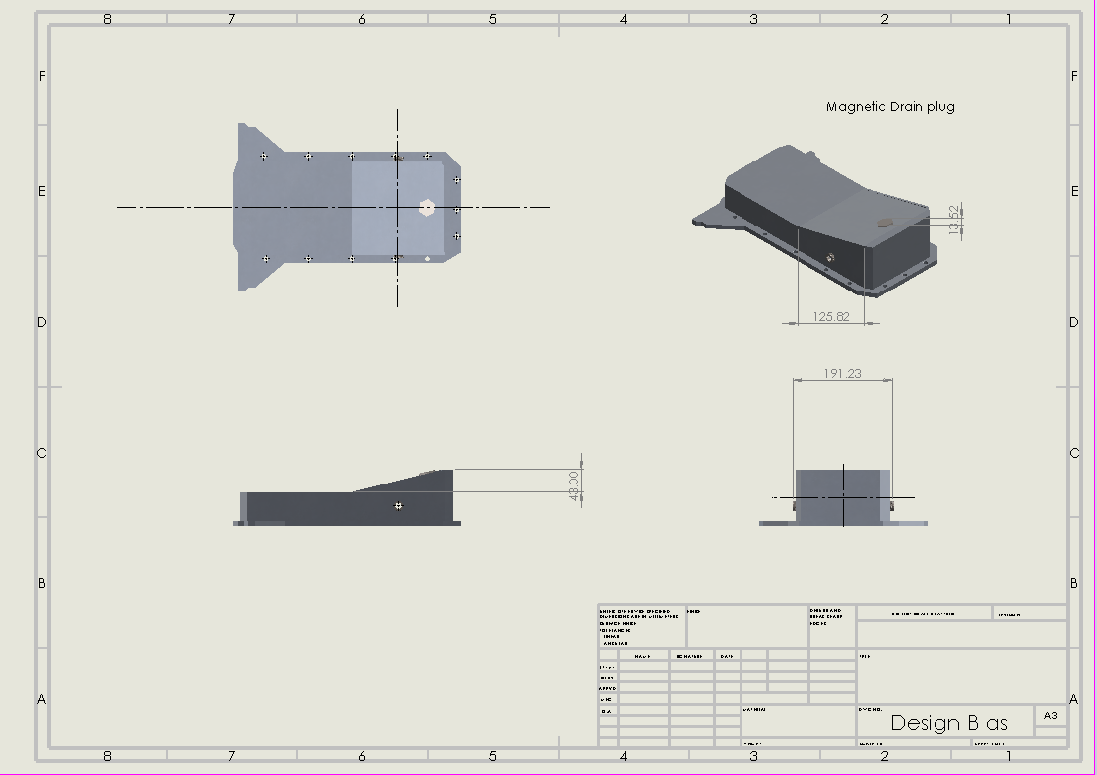
Dry Sump Design B
Figure 7

Figure 7 Shows the Second design of the dry sump.

Advantages:
- This sump has similar advantages to design A, however there is a few added features.
- The sump has a magnetic drain plug, which can help remove any large metal fragments in the oil. This can help engine reliability as there is less chance of the engine being damaged by metal fragments.
- The sump had a slope bottom so any fragments can settle to the bottom of the sump and will make a service more effective.
- The drain plug can be removed quickly for an instant inspection of engine oil and can make it easier to diagnose an engine problem because the sump wouldn’t need to be taken off for a routine inspection.

Disadvantages:
- The drain plug is magnetic and needs to be made of steel, this increase the weight of the dry sump. The weight of the drain plug is an extra 0.2 of kilo.
- Also, as the sump is now sloping, more material is needed so the new weight is nearly 3kg this can be a huge turn off for people who will be using the sump for motor racing
- Overall depth of the sump is deeper by 43mm, this means the engine cannot be mounted as low.
- The contact point of the steel drain plug to the aluminium sump can cause corrosion and if left in the sump for too long, damage can be caused to the threads, meaning the sump will not be functional

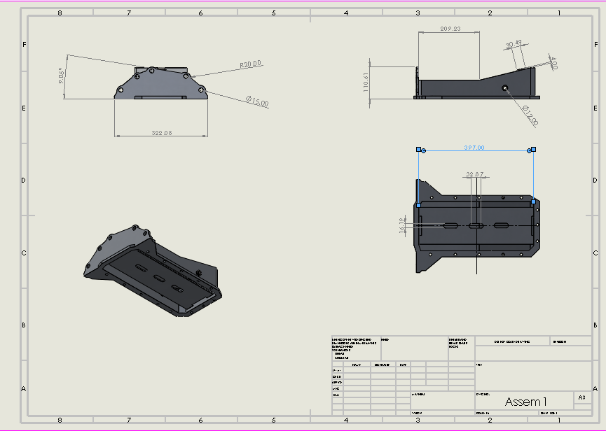
Dry Sump Design C/Final Design

Figure 8

Figure 5 Shows the Third and final design of the dry sump.

Advantages:
- The main advantage of this design compared to design A and B is that this sump has an oil catch tray, this will ensure that the oil feed pipe will not run dry when the car is rolled over. This means there is less chance of the engine running with no oil.
- This design has gearbox mounting points. This will ensure a secure fit to the gearbox and increase strength of the sump when mounted to engine block
- The fly wheel will now be covered meaning it is safer for motor racing and more protected against track debris.
- The total weight is 3.6kg which is within the 5kg target

Disadvantages:
- Even though this final design has the most beneficial features it is now the heaviest out of the 3. If a drain plug wasn’t needed and the costumer preferred the fly wheel to be open to save weight then this could be a point against this final design.

Customer requirement | Requirement importance rating (out of 10)
The product should be light weight | 8
The product should be easy to install (initial set-up) | 5
In the event of a roll-over, the engine should not be flooded with lubricant | 9
The product should be low cost | 7
The product should allow easy/fast access for servicing/maintenance | 7
Figure 9

Figure 12 above shows initial market research that was taken before the design of this dry sump. Design C meets all of these costumer requirements.
- The product should be light weight = Design C is made from cast aluminium and is 3653.64 grams with the drain plug and pipe connectors fitted
- In the event of a roll-over, the engine should not be flooded with lubricant = Design C is witted with an Oil Catch plate/Baffle to make sure the engine isn’t flooded
- The product should allow easy/fast access for servicing/maintenance = Design C is fitted with a magnetic drain plug to ensure all the oil can be drained out of the dry sump system.

References

- (Dry Sump) ARE. (2017). Dry sumps BMW. Available: https://www.drysump.com/index.php/oil-pans/bmw/59-bmw-m-10-4-cylinder. Last accessed 21/01/20.

- (DrySumpinfo) Know your parts . (N/A). Dry sumps . Available: https://www.knowyourparts.com/technical-resources/engine/oil-system-differences/. Last accessed 21/01/20.

Appendix


