

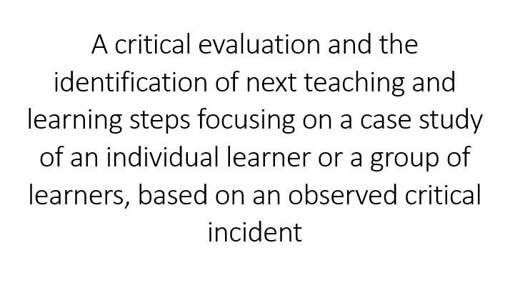

Helen Frey

P131560 / 1252724

Lecturers: Karl Jones / Iwan-Ellis Williams

PGCE Secondary

Table of Contents

1. Introduction 3
2. Observations 4
3. Methodology 5
Researcher Roles 5
Structure 6
Case Studies 6
Case Study Advantages 7
Case Study Disadvantages 7
4. Donaldson’s Four Purposes 8
Observed Critical Incident 8
The Four Purposes in Action 9
5. Literature Review 10
Working Memory 10
Cognitive Load Theory 12
Dual Coding Theory 17
Dual Coding Theory and Split Attention 18
6. Critical Reflection, Evaluation and Next Steps 19
Critical Reflection 19
Critical Incident Evaluation 22
Next Steps 22
7. Conclusion 23
8. Bibliography/Reference List 25
9. Appendix 1: Observation 1 30
10. Appendix 2: Observation 2 35
11. Appendix 3: Observation 3 40
12. Appendix 4: Observation 4 46

Introduction
This essay sets out to evaluate one of four critical teaching incidents, relating to either an individual or group of learners that were observed within a classroom environment. How the incident occurred will be considered and in what way it can be used to guide teaching practice will also be examined using a variety of learning theories.

Tripp (Tripp, 2006), Cohen et al (Cohen, 2018) and Flanagan and Wragg, (cited in Cohen, 2018) concur that a critical incident/event in teaching is usually a single event in time that can give insight into a situation or person. These incidents can relate to the way a teacher behaves or their method of teaching. It can also be how a pupil reacts out of character and how this is dealt with. They are often considered to be non-routine.

The interpretation of a critical incident and the significance that is attached to this interpretation will form the basis of an in-depth, holistic evaluation of the event. The use of critical incidents is just one way to develop professional practice within an educational context and can be used as a starting point to examine awareness of teachers’ professional judgments (Tripp, 2006).

Research and reflection will determine what made this a critical incident and the research and reflection will be objectively analysed in depth in order to form a judgment.

The advantages and disadvantages of case studies will be considered. Learning outcomes will be studied and how this could enhance personal reflective practice and next teaching and learning steps will be investigated to direct personal professional practice.
All the ethical requirements pertaining to consent were established between Yr Athrofa and the school concerned. The BERA (British Educational Research Association) guidelines for anonymity were strictly adhered to.

Observations
The four observations took place in a comprehensive school in an urban area and can be found in Appendices 1-4. According to a 2016 Estyn Report the comprehensive school has approximately 1,100 pupils on roll that include 177 sixth formers. The school is English-medium and has approximately thirteen-point six percent of pupils eligible for free school meals (below the national average of seventeen-point one percent). Twelve percent of the pupils come from twenty percent of the most deprived areas in Wales. The majority of the pupils are white British with around one-point four percent from ethnic groups requiring English as an additional language. Few of the pupils are fluent Welsh speakers. The special needs education is lower than the national average (twenty five-point one percent) at nineteen percent and the percentage of pupils requiring a statement of special needs is one-point one percent, also below the national average (two-point four percent). The Estyn Report also summarises the school’s performance as “Excellent” (A report on Bryntirion Comprehensive School Merlin Crescent Cefn Glas Bridgend CF31 4QR, 2016)

The age range of the observed classes were between twelve and fourteen years old (years eight and nine). The average class size was 28. Two of the lessons were of mixed ability and two were from ‘higher sets’.

One class was observed during two subjects with different teachers and it was interesting to note the various approaches to teaching the same pupils and how the pupils’ behaviour changed between subject content and teacher.

Methodology

Researcher Roles
According to Cohen (Cohen, 2018), the researcher roles are split as follows:
- complete participant where one member secretly observes other members of the same group without their prior knowledge or consent.
- the participant-as-observer where the member of the group is known to be an observer.
- the observer-as-participant who is not a member of the group, can participate in a peripheral role and is known to be an observer.
- the complete observer (overt or covert) whose presence is usually unknown to the group.
The rationale for the researcher role for this critical incident essay was the complete observer model. The observer’s participation was overt as they were in the classroom, although they were part of neither the teacher nor the class group. The pupils were unaware of who was being observed whether it was themselves or the teacher and the only influence the observer had was that of being present. The context of the observation was naturalistic as the subjects were within their own habitual classroom setting rather than a laboratory (Cohen, 2018).

Structure
Cohen et al (Cohen, 2018) state that a structured observation allows numerical data to be collated to allow comparisons or patterns to be created. The observations must be mutually exclusive and unambiguous. For this observation there was a form that was completed, however this did not really fall into the rigid structure applied by Cohen. Rather, the nature of the form allowed for a variety of scenarios that could observed and therefore did not fall into the unstructured category either. The case study therefore was semi-structured.

Case Studies
Verschuren (Verschuren, 2003) suggests that case studies are a hybrid of research types, for example, observational, action, experimental or survey and include a range of data collection methodology, both qualitative and quantitative.

(Yin, 2009) states that case study designs come in four models:
- The single case design that focuses on unique or typical cases.
- Embedded single case where more than one subset of analysed units is collated into one design.
- Multiple case designs that would be used for comparative research.
- Embedded multiple-case design that would be used for surveys etc.
This case study would be designed using the single-case method. This approach to inquiry would develop into an in-depth analysis of one event that has been taken as a snapshot of an activity by one or more individuals, making it a cross-sectional study (Creswell J, 2018).

Case Study Advantages
- Nisbet and Watt (Nisbet and Watt cited in (Cohen, 2018)) propose that case studies can observe unique characteristics that could be lost in a pure data collection study.
- Adelman et al (Adelman et al cited in (Cohen, 2018)) postulate that case studies focus on complexity and subtleties of an instance.

Case Study Disadvantages
- Wellington (Wellington, 2015) notes that case studies are not able to be replicated, may not be representative or able to be generalised.
- Adelman et al (Adelman et al cited in (Cohen, 2018)) contradict Wellington as they believe that generalisations can be made about an instance.
- Shaughnessy et al (Shaughnessy et al, cited in Cohen 2018) claim that case studies lack control over variables and are not systematic. They go on to suggest that bias forms a large part of case studies and it can be difficult to establish cause and effect.

Donaldson’s Four Purposes
A new curriculum has been designed for Wales (The Curriculum for Wales Framework) and will be implemented in 2022 (Government, 2020). There are Four Purposes that have been chosen as the starting point for change:
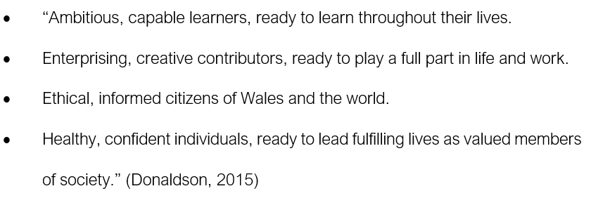

To assist with these aims, critical evaluations of teaching methods have been proposed.

Observed Critical Incident
The critical incident (Appendix 4) took place throughout the lesson. The pupils were told to write the heading in their book and underline it, then write ‘x’, then write ‘y’. This control of what they put into their books, even going as far as to how many lines to leave (irrespective of how big or small their writing was) between questions made me ask ‘how much independence do these children have’? How can these children become independent learners when every single move is decided for them in minute detail?

The teacher then showed a film and commented throughout. Drawing the pupils’ attention to every detail that they would need to observe and possibly others that were not required. There are two parts to this:
- the pupils become reliant on [someone] the teacher to observe what was going on and relate the information back to them which ties in with the independent learning issues above.
(b) did watching and talking give the children cognitive overload as they were meant to be answering questions about the part of the film they watched?

This essay will focus on the cognitive overload issue noted in (b) above.

The Four Purposes in Action
The incident can be linked to the Four Purposes through the following:
- “Ambitious, capable learners who are questioning and enjoy solving problems”.

How can these children question and solve problems whilst they are being spoon-fed both the questions and the answers?

- “Ethical, informed citizens who find, evaluate, and use evidence in forming views” ¹.

They are not being shown how to find evidence to form their own views.

- “Creating healthy, confident individuals who are building their mental and emotional well-being by developing confidence, resilience and empathy” ¹.

Their emotional well-being may suffer as will their confidence when they find they are unable to do anything without being told how to do it in minute details.

- “Enterprising, creative contributors who identify and grasp opportunities” ¹.

The pupils will be unable to identify opportunities without assistance.

Literature Review
The critical incident (Appendix 4) identified some practices where it could be useful to understand working memory limitations and how to impart knowledge without giving the pupil too much or too little information. Explored in this literature review are working memory, Cognitive Load Theory, Rosenshine’s Principles, the Dual Coding Theory and Split Attention.

Working Memory
Furst (Efrat Furst - Learning in the Brain, 2018) states that working memory is the use of environmental stimuli in real time combining with long term memory knowledge to create a result. Furst suggests that it is only when information is processed in a meaningful way that it can be stored in the long-term memory.

Gathercole et al (Gathercole and Alloway, 2004) state that the working memory is the short term ability to hold and manipulate information.

Furst (Furst, 2018) categorises the working and long term memory into four categories as ‘know’, ‘understand’, ‘use’ and ‘master’, applied through an interleaving effect. The differences between the know and the master comes from elaboration, explanation, and examples with the understand to use being (with effort) retrieval, spacing and interleaving. Both know and master have the same working memory load, it is just that one is retained for immediate use whilst the other is retained for long-term use.

Piaget’s Theory of Conceptual Schema suggests that everyone has a mental model of what things should be in order to make sense of the world around us. He used schemas as building blocks for cognitive models that allow mental representations to be used to learn new concepts as shown in Figure 1. His stages of cognitive development are also found in Figure 1. (Jean Piaget’s Theory and Stages of Cognitive Development | Simply Psychology, no date)
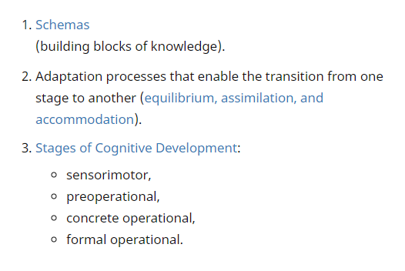
Figure 1: Jean Piaget’s Theory of Cognitive Development
(Jean Piaget’s Theory and Stages of Cognitive Development | Simply Psychology, no date)
Ausubel (Ausubel’s Learning Theory, no date) suggested that new knowledge must be built on known concepts in the same way as Piaget. Figure 2 shows his belief that meaningful learning requires structures that new knowledge becomes anchored to and rote learning is difficult because it has nothing that is meaningful.
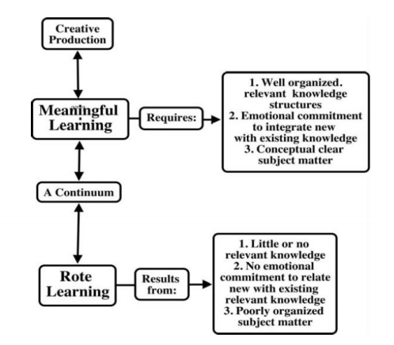
Figure 2: Ausubel's Meaningful Learning

Cognitive Load Theory
Sweller defined the cognitive load as:
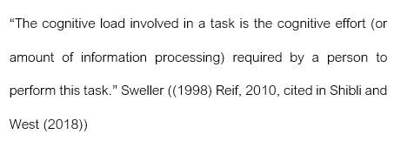

Dylan William suggested that the Cognitive Load Theory is “… the single most important thing for teachers to know” (Shibli D, West R, 2018).

The basis for cognitive load is that the working memory can only process limited amounts of information at any given time. There are three types of cognitive load:
- Intrinsic: the difficulty inherent within a subject that can be influenced by prior knowledge.
- Extraneous: deals with the difficulties that are influenced by the way the material is presented.
- Germane: positive influences such as schemas that aid the processing.
(Shibli D, West R, 2018)

Cognitive overload happens when the working memory capacity is exceeded. Chandler et al (Chandler and Sweller, 1991) suggest that splitting one’s attention by discussing the same subject which has been separated by time or space adds to the cognitive load, making it extraneous (simultaneous oral/text presentations).

Kalyuga et al (Kalyuga and Renkl, 2010) suggest that if there is insufficient cognitive load then this too creates an ‘expertise reversal effect’ and may have a detrimental effect on learning by the learner having too much extraneous information, such as easy models etcetera.

Vygotsky (Chaiklin, 2003) believed that there was a Zone of Proximal Development which was just beyond a student’s current ability but within their capability. Vygotsky indicated that each student had a Zone of Proximal Development that was unique to them. If they were being taught outside of this area, then they would experience either boredom or frustration. Vygotsky thought that what the pupil was capable of accomplishing today under guidance or collaboratively with peers, the pupil would be able to accomplish independently tomorrow.

In a comparable approach, Bjork, (Research | Bjork Learning and Forgetting Lab, no date) a cognitive psychologist, coined the phrase “desirable difficulties”. He postulated that desirable comes from long-term retention and difficulties is the challenges due to the fact that measurable performance improvement is not immediate.

Bjork explains the concept of slowing down learning and transferring knowledge by interleaving different problem-types within the same lesson or subsequent lessons. The ‘testing effect’ was shown to have improved memory due to the fact that a learner going through the act of trying to remember to answer the question made it easier to remember at a later stage.

Van Merriënboer et al (Merrienboer, 2003) appears to have considered a type of scaffolding system that was later favoured by Rosenshein.

Rosenshine (Rosenshine, 2012), over a series of decades, conducted research with his colleagues, concerning cognitive science and created a 17-step, later reduced to a 10-step ‘principles of instruction’ based upon the results of this research. Tom Sherrington (Sherrington, 2019) reduces these to four separate and distinct strands:
- Sequencing concepts and modelling
- Questioning
- Reviewing material
- Stages of practice
Rosenshine (Rosenshine, 2012) and Sherrington (Sherrington, 2019) postulate that the working memory is finite and that it is necessary for knowledge to be stored in the long-term memory. If this information can be organised within schemata, connected to already-known knowledge, it is simpler for this information to be retained, and the easier it becomes to the working memory. They also go on to state that if this schema is stored incorrectly or not retrieved frequently enough then it will be forgotten.
- Sequencing concepts and modelling suggest that all new material should be presented in small steps with structured practice after each step. The thought processes that the teacher goes through during the modelling should be explicitly narrated to allow the learners to follow it. The modelling should form a scaffold from the start whereby the model is a representation of the completed task and then bit by bit the learners have to build the model themselves with the scaffolding being taken down in direct correlation to the learnings understanding.

- Questioning should be based on the Lemov (Lemov, 2016) cold-calling technique whereby there is no opt-out. All learners will be questioned at one time or another irrespective of whether they have volunteered to answer or not. Lemov goes on to suggest that if half-formed answers are given this should be acceptable as this allows other students to refine the answers.

Lemov (Lemov, 2016) also advocates a ‘think, pair, share’ scheme that allows students time to think and rehearse their answers with their colleagues before having to feedback to the class.

- Reviewing material should be inevitable and predictable as without regular retrieval the long-term memory and recall are hindered. It is suggested that daily review should be at the beginning of every lesson, with a weekly and monthly review so that connected ideas are reinforced and built upon within their schemata.

- The stages of practice are a series of instructional procedures that will allow for practice to take place, starting with guidance, modelling whereby misconceptions are minimised. With the scaffolding taken off slowly the onus of learning goes from the teacher to the student and during this period the students are monitored to correct or assist with their practice.
(Rosenshine, 2012; Sherrington, 2019)

Dual Coding Theory
Whilst the Cognitive Load Theory suggests to reduce input, Paivio et al (Paivio and Csapo, 1973) postulates imagery (and/or imagination of objects or situations) either alone or associated with words yield higher recall. They went on to hypothesise that verbal and image are additive in nature on recall achievement and combinations of dual coding was the most successful.

Robinson et al (Robinson and Kiewra, 1995) conducted experiments and realised that pupils learnt better from graphical organisers than text /and or outlines.

How organisers should be presented to students has long been assumed to be following text as an organiser (Shaw et al., 2012).

Robinson et al (Robinson et al cited in (Shaw et al, 2012)) challenge this view, following their studies on undergraduates that were shown graphical organisers before or after a narration, and were then tested on their retention and transfer capabilities. This study demonstrated that the group that received graphical organisers before were more successful than those who received graphical organisers after. However, they did not appear to test what happened when graphical organisers were given during the narration.

Dual Coding Theory and Split Attention

Mayer and Anderson (Mayer and Anderson (1991) cited in (Rosen, Fullwood, 2012)) studied four conditions: “a words-with-pictures condition, a words-only condition, a pictures-only condition, and a control condition” and found that groups with more than one element surpassed the others on memory recall.

Mousavi et al (Mousavi et al (1995) cited in (Rosen, Fullwood, 2012)) extended this study by linking verbal and non-verbal aspects in an attempt to improve the capacity of working memory. The study comprised three groups: “the simultaneous group, the visual-visual group, and the visual-auditory group”. Students in the simultaneous group viewed geometry problems by reading a text, hearing the same text, and seeing a diagram at the same time. This created cognitive overload due to the split nature of the students’ attention. Students in the visual/visual group saw the diagram and read a text. The cognitive load was again excessively high as there was still split attention. It was only in the visual/auditory group, when students saw the diagram and had narrative going on to associate with the diagram that the results were consistently better than the other groups.

Mayer and Moreno (Mayer and Moreno 1998 cited in (Rosen, Fullwood, 2012) extension of this study with animations/text or animations/narration contradicted Paivio’s Dual Coding Theory as the animation/narration outperformed the animations/text. Mayer and Moreno hypothesise that this is due to the nature of text insofar as a sentence consists of many elements and this competes with the animations to create overload.

Critical Reflection, Evaluation and Next Steps

Critical Reflection
Critical reflection is the identification of assumptions and questioning of the beliefs and values held in an attempt to find alternative behaviours (Cranton, 1996 cited in (Shandomo, 2010)).

According to Education Wales (Pedagogy for professional learning - Hwb, no date) reflective practice gives opportunities to teachers to critically reflect on current practices and to collaborate with others to see how they think the practices can be developed or improved. The Professional Standards develop collaboration and innovative professional learning practices (Hwb, no date) that assist teachers to critically evaluate their methods in an ongoing manner. Professional learning allows pedagogy to develop as can be seen in Figure 3 below.
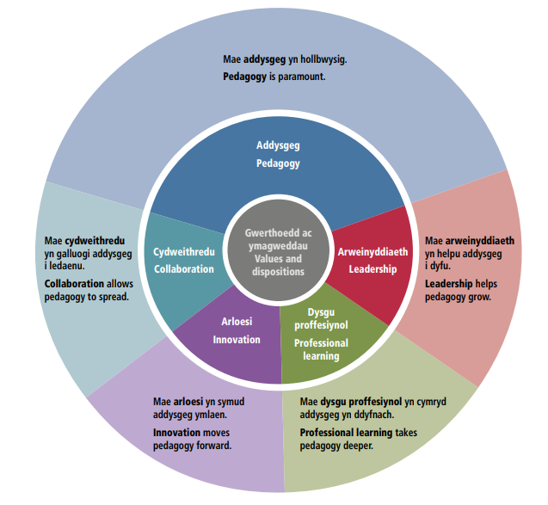
Figure 3: Professional Standards in Wales practices (Hwb, no date).

Brookfield (Brookfield, 2002) suggests that critically reflective teaching challenges the basic assumptions teachers make by using four lenses: students’ eyes, colleagues’ perceptions, educational literature and teachers’ autobiographical experiences. Brookfield goes on to say that by using these differing viewpoints a more balanced reflection can take place of what is actually going on within the teaching/learning experience.

Gibbs’ Reflective Cycle (Gibbs’ Reflective Cycle, 2019), Figure 4, was created to define the cyclical fashion of learning from both positive and negative experiences. He suggests that there are six stages:
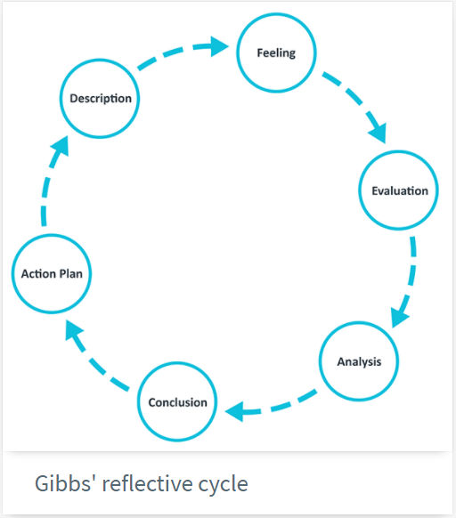
Figure 4: Gibbs Reflective Cycle (Gibbs’ Reflective Cycle, 2019)

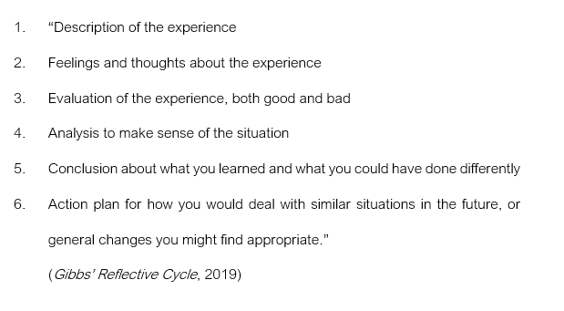
As a teacher, it can be seen that the Reflective Cycle would certainly improve various aspects of teaching and to allow focus to be maintained on positive experiences. It would then be interesting to note which aspects of these would work in a variety of different settings, for example, age groups, classrooms. It should be taken into consider that just because something worked for one class, would not necessarily mean that it would work in other situations or even the same situation with a different class or subject.

Critical Incident Evaluation
The critical incident (Appendix 4) was based on the pupils’ capacity to absorb information from a visual stimulus whilst the teacher was talking to them. They were also attempting to answer a series of questions based on what they were watching. Listening to the teacher at the same time as they pointed out what they wanted them to observe, whilst viewing the film, leads me to think that there may have been cognitive overload. It was unclear whether the questions were based on the ongoing commentary or whether they were in fact a different set of information that was required to be held in working memory.

Next Steps
From the literature review it is clear that working memory is indeed finite and as such is easily overloaded. An overload can come from the intrinsic value of the material, the presentation, or a mixture of both.

My teaching philosophy will attempt to find the point of ‘desirable difficulties’ without going into cognitive overload by using scaffolding/modelling techniques. Consideration will be given to the hypothesis that insufficient stimulus can be considered an overload in itself. Differentiation between the various ability ranges within any given class would also have to be accommodated.

This will be dependent on a plethora of currently unknown data such as what range of abilities is in the class, what age group etcetera. The challenge will be to get to know each class well enough and gain sufficient experience to know which method would hit the desirable difficulties spot without going into cognitive overload. The answer clearly has to be with critical reflection and using these techniques to learn more and consequently make each lesson better.

Conclusion
Four critical incidents were observed, and one was selected to use as an in-depth case study. The case study was semi-structured and cross-sectional. The nature of critical incidents was examined and in particular what the advantages and disadvantages were. The cross-sectional nature of critical incidences was shown to be difficult to generalise.

The literature review showed the finite capacity of working memory and how for knowledge to be retained and recalled at will it was required to be used often. Schemas and scaffolding/modelling were considered advantageous.

Dual Coding has measurable success in getting information from the working memory to the long-term memory where, if coded correctly, gives the student the ability to recall and take more information from working memory to long-term memory. The difference between dual coding and split attention was minimal so any dual coding required a great deal of thought.

Critical reflection, using either Brookfield’s Lenses or Gibbs’ Reflective Cycle method, is vital in the teaching profession. Over time this can only enhance the pedagogical nature of personal performance within the classroom.

Bibliography/Reference List
A report on Bryntirion Comprehensive School Merlin Crescent Cefn Glas Bridgend CF31 4QR (2016). Available at: www.estyn.gov.wales (Accessed: 25 October 2020).

Brookfield, S. D. (2002) ‘Using the lenses of critically reflective teaching in the community college classroom’, New Directions for Community Colleges, 2002(118), pp. 31–38. doi: 10.1002/cc.61.

Chaiklin (2003) Vygotsky’s Educational Theory in Cultural Context - Google Books. Cambridge: Cambridge University Press. Available at: https://books.google.co.uk/books?hl=en&lr=&id=mfCHutwHT-cC&oi=fnd&pg=PA39&dq=vygotsky%27s+zone+of+proximal+development&ots=uinRp9nZqA&sig=bP0jpARMom-yliAUA-v9RuBmTXA&redir_esc=y#v=onepage&q=vygotsky’s zone of proximal development&f=false (Accessed: 25 October 2020).

Chandler, P. and Sweller, J. (1991) Cognitive Load Theory and the Format of Instruction.

Cohen, M. and M. (2018) Research Methods in Education. 8th edn. Edited by W. Ltd. Bolton: Routledge.

Creswell J, C. D. (2018) Research Design. 5th edn. Edited by S. P. Lds. London: Bell and Bain Ltd.

Donaldson, G. (2015) Successful Futures Independent Review of Curriculum and Assessment Arrangements in Wales.

EfratFurst - Learning in the Brain (2018). Available at: https://sites.google.com/view/efratfurst/learning-in-the-brain?authuser=0 (Accessed: 10 October 2020).

Gathercole, S. and Alloway, T. P. (2004) ‘Working memory and classroom learning Working memory and classroom learning Susan E . Gathercole and Tracy P . Alloway University of Durham To appear in : Journal of Professional Association for Teachers of Students with Specific Learning Difficulties Con’, Dyslexia, 15(June), pp. 4–9.

Gibbs’ Reflective Cycle (2019) The University of Edinburgh. Available at: https://www.ed.ac.uk/reflection/reflectors-toolkit/reflecting-on-experience/gibbs-reflective-cycle (Accessed: 11 October 2020).

Government, W. (2020) Developing a Vision for Currciulum Design, HwB. Available at: https://hwb.gov.wales/curriculum-for-wales/designing-your-curriculum/developing-a-vision-for-curriculum-design/#curriculum-design-and-the-four-purposes (Accessed: 18 September 2020).

Graphic Organisers | TeachingEnglish | British Council | BBC (no date) British Council. Available at: https://www.teachingenglish.org.uk/article/graphic-organisers (Accessed: 11 October 2020).

Hwb (no date) Professional Standards in Wales, Hwb. Available at: https://hwb.gov.wales/api/storage/2e137fc7-73da-4ee7-8f66-d10dca6977d1/professional-standards-for-school-practitioners-in-wales.pdf (Accessed: 11 October 2020).

Jean Piaget’s Theory and Stages of Cognitive Development | Simply Psychology (no date). Available at: https://www.simplypsychology.org/piaget.html (Accessed: 25 October 2020).

Kalyuga, S. and Renkl, A. (2010) ‘Expertise reversal effect and its instructional implications: introduction to the special issue’, 38(3), pp. 209–215. doi: 10.1007/sl.

LEARNING THEORIES Ausubel’s Learning Theory (no date). Pendidikan. Available at: http://fpmipa.upi.edu/data/report_activity/9875881844.pdf (Accessed: 15 October 2020).

Lemov (2016) Teach Like a Champion Field Guide. 2nd edn. Jossey-Bass.

Merrienboer, J. J. G. Van (2003) ‘Taking the Load Off a Learner’s Mind: Instructional Design Learning’, Educational Psychologist, 38(1). doi: DOI: 10.1207/S15326985EP3801_2.

Paivio, A. and Csapo, K. (1973) ‘Picture superiority in free recall: Imagery or dual coding?’, Cognitive Psychology. Academic Press, 5(2), pp. 176–206. doi: 10.1016/0010-0285(73)90032-7.

Pedagogy for professional learning - Hwb (no date) Hwb. Available at: https://hwb.gov.wales/professional-development/national-approach-to-professional-learning/pedagogy-for-professional-learning (Accessed: 11 October 2020).

Research | Bjork Learning and Forgetting Lab (no date). Available at: https://bjorklab.psych.ucla.edu/research/#idd (Accessed: 6 October 2020).

Robinson, D. H. and Kiewra, K. A. (1995) ‘Visual Argument: Graphic Organizers Are Superior to Outlines in Improving Learning From Text’, Journal of Educational Psychology, 87(3), pp. 455–467. doi: 10.1037/0022-0663.87.3.455.

Rosen, Fullwood, H. (2012) ‘Dual Coding Theory and Split Attention in the Learning of Abstract Words.: EBSCOhost’, International Journal of Instructional Media, 39(3), pp. 181–188. Available at: https://web.b.ebscohost.com/ehost/pdfviewer/pdfviewer?vid=1&sid=54406a87-5fd1-4535-95f2-b7f14d0dd9d0%40pdc-v-sessmgr04 (Accessed: 10 October 2020).

Rosenshine (2012) Principles of Instruction, American Educator. Available at: https://www.aft.org/sites/default/files/periodicals/Rosenshine.pdf (Accessed: 4 October 2020).

Shandomo (2010) ‘The Role of Critical Reflection in Teacher Education’, School-University Partnerships, 4(1), pp. 101–113. Available at: https://files.eric.ed.gov/fulltext/EJ915885.pdf (Accessed: 11 October 2020).

Shaughnessy (2003) Research Methods in Psychology, book. Available at: https://steladhima.files.wordpress.com/2014/03/john-j-shaughnessy-eugene-b-zechmeister-jeanne-s-zechmeister-research-methods-in-psychology-2012.pdf (Accessed: 2 October 2020).

Shaw, S. et al. (2012) ‘Graphic organizers or graphic overviews? Presentation order effects with computer-based text’, Educational Technology Research and Development. Springer, 60(5), pp. 807–820. doi: 10.1007/s11423-012-9257-2.

Sherrington (2019) Rosenshine’s Principles in Action. 1st edn. Woodbridge: John Catt Educational Ltd.

Shibli D, W. R. (2018) ‘Cognitive Load Theory and its application in the classroom | impact.chartered.college’, Journal of Chartered College of Teaching, (10). Available at: https://impact.chartered.college/article/shibli-cognitive-load-theory-classroom/ (Accessed: 4 October 2020).

Tripp, D. (2006) Critical Incidents in Teaching. Bodmin: MPG Books Ltd.

Verschuren (2003) ‘Case Study as a Research Strategy: some ambiguities and opportunities’, International Journal of Research Methodology, 6(2), pp. 121–39.

Wellington (2015) Educational Research. Second Edi. London: Bloomsbury Academic.

Yin (2009) Case Study Research: Design and Methods. 4th edn. SAGE PublicationsSage CA: Los Angeles, CA.

Appendix 1: Observation 1
OBSERVATION / FIELD NOTES
(Questions adapted from Fletcher Wood (2016)
Date and time, year group:

28 September 2020 at 9 am.

Year 8: 12-13-year olds.

Lesson details: (Context and focus -/AoLE/subject- is it near start of end of unit of study? Indoors/outdoors? Ability range? Any particularly relevant information).

Art, mixed ability group, indoors.
Week 3 of Scheme of Work, following on from last week’s lesson on graffiti.
Approximately 28 students.

Classroom culture: (What is the classroom ‘vibe.’? What do attitudes, dispositions, behaviours towards learning seem like at this point in time?)

Very flexible approach and the pupils were allowed to whisper between themselves.

One student in particular was disrupting the class and had been spoken to separately beforehand which was reinforced at one stage.

Objectives: (What happens in the environment that communicates the purpose of the experiences? What can be observed regarding the way lesson activities relate to these purposes?

The purpose was explained at the beginning of the lesson and carried on from the previous lesson.
Questions were asked about the previous lesson’s terminology/overview by the teacher to see what pupils had learned/remembered.

Direction: (What can be observed that helps learners understand what they are engaging in? What in the environment helps them understand how to achieve well)?

Ideas were kept on the board whilst the lesson was underway so that they could be referred to. Ideas on paper were on every other desk again to be referred to for ideas.

The teacher had done his own drawing explaining various elements of what and why he drew this particular way. The teacher went around the class, commenting on what could be done to improve the image.

Access and challenge: (What can be observed in the environment that enables engagement of learners? What can be observed regarding levels of challenge?

There was an extended task given to one learner who had finished their current task. This pushed the learner to go further in depth with the drawing they had created. The task was specific and referred to shading and depth.

Assessment: (Can anything be observed about how student’s existing knowledge is used? Can anything be observed regarding the development of knowledge during or after the experience)?

Questions were asked about many things that would assist with their image. Complementary colours were discussed, and this was visually pointed out on the wall.
Reinforcement of the name of the techniques was repeated throughout the lesson and questioned at the end of the lesson.

Pupils were asked about well-known and obscure artists that had been spoken about and if they could incorporate any of those styles into their piece of work.

The teacher went around and looked at everyone’s work and made individual comments about what was seen, how to improve their work and at one point I observed clear directions advising one pupil to use ‘x’ technique to ‘get their current grade up’.

Specifics / Critical Incidents: (Are there moments which cause you to consider aspects of practice when you come across them in future teaching)?

It was apparent that only the girls were answering questions and rather than select one boy, he asked someone within the group of boys to volunteer an answer.

Knowing the class as he did, it would have been difficult to put one of the learners ‘on the spot’ to answer the question so the teacher allowed them to choose to volunteer rather than force one individual boy to answer.

The group of boys appeared to be disinterested and this forced them to become involved as a group as they no longer knew if they were going to be asked to answer the next question as it was obvious that they could no longer be uninvolved.

It would certainly be one of the methods that I could employ within my teaching strategies to enhance participation.

CRITICAL INCIDENT IDENTIFICATION RECORD
Details relevant to the research context.  Date/time.  Age/Stage of group.  People involved.  Contextual  information from field notes. | Year group 8: 12-13-year olds  9 am on 28 September 2020 (first lesson on a Monday morning).  3 weeks into the Scheme of Work.  Art in a group of mixed ability learners.  Teacher and classroom.  Urban but not inner city.  Approximately 28 students.
What happened? A detailed description of what you observed and what thoughts on pedagogy and practice occurred to you as a result, looking towards your research. | This observation is the reaction between a group of pupils and the teacher.  It was apparent that only the girls were answering questions and rather than select one boy, the teacher asked a group of boys to volunteer an answer.  They appeared to be disinterested and this forced them to become involved as they no longer knew if they were going to be asked to answer the next question as it was obvious that they could no longer be uninvolved.  The method of pedagogy for this is Behaviourism.  Four Purposes, enterprising, creative contributors, healthy confident individuals, and ambitious capable learners.

Appendix 2: Observation 2
OBSERVATION / FIELD NOTES
(Questions adapted from Fletcher Wood (2016)
Date and time, year group:

28 September 2020 at 10 am.

Year 9: 13-14-year olds.

Lesson details: (Context and focus -/AoLE/subject- is it near start of end of unit of study? Indoors/outdoors? Ability range? Any particularly relevant information).

English Literature
3rd week into Scheme of Work.
Indoors Year 9 (high level) class
Relatively similar levels of ability.
Split lesson for break.
Approximately 28 students.
Classroom culture: (What is the classroom ‘vibe.’? What do attitudes, dispositions, behaviours towards learning seem like at this point in time?)

Very focused on learning, with a respectful demeanour to the teacher.

Objectives: (What happens in the environment that communicates the purpose of the experiences? What can be observed regarding the way lesson activities relate to these purposes?

Continuing lesson on a play called an Inspector Calls. At the beginning of the lesson it was put into context by asking questions to recall what they had read up to the point where they were in the book.

It was explained how the lesson would play into the exam environment by studying in a particular way.
Direction: (What can be observed that helps learners understand what they are engaging in? What in the environment helps them understand how to achieve well)?

The lesson was clearly broken down, showing what the grading criteria was and how it could be achieved.

Access and challenge: (What can be observed in the environment that enables engagement of learners? What can be observed regarding levels of challenge?

The students were questioned throughout the lesson and the students put their hands up to reply. Students who did not engage were asked to reply even though they did not put their hands up, ensuring their participation. It was difficult to tell whether there was any differentiation from the questioning but the range of abilities was very similar so it is unclear whether much differentiation would be required.

Assessment: (Can anything be observed about how student’s existing knowledge is used? Can anything be observed regarding the development of knowledge during or after the experience)?

Questions were asked concerning their prior knowledge of the book up to the point that they had read.

The teacher went around the class and observed/commented on their work and asked for clarification or more information when required.

Specifics / Critical Incidents: (Are there moments which cause you to consider aspects of practice when you come across them in future teaching)?

They selected someone to read quite a lengthy part of the play who had already read that persona during the previous lesson. Perhaps they could have made another person read who had not participated last time.
Four purposes, enterprising, creative contributors.

On leaving the room I observed the teacher telling one pupil, discretely, that it was nice to hear them contribute to the lesson. His face lit up as he had been rewarded for his behaviour with a personalised positive comment.

Positive reinforcement will be an aspect that will be embraced in my personal practice.

Four Purposes, healthy, confident individuals

CRITICAL INCIDENT IDENTIFICATION RECORD

Details relevant to the research context.  Date/time.  Age/Stage of group.  People involved.  Contextual  information from field notes. | English Literature Lesson  28 September 2020  10 am, Monday morning  Year 9 (high level) class: 13-14-year olds  Split lesson for break so the pupils had to settle in twice.  Urban school - school uniform was worn without ties.  Teacher and individual pupil.  Approximately 28 students.
What happened? A detailed description of what you observed and what thoughts on pedagogy and practice occurred to you as a result, looking towards your research. | This observation is based on the reaction of one pupil when given positive feedback on his participation within a lesson. As he left the room the teacher told him that it was nice to see him participate in the lesson without having to be chosen to answer a question. His face lit up with this reward.  Positive reinforcement worked with this pupil and I think he will definitely contribute to the classroom activities more after this feedback. This should be incorporated into lessons as a routine practice to reward good behaviour.  This follows the Behaviourism pedagogy using Skinner’s model.  This brings in two aspects of the Four Purposes, healthy, confident individuals, and enterprising, creative contributors “ready to play a full part in life and work”.

Appendix 3: Observation 3
OBSERVATION / FIELD NOTES
(Questions adapted from Fletcher Wood (2016)
Date and time, year group:

29/9/2020 at 9 am.

Year 8: 12-13-year olds.

Lesson details: (Context and focus -/AoLE/subject- is it near start of end of unit of study? Indoors/outdoors? Ability range? Any particularly relevant information).

Mathematics, mixed range of abilities.
Week 3, beginning of Scheme of Work, the lesson continued on the work regarding ‘perimeters’ from the last lesson.
Approximately 28 students.
Classroom culture: (What is the classroom ‘vibe.’? What do attitudes, dispositions, behaviours towards learning seem like at this point in time?)

Mixed vibe, one half appeared really interested in learning whilst the other half seemed to not want to do mathematics.
Busy atmosphere.

Objectives: (What happens in the environment that communicates the purpose of the experiences? What can be observed regarding the way lesson activities relate to these purposes?)

Continuing theme on perimeters and introducing areas. Examples were gone through on the board and questions were asked and answered by a variety of pupils.

Direction: (What can be observed that helps learners understand what they are engaging in? What in the environment helps them understand how to achieve well)?

Questioning and explaining misconceptions in the answers given by the pupils.
Access and challenge: (What can be observed in the environment that enables engagement of learners? What can be observed regarding levels of challenge?

The lesson plan was structured and allowed for differentiation by having a presentation that included by the end of this lesson ‘all’ and ‘most’ should have completed ‘x’.

Assessment: (Can anything be observed about how student’s existing knowledge is used? Can anything be observed regarding the development of knowledge during or after the experience)?

Questions were asked during the scaffolding and modelling part of the lesson. Whilst the pupils were working through various examples, the teacher went around the classroom to see how well they were doing individually and correcting where required.

Specifics / Critical Incidents: (Are there moments which cause you to consider aspects of practice when you come across them in future teaching)?

The teacher asked for an answer and pointed to an individual, when she was not immediately forthcoming, he asked another pupil. The original pupil was upset at not having been allowed to show her ability and told the teacher it was not fair. At this point she was given a ‘bad mark’ on her record for backchatting.

Having asked the pupil to respond it may have taken them a bit more time to have formulated the answer to be able to voice it.

The teacher specifically asked a group of disengaged boys to answer a question then went to ask a regular (I know the answer – good pupil) on the opposite side of the class without following up on having asked the boys to answer.

Getting disengaged students to participate keeps them involved but not following through gives them mixed feedback on whether their answers are valid or worthwhile.

CRITICAL INCIDENT IDENTIFICATION RECORD

Details relevant to the research context.  Date/time.  Age/Stage of group.  People involved.  Contextual  information from field notes. | 29/9/2020 at 9 am.  Year 8: 12-13-year olds.  Mathematics.  Mixed range of abilities.  Teacher and classroom.  Approximately 28 pupils.
What happened? A detailed description of what you observed and what thoughts on pedagogy and practice occurred to you as a result, looking towards your research. | One particular pupil was in what appeared to be an ongoing behavioural issue with the teacher. Pupil x was observed at the beginning of the lesson to open her own window (which was acceptable as it was hot) and they then slid over the desk to open the window in the next row. The teacher explained that they needed to walk around the desk if they wanted that window open too.  Pupil x was disruptive throughout the lesson. However, at one stage during another behavioural dispute they said on more than one occasion that there were too many numbers on the board.  This incident led me to believe that the pupil, despite facing challenges from an ongoing issue in their private life (which was being dealt with by many professionals within the school), may have needed to be tested for dyscalculia which could lead to a reduction in behavioural issues within the classroom.  The teacher asked for an answer and pointed to an individual, when she was not immediately forthcoming, they asked another pupil. The original pupil was upset at not having been allowed to show her ability and told the teacher it was not fair. At this point she was given a ‘bad mark’ on her record for backchatting. Having asked the pupil to respond it may have taken them a bit more time to have formulated the answer to be able to voice it.  The teacher specifically asked a group of disengaged boys to answer a question then went to ask a regular (I know the answer – good pupil) on the opposite side of the class without following up on having asked the boys to answer.  Getting disengaged pupils to participate keeps them involved but not following through gives them mixed feedback on whether their answers are valid or worthwhile.  Four Purposes: both of these incidents fall under the ‘Healthy, confident individuals’ purpose.  With regard to my personal practice I would try and wait a bit longer having asked a question before moving on to the next person.  Behavioural pedagogy influenced by Watson.

Appendix 4: Observation 4
OBSERVATION / FIELD NOTES
(Questions adapted from Fletcher Wood (2016)
Date and time, year group:

29/9/2020 at 10 am.

Year 8: 12-13-year olds.

Lesson details: (Context and focus -/AoLE/subject- is it near start of end of unit of study? Indoors/outdoors? Ability range? Any particularly relevant information).

Religious Studies, higher tier, indoors.
Week 3 of Scheme of Work, in the middle of a series of lessons regarding conflict, prejudice and discrimination.
Split lesson with break.
Approximately 29 students.
Classroom culture: (What is the classroom ‘vibe.’? What do attitudes, dispositions, behaviours towards learning seem like at this point in time?)

Very rigid with a strict attitude towards behaviour. The seating plan was not of the pupil’s choice and was boy, girl, etc.

Objectives: (What happens in the environment that communicates the purpose of the experiences? What can be observed regarding the way lesson activities relate to these purposes?

There were a lot of open-ended questions asked. This was followed by the pupils given time (for example, five minutes) to consider what they were going to discuss on two specific areas.

Direction: (What can be observed that helps learners understand what they are engaging in? What in the environment helps them understand how to achieve well)?

There were signs and images all around the wall that they could use to answer a variety of questions.
Access and challenge: (What can be observed in the environment that enables engagement of learners? What can be observed regarding levels of challenge?

The differentiation came in allowing parts of questions to be answered and then asking more able students to ‘elaborate’ on that answer or just left without in-depth investigation.
Assessment: (Can anything be observed about how student’s existing knowledge is used? Can anything be observed regarding the development of knowledge during/after the experience)?

They were asked questions about pre-existing knowledge regarding prejudice and discrimination and whether they considered it had happened to them.

Specifics / Critical Incidents: (Are there moments which cause you to consider aspects of practice when you come across them in future teaching)?

They were told to write the heading in their book and underline it. Then write ‘x’, then write ‘y’. This control of what they put into their books, even going as far as to how many lines to leave (4: irrespective of how big or small their writing was) between questions.

The teacher then showed a film and commented throughout. Drawing the pupils’ attention to every detail that they would need to observe. The pupils were also asked to answer questions that were on a sheet in front of them based on what they noticed during the film.

CRITICAL INCIDENT IDENTIFICATION RECORD

Details relevant to the research context.  Date/time.  Age/Stage of group.  People involved.  Contextual  information from field notes. | 29/9/2020  10 am, split lesson with break.  Year 8: 12-13-year olds.  High level of abilities.  Approximately 29 students.
What happened? A detailed description of what you observed and what thoughts on pedagogy and practice occurred to you as a result, looking towards your research. | The pupils were told to write the heading in their book and underline it. then write ‘x’, then write ‘y’. This control of what they put into their books, even going as far as to how many lines to leave (irrespective of how big or small their writing was) between answers made me question how much independence these children have. How can these children become independent learners when every single move is decided for them in minute detail.  Four Purposes: Enterprising, creative contributors.  The teacher then showed a film and commented throughout. Drawing the pupils’ attention to every detail that they would need to observe to answer a series of questions written down in front of them. There are two parts to this:  (a) they then rely on the teacher to observe what was going on and relate the information back to them which ties in with the independent learning issues above.  (b) did this give the children cognitive overload as they were meant to be answering questions about the part of the film they watched whilst listening to the teacher talk.  The pedagogy underlining this would be Cognitive Overload Theory

The Four Purposes: (Donaldson, 2015)
Figural organizations of text information (Robinson and Kiewra, 1995), relationship chart or mind map (Graphic Organisers | TeachingEnglish | British Council | BBC, no date)

