8/28/2020
MODULE CODE ACCC5001
DATABASE MANAGEMENT SYSTEMS
CLOUD COMPUTING
ALEKSANDAR IVANOV ANDONOV
STUDENT NUMBER 1813107

TABLE OF CONTENTS
Introduction………………………………………………………………. 2
Transaction…………………………………………………………………2
Concurrency support…………………………………………………. 3
Commit command………………………………………………………3
Rollback command……………………………………………………..4
Difference between Commit and Rollback………………….4
ACID properties of transaction……………………………………4
Concurrency problems ……………………………………………….5
Isolation Levels ………………………………………………………….7
Dirty Read Problem…………………………………………………...7
Triggers……………………………………………………………………..9
Conclusion …………………………………………………………………14

Introduction
Using SQL to store a database can be a positive, but also dangerous. If you use SQL, care must be taken when accessing a database that is used by hundreds, thousands, or even millions of users - because it may unintentionally make a mistake or erase all data. Therefore, in DBMS there are some closely related functions – Transaction and Concurrency support, which guarantee that any database should be reliable and remain in a steady state. (w3schools, n.d.)
To explain this, let's create a diagram that shows the processing phases of the Transaction. The processing of transactions requires three phases, as you can see in the image below. First, the transactions need to begin. Then we need to write down the DML operations that we want to run as one function. Also, we need to test for errors in third phase. If an error occurs, i.e. if any of the DML statements fail, then return the transaction (any data that is changed in the database would be cancelled and return ) otherwise commit the transaction to permanently transfer the data to the database. (dotnettutorials.ne, n.d.)
- Begin the transaction
- Process database commands
- Check for errors
If error occurs
Rollback the transaction
Else
Commit the transaction
Transaction
A transaction is a set of specific actions that a program performs to access or modify a user or database. The main objective of the process is that the actions must be finalised or cancelled in full. A transaction is a series of operations that are presumed to be a piece of logic. The transaction allows to group a series of tasks as a single logical unit, and all of these task sets are either all committed, or all reverted back or rollback if error occurs. In simple terms we can describe that a transaction is a series of SQL statements which should be executed as one unit.
We use transactions when we want to validate that all of our commands are working on the same data - when we want to make sure that there are no other transactions that can operate on these data, while our request is being executed. When you are looking for a sequence of commands you want to execute. When the actions are executed concurrently or overlapping and each of them stays different. (khanacademy, n.d.), (bg.volgaproject.net, 2018), (techs-mobile.blogspot.com, n.d.), (dotnettutorials.ne, n.d.)
Concurrency support (control) is the method of handling simultaneous execution of transactions in a multiprocessing database system (such as queries, changes, inserts, deletes, and so on) without interfering with each other. The aim of this control is to allow multiple users to access the database concurrently without having to influence each other. Concurrency is a condition resulting from the transaction process in a database. Concurrence occurs when two or more users attempt to access the same information or data. DBMS rivalry is considered a problem because access to data by two separate users concurrently can lead to inconsistent results or invalid performance.
One problem with multiple DBMS users is the possibility of two or more users simultaneously trying to modify data in the database. If this form of behaviour is not managed carefully, otherwise the database may become inconsistent. (/tutorialink.com, n.d.), (saurabhhooda, 2020)
However it may also be possible for transaction to fail after some of its operations have been done. The fault can be due to hardware , software or power etc.Therefore to avoid this , Database has two important commands – COMMIT and ROLLBACK. When the actions in a transaction are done, two outputs are possible.
Commit command
Commit is a SQL statement that means that a transaction is completed successfully. Once a transaction completes its execution without interruption, the modifications made to the database are final by the transaction. Which means that the database cannot recover its previous states in which it was the operation, prior to the execution of the first command.
When the transaction completes successfully, the results are fixed and the database goes into a new sequential state. (/techdifferences.com, 2016)
For another situation, all changes made by it during the transaction will not be registered in the database. As a result, the transaction is not started at all.This output is called “Abort”. ABORT rolls back the existing transaction and discards all the changes made through the transaction. This command is similar in action to the regular SQL ROLLBACK and is present for historical reasons only
Rollback command
As COMMIT, ROLLBACK is also a SQL command and it means that the transaction was not successfully completed. Therefore, the transaction is terminated in order to eliminate the transaction's modifications. After ROLLBACK has been executed, no changes made to the current transaction will be kept.
When the execution happens wrongly, and if an error is identified , it will be cancelled. At the same time, the database needs to be returned to the state it was before the execution.
Difference between Commit and Rollback
The key difference between SQL's COMMIT and ROLLBACK statements is that all the changes made by the current transaction become final through the execution of COMMIT statement. In contrast, the execution of ROLLBACK erases all modifications made by the current transaction.
The change made by the transaction cannot be ROLLBACK when COMMIT statement has been executed. When the ROLLBACK command is executed, however, the database arrives at its previous location.
COMMIT gets executed when the transaction statements are completed successfully. The ROLLBACK is therefore executed when the transaction is not successfully completed. (/techdifferences.com, 2016)
In the databases world in order to maintain consistency in a database, before and after the transaction, specific properties are followed. These properties are called ACID.
There are four key properties of transaction;
ACID properties of transaction
Atomicity - a transaction is an inseparable atomic unit that must be completed or cancelled. With that, we say that either the whole transaction happens at once or does not occur at all. No midway, i.e. transactions do not occur in part. Transaction work should be atomic, meaning that all work is one object. When a transfer is carried out by the user, either the transaction should complete and execute all the operations requested, or it will fail, and do nothing. Atomicity deals with the transaction process, and the work is not left unfinished by an RDBMS transaction.
Consistency preservation - a transaction should maintain continuity, meaning that if it is executed completely from start to finish without intervention from other transactions, it will move the database from one stable state to another. This means that integrity constraints must be maintained before and after the transaction, so that the database is consistent.
Isolation - a transaction should appear as if it is carried out in isolation from other transactions, although many transactions are executed at the same time. That is, no other transactions occurring at the same time can conflict with the execution of a transaction. Any transaction that is carried out is independent of the others. Not all the outcomes of a gaping cycle should be available for other transactions. This property means several transactions can take place concurrently without contributing to database state irregularity. Transactions take place individually, without any intervention. Changes that occur in a particular transaction will not be visible for any other transaction until that particular change is written to memory or committed in that transaction.
Durability - This property guarantees that the changes and modifications to the database must be stored in and written to the disc until the operation has been completed, which will continue even if a system failure occurs. These updates are now permanent and will be stored in permanent memory.The transaction 's results, therefore, never get lost. Due to subsequent failures, all outcomes obtained during a successful transaction should not be lost. They are permanently stored in a database.
In general, the ACID properties provide standard to ensure a database's correctness and accuracy in such a way that each transaction is a group of operations that acts as a single entity. It produces consistent results, acts in isolation from other operations, and stores durably the processed information. (bg.volgaproject.net, 2018), (geeksforgeeks-ArchitNangalia, 2019), (www.brainkart.com, n.d.), (saurabhhooda, 2020)
Concurrency problems
When concurrent transactions are completed in an uncontrolled way, several problems can happen.
Concurrency is a condition resulting from the transaction process in a database. The Concurrency occurs when two or more users attempt to access the same information or data. DBMS conflict is considered a problem because accessing data by two separate users concurrently can lead to conflicting results or invalid behaviour.
As we know, ACID properties are used to maintain consistency in the database. Isolation determines how the integrity of transactions is visible to other users and systems. This means that a transaction should take place in a system in such a way that it is the only transaction that has access to the resources in a database system. Levels of isolation describe the degree to which a transaction must be separated from the changes made by every other transaction within the database system. The level of transaction isolation is defined by the following types of concurrency problems:
- Dirty Reads
- Lost Updates
- Non – Repeatable Reads
- Phantom Reads
Dirty Reads - This problem arises when the modified, yet uncommitted data is read from another device. For example, if one process has changed data but has not committed it yet, then another process will read the same data. This leads to the user becoming incoherent in state. One transaction reads data that has not yet been sent by another transaction, so some data is eventually returned by another transaction.
Lost Updates - This question occurs when two systems try to access the same data at the same time. This problem can result in data loss, or the second process may overwrite the first change in process.
Non – Repeatable Reads - Non-repeatable reading happens when a transaction reads the same row twice and each time it receives a different value. When this transaction is not complete, the same data is accessed by another transaction. Therefore, the data read by the first transaction two times may be different from the two read data in the first transaction and the alteration of the second transaction. Within a transaction the data read twice is not the same.
Phantom Reads - If two same queries carried out by two users show different output, then this would be a Phantom Read issue. For example, if user Y selects a question to read some data, user H adds some new data at the same time, but user Y can only read the old data at the first attempt, but when user Y re-requests the same statement the user receives a different data set. (alibabacloud.com, 2018), (geeksforgeeks-SaurabhKushwaha, 2019), (saurabhhooda, 2020)
Isolation Levels
The SQL standard explains four isolation levels;
1.Read Uncommitted
2.Read Committed
3.Repeatable Read
4.Serializable
5.Snapshot
Read Uncommitted - In this stage, one transaction that read changes made by another transaction that have not yet been committed, causing the dirty read issue. Transactions at this level aren't isolated from each other. Read uncommitted level has an issue whit the dirty reading. This level of isolation is least restrictive of all the levels of isolation and allows reading uncommitted data.
Read Committed – In this level, we are only allowed to read the committed data, which means the dirty read problem is eliminated by this stage. In this point, if you are reading data then the simultaneous transactions that can delete or write data will block some work until other work is complete.
Repeatable Read - In this stage the transaction must wait until the update or read demand of another transaction is complete. But if an insert transaction occurs it won't wait for anyone.
Serializable - This is the highest level of isolation. In this level of isolation, we can ask any transaction to wait until the current transaction completes.
Snapshot - Here each transaction has its own copy of data, and if a user wants to execute a transaction like an update or insert, it tells him to re-check all the procedure before the execution of the process begins. (saurabhhooda, 2020), (geeksforgeeks-SaurabhKushwaha, 2019)
Dirty Read problem
A dirty read occurs when one transaction is allowed to read data that is being changed by another transaction which is running concurrently but it has not yet committed.
Transaction 2 has to wait for the completion of transaction 1 before being executed. The question is - Why?
The response is that the default level of isolation between transactions is "Read committed." The level of exclusion Read Committed means that data can only be accessed by a transaction once it is in the committed state.

Transaction1

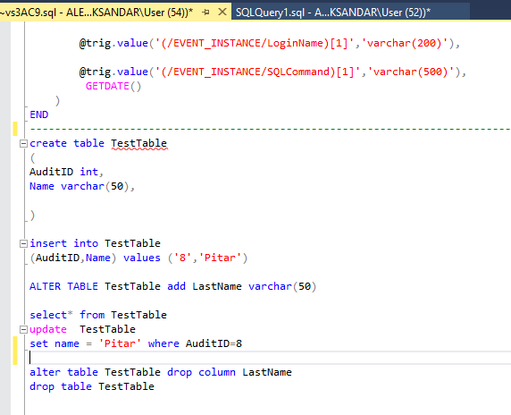

Transaction 2
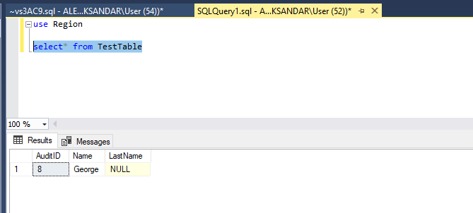

If we use Read Uncommitted level of isolation, this situation will be in reverse. Transaction 2 do not need to wait for the completion of Transaction 1.
Triggers
Trigger are the SQL codes that are automatically executed in response to certain events on a particular table. These are used to maintain the integrity of the data. To improve the data integrity trigger can be used. When a data operation is taken, it is possible to test if data manipulation is compatible with the underlying market principles, thereby eliminating erroneous entries in a list. To monitor and control the actions that are performed this trigger can be used.
The triggers are usually dived into three different types which are DML- trigger, DDL-trigger and Logon trigger. DML trigger is used for the operations Insert, Update and Delete. DDL is used for Create, Alter and Drop. The Logon trigger is used when the user wants to log into SQL server to execute operations.
The problem that has been established in the Veterinarian Surgery can be solved by using the triggers above.
In the tables below I have shown how the triggers work.

Trigger on Database
When creating the trigger table on database for create- table, alter table and drop table. By doing this we can follow each user and the operations they do in each table and consequently the user can manipulate the data.
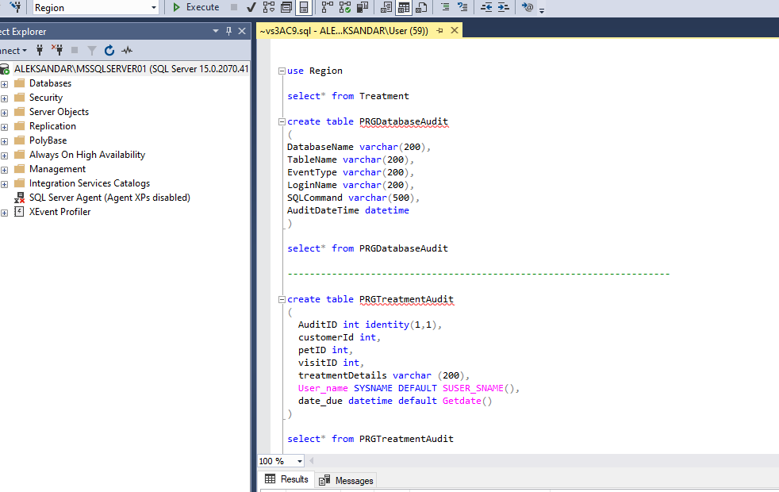

Test Trigger Database
In this table we can see that each user’s data is stored in the trigger on database.
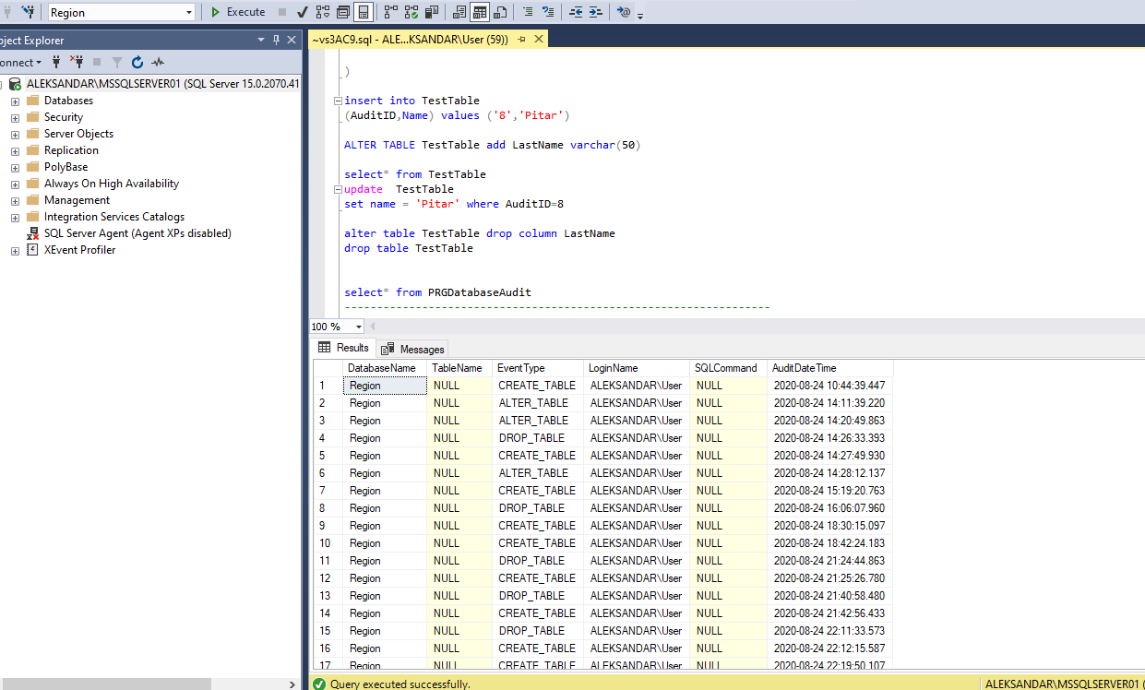

Test Trigger on View
The benefits of the view are that it can be used as a security mechanism and can also hide complexity. The main purpose is that it provides the restricted access of data to the user.

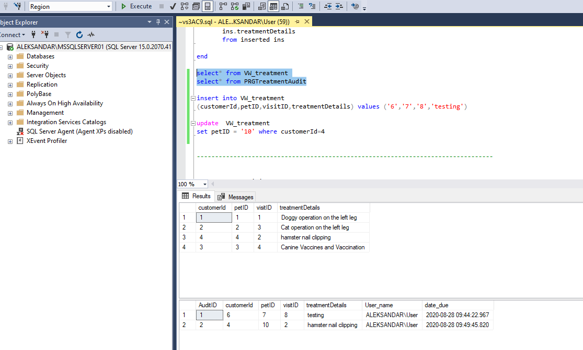
Test Trigger “delete” on Treatment
As you can see below in the image, we have trigger on the table treatment which records if the user wants to delete any data.
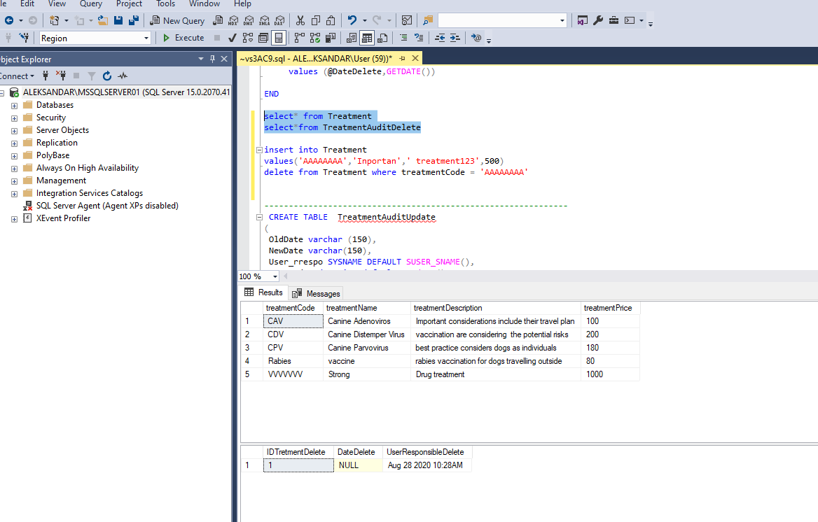
Test Trigger “Update” on Treatment
The Update Trigger records if the user updates and makes any changes to the data.
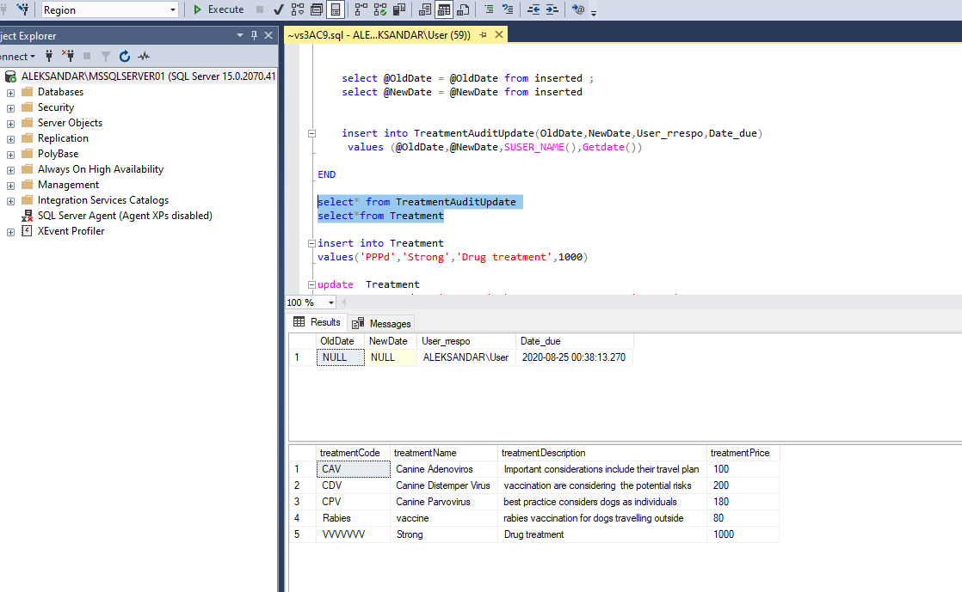

Test Triger “Insert” on Visit
The next trigger is Insert on the table visit. If the user wants to add any data to this table, it will be recorded.
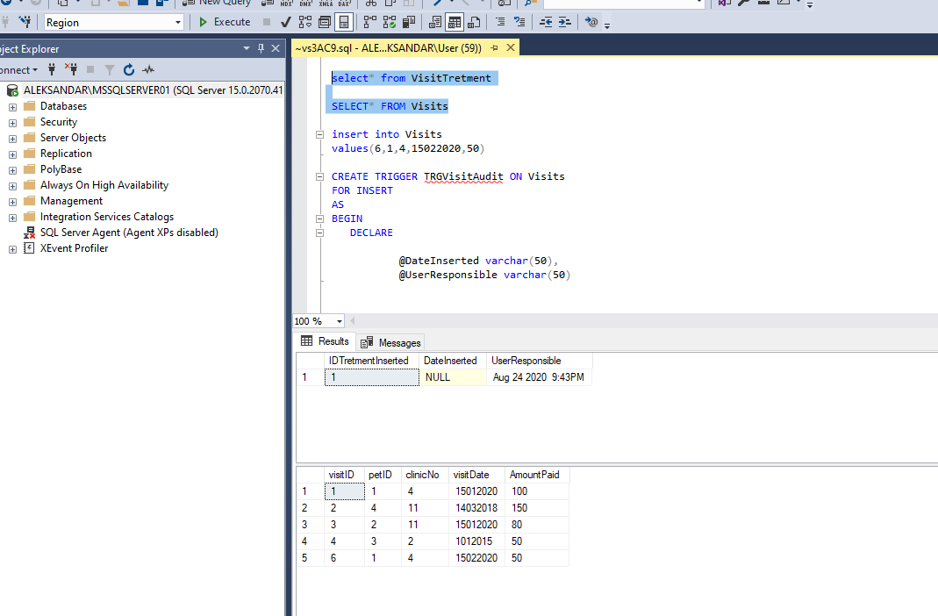

Conclusion
When using a database system, it is necessary to check that users, privileges, access rights are set correctly from the beginning. As a general rule, there should be only a limited number of users with full access to the database, otherwise, this can be dangerous. To avoid errors, it is essential and mandatory to follow the rules of operation in the DBMS.

References
/techdifferences.com. (2016, october 27). Difference Between COMMIT and ROLLBACK in SQL. Retrieved from techdifferences.com: https://techdifferences.com/difference-between-commit-and-rollback-in-sql.html
/tutorialink.com. (n.d.). Concurrency control. Retrieved from /tutorialink.com: https://tutorialink.com/dbms/concurrency--control.dbms
Alhaddad, M. (n.d.). SQL Tutorials - 22.DML Triggers in SQL. Retrieved from www.youtube.com: https://www.youtube.com/watch?v=wCinUKcsIHA
alibabacloud.com. (2018, August 22). Dirty read, Phantom Read and non-repeatable READ + Transaction ISOLATION level _ dirty Read. Retrieved from topic.alibabacloud.com: https://topic.alibabacloud.com/a/dirty-read-phantom-read-and-non-repeatable-read--transaction-isolation-level-_-dirty-read_8_8_20295064.html
bg.volgaproject.net. (2018). Транзакции - какво е това? Транзакция на база данни. Retrieved from bg.volgaproject.net: https://bg.volgaproject.net/kompyutery/62457-tranzakcii-chto-eto-takoe-tranzakciya-bazy-dannyh.html
dotnettutorials.ne. (n.d.). Transaction in SQL Server. Retrieved from dotnettutorials.ne: https://dotnettutorials.net/lesson/transaction-management-in-sql-server/
geeksforgeeks-ArchitNangalia. (2019, november 21). ACID Properties in DBMS. Retrieved from /www.geeksforgeeks.org: https://www.geeksforgeeks.org/acid-properties-in-dbms/
geeksforgeeks-SaurabhKushwaha, s. (2019, April 1). Transaction Isolation Levels in DBMS. Retrieved from www.geeksforgeeks.org: https://www.geeksforgeeks.org/transaction-isolation-levels-dbms/
khanacademy. (n.d.). Направи своя SQL по-сигурен. Retrieved from bg.khanacademy.org: https://bg.khanacademy.org/computing/computer-programming/sql/modifying-databases-with-sql/a/make-your-sql-safer
saurabhhooda. (2020, May 12). Concurrency Control in SQL Server. Retrieved from www.sqlservercentral.com: https://www.sqlservercentral.com/articles/concurrency-control-in-sql-server
SQL, G. (2020, Jun 29). Triggers in SQL Server 2019 | Complete beginners tutorial | DML Trigger and DDL trigger. Retrieved from www.youtube.com: https://www.youtube.com/watch?v=loF5gP738YU&t=613s
Techie, S. -Q. (2019, May 25). SQL Tutorial 13: TCL Commands | Commit | Rollback. Retrieved from www.youtube.com: https://www.youtube.com/watch?v=W0dJ8e_IIZI&t=3s
techs-mobile.blogspot.com. (n.d.). Транзакции в бази от данни. Retrieved from /techs-mobile.blogspot.com/: http://techs-mobile.blogspot.com/2010/03/blog-post_07.html
w3schools. (n.d.). www.w3schools.in. Retrieved from Transaction and Concurrency Control: https://www.w3schools.in/dbms/transaction-and-concurrency-control/
www.brainkart.com. (n.d.). Desirable Properties of Transactions. Retrieved from www.brainkart.com: http://www.brainkart.com/article/Desirable-Properties-of-Transactions_11558/

