

Master of Business Administration (MBA)
LCMB7034 - International Business Concepts
International Expansion Strategy for IKEA: A Strategic Evaluation of Market Entry into Bangladesh
Student Name: Rozar Robertbhai Macwan
Student ID: 2509179
Lecturer: Mansoob Murshed (Birmingham)
Wordcount: 5388

Executive Summary
This report assesses the possibility of Internationalisation of IKEA to Bangladesh through evaluating the international strategy adopted by the firm, attractiveness of the Bangladeshi market and how best mode of market entry can be adopted. The transnational approach should be characterised as one that involves global standardisation with partial local adaptability in order to gain operational efficiency and responsiveness to the markets. An overall evaluation of the political, economic, legal, and cultural environment of Bangladesh shows that it has a high growth potential in the long run due to increased urbanisation, growing middle class, and growing demand of modern home furnishing although it faces numerous challenges such as complexity of regulation, inflation and political insecurities. Bangladesh is a strategically attractive emerging market proven through application of the Five Forces as developed by Porter, SWOT analysis and the OLI framework developed by Dunning. A joint venture where the majority has control is deemed to be the appropriate strategy to use since it will balance between strategic management, local market understanding and mitigation of risk. Lastly, feasible suggestions are outlined to benefit sustainable market entry, sustainable competitiveness and effective international growth.

Table of Contents
Executive Summary 2
1. Introduction 5
2. Organisational Classification and Global Strategy 5
2.1 Company Overview 5
2.2 Bartlett and Ghoshal Framework 6
2.3 Global Configuration 7
3. Macro-Environmental Appraisal 8
3.1 Bangladesh Overview 8
3.2 Political Environment 9
3.3 Economic Environment 10
3.4 Legal Environment 12
3.5 Cultural Environment 13
3.6 Industry Attractiveness 13
3.7 Market Attractiveness 15
3.8 Dunning's OLI Framework 16
4. Entry Mode Strategy 17
4.1 Historical International Expansion 17
4.2 Evaluation of Historical Strategy 18
4.3 Alternative Entry Modes 19
4.4 Recommended Entry Mode 20
4.5 Strategic Recommendations 21
Section 2: Reflective Account (Gibbs Reflective Cycle) 22
Stage 1: Description 22
Stage 2: Feelings 22
Stage 3: Evaluation 22
Stage 4: Analysis 23
Stage 5: Conclusion 23
Stage 6: Action Plan 24
References 25

List of Tables
Table 1: Global Profile of IKEA 6
Table 2: Bangladesh Economic Indicators 9
Table 3: SWOT Analysis for IKEA's Proposed Entry into Bangladesh 16
Table 4: Historical Market Entry Modes Used by IKEA 18
Table 5: Comparison of Alternative Entry Modes 20

List of Figures
Figure 1: Adapted Bartlett and Ghoshal Matrix 7
Figure 2: Global Map of IKEA's Operating Markets 8
Figure 3: Bangladesh Retail Market Growth (2021–2025) 11
Figure 4: Porter's Five Forces Analysis of Bangladesh's Furniture Industry 15

1. Introduction
Globalization has emerged as a strategic focus to multinational corporations (MNCs) aiming at sustainable growth, competition and entry into new consumer markets (Contractor, 2021). Market entry choices need to be made by considering host-country situations as well as the organisational strategic competencies to reduce risks and the long-term value production (Cavusgil, Knight and Riesenberger, 2019). With its cost leadership strategy, standardised Scandinavian design, and effective global supply chain, IKEA, the largest home furnishing retailer in the world, has developed a magnitude of presence on a global scale, operating in over 60 markets globally (IKEA, 2025b). Bangladesh is a vast untapped market although its high growth rate by far, the high rate of urbanisation, the rising middle-class population and its growing demand on modern home furnishing make it an enticing target (World Bank, 2025a). The report critically analyses the international strategy of IKEA, evaluates the attractiveness of Bangladesh as a market in the political, economic, legal, and cultural lenses in terms of Dunning OLI framework and recommends a viable market entry strategy. A reflective assessment of the research and analysis process that had been conducted during the process of completing the assessment is the final part of the report.

2. Organisational Classification and Global Strategy

2.1 Company Overview
IKEA was founded in 1943, by Ingvar Kamprad, in Sweden and has since grown to become the largest home furnishing store in the world with low-priced, practical and sustainable products based on a unique flat-pack concept. Its business model is an amalgamation of cost leadership, uniform product design, economies of scale and customer self service in offering value at competitive prices. The vision, to provide a better everyday life to the many people is the foundation of IKEA in its approach of being accessible, sustainable, and innovative (Inter IKEA Group, 2025). The company includes retail shops, online shops, design studios, and home furniture services. In FY2025, IKEA Retail registered a total of €45.1 billion in sales, it has a customer meeting point and stores numbering about 500 with over 60 markets. It also has a global supply chain comprising approximately 1,800 suppliers spread all over the world in 50+ countries, with regional distribution centres and responsive digital logistics that improve manufacturing effectiveness and inventory optimization.
Table 1: Global Profile of IKEA
Indicator | Details (FY2025)
Founded | 1943, Sweden
Vision | Better everyday life for the many people
Retail Sales | €45.1 billion
Markets | 60+
Stores & Customer Meeting Points | ~500
Suppliers | ~1,800 in 50+ countries
Business Model | Cost leadership with flat-pack retailing
Source: IKEA (2025b)

2.2 Bartlett and Ghoshal Framework
The framework by Bartlett and Ghosal (1989) categorizes firms based on their demand to integrate globally and to be responsive locally. IKEA exhibits the traits of the transnational strategy, being globalised amidst localization. The fundamental aspects such as Scandinavian design, product development, branding and procurement have central coordination to ensure economies of scale and a uniform international image. Nonetheless, IKEA as well localizes product collections, food products, in-store design, and promotional efforts to local consumer tastes, buying capacity, and cultural demands. This mix helps the company to be efficient in its operations as well as responding to various market conditions (DasGupta, Kumar and Pathak, 2022).
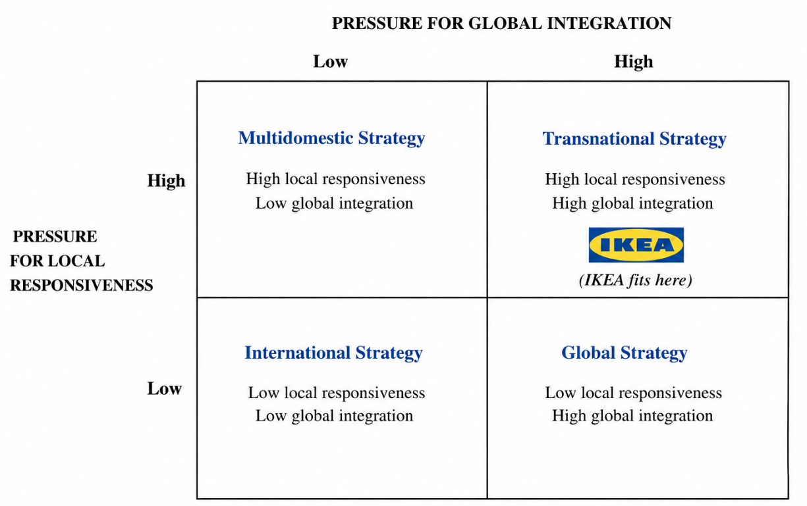
Figure 1: Adapted Bartlett and Ghoshal Matrix
Source: Self-made

2.3 Global Configuration
This well-developed global configuration, which involves sourcing, manufacturing partners, logistics, retailing business and digital commerce strengthens the competitive advantage of IKEA (Li et al., 2022). Its geographically diversified supplier base minimizes supplier risk, cost-effectiveness, and facilitates distribution systems guarantee the availability of products worldwide. The swift development of omnichannel retailing is a combination of online channels and brick-and-mortar stores enhancing customer experience and operational adaptability (Hagberg and Jonsson, 2022). Together, the global integrated value chain, excellent brand recognition, sustainability of sourcing activities, and effective logistics that IKEA has established have resulted in a sustained competitive edge and enable the firm to find a solid strategic base to explore new markets in emerging markets like Bangladesh (IKEA, 2025a).
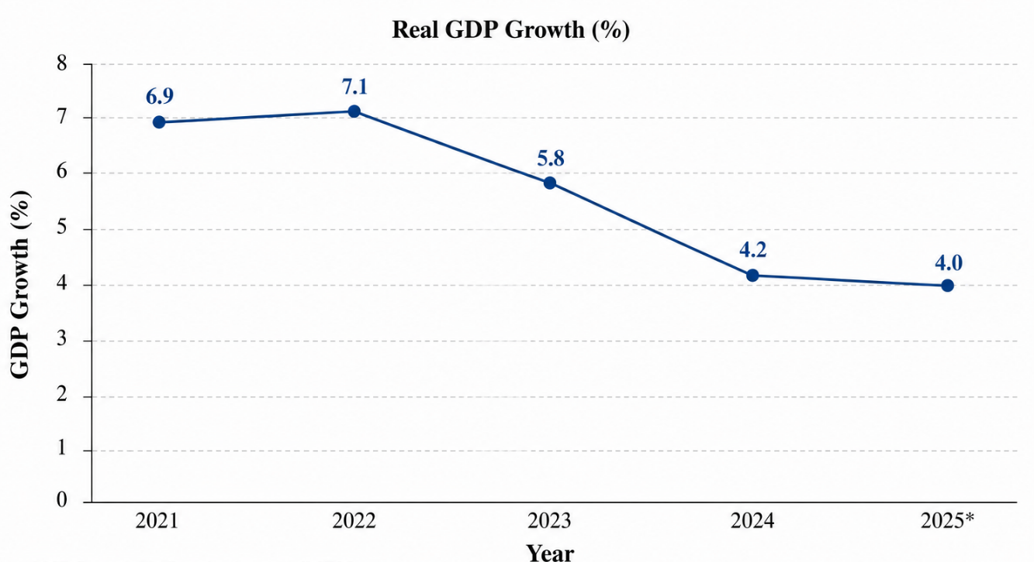
Figure 2: Global Map of IKEA's Operating Markets
Source: Self-made Adapted from IKEA (2025b).

3. Macro-Environmental Appraisal

3.1 Bangladesh Overview
Bangladesh has been the fastest growing economy in South Asia and this has offered some significant opportunities to multinational retailers with an ambition to enter into emerging markets (Gehlen, Marx and Reckendrees, 2023). The International Monetary Fund (IMF) also estimates that Bangladesh has witnessed a nominal Gross Domestic Product (GDP) of more than US $470billion, aided by a continuous industrialisation, export-based manufacturing and rising domestic consumption in 2025 (International Monetary Fund, 2025a). Its population of more than 175million makes it the eighth most populated country in the world, whereas, fast urbanisation has led to 0.41 numbers of its citizens living in cities (World Bank, 2025a). Metropolitan centres such as Dhaka, Chattogram and others have value added residential and commercial developments and have created a growing demand of home furnishing goods of a modern nature (Euromonitor International, 2025).
The growing middle-income society in Bangladesh is a promising source of consumers in IKEA, which owns the value-oriented business model. Increased female participation in the workforce, growing household incomes, and shifting lifestyles have enhanced the need on affordable furniture, home furnishings, and space saving home solutions (OECD, 2023). Retail modernisation has been quite rampant as the organised forms of retailing, shopping malls and e-commerce platforms expand alongside the traditional markets (Euromonitor International, 2025). In addition, the domestic furniture industry has shown high growth, which can be attributed to the growth of urban housing, and increased awareness of consumers on modern interior design. Even though the industry is still controlled by domestic suppliers like Hatil, Otobi and Navana Furniture, the comparatively low presence of international furniture retailers gives the chance to IKEA to launch internationally known products as well as to utilise its economies of scale and sustainable product line (UNCTAD, 2025).
Table 2: Bangladesh Economic Indicators
Indicator (2025) | Value
GDP (Nominal) | US$470+ billion
Population | 175+ million
Urban Population | ~41%
GDP Growth | ~4.0%
Inflation | ~9–10%
Major Industries | Textiles, Manufacturing, Retail, Furniture
Source: International Monetary Fund (2025a); World Bank (2025a) ; Euromonitor International (2025).

3.2 Political Environment
The political environment in Bangladesh has both strategic opportunities and institutional barriers to foreign investors. Tax incentives, export processing zones, infrastructure among other projects and easier investment processes through governmental initiatives are the incentives that drive foreign direct investment in Bangladesh under the umbrella of Bangladesh Investment Development Authority (BIDA), 2025). These reforms endorse the national goal of becoming an upper-middle-income nation as well as enhancing foreign involvement in manufacturing and retail jobs (OECD, 2025).
Although these improvements have been made, there are still strong governance constraints. The issue of political instability, inconsistency in regulations and bureaucratic delays persists to add uncertainty in the operations of MNEs. Despite the reforms made by the institutions that make the investment climate better, the inefficiencies of the administration continue to limit the setting up of the businesses and their adherence to the regulations (World Bank, 2025a). Moreover, ill governance and poor quality of regulations may add to the transaction cost and slow down business activities especially when a retailer needs a lot of licensing and logistical facilities (International Monetary Fund, 2025b).
Furniture tariffs are also a form of protection that helps domestic production to become less competitive than completely imported products. The ability to incorporate local sourcing and supply-chain partnership, as well as imported product lines, would make IKEA competitively viable in the long run. However, as long as more investment in transport infrastructure and special economic zone increases access to the future market, unbalanced application servicially restricts immediate gains (Bangladesh Investment Development Authority (BIDA), 2025). As such, Bangladesh has a moderately risky institutional, equally politically conducive environment, which demands cautious stakeholder involvement and active regulatory control.

3.3 Economic Environment
The economic environment in Bangladesh is quite supportive to the long term growth of IKEA although there are a few short term macroeconomic limitations (Nazzal et al., 2025). It is estimated that the economy will experience growth of about 4% in 2025 due to the growth of the industrial sector, the export performance, and investment of infrastructure even amid uncertain global economies (International Monetary Fund, 2025a). The economic growth will eventually lead to a growth in the disposable income and consumer demand to purchase household goods and modern furniture.
Inflation of about 9-10% however, is still depressing the purchasing power of households and raising operating expenses on the part of the retailers (International Monetary Fund, 2025a). Price uncertainty is also a result of exchange-rate volatility which then subjects import-dependent businesses to uncertainties in prices. As IKEA first depends on its sourcing network worldwide, changes in the cost of imports can decrease profitability unless it is complemented by more localised procurement and the supply-chain.
However, positive population trends greatly override such short term problems. The trend of growth in middle-income households, rapid urbanisation and the building of more apartments keeps boosting the demand of space-saving affordable furniture that can be used by modern urban living (World Bank, 2025b). At the same time, organised retail, shopping centres and online shopping platforms are growing at an overwhelming pace because of the growing internet penetration and smart phone usage (Euromonitor International, 2025). These measures support the omnichannel retail approach by IKEA, which involves both digital selling and physical retail outlets, diminishing the risk of entering the market, and enhancing the customer reach and availability.
Despite the need to price and source carefully due to inflation and currency risk, the growing consumer market in Bangladesh, quality demographics and retail modernisation are good indicators of strong sustainable economic long term market prospects. A gradual process of investing in digital retail coupled with slower physical growth and sourcing more locally would thus make IKEA stronger, and it would maximise future growth.
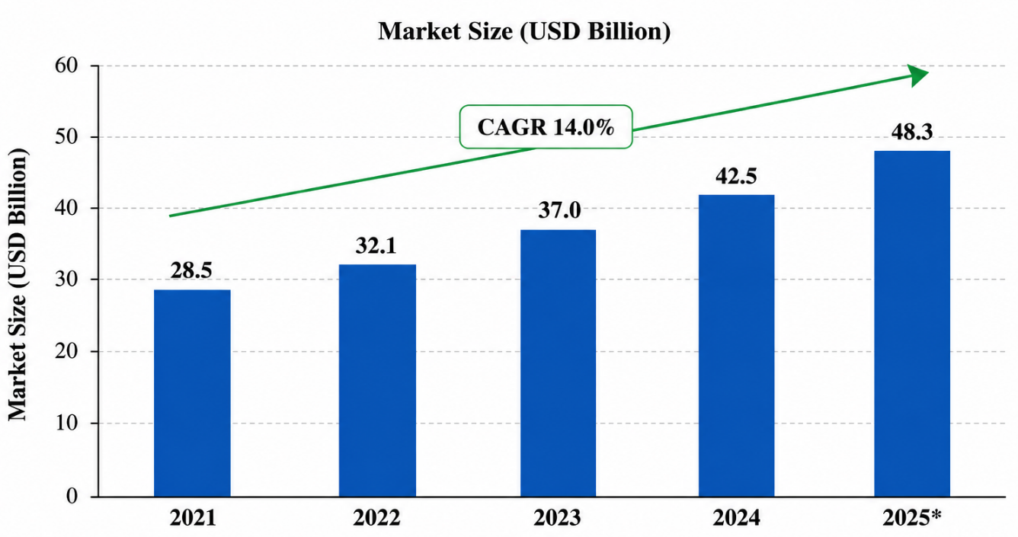
Figure 3: Bangladesh Retail Market Growth (2021–2025)
Source: Self-made Adapted from Euromonitor International (2025)

3.4 Legal Environment
The legal framework in Bangladesh has continued to be enhanced to promote foreign investment with guarding domestic industries, to open opportunities as well as compliance requirements to multinational retailers, including IKEA (Meyer et al., 2023). The Foreign Private Investment (Promotion and Protection) Act offers legal protection of the foreign investors by protecting them against expropriation and allowing profit repatriation thus enhancing investment confidence. Moreover, the Bangladesh Investment Development Authority (BIDA) in 2025 has eased business registration processes and provides incentives to foreign companies that have operations in economic zones.
Irrespective of these reforms, IKEA would be faced with a number of regulatory challenges. Custom duties and other additional taxes on furniture and home furnishing are considered to be relatively high to favor domestic manufacturers, which may translate into higher prices of retailing products in case they are all imported. The formation of local sourcing alliances or regional assembly facilities might therefore lower tariff risk, and enhance cost competitiveness (OECD, 2025). The consumer protection laws also have taken a central role and businesses are expected to have clear pricing, safety standards of products and do fair business among other factors. Awareness of these regulations would lend credence to IKEA throughout the world with its quality and responsible retailing integrity (Inter IKEA Group, 2025).
Labour laws need to be observed with regard to minimum wages, welfare of employees and occupational safety rules. Since IKEA has a solid corporate philosophy of ethical sourcing and responsible employment, its need to comply with the labour regulations in Bangladesh not only fits into its long-term sustainability plan but also contributes to the corporate legitimacy of IKEA (IKEA, 2025a). The protection of intellectual property has also improved, but there is still weaker protection and enforcement compared to most developed economies. Securing IKEAs trademarks, product design and proprietary concept would then need a legal vigil, the continuous legal surveillance. In general, the legal environment in Bangladesh is generally favourable to foreign investment but needs active enforcement of regulations and proper supply chain management to reduce risks in the operation (UNCTAD, 2025).

3.5 Cultural Environment
Cultural fit is a significant factor of IKEA success into Bangladesh market. With reference to the cultural dimensions proposed by Hofstede, the Bangladeshi society is rather high in terms of collectivism, hierarchy respect, moderate uncertainty avoidance, i.e. the household buying decisions are often made by more than one person (Hofstede, Hofstede and Minkov, 2010). This cultural trait contributes to the value proposition of IKEA that focuses on families, although the decision to buy will be probably more deliberate as compared to most Western markets.
Context Theory by Hall also indicates that Bangladesh is primarily a high-context culture, or the interpersonal trust, long-term relationships and social interaction plays a critical role in consumer behaviour. Therefore, the standardised global retail concept used by IKEA might not be adequate to create customer loyalty. Rather, it would be through integration of global operational efficiency and the culture responsiveness approach to marketing together with consumer trust building through customer engagement and after sales services that will lead to long term competitiveness.
The changing consumer preferences are being altered at the same time due to rapid urbanisation, growth in education and exposure to international lifestyle as provided by digital media (Euromonitor International, 2025). The youthful professionals are more focused on today and multifunctional and environmentally friendly furniture befitting the apartment living and this is a good strategic fit on the current product range in IKEA. However, the Bangladeshi market is highly price elastic. Consequently, ensuring prices remain competitive as business gets selective like modifying product size, interior design and promotional tactics is bound to produce more acceptance than standardisation as practiced in the whole world.

3.6 Industry Attractiveness
The furniture sector in Bangladesh shows promising potential growth performance in the long-run despite the rising domestic competition. This model is Porters Five Forces which is quite a form of systematic analysis of the competitive formation in the industry (Porter, 1980).
The rivalry is moderate due to the presence of well established domestic producers such as Hatil, Otobi, Navana Furniture and Akhtar Furnishers which have good distribution networks, established brands and favourable pricing among others. Nevertheless, the international furniture retailers relatively low involvement decreases the direct competition of international brands and gives IKEA the chances to distinguish themselves in terms of design innovation, sustainability and customer experience rather than just price.
New entrants threat is moderate as well. Despite the temptation to enter the market due to increasing consumer demand, developing the national retail network, high-quality logistics processes and high brand recognition rate demand substantial capital investment and managerial skills, which puts a significant barrier to entry (Ghauri, Strange and Cooke, 2021). Bargaining power of the suppliers is moderate since Bangladesh has a growing local furniture manufacturing industry with regional sourcing options. Diversity in the global procurement network would additionally enhance the purchasing power in IKEA since there would be less reliance on the suppliers.
On the other hand, the buyer power is not that low, as the consumer is the most price-sensitive group and has the liberty to change among the competing domestic stores at ease. This means IKEA has no choice but to compete not only in terms of price but in terms of quality, functionality, sustainability and brand image to a product. Potential substitutes are also moderate, with the local carpenters and informal manufacturers offering cheaper customised options. However, the standardised quality of IKEA, guarantees, green manufacturing and one-stop shopping experience are also valuable competitive advantages against the informal suppliers. In general, the positive demographic factors and urbanisation counterbalance competitive pressures contributing to the industry attractiveness in the long-term.
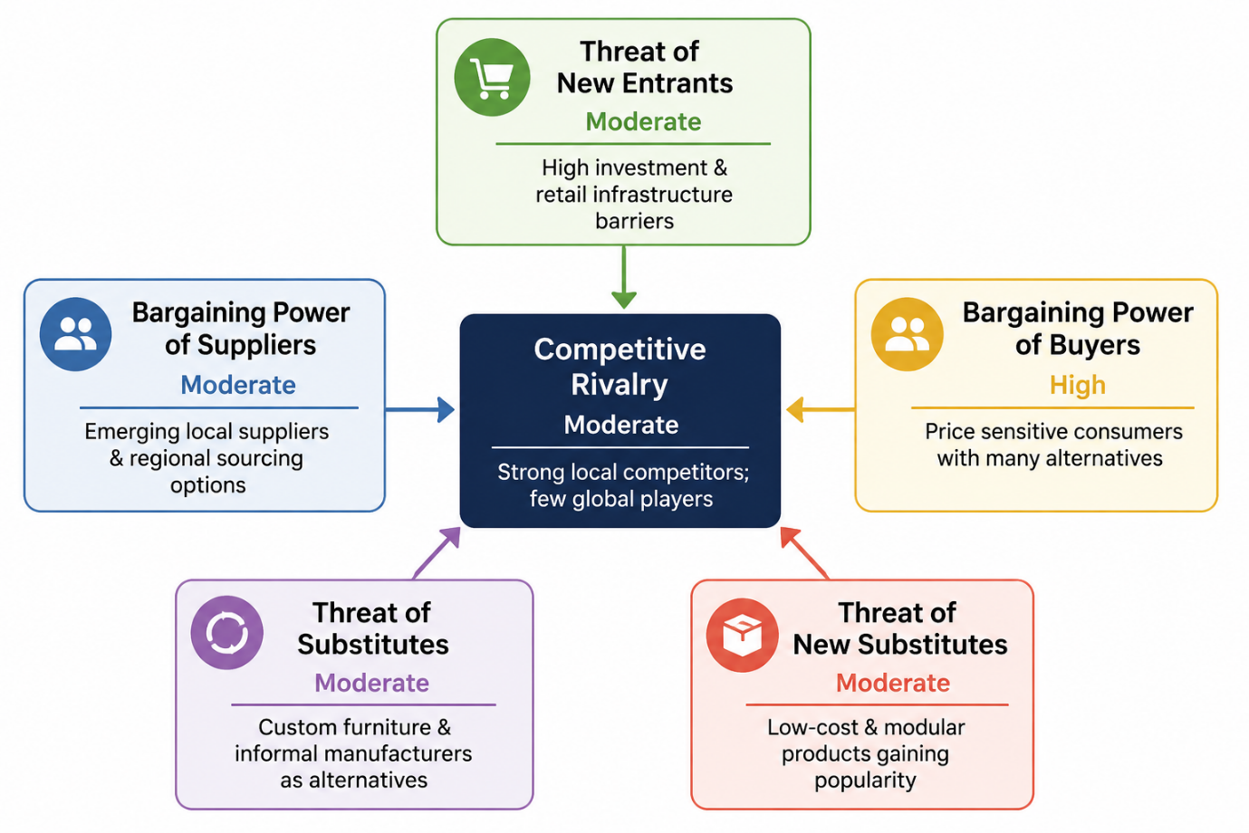
Figure 4: Porter's Five Forces Analysis of Bangladesh's Furniture Industry
Source: Self-made

3.7 Market Attractiveness
In general, the macro-environment shows a high long-term potential of IKEA although institutional and operational risks can be traced. The rise of middle-income families and growing demand of low cost-high-speed urbanisation are in line with the global business model of IKEA (World Bank, 2025a). Moreover, the ongoing increase in the presence of organised retailing and e-commerce opens up additional possibilities to use the omnichannel strategy of IKEA, to combine physical retailing with online outlets (Euromonitor International, 2025).
However, short-term profitability could be limited by inflation, exchange-rate volatility, and regulatory complexity and infrastructure constraints. Well-established domestic rivalry also makes it necessary that IKEA innovate, stay green and offer high-quality customer experience instead of merely intense price field. As a result, Bangladesh is to be viewed as a medium-risk but strategically desirable market that will have to be invested in and given gradual localisation.
Table 3: SWOT Analysis for IKEA's Proposed Entry into Bangladesh
Strengths | Weaknesses
Globally recognised brand with strong reputation | Limited local market experience
Cost-efficient global supply chain | Dependence on imported products during initial expansion
Affordable and sustainable product portfolio | Significant initial capital investment

Opportunities | Threats
Growing middle-class population | Political and regulatory uncertainty
Rapid urbanisation and housing demand | Inflation and exchange-rate fluctuations
Expanding organised retail and e-commerce | Strong domestic furniture competitors
In general, these opportunities are significantly greater than the threats and argues in favor of Bangladesh as a strategically relevant market to expand internationally in the future of IKEA.

3.8 Dunning's OLI Framework
The Eclectic Paradigm offered by Dunning is a very wide system of evaluating the suggested investment of IKEA in Bangladesh (Dunning, 1988). IKEA has good ownership advantages, such as its worldwide-known brand, Scandinavian design experience, sustainable business output and highly efficient global sourcing base. These company-specific resources allow economies of scale, operational efficiency and affordable prices and reinforce customer loyalty (Luo and Zahra, 2023).
Another key location consideration in Bangladesh is the fact it has a population more than 175 million, a growing urbanisation, growing middle-income families and favourable policies concerning foreign investments (International Monetary Fund, 2025a). Nevertheless, the lack of infrastructure, regulatory sophistication and vagaries in the macroeconomic environment must be handled with careful investment planning to have sustainable future performance.
Lastly, internalisation benefits imply that having a higher level of operational control would be more effective in safeguarding the brand name, product quality, supply chain performance, and omnichannel retailing approach of IKEA compared to franchising alone. A joint venture with majority ownership would then represent a good balance between strategic control and the local market expertise. Together, the OLI framework shows that ownership-specific advantages of IKEA would fit well with the long-term market potential of Bangladesh under institutional risk approach in the form of a step-by-step, well-thought-out market-entry plan.

4. Entry Mode Strategy

4.1 Historical International Expansion
IKEA has taken a cautiously thought-out international expansion policy balancing global standardisation and local selective adaptation to market circumstances (Lo and Nguyen, 2023). Instead of existence of one mode of entry, the company has been found to adopt various mode of entry basing on the size of a market, regulation demands, investment risks and long term objectives of the strategy. The Inter IKEA franchise system has seen franchising to be the most dominant mode of expansion in IKEA, which has facilitated the rapid international expansion without any change in the brand identity or even the standards of operation (Inter IKEA Group, 2025). Franchise partners run stores in accordance with strict contracts; they are obliged to adhere to the concept of retailing IKEA around the whole world, but use their research into the local market. The model has been applied with success in many European and Middle Eastern markets.
IKEA has created wholly owned subsidiaries in those countries where there is a strategic importance in the operational control. The United Kingdom, Germany and China, are examples where direct ownership has facilitated a consistent application of corporate strategy, integration of the supply chain and customer experience management. Conversely, IKEA has in some occasions, opted to use joint ventures in entering markets that have been defined by regulatory barriers or institutional nature. Its first move to India was a joint venture in sourcing operations before it proceeded to plan wholly owned retail operations after the liberalisation of the regulations.
Licensing has been less prominent in the process of IKEA internationalisation strategy, owing to the fact that the firm aims to safeguard its intellectual property, quality product and brand image by the centralization of operational control. In more recent times, digital transformation has started to be a significant aspect of global expansion. The vast adoption of e-commerce platforms, availability of click-and-collect service and digital planning tools in the key markets have allowed IKEA to engage in omnichannel retailing and enhanced the customer accessibility without necessarily making significant investments in tangible retailing (IKEA, 2025a). This electronic facility allows more versatility in moving to more emerging markets where the organised retail infrastructure is only being established.
Table 4: Historical Market Entry Modes Used by IKEA
Entry Mode | Example Countries | Strategic Purpose
Franchising | UAE, Saudi Arabia, Spain | Rapid expansion with local expertise
Wholly Owned Subsidiaries | UK, Germany, China | High control and brand consistency
Joint Venture | Early sourcing partnerships in India | Regulatory compliance and local knowledge
Licensing | Limited applications | Intellectual property protection
E-commerce Expansion | Global markets | Omnichannel growth and market accessibility

4.2 Evaluation of Historical Strategy
The internationalisation approach of IKEA has a number of strengths. Franchising and wholly owned subsidiaries have allowed the company to expand to a wide geographic presence and also to make the balance between investment levels and control of the business. Economies of scale have been created through standardised products, channel logistics and a good brand management strategy and have been used to promote the cost leadership strategy of the IKEA across various international market places. In addition, localisation in the selection of marketing, food and store layouts has enhanced customer acceptance without affecting the global brand consistency.
Nevertheless, there have been limitations that have arisen. Big box stores cost a lot of money to establish, and they need an excellent transport network, thus expansion into an emerging economy is complicated. Consumer behaviour and tastes have demanded more readjustment in some markets than previously expected. First-mover difficulties in China and India showed that too much standardisation can restrain adaptability to local market dynamics, especially when it comes to pricing, product size and shopping habits.
These are some of the experiences that can teach significant things in the future growth. IKEA has progressively realised the necessity of figuring out the blend of worldwide productivities and local responsive through gradual investment, online retailing and tighter interaction with local vendors (Cuervo-Cazurra, Doz and Gaur, 2020). Future market entry plans need to therefore focus on flexibility, local collaboration and slow market building without compromising on global operational standard of operations at IKEA.

4.3 Alternative Entry Modes
It is possible to think of several alternative market entry strategies that have their own strengths and weaknesses as applied to the situation in Bangladesh.
Greenfield investment is fully controlled in terms of ownership and operations but it is costly to implement in terms of finance, time and more risky. Acquisition offers access to a market in the short-term but is limited by the lack of large scale furniture retailers who may be suitable and integration difficulties. Franchising supports rapid growth at a lessen financial involvement but restricts the strategy over customer experience and quality of operations. Strategic alliances help in terms of sharing knowledge and accessing resources locally but can lead to conflicts in terms of decision-making and strategic priorities. Joint ventures moderate both the control and local experience, uniting IKEA global competencies and a country partner knowledge of the market, distribution systems, and regulatory knowledge and skills (Koleša, 2022).
Table 5: Comparison of Alternative Entry Modes
Entry Mode | Control | Investment | Risk | Suitability for Bangladesh
Greenfield | High | High | High | Moderate
Acquisition | High | High | Moderate | Low
Franchising | Low–Moderate | Low | Moderate | Moderate
Strategic Alliance | Shared | Moderate | Moderate | High
Joint Venture | High (Shared) | Moderate | Moderate | Very High

4.4 Recommended Entry Mode
The most suitable entry mode to IKEA expansion into Bangladesh is the joint venture, which is majority controlled. This is a good middle ground between strategic control and market understanding within the local market as the financial and functional risks of a wholly owned Greenfield investment are diminished. Partnerships with an already existing domestic retail or logistics firm would ease regulatory compliance, location choice, supply chain creation and consumer market insights (Bangladesh Investment Development Authority (BIDA), 2025). Meanwhile, the idea of the majority ownership would also enable IKEA to offer quality standards, sustainability promises, price campaign and brand coherence (Inter IKEA Group, 2025). This incremental strategy fits into the institutional environment of Bangladesh, and would allow the market to grow gradually, to be larger-scale when the institutional environment has fully developed.

4.5 Strategic Recommendations
IKEA must embrace the strategy of going gradual to increase chances of winning in a new market since it is a phased strategy that would focus on maintaining control as a strategy element and responsiveness as a local factor. The joint venture with a common partner with a substantial majority who has experience in the business in Bangladesh or a logistical company would ease institutional risks and give a chance to comply with regulation and provide market knowledge. Initial capital investment would be low if e-commerce and click-and-collect operations started first and substantial physical expansion commenced much later when at least some understanding of consumer demand is attained by way of an omnichannel strategy. Raising the degree of sourcing of the chosen furniture and accessories domestically would minimize the costs of imports, the exposure to tariffs and vulnerability to the supply chain and contribute to sustainability goals. In addition, modifying the chosen products and marketing messages to include the lives of Bangladeshi consumers in terms of their apartment life and cultural anticipations would enhance customer acceptance. Brand consistency can be maintained by ongoing employee training about IKEA sustainability values, customer service standards and customer operation practices. Lastly, there should be growth in a staged, performance-based manner starting in Dhaka before rolling to other big cities when commercial viability and operational stability have been proved.
The history of internationalisation at IKEA shows that its global standardisation coupled with selective localisation have been key to its competitive advantage. The Bangladesh market is a good entry opportunity due to the favourable demographic factors, growing consumer demand and an increasing organised retailing in the face of institutional and macroeconomic risk factors (International Monetary Fund, 2025a). Taking into account the background of the company of IKEA, and the nature of the business environment within the country, majority-controlled joint venture would offer the best balance between control, investment and flexibility. IKEA would be able to create a sustainable long-term presence with this strategy and operational risk management and would provide the company with a solid base to grow in the future.

Section 2: Reflective Account (Gibbs Reflective Cycle)

Stage 1: Description
This examination involved me examining the international expansion strategy of IKEA and advising it on how to enter Bangladesh by applying the concept of international business theory and empirical studies. I used a well-organized research plan throughout the project, through which I could use academic journal articles, textbooks, company reports and publications of international organisations, such as World bank, International monetary Fund (IMF), United Nations Conference on Trade and development (UNCTAD) and Bangladesh Investment development Authority (BIDA). I planned the report based on the assessment requirement starting with the classification of organisations with a framework developed by Bartlett and Ghoshal, macro-environmental analysis, Dunning OLI Framework and market entry analysis. The lectures were significant in offering a clear perception of the theoretical concepts whereas academic literature helped me to put the theoretical concepts in criticism and provide a practical implementation of the concepts in an international business.

Stage 2: Feelings
When I started working on the assignment, I was rather unclear about choosing an appropriate multinational corporation and a country that fits in the requirement of the assessment of having no substantial presence of operation before June 2026. There was also the problem of me struggling to apply various international business theories in a single report in a continuous form and at the same time be critical rather than just describing the concepts. My confidence was also growing as I went on due to the fact that the lectures made me understand connections between internationalisation theories and strategic decision-making. The analysis of good academic research and industry reports assisted me in getting an idea of how theoretical models might be applied to explain real business decisions. Throughout the course of the assessment, at a later point I was more at ease assessing evidence, evaluating alternative strategies of entry and then deriving grounded recommendations backed with theory and with up-to-date business information.

Stage 3: Evaluation
In general, I think it was a good research process since I used credible and up-to-date sources instead of baseless opinions. The academic literature and industry reports allowed me to assess the reliability of my analysis and thus compare perspectives before making conclusions. Using other strategies like the international strategy model developed by Bartlett and Ghoshal, the Porters Five Forces and Dunning OLI Paradigm enhanced the quality of the report by laying down organised methods of analysing international expansion at IKEA. Nevertheless, the evaluation did have its issues. The existing data on IKEA market presence and the business environment in Bangladesh had to be thoroughly checked, as the international business environment is, nevertheless, developing. Moreover, to synthesise large amounts of information into extensive yet simple to understand arguments, a lot of planning and time management was essential.

Stage 4: Analysis
When looking back upon the experience of the assignment, I have realised that my experience of integrating lectures with independent academic research helped me to achieve a much deeper insight into the concept of international business strategy. The lectures presented theoretical approaches, and academic journals showed how these models are implemented and critiqued by actual organisations set up. This helped me go beyond descriptive writing and consider both advantages and disadvantages of various strategic methods. Evaluation of sources also came as a significant part of my education. Instead of getting information on the surface, I kept comparing the results of scholarly literature, company publications and international organisations to keep it constant and credible. This strategy boosted my capacity in critical thinking and evidence-based decision making. Additionally, the examination of the political, economic, legal, and cultural environments of Bangladesh indicated that the decisions concerning international expansion are complicated, and that the key to entering the markets successfully is to strike a compromise between global standardisation and the adaptation to the local markets. Those experiences strengthened the significance of the combination of theoretical and practical business analysis in developing strategic recommendations.

Stage 5: Conclusion
This assignment has assisted me in enhancing my studies and the knowledge I have as an expert in international business management. I gained a better understanding of how strategic frameworks enable an evidence-based method of decision-making and the way other market situations can shape international expansion plans. I also understood that there is no one universal way to enter a market when all these factors should be taken into consideration: organisational resources, institutional environments and long-term strategic objectives. The research process enabled me to enhance my critical evaluation skills in order to assess the various sources, form logical arguments and support recommendations based on academic evidence and not assumptions. Comprehensively, I acknowledge that the assessment has not only boosted my self-confidence in the application of international business theories in addressing complex organisational issues but also my skills in conducting systematic research in business matters.

Stage 6: Action Plan
In my academic and professional work, I will expand on the skills acquired in this assessment in future. I will initiate research earlier to give more time to assess the literature, to compare opposite opinions as well as to sharpen the critical analysis. Another skill I will develop is to improve my skills of interpreting data in the international market analysing both reports published by organisations throughout the world and keeping up with the changes made to the multinational businesses. Moreover, I will be enhancing my competencies in resorting to business frameworks in practice instead of applying them as descriptions. They will assist my future work in the field of international business as I will be able to analyse foreign investment opportunities, determine market risks and prescribe strategic expansion decisions with the help of credible evidence. Above all, I will still incorporate academic theory, professional research and critical reflection in decision making to come up with credible evidence-based recommendations on complex issues in business around the world.

References
Bangladesh Investment Development Authority (BIDA) (2025) Bangladesh Investment Development Authority. Available at: https://investbangladesh.gov.bd/ (Accessed: 25 July 2026).
Bartlett, C.A. and Ghoshal, S. (1989) Managing Across Borders: The Transnational Solution. Boston: Harvard Business School Press.
Cavusgil, S.T., Knight, G.A. and Riesenberger, J.R. (2019). International business : The new realities. Harlow: Pearson.
Contractor, F.J. (2021). The world economy will need even more globalization in the post-pandemic 2021 decade. Journal of International business studies, 53(1), pp.156–171. doi: https://doi.org/10.1057/s41267-020-00394-y.
Cuervo‐Cazurra, A., Doz, Y. and Gaur, A. (2020). Skepticism of globalization and global strategy: Increasing regulations and countervailing strategies. Global strategy journal, 10(1), pp.3–31.
DasGupta, R., Kumar, S. and Pathak, R. (2022). Multinational enterprises’ internationalization and adoption of sustainable development goals. International journal of Managerial finance, ahead-of-print(ahead-of-print). doi: https://doi.org/10.1108/ijmf-09-2021-0416.
Dunning, J.H. (1988) 'The Eclectic Paradigm of International Production', Journal of International Business Studies, 19(1), pp. 1–31.
Euromonitor International (2025) Economy, Finance and Trade: Bangladesh. Available at: https://www.euromonitor.com/economy-finance-and-trade-bangladesh/report (Accessed: 25 July 2026).
Gehlen, B., Marx, C. and Reckendrees, A. (2023). International business, Multi-Nationals, and the nationality of the company. Taylor & Francis.
Ghauri, P., Strange, R. and Cooke, F.L. (2021). Research on international business: The new realities. International business review, 30(2), p.101794. doi: https://doi.org/10.1016/j.ibusrev.2021.101794.
Hagberg, J. and Jonsson, A. (2022). Exploring digitalisation at IKEA. International journal of Retail & distribution management, 50(13), pp.59–76.
Hofstede, G., Hofstede, G.J. and Minkov, M. (2010) Cultures and Organizations: Software of the Mind. 3rd edn. McGraw-Hill
IKEA (2025a) IKEA Sustainability Strategy 2025–2030. Available at: https://www.ikea.com/global/en/images/IKEA_Sustainability_Strategy_2025_2030_v3_251013_f76f0e6498.pdf (Accessed: 25 July 2026).
IKEA (2025b) Year in Review FY25. Available at: https://www.ikea.com/global/en/our-business/how-we-work/year-in-review-fy25/ (Accessed: 25 July 2026).
Inter IKEA Group (2025) Inter IKEA Group Sustainability Statement FY25. Available at: https://www.inter.ikea.com/-/media/interikea/igi/financial-reports/fy25-financial-reports/inter-ikea-group-sustainability-statement-fy25.pdf?rev=e31e4c25b5754ad998ed49a8b62c340d (Accessed: 25 July 2026).
International Monetary Fund (2025a) Bangladesh: Third and Fourth Reviews under the Extended Credit Facility Arrangement and the Extended Fund Facility Arrangement. Available at: https://www.imf.org/en/publications/cr/issues/2025/06/26/bangladesh-third-and-fourth-reviews-under-the-extended-credit-facility-arrangement-and-the-568045 (Accessed: 25 July 2026).
International Monetary Fund (2025b) IMF Annual Report 2025. Available at: https://www.imf.org/external/pubs/ft/ar/2025/ (Accessed: 25 July 2026).
Koleša, I. (2022). Becoming an international manager: Identity work by managerial international assignees from emerging markets. Springer Nature.
Li, F., Chen, Y., Ortiz, J. and Wei, M. (2022). The theory of multinational enterprises in the digital era: State-of-the-art and research priorities. International journal of emerging markets, 19(2). doi: https://doi.org/10.1108/ijoem-03-2021-0366.
Lo, F.Y. and Nguyen, P.Q. (2023). Digital internationalisation: Dependence in multinational enterprise network and subsidiary performance. European j. of International management, 1(1). doi: https://doi.org/10.1504/ejim.2023.10062819.
Luo, Y. and Zahra, S.A. (2023). Industry 4.0 In international business research. Journal of International business studies, 54(3), pp.403–417. doi: https://doi.org/10.1057/s41267-022-00577-9.
Meyer, K.E., Li, J., Brouthers, K.D. and Jean, R.-J.B. (2023). International business in the digital age: Global strategies in a world of national institutions. Journal of International business studies, [online] 54(4), pp.577–598. doi: https://doi.org/10.1057/s41267-023-00618-x.
Nazzal, A., Niñerola, A.M., Sánchez-Rebull, M.-V. and Barberà-Mariné, M.G. (2025). A systematic mapping review of foreign direct investment by multinational corporations in emerging economies. Humanities and social sciences communications, [online] 12(1). doi: https://doi.org/10.1057/s41599-025-04571-y.
Organisation for Economic Co-operation and Development (OECD) (2023) Production Transformation Policy Review of Bangladesh. Available at: https://www.oecd.org/content/dam/oecd/en/publications/reports/2023/09/production-transformation-policy-review-of-bangladesh_a305bdac/8b925b06-en.pdf (Accessed: 25 July 2026).
Organisation for Economic Co-operation and Development (OECD) (2025) Foreign Direct Investment Qualities and Impact. Available at: https://www.oecd.org/en/topics/sub-issues/foreign-direct-investment-qualities-and-impact.html (Accessed: 25 July 2026).
Porter, M.E. (1980) Competitive Strategy. New York: Free Press.
United Nations Conference on Trade and Development (UNCTAD) (2025) Report on the Implementation of the Investment Policy Review of Bangladesh. Available at: https://unctad.org/publication/report-implementation-investment-policy-review-bangladesh (Accessed: 25 July 2026).
World Bank (2025a) Bangladesh Overview. Available at: https://www.worldbank.org/ext/en/country/bangladesh (Accessed: 25 July 2026).
World Bank (2025b) World Bank Annual Report 2025. Available at: https://www.worldbank.org/en/about/annual-report (Accessed: 25 July 2026).

