The Greenfield Tapes
A Short Film by
Samuel Petrus Langgi

Table of Content

Introduction …………………………………………………………………………………..3
Scriptwriting phase ………………………………………………………………………...4-5
Filming phase ………………………………………………………………………………6-9
Editing phase ……………………………………………………………………………10-14
Self-thoughts ………………………………………………………………………………..15
References …………………………………………………………………………………..16

Introduction
At the time of writing, my project, The Greenfield Tapes is completed and this essay is written to tell the detailed story of how The Greenfield Tapes came to be. To start us of, I came up with the name The Greenfield Tapes at the last hours of finishing up my project. I had a backup name: The Carmarthen Project. However, I thought that it would be too unoriginal. Finally, I had it: The Greenfield Tapes. Those recordings were going to be memories for Sam. That’s why he records it on his camera. Not knowing that he will die in a few days, Sam would assume that there will be more “tapes” to be recorded in the future. Hence, the “s”. The Greenfield Tapes was initially just a simple idea that I had in mind for a friend in the early stages of brainstorming ideas for our projects for the modules Developing Creative Project (CAMF6001) and Creative Project (CAMF6002). However, as time passed and said friend had already decided to go on a different direction in terms of his project’s genre, that simple idea that was meant for him kept developing in my mind and finally, I decided to keep the idea for myself. The reason I even had the thought of suggesting to my friend to make a found footage film was because I myself wasn’t sure what I was going to do for the project. Too many possibilities and genres to choose from and I could only choose one. Finally, after spending a few days thinking of what to do for the project, I managed to narrow down my ideas to two, a short film or a mockumentary.
However, choosing between the two would prove even more difficult than narrowing it down to those two ideas. So, to give my mind a break, I let it wander beyond those two options and started thinking of ideas for my friend who was still in the process of coming up with ideas for his project. At that moment, I remembered I thought, “Since Jett is pretty keen on making a documentary, why not suggest to him to go ahead with the documentary, but add a twist at the end to spice thing up a little. Maybe include a serial killer or something…”. But that’s when something lit up in my brain and I thought, “Hold up, this isn’t such a bad idea…not bad at all. But wait, isn’t a “documentary with a twist at the end” just another word for a film genre called found-footage? And isn’t found-footage sort of like the combination of my two main ideas? After all, a found-footage film is a film which was shot in the style of a mocumentary or documentary.” Hence, I ended up not telling Jett about the idea for some reason and began to further develop the idea that was the seed that will eventually grow into The Greenfield Tapes.

Scriptwriting Phase
Long story short, I pitched the idea to my supervisors and got the green light to start developing the project. One of the first things that I did was transferring everything that I had in my mind regarding the film onto paper in the form of a step outline. The step outline mapped out the main events that happens in the short film including the exposition, rising action and climax. From there on, the step outline kept on growing and developing with every new idea and detail no matter the size. At that stage, I was just having fun churning out as much ideas as possible for the film. For instance, ideas for plots, details, characters, flow of the story, etc. After that, when I felt confident that the step outline is good enough to provide me with enough materials to start writing a script, which is in my opinion, one of the most difficult and important part of the filmmaking process, I sat down and started typing. Blank pages were filled with words as the days go by. Admittedly, the process of writing the script was quite slow in my opinion because some days I just don’t feel like writing. Eventually, it took me about two weeks to finish the first draft of my script which was 30 pages long. However, it was 15 to 18 pages too long for a 10 to 15 minutes short film. So, it took me another roughly two weeks to edit the script and to shorten it down to 18 pages over two more drafts. After showing my supervisors the third and final draft of my script, they finally gave me the green light to start filming.

Filming Phase
Altogether, there are eleven scenes in The Greenfield Tapes and with a shot list, I managed to divide the scenes into four filming sessions based on the day, time and location of filming and also the cast for each scene. In my head, I was hoping that four filming sessions meant only four non-consecutive days of filming in March, which meant plenty of time for me to enjoy Wales and to edit the film in April and May. Besides that, the process of filming would also be more organised and the cast do not have to travel so much to shoot a different scene at a different location or change their outfit just because it’s a different day in the film. For example, Scenes 1 to 4 are filmed on the same day because all four scenes are during the day and are located in the same area. Besides that, only four out of five actors were needed for those scenes. So, the person not acting in Scenes 1 to 4 doesn’t have to be present for that particular session.
17th of March 2019. It was a Sunday and it was also the first day of filming. The sun was bright and the skies were clear and I basically only had four things for the filming session. First, a Canon camera to the record the film. Second, a Rode microphone attached on top the camera to capture the audio. Third, the script of my film in my hand as I memorised a few measly lines that I had while imagining how I would shoot the scenes and finally, a cast of four acting students that I had only made acquaintances with and have yet to see them acting in front of a camera. To be honest, it was quite difficult to film as I needed to record and make it look natural and say my lines at the same time. While the cast were great and managed to memorise their lines, I forgot mine during the first few takes. But after a few more takes, I managed to get it right and checked if the audio was good. After that, I proceeded to shoot the remaining scenes for that session.
Unfortunately, my plan to shoot the entire film in four sessions or four days was disrupted as soon as I realised that I forgot to purchased or make myself some sort headstone or memorial for my film. Hence, I had to postpone filming four scenes as those scenes features the memorial. So, while waiting for my memorial to arrive in the mail, I proceeded to shoot other scenes that doesn’t require the it, which wasn’t many. There were only three other scenes that I could film. So, I filmed all three in a session. After that, it was a waiting game for me. By the end of March, I had filmed six out of eleven scenes. The bad news is, I had to wait for about a month to continue filming as my memorial would only be delivered during the Easter break in April. Unfortunately, my cast were out on holidays during the break which meant filming will only resume at the end of April. With that being said, I didn’t work much on my project throughout April besides editing and compiling the scenes that I had filmed. However, as soon as Easter was over and my cast had returned from their holidays, we resumed filming the remaining five scenes throughout the first week of May.

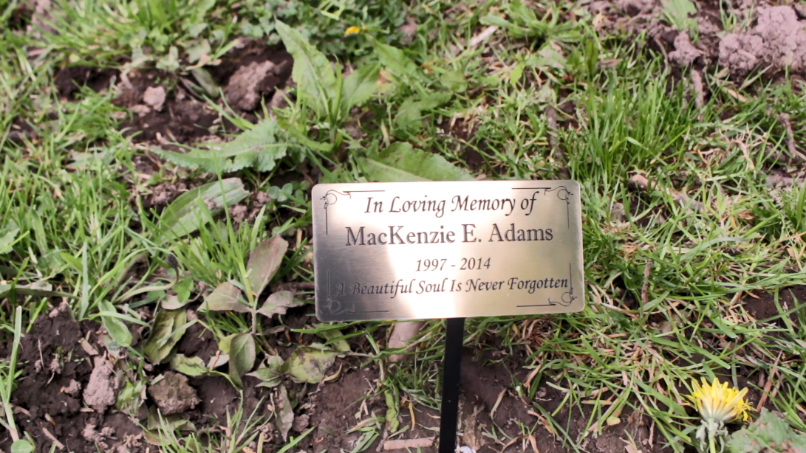

During filming, I faced some problems that couldn’t be helped during my filming progress. For instance, I had to make the decision of cutting out or reshooting Scene 5 because one of the cast members lost his cap which was important to the continuity of the film. Alas, after a long consideration of how much will the cutting of Scene 5 affect the flow of the story, I decided to cut off Scene 5 altogether. Another problem I faced was while filming Scene 9, we encountered a few drunk people who started to talk to us which disturbed our filming schedule as one of the cast members felt uncomfortable in that situation and wanted to stop filming, forcing us to reschedule.
Other than that, there were some scenes where I found myself not prepared to shoot them. For example, while filming Scene 10 (night scene), I was left in the dark in the horse field (scene location). Literally, it was pitch black. So, some of the cast members and me had to turn on our phones’ flashlights to navigate our way to the filming spot halfway up the hill. Personally, I had another problem: I had no idea how I was going to film that scene. It was much harder than I imagine it would be because I expected help from any sort of artificial lighting such as streetlights. Unfortunately, there were none and it was totally dark. So, I honestly think that the fault was with me as the director for not being prepared and I am someone who gets quite nervous in situations like that. Finally, I got to shoot the scene in two takes with one hand holding the camera and the other hand holding my phone with the flashlight on. That was because I didn’t really have a plan on how to shoot so I just did the best that I could on the camera and hope for the best outcome. Other than that, just a little detail, the cap that Ellen was wearing in Scene 11 was used by Aaron in previous scenes. This signifies that Ellen has somehow “got” Aaron and that is why she has his cap in her possesion. However, despite all the problems that I faced, I see it now as a lesson and experience learned from mistakes. In the future, I should prepare for any filming activities much earlier and test out the location of filming before actual filming day. Luckily, all the clips that I took was usable and surprisingly looks quite natural.

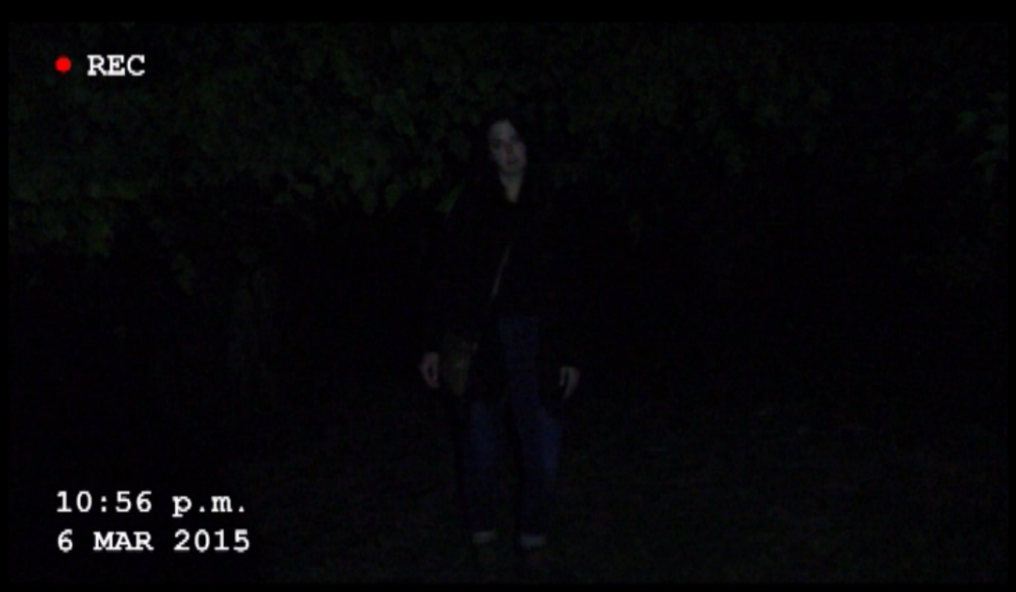

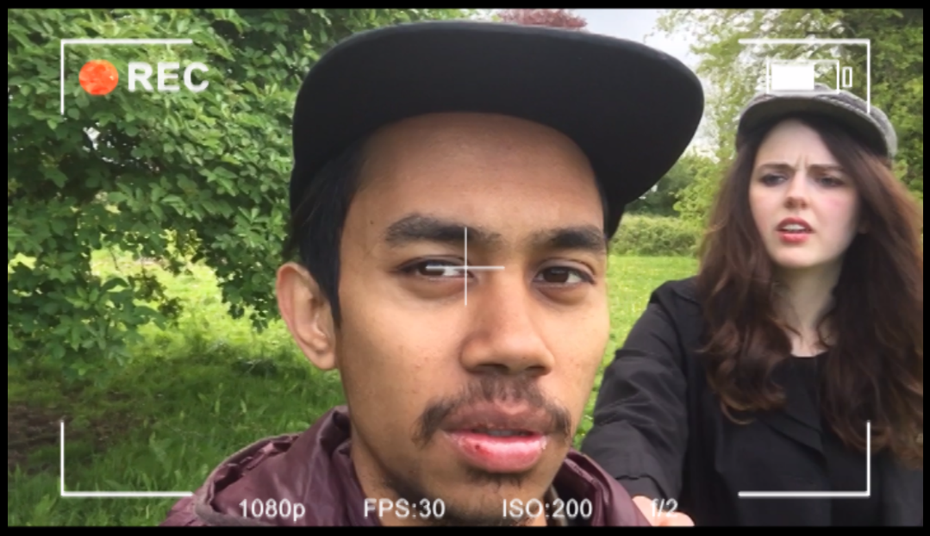

Editing Phase
After the filming part was over, I went straight into the editing phase. To be honest, I thought that the hardest part was behind me, but then I started editing the film. By utilising the Adobe Premiere Pro as my main software for editing my film, one of the first problem that I encountered was choosing the best clip from each scene. I had watch through all the recordings that I took and consider the lighting, audio, acting and the overall quality of each clip before I can start choosing which clips will make it into the film. Besides that, not every clip is perfect in terms of its visual and audio quality. For example, some of my clips have good lighting and visuals but the background noise is noisy that it overpowers the casts’ voices. Hence, I had to cut and merge two or more takes together to get a better overall quality for that particular scene while keeping an eye on the flow of the scene. After chopping, mixing and selecting the clips for the film and arranging them on the timeline, I started to put in all the necessary effects to make my found-footage film look as real and natural as possible. With the help of my supervisor, Mr. Aggersberg, I started out by adding in an adjustment layer which consist of a red dot, the letters “REC”, the timecode and the date to give the film a found-footage or vhs-esque feel.

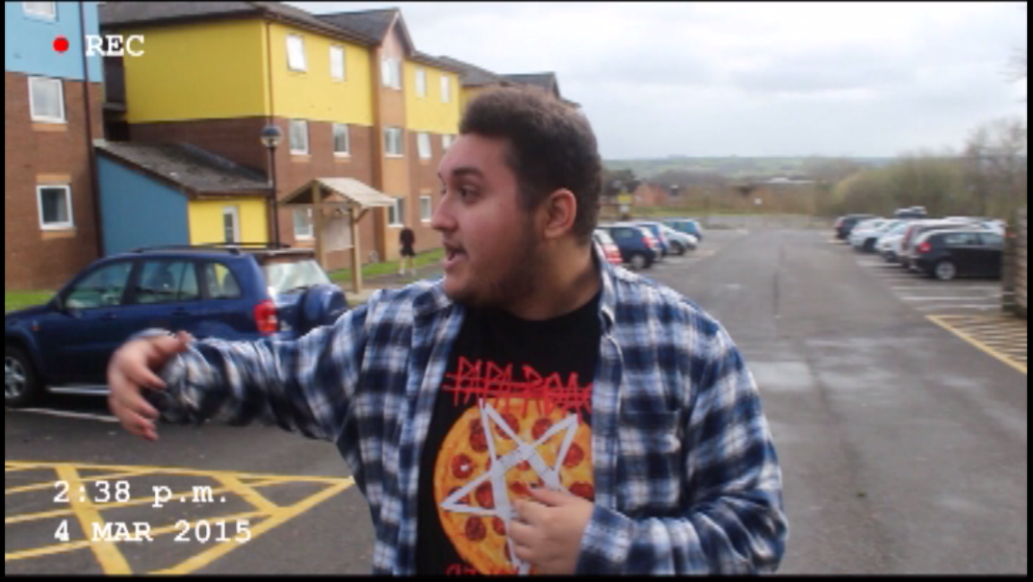
After that, I added in visual glitches as I wanted to have glitches visible whenever the character Ellen is around to signify that she is a from the supernatural world and that she has some sort of supernatural energy that causes disruptions in digital devices, in this case, the camera, to have glitches on its screen every time Ellen is in the shot or just by her being present in the area. In addition to that, the glitches become more intense as Ellen gets closer to the camera. The glitches that are seen in the film are made of two layers. The first layer is a glitch effect overlay that I downloaded from YouTube. However, since that video is only a minute long and the intensity of the glitches fluctuates throughout the video, I had to cut the video to separate the intense glitches from the mild glitches. These two glitches were then arranged on the same timeline according to their intensity whenever Ellen is around. With that being said, the intense glitches are seen when Ellen is in close proximity with the camera whereas the mild glitches are seen when Ellen is around the area but is not in the shot or extremely close to the camera. However, one layer of glitches doesn’t seem to do the film justice. That’s where the second layer of glitches comes in. The second layer are glitches that I created manually on Premiere Pro. These glitches are more visible and intense compared to first layer. So, whenever Ellen is in the shot or close to the camera, I added those albeit short but effective split-second glitches on top of the first layer of glitches.
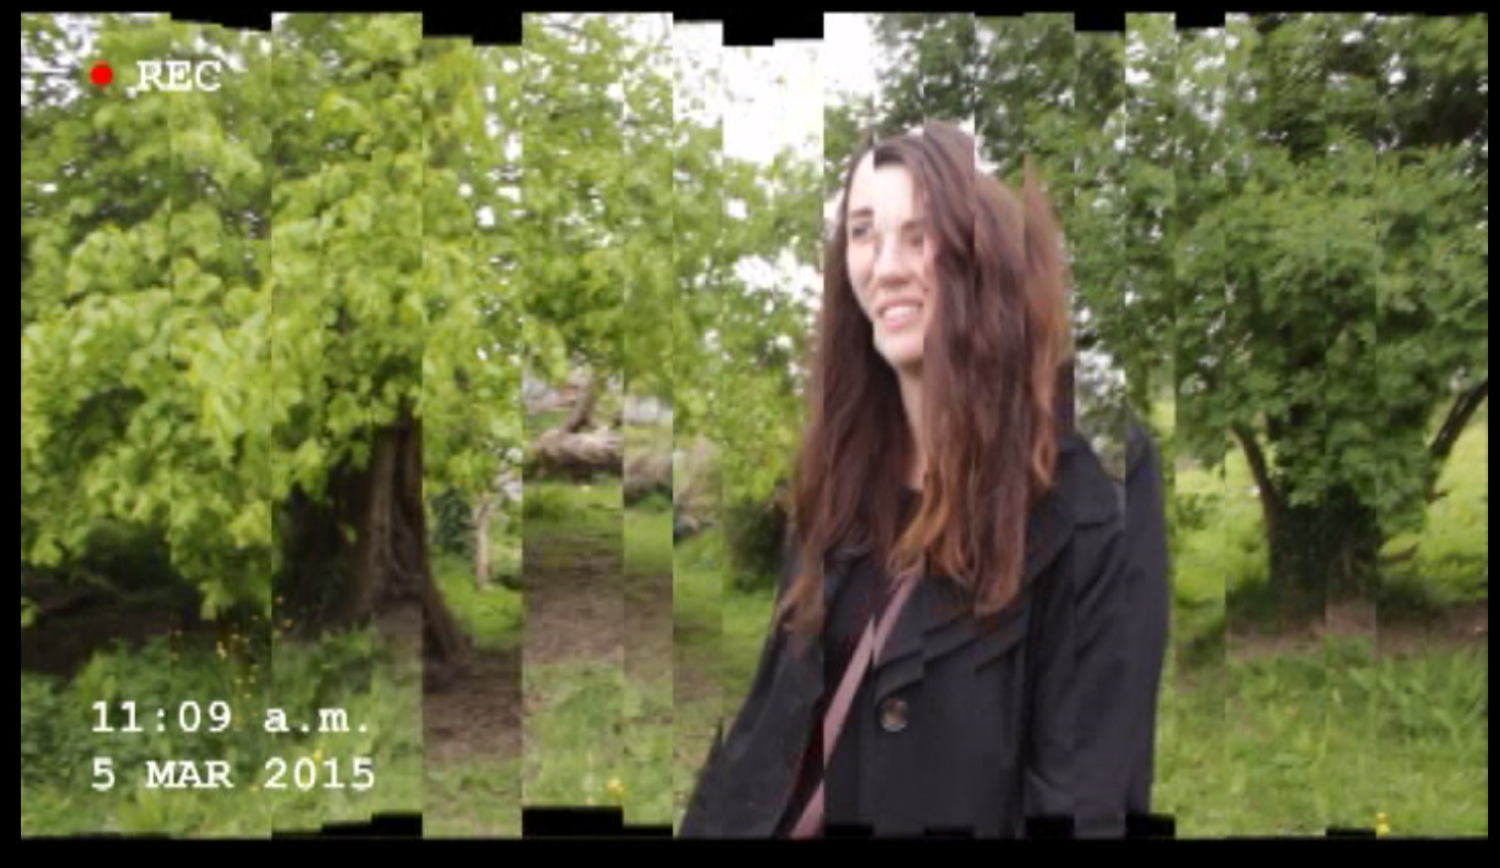
Next, as suggested by Mr. Aggersberg, I added in a whip pan transition that I learned from YouTube between scenes 9 and 10 to mimic a supernatural teleportation from one place to another. Then, immediately after the “teleportation”, I started to add sound effects for the first time in the film. After conducting a trial and error on choosing the audio for Scene 10, I finally narrowed it down to two scary wind sound effects, thunders, one “The Shining” type of creepy music and one intense piece of music that I picked purposely from The Dark Knight.

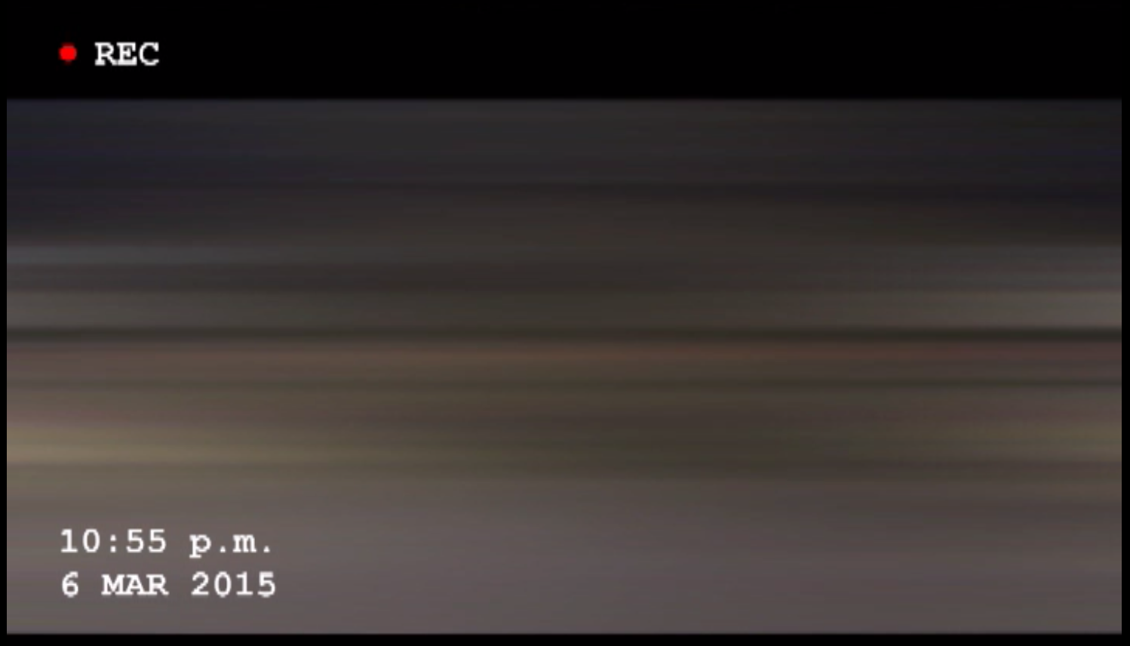

Next, the newspaper clipping scene was an idea that I had thought off quite early during the film development phase. Then, my other supervisor, Mr. Jones gave me an idea of doing a zoom out that starts of with Ellen’s face and ends with the newspaper headlines a la The Shining. Hence, I downloaded a picture from MacKenzie’s Facebook (with her permission) and edited it on a newspaper by learning the editing technique from YouTube. That’s when I got the idea of using an old song to create a disturbing and intense vibe as the newspaper clipping zooms out. The song that I chose was At Last by Etta James. It is one of my favourite jazz songs and I think some of the lyrics do relate to Ellen.
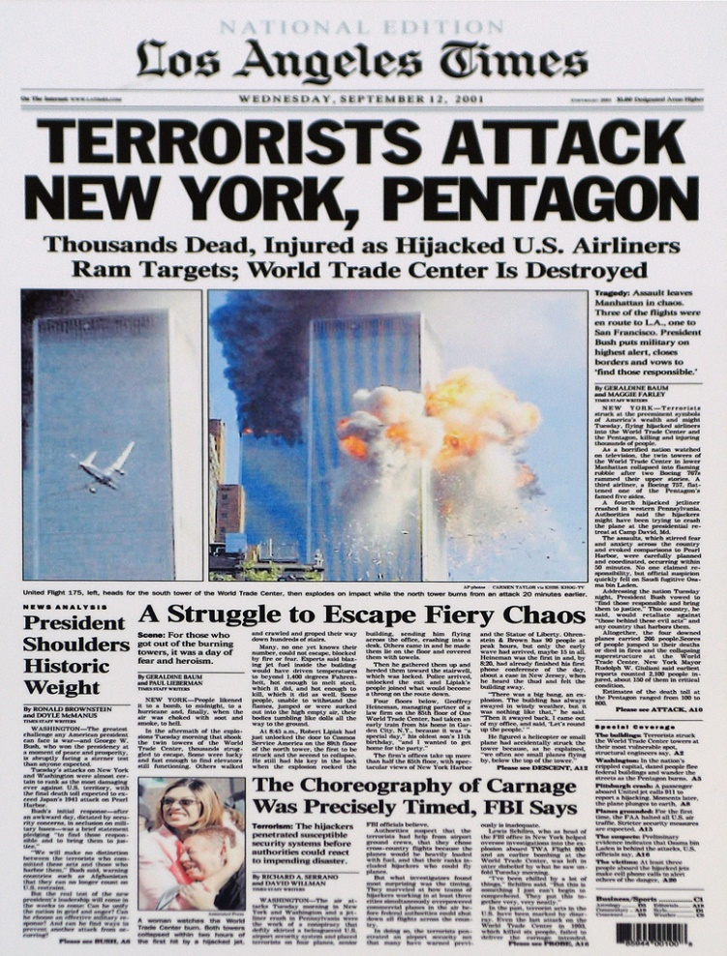
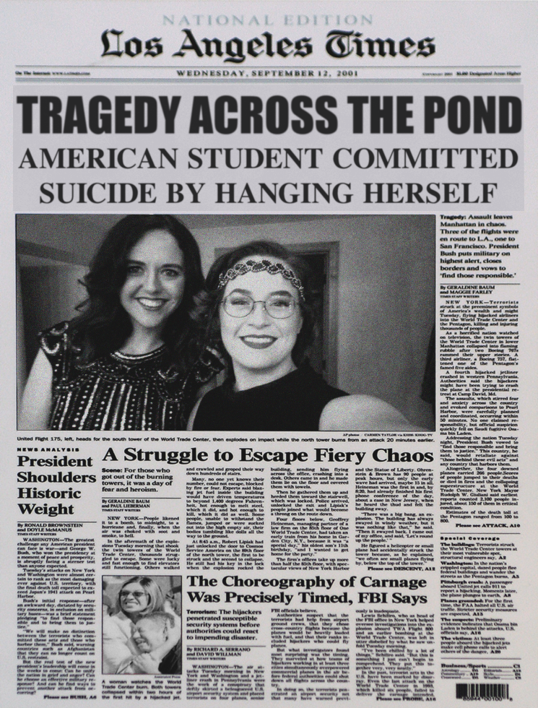
For the credits, I was having a hard time deciding between a still or rolling end credit scene. Finally, I opted for a traditional white letter on black background and chose the still title. Honestly, I quite like the old-school look of it. The final visual effect that I added was a camera viewfinder digital overlay for Scene 11. The reason I chose that particular overlay is because it has a more modern look compared to the one Sam’s camera had on. This simply signifies that it is a different camera and Jett is the new victim.

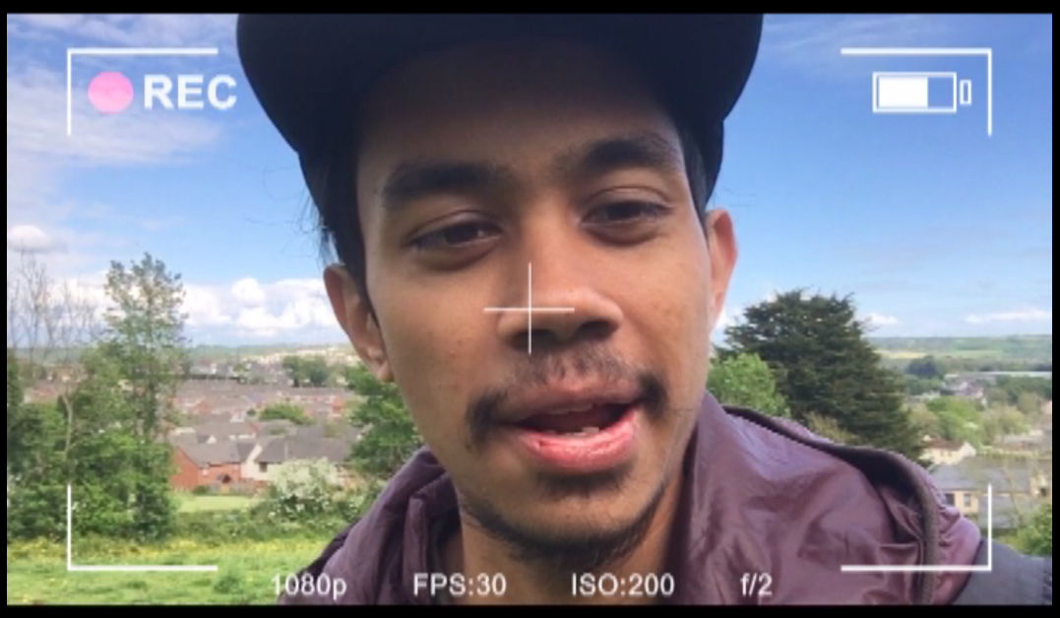

Editing was a fun part of the progress I would say. It takes a long time, but with these days’ technology, it makes editing so much easier and fun. YouTube has been really helpful to me as a learning tool as it teaches me all sorts of editing techniques that I used in my film.

Self-Thoughts
In conclusion, this filmed has been many things to me. It has been a teacher where I learn how to manage my time, face problems that I had never thought of before, work with other people, be independent and of course, to be a better scriptwriter and director. I think I have identified my weaknesses and also practised my strengths. It has been wonderful roller coaster ride working on this piece of work for four months that I could confidently say that making The Greenfield Tapes is one of the top five things that I am proud that I did it.

References
Music
https://www.youtube.com/watch?v=fo0G59aygu8
https://www.youtube.com/watch?v=S-cbOl96RFM
https://www.youtube.com/watch?v=1zyhQjJ5UgY
https://www.youtube.com/watch?v=BLWjkGpzBug

Movie Inspiration
Blair Witch Project
Project X
Chronicles
The Shining
Trollhunter

Editing techniques
https://www.youtube.com/watch?v=vxMzUiI-HLI
https://www.youtube.com/watch?v=IxtygoMRsR8
https://www.youtube.com/watch?v=uIgafwtozHE

Word count: 2850 words

