ACADEMIC AND EMPLOYABILITY SKILLS
SHAHBAZ ZAFAR
1814615
BMSK40001_LON
LLOYD BEHARRY

Table of Contents

Introduction 3
Section 1 3
Definition of Employability skills 3
Positive attitude 3
Communication 3
Self -management 4
Teamwork 4
Ability to learn 4
Decision making and problem-solving skill 4
Skill of resilience 4
Section 2 5
Communication skill 5
Listening 5
Speaking 6
Reading 6
Empathy 6
Observation 6
Figure 2: Communication Skill 7
Section 3 7
Skill of self-management 7
Self- Confidence 8
Stress management skill 8
Organisational skill 8
Self-motivation 8
Section 4 9
Team Work 9
Conclusion 9
Reference list 10
Appendix 1: Employability skills 11

Introduction
Academic skills possess great importance in increasing the chance of getting employed in various fields. The study focuses on to bring forth the importance of different academic skills such as communication skills, self-management skills which help an individual to increase the chance of employment in the real world outside during their future attempts. Communication plays an important role in helping individuals to bring effectiveness in conversation. With the help of organizational skill individuals learn to organize and manage themselves in an effective way. The aims and objectives of this study are to describe the importance of these skills in a detailed manner in order to help the reader to make an assessment regarding their importance of getting employment.

Section 1

Definition of Employability skills
The term employability skill refers to the skills of transferable nature which are necessary for individuals in order to create the chance of employability in an effective way. As opined by Collet et al. (2015, p.537), employers often set the outlines of different skills with stresses on effective subject knowledge and technical understanding which they expect from an employee. Different skills that employers are looking for from the part of their employee include: Refer to Appendix 1

Positive attitude
Possessing a positive attitude helps individual to express them as a prepared one in order to take on the challenge of any critical situation. It also helps the employer to assess the positive attitude of employee even the chances of winning are low in some critical aspects.

Communication
Effectiveness in communication helps individual to assess any problem in a suitable way. As opined by Messum et al. (2017, p.121), communication contains the power to convince others to turn any critical situation in favor. Communication also helps employees to understand different problem of their employee in an easy manner in order to increase productivity in the respective sectors to which they will be hired.

Self -management
The skill of self-management helps individual to acquire the skill of managing them in an effective way. The term denotes the management of you first so that any steps taken by them do not harm others or the organisation to which the individual will be hired. The skill of self-management improves the level of confidence and ability to tackle situation thereby increasing efficiency of individual effectively.

Teamwork
The importance of teamwork in organisational context cannot be ignored. Every organization tries to improve their training schedule in a way so that their employees understand the importance of teamwork and apply it to develop the efficiency scenario of the organisation. Employers always look for this ability within individual to handle team in an effective way so that they can explore the different skills of different worker to bring in efficiency in a group to improve the efficiency of an organisation.

Ability to learn
Learning ability in terms of willingness to learn plays a crucial role in development of employability skill. Employer always looks forward to exploring the willingness of employee in terms of learning new things. Learning ability helps individual to learn new things in quick succession and take part in the development activities organised by the organisation to which they are opting to get hired.

Decision making and problem-solving skill
Employers of any organisation strive to explore the decision making skill within individual that can help them to take any courageous decision in order to solve critical problems during crisis period. As opined by Suleman (2016, p.172), development of problem-solving ability help individual to take effective decision that helps them to gain confidence in handling critical situation effectively.

Skill of resilience
Resilience skill helps individual to be flexible and improve their ability to adopt change in different situational context. Employers look for this resilience skill so that the employee can take effective decision with the course of time in order to bring in changes within the organisational structure to improve its productivity.
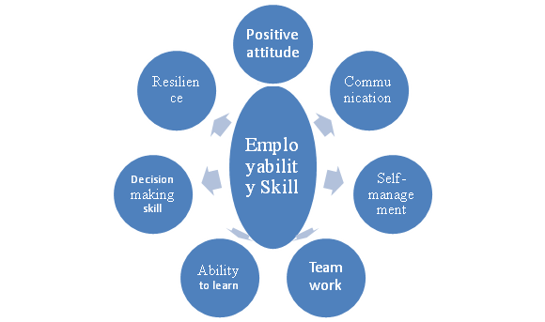
Figure 1: Employability Skill
(Source: as influenced by Messum et al. 2017, p.122).

Section 2

Communication skill
Communication skill refers to the ability which is used by individual while receiving and providing various kinds of information. As opined by Sumanasiri (2015, p.82), the skills of communication include some aspects such as speaking, listening, empathising, reading and observing. The skill of communication also helps individual to understand the differences in face-to-face communication, interaction through telephonic conversation and communication through digital platforms.

Listening
Improvement in listening ability helps individual to assess thing in a better way and communicate according to the process. As opined by Jackson (2015, p.357), active listening refers to the ability to pay attention to closed nature to the person who is having a conversation from the opposite end. People who listen in an active manner are always regarded well by employers or co-workers because they pay attention and shows respect to others while having conversation. As listening ability helps person to assess things better, it helps the individual to communicate well with others in analysing situation in an effective way.

Speaking
Ability to speak well is an important part of having good communication skill. Employers of different organisation look for this ability to speak well as this is the most important aspect that helps individual to interact with clients or employee in an effective way and analyse different problems in an easy manner.

Reading
Improvement in reading helps individual to build effective communication skill. Reading different thesis and work of projects also help individual to assess things better and improve the reliability of information that the person is going to use while communicating with others.

Empathy
The term empathy refers to the ability which helps individuals to share and understand the emotions of others. As opined by Cassidy (2016, p.511), this communication skill is important as this help individual to understand and analyse the emotion of others and act according to that basis in order to bring in changes indecision. Employers look forward this skill as this helps individual to assess situation better and take suitable decision that will be helpful to increase organisational performance.

Observation
The skill of observation helps individual build effective communication as this bring authenticity in delivering information while conversing with others. Effective observation helps people to make quick assessment of any critical situation and moderate their decision according to that (Edwards et al. 2015, p.351). Employers of any organisation tend to explore the observation skill from individual as this will help them to bring reliability in sharing information through effective communication with others.
Ways to improve Communication skill
Individual can improve their communication skill by possessing themselves attentive in every respect. Development of reading habits is another aspect through which individual can possess to improve this skill. Individuals can also improve this skill of communication by attending different workshops or classes in relation to communication. Making more exposure to outer world and creating scope of interaction can also improve the communication skill of the employee in an effective way (influenced by Edwards et al. 2015, p.351). As this skill is an important aspect to understand clients view in a better way, the development of communication skill will increase the chances of employment of individual in their future endeavors.

Figure 2: Communication Skill
(Source: as influenced by Jackson, 2015, p.352).

Section 3

Skill of self-management
Self-management skill defines the abilities to gain control over feelings, activities, and emotions in order to gain discipline in life. As Opined by Travers et al. (2015, p.230), self-management helps individual to learn the ability to manage things and situation and convert them to bring profitability in organizational context. It also helps individual to get the knowledge of time management which is an important aspect to get employment of an individual.

Self- Confidence
Employers always tend to explore the confidence level of the employee in order to handle difficult situation in an effective way. As opined by Jackson and Wilton (2016, p.272), individual with self-confidence can possess positive attitude to handle any difficult situation that can arise in an organisational context. High confidence level also helps employee to improve efficiency in performance of their job which is assigned to them.

Stress management skill
It is impossible to find a stress free work in this current competitive scenario of market. Stress management skill, therefore, plays a crucial part in handling job in any organisational context. Employers search this quality within the individual to take important decision in crisis period through the effective handling of stress. Development of this quality is an important aspect to ensure employment of an individual. Going to holidays and vacation and performing different hobbies related activities can help individual to manage stress in an effective way (influenced by Jackson and Wilton 2016, p.272).

Organisational skill
Building effective organisational skill is vital for any employee to manage different activities in specific time frame or schedule. Development of time management skill improves the skill of organisation management in an effective way. Employers look for this organisational skill within the individual as this can be helpful for them to manage different activities such as solving problems, completion of job within time managing employee with suitable and effective manner. Time management help employee to prioritize and set their goals, creation of effective time schedule, making lists of tasks, balancing leisure hours and working hours. It also helps employee to break task of large nature into a smaller one in order to complete job on time (Cohen, 2017, p.158).

Self-motivation
Self-motivation is the most powerful force that helps individual to drive oneself to do things in an effective way and achieve success in personal as well as in business perspective. It is an important aspect that the employers of different organisations are tending to look for. Employer judges the motivation level of individual as this can help them to accomplish their job in any difficult situation. In order to ensure employability, the development of this skill is necessary for this context.

Section 4

Team Work
The term teamwork refers to the collaborative effort of a group in order to achieve a common perspective or goal in the most efficient and effective way. As opined by García-Campayo et al. (2016, p.403), teamwork with the organizational framework helps individual to explore different abilities and make them utilize in their work to generate suitable output in terms of production. The section that effective teamwork helps to improve includes:

Conclusion
Thus it can be concluded that the study has given its importance to the different academic skills in order to enhance the chances of acceptance of individual to the employers of different organisations during their employment. In order to bring out the importance of communication skill, the skill of teamwork in employability structure the study has also stressed its light on the different aspect of employability skill in order to make reader aware regarding the importance of this skill in getting employment in this competitive world.

Reference list
Cassidy, S., (2016). Developing employability skills: Peer assessment in higher education. Education+ training, 48(7), pp.508-517.
Cohen, E., 2017. Employee training and development. In CSR for HR. Routledge: Abingdon.
Collet, C., Hine, D., and Du Plessis, K., (2015). Employability skills: perspectives from a knowledge-intensive industry. Education+ Training, 57(5), pp.532-559.
Edwards, A., Elwyn, G., Hood, K., Atwell, C., Robling, M., Houston, H., Kinnersley, P. and Russell, I., (2015) . Patient-based outcome results from a cluster randomized trial of shared decision making skill development and use of risk communication aids in general practice. Family practice, 21(4), pp.347-354.
García-Campayo, J., Puebla-Guedea, M., Herrera-Mercadal, P. and Daudén, E., 2016. Burnout syndrome and demotivation among health care personnel. managing stressful situations: the importance of teamwork. Actas Dermo-Sifiliográficas (English Edition), 107(5), pp.400-406.
Jackson, D. and Wilton, N., 2016. Developing career management competencies among undergraduates and the role of work-integrated learning. Teaching in Higher Education, 21(3), pp.266-286.
Jackson, D., (2015). Employability skill development in work-integrated learning: Barriers and best practice. Studies in Higher Education, 40(2), pp.350-367.
Messum, D., Wilkes, L., Peters, C. and Jackson, D., (2017). Senior Managers' and Recent Graduates' Perceptions of Employability Skills for Health Services Management. Asia-Pacific Journal of Cooperative Education, 18(2), pp.115-128.
Suleman, F., 2016. Employability skills of higher education graduates: Little consensus on a much-discussed subject. Procedia-Social and Behavioral Sciences, 228, pp.169-174.
Sumanasiri, E.G.T., Yajid, M.S.A. and Khatibi, A., (2015). Review of literature on graduate employability. Journal of Studies in Education, 5(3), pp.75-88.
Travers, C.J., Morisano, D. and Locke, E.A., (2015). Self‐reflection, growth goals, and academic outcomes: A qualitative study. British Journal of Educational Psychology, 85(2), pp.224-241.

Appendix 1: Employability skills

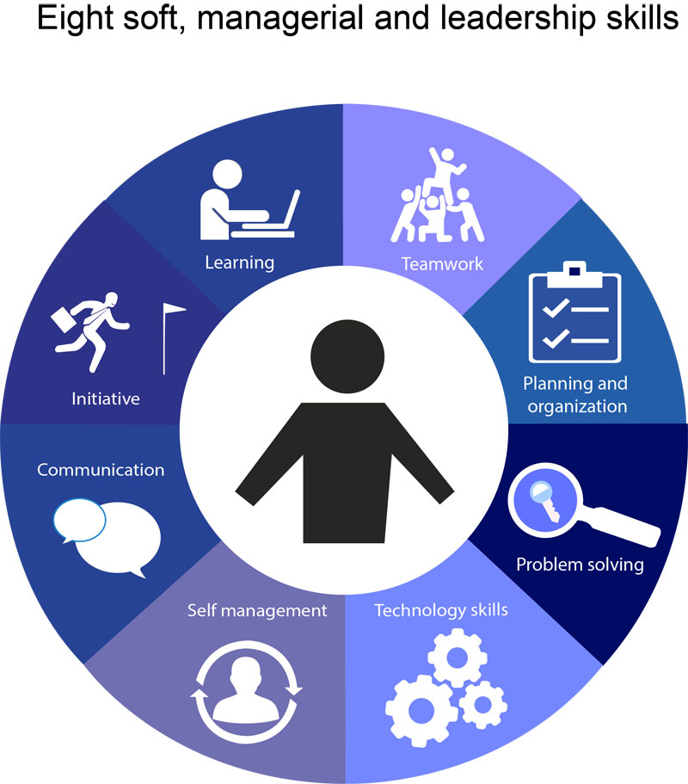
(Source: https://www.livewireindia.com/employment_proficiency_program_training.php)

