Effective Team Working and Communication

Student Name:Iuliana Tender(1912282)
Module Title:Effective Team Working and Communication
Assigment Title:Certificat of Higher Education in Skills for the Workplace
Module Lecturer:Akinseye Aluko
Executive Summary
The report contains a short study on teamwork and communication and how it helps in an organization. A brief discussion of communication, teamwork, types of communication, and its use in the workplace is contained in the report. Theories of communication and teamwork models are elaborated. How communication is important and added with teamwork brings productivity and growth are depicted through the report.

Table of Contents
Effective Team Work and Communication 1
Introduction 4
Discussion 4
Communication 4
Types of communication 6
Barriers in communication 9
Helical Model of Communication 10
Teamwork 11
Characteristics of effective teamwork 11
The Hackman Model of Team Effectiveness 12
Conclusion 13
Reference 14

Introduction
Communication is an important essence of life and all living organisms existing on earth have their means of communication through sound, speech, bodily movements, or visual changes. In this report characteristic of effective communication, types of communication, its importance in the workplace along disturbances in its process id discussed. The study is done to identify the communication skill and their importance in teamwork. The difference between two people based on their attitude, gesture body language, and gesture is observed through communication skills. In an organization, the relationship among the employees and with the co-workers in a team plays a crucial role which impacts the functioning of that particular company. Cultivation and practice of teamwork through efficient communication boost the employees and encourages them to work in a healthy environment. This further fosters innovative ideas leading the organizational success. Administrative bodies should hire people by checking their communication skill and make teams of people with complementary skills to ensure smooth operational functions in the organization. Good communication with colleagues keeps the mind fresh, improving work productivity.

Discussion

Communication
Communication is the exchange of thoughts, knowledge, or information to fulfill the purpose of the conversation in the best possible manner (Samovar et al., 2017). It is the two-way street where ideas are communicated among parties in a way that the receiver comprehends the message represented by the sender. Effective communication ensures the idea or speech to be simple and decidable by the receiver, and just delivery of the message is not enough.
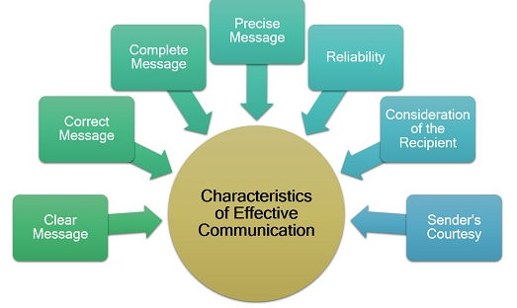
Fig: Representing characteristics of effective communication
Source: Created by the student
The elements that make effective communication are represented in figure and discussed below.
- Message clarity: the message sent by the sender must be systematically framed to retain its meaningfulness and easily understandable
- Correct Message: communicated information must be free of errors, grammatically or others, and should not provide a vague or false sense
- Coherent: The sender and receiver should understand what goes out and what comes in or the purpose of the message will go in vain. Coherent communication is logical. Sequential and well-planned.
- Completeness of Message: incomplete information may mislead the delivered message leading to wrong decision making
- Precise Message and consistency: straight forward communication with precise and short messages helps in taking a better decision
- Reliability: the sender must ensure conveying correct message and receiver must rely on the message and sender
- Consideration of the recipient: for smooth communication along with physical setting, language, knowledge, position, and education level of the receiver should be checked.
- Sender’s courtesy: the reflection of the sender's humbleness, courtesy, and respect must show up in the drafted message.
Scientific study has depicted communication by dividing it into
Communication studies-that involves human communication
Information theory – communication-related to the storage, quantification, etc.
Bio semiotics – communication between and in living beings or organisms
Importance of communication in the workplace
Commutation is not an easy task, but is worth it when comes to its requirement in the workplace, as it is an integral part of the workplace and needs to be practiced more.
Significance of good communication are:
- Employees can openly share their ideas without fear of outrage
- Increases the work satisfaction level by increasing their engagement in work
- Builds a skilled and productive team for the company
- Promotes the team spirit and increase the self-esteem of workers
- Builds a place for workers to think creatively and helps in innovation
- Disputes and ambiguities are eliminated quickly
- Easy to build and manage a team having the same goal leads to foster organizational growth
- Transparency and trust of workers is ascertained
- Develops a healthy workplace culture with stronger employees relations

Types of communication
The different types of communication are discussed below to enhance and present conscious, focused, and effective communication.
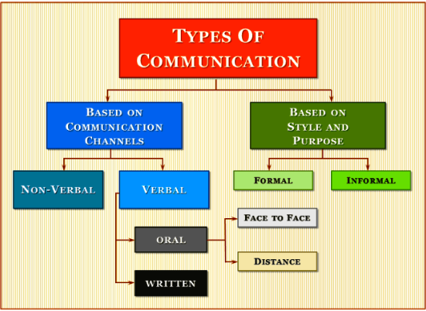
Fig: Types of Communication
Source: https://www.educba.com/types-of-communication/
Formal communication
Communication carried on for official purposes which also include the gamut of verbal expression in need of formal communication. Formal communication is the core of professional life and is a much slower process of interaction. It can be backed by a written part and is considered a reliable source of information (Polat et al., 2018). Communication takes place through predetermined channels.
Informal communication
It is a popular form of communication and is often referred to as grapevine. It is unofficial communication where information is spread by word-of-mouth. Informal communication does not follow any structure or protocol and is spontaneous and free-flowing so not considered as a reliable source (Allen, 2016). It is a user friendly and advantageous type of communication known so far.
Oral Communication (face-to-face)
Face-to-face oral communication is the expression of the idea directly to speech and is the most recognized form of interaction that can be carried on both formally and informally (Vogel et al., 2018). Oral communication gets better with awareness and practice that helps in controlling the oral expressions. It is an engaging form of interaction and is a vibrantly live with present moment tuning, revoking, and revising of expressions.
Oral Communication (distance)
The communication is done in mobiles, VOIP, 2-way webinars, and video conferencing has made us think the world to be a smaller place. Voice tone and the delivery place is given utmost priority in this form of communication. This type of communication can be both informal and formal giving more priority to listening. A little slower pace of speaking makes the conversation smooth and has a portion to re-iterate whenever required. This misses non-verbal communication to some extent but backs written communication.
Written Communication
Written communication was a form practiced decades ago to persons at a distant place. Occasionally informal, this communication was also seen in formal cases like a notice from the bank, legal notice, or notice from the business client. The form of written communication has now changed to take replacement in the form of emails, blogs, etc. Informal communication does not have structure but has the basic structure for formal ones includes an introduction, agenda, message body, and conclusion, with clarity in the message to be conveyed.
Non-Verbal communication
The subtle and most powerful means of communication includes physical posture and gesture, the pace of voice and tone, and the attitude of communication (Burgoon et al., 2016). In customer care service non-verbal communication has a greater role to play. For instance, if a problem occurs and the customer care executive assures the customer to resolve the matter with a smile, the body language of reassurance makes a difference.
Visual communication
Medicine industry has wide use of visual communication, as the representatives of the company show the new medicines to the doctors’ to get them prescribed, to make them confident to suggest it to the patients. Visual communication elements are design, advertisement, presentation, topography, and many more.
Listening
The most important aspect of communication is the act of listening although it does not take place in the list of communication. Any work is impossible if the other party does not listen, and engagement in a discussion needs this aspect the most.
To summarise, formal, verbal, and non-verbal, written, and visual communication are used by the team, while informal, informal written, along with verbal and non-verbal communication are used by a group of people.

Barriers in communication
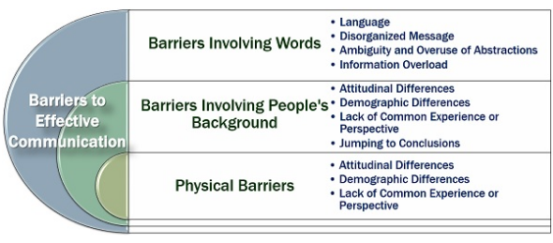
Fig: Barriers to effective communication
Source: https://theinvestorsbook.com/effective-communication.html
Hindrances or obstacles in the communication process or channel make it troublesome for both the sender as well as the receiver as words play a vital role in the communication process, disturbance in the way of presentation of the message leads to miscommunication further leading to organizational failure. Barriers can be categorized into various types that involve words barrier, physical barriers, and barriers from people's backgrounds. In the case of words, language, overuse of abstraction, or notation, the unorganized message loses the efficiency of the information. Employees interested in pursuing other than the company's target slows the rate of organizational success. Information overload also exhausts the receiver which the management team in an organization needs to handle. Again, demographic differences, attitudinal, or lack of common experience and jumping into conclusions quickly are the problems faced by people's backgrounds. Physical disability of people, noise, and physical distance are the barriers arising from physical mediums that do not let many employees think of them as an integral part of the company, thus shows little interest in achieving its goals.

Helical Model of Communication
The communication model is designed by Frank Dance in the year 1967, is represented by a smooth spring-like curve going upwards and coming down, similar to simple helix structure, depicting a non-linear and dynamic process of communication.

Child (Day 1) communication evolves
↓
Communication continues
↓ ↑
(Communication depends on past activities)
↓
(Current day) communication continues with modifications

Fig: Helical Communication Model
Source: https://www.managementstudyguide.com/helical-model-of-communication.htm)
Frank Dance's model uses the form of a helix to emphasize the communication difficulty as he has built the model like the structure of helix growing bigger on moving upwards. Communication in helical structure is compared with the evolution of the human communication process, dated from before birth to the present day, having a broader perspective. All actions that a human takes from day 1 till the present moment are considered to influence and build a person's communication sphere. Accumulation of all such activities is done to find the link to its influence from the past. Comparing with human life, from birth communication moves forward, but at some time it also moves backward due to memories, and eliminating the errors finally results in effective future communication. Crying of a baby is the first form of interaction, to know about the baby's health. Next, the baby cries for food or sleep, learns words, language, and much more. The acquired knowledge is applied to practice linking with past views. Thus cry is spiral at the bottom and complicates and widens growing upwards with the age of the individual. Similarly, the Helix model can be used in educational institutions to promote the knowledge-based growth of the economy with innovation. It creates a linear relation between entrepreneur and academic circle, develops communication and information technology that helps in building the societal and national infrastructure.
It is a simple model recognizing both sender and receiver making it as two ways model that includes intelligence, experience, and language in it. But being so simple and new model critics call it abstract as variables can't be separated and communication does not aim growth all the time.

Teamwork
A team is a group of a small number of people having complementary skills and are all committed to a common goal and approach to attain it, holding themselves mutually accountable. Effective teamwork along with proper leadership competency brings success to any size of the organization.

Characteristics of effective teamwork
Some of the features of teamwork are clear direction towards the target coupled with open and honest communication of the team by listening and conversation. The spirit of collaboration, "None of us are smart as all of us" by Ken Blanchard with well-defined roles and supporting of change and risk raking is crucial. Trust among members, encouraging efficient ideas and difference in decision making makes a fun-loving team to work together.

The Hackman Model of Team Effectiveness
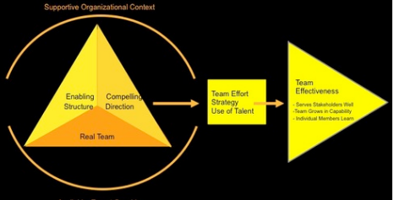
Fig Hackman Model
Source: https://www.wrike.com/blog/6-different-team-effectiveness-models/
Author J. Richard Hackman proposed the model which includes 5 conditions to increase the probability of team effectiveness (Verhoeven et al., 2017). The 5 necessary conditions are
1) Being a real team
2) Setting a clear challenging goal
3) Having a structure to organize and conduct work
4) A team receives adequate support of resources
5) Expert guidance makes the best team, as recognized by the US intelligence community.
Communication among members of the team is an essential eve to achieve the best performance from a team. The team must be lead by a potential leader who will be able to drive the team towards the same target. Discipline within the team is important which can again be achieved by a form of communication that is listening. Organized teams with a set target guided by the right leader improve the work productivity and encourage the team to complete a task. Communication helps in resolving the differences in the ideas and thoughts of the team members and encourages an environment where employees will suggest new ideas without fear of outrage.

Conclusion
The report above conclusion can be drawn that a team with effective communication performs effective teamwork, and achieves better organizational success. Communication depicted by Helical Model works as an influence in teamwork. Eliminating the barriers in the communication process and by adopting theories of teamwork the work is analyzed. The high performance of a lot of teams lies in the mysterious mixture of group dynamics, support form organization along with individual perspective. The models help in identifying the lack of scientific elements to boost the overall effectiveness. A powerful team with good ethics smoothed organizational success by increasing team productivity and output rate.

Reference
Allen, M., 2016. Transformational Organizational Change, Reinforcing Structures, and Formal Communication. In Strategic Communication for Sustainable Organizations (pp. 139-188). Springer, Cham.
Polat, V., Lynn, G., Akgün, A.E. and Onat, O.E., 2018. Formal and informal communication in new product development teams: the mediation effect of team trust. International Journal of Innovation: IJI Journal, 6(2), pp.97-111.
Samovar, L.A., Porter, R.E., McDaniel, E.R. and Roy, C.S., 2017. Communication between cultures. Nelson Education.
Verhoeven, D., Cooper, T., Flynn, M. and Shuffler, M.L., 2017. Transnational team effectiveness. The Wiley Blackwell Handbook of the Psychology of Team Working and Collaborative Processes, pp.73-101.
Vogel, D., Meyer, M. and Harendza, S., 2018. Verbal and non-verbal communication skills including empathy during history taking of undergraduate medical students. BMC medical education, 18(1), p.157.

