


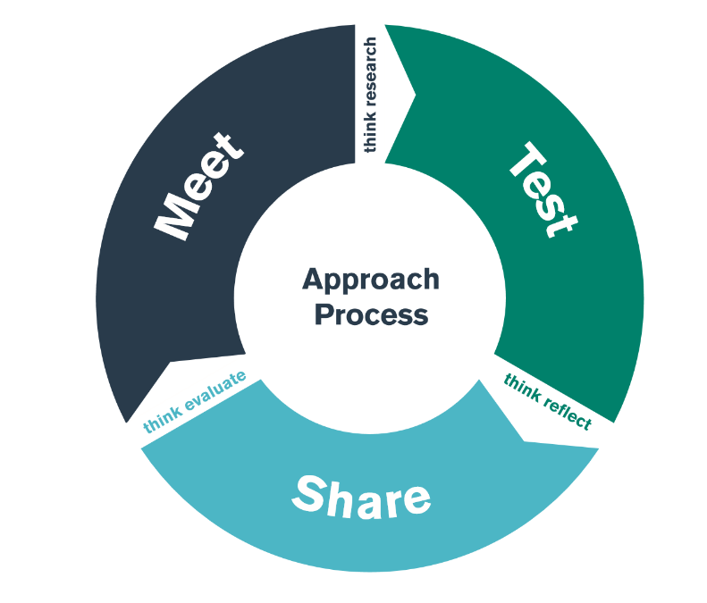

Cognitive & Physical Development
TEST Day

Student-Teacher Enquiry Evidence Record

‘Approaches in Action’

14th October 2026

What is the purpose of the bridging activity?

By the end of the TEST day, you should have an understanding of some of the strategies, policies and approaches that the school use to ensure the cognitive and physical development of their learners.

What are some of the key principles the school adhearse to when addressing teaching and learning?

Which policies include children’s cognitive developmet as a focus? (Teaching and learning policy?)

What does/ do the policy/cies state?

Are there any links between the school’s behaviour policy and a Behaviourist approach? If so, discuss these below:

How is the importance of children’s Learning evident throughout the school/ class? (eg displays, assemblies)

How are children rewarded for their Learning/ cognitive development?

What do the staff do to create a classroom climate that promotes their children’s desire to learn?

How does the physical environment of the classroom promote children’s learning and cognitive development? Are there specific resources that aid this?

What strategies do staff utilise to support children who are finding a task challenging?

How do staff enable children to understand how well they are doing in their learning?

From classroom observation, can you describe a learning experience where an ADULT performed the role of ‘More Knowledgeable Other’ (MKO) and a learner was able to do then something that they couldn’t previously do?

From classroom observation, can you describe a learning experience where a CHILD performed the role of ‘More Knowledgeable Other’ (MKO) and another learner was able to do then something that they couldn’t previously do?

Did you observe any of the following approaches in the school environment?

Activity/ Strategy | Description | Your personal reflection
Independent work

A learner working on their own to complete a task

Collaborative ‘Paired’ work

Two learners working together to complete a task

Collaborative ‘Group’ work

Three or more learners working together to complete a task

Repetition

Learners engaging in ‘repetition’ to aid memeory

Peer teaching

One child teaches another

Active Learning

Children taking an active role within the learning experience, including thinking.

Pupil Choice

Children selecting what they want to learn/ how they want to learn etc

Have you observed any further examples of constructivist, behaviourist or humanist approaches to teaching?

Did you notice any children displaying of the main characteristics of the ‘Preoperational stage’ of cognitive development?

Symbolic play  (Using object to represent something else ) | Egocentrism  (Unable to see another’s view) | Using Symbols  (Using words and pictures to represent objects) | Role Play  (Pretending to be somebody else – Mum/ Dad/ Policeman etc) | Conservation  (Understnding when obects associated with capacity, weight, length, number etc remain constant)
Concrete Thinking  (Only thinking about what is physically in their environment and taking things literally) | Not using Logic  (Driving an activity with emotion not with clear sense or reasoning) | Reflections

During observation, did you see a learner develop their understanding of something by ‘adding new’ information (assimilation) to their existing of ‘categories of knowledge’ (schemas)?

During observation, did you see a learner change their understanding or alter their ideas (accomodation) in light on new information?

‘Focus on Physicality’

During classroom and playtime observations, note aspects of interest in the following areas:
Observation Sheet  Physical Development | Fine Motor Skills  Fasten clothes or dress/Use tools - instruments/Access containers/Open doors etc./Making marks-writing/Using IT/Shows hand preference/Pouring liquids with no spilling/Uses clay with control | Gross Motor Skills  Crawling/Walking/Running/ Skipping/Leaping/Jumping-landing/Balancing/Sending receiving balls/Lifting carrying placing/cycling/pushing-pulling | Resources  Toys/Equipment/objects/ Spaces/Places | Environment  Purpose/Access/Safety/ Motivation/Supervision / Atmosphere
Nursery
(3-4yrs)

Reception
(4-5yrs)

Year 1
(5-6yrs)

Year 2
(6-7yrs)

What are some of the ‘whole school approaches’ utilised to aid the physical development of pupils?

How does the school promote children’s understanding that regular exercise improves health and fitness?

What do the staff do to create a classroom climate that promotes their children’s physical skills?

How do staff develop children’s ability to use/manipulate small and large object and resources?

IF POSSIBLE / APPROPRIATE observe children during a ‘physical’ activity. This may be a whole class gymnastics session in the hall, a dance lesson, a games activity in the outdoors etc.

Context:

Focus | Observations | Role of the adult + Strategies utilised to aid development
How well do the children control their bodies when rolling, jumping, running, etc.?

How do the children respond to different sounds?

Do the children demonstrate an understanding of spatial awareness?

Are the children able to use the space that is around, behind, underneath, below, over and under, on top of and away from them?

Can children adjust their speed show fast/slow movements or strong/light movements, and stop suddenly?

Can children adjust their direction and show high/low movements ?

How are the children’s balancing skills developing?

Observe a group of children engaing in a task. Has the children’s coordination improved during the activity? Do they have increased control over their bodies?

Are children involved in physical activities that allow them to work as individuals, with a partner and in small groups, sharing ideas and helping each other to improve? Give examples.

What strategies do staff employ that support children’s ‘adventurous’ play?

Explore the learning environment, what resources are available to support children’s physical development?

Describe two physical activities. One that occurred in the indoor environment and one that occurred in the outdoor environment.

Reflect on your observations, comment on the children’s development of coordination, gross motor skills, fine manipulative skills, confidence, sensory awareness, role of the adult and ability to use a range of tools and small and large equipment.

Description of the indoor environment  physical activity | Description of the outdoor environment  physical activity
Reflection | Reflection

