University of Wales Trinity Saint David
Wales Institute of Science and Art


Electronic Circuits Testing and Applications

Electrical Control Systems ACHA4010

Catriona Burn
2203239
March 2024
Contents
1 Task 2 1
1.1 Scope Time Division Calculations (4) 1
1.2 Function Generator output sine wave (3) 1
1.3 Unsmoothed Rectifier Wave (3) 1
1.4 Smoothed Rectifier Wave with capacitor (3) 1
1.5 Drop in Voltage Question (4) 1
1.6 Different Voltage Readings Question (5) 1
1.7 Rectifiers use in Automotive applications Question. (4) 1
1.8 Probing Question (4) 1
2 Task 3 2
2.1 Scope Time Division Calculations (4) 2
2.2 Function Generator output square wave (3) 2
2.3 Capacitor charge and discharge wave marked at correct points. (3) 2
2.4 Basic Capacitor Calculations (3) 2
2.5 Capacitor discharge table (4) 2
2.6 Gradient Plot and calculations (4) 2
2.7 Capacitor Uses (5) 2
2.8 Inaccuracies Question (4) 2
3 References 3

[Figure 1] Sine wave 1
[Figure 2] Rectifier wave 1
[Figure 3] Rectifier wave with Capacitor 2
[Table 1] Voltage readings 3
[Figure 4] (All About Circuits, 2016) 3
[Figure 5] Function generator square wave 4
[Figure 6] Marked 63.2% of charge wave 5
[Figure 6] Marked 36.8% of discharge wave 5
[Table 2] Capacitor discharge 6
[Figure 7] Time against Log(V) graph 7

Task 2

Scope Time Division Calculations (4)
$$f=\frac{1}{Period} Period=\frac{1}{f}=\frac{1}{10}=0.1s$$

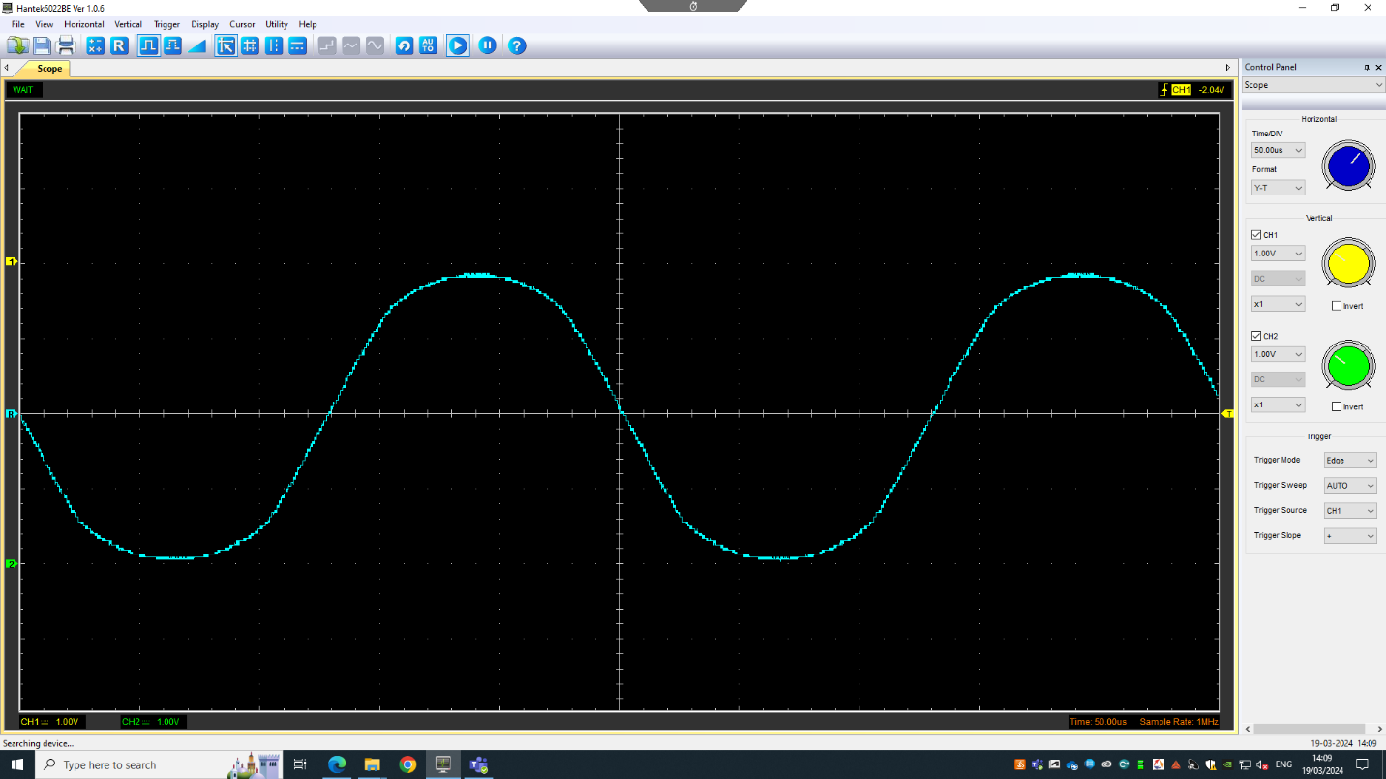
Function Generator output sine wave (3)
[Figure 1] Sine wave

Unsmoothed Rectifier Wave (3)
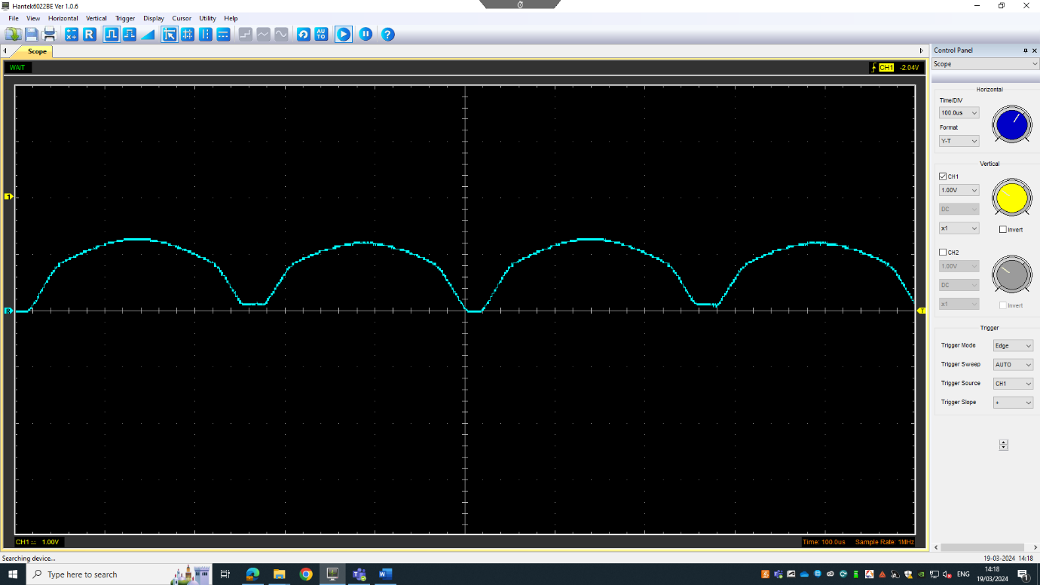
[Figure 2] Rectifier wave

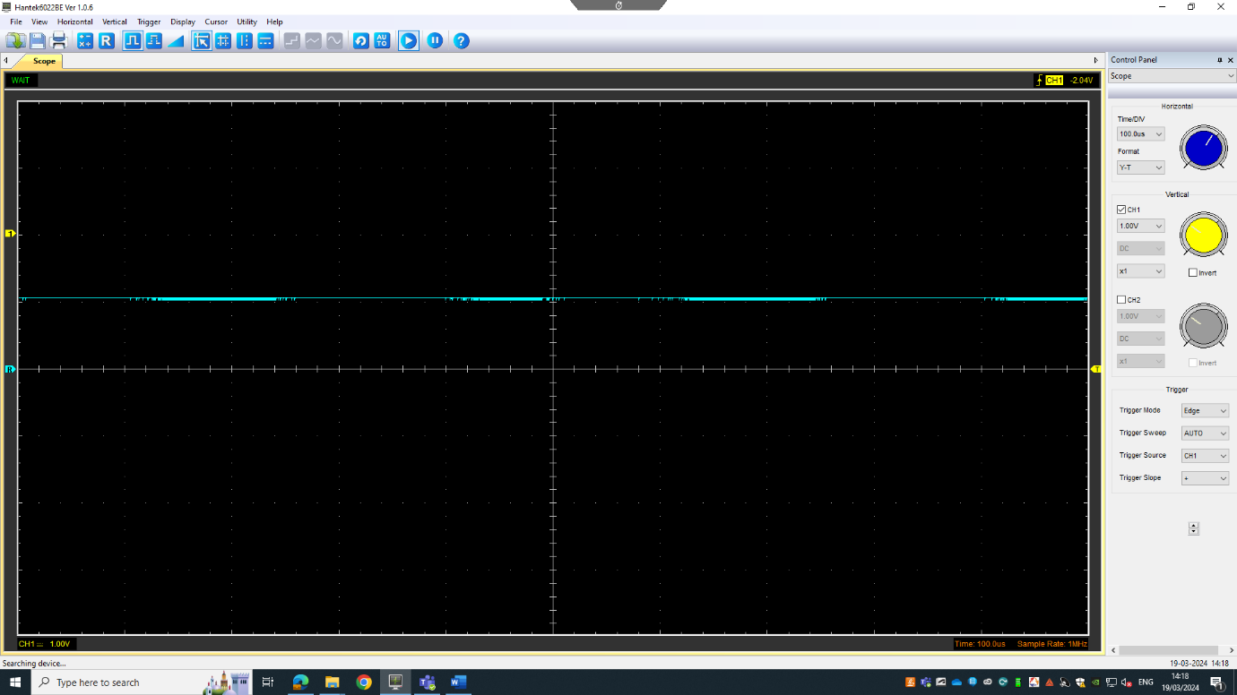
Smoothed Rectifier Wave with capacitor (3)
[Figure 3] Rectifier wave with Capacitor

Drop in Voltage Question (4)
There is a difference in the peaks of the sine wave and the unsmoothed rectifier wave. This voltage is lost throughout the circuit. It is lost due to resistance when passing through components. These components are the resistor and the diodes.

Different Voltage Readings Question (5)
Peak Voltage | Peak to peak Voltage | Root Mean Square Voltage
3.69V | 7.60V | 2.60922V
[Table 1] Voltage readings

Root mean square is the dc current that dissipates the same amount of power as the average power dissipated by ac current (Khan Academy, 2021). It is different because it is the average, not the maximum, so it will be lower than the peak voltage. Figure 3 below shows where Peak Voltage (V_{p}), Peak to peak voltage (V_{pp}) and root mean square voltage (V_{RMS}) are found on the wave.
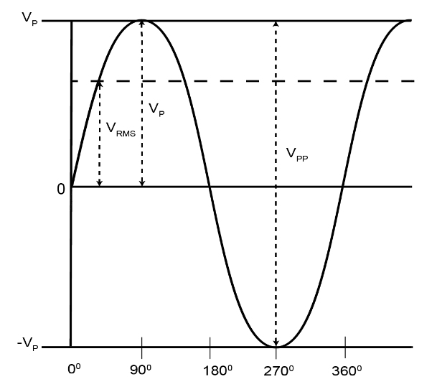

[Figure 4] (All About Circuits, 2016)

Rectifiers use in Automotive applications Question. (4)
A use of rectification in Automotive vehicles is in alternators. The rectifier converts an alternating current to a direct current for use in the battery or electrical system. The battery requires a rectifier because the dc current is used to charge it and without it, the battery would produce an ac current which would drain the charge (Fang et al., 2019).

Probing Question (4)
The function generator sends a signal through the circuit and back into the generator, producing the wave. The input and output signal cannot be obtained at the same time because the oscilloscope doesn’t have a connection that is common to both channels. This makes displaying both waveforms difficult because there is no common node to connect them to. To allow simultaneous probing, a scope with isolated input channels could be used. A downside to an isolated input channel is that there is likely to be more baseline noise on the reading due to radiation (Jain and Agarwal, 2007).

Task 3

Scope Time Division Calculations (4)
$$τ=R×C=10Ω×10μF=100μs$$
$$20τ=20×\left(100×{10}^{-6}\right)=2ms$$
$$f=\frac{1}{Period}=\frac{1}{2×{10}^{-3}}=500Hz$$

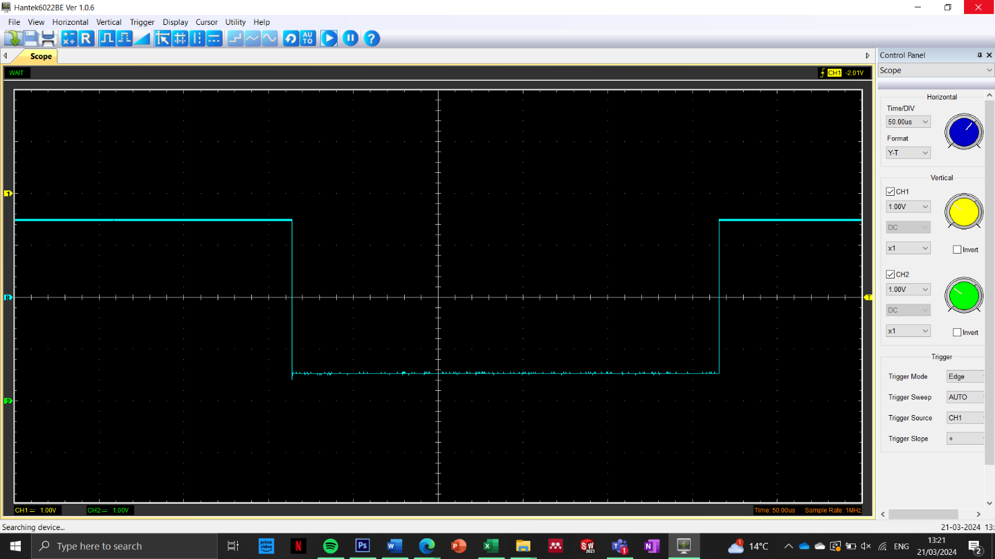
Function Generator output square wave (3)
[Figure 5] Function generator square wave

Capacitor charge and discharge wave marked at correct points. (3)
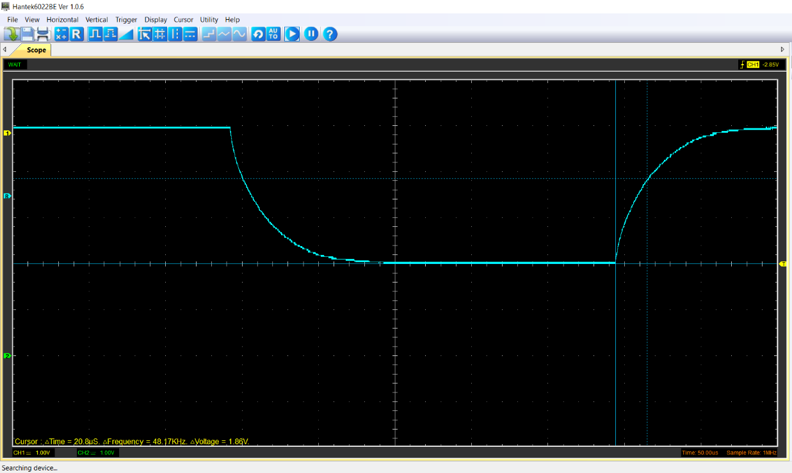
Charge: 63.2% of 2.94V = 1.86V
[Figure 6] Marked 63.2% of charge wave

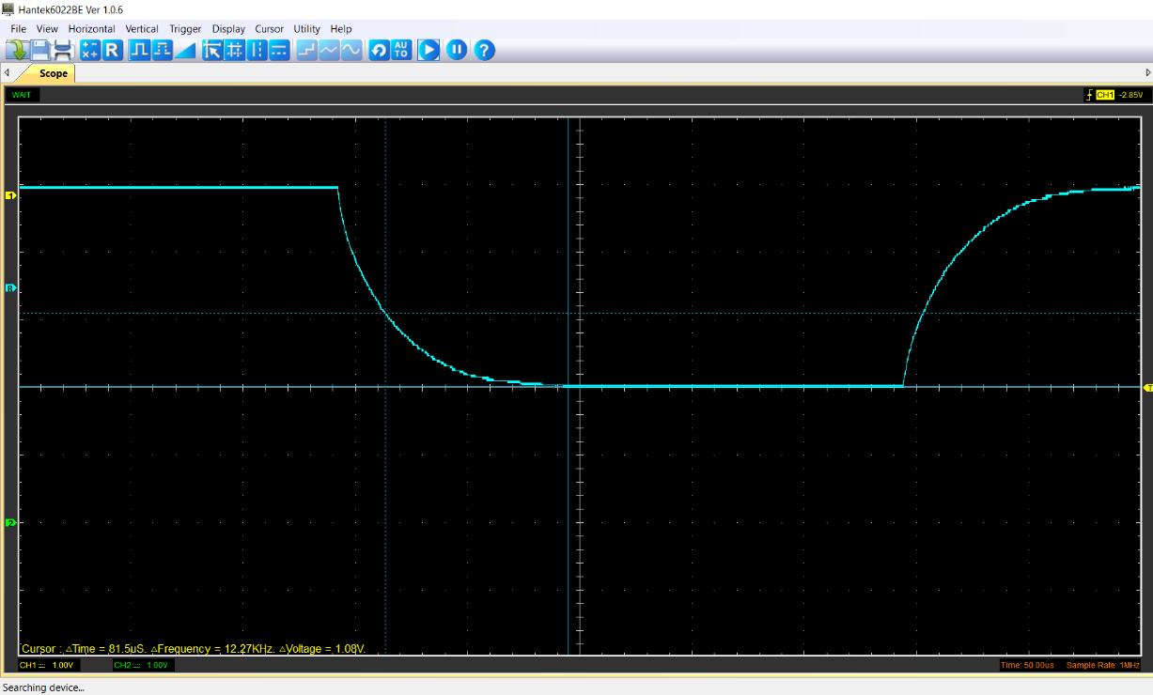
Discharge: 36.8% of 2.94V = 1.08V
[Figure 6] Marked 36.8% of discharge wave

Basic Capacitor Calculations (3)
Charge:
𝑃𝑒𝑎𝑘(𝑉) − 𝑆𝑡𝑎𝑟𝑡(𝑉) × 63.2% + 𝑆𝑡𝑎𝑟𝑡(𝑉) = 𝑉 𝑡𝑜𝑝 𝑐𝑢𝑟𝑠𝑜r
$$2.94-0 ×0.632+0=1.86V$$
Discharge:
𝑃𝑒𝑎𝑘(𝑉) − 𝑆𝑡𝑎𝑟𝑡(𝑉) × 36.8% + 𝑆𝑡𝑎𝑟𝑡(𝑉) = 𝑉 𝑡𝑜𝑝 𝑐𝑢𝑟𝑠𝑜r
$$2.94-0×0.368+0=1.08V$$

Capacitor discharge table (4)
Time (s) | Voltage (V) | ln (V) | dy = y2 – y1  dy = ln(V)2-ln(V)1 | dx = x2- x1  dx = Time2 – Time1 | dy/dx
0.002499 | 5.2353 | 1.655424149 | x | x | x
0.002665 | 5.0471 | 1.618813821 | -0.036610328 | 0.000166 | -220.5441467
0.002831 | 4.7961 | 1.567803088 | -0.051010733 | 0.000166 | -307.2935738
0.002997 | 4.6863 | 1.544643359 | -0.023159729 | 0.000166 | -139.5164406
0.003163 | 4.5294 | 1.51058948 | -0.034053878 | 0.000166 | -205.1438442
0.003329 | 4.451 | 1.49312879 | -0.01746069 | 0.000166 | -105.1848817
0.003495 | 4.3255 | 1.464527741 | -0.028601049 | 0.000166 | -172.2954783
0.003661 | 4.2784 | 1.453579108 | -0.010948633 | 0.000166 | -65.95561875
0.003827 | 4.1686 | 1.427580248 | -0.02599886 | 0.000166 | -156.619638
0.003993 | 4.1216 | 1.416241437 | -0.011338811 | 0.000166 | -68.30608758
[Table 2] Capacitor discharge

Gradient Plot and calculations (4)
[Figure 7] Time against Log(V) graph

Gradient = $τ$ =-160.0955233s
Resistance = 5100Ω
$$τ=R×C$$
$$C=\frac{τ}{R}=\frac{-160.0955233}{5100}=-0.031391279=-0.031F=-31mF$$

Capacitor Uses (5)
Some examples of capacitor uses in automotive or motorcycles are fuel pumps, automatic windows, air conditioning, windscreen wipers, regenerative braking systems, alternators, electronic control unit for battery controls (Castiglia et al., 2022). Film capacitors are used in keyless entry systems and tyre pressure monitors too (Powers, 2015).

Inaccuracies Question (4)
The measurements of capacitance may be different to the specified value because the measurements are an average and if one of the values is off, it will change the whole number. Measurement errors can come from the equipment if it is damaged or not calibrated properly. Other errors can come from vertical noise from a bad connection (wire or equipment damage) or environmental noise if the probes are sensitive. Background noise can cause frequency inaccuracy which can also create errors in the measurements.

References

All About Circuits (2016). RMS Voltage Calculator. [online] Allaboutcircuits.com. Available at: https://www.allaboutcircuits.com/tools/rms-voltage-calculator/.
Castiglia, V., Campagna, N., Tommaso, A.O.D., Miceli, R., Nevoloso, C., Pellitteri, F., Puccio, C. and Viola, F. (2022). Modeling, Simulation, and Characterization of a Supercapacitor in Automotive Applications. IEEE Transactions on Industry Applications, 58(2), pp.2421–2429. doi:https://doi.org/10.1109/tia.2022.3142707.
Fang, X., Ding, H., Huang, Y., Yiliang Lv, Zhou, J., Zhao, Z. and Wang, Q. (2019). A 50-T High-Stability Flat-Top Pulsed Magnetic Field Energized by a 100-MW Pulsed Alternator-Rectifier Power Supply With Model Predictive Control. IEEE Transactions on Plasma Science, 47(1), pp.958–964. doi:https://doi.org/10.1109/tps.2018.2878969.
Jain, S. and Agarwal, V. (2007). A Single-Stage Grid Connected Inverter Topology for Solar PV Systems With Maximum Power Point Tracking. IEEE Transactions on Power Electronics, 22(5), pp.1928–1940. doi:https://doi.org/10.1109/tpel.2007.904202.
Khan Academy (2021). What is RMS value? (& why should we care?) | Alternating currents | Physics | Khan Academy. [online] www.youtube.com. Available at: https://www.youtube.com/watch?v=VB1ZYtzqPQo&t=4s [Accessed 23 Mar. 2024].
Powers, N. (2015). Capacitor Powered Cars: Capacitors in Automotive Applications. [online] Arrow.com. Available at: https://www.arrow.com/en/research-and-events/articles/capacitors-in-automotive-applications.

