Charlotte wilkins
Work based report of the communication for performance.

PAGE 1) EXPLAIN the relevance of the communication cycle for effective communication in the workplace
PAGE 2) EXPLAIN with examples, the importance of selecting an appropriate tone, language, and level of formality in management communications
PAGE 3) ASSESS the effectiveness of a range of verbal and written communication methods within your area of the organisation
PAGE 4 ) EVALUATE theories of motivation relevant to your workplace and motivation in the workplace
PAGE 5) SELECT a theory add it to your workplace – evaluate the impact
PAGE 6) DEVELOP appropriate criteria to evaluate own ability to communicate effectively
PAGE 7) COLLECT AND ANALYSE feedback on own verbal and written communication skills
PAGE 8) EVALUATE own communication skills as a manager, identifying strengths and areas for improvement … then produce a PDP to address these

.Explain the relevance of the communication cycle for effective communication in management
The communication cycle in management is highly important so you can communicate with your employee if and when needed is this is mostly on a daily basis in the workplace whether it be face to face, over the phone or written thought email or another form or written communication, an example of the communication cycle would be for example , if my manager were to send me an email, he formulates and encodes the message and sends to me via email I then read and send feedback back to that message via email or another form or communication which he would receive and decode.
Here is an example of a communication cycle.
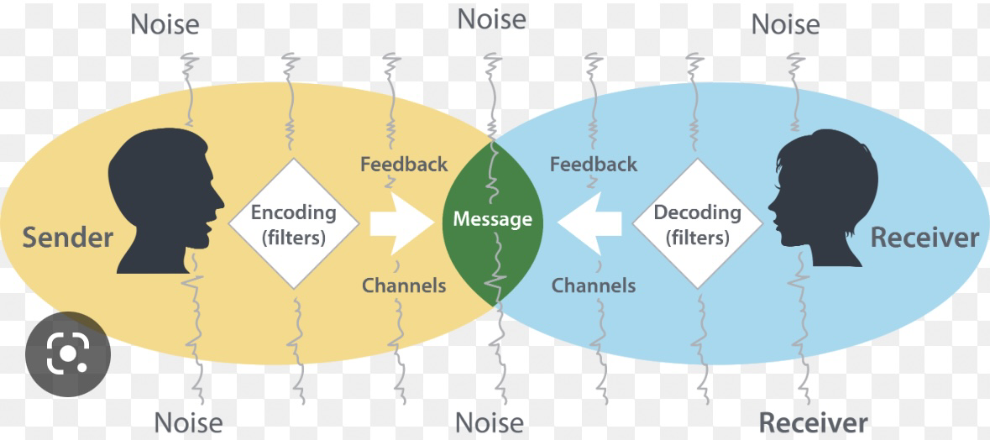
Communication is a means of transmitting information and making oneself understood by another or others, it is important for effective performance in organisations and the the workplace to build and maintain relationships.
Maintaining workplace relationships help employees achieve high levels of productivity and supports staff motivation. Effective communication is essential to facilitate improvements in exchange of information between team members. There are many types of communication, Verbal communication, Nonverbal communication, Written communication, Visual communication and listening.
Verbal communication encompasses all communication with spoken words it is important to use the right type of body language, speak clearly and use an appropriate tone when speaking.
Non-verbal communication is when people would go by your tone of voice, facial expressions, body language, and eye contact.
Written communication can take the form of anything you can write or type such as emails letters notes text and text messages.
Visual communication would commonly be used as presentations, diagrams, physical model's drawings and illustrations.
Listening is an important part of communication and in order to be a good communicator you must
master the art of listening and engaging your mind whilst the other person speaks and focusing on what they are saying.

It is important for us to have good communication in the workplace to make sure our employees or people we care for are happy within our company. One of the biggest problems in the workplace is communication barriers, recognising communication barriers can resolve communication issues and can help you be more successful at your job I maintain a positive work environment. Poor communication can also lead to errors in the workplace which in some companies e.g care settings, can be dangerous especially when you're in charge of medications and looking after vulnerable people.
.Explain, with examples, the importance of selecting an appropriate tone, language, and level of formality in management communications
Tone of voice plays a big role in communication as it can effect how people understand/ perceive your message .Tone of voice should be appropriate to the situation ,treat employees with respect whilst listening to them for example ..raising your voice or having a stern voice towards your employees will make them afraid to approach and speak to you leading to poor communication and can in turn make them not want at attend work ,having your employees happy and wanting to come into work is important for your workplace to flourish and employees to succeed in the workplace.
Here is an example of a positive tone
-One of our staff members was coming into work on her days off to help our team when we short on staff and to make sure all our residents needs are met and fulfilled , not only that she has excelled in all her work and training therefore achieving outstanding results to help with furthering her career as she is willing to learn and educate herself further.
Our manager asked her to come into his office for a monthly supervision and proceed to give her praise on how far she has come in such a short amount of time ,explaining to her how her attitude in work and towards the people we care for is outstanding and how she continues to excel giving 110% and how he can see her going far within our industry of work and to keep up the good work. This would be a good example of a positive tone.
Another example – another member of staff was also called for her monthly supervision, this example would come under a more formal approach as her attitude towards work was declining, multiple occasions throughout the month she wouldn’t turn up for work giving various reasons as to why ,our manager wanted to have a chat to see if there were any particular reasons why she didn’t want to come into work and to see if she was struggling with the online training as she was falling behind and not meeting the deadlines, also her attitude towards others had taken a more negative approach , this would be a more formal conversation keeping a more serious approach however also being supportive and wanting to help .
.Assess, the effectiveness of a range of verbal and written communication methods within your area of organisation
The effectiveness of written communication within my workplace is vital as it's within the mental health care setting ,we use written communication on a daily basis to document the service users daily activities ,as well as their care plans which includes all their personal information ,risk assessments and medication information, it is our responsibility to read through and write in these files every day to make sure the people we care for are safe and well looked after. As well as written communication the staff have handover twice a day to go over what has happened throughout the day if there has been any incidents etc, without these forms of communication the staff wouldn’t be able to do their job efficiently and could lead to mistakes.
There are also other forms of written communication including emails, letters, training manuals, memos, online training and contracts which all are vital in my organisation
Verbal communication occurs in many different aspects including presentations, training sessions, group meetings, performance appraisals, one -on -one discussions, interviewing and disciplinary sessions. Meetings are one of the most common types of verbal example in the workplace ,meetings provide staff with the opportunity to address any concerns they may have about daily tasks or any other issues they may have ,they also can be used for employees to voice any ideas they may have to improve things with in the workplace for the people we care for of for the employees.
.Evaluate theories of motivation relevant to your workplace
In my workplace we have monthly supervisions/ appraisals where my manager and I get to discuss how things are going within my role in our work setting ,this gives us a chance to bring up any questions or worries we may have and if we are happy or if anything is bothering us ,it also gives my manager the chance to give me feedback on how I’m doing my job ,when my manager praises me on the good work that I’m doing, it motivates me ,builds my self-esteem and makes me want to do more and to come into work and motivate other employees. As well as our appraisals the manger does a appreciation week where all staff get a card and a message inside praising the work we do and how we take care of our residents, we also have employee of the month which pushes us to motivate ourselves even further all these leads me to want to motivate myself to come into work. My main reason for work is that I have intrinsic motivation and want to help the people I care for as I’m a caring person and I enjoy the job that I do and want to learn more about the mental healthcare setting I suppose i can also say that I’m extrinsic as I want to work my way higher up the work chain earn more money and go further in my career.
.Evaluate the principle factors that may effect performance and motivation in the workplace
There are many factors that could affect performance in the workplace
Communication- referring back to the communication cycle one of the main factors that could affect the workplace could be poor and little communication and interaction between management, their employees and residents in their care leading to an unhappy workplace an environment, lack of interaction between employees could cause errors and staff not being able to do their jobs efficiently.
Poor management- poor management in the workplace is one major factor,
having a manager who is constantly nit picking and finding faults in your work, offering no support on your work instead of supporting you and encouraging you to do well,
this would in turn make employees feel discouraged and uninterested in their job.
Managers should communicate effectively in order to inspire their employees , they should motivate their staff so they want to work which leads to more productivity , getting employees to work efficiently depends on how the manager motivates and influences them , employees want a leader who pays attention and listens to them , getting them to bring in new ideas and be a part of decision making also leads to happy employees who want to come into work and achieve positive results in the workplace.
.Select a theory of motivation – apply it to your workplace- evaluate the outcome
I have chosen to use Maslows hierarchy of needs to apply to my workplace
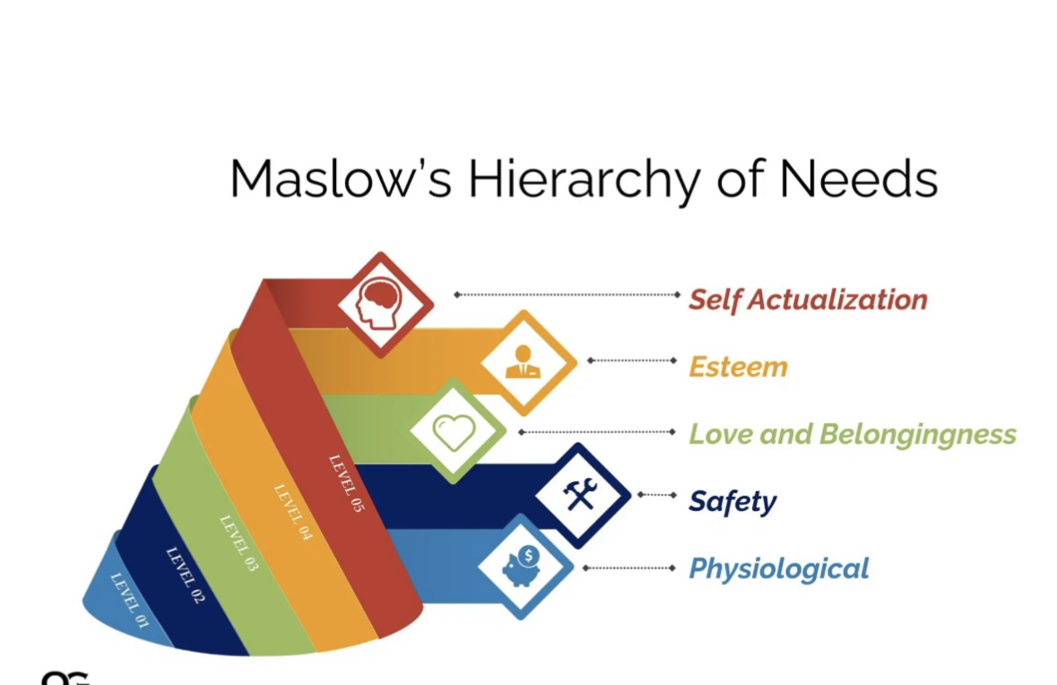
Maslows Hierarchy of needs is a pyramid with five levels, people will start from the bottom and will try and work themselves to the top of the pyramid, at the bottom of the pyramid is psychological needs this includes air, sleep, and food. The second layer would be safety this provides security, shelter and protection. The third level is love and belongingness this includes recognition and social interaction. The fourth level is esteem which provides self-esteem and status, the final and top level is self-actualisation, where people are self-motivated to do what they want, Maslows theory suggests that you need to satisfy each level of needs to motivate your team members.
These are the reasons I would apply apply Maslows theory to my workplace.
Bottom layer – employees start with the basic needs to work wit the physiological aspect ,they work for survival this includes food , shelter clothing and sleep ,many of employees at my workplace have family’s to care for so it’s imperative that their basic needs are met, these needs must be met before they can motivate themselves further to achieve any other needs .
As Employees at my place of work have built up to a stable basis and therefore have moved up the pyramid to security and safety this has led most to feel financially stable and wanting to purchase a new home to feel safe and comfortable for themselves and their family.
Love and belonging-many of my team members have become good friends inside and outside of work we would compare each other as a work family
As we have good communication,
This also has a positive income on the people we support as there is no bad negativity and leads to an all-around happy environment which is crucial in our care setting, also feeling part of a good work team and feeling content builds your self-esteem and wants you to work.
Esteem- my work team I would say have built good self-esteem as they have earned and worked their way up the pyramid and accomplished things in our workplace to earn appreciation and respect from management and other team members, this will help them move up to self-actualisation needs, this is where certain members of my work team have worked their way up to, they have motivated themselves to the top tier by focusing on their personal growth .
This theory of motivation I would say has had a positive impact with all at my place of work.
.Develop appropriate criteria to evaluate own communication effectively
I feel like I am a very good communicator in my workplace as I’m a very good listener and speaker, I always take the time out to see if the people I support or my other teammates are happy and know what they're doing ,I offer any help or support as to if and when needed or if they just need to debrief to someone if any issues have occurred or if there has being any incidents as this can happen quite frequently in our workplace, there are other various ways in which I have to communicate I sometimes have to make important phone calls most of the time these phone calls are to service users family’s ,these conversations can either be positive or can sometimes be of a serious nature that needs to be addressed, so good communication is vital within these areas. My communication skills have effectively grown since I started my job and gains positive feedback off my manager, also I am more than able to exchange information by writing and sending emails.
I believe I have a positive tone and body language as my teammates and residents are always able to approach me with no issues.
.Collect and analyse feedback on own verbal and written communication skills
I have asked my deputy manager for feedback on my verbal and written communication skills in my workplace here is the feedback she presented me with- my communication skills were excellent verbally and my tone and approach always come across in a friendly yet professional manner, she appreciates my ability to listen and and put others first regardless of the situation, I am good at remaining calm and being able to Deescalate bad Situations that may arise.
I am a good listener and am always there when needed when my teammates need to debrief etc, I’m also good at giving informative information.
As for my writing skills she replied that my online training and other relevant courses are completed and up to date and continue to meet deadlines, when it comes to filling in important documents, for example daily records I’m always right concise and give all the relevant information that’s needed.
I agree with what my deputy manager has said about my communication skills, however there is things I could improve on in my opinion, I will continue to work on these skills as my career continues to grow.
.Evaluate own communication skills as a manager identifying strengths and areas for improvement..and the. Produce a PDP to address these
Strengths | Weaknesses
Positive attitude. | Easily distracted on times
Work well as part of a team. | Not good with numeracy
Good communicator | Not confident with public speaking /doing presentation
Good listener | Computer literacy Could be better
Highly motivated

Here is my PDP
What do I want to do? | How can I do it? | What resources will I need? | How will I measure success? | Target date for review.
Pass my university course | By studying ,learning and attending my classes | Access to a computer and internet | By completing the course and getting feedback | October 2023
Gain confidence with public speaking in large groups | By practising at home with family and friends | Support from friends , family and tutor | By getting feedback | December 2023
Improve my I.t skills | Taking a course and practicing at home | Computer and access to internet | By seeing an improvement myself and getting feedback | December 2023

