

Structural Design

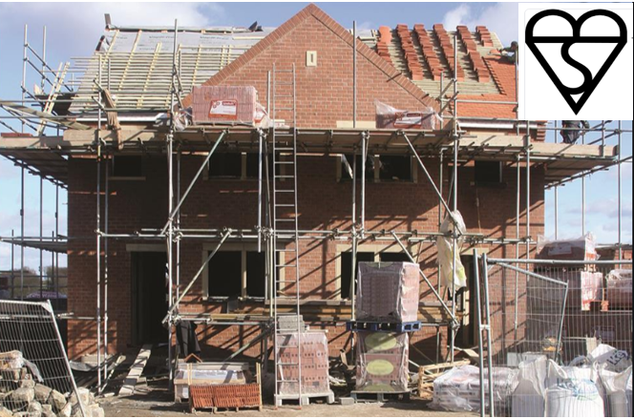

Matthew Riddler- 1904663@student.uwtsd.ac.uk
Contents

Introduction

Beam Characteristics

Beam Design
- Steel Beam Design
- Timber Beam Design
- Reinforced Concrete Beam Design

Conclusions & Recommendations

Appendices

Introduction
Trinity St David’s are building a residential property on behalf a client. The client has requested a design change for the area above the ground floor Utility & WC area as shown in figure 1 & 2, initially this was to incorporate a dual pitched roof, but the client would now like a flat roof with a patio area.
In order to meet local building authority requirements, Trinity St David’s have been requested to submit valid designs & calculations for Steel, Concrete & Timber beams. The feasibility of each material will be assessed & necessary calculations made to determine which material is most suitable.

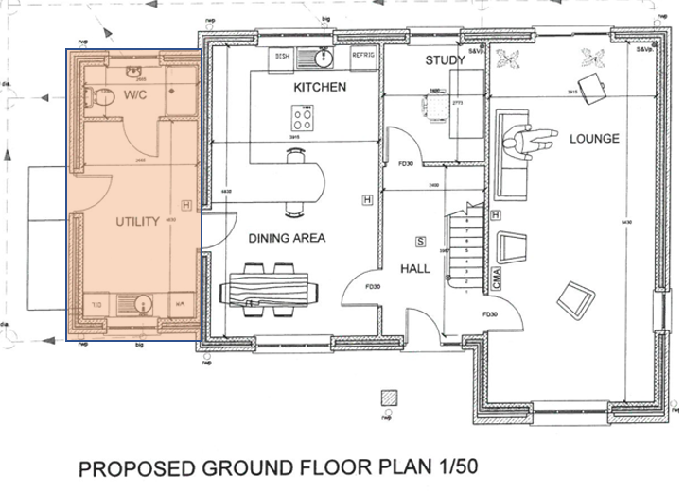
Figure 1- Proposed ground floor plan with highlighted Utility & WC area.

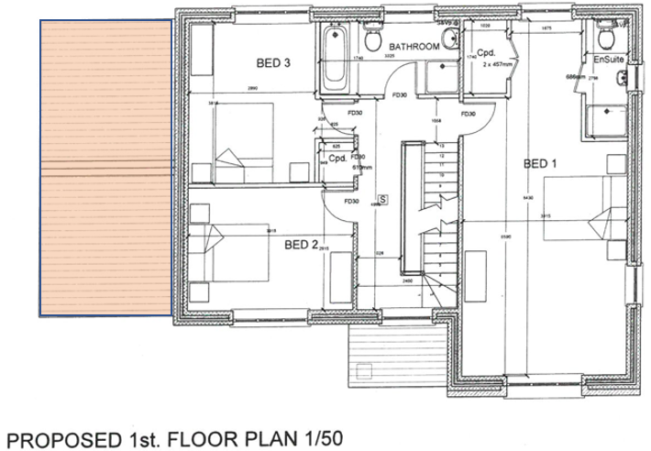
Figure 2- Proposed dual pitched roof with highlighted area for design change

Beam Characteristics
Using the plans for the proposed development, the length (L) of the beam is 2865mm (2.86m), this characteristic will remain constant for each type of material.
Prior to calculating the requirements for each type of material, the loads, forces & moments for a simply supported beam will be calculated to be applied to the equations for each beam design.

Uniform Distributed Load (UDL)
The diagram & calculations for the UDL are shown in Appendix 1.
UDL= 0.75 kN

Bending moment (M)
The diagram & calculations for the bending moments are shown in Appendix 2.
Total bending moment (M) = 2.01 kNm
Shear Force Diagram
The shear force diagram calculations for a simply supported beam are shown in Appendix 3. This is particularly important when assessing the credibility of the use of timber for the beam design.

Beam Design

Steel Beam Design
Steel as a building material is very sought after for its extreme strength & durability. Its ductile nature means it can be subjected to large loads & will not fracture. Steel is one of the most easily recycled materials which is favourable from a sustainability perspective. Steel is also very adaptable & can be formed to make many building materials such as beams, frames & cables. Steel also binds well with concrete & is used for reinforcement in concrete beams & foundations. Due to it extreme strength it is commonly used for very large structures such as stadiums skyscrapers & warehouses as shown in Figure 3. below.
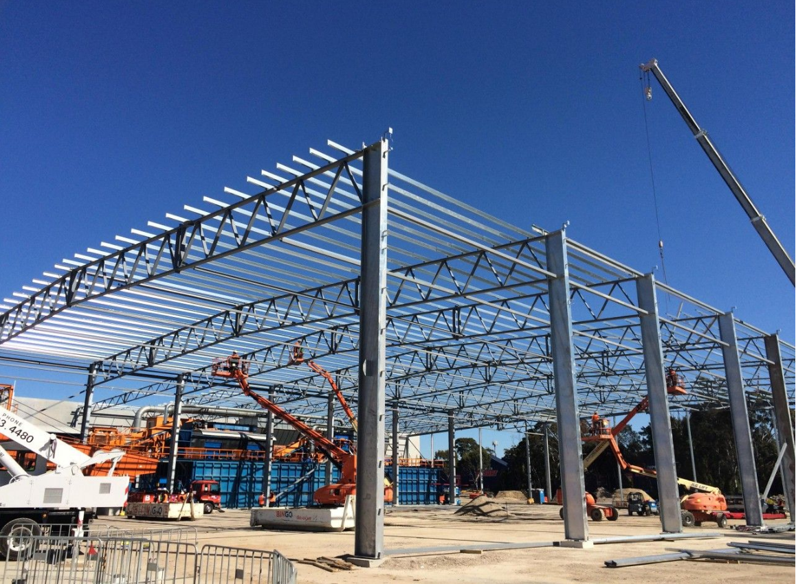
Figure 3- Example of a steel structure- www.strongholdfab.com

Figure 4. Below shows the universal Steel beam data sheet:
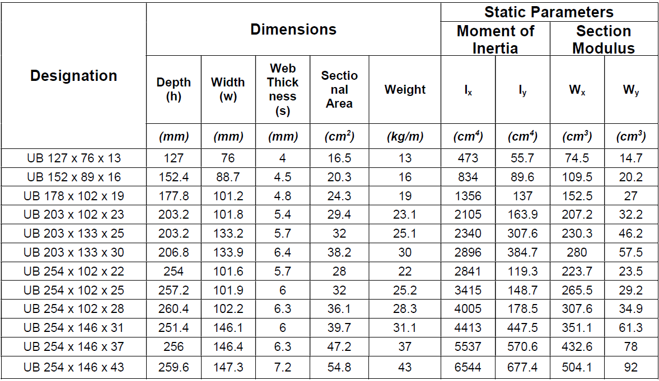
Figure 4- Universal Steel beam data sheet
Now the bending moment (M) has been calculated, this can be applied to the parameters given by the Eurocode (5) design standards for Steel. Appendix 4 shows the calculations used to determine the section modulus (W_{y}) from the figures & therefore to confirm what strength beam is required.
As the section modulus (W_{y}) calculated = 4.36 cm³ - UB 127 x 76 x 13 will be more than adequate for the beam design.

Reinforced Concrete Beam Design
Concrete is the most commonly used man-made material on earth. It is a versatile construction material used extensively in buildings, bridges, roads and dams. Its uses range from structural applications, to paviours, kerbs, pipes and drains. It is favoured for its weatherproof & fireproof properties. It is widely used with steel reinforcement for foundations as shown in Figure 5.
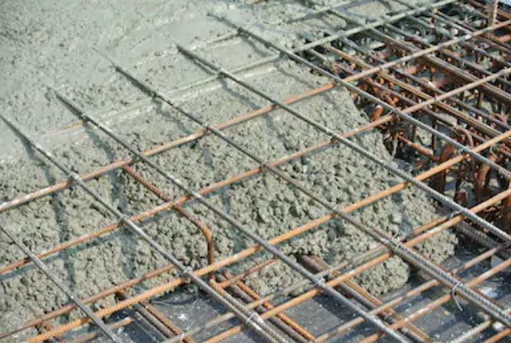
Figure 5 – reinforced concrete foundations – www.basiccivilengineering.com
C40 concrete will be used for the design of the concrete beam. The initial design calculations are shown in Appendix 5. , these calculations confirm there is no compression reinforcement required.
Appendix 6. show the amount of Steel reinforcement required for the Concrete beam, this has been calculated at 36.40mm²
The standard reinforcement bar sizes are shown in Figure 6. below, As the calculations suggest a reinforcement area of 36.40mm², 2 x 6mm bars would be sufficient ( 2 x 28.3 = 56.6mm²) or 1 x 8mm bar ( 1 x 50.3= 50.3mm²)

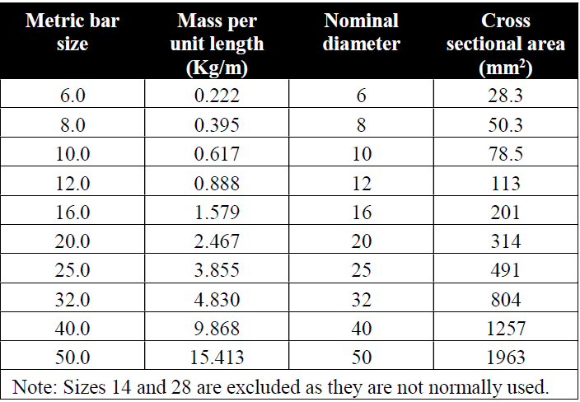
Figure 6- Steel reinforcement Bar size chart

Timber beam Design
Timber as a building material is one of the oldest materials used in the construction industry, it is highly adaptable & easily machined & offers a sustainable building solution. Hardwoods are commonly used in the construction of walls, ceilings and floors, while softwoods are often used to make doors, furniture and window frames. Some examples of the most popular hardwoods include oak, maple, mahogany, cherry, walnut, and teak. Figure 7. Below shows a timber structure being built.
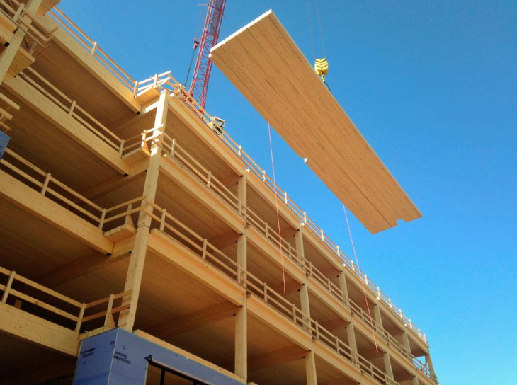
Figure 7- An example of a timber building- www.smithsonianmag.com
C16 class timber will be used in the timber beam design. The strength properties for C16 class timber are shown in Figure 8. Below.
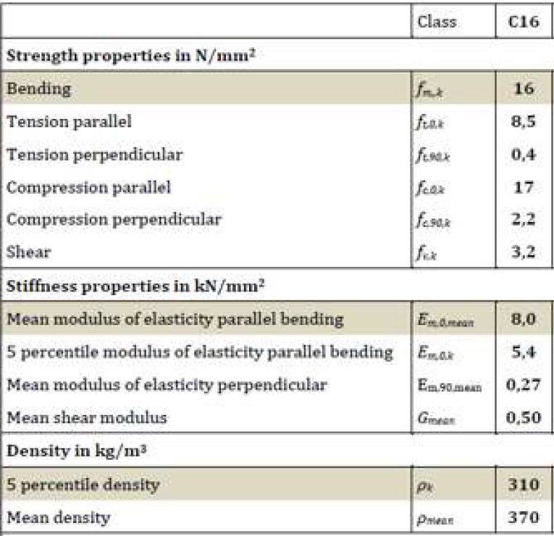
Figure 8- C16 Timber class Strength properties.
Due to the intended use of the beam, it will be deemed as Class 1 in the design standards Eurocode (5) as shown in Figure 9. Below:

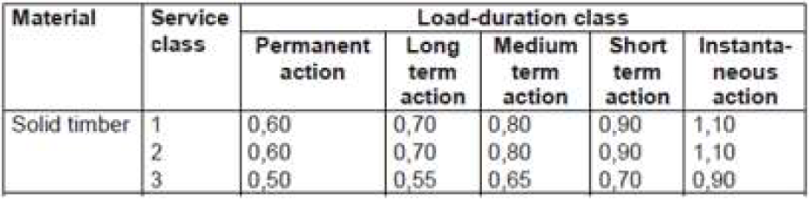
Figure 9- Kmod Values from Eurocode (5)

Along with the bending moment (M), it is crucial to apply the shear force (F) to the timber calculations, as shown in Appendix 7. & Appendix 8.
As the bending stress applied (5.250Nmm²) is less than the given bending strength (7.385Nmm²), the bending expected is Ok.
As the shear stress applied (0.102Nmm²) is less than the Shear strength (1.477Nmm²), this shows that the beam design is Ok.

Conclusion & Recommendations
In conclusion, each type of material assessed for the beam design was sufficient for the intended use & the calculations within this report show each material is well within safe & accepted parameters.
Naturally, Steel is the strongest material out of the three & there are no concerns with bending or failure. If used, Steel would be the most expensive material. Steel will also be the heaviest beam. The thermal properties of Steel are a lot less favourable than other materials so are not ideally suited for a domestic dwelling.
A concrete beam with minimal steel reinforcement will be sufficient. As the beams will be used on a residential dwelling the aesthetics of a concrete beam need to be considered & reinforced concrete by nature is less favourable, the size of the concrete beam will also be of considerable size. The thermal properties of this material are also less favourable.
For the intended use, this report recommends using a timber beam design for the flat roof patio area. A timber beam will blend in more aesthetically with the rest of the dwelling. Timber also possess better thermal properties than the other materials considered. From the calculations within the report, as C16 class timber was more than adequate for the intended use, it may be prudent to consider a lower strength class timber for the beam design, therefore reducing cost. A separate report will need to be compiled to assess the potential of this.

Appendices

Appendix 1.

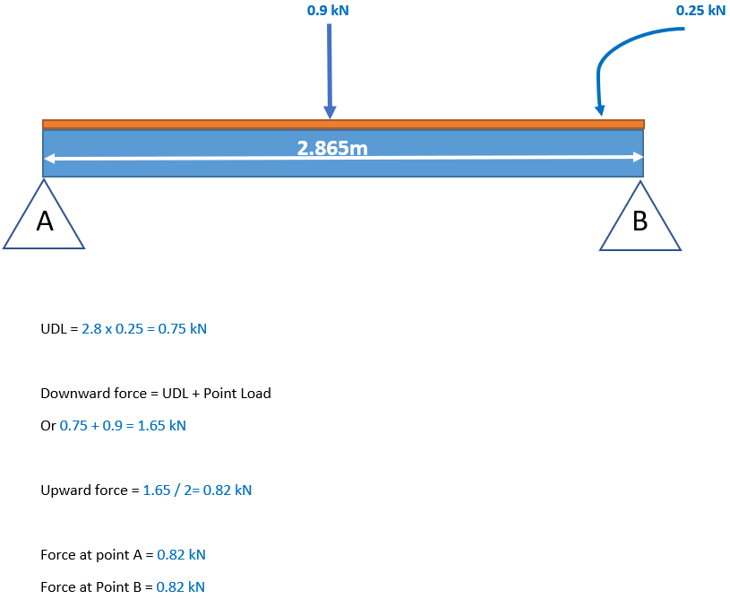

Appendix 2.

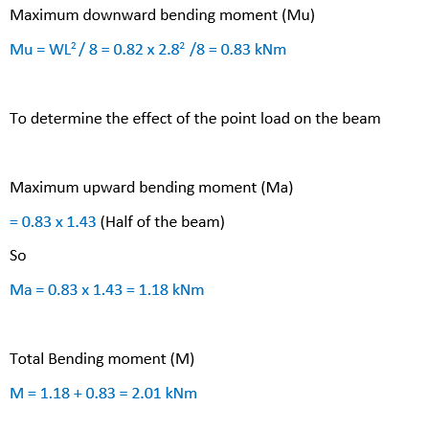

Appendix 3.
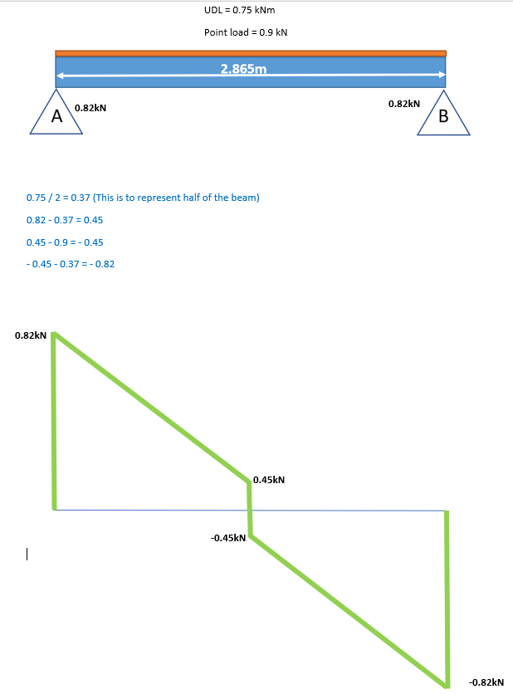

Appendix 4.

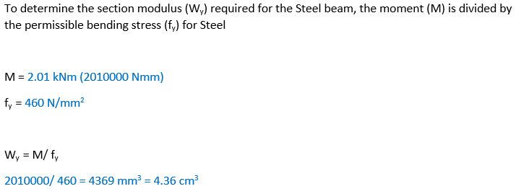

Appendix 5.

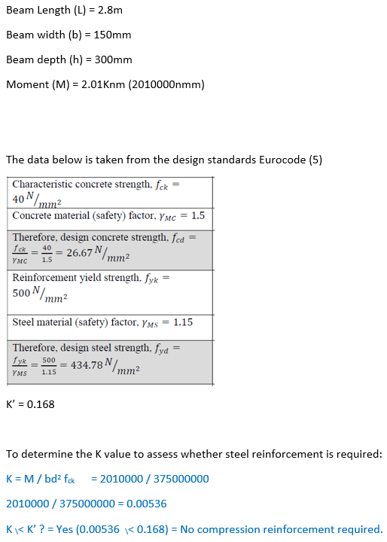

Appendix 6.

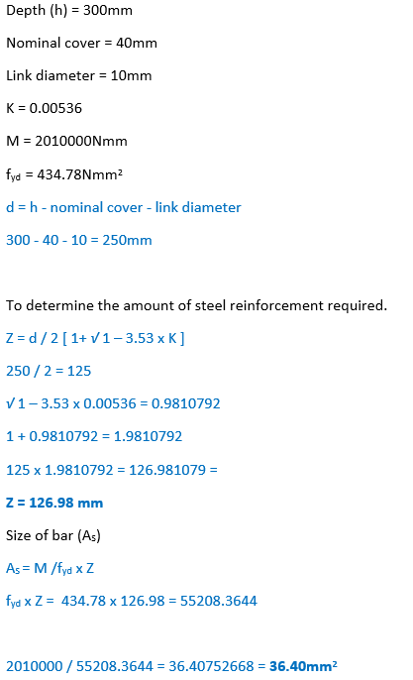

Appendix 7.

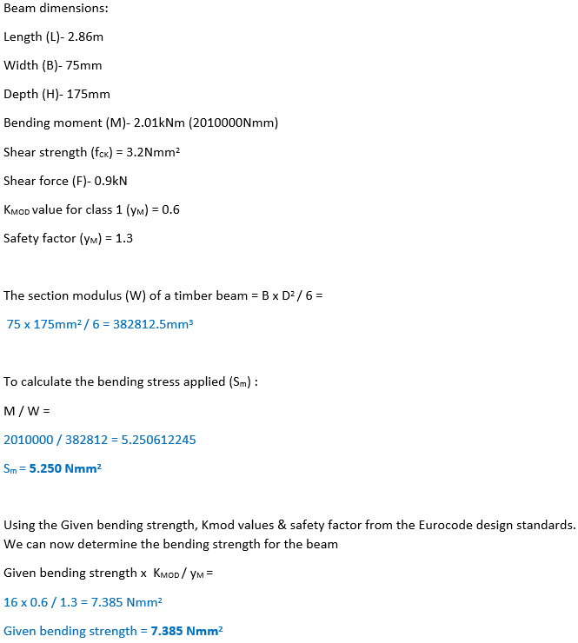

Appendix 8. (Continued from appendix. 7)



