

Service Improvement Report: Improving Patient Safety at Virginia Mason Hospital through Quality Improvement Strategies

Student name: Fatma Yusuf Gorji

Student ID: 2526418

Programme: MSc Public Health and Social care in practice

Module: Quality Assurance and Service Improvement

Module Code: LCHS70006

Assignment Titel: Component 2 Service Improvement Report
Lecturer: Dr Fahad khan

Table of Contents
1. Introduction 4
2. Main Body 5
2.1 Overview of the Quality Issue 5
2.2 Root Cause Analysis 6
2.3 Donabedian Model 7
2.4 Strategic Analysis 8
2.5 Critical Discussion of Quality Management Theories 9
2.6 Evidence from Literature 10
3. Recommendations 11
Recommendation 1: Strengthen Patient Safety Culture 11
Recommendation 2: Improve Incident Reporting Systems 12
Recommendation 3: Leadership Development and Staff Empowerment 12
Recommendation 4: Improve Multidisciplinary Communication 12
Recommendation 5: Continuous Staff Education and Training 12
3.1 Implementation Strategy 13
4. Conclusion 14
References 16

1. Introduction
Virginia Mason Hospital is a premier example of continuous efforts to improve and organize health services to deliver high quality, patient-centred care and its dedication to continuously improve the quality of its services for patients and families. The hospital opened in Seattle WA using the Virginia Mason Production System, essentially a Toyota Production System (TPS) with Lean Healthcare principles, to respond to the challenge of how they deliver their health care services. This transformation focused the organization from a reactive to a proactive patient safety system with the objectives of preventing errors, improving clinical processes, eliminating waste and enhancing overall patient experience. The strategy of embedding quality improvement in their practice shown by Virginia Mason has served as a blueprint for how other healthcare organisations can achieve the same with their patients, efficiency and to their high standards. Patient safety is a public health problem because of the harms resulting from preventable errors, brought about by loss of life, longer hospital stays and higher health care costs. But competent individuals in healthcare are not sufficient for safe healthcare; competent and effective organisational systems, leadership, communication and evidence-based clinical practice is required (Neutze and Wiggs, 2023). All these systems have an adverse impact on patients' confidence, the wellbeing of staff, the quality of treatment and a strain on health services if failed. Patient safety is one of the primary considerations in an organisation's journey towards reliable and effective service delivery that focused on the needs of the patient.

While Virginia Mason has made a lot of progress in patient safety and quality improvement several patient safety issues remain relevant to it (Burgess et at, 2022). While there are also continuing risks during prescribing, dispensing and administering, there is also the risk of promoting incomplete information transfer or delays in clinical decision-making where there are communication gaps between multidisciplinary teams. Adverse incidents and near misses are not reported at the right time causing a lack of organizational learning and learning in order to correct the situation in time. Also, poor leadership involvement can negatively impact employee engagement's effectiveness for quality improvement initiatives and may affect the ability to develop an effective safety culture. These decoupled errors, when they are linked together, bring to the fore the fact that errors arising in the patient safety are not the result of unskilfully executed individual acts, but a result of processes within the organization’s aim of this report is
to critically analyse patient safety problem that exists at Virginia Mason Hospital and explore some potential explanations to the root cause of the patient safety issue and proposed theories and models/analysis to address problems. It also seeks to create evidence-based considerations to complement patient safety culture and organizational performance and get interdisciplinary collaboration (Gibbons et al., 2026). Finally, a pathway for future implementation is reflected in the report, which will facilitate sustainable improvements in services, reduce the risk of avoidable harm to patients and ensure long-term care services are safe, effective and of high quality.

2. Main Body

2.1 Overview of the Quality Issue
There are several areas that are apparent from Virginia Mason Hospital patient safety concerns that were written about such as: patients receiving the wrong medication, poor communication between clinicians, failing to report the clinical episodes promptly, and inconsistencies in management behaviours (Atif 2026). The problems lead to higher risk of patient harm that might have been avoided, longer hospital stays, decreased staff confidence and harm to organizational performance. There will also be extra health care costs, legal ramifications and reputational effects from a safety incident; and knowing that continued monitoring, learning and systematic quality improvement are crucial parts of keeping inaccessible health care systems high quality is important.
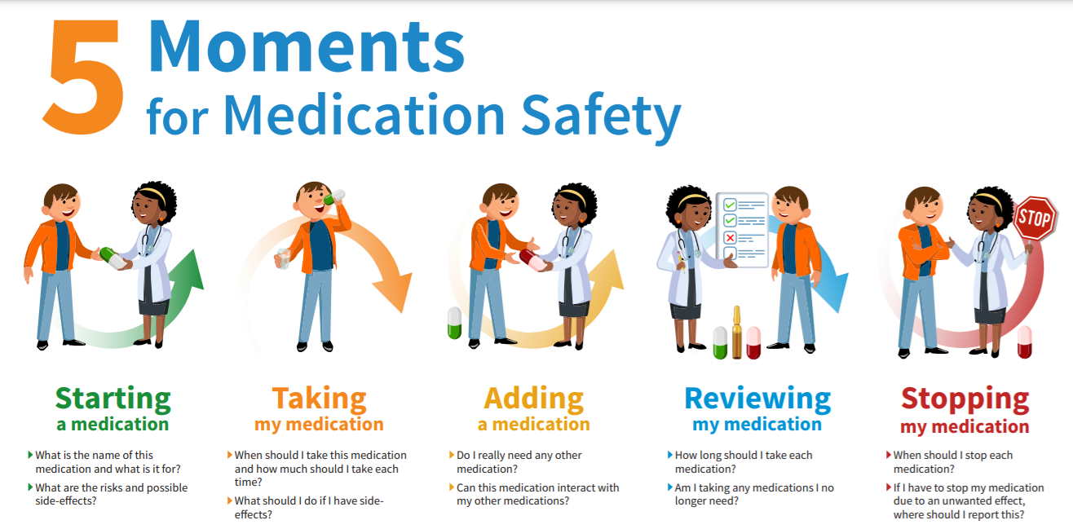
Figure: Medication error in hospital illustration nurse pharmacist patient safety
(Source: Atif 2026)

2.2 Root Cause Analysis
Patient safety incidents are not the responsibility of just one individual, is the chain of organisational factors trigger adverse events, which do not and should not happen, and require understanding (Ali and Relles, 2026). A Fishbone (Ishikawa) analysis shows that poor leadership can lead to several reduced levels of accountability, a poor safety culture within the organisation and lag Time in responses to the current risks. When there is unclear communication between the multidisciplinary teams, there will be more handovers that won't be complete or clear, as well as inaccurate information about treatment and transfer of medication information. Staff related factors such as workload pressures, fatigue, lack of training and lack of competencies development make them more vulnerable to clinical errors. The demands of the workplace – time pressures, overcrowding, multiple interruptions, etc. – and weak organizational factors such as reporting variability can adversely affect clinical decision making and medication control. The following are technological factors that cause information errors: inappropriate system of using EHR systems and drug's prescribing/dispensing are examples of these factors. The clinical procedures are inefficient, the care given is not standardised and variation is introduced to the care delivery
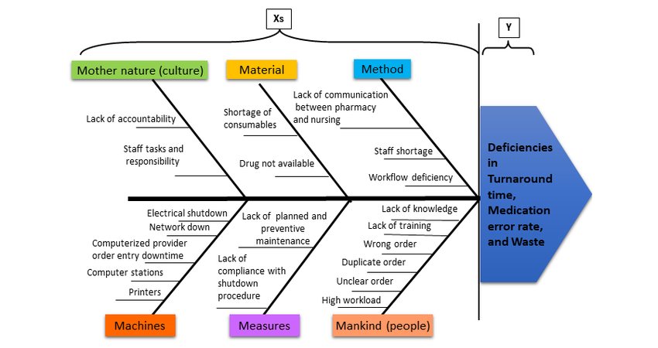
Figure: Fishbone (Ishikawa) diagram patient safety hospital medication errors
(Source: Ali and Relles, 2026)
The 5 Whys can be used to get a deeper understanding of deep root causes in the organization. Most of the reasons cited for non-consistent use of verification procedures are that they are too time consuming and disrupt workflows and have been reported as errors for health reasons. Delayed reporting due to fear of staff getting blamed for inaccuracies and the time required to report means that there are less opportunities for learning within the organisation (Thakur et al., 2023). Limited, unclear or no systems, or regular oversight and scrutiny over interactions between disciplines results in limited communication. None of the above are operators-specific failures, but organizational and systems failures that will need to be addressed and adequately improved by ongoing, continuous, system wide quality improvement (QI) efforts which will involve a commitment to a safety culture, leadership commitment and continuous learning.

2.3 Donabedian Model
The Donabedian Model is a very all-encompassing system that includes the linkages between structures, processes and outcomes, as well as performance assessments of healthcare. The structural dimension could be the commitment of the clinical/hospital leadership, hospital governance arrangements, the capability of staff, the culture and technology/finance available in Virginia Mason Hospital (Hannick and Koyle 2025). Operational variations, poor staffing and governance can result in poor clinical outcomes and safety incidents, good governance and staffing is the first step to robust clinical care. Such positive organisational culture enables people to share openly and give place to Lifelong Learning, which will be beneficial in the quality improvement process. The Process dimension is related to the care given – such as giving care and reporting incidents, managing medication, communicating between the different professions of care, following clinical guidelines and taking clinical decisions based on evidence.
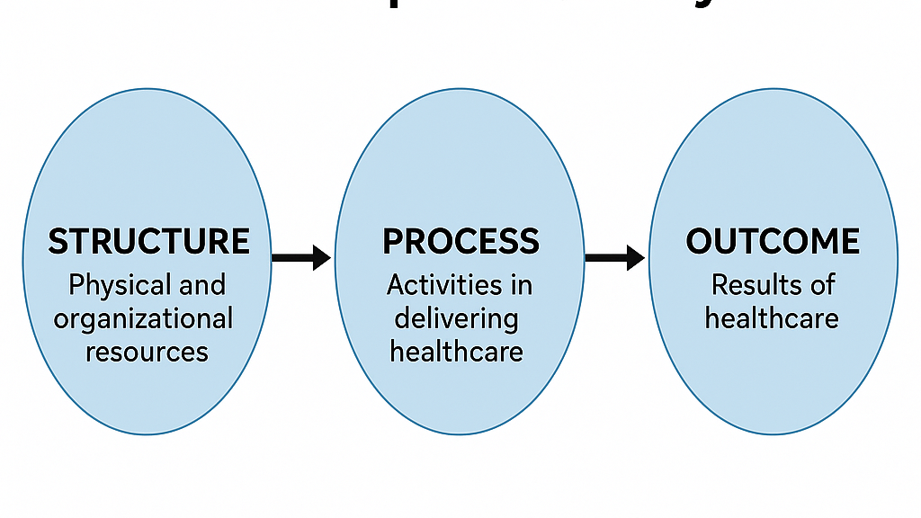
Figure: Donabedian Model Structure Process Outcome healthcare quality diagram
(Source: Hannick and Koyle 2025)
Typical operations and communication minimize any possibilities of unwanted variations, and medication errors and/or treatment delay. These report on the 'outcome' aspect of a range of patient safety-related incidents, staff satisfaction, patient satisfaction, quality of care, and organisational learning (Kruse et al., 2022). Positive outcomes are used as evidence of success resulting from quality improvement interventions and as a starting place to shape the development of future services. Its value is justifiable but there are limitations in the Donabedian Model. The framework is likely to ignore many factors that affect the health system's ability to function successfully and will certainly underestimate the context and/or norms supporting patients' skills and practices that affect patients' safety. Using it for systematically defining improvement priorities continues to be useful and it can also be used as a structured way to assess in the quality of services within Health Care Organisations.

2.4 Strategic Analysis
The SWOT Analysis provides valuable details with respect to how resources and various other factors affect the safety of patients in Virginia Mason Hospital. A few things that stand out as successes in connection to our organisations Continuous Improvement approach, Waste Elimination and stance on our customers/patient’s service in Numbers, especially as an application of Lean Healthcare principles (Lean in Frosch Holmager Sloth 2026). There is also strong executive leadership to support sustainable quality improvement programmes and innovative organisational culture through the multidisciplinary approach. But there are areas which could be improved, including weak communication between departments, weak staff engagement, not being keen to move organisations and poor efficiency in incident reporting at times. With proactive interventions the obstacles in the way of effective patient safety programmes can be tackled to keep patient safety programmes effective.
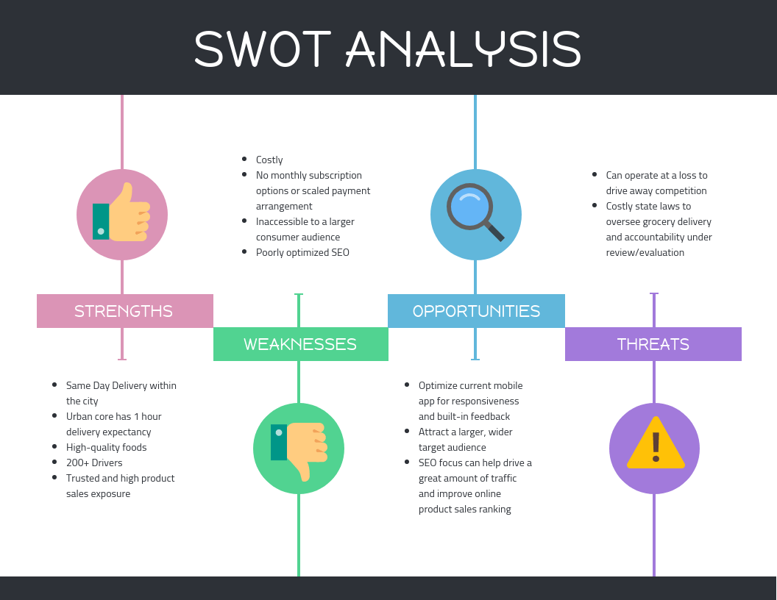
Figure: SWOT analysis healthcare hospital quality improvement infographic
(Source: Lean in Frosch Holmager Sloth 2026)
There are several other options that may be available to improve the quality of services including increased investment in digital health – that is how the product is leveraged for health, an improvement of clinical decision-support systems – patients' participation in safety measures through greater involvement, and an improvement of patients' skills by increasing their education. Advancements in artificial intelligence, predictive analytics, and electronic reporting systems have provided new ways of improving identification of risks at an early stage and evidence-based decision making. To further stimulate innovation and organisational learning, national and international quality improvement organisations can be involved. Continuous service improvements will be made both at home and away. Multiple factors come into play when considering an organisation's operation, these include – the need of the patient, the need of the care system and the financial challenge, changing government policy and complexity of the health and social care system grows (Okrent, 2025). Digital systems are no exception and should be continually monitored and increased risks from any cybersecurity should be invested in. For Virginia Mason Hospital to continue to improve or tweak its quality improvement initiatives so they remain relevant to patient safety and cutting edge in this constantly changing health care field.
2.5 Critical Discussion of Quality Management Theories
There are several theories of quality management and some of those may help in enhancing patient safety; however, when implemented, it will depend on the nature of the organisation and how it can be implemented. The Continuous Quality Improvement (CQI) approach is a process of incremental change, where a process of measurement, evaluation and participation by all staff is maintained (Williams and Best, 2022). But only sustainable learning can do that, and it may take time before it is done; it's not a quick process and requires sustained commitment. When taking a different perspective, TQM provides an alternative perspective of commitment and involvement of an organisation with quality and customer satisfaction. It will need an eagerness of leadership to progress and support change and will take a great deal of shifting in how people think about and appreciate collaboration and accountability. Furthermore, Lean Healthcare is particularly being embraced at Virginia Mason Hospital, as they strive to unambiguously deliver value in care, reduce waste and enhance workflow efficiencies. Lean work also has a direct impact on the care system and on operational efficiency via reduction of unnecessary variations in clinical processes and greater efficiency. However, just high levels of efficiency cannot overcome more complex Human and behavioural factors which may impact patient safety. Six Sigma, in addition to Lean, utilises some statistical means to aid in lowering defects (process variation) (Stark et al., 2023). It's very technical and will only be of use to agency staff if they are trained in that but has been very helpful in addressing measurable clinical problems.
The concept of Accountability to Patient and Organisation, as part of Clinical Governance is woven into the following elements: clinical effectiveness (Accountability to Patient); Risk Management (Accountability to Organisation); and professional development (Voice of the customer). Transforming operational incidents to negative, is a result of a mix of human, technological, process and cultural interactions and not because of any one actor, according to Systems Thinking (Fukami, 2025). In the context of Virginia Mason Hospital's mission as an integrated improvement organization, integrated Systems Thinking and Lean Healthcare is the most suitable process to sustainable patient safety improvement.

2.6 Evidence from Literature
There are numerous ways that any evidence suggests that only organisations include comprehensive quality management systems, not individual interventions, will succeed in promoting increased patient safety (Mendes and França, 2025). The results indicate that medication error may not necessarily be a fault of the individual, it can be due to aspects of communication, disruption of the working flow, poor safety culture and failure of the working organisation system. Recent research also indicates that the culture of openness regarding reporting in the hospital environment is associated with an increase in organisational learning as willingness to report and not blame is higher. This learning is used to emphasise similar vulnerabilities and practices to prevent injuries by proactive measures taken by healthcare organisations. Within the field of culture for patient safety, this research has demonstrated that fostering leadership is also an important topic in literature. Leaders who engage the practice team in their ideas and wants, encourage learning about improvement and provide support for resources ensures the ethos for quality is embedded in everyday actions of the work.
conversely, poor leadership engagement may cause chaos in communications among employees, poor allegation engagement, and related incomplete observance of safety policies and procedures (Lachman, 2024). Disciplinary team working, structured communication tools and standardized care pathways also have demonstrated better improvement in care degradation and better coordination of care. Digital technology, real time incident reporting systems and continued training for staff are pushing the adaptation of patient safety reinforcement to national and international health organisations. Furthermore, The use of electronic medication management systems (EMMS), decision support technologies and adherence to routine have been shown to have a positive effect on the minimisation of clinical errors, reliability of services (Minges et al., 2025). When taken together, this evidence highlights that service improvement to be sustainable demands more than a single corrective action; a strong leadership, effective communication, continued learning, and system-wide quality improvement methodologies are all required.

3. Recommendations

Recommendation 1: Strengthen Patient Safety Culture
Patient safety culture at Virginia Mason Hospital could be further enhanced by encouraging transparent and open communication and a "just culture" in which everyone understands it's important to report incidents without fear of reprimand for failure. Ongoing learning in an organisation and shared ownership of the arrangements both have evidence of positive benefits for organisations with good safety cultures and fewer adverse events which further increase staff engagement and enhance patient outcomes. Constructive learning and improvement is: Organisational responsibility; consistently associated with fewer adverse events; associated with high staff engagement and outcomes that are good for patients.

Recommendation 2: Improve Incident Reporting Systems
Furthermore, There is a need to improve the existing incident reporting system by introducing the use of user-friendly reporting platform through electronic systems that will promote timely incident reporting, particularly the ‘near miss’ incidents (near miss is an incident that could have harmed patients but did not do so due to additional factors or methods involved in its prevention) (Anumolu and Samant, 2026). Reporting systems that are effective have been shown to facilitate organisational learning, early identification of potential for harm, prevent harm and errors from occurring and support ongoing service quality and patient safety improvements.

Recommendation 3: Leadership Development and Staff Empowerment
Moreover, Leadership development programmes need to include quality improvement, change management and patient safety skills for managers and allow frontline staff to be involved in service improvement programmes. Effective leadership builds on these values ensuring that there is accountability, staff engagement, there is information available as evidence to support decision making and that there is a quality patient focused care culture within the organisation.

Recommendation 4: Improve Multidisciplinary Communication
The communication between various disciplines needs to be further strengthened – with proper protocols for the handover, regular interdisciplinary conference meetings and structured communication systems – at Virginia Mason Hospital. Properly working together decreases the amount of misunderstanding, increases the accuracy of clinical decisions, better continuity of care, reduces the risk of medication mistakes and provides coordinated, safe and efficient care delivery across clinical departments.

Recommendation 5: Continuous Staff Education and Training
Ongoing education and simulation-based training to achieve "Medication Safety", "Incident Reporting", "Communication" and "Quality Improvement Practices" should be provided. Staff professional development ensures the skills and standards of staff are maintained and allows healthcare professionals to keep up with the changing patient safety concerns that arise when staying evidence based (Winner et al., 2022).

3.1 Implementation Strategy
The recommended interventions should be carried out in the plan-do-study-act (PDSA) cycle with ideas and interventions being planned, executed, studied, and tweaked accordingly in an iterative process to seek continuous improvement. During the Plan phase, the patient safety team, hospital management, clinicians, pharmacists, nurses, and IT professionals should come together and establish patient safety goals, set measurable objectives, allocate financial funding and human resources, and develop a standard medication management plan, an incident report system, and a standard communication plan (Wang et al., 2025). This should take place in the first three months. The interventions should be introduced to departments in a pilot programme over the next three months (Do phase). All staff should be trained; electronic reporting systems should be installed and regularly held multidisciplinary meetings to learn and engage staff
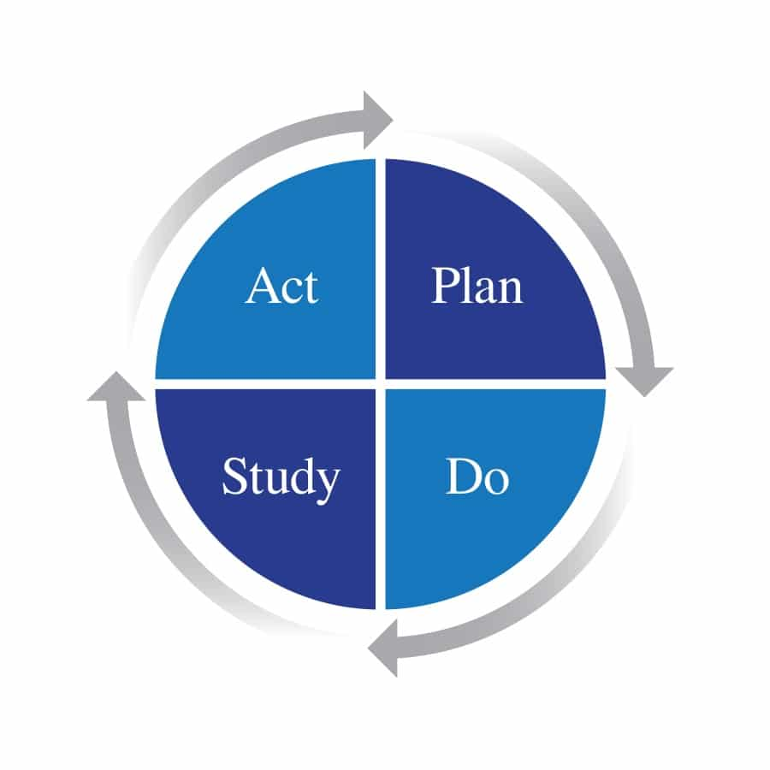
Figure: PDSA Cycle Plan Do Study Act healthcare quality improvement diagram
(Source: Wang et al., 2025)
Subsequently, This should be evaluated during the Study phase using the information garnered from the data of the next 3 months of the interventions' performances (Khan et al, 2025). Some examples of Key Performance Indicators (KPIs) include reduction in medication errors, increased reporting of incidents, increased responses to safety practices, increased patient satisfaction measures, decreased time spent on adverse activities, increased staff morale and employee engagement. Patient and health care provider feedback for strengths and areas for improvement should be sought as well. Finally, Good interventions must be replicated in all hospital departments during the act and weaknesses must be tackled by changing the policy and engaging in extra training and/or reviewing processes. Quarterly quality audit, leadership review and patient safety dashboard, along with an annual organisational review are recommended to be carried out as regular monitoring (Neutze and Wiggs, 2023). The implementation plan is 12 months long, providing sufficient time to ensure the culture of continuous quality improvement becomes embedded in the organization, services continue to improve, patient safety is enhanced, and performance is improved at Virginia Mason Hospital.

4. Conclusion
The top two reported quality problems that led to patient safety problems at Virginia Mason Hospital are: Medication errors, ineffective communication and delayed reporting of events impact patient services and Leadership involvement is inconsistent. All these challenges affect the quality of patient care, confidence of staff, costs of the organisation, and safe patient care. During the Root Cause Analysis these issues were identified as being related to each other across the organisation rather than being single issues as poor communications, staffing levels, policy/process, technology, or clinical working practices. Longitudinal perspectives allowed at the organisational level using the Donabedian Model, SWOT analysis and quality management theories to perceive organisational aspects of patient safety in relation to organisation (structure), processes and outcomes. It is believed that Lean Healthcare and Systems Thinking are most relevant to Virginia Mason Hospital, as they share an orientation towards continual improvement, standardisation and multidisciplinary team working, and learning within the organisation. Several general theories can be accessed, all of which stress the need to change the system, a positive safety culture and effective leadership to ensure sustainable improvements to services being provided. Based on information collected in this report the recommendations made are: Develop a culture of patient safety more effectively; Improve incident reporting systems; Effective multi-disciplinary communication; Foster leadership skills and staff education. With the support of a structured implementation approach to PDSA the interventions will realistically be expected to lead to a decrease in preventable patient harm, an improvement in the quality of healthcare services, increase organisational resilience, increase staff engagement and a sustainable culture of continuous improvement, ensuring that more safe and effective care is delivered to ensure the quality of healthcare services, results in a more patient-centred culture.

References
- Ali, A. and Relles, D. (2026) ‘Managing the Culture and Teaching of Patient Safety and Quality Improvement’, in Graduate Medical Education in General Surgery: Processes and Strategies for Program and Learner Success. Cham: Springer Nature Switzerland, pp. 99–111. Available at: https://link.springer.com/chapter/10.1007/978-3-032-18214-2_10
- Anumolu, S. and Samant, M. (2026) ‘Optimizing Hospital Bed Capacity: How Lean-AI Integration Prevents Capacity Constraints from Multiplying Demand’, Intelligent Hospital, p. 100048. Available at: https://www.sciencedirect.com/science/article/pii/S3050837126000019
- Atif, T. (2026) ‘Policy as a Catalyst for Shaping Organisational Culture, Ethics, and Safety in Healthcare: Aligning Culture in Healthcare Organizations’, in Fostering Organizational Culture for Provider Well-Being: The 5S’s Well-Being Framework. Hershey, PA: IGI Global Scientific Publishing, pp. 227–258. Available at: https://www.igi-global.com/chapter/policy-as-a-catalyst-for-shaping-organisational-culture-ethics-and-safety-in-healthcare/406259
- Burgess, N., Currie, G., Crump, B. and Dawson, A. (2022) Leading Change Across a Healthcare System: How to Build Improvement Capability and Foster a Culture of Continuous Improvement: Lessons from an Evaluation of the NHS-VMI Partnership. Available at: https://wrap.warwick.ac.uk/id/eprint/169460/
- Frosch Holmager Sloth, C., Schlosser Mose, L., Knudsen, T., Andersen, P.T. and Overgaard, C. (2026) ‘Organizational culture and quality improvement in healthcare: A qualitative case study using the competing values framework’, Quality Management Journal, 33(2), pp. 121–139. Available at: https://www.tandfonline.com/doi/abs/10.1080/10686967.2025.2578504
- Fukami, T. and Fukami, T. (2025) ‘The Importance of Supportive Leadership in Advancing Patient Safety’, Cureus, 17(10). Available at: https://www.cureus.com/articles/395576-the-importance-of-supportive-leadership-in-advancing-patient-safety.pdf
- Gibbons, A., Johns, R. and Sampson, C. (2026) ‘Measuring the Culture of Improvement: A mixed-methods tool to track improvement capability, culture and networks over time in a large NHS Trust’, BMJ Open Quality, 15(Suppl 2), p. A27.2. Available at: https://bmjopenquality.bmj.com/content/15/Suppl_2/A27.2
- Hannick, J.H. and Koyle, M.A. (2025) ‘Quality Improvement and Patient Safety in Surgery’, in Evidence-Based Surgery: A Guide to Understanding and Interpreting the Surgical Literature. Cham: Springer Nature Switzerland, pp. 227–233. Available at: https://link.springer.com/chapter/10.1007/978-3-031-87083-5_20
- Khan, S.J., Akbar, M.A. and Mahmood, S. (2025) ‘Strengthening Health Systems in Pakistan: Policy Reforms and Implementation Challenges’, Pakistan Journal of Health Solutions, 3(1), pp. 27–37. Available at: https://www.pakistanhealthsolutions.org/index.php/PJHS/article/view/24
- Kruse, T., Dickinson, B., Weylandt, S. and Trimakas, A. (2022) ‘New IDS merger aims to improve value and access for its communities: Two health systems in the Pacific Northwest decided the time is ripe for the kind of merger that can begin to meaningfully transform our nation's healthcare system’, Healthcare Financial Management, 76(7), pp. 32–38. Available at: https://go.gale.com/ps/i.do?id=GALE%7CA724368990&sid=googleScholar&v=2.1&it=r&linkaccess=abs&issn=07350732&p=HRCA&sw=w
- Lachman, P. (2024) Oxford Professional Practice: Handbook of Quality Improvement in Healthcare. Oxford: Oxford University Press. Available at: https://books.google.com/books?id=qRHwEAAAQBAJ
- Mendes, L. and França, G. (2025) ‘Lean thinking and risk management in healthcare organizations: a systematic literature review and research agenda’, International Journal of Quality & Reliability Management, 42(3), pp. 851–892. Available at: https://www.emerald.com/ijqrm/article/42/3/851/1240112
- Minges, K.E., Chen, P., Loh, K., Sutton, L.M. and Bernheim, S.M. (2025) ‘How do hospitals that serve low socioeconomic status patients achieve low readmission rates? A qualitative study of safety-net hospitals’, BMJ Open, 15(2), p. e083384. Available at: https://bmjopen.bmj.com/content/15/2/e083384.abstract
- Neutze, D. and Wiggs, B. (2023) ‘Quality improvement’, in Chronic Illness Care: Principles and Practice. Cham: Springer International Publishing, pp. 497–509. Available at: https://link.springer.com/chapter/10.1007/978-3-031-29171-5_38
- Okrent, M.D. (2025) Case Studies and Success Stories of Lean Six Sigma. Available at: https://pressbooks.ulib.csuohio.edu/applyingleansixsigmaoe/chapter/chapter-14-case-studies-and-success-stories-of-lean-six-sigma/
- Stark, C., Hookway, G., McVicar, G. and Van Woerden, H. (2023) The Field Guide to Rapid Process Improvement Workshops in Healthcare: Applying Lean to Improve Quality and Patient Experience. New York: Productivity Press. Available at: https://api.taylorfrancis.com/content/books/mono/download?identifierName=doi&identifierValue=10.4324/9780429020742&type=googlepd
- Thakur, V., Akerele, O.A. and Randell, E. (2023) ‘Lean and Six Sigma as continuous quality improvement frameworks in the clinical diagnostic laboratory’, Critical Reviews in Clinical Laboratory Sciences, 60(1), pp. 63–81. Available at: https://www.tandfonline.com/doi/abs/10.1080/10408363.2022.2106544
- Wang, J., Lv, H., Chen, M., Liu, C., Ren, W., Jiang, H. and Zhang, L. (2025) ‘A systematic review of Lean implementation in hospitals: Impact on efficiency, quality, cost, and satisfaction’, International Journal of Health Policy and Management, 14, p. 8974. Available at: https://pmc.ncbi.nlm.nih.gov/articles/PMC12573144/
- Williams, S.J. and Best, S. (2022) ‘What does a systems approach to quality improvement look like in practice?’, International Journal of Environmental Research and Public Health, 19(2), p. 747. Available at: https://www.mdpi.com/1660-4601/19/2/747
- Winner, L.E., Reinhardt, E., Benishek, L. and Marsteller, J.A. (2022) ‘Lean management systems in health care: a review of the literature’, Quality Management in Healthcare, 31(4), pp. 221–230. Available at: https://journals.lww.com/qmhcjournal/fulltext/2022/10000/Lean_Management_Systems_in_Health_Care__A_Review.4.aspx

