
Planning and Delivering an International Meeting/Event

Module Title: International Meetings Management for the Hotel Industry

Lecturer: Kathryn flynn

Name of the Student: Baby Lima
Student’s ID: 2133582
Date : 07/11/24

AI Acknowledgement
I confirm that I have not used any AI tools in the research and creation of this assignment and have not presented any AI-generated materials as my own work. I confirm that I have copies of my drafts, notes, and other resources I used, which I may be asked to provide in evidence.

Table of Contents
1. Introduction 4
2. The Event Cycle 4
3. Event Concept 5
4. Aim and Objectives of the Meeting / Event 6
5. Event Management 7
6. Event Budget 9
7. Industry Trends / Issues / Impacts 10
8. Situational and Cultural Considerations Using SWOT Analysis 12
9. Conclusion 13
References 14

1. Introduction
The "Winter Hospitality and Tourism Summit 2024" is an annual networking and educational event for UK hospitality professionals. The summit will focus on winter tourism, bringing critical insights into seasonal marketing strategies, business volume, and sustainable practices during the off-peak winter months (Fox et al., 2014). The event has been chosen to address the growing interest in sustainable winter tourism, which acknowledges the unique challenges and opportunities associated with promoting travel during this quieter season.
The Harrogate Convention Centre in Yorkshire, where it has all the right conditions to take place, is easily accessible, close to winter tourism destinations, and there are good facilities (Getz and Page, 2019). Quite perfect for the seasonal theme because the venue features advanced technology and spacious conference halls to facilitate a friendly atmosphere for both virtual and in-person attendees​.
The event is important to all stakeholders in the tourism sector, including hotel managers, tour operators, and event planners, as it presents the opportunity to learn about various sustainable tourism solutions and novel marketing techniques (Getz and Page, 2019). Since few competitive winter-themed events exist, this summit caters to seasonal tourism strategy, hence aimed at enhancing industry practices to aid in the local economies in the winter​

2. The Event Cycle
An event cycle is a defined procedure which describes planning, executing, and assessing events so that all functions may be managed effectively from creation to completion. Among such models, the popular Event Management Body of Knowledge is based on five stages, including initiation, planning, implementation, the event, and closure (Meredith, 2022). The EMBOK defines the entire framework related to events as a whole in five aspects: design, administration, operations, and risk management.
Application of the EMBOK model during the Winter Hospitality and Tourism Summit 2024
Initiation: At this phase, the objectives of the summit were activated (O’Toole, 2011). The activation of objectives was aimed at ensuring that tactics in winter tourism that focus on UK hospitality professionals and focusing the venue to the venue of Harrogate Convention Centre, that is highly ideal for any event during winter.
Planning: Key elements of planning included the schedule of events, selection of speakers on topics like "Winter Tourism Opportunities in the UK," and contacting UK tourism boards to source sponsorship (Rogers and Wynn-Moylan, 2022). Logistical planning was extensive in determining access to both hybrid access and virtual platforms as well as any on-site activities.
Implementation: This included the creation of marketing campaigns to generate participation and a partnership with players in the industry (Jones, 2017). Staffing in the context of technical support and hospitality was planned to allow for successful delivery of the event.
Event: The summit will offer workshops, panel discussions, and a winter-themed exhibition (Smith, 2012). It will include both an online and offline network as well as an interactive experience to provide maximum engagement.
Closure: Attendee feedback and sponsor return on investment are collected with post-event surveys and reports to fine-tune events (Richards et al., 2022).

3. Event Concept
On the day of the Winter Hospitality and Tourism Summit 2024, delegates and guests will be treated to a well-thought-out schedule designed to provide valuable insights, networking opportunities, and interactive winter-themed experiences (Zarotis, 2021).
8:30 AM – Registration and Networking Breakfast
Guests are welcomed at the Harrogate Convention Centre with a winter-themed breakfast featuring local seasonal fare. This initial session provides an opportunity for delegates to meet industry peers and establish early networking connections.
9:30 AM – Keynote Opening: "UK Winter Tourism Opportunities"
Summit opening by one of the UK's leading tourism experts. It is a keynote session that will be on the existing opportunities for winter tourism and the economic potential of seasonality (Zarotis, 2021).
11:00 AM – Panel Discussion: "Sustainable Practices for Seasonal Businesses"
A panel of industry leaders explores sustainability strategies, the action step companies can take to operate sustainably through winter (Narval et al., 2019). Participants are encouraged to ask their questions so that they may be included in an interactive environment.
12:30 PM: Lunch and Winter Hospitality Showcase
A lunch buffet will be provided, including mouth-watering winter-themed cuisine (Zarotis, 2021). During lunch, participants have an opportunity to visit the Winter Hospitality Showcase, which includes a list of products, services, and technologies for winter tourism.
2:00 PM - Session I – Digital Marketing for Winter Tourism
The first of the four workshops focuses on digital marketing in winter tourist destinations. The session will help the delegates realize certain campaign approaches, the application of social platforms, and possibilities for employing digital narratives to present winter-related locations (Narval et al., 2019).
3:30 PM - Workshop 2 Customer Experience for Winter Hospitality
Expanding on guest experience, this hands-on workshop covers unique offerings to enhance winter hospitality-from creating cozy atmospheres to offering seasonal services (van Antwerpen, 2023). Throughout this activity session, delegates will contribute their original ideas and share their best practices.
5:00 PM Closing Remarks and Future Outlook
It culminates in concluding thoughts on the future of winter tourism in the UK. It gives delegates guidance on how the insights gained can be applied within their businesses.
5:30 PM – Evening Networking Reception
The day ends in an evening reception where one has the opportunity to sit back, enjoy seasonal drinks, and network with peers in a relaxed atmosphere (Bladen et al., 2017). A final session provides further opportunities for meaningful connections and discussion possibilities.

4. Aim and Objectives of the Meeting / Event
Aim: The Winter Hospitality and Tourism Summit 2024 will focus on providing UK hospitality professionals with actionable insights, strategies, and partnerships to leverage winter tourism and improve sustainable business growth during the winter season.
There are three objectives of Winter Hospitality and Tourism Summit 2024, justified under SMART framework:
- Increase Sustainable Practicing Knowledge
Specific: A minimum of three applicable steps to sustainable winter tourism provision shall be offered to attendees.
Measurable: Out of the attendees at least 90% are achieved, as evidenced through online surveys after the summit has been concluded.
Achievable: The content would relate more to the needs of tourism professionals who are concerned by sustainability.
Relevant: This is in the era where sustainability is rising when it comes to seasonal touring.
Time-Bound: It is achieved when summits are concluded.
- Enhance Industry Networking
Specific: Stages will connect more than 100 industry professionals
Measurable: At least 50% of people will agree on new collaboration or partnership
Achievable: Sessions in networking as well as collaborative workshops maximize interaction
Relevant: Professional networks are created and built for the expansion of winter tourism strategies
Time-bound: Feedback is solicited after the event.
- Enhance Digital Engagement
Specific: Increase virtual attendance along with social media engagement.
Measurable: A minimum of 500 virtual attendees and 1,000 social media interactions.
Achievable: Marketing campaigns and digital promotions assist in increased engagement.
Relevant: It extends reach and access to the audience beyond the in-person presence.
Time-Bound: Measured by day of event.

5. Event Management
It is very important to ensure that Winter Hospitality and Tourism Summit 2024 is successful in all phases of the EMBOK model initiation, planning, implementation, event, and closure by multiple skills and resources which follow below.
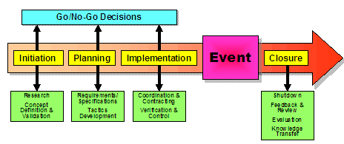
1. Initiation
Skills: Skills that must be required are related to strategic planning and involving the right stakeholders for building a clear vision and proper objectives of the event (Bladen et al., 2017).
Resources Required: Market research data for determining the main topics and target audiences, as well as partnerships with tourism boards and industry leaders for support.
2. Planning
Skills Required: Event management skills, financial planning, and coordination of logistics for a comprehensive plan (Salama, 2021).
Resources Required: A detailed project management timeline, budget estimates (£50,000), and resource allocation for venue selection and catering services. Software tools for scheduling and budgeting are also required (Salama, 2021).
3. Implementation
Skills: This includes skills and requirements needed for the presentation and communication of the hybrid event with various stakeholders to generate attention and interest through diverse platforms (Antchak, Getz and Ziakas, 2019). Technical skills involved are management of hybrid event platforms.
Resources: Resources required will be marketing materials, either in the form of print or digital, social media to support the promotion process, a dedicated team dealing with all aspects of handling registration processes, technical supports, and on-site event management (Antchak, Getz and Ziakas, 2019).
4. Event
Skills Required: Facilitation and crisis management skills during the event so that issues are resolved promptly and make their event a successful one (Getz and Page, 2016).
Resources Needed: Venue facilities, Audio Video (AV) equipment’s for presentations, catering for food and beverage, innovative activities like workshop and networking sessions to give it a complete flavour (Getz and Page, 2016).
5. Closure
Skills required: Evaluation and analysis skills, to measure effectiveness of the event, and take the feedback.
Resources: Thisincludes survey tools to collect information post-event, financial analysis for profit measurements, and reporting tools in summarizing outcomes and lessons learned for future events (Getz and Page, 2016).

6. Event Budget
The budget of the Winter Hospitality and Tourism Summit 2024, which comprises income and expenses, ensures that the event is financially viable while creating maximum impact on the winter tourism sector.
- Income Distribution
Ticket Sales:
The income from ticket sales is expected to be £60,000. This is projected based on 600 attendees at a ticket price of £100. This forms the main source of income.
Sponsorships:
Expected sponsorship input by the UK tourism boards and hospitality brands. It should accrue £20,000. This shall sponsor the marketing and operating cost
Exhibitor Fee
The exhibitor fees generated from the Winter Hospitality Showcase by the involved firms stand at £5,000. It forces the local vendors to promote the products sold during winter
Advertisement
There is income beyond what is projected by adverts that appear in the programme for the event as well as the promotional literature. At an estimate, it shall amount to £5,000
Total Income Forecasted: £90,000
- Expenses Accounts
Rent of Venue:
An estimation of £20,000 is put on the rentals of the Harrogate Convention Centre with all the apparatus and facilities needed.
Labour or Personnel Costs:
Event manned in terms of registration technical support, and hospitality purposes will cost £15,000 to ensure that these events are well managed
Marketing and Promotion:
In marketing, there will both forms of digital and printed to be done at a sum of £10,000.
Catering:
Catering in meal and refreshment during an occasion is approximated at a sum of £5,000. Foodstuffs will be local and seasons to go with the aspect of the event.
Logistics and Miscellaneous Costs:
Additional costs for AV, decor, etc. £5,000 have been provided
Total Cost Projected: £55,000
- Funding and Income Generation
The sources of funding include ticket sales and sponsorship agreements, with an emphasis on cooperation with industry stakeholders to make the event successful. The event will focus on sustainable practices and winter tourism, and this theme will attract participants and sponsors, thus raising effective income (Richards et al., 2022). Moreover, exhibitors as local businesses will enhance community support and visibility, thereby making the event financially stable and creating long-term relationships in the hospitality sector (Sassen, 2019).

7. Industry Trends / Issues / Impacts
- Industry Trends
Sustainability and Eco-Friendly Practices: The demand for sustainable practices is at an all-time high, with events taking measures to reduce their carbon footprint. This trend affects the Winter Hospitality and Tourism Summit 2024, such as offering catering options that are eco-friendly and promoting sustainable tourism strategies for the guests (Rogers and Wynn-Moylan, 2022).
Hybrid Events: Hybrid formats for events are increasingly adopted to include a mix of both in-person and virtual attendance. Such a shift has helped extend the audience base and increased flexibility (Murray & Overton, 2014). It also happens to resonate well with the structure of this summit, accommodating remote participants as well as on-site guests. A 2021 survey of 8,227 marketers worldwide revealed that 40 percent of their events were expected to be virtual in 2022, 35 percent hybrid, and another 35 percent in person. That is up from the 35 percent share of virtual events in 2020 but down from the 32 percent share of both hybrid and in-person events in 2020.
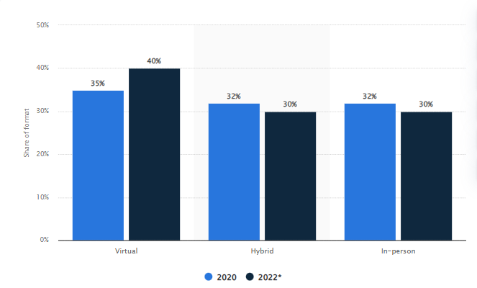
(Sourse: Majidi, 2023)
Technology Integration: Advances in event technology are changing the way events are planned and experienced, especially with mobile apps for managing events and interactive engagement tools. The summit will ensure virtual participation through seamless integration and real-time interaction in sessions.
- Industry Issues
Economic Uncertainty. Global MICE market size was at USD 935.01 billion in 2023, calculated at USD 998.59 billion in 2024 and is expected to touch around USD 1986.01 billion by 2034, from 2024 to 2034 growing at a CAGR of 7.12%. However, the notions of the economy make it difficult and are having an impact on budgets and attendee heads. Summit marketing strategies have to be shifted to include participants in light of financial apprehension (Mair, 2019).

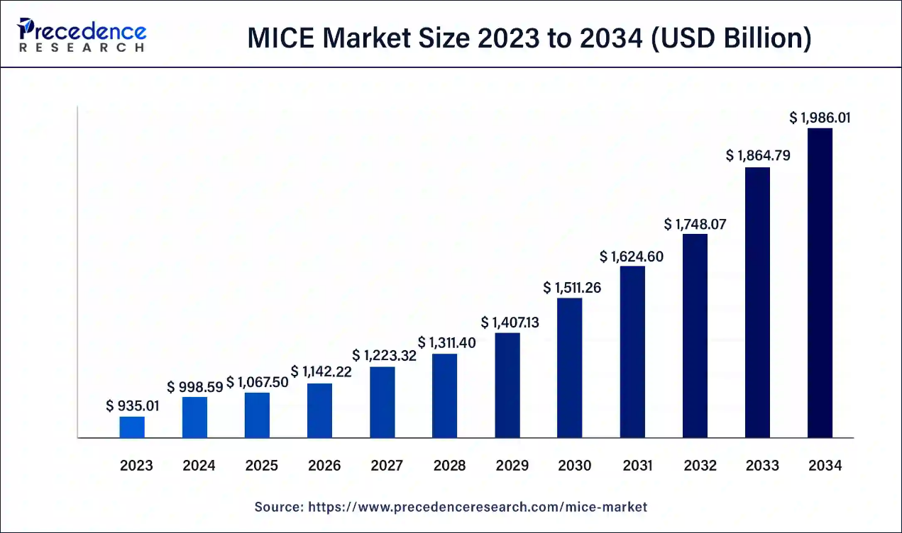
(Source: Precedence Research, 2024)
Health and Safety Regulations. Events will have to contend with shifting health and safety mandates when emerging from the pandemics. The summit will have to ensure that the event delivery is in step with certain local regulations surrounding events for gaining confidence in the event, especially on the part of the attendees.
- Industry Impacts
Shift in Consumer Preference: The pandemic has shifted consumer preferences toward more experiential and individualized events. Tailored workshops and networking events are something the Winter Hospitality and Tourism Summit can focus on that enhances attendee engagement (Getz and Page, 2019).
Greater Competition: In the coming years, when the market starts to flourish, attendees and sponsorships will attract even more intense competition. Differentiation would then be found through unique content and great takeaways (van Antwerpen, 2023).

8. Situational and Cultural Considerations Using SWOT Analysis
Knowledge about situational and cultural considerations is required in order to organize Winter Hospitality and Tourism Summit 2024. It will be completed effectively, as these elements affect the engagement of participants, marketing strategies, and the event's relevance.
Strength | Weakness
- The event is tapping into a growing trend for sustainable winter tourism.  - A well-defined target audience-the hospitality professional-is defined  - a hybrid format can accept both in-person and virtual attendees. | - Limited awareness of the market on winter tourism shall discourage attendance.  - There will also be a challenge as to whether there is necessary technology to facilitate virtual attendance.
Opportunities | Threat
- There is an opportunity when the summit is marketed at presenting the leadership in knowledge through sustainable tourism practices.  - This can be further cemented by partnership with small businesses around. | - The cultural perception of traveling in winter may vary from one region to another, which may affect the attendance from areas where winter tourism is not valued as much.  - In addition, unpredictable weather conditions may affect travel plans and overall attendance.

9. Conclusion
It would be clear that the Winter Hospitality and Tourism Summit 2024 is an event structured for very specific needs in sustainable winter tourism in the UK. The hybrid model of the Harrogate Convention Centre is hosting this summit, making it very effective in bringing invaluable insights and networking, as well as learning for industry professionals. It fills a gap in the hospitality sector by discussing seasonal challenges and offering focused workshops and discussion. Careful attention to situational and cultural factors will make a difference for winter tourism.

References
Antchak, V., Getz, D. and Ziakas, V., 2019. Event portfolio management: Theory and methods for event management and tourism.
Bladen, C., Kennell, J., Abson, E. and Wilde, N., 2017. Event project management: feasibility, planning, delivery and evaluation. In Events Management (pp. 20-49). Routledge.
Fox, D., Gouthro, M.B., Morakabati, Y. and Brackstone, J., 2014. Doing events research: From theory to practice. Routledge.
Getz, D. and Page, S.J., 2016. Progress and prospects for event tourism research. Tourism management, 52, pp.593-631.
Getz, D. and Page, S.J., 2019. Event studies: Theory, research and policy for planned events. Routledge.
Jones, M.L. (2017) Sustainable event management [Preprint]. doi:10.4324/9781315439723.
Mair, J. ed., 2019. The Routledge handbook of festivals (pp. 1-11). London and New York: Routledge.
Majidi, M., 2023. Marketing events worldwide 2020-2022, by type. [Online]. Available at: https://www.statista.com/statistics/1265830/marketing-events-type/ [Accessed on: 27th October 2024].
Meredith, J. (2022) Project management: a managerial approach.
Murray, W. and Overton, J. (2014) Geographies of globalization [Preprint]. doi:10.4324/9780203860199.
Narval, A., del Rosario, J. and Baraero-Era, J.S., 2019. Lessons Learned from Organizing an International Event. Asia Pacific International Events Management Journal, 1(1), pp.25-28.
O’Toole, W. (2011) Events feasibility and development: from strategy to operations. Elsevier: Oxford.
Precedence Research, 2024. MICE Market Size, Share, and Trends 2024 to 2034. [Online]. Available at: https://www.precedenceresearch.com/mice-market [Accessed on: 27th October 2024].
Richards, G., Censon, D., Gračan, D., Haressy, M., Kiráľová, A., Marulc, E., Rossetti, G., BarkiđijaSotošek, M. and Sterchele, D., 2022. Event management literature: exploring the missing body of knowledge. Journal of Policy Research in Tourism, Leisure and Events, pp.1-22.
Rogers, T. and Wynn-Moylan, P., 2022. Conferences and conventions: A global industry. Routledge.
Salama, M., 2021. Event project management. Risk Management and Agile Project Management, pp.73-76.
Sassen, S. (2019) Cities in a world economy. Thousand Oaks, CA: SAGE Publications, Inc.
Smith, A., 2012. Events and urban regeneration: The strategic use of events to revitalise cities. Routledge.
van Antwerpen, S., 2023. A proposed integration of the event and project management body of knowledge. International Journal of Applied Sciences in Tourism and Events, 7(2), pp.108-119.
Zarotis, G.F., 2021. Event management and marketing in tourism. Glob. Acad. J. Humanit. Soc. Sci, 3, pp.75-81.

