Name: Zenit Yunis
Student ID: 2311847

Component 2:

Introduction
The report is dedicated to the healthcare assistant (HCA) role in the UK National Health Service considering one of the current positions that are announced in NHS Jobs. Healthcare Assistant is a key role in health and social care and provides nurses and other medical professionals with the support of high-quality and patient-centred care delivery (Alharbi et al., 2024).
The purpose of this report is to critically analyse the employability skills required to play this role, contrast my existing skills and experiences with the requirements, and develop a systematic action plan to enhance my employability. Moreover, the report will show how I can establish a powerful personal brand, foster professional identity, and enhance effective networking skills to secure sustainable employment at the NHS.
This discussion corresponds to the module learning outcomes, especially to the assessment of employability skills in a practical environment and the development of a professional identity in a certain career opportunity. The report will also eventually illustrate how I can become a competent and employable medical practitioner out of being a student.

Job Description and Person Specification
The role of the Healthcare Assistant assumes that they work under the supervision of registered healthcare professionals, such as nurses and general practitioners to provide the required patient care. As shown in the chosen NHS job advert, part of the main tasks involves routine health cheque-ups of patients, supporting health promotion programmes, monitoring vital signs such as blood pressure and temperature, and facilitating support of such clinical practises as wound management and chronic illnesses (NHS Jobs, 2026).
Besides, Healthcare Assistants ought to take care of patient records being correct, making clinical surroundings in order and steaming equipment. The role entails close interaction with patients, including personal care, mobility, and emotional support, which makes it very patient-centred. According to the person specification, there are some key requirements. These include good communication, basic IT knowledge, organisational skills and working either individually or as a multidisciplinary group. Employers also require candidates to be empathetic, reliable, capable of learning, and willing to learn clinical skills (McNulty and Politis, 2023).
Formal qualification is not always standardised, with the most common criteria being used by employers to be a reasonable level of literacy and numeracy and pertinent healthcare experience or training, such as the Care Certificate or Level 2/3 healthcare qualifications (NHS Jobs, 2026). In addition, it must be aligned with NHS values including compassion, respect, and dedication to quality care. Overall, the job requires technical skills as well as interpersonal abilities depending on the level of complexity and responsibility to offer safe and effective patient care.
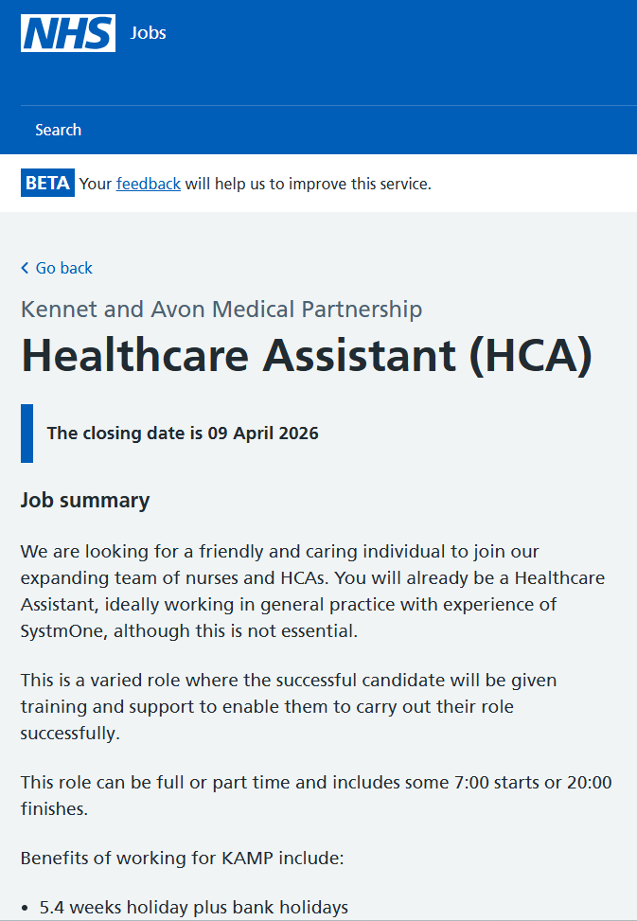
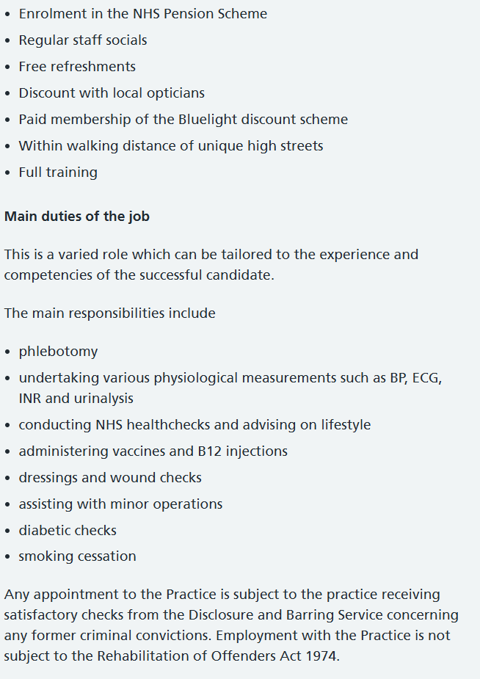
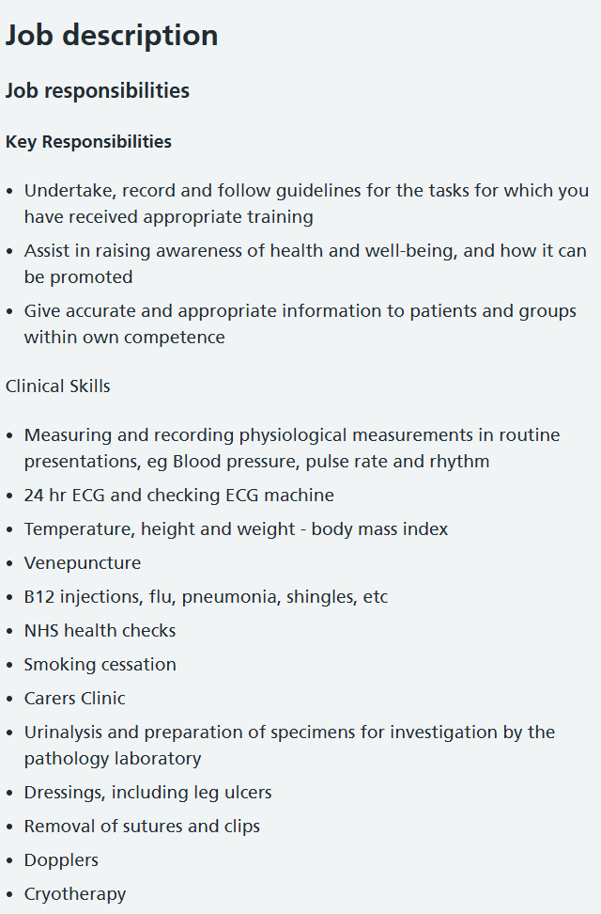
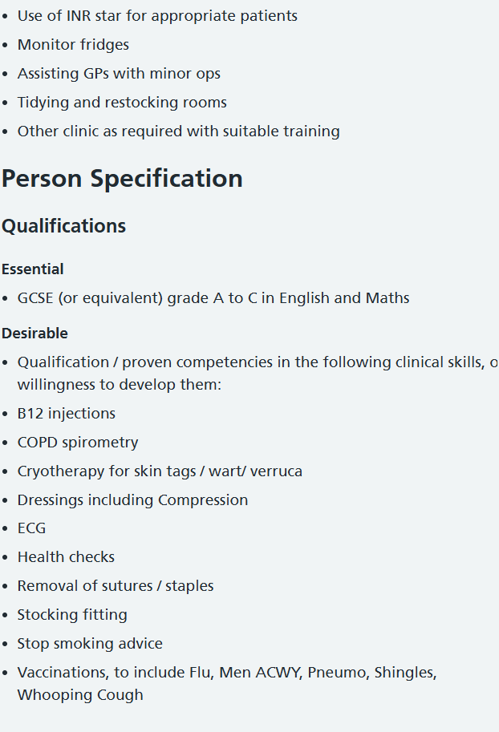
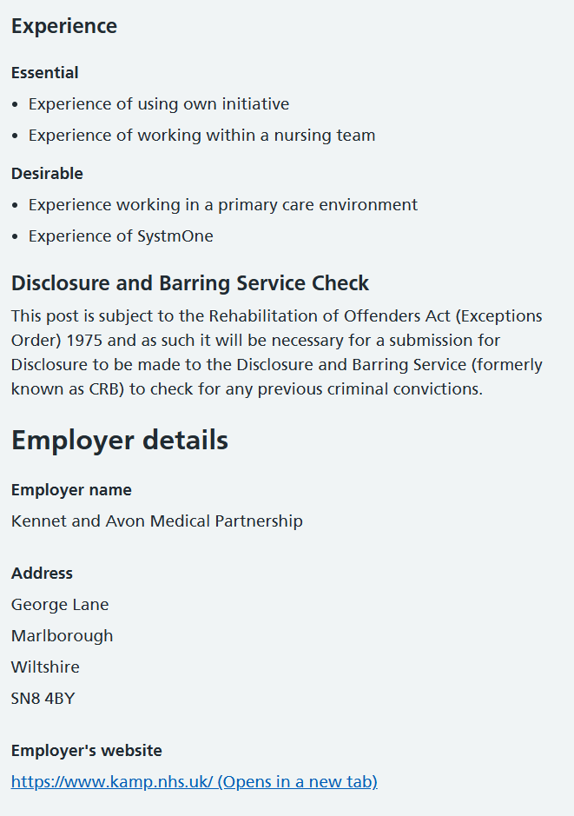

Analysis of Employability Skills
The role of the Healthcare Assistant must possess interpersonal, clinical, and organisational skills that are needed to provide the quality of care. One of the most important skills is communication. Communication assists HCAs to effectively communicate with patients, understand patient needs, and exchange correct information with healthcare professionals (AlHamazani, 2024). Ineffective communication can lead to poor care delivery and poor understanding, and the patient levels of satisfaction can be decreased, thus it is a core competency in a clinical setup.
It is also important to have emotional intelligence and empathy. Healthcare Assistants are usually assigned to deal with vulnerable individuals who may be in pain, anxious, or distraught (Rawles, 2025). Empathy allows professionals to win trust and provide emotional support, resulting in patient wellbeing and recovery. Self-awareness and self-stress coping in hard situations can also be supported with emotional intelligence.
Teamwork is another skill, which HCAs need to have, and they work within multidisciplinary teams. Proper collaboration leads to continuity of care and improves the outcomes of patients (Rahha et al., 2024). A strong collaboration with nurses, doctors, and other workers presupposes the skills to respect various roles, communicate, and make the common contribution.
Observational and clinical skills are important as well. Healthcare Assistants have the duty of ensuring that they check on vital signs as well as detecting changes in the conditions of the patients (Areia et al., 2022). This includes attention to detail and the capability of performing prompt action on the occasion when problems arise as a problem. The competencies relate directly to the quality of care and patient safety.
Additionally, organisational skills and time management skills are necessary in order to deal with multiple tasks. Healthcare systems have been characterised as hectic and HCAs have no option but to be task-focused in an attempt to meet the needs of the patients (Gyberg, 2023). Organisational deficiencies might cause failure to meet schedule and poor quality of care.
Finally, versatility and resilience are significant factors since the industry of working in healthcare is frequently hectic. HCAs are susceptible to emotional burnouts, overworking, and workloads. These problems are met with resilience so that they do not affect their professional standards (Mahmoud, 2025). Overall, these employability skills are interdependent and to be able to effectively work in the role of a Healthcare Assistant.

Self-Assessment of Competencies
In the comparison of my present strengths with the position of a Healthcare Assistant, one can list both strengths and weaknesses. One of my strengths, which will enable me to meet the emotional needs of patients, is empathy. This is highly appropriate to the job requirements, since patient welfare is based on caring.
I also possess good communication skills and this allows me to communicate effectively with other individuals. The combination of academic activities with group work, along with the skills of listening, speaking, and cooperating with colleagues, have enabled me to obtain some skills that I have gained. The other strength is the teamwork where I feel free to work within a team setting and contribute to a shared goal.
However, certain things need improvements on my part. Confidence in leadership and decision-making is one of these areas. Although I am a good member of a team, I do not always feel confident to act on my own when not knowing the relevant culture. The ability to build this skill will help in advancing in the field of health care.
Networking is another area that can be improved. My existing professional network is narrow and this may limit career development. Establishing relationships in the medical industry will be crucial to understand and acquire jobs. I also require improvements in my applied clinical experience. Despite having theoretical knowledge acquired in the course of my degree, practical experience will be essential in growing competence and confidence in actual healthcare contexts.

Experience and Qualifications
I am undertaking BSc in Health and Social Care, which offers a solid theoretical underpinning in a career in healthcare. I have acquired experience of caring about patients, protecting them, communicating, and professional ethics through my studies. These domains relate directly to the position of Healthcare Assistant.
Besides my studies, I have acquired transferable skills as a result of coursework and group projects. These are teamwork, communication, critical thinking, and time management. These skills are highly desirable in the healthcare environment and assist in the effective execution of the position.
My experience of practical work is limited at the moment, but I intend to be active in volunteering and work placements to get practical experience. This will enable me to put into practise the theoretical information in the real-world situation and achieve necessary clinical and interpersonal skills.

Personal Brand and Professional Identity
Personal branding is based on caring, trustworthy and morally inclined. I want to be perceived as a caring and professional individual who is committed to delivering quality care to patients. In the medical field, personal branding may be applicable since it reflects the principles, behaviours, and professional qualities of an individual (Musch et al., 2023).
To develop a personal brand, I will strive to enhance my online and offline existence. With the help of creating and updating my current LinkedIn profile, I will be in a position to be able to show off my skills, achievements and professional objectives.
Furthermore, the Continuing Professional Development (CPD) practises will be used as the evidence of my lifelong learning dedication. Also, I will take into account the opportunities of working in the sphere of activities connected with healthcare such as volunteering, workshops. The experiences will not only enrich my skills, but would also help form my professional identity. With professionalism, empathy and hard work, I can build a strong and credible personal brand.

Unique Selling Point (USP)
My strength lies in the fact that I am self-aware, I possess an excellent sense of empathy, and my level of communication is also very high. I also personally have a clear understanding of the emotional wellbeing in healthcare, in this case, burnout and patient care. This knowledge will empower me to offer care in a holistic caring manner.
Besides, my reflective ability enables me to be able to continuously evaluate and improve on my performance. This commitment to self and career advancement makes me a very driven and growth-oriented character. These qualities qualify me to be an eligible applicant of the role of Healthcare Assistant.

Plan of Action and Timeline
To achieve my dream of becoming a Healthcare Assistant, I have developed a five-year action plan and the plan is as follows:
Year | Objectives | Key Actions | Expected Outcomes
Year 1 | Develop the background knowledge and ability | Full BSc Health and Social Care degree courses; volunteer in medical or community positions. | Good theoretical knowledge; the first practical experience of the care settings.
Year 2 | Get pertinent experience and qualifications | Complete the Care Certificate; do placements or part time healthcare jobs; go to workshops. | Better applied competencies; certification; better workability.
Year 3 | Clinical competence development | Seek entry-level positions in healthcare; obtain practical experience working with patients; enhance communication and observation skills. | Greater trust in the clinical environment; enhanced professional practice.
Year 4 | Securing the role of Healthcare Assistant | Search NHS vacancies in the position of Healthcare Assistant; prepare interviews; create professional portfolio. | Working as a Healthcare Assistant; the real practice of skills.
Year 5 | Continuous growth of profession | Participate in CPD training; attend medical workshops; find mentorship opportunities. | Career advancement; increased knowledge and sustainability.
Table 1: Action Plan and Timeline for Healthcare Assistant

Resources Required
A number of resources will be needed in order to meet my career goals. These comprise training programme opportunities like the Care Certificate, volunteering and work placement opportunities and mentoring under seasoned healthcare professionals. Moreover, web-based tools like LinkedIn will play a crucial role in developing my professional circle and advancing my personal brand.

Networking Strategy
The healthcare industry relies heavily on networking when it comes to career development. To establish my professional network, I will be proactive in engaging healthcare workers through LinkedIn and attending other corresponding workshops and events. I will also seek mentorship opportunities that will help me to be guided and have an insight into the profession.
The expansion of my network can ensure gaining access to employment opportunities, knowledge of industries and enhance my employability. Bridging and connecting relationships will also be necessary in order to achieve success in long-term career.
Communication Skills to the Employers
In order to sell my skills to the job seekers, I will prepare an individual resume and a cover letter that will reflect my relevant skills, experiences and achievements. I will also possess a professional LinkedIn profile that will indicate my qualification and professional goals. I will also practise interviews by training responses that express my competencies and understanding of the Healthcare Assistant role. Communication will be critical in influencing the strong case as a desirable candidate, and this will be done boldly.

Conclusion
In summary, employability skills related to the Healthcare Assistant job are multifaceted and comprise teamwork skills, empathy skills, communication, and resiliency skills. This report has allowed me to assess my current capabilities and areas of development. In spite of my good interpersonal skills, I need to work more on the practical experience, confidence, and networking.
Through effective action plan and conscious working towards self-brand, I would be able to become more employable and reach my career objective. The ability to develop professionally and have a constant amount of knowledge and effective networking opportunities will be crucial in getting the position in the NHS and help to provide high-quality patient care.

References
AlHamazani, A.A.F., 2024. EFFECTIVE COMMUNICATION IN HEALTHCARE TEAMS: A PATIENT-CENTERED APPROACH. Gland Surgery, 9(2), pp.517-524.
Alharbi, S.T.M., Tabiqe, H.F.A., Rayani, S.A.A., Gabi, T.M.Y., Ghabi, M.A.H., Ahmed, M.M.H., Shagri, M.M.I., Khardali, A.A.H., mahdy Arige, W.M. and Shtab, R.H.Y., 2024. The Role of Health Assistance in Enhancing Patient Care. Journal of International Crisis and Risk Communication Research, 7(S12), p.402.
Areia, C., King, E., Ede, J., Young, L., Tarassenko, L., Watkinson, P. and Vollam, S., 2022. Experiences of current vital signs monitoring practices and views of wearable monitoring: A qualitative study in patients and nurses. Journal of advanced nursing, 78(3), pp.810-822.
Gyberg, A., 2023. Constructing patient safety. Exploring unsafe care events in hospital settings as reported by patients, relatives, and healthcare professionals.
Mahmoud, N.N., 2025, March. Thriving through career challenges: building and maintaining resilience. In Seminars in Colon and Rectal Surgery (Vol. 36, No. 1, p. 101082). WB Saunders.
McNulty, J.P. and Politis, Y., 2023. Empathy, emotional intelligence and interprofessional skills in healthcare education. Journal of Medical Imaging and Radiation Sciences, 54(2), pp.238-246.
Musch, K.L., Tyler, L.S., Vest, T.A. and Ivey, M.F., 2023. A personal brand strategy to elevate the new practitioner’s career. American Journal of Health-System Pharmacy, 80(21), pp.1531-1534.
NHS Jobs, 2026. Healthcare Assistant (HCA). Retrieved from: < https://www.jobs.nhs.uk/candidate/jobadvert/A0997-26-0002?searchFormType=main&keyword=Healthcare%20Assistant%20(HCA)&language=en> [Accessed on March 30, 2026]
Rahha, N., Alanazi, D., Alshammari, S.R.S., Alenazi, M.F.M., Alenezi, M.S.Q., Aldaghmani, H.H., Alsaiari, A.S., Aqshan, W.A.F., Asiri, H.S.I., Alkuwaykibi, A.S.J. and Alruwaili, B.M.G., 2024. Collaborative Practice Models Between Nursing And Social Work Professionals: Effects On Patient Satisfaction And Continuity Of Care. The Review of Diabetic Studies, pp.409-417.
Rawles, Z., 2025. Essential knowledge and skills for healthcare assistants. Taylor & Francis.

