April 2023
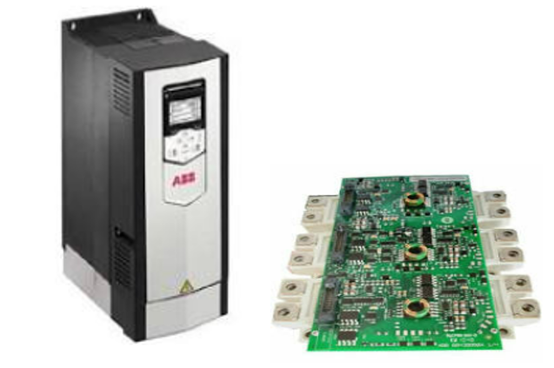  Power electronics and Drives  Module code: ACDA6004 |   Author: Brett Williams  Student id : 2215656

Table of Contents
Task 1 2
Motor Control 2
Disclaimer 2
Motor A- Rolling Mill 500kW Motor x5 (400V) 2
Motor B- Gantry Crane 80kW Motor x 10 (400V) 5
Motor C- Conveyor 10kW Motor x 23 (400V) 6
Motor D- Cutting Machine 5kW Motor x 17 (400V) 7
Motor E- Pumps + Fans 1kW Motor x 127 (230V) 9
Summary 10
Task 2 11
Rectification. 11
Component summary 11
Harmonics 14
Harmonic Legislation 15
Power factor 15
Using an IGBT bridge rectifier in a Variable speed drive(VSD) 16
Pulse Width Modulation 17
Regeneration 18
Power savings using Variable Speed Drives 18
Additional information 18
EU Ecodesign Regulation (inc UK) 19
Datasheets, Website and document links 20
Biblography 21

Task 1

Motor Control

Disclaimer
It is assumed for completeness of this assignment that every new motor being offered as part of the factory upgrade is of the latest available technology and is capable of being controlled at a varying frequency/speed and this variation in control will not cause unwanted stresses to the mechanical drive train. None of the motor rating plates have been provided, so some assumptions have had to be made when selecting suitable motor controlling equipment.

Motor Control

To refit out a factory with new motor controllers for 5 different types of induction motors the following research and conclusions are offered.

All preferred motor starting selections are identified with a blue background to ease the reader. The selection justification comment is given below each of the hardware options researched.

Motor A- Rolling Mill 500kW Motor x5 (400V)

Make /Model | Starter type  Size/weight | Protection  IP rating  Noise levels | Estimated Cost £’s  warranty | Flexible control system | Data gathering | Comms link
N/A at this power/Size rating | DOL | N/A | N/A | N/A | N/A | N/A
Schneider  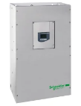  ATS48C66Q  RS 219-9885 | Star delta starter  670x400x300mm  51.4kg | Phase failure Line  Thermal-Motor  Thermal- Starter  IP00  Noise level-55dB | 7344.78  Inc free del  Warranty-18 month | More complex than DOL  Soft stop not possible  Limited I/O  4 inputs  5 outputs (3 relay) | limited due to contactor configuration  on/off/trip. | Modbus- RJ45- Serial RS485
Comment- Schneider ATS48C66Q- Does not meet basic motor control criteria
Siemens  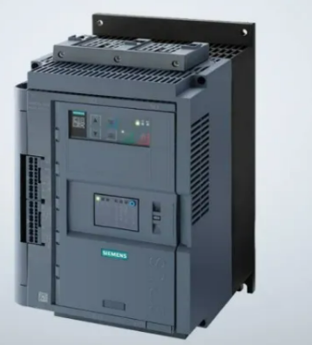  SIRUS 3RW5248  RS 210-9548 | Star delta starter  210x393x203  11kG | Motor overload  Current Limiting  Safe torque  Ramp up  Ramp down  Intrinsic device  IP00/ IP20 with cover | 4906.97 base model all options are extra  Eg | Limited to  1 Ana o/p  1 x Dig i/p  3 x Dig o/p | Various options available at extra cost | PROFINET EtherNet/IP Modbus RTU Modbus TCP PROFIBUS
Comment- SIRUS 3RW5248 Does not meet basic motor control criteria
Siemens  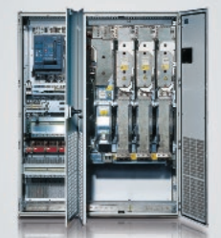  G150  SL3710-1GF35-8AU3 | Variable Speed Drive  Isolator  Motor Protection  Circuit breaker  EMC Filter  CE markings | IP54  Safe torque off  Safe brake control  Safe direction | Cost TBA  12 month warranty | Local control panel  2 Ana- i/p  2 x Ana o/p  6 Dig i/p  Dig input interlock  2 Dig i/p/o/p 24V  3x relayo/p  Safe Torque off  Extensive i/o options | USB connectivity for programming | Ethernet  Options for  DeviceNet  PROFIBUS  ControlNet  EtherCAT  POWERLINK  EtherNet/IP
Siemens rating info
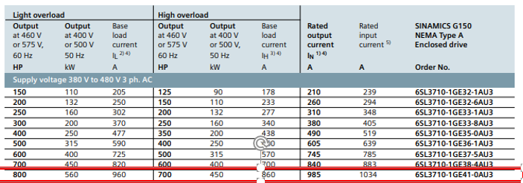

Comment- Siemens 6SL3330-6TE41-1AA3- Very similar to the ABB option, Discounted due the contract being in place to support the ABB hardware and commissioning.
ABB  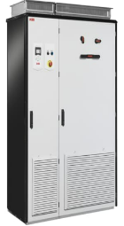  ACS880-17- 1210A-3 | Variable Speed Drive  2145x2230x698  1970kG’s  WEEE- category 4  IP54  THD <3%  EMC filter  Air circuit breaker | Over voltage. Under voltage.  Temp  Safe torque off built-in as standard  Optional safety modules for extended safety functions Encoderless safe speed detection  thermistor  SIL 3 capability  9yr service intervals | 92880.00 x5  Total 464,400  12month Warranty  voltage boost the same power is achieved with less current, which improves motor efficiency and may allow a smaller motor to be used.  Also benefit with ride through during glow voltage to ensure reliable operation | Panel cnt  2 Ana- i/p  2 x Ana o/p  6 Dig i/p  Dig input interlock  2 Dig i/p/o/p 24V  3x relayo/p  Safe Torque off  Extensive i/o options  Increased system efficiency with common DC solutions | USB connectivity for laptop programming and data gathering.  Bluetooth connectivity for basic running parameters  App available  Removable memory module | Modbus/Ethernet included.  Options for  DeviceNet  PROFIBUS  ControlNet  EtherCAT  POWERLINK  EtherNet/IP  NETA21-remote data monitoring via cloud
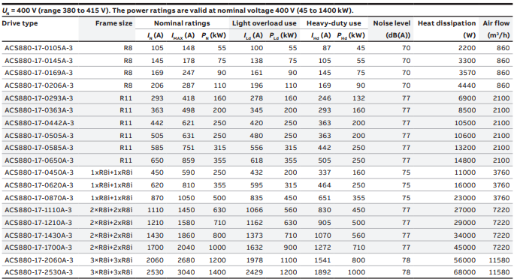

Selection justification comment - ABB -ACS880-17-1201A-3 preferred option:
I have decided to choose ABB’s ACS880-17 Cabinet built regeneration drive option from their robust industrial offerings. I believe this cabinet built drive would best suit the high demand from a rolling mill application and would provide energy savings by regeneration of power back into the electrical network would be achieved during its cyclic running.
This is also a solution in one box provided by the supplier. No further filters, protection or switching hardware would be required.
A Common DC bus would ensure any regenerative power would be passed back into the common connection for the other drives to utilise minimising the import of electricity from the grid.
Communication is vast and includes the most common Ethernet IP.
The main reason for choosing this drive is that it is correctly rated at 630kW for Heavy duty use ensuring that the hardware is built to be able to deliver the maximum load for the full running time if required. Preventing temperature stressing and reduced life cycle is a big advantage . This drive is also stated as having an efficiency level of 97%. Ensuring money well spent. This regeneration model will help offset the purchase costs over time with a common DC BUS setup the regenerated power will assist the other drives in the system. Reducing the need to continuously import all the power directly off the National Grid.

- Exceptional hardware capabilities including STO (safe torque off)
- Increased system efficiency with common DC solutions
- No further external protection required.
- Remote and learnable fault diagnosis
- Fully customisable for the application
- Programmable and removable pen-drive for easily repeatable programming of multiple units.
- leading manufacturer/supplier of Drives and associated components
- ABB have a Tata works wide contract to support on-site breakdowns with immediate response
- Market leading hardware that has won many industrial innovative awards
- Discount prices due to contract
- Experienced specialist repair engineers with bespoke portable test kit for fast and efficient onsite repairs.
- Local Engineers and representatives
- They offer to stock expensive spares locally and at no cost to the customer.
- Smaller spares can be delivered by courier
- Recognised local repair center in Avonmounth
- Commonality of available spares works wide due to already installed hardware
- Long service intervals
- Excellent running data analysis via front panel, ipad/laptop application or SCADA
- Single point of contact with a local rep.
- Onsite personnel are familiar with the hardware and software capabilities. [1]

Motor B- Gantry Crane 80kW Motor x 10 (400V)

Make /Model | Starter type  Size/weight | Protection  IP rating  Noise levels | Estimated Cost £’s  warranty | Flexible control system | Data gathering | Comms link
N/A at this power/Size rating | DOL | N/A | N/A | N/A | N/A | N/A
WEG  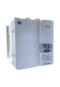  SSW07 | Soft Start  110kW | Electric motor protection | 1398.24 | Limited to Stop + Start | Lacks available info | Keypad and communication modules are extra options
Comment- WEG SSW07 Does not meet specified motor control criteria

Siemens  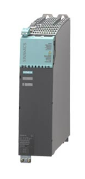  6SL3136-7TE28-0AA3 | 400V 3 phase  Wall mount  WEEE compliant  EMC filters  Motor protection  22kG | 80kW  133A  S120  Active line module | Estimated Value - 15,386.00 | Local control panel  2 Ana- i/p  2 x Ana o/p  6 Dig i/p  Dig input interlock  2 Dig i/p/o/p 24V  3x relayo/p  Safe Torque off  Extensive i/o options | USB connectivity for programming | Ethernet  Options for  DeviceNet  PROFIBUS  ControlNet  EtherCAT  POWERLINK  EtherNet/IP
Comment- Siemens 6SL3136-7TE28-0AA3. Discounted in favour of the regenerative option below

ABB  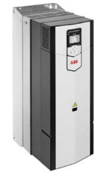  ACS880-17-0206A-3 | 400V 3 phase  Regenerative drive  Wall mount  THD <3%  EMC filters  Motor protection  WEEE compliant | 90kW- Heavy Duty | 23,450.00 x10  Total 234,500  12 month warranty | 2 x Ana- i/p  2 x Ana o/p  6 Dig i/p  Dig input interlock  2 Dig i/p/o/p 24V  3x relay o/p  Safe Torque off | Front panel Display  USB connectivity for laptop programming and data gathering.  Bluetooth connectivity for basic running parameters | Modbus/Ethernet included.  Options for  DeviceNet  PROFIBUS  ControlNet  EtherCAT  POWERLINK  EtherNet/IP  NETA21-remote data monitoring via cloud
Selection justification comment- ABB ACS880-17-0206A-3 Fast setup with a plug in removable memory module, common communication setup and data gathering. Regenerative drive adds power into the common network when crane is lowering each and every load.
Reduced electricity import costs due to common bus option.
Excellent communication connections and options built in. All protection EMC filters and comes with bespoke crane controller software built in. This product is designed and manufactured as a crane controller ensuring maximum protection, reliability and is extremely energy efficient due to the embedded control software. Virtual companioning is also an option.
The Heavy duty 90kW option was chosen due to its ability to react and ride through large demand of torque during heavy duty use.
Cranes (EOT cranes), +N5050 • Mechanical brake control • Slow down and end limit logic • Antisway • Hoist speed optimization • Shaft synchro

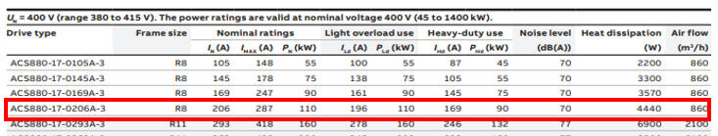 [1]

Motor C- Conveyor 10kW Motor x 23 (400V)

Make /Model | Starter type  Size/weight | Protection  IP rating  Noise levels | Estimated Cost £’s  warranty | Flexible control system | Data gathering | Comms link
N/A at this power/Size rating | DOL | N/A | N/A | N/A | N/A | N/A
Comment- DOL is not an viable option for starting motors over 7.5kW

Allen Bradley  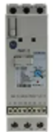  RS 418-6928 | Soft Starter  IP2X  2.6 kg | Over load protection  Thermal protection | 400.67 | Hold to test circuit function  No I/O |  | Programmable option module
Comment- a cheap option but does not provide any i/o as it is designed to be connected to OEM basic controller. Not an all in one box option, multiple additional options for full motor control are required, many single items of failure will make this complex and unreliable.

Siemens  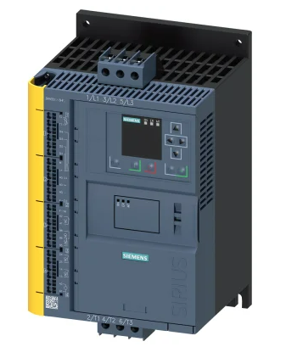  RS 226-1564 | 11kV Soft Starter  480V 3 phase  275x170x152mm | IP20 | 1389.06 | N/A | 1x Ana o/p | PROFINET  EtherNet/IP  Modbus RTU  Modbus TCP
Comment- Elevated Voltage is slightly higher than required. Not capable of variable motor speed.

ABB  ACS880-31-032A-3 | 400V 3 phase | 11kW- Heavy Duty  Over load protection  Thermal protection | 3790 x 23  Total 87170 | 2 x Ana- i/p  2 x Ana o/p  6 Dig i/p  Dig input interlock  2 Dig i/p/o/p 24V  3x relayo/p  Safe Torque off | USB connectivity for laptop programming and data gathering.  Bluetooth connectivity for basic running parameters | Modbus/Ethernet included.  Options for  DeviceNet  PROFIBUS  ControlNet  EtherCAT  POWERLINK  EtherNet/IP  NETA21-remote data monitoring via cloud
Selection justification comment - Fast setup with a removable memory module, common communication setup and vast data gathering/ access via a multitude of included ports ie USB. Worth the extra cost. Extra low harmonic drive won’t stress the network even with multiple drives switching simultaneously.
Up to 32 drives can be connected to one control panel for easier and quicker operation. When using panel bus, only one control panel required.

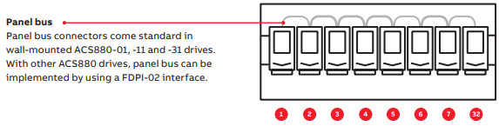

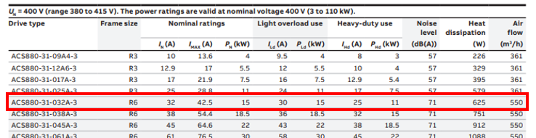
[1]

Motor D- Cutting Machine 5kW Motor x 17 (400V)

Make /Model | Starter type  Size/weight | Protection  IP rating  Noise levels | Estimated Cost £’s  each  warranty | Flexible control system | Data gathering | Comms link
Eaton  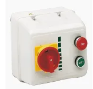  RS 528-7612 | DOL  184x184x184mm | 3 pole contactor  Thermal overload  IP55 | 283.82 | N/A | N/A | N/A
Comment- Eaton DOL Basic motor starter comprising of ON/OFF and Isolator only lacking in available information

Eaton  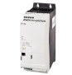  174339 DE1-34011FN-N20N | 400V 3phase  90x90x231mm  1.7kg’s | Power rating 5.5kW  Overload  IP20  CE marking | 523.29+  76.53+  DT module | Optinal parameter modiule 820-3597  1 Ana i/p  4 Dig i/p | Optional DT module | ModBus RTU
Comment – Eaton 174339- Extra modules additional costs, no information found on data gathering

RS PRO  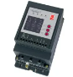  227-5223 | 400V 3phase  90x90x231mm  2.4kg’s | 7.5kW  IP42  Overcurrent trip  Max output current trip  Limited starts per hr | 266.77 | Limited control and flexibility  FLA-Front panel potentiometers | N/A | ModBus RTU
Comment- RS PRO limited starts per hr, no info on data gathering and basic connectivity

Siemens  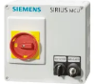  RS 665-6277 | 400V 3phase  220x182x145mm  2.9kg’s | 5.5kW  IP54  Circuit breaker | 503.89 x17  Total 8566 | FWD/RVS switch  Man/Aut keyswitch | N/A | N/A
Selection justification comment - A great value solution, complete with isolator and fwd/Rvs switch also Man/Aut key-switch. Although this minimal motor protection option can be added to if required. Due diligence is required on the factories supply to ensure a EMC and Harmonic filter is present otherwise the VSD option may be a better solution as the drive option has these components built in as required by mandatory legislation (EU)2019/171. [2]

ABB  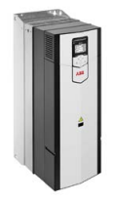  ACS880-31-017A-3 | 400V 3 phase | 7.5kW  Over load protection  Thermal protection | 2690 | 2 x Ana- i/p  2 x Ana o/p  6 Dig i/p  Dig input interlock  2 Dig i/p/o/p 24V  3x relayo/p  Safe Torque off | USB connectivity for laptop programming  and data gathering.  Bluetooth connectivity for basic running parameters | Modbus/E thernet included.  Options for  DeviceNet  PROFIBUS  ControlNet  EtherCAT  POWERLINK  EtherNet/IP  NETA21-remote data monitoring via cloud
Comment ABB ACS880-31-017A- excellent comms and control options, no filters or further protection required, Discounted as most expensive solution, too complex a solution for this basic function.

Motor E- Pumps + Fans 1kW Motor x 127 (230V)

Make /Model | Starter type  Size/weight | Protection  IP rating  Noise levels | Estimated Cost £’s  warranty | Flexible control system | Data gathering | Comms link
Invertek  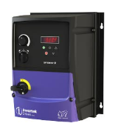  ODE-3-120105-1F4#-01 | VSD  Built in isolator  EMC filter  230V  1.1kW  257x187x220mm  3.5kg  Internal brake | IP20 or IP66 | 533.99  12 month warranty | Switched Fwd/Rvs  Ana o/p  Relay o/p  Ana i/p  Dig i/p  Potentiometer control shaft speed | Operational Keypad | Modbus RTU
Comment;- good basic function for pump and fan speed control. Lots of unknowns that require contacting the OEM.

Control Techniques  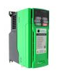  C200-02200075A | VSD  230V  1.5kW  226x90x160mm  3.3kg  Internal brake | Overload  Overcurrent  Phase loss  Short circuit ground  Motor thermal | 342.00  12 month warranty | Dig i/p x5  STO  Status relay | Front panel | Various comms modules
Comment: good basic function for pump and fan speed control. Lots of unknowns that require contacting the OEM.

Schneider  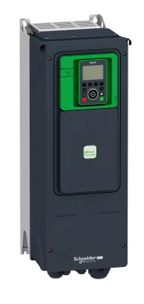  RS 219-9969 | VSD  230V  1kW  68x270x237mm  1.9kg | IP20 | 1188.50  12 month warranty | STO  Dig O/P x1 | 7 seg display | RJ45 for Modbus
Comment : discounted as drive has to be used with a servo motor
Rockwell A-B  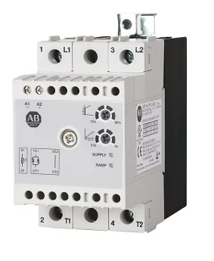  RS 220-0970  154-SP1C25NAD | DOL starter  230V  1.5kW  68x270x237mm  1.9kg | IP20 | 140.99 | Potentiometer control shaft speed | Status LED’s | N/A
Comment : Discounted as a separate isolator is required, no stop start switches or housing

ABB  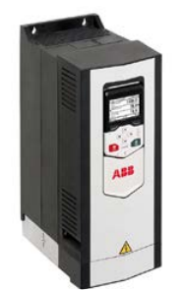  ACS880-01-10A6-2 | Industrial drive  230V  1.5kW heavy duty  Wall mounted | IP55  Over load protection  Thermal protection  Harmonic filter  EMC filter  Functional safety | Est 1755 x127  Total 222,885 | 2 x Ana- i/p  2 x Ana o/p  6 Dig i/p  Dig input interlock  2 Dig i/p/o/p 24V  3x relayo/p  Safe Torque off | USB connectivity for laptop programming  and data gathering.  Bluetooth connectivity for basic running parameters | Modbus/E thernet included.  Options for  DeviceNet  PROFIBUS  ControlNet  EtherCAT  POWERLINK  EtherNet/IP  NETA21-remote data monitoring via cloud
Selection justification comment : Sticking with the ABB option due to the already selected drives and options above would be the smart move for obvious reasons like commonality, operator familiarity and engineering contracts. This all in one box approach reduces the requirement for external filtering options that can be both complex and expensive they also add multiple points of failure.

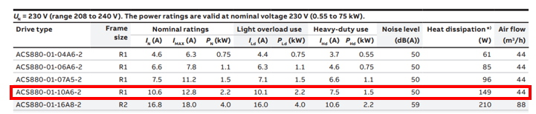

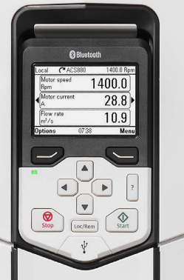
For these small centrifugal loads (pump and fans) I would utilise a simple flow or level control and vary the driven speed of the load according to the requirement using the built in P+ID option. This would off-set the higher purchasing costs, See further details below on the cube law for a more detail.

As with all the ABB options ,common control front panel identical on all drive options. With USB or Bluetooth connectivity to access drive parameters and data logging.

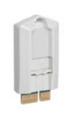

Removable memory unit for fast drive replacement parameter programming

[1]

Summary

VSD are becoming cheaper and the preferred option for motor controllers, they offer great connectivity and protection. The industrial drives on the market today are very well built and easily programmed. Choosing a well-supported market leading manufacturer is the preferred option as incorrect installation can drastically reduce its longevity and this can result in a costly reinstallation.

May drives have in built bespoke running parameters as well as dedicated PID’s controllers for cranes and pumps.

Low harmonic options as well as water cooled drives are definitely well worth investigating. May new type IGBT active drives are now on the Enhanced capitol allowance listing and users can benefit by having the total purchase and installation costs reduced by 21% if they purchase from the schemes preferred hardware list.
[3]

Task 2

Rectification.

Phase controlled rectifiers inject harmonics (current) into the electrical power network, These harmonics cause costly disturbances (covered in the next section of this assignment) in the input current. Active/passive filtering can be added to reduce this effect, extra equipment takes up more spaces and increases costs and power losses.
Component comparison table
Diode  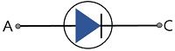  2 terminal:_ anode + Cathode | Thyristor  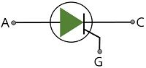3 terminal: - anode, Cathode + Gate | IGBT  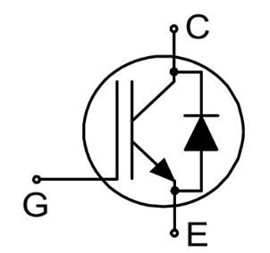  3 terminal: - anode, Cathode + Gate
2 layers p-n  Not externally triggered | 4 layers p-n-p-n  externally triggered via gate | 2 paths, p-n-p + n-p-n  externally triggered via gate, fastest switching capabilities
Cheap and simple to use and manufacture | More expensive than diode | Very expensive, precise manufacturing process and use of rare materials
High power losses and causes disturbances, requires active power factor correction | Input harmonic filtering required | Produce less input harmonics
Basic and very limited | Increased overall costs and complexity | Faster dynamic response time
clearly identifiable shouldered waveform | Better than diode | Minimises voltage notching
Low operating voltage | Low operating power factor | Increased switching ability
Component failure will prevent use , increases downtime and costs | Component failure will prevent use, increased downtime | Component failure- redundancy ensures availability- limiting downtime
May require oversized transformer, increased costs | Larger than diodes, smaller than IGBT | Buck or boost converters eliminate the need for auto-transformer. This reduces costs

Component summary
From the table both the operation of the devices vary considerably and are suited for very different applications. Diodes are better suited for logic gates and multiplier circuits whiles thyristors are mostly found in high power motor controllers, inverters and protection circuits. These are soon to be if not already superseded by IGBT in many applications where the costs and reliability are appreciated.

Proteus Simulation

6 Pulse Rectifier proteus simulator circuit
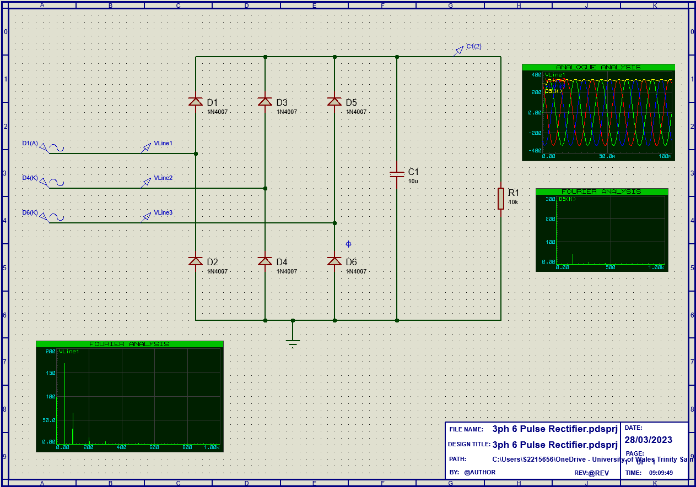

This 6 pulse diode full wave rectifier circuit shows that the THD is highest at the (fundamental)50Hz frequency and drastically reduces every 50Hz thereafter.
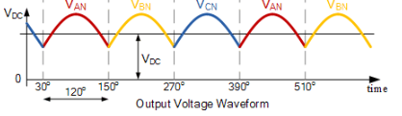
A 6 pulse diode rectifier is unable to control the output pulses, therefore the output waveform would look like this example with each of the 3 phases 120° apart. Not true DC as there is a lot of ripple present.

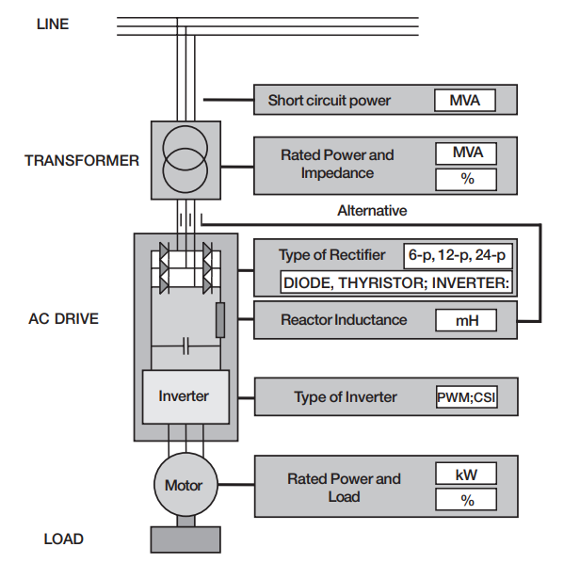

To improve harmonics, it is more cost effective to improve the internal rectifier components to minimise the current harmonics being multiplied instead of installing large costly supply line active filtering.

CAUSE | EFFECT
The larger the motor | The higher the current harmonics
The higher the motor load | The higher the current harmonics
The larger the DC or AC inductance | The lower the current harmonics
The higher the number of rectifier pulses | The lower the current harmonics
The larger the transformer | The lower the voltage harmonics
The lower the transformer impedance | The lower the voltage harmonics
[3]

Although structural modifications can be used to strengthen the supply, alternatively 12 or more pulse drives can be used in a controlled rectifier in order to improve the internal filtering.

12 Pulse Rectifier proteus simulator circuit

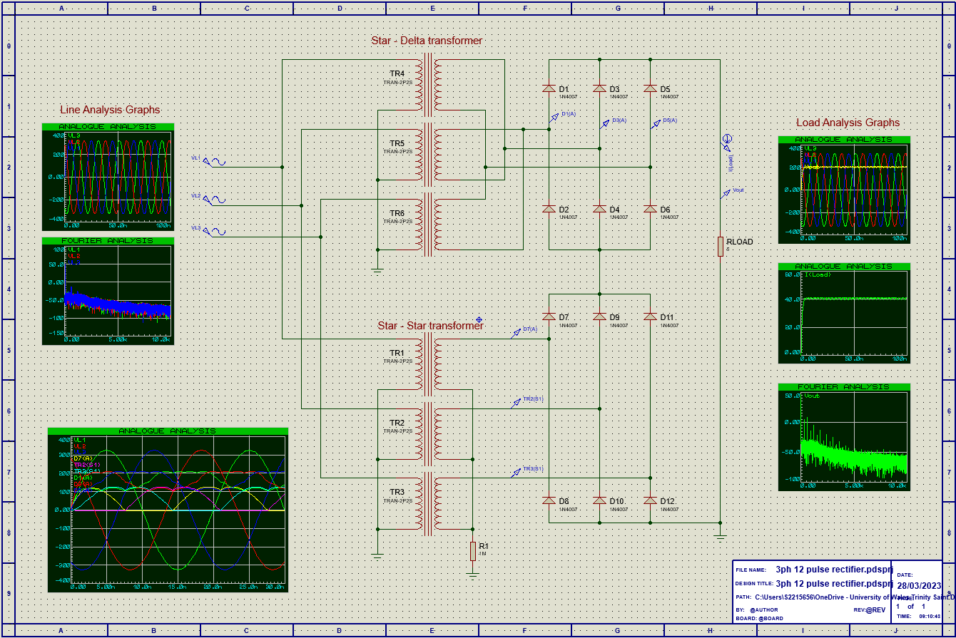

This 12 pulse rectifier circuit adds complexity and increases cost to achieve a stable and low harmonic circuit. The transformer would be costly and with multiple diodes this increases the individual component failure rate by 100%,deeming this application to be costly and increases it unreliability.

Harmonics

In an ideal world the current within the electrical grid is a pure sine wave and does not contain any harmonics.
In reality current disturbances are present and they do contain harmonic effects.
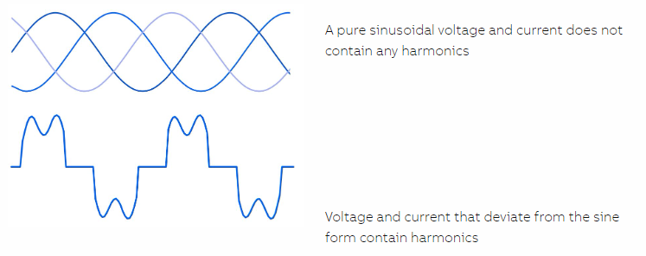

Harmonics are electrical disturbances on the network caused by non-linear loads such as PLC’s, motor starters, diode and thyristor bridges as well as UPS and Variable speed drives. These disturbances can be costly to a business as the elevated current can cause heating effects in common coupling points within the network. These can lead to premature hardware failure.

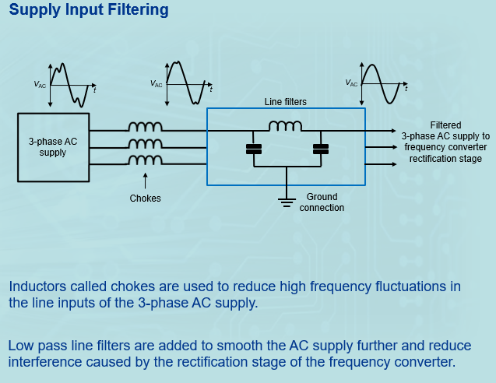
[3]

As can be seen above diagram, the incoming sine wave complete with its disturbances requires filtering to eliminate or reduce the effects on the network. It is altered by the switching devices in the rectification stage. These are known as harmonic filters.

- Apparent power is the amount of power delivered to a circuit – Measured in VA
- Active power is the portion of the apparent power used by resistive elements – Measured in W
- Reactive power is the portion of the apparent power wasted by reactive elements – Measured in VAr

Reactive power must be minimised due it being a wasted expense to a company. Large manufacturing companies like Tata Steel UK will incur huge costs by the regulator for having a poor power factor which according to present Legislation.

Harmonic Legislation
Harmonic limits are measured at the point of common coupling (PCC) these are monitored to limit the total voltage harmonic distortion (THD). Voltage distortion is dependent on system impedance, the two most common condition that can result in high impedance is the system is in resonance or the network is too weak to supply the load.
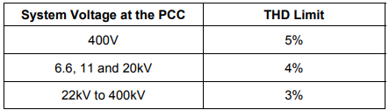
The limitations of the systems thresholds are set out in the G5/4-1 standards.

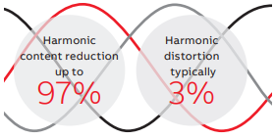
Failure to comply to these standards can be both costly to a buisness with increased failure of any machines connected to the network.

[3]

Power factor

Power factor is the angle by which the current either leads or lags the voltage, this angle is represented as cos(Φ)
cos(Φ)= to a number between 0-1, with 1 being the best as it means that both current and voltage are in phase.
A typical induction motor will have a power factor of between 0.75-0.9 at full load.

Example 1

A 3phase 415V Motor takes 10amps with a pf of 0.75=

V x I x ³√ x pf = p

415 x 10 x 1.73 x 0.75 = 5384.6watts /1000 = 5.4kW

Example 2

A 3phase 415V Motor takes 10amps with a pf of 0.90=

V x I x ³√ x pf = p

415 x 10 x 1.73 x 0.90 = 6461.5watts /1000 = 6.5kW

A difference of 1.1kW per running hour.

With our factory refit in task 1 suggesting a typical refit of 182 induction motors totalling 3742kW full load power requirements every hour.

Total electricity costs would be £118,995.00 per hour x running hrs per year (80%)

£118,995.00 x 7008 = £8,339,169.60 Average Electricity import costs per year

((31.8p/kWh of electricity January to March 2023(www.Gov)
[4]

Rectifier

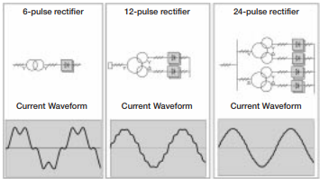
The most common rectifier circuit in 3-phase AC drives is a 6-pulse diode bridge. It consists of six uncontrollable rectifiers or diodes and an inductor, which together with a DC-capacitor forms a low-pass filter for smoothing the DC current. The inductor can be on the DC- or AC-side or it can be left totally out. The 6-pulse rectifier is simple and cheap but it generates a high amount of low order harmonics 5th, 7th, 11th especially with small smoothing inductance. If the major part of the load consists of converters with a 6-pulse rectifier, the supply transformer needs to be oversized and meeting the requirements in standards may be difficult.

Often some harmonics filtering is needed.
[5]

Increasing the amount of pulses moves the harmonics further down the spectrum and reduces the overall effect on the lower orders. Unfortunately 24 pulse transformers are extremely expensive and require a long build time.

Using an IGBT bridge rectifier in a Variable speed drive(VSD)

Introducing an IGBT rectifier bridge within a VSD, brings several benefits as the hardware allows both rectification and regeneration, by delaying the firing angle over 90° allows the DC voltage to go negative, sending power back to the power supply..

Advantages | Disadvantages
Able to boosts weak networks | High costs
Regenerative option | Some extra filtering
Lowest harmonic disturbance
Independence ride through on component failure
High reliability
High current switching capability
Very reliable

Example Waveform

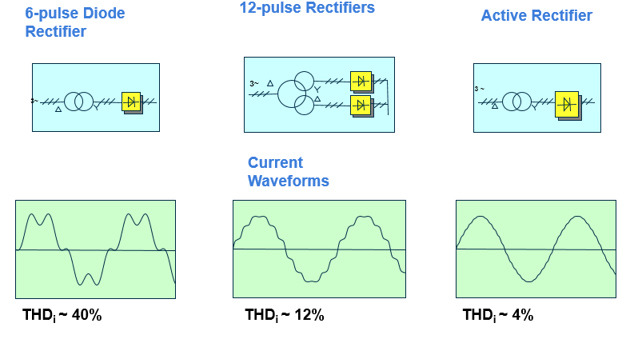

Using an active IGBT rectifier can eliminate the requirement of costly bespoke transformers whilst they can achieve an almost perfect sine wave.
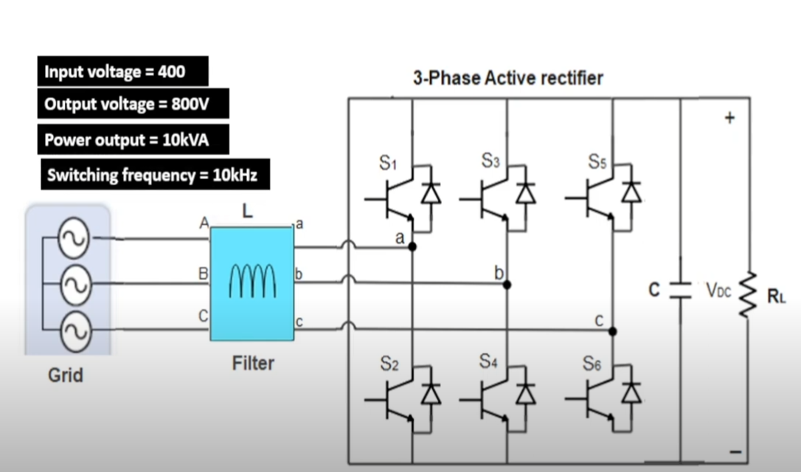
[6]
With the ability to delay the firing angle as the IGBT requires a triggering pulse to switch it on makes it possible to control the DC-voltage level and displacement power factor separately, Regardless of the power flow direction.

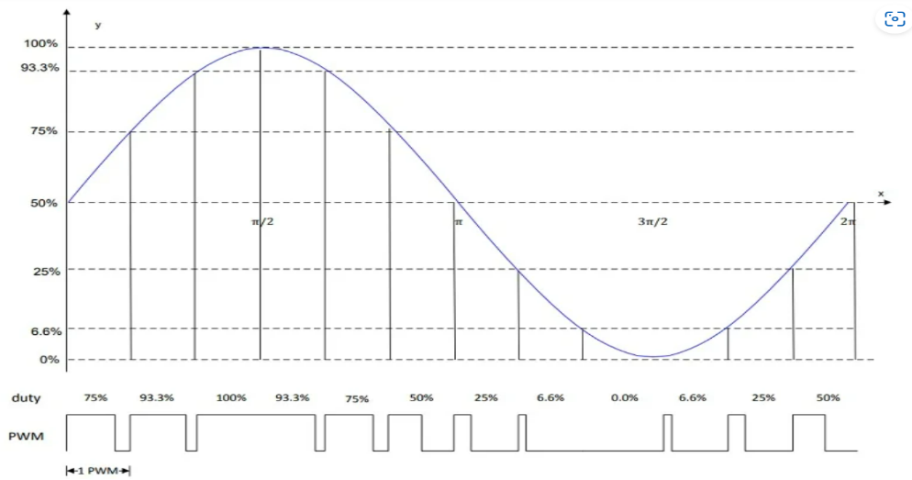

Pulse Width Modulation

By switching the IGBT ON or OFF time at a very high frequency reduces the average amount of electrical power a device requires.

Keeping the pulses ON to best suit the application will increase the overall average.

[7]

Regeneration

Regeneration of energy The ACS880 offers a number of solutions for applications where electrical braking is needed. As standard, ACS880 drives have a flux braking feature that provides greater deceleration by increasing the motor flux. If this is not sufficient, the internal brake chopper can be used together with a brake resistor. The most advanced solution is the ACS880 regenerative drive variant, which allows, continuous braking, providing the possibility for remarkable energy savings. ACS880 also supports common DC bus configurations, where the braking energy from one load can be utilized by other loads

[1]

Power savings using Variable Speed Drives (Cube law)

Energy savings can be made on centrifugal loads, by slowing the load down or varying the frequency as shown on the affinity curve.
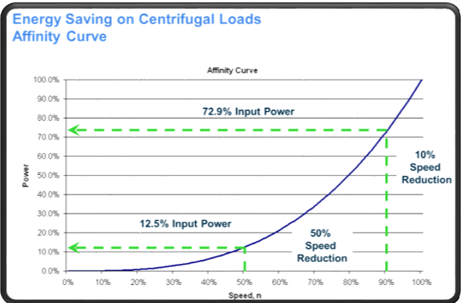
Reducing the driven speed of a centrifugal pump (as suggested in task 1) by 10% the input power requirement would reduce by the cube ie; 0.9x0.9x0.9= 0.729 or 73% therefore a power savings of almost 27%.
If the speed is reduced by 10% then the flow is also reduced by 10%
The delivery pressure would also be reduced by ² of the reduction 0.9x0.9= 0.81 or reduced by 19%

By reducing the driven speed of a centrifugal pump by 50% the input power requirement would reduce by the cube ie; 0.5x0.5x0.5= 0.125 or 12.5% therefore a power savings of 87.5%.

Additional information

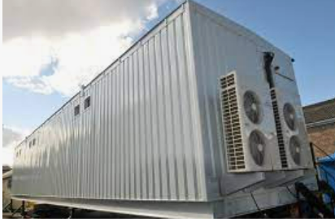
Keeping drives cool and their airflow clean is paramount in maximising their longevity. Due to the size, weight and capacity of installing multiple large drives. It may be an option to house them all within a bespoke container type room as supplied by Bradgate containers (www.bradgate.co.uk). The addition of an air cooler, air filtration, all are fully installed within a climate controlled container and would provide a very stable environment to help maximise the drives longevity.

Some of the auxiliaries could even be run from the regenerative power supplied by efficiently running a rolling mill, which is a batch type process, using a common DC Bus to supply the power to all available drives. [6]

As can be seen from the offerings above in task 1 the chosen 630kW drive is capable of outputting a massive 29kW of heat and demands 7220m³/hr of clean air for efficient cooling per unit. Any restrictions will quickly reduce the life cycle of the drive. Inefficient cooling and heating effects the hardware enormously and can quickly cause premature, unplanned failure. Repairs can be expensive as the main switching components are made of rare materials and are manufactured in specialist air controlled clean rooms.

EU Ecodesign Regulation (inc UK)


Minimum efficiency levels are a mandatory requirement and even more stringent and demanding regulations have been implemented for low voltage DOL induction motors but also for VSD with voltages up to 1000V.
The more stringent mandatory regulation (EU)2019/171 replaces the 640/2009 version.
- Efficiency level mandatory for AC drives.
- Power range from 0.12 to 1000 kW.
- 3-phase drives with diode rectifier including ABB’s micro, machinery, general purpose, industrial and industry-specific drives.
- Drive manufacturers must declare power losses in percentage of the rated apparent output power at 8 different operating points as well as standby losses. The international IE level is given at the nominal point.
- Drives fulfilling the requirements will be CE marked.

All the researched ABB products in this assignment fulfil the requirements above.
[7]

Datasheets, Website and document links

Schneider ATS48C66Q- soft starter- Altistart_48_ATS48C66Q.pdf (rs-online.com)
Siemens 3RW5248 – Soft starter - A700000007242940.pdf (rs-online.com)
ABB ACS880-17 manual- ACS880-17 (160 to 3200 kW) manuals (abb.com)
Siemens drive 6SL3330-6TE41-1AA3- Smart Line Modules - Industry Mall - Siemens WW
Drive Application Programming - Software tools | ABB
ABB Drive and Motor Selector
3RA1445-8XC21-1AG2 Siemens (wiautomation.com)- Star delta starter
WEG- Product specifications | WEG SSW07 Soft Starter For Three Phase Motor, 110kw from The Inverter Drive Supermarket 10233131 | Google Shopping
Siemens- Product Details - Industry Mall - Siemens WW
ABB Drive and Motor Selector
Datasheet - DE1-34011FN-N20N (eaton.com)
150-C25NBR | Allen Bradley 11 kW Soft Starter, 460 V ac, 3 Phase, IP2X | RS (rs-online.com)
RS PRO 7.5kW @ 400Vac Soft Starter, 187 → 575 V ac, 3 Phase, IP42, 15 Amps | RS (rs-online.com)

Siemens 3RK4353-3PR58-1BA0 | Siemens 5.5 kW DOL Starter, 400 V ac, 3 Phase, IP54 | RS (rs-online.com)
Power system design-Active Front End Rectifier (powersystemsdesign.com)
Allen Bradley - https://docs.rs-online.com/4b6f/0900766b8160f9d2.pdf
ABB Drive and Motor Selector
ABB- PDF link harmonic Technical_Guide6_EN.pdf

Quotes
ABB quote to supply motor starters A-E quote: OPP-23-5981042

Biblography

[1] | ABB, “Low Voltage Industrial AC drives,” 2022. [Online]. Available: https://search-ext.abb.com/library/Download.aspx?DocumentID=3AUA0000098111&LanguageCode=en&DocumentPartId=1&Action=Launch. [Accessed 02 2023].
[2] | Siemens, “Sirus MCU Motor starter,” Radio Spares, 03 2009. [Online]. Available: https://uk.rs-online.com/web/p/motor-starters/6656277. [Accessed 02 2023].
[3] | Carbon Trust, “Motors and drives,” 02 2014. [Online]. Available: https://assets.publishing.service.gov.uk/government/uploads/system/uploads/attachment_data/file/376182/ECA764_Motors_and_drives.pdf. [Accessed 03 2023].
[4] | ABB, “Tech guide 6 AC drive Harmonics,” 5 2020. [Online]. Available: www.abb.com/motors&drives. [Accessed 04 2023].
[5] | ABB, “Overcome Challenges of harmonics,” 2023. [Online]. Available: https://new.abb.com/drives/harmonics. [Accessed 04 2023].
[6] | Gov, “Energy bills 2023,” 01 2023. [Online]. Available: https://www.gov.uk/government/publications/energy-bills-support/energy-bills-support-factsheet-8-september-2022#:~:text=33.2p%2F%20kWh%20(pence%20per,2022%20to%2030%20June%202023. [Accessed 04 2023].
[7] | J. Dodge, “Active front end rectifier,” 15 03 2022. [Online]. Available: https://www.powersystemsdesign.com/articles/active-front-end-rectifier/22/18747. [Accessed 04 2023].
[8] | Control Automation, “Pulse Width Modulation,” 03 2000. [Online]. Available: https://control.com/technical-articles/understanding-the-basicsof-pulse-width-modulation-pwm/. [Accessed 04 2023].
[9] | Bradgate, “Bradgate containers,” 01 2023. [Online]. Available: https://www.bradgate.co.uk/content/about-bradgate-container-housing-manufacturers-bradgate-containers. [Accessed 04 2023].
[10] | GOV, “Commission Delegated Directive (EU) 2019/171,” 02 2020. [Online]. Available: https://www.legislation.gov.uk/eudr/2019/171. [Accessed 04 2023].
[11]

Word count Total 1870

