

Investigating the Role of Communication in the Business Environment - Tesco

Student Name: Nicuşor-lonut Mihai
Student ID: 2514112
Module: LCBB4009
Date of Submission: 23/04/2026
Report structure
1. Introduction 3
2. Communication and Methods 3
3. Common Issues 5
4. Recommendations 6
5. Conclusion 6
6. References 7

Introduction

In my opinion, communication is a key element in any business environment because it allows employees and managers to share information, coordinate activities and achieve organisational goals. Without effective communication, even well-structured organisations can face serious problems such as confusion, low productivity and poor decision-making.
The purpose of this report is to analyse the role of communication in a business context and to understand how it works in practice. The report will discuss different communication methods used in organisations, identify common communication issues, and provide practical recommendations for improvement.
In today’s business environment, communication has become even more important due to globalisation and the use of digital technologies. Companies are no longer limited to one location, and employees often need to communicate across different departments, cities or even countries. This makes communication more complex and increases the need for clear and effective methods. At the same time, organisations must ensure that information is shared quickly but also correctly, which can be a challenge. Understanding how communication works in practice can help organisations avoid problems and improve both internal processes and relationships with customers.
This report will focus on Tesco as a case study. Tesco is one of the largest retail companies in the United Kingdom, operating a wide network of stores and services. Due to its size and complexity, communication is essential for maintaining coordination between departments and ensuring efficient operations (Tesco plc, 2023).

Communication and Methods

Communication in a business context refers to the process through which information, ideas and messages are exchanged between individuals or groups within an organisation. Effective communication means that the message is clearly transmitted and correctly understood by the receiver, which reduces errors and improves performance (CFI, 2023).
In large organisations such as Tesco, communication plays a crucial role in connecting different levels of management and ensuring that employees understand their responsibilities. For example, head office communicates strategic decisions, while store managers communicate operational tasks to employees.
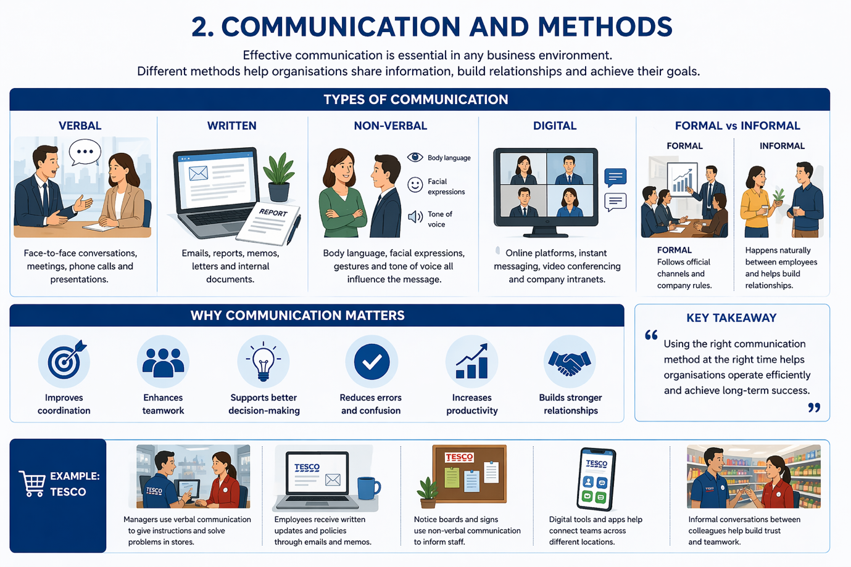
There are several communication methods used in businesses. One of the most common is verbal communication, which includes meetings, discussions and phone calls. This type of communication allows quick interaction and immediate feedback. In Tesco, verbal communication is often used by managers to give instructions and solve problems directly in stores.
Another important method is written communication, such as emails, reports and internal documents. Written communication provides a permanent record and helps ensure consistency. Tesco uses internal systems and emails to share updates, policies and instructions across departments.
Non-verbal communication is also relevant, even if it is sometimes underestimated. Body language, facial expressions and tone of voice can influence how a message is interpreted. For instance, a confident and clear communication style can increase employee motivation.
In addition, digital communication has become essential in modern organisations. Tools such as online platforms, messaging systems and video conferencing allow fast communication across different locations. Tesco relies on digital systems to manage operations and connect employees across stores.
Another distinction is between formal and informal communication. Formal communication follows official channels and procedures, while informal communication happens naturally between employees. Both types are important, as formal communication ensures structure and control, while informal communication supports relationships and teamwork (Investopedia, 2024).
Overall, effective communication helps organisations improve efficiency, reduce mistakes and support better decision-making.

Common Issues

Despite its importance, communication in organisations is not always effective. There are several common issues that can affect how information is shared and understood.
One of the most common problems is miscommunication, which occurs when a message is not clearly understood or is interpreted incorrectly. In a large organisation like Tesco, miscommunication can lead to operational errors, such as incorrect product orders or misunderstandings between staff and management. This can also affect customer satisfaction.
Another issue is information overload. Employees may receive too many emails, messages or instructions in a short time. As a result, important information can be ignored or missed. In a company like Tesco, where communication is constant, this problem can reduce efficiency.
Cultural and language barriers also play an important role. Tesco employs people from different backgrounds, and differences in language or communication style can create misunderstandings. For example, some employees may prefer direct communication, while others may find it uncomfortable.
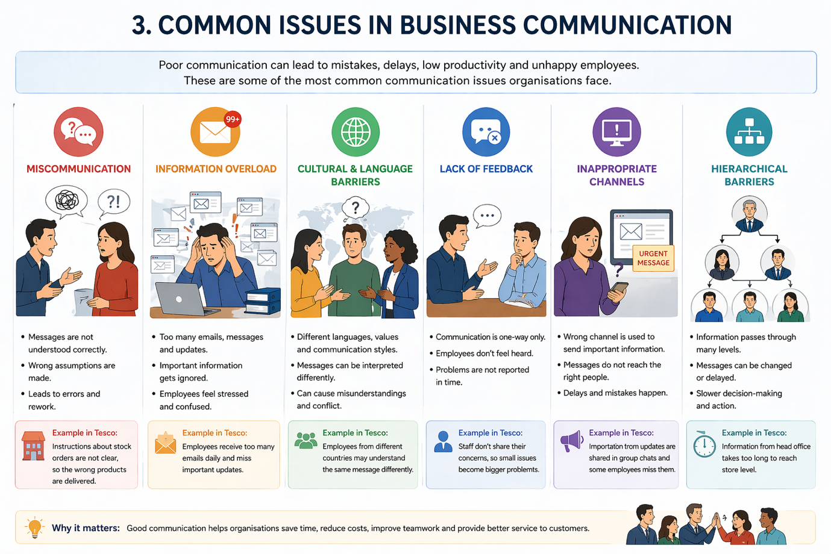
A further issue is the lack of feedback. Communication should be a two-way process, but sometimes employees do not have the opportunity to ask questions or express their opinions. This can lead to confusion and reduce employee engagement.
Inappropriate communication channels can also create problems. If the organisation does not use the correct method for a message, it may not reach the right people. For instance, important information shared only through informal communication may not be taken seriously.
Finally, hierarchical barriers can slow down communication. In large organisations, information often passes through multiple levels of management, which can delay communication and sometimes change the original message.
In Tesco, these issues can appear due to the size and complexity of the organisation. If not managed properly, they can affect both internal performance and customer experience.

Recommendations

Personally, I think that to improve communication, organisations like Tesco should focus on several practical strategies.
First of all, communication should be clear and structured. Messages should be simple and easy to understand in order to reduce misunderstandings.
Second, organisations should use appropriate communication channels depending on the situation. For example, urgent information should be communicated verbally, while important details should be confirmed in writing.
Encouraging feedback is also essential. Employees should be able to ask questions and share their opinions, which can improve understanding and engagement.
Training programmes can help employees and managers develop better communication skills, especially in dealing with cultural differences and teamwork.
Finally, companies should try to manage information flow more effectively by prioritising important messages and avoiding unnecessary communication.
These strategies can help Tesco improve communication and create a more efficient and collaborative work environment.

Conclusion

In conclusion, communication is a fundamental part of any business organisation. It plays a key role in coordinating activities, improving understanding between employees and supporting the achievement of organisational goals. Without effective communication, even a well-structured company can face difficulties such as confusion, delays and reduced productivity. Communication helps ensure that everyone in the organisation understands their responsibilities and works towards the same objectives.
This report has shown that communication can take many forms, including verbal, written, digital and non-verbal methods. Each of these methods has its own advantages and is used in different situations depending on the needs of the organisation. For example, verbal communication is useful for quick decisions, while written communication provides a clear record. Digital communication is also becoming more important, especially in large organisations where employees are located in different places.
At the same time, communication challenges such as miscommunication, information overload and cultural differences can negatively affect performance if they are not managed properly. These issues can lead to mistakes, misunderstandings and lower employee motivation. In large organisations like Tesco, these problems can be more visible because of the number of employees and the complexity of operations. Therefore, it is important for organisations to recognise these challenges and take action to reduce their impact.

For Tesco, effective communication is essential due to its size and structure. By improving communication practices, encouraging feedback and using appropriate tools, the company can reduce errors and improve efficiency. Managers also have an important role in making sure that communication is clear and consistent across all levels. Overall, strong communication supports teamwork, helps organisations adapt to change and is very important for long-term success in a competitive business environment.

References

- Corporate Finance Institute (2023) Business Communication. Available at:
https://corporatefinanceinstitute.com/resources/management/organizational-structure/
- Investopedia (2024) Business Communication. Available at:
https://www.investopedia.com/terms/b/business-communication.asp
- Tesco plc (2023) About Tesco. Available at:
https://www.tescoplc.com/about/
- Mullins, L.J. (2019) Organisational Behaviour in the Workplace. Pearson
Robbins, S. & Coulter, M. (2021) Management. Pearson

