Rate Of Reaction

Lab Report

Thomas Lumsden OME Chemistry
2427105

Table of Contents

1 | Introduction | 3
1a | Purpose of experiment | 3
1b | Hypotheses undergoing testing | 3
1c | Variables | 3
2 | Theory | 3
2a | Basic concepts, principles and laws, definitions | 3
2b | Equations & Formulas | 4
2c | Relevance of experiment to OME | 4
3 | Results | 4
3a | Experimental Data | 4
3b | Calculations
4 | Discussion | 4
4a | Interpretation of Experimental Data | 4
4b | Limitations or potential error | 5
5 | Conclusions | 5
6 | References | 5
7 | Appendix | 6
7a | Materials & Equipment | 6
7b | Experimental Procedure | 6

1. Introduction

a) Purpose of experiment
The purpose of this Rate of Reaction experiment is to determine the effect of concentration, temperature and surface area on the rate of reaction by measuring how quickly reactants are transformed into products in the reaction. In this case it is magnesium reacting with hydrochloric acid.

b) Hypotheses undergoing testing
As the concentrations, temperature and surface area of hydrochloric acid increase, the solutions will have a higher rate of reaction when reacted with magnesium.

c) Variables
Mass of Magnesium strips: 0.0765
Mass of Magnesium sheddings: 0.0821

2. Theory

- Basic concepts, principles and laws, definitions

Concentration of the solution:
The concentration of the hydrochloric acid is defined as the amount of the solute in the overall solution. The solution being hydrochloric acid and water, so the less water and the more HCl, the higher the molarity of the solution. The higher the molarity of the solution, the higher the rate of reaction should be.

Temperature of the solution:
The temperature of the given solutions determines the rate of the reaction, as the higher the temperature of the solution, the faster the magnesium will dissolve, resulting in a higher rate of reaction.

Surface area of the solution:
Increasing the surface area of the reactant in a solution accelerates the reaction rate because it provides more sites for collisions between reactants. In this case it is using sheddings of magnesium instead of strips that were used to find the concentration and temperature rates.

- Equations & Formulas

To find the rate of a reaction from a graph, find the slope of the gradient at the start of the reaction (at t = 0) where the change in concentration with respect to time is the greatest.

$$rate= \frac{∆V_{H2}}{∆t}$$

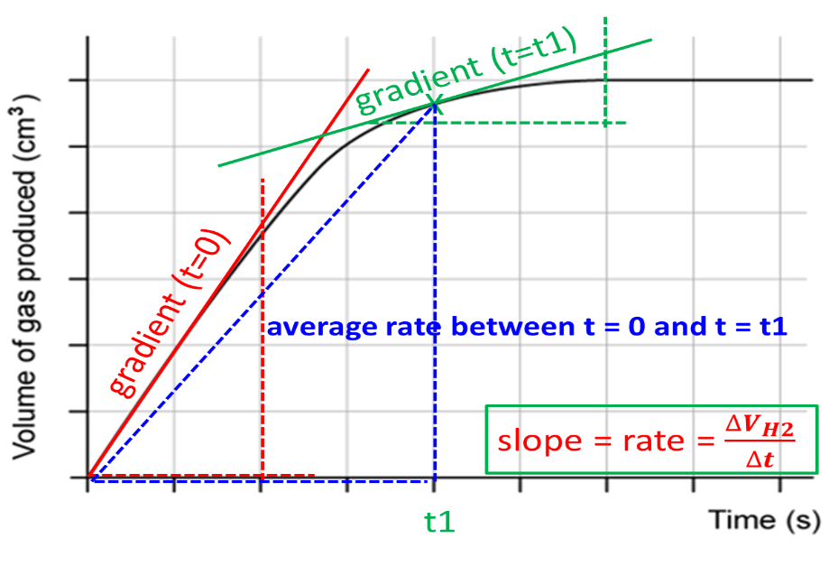
The rate of reaction can also be determined at any time, t, (instantaneous rate) by plotting the gradient at the selected time and calculating its slope.

c) Relevance of experiment in OME
An example of a Rate of Reaction experiment being used in the OME industry is the High Explosive Initiation Time (HEIT). Which “assesses the intrinsic sensitivity of energetic materials based on their reaction rates.” This experiment is used to provide a precise assessment of the high-temperature reaction kinetics for the chemical decomposition of explosive materials. The HEIT test measures decomposition kinetics under extreme conditions. This experiment demonstrates how quickly energy is released, which directly correlates with an explosive's sensitivity and stability [1].

A rate of reaction was also used in the Trinity test and played a crucial role in determining the efficiency and effectiveness of the implosion system and the nuclear reaction itself. The rate of reaction experiment was crucial in verifying that the implosion system worked as intended, measuring the actual efficiency of the nuclear reaction, and providing critical data for the future development of nuclear weapons.

3. Results

- Experimental data

Balanced Chemical Equation:

2HCl + Mg H₂ + MgCl₂

Mg |  | 2 M HCl
mass | moles | volume | moles
0.0765 | 0.00315 | 20ml | 2
0.0765 | 0.00315 | 15ml | 1.5
0.0765 | 0.00315 | 10ml | 1
0.0765 | 0.00315 | 5ml | 0.5

I. Effect of concentration of HCl on speed of H₂ gas evolution:
0.5 M HCL |  |  | 1.0 M HCl |  |  | 1.5 M HCl |  |  | 2.0 M HCl
 |  |  | T 1 = 23.9
time, (20s) | V H2, mL |  | time, (10s) | V H2, mL |  | time, (10s) | V H2, mL |  | time, (10s) | V H2, mL
10 | 1 |  | 10 | 6 |  | 10 | 21 |  | 10 | 30
20 | 2 |  | 20 | 11 |  | 20 | 35 |  | 20 | 45
40 | 4 |  | 30 | 15 |  | 30 | 45 |  | 30 | 50
60 | 6 |  | 40 | 19 |  | 40 | 55 |  | 40 | 55
80 | 8.5 |  | 50 | 22 |  | 50 | 57 |  | 50 | 60
100 | 10 |  | 60 | 27 |  | 60 | 58 |  | 60 | 64
120 | 13.5 |  | 70 | 30 |  | 70 | 60 |  | 70 | 67
140 | 15 |  | 80 | 33 |  | 80 | 62 |  | 80 | 67
160 | 16 |  | 90 | 35 |  | 90 | 64 |  | 90 | 67
180 | 18 |  | 100 | 38 |  | 100 | 65 |  | 100
200 | 19 |  | 110 | 40 |  | 110 | 67 |  | 110
220 | 22 |  | 120 | 43 |  | 120 | 68 |  | 120
240 | 24 |  | 130 | 45 |  | 130 | 70 |  | 130
260 | 26 |  | 140 | 47 |  | 140 | 70 |  | 140
280 | 27 |  | 150 | 49 |  | 150 | 70 |  | 150
300 | 28 |  | 160 | 51 |  | 160 |  |  | 160
320 | 30 |  | 170 | 52 |  | 170 |  |  | 170
340 | 30.5 |  | 180 | 53 |  | 180 |  |  | 180
360 | 31 |  | 190 | 54 |  | 190 |  |  | 190
380 | 32 |  | 200 | 55 |  | 200 |  |  | 200
400 | 32 |  | 210 | 55 |  | 210 |  |  | 210
420 | 33 |  | 220 | 56 |  | 220 |  |  | 220
440 | 34 |  | 230 | 56 |  | 230 |  |  | 230
460 | 35 |  | 240 | 56 |  | 240 |  |  | 240
480 | 35 |  | 250 | 56 |  | 250 |  |  | 250
500 | 36.5 |  | 260 | 56 |  | 260 |  |  | 260
520 | 36.5 |  | 270 | 56 |  | 270 |  |  | 270
540 | 38 |  | 280 | 56 |  | 280 |  |  | 280

[HCl] | time to dissolve Mg | average rate | instantaneous rate at
[HCl] | time to dissolve Mg | average rate | t = 0 s
0.5 M | 540s | 0.07037M/s | 0.1M/s
1.0 M | 280s | 0.2M/s | 0.55M/s
1.5 M | 150s | 0.46666M/s | 1.75M/s
2.0 M | 90s | 0.74M/s | 3M/s

II. Effect of temperature on speed of H₂ gas evolution
T 2 = 45.3 |  |  | T 3 = 61.8 |  |  | T 4 = 26.8
time, s | V H2, mL |  | time, s | V H2, mL |  | time, s | V H2, mL
10 | 20 |  | 10 | 23 |  | 10 | 15
20 | 32 |  | 20 | 34 |  | 20 | 28
30 | 40 |  | 30 | 44 |  | 30 | 36
40 | 46 |  | 40 | 49 |  | 40 | 45
50 | 53 |  | 50 | 54 |  | 50 | 52
60 | 58 |  | 60 | 57 |  | 60 | 58
70 | 59 |  | 70 | 58 |  | 70 | 63
80 | 60 |  | 80 | 59 |  | 80 | 68
90 | 61 |  | 90 | 60 |  | 90 | 71
100 | 61 |  | 100 | 61 |  | 100 | 71
110 | 62 |  | 110 | 61 |  | 110 | 72
120 | 63 |  | 120 | 62 |  | 120 | 72
130 | 63 |  | 130 | 62 |  | 130 | 72
140 | 64 |  | 140 | 63 |  | 140 | 73
150 | 64.5 |  | 150 | 63 |  | 150 | 73
160 | 65 |  | 160 | 63 |  | 160 | 74
170 | 66 |  | 170 | 63 |  | 170 | 74

temperature | time to dissolve Mg | average rate | instantaneous rate at
temperature | time to dissolve Mg | average rate | t = 0 s
T 1 | 170s | 0.2M/s | 0.55M/s
T 2 | 220s | 0.388M/s | 2M/s
T 3 | 170s | 0.371M/s | 2.3M/s
T 4 | 170s | 0.435M/s | 1.4M/s

Mg turnings |  | rate
mass | moles | average | instantaneous at t = 0s
0.0821g | 0.00338 | 0.324M/s | 0.75M/s
III . Effect of the surface area of Mg on speed of H₂ gas evolution
T 1 = 23.9
time, s | V H2, mL
10 | 10
20 | 16
30 | 24
40 | 30
50 | 35
60 | 39
70 | 43
80 | 46
90 | 50
100 | 52
110 | 55
120 | 57
130 | 59
140 | 61
150 | 62
160 | 63
170 | 64
180 | 65
190 | 66
200 | 67
210 | 68

b) Calculations
temperature | average rate | instantaneous rate at
temperature | average rate | t = 0 s
T 1 | 56/280=  0.2M/s | 11/20=  0.55M/s
T 2 | 67/170=  0.388M/s | 20/10=  2M/s
T 3 | 63/170=  0.371M/s | 23/10=  2.3M/s
T 4 | 74/170=  0.435M/s | 28/20=  1.4M/s

[HCl] | average rate | instantaneous rate at
[HCl] | average rate | t = 0 s
0.5 M | 38/540=  0.07037M/s | 6/60=  0.1M/s
1.0 M | 56/280=  0.2M/s | 11/20=  0.55M/s
1.5 M | 70/150=  0.46666M/s | 35/20=  1.75M/s
2.0 M | 67/90=  0.74M/s | 30/10=  3M/s

4. Discussion

a) Interpretation of Experimental Data
For the initial rate of concentration reaction, the data that was gathered from the experiment was expected, as the rate of the reaction increased when the molarity of the solution was higher. The instantaneous rates were also increasing.

The temperature rate values were also expected, as the solutions with the higher temperature had higher rates, since the magnesium was dissolved quicker.

b) Limitations or potential error
Exposure of the magnesium to air before it is used within the experiment could hinder the heat transfer, resulting in inaccurate readings. The layer of oxidation can impede on the rate at which the aluminium is dissolved at in the liquid, this increases the time it takes for the magnesium to be fully dissolved, resulting in an inaccurate value for the rate at which the magnesium dissolves at.

Another cause for potential error is not keeping the gas syringe perpendicular. This could hamper the rate at which the syringe fills with gas, as the gas takes longer to travel through the syringe if it is tilted upward. This gives an incorrect interpretation of the rate at which the gas is being emitted by the reaction, as it would be filling slower than expected.

5. Conclusion

In conclusion, the rate of reaction experiment was successfully conducted. Increasing rates were collected when the concentrations, temperatures and surface area of the solutions were higher.

6. References

[1] V.W. Manner, M.J. Cawkwell, K.D. Spielvogel, D.G. Tasker, J.W. Rose, M.Aloi, R.Tucker, J.D. Moore, M.C. Campbell, T.D. Aslam. “An Integrated Experimental and Modeling Approach for Assessing High-Temperature Decomposition Kinetics of Explosives”. Journal of the American Chemical Society 2024 146 (38), 26286-26296

7. Appendix

a) Materials & Equipment
Chemicals:
- Magnesium ribbon cut into 4 cm length and weighed
- Magnesium powder (same mass as ribbon)
- Hydrochloric acid (2.0 M and 1.0 M)
- DI water
Equipment:
- Long test tube with arm
- Gas syringe
- Rubber bung and delivery tube to fit the test tube
- Two large beakers for the water bath and reaction mixture
- Pipette and pipette filler
- Two clamp stands
- Test tube holder
- Thermometer
- Ring stand, Bunsen burner, clay triangle
- Stopwatch
- Graph paper

b) Experimental procedure

Effect of HCl concentration on the speed of H₂ gas evolution
- Have four 20.0 mL solutions of HCl prepared with the concentrations: 2.0 M, 1.5 M, 1.0 M & 0.5 M. Have the pipette measure the appropriate volumes of the 2.0 M HCl solution and DI water.
- Pour the HCl solution with the lowest concentration into the test tube with arm.
- Add 4 cm strip of magnesium ribbon to the test tube and quickly put the bung back and start the stopwatch.
- Record the volume of hydrogen gas given off at 10 second intervals. Continue timing until no more gas is given off.
- After the reaction is completed, discard the reaction mixture in the waste beaker.
- Measure the temperature of 1.0 M HCl.
- Repeat the same experiment for the other three concentrations of HCl.

Effect of temperature on the speed of H₂ gas evolution
- Set up a water bath. Pour water into the large beaker and heat it over the Bunsen burner till the temperature of water increases by approximately 10˚C when compared to the initial temperature of 1 M HCl measured in the previous part.
- Pipette 20 mL of 1.0 M stock solution into three test tubes.
- Place the first test tube with 1.0 M HCl in the water bath and wait until the temperature of the acid reaches the temperature of the water in the water bath.
- Quickly transfer the warm HCl into the tube with the arm, put 4 cm piece of magnesium ribbon, put the bung back, and start the stopwatch.
- Continue timing until no more gas is given off.
- After the reaction is completed, discard the reaction mixture in the waste beaker.
- Repeat the same experiment for two more temperatures (ideally 10˚C apart).

- Effect of the surface area of Mg on speed of H₂ gas evolution
- Use the pipette to transfer 20 mL of 1 M HCl at room temperature into the test tube with arm.
- Quickly add the Mg turnings into the test tube, put the bung back, and start the stopwatch.
- Continue timing until no more gas is given off.
- After the reaction is completed, discard the reaction mixture in the waste beaker.

End

