BSc applied computing


An investigation into the “minimalistic approach” of software development to help users.

Student name: Keelan Rochard

Supervisor name: Jeanette Adams

Date: 26/03/2020

Acknowledgements
Thank you to my parents who said I could create this project when I didn’t believe them.

Thank you to Kirsty Philips who gave me all the emotional support when I needed it.

Thank you to Cyrus and Marcus Ryan for helping me get through this project and many others like this through your music.

Thank you to Christopher Manley I would not have made this project if he did not convince me to take this course all that time ago.

Finally thank you Jeanette Adams who has been the best teacher, tutor and guide on this project I could not have done this without you.

ABSTRACT

This research project has been carried out over several months and was made to determine if minimalistic design in user interfaces is the way forward. This has been done through extensive research on what minimalistic design is, how users can benefit from minimalistic design and a comparison of two or more systems one with minimalistic design implemented to test against real-time users and discover if the hypothesis can be determined true, false or something else entirely.
The project’s aim was “To outline whether a minimalistic approach to software interface design helps users work more efficiently” the project aims will follow: To conduct primary research within the NPTC Neath campus and analyse the EPOS System. To conduct a detailed study of academic literature using research methodologies and critically review. Design and implement an EPOS system based on knowledge gained from the literature review. Evaluate the success of the new system and identify plans for future modifications.
The project has use research methods including primary and secondary research, experiments and questionnaires to help with the findings. The findings were that the system was a success and liked among employees of the college however did not prove faster in the testing process this could be because of the learning curve of the new system needed to be bigger however the project timeline was not equipped to handle this. The conclusions and recommendations to make are that the project should have more user input and to actually have an experienced programmer create a fully functioning till system tested against actual customers.
The final conclusion and recommendations I would make is to maybe use different software for designs I believe the mock ups and wire frames could have easily been made in Microsoft power point to make the speed of the design process go faster. The designs were originally made in adobe illustrator and visual basic which took time to get used to these systems again when I could have already used a software I was familiar with to complete this stage.

Contents
CHAPTER 1 - INTRODUCTION 5
CHAPTER 2 - RESEARCH & REVIEW OF LITERATURE 6
CHAPTER 3 - RESEARCH AND/OR DEVELOPMENT METHODOLOGY 19
CHAPTER 4 - DESIGN & IMPLEMENTATION 26
CHAPTER 5 – EVALUATION 34
CHAPTER 6 - CONCLUSIONS AND RECOMMENDATIONS 37
CHAPTER 7 – REFLECTION 39
CHAPTER 8 – REFERENCES 42
‌CHAPTER 9 - APPENDICIES 47

CHAPTER 1 - INTRODUCTION

Introduction
This research project will be carried out over the next several months and will determine if minimalistic design in user interfaces is the way forward. This project has decided to use this theory as it is somewhat original and after some basic searches it is not found as a common or proven theory. This will be done through extensive research on what minimalistic design is to provide background research and find an effective definition, where you can find minimalistic design over various different examples over the globe in different environments. Also a comparison of two or more systems will be used to prove this theory, one with minimalistic design implemented to test against real-time users and discover if the hypothesis can be determined true, false or something else entirely. The project will also use a research method to lay out how the project will be structured. This will most likely be the research onion as it is a solid methodology to follow with various paths the project can take. The actions that will take place during the project’s generation is to use user testing and questionnaires to tell if the new system meets the user’s satisfaction and faster serving time than the current system, proving or disproving the theory. This action also allows the use of primary data to be collected and which can be qualitative and quantitative data to draw a clear conclusion that the user liked the minimalistic approach or not.
To summarise, the main areas the report will show is the background research of minimalism design. Then the report will show the research methods and planning techniques the project will use. Finally, the report will display design elements of the project as well as the implementation and reflection of how the project could be produced more efficiently.

CHAPTER 2 - RESEARCH & REVIEW OF LITERATURE

1 Introduction to the literature review
The following section in this report is the review of different types of arguments and comparisons of what minimalistic design. Application design and the separation of apps to split and minimalize tasks, physical hardware design of phones that have changed over different models to become more minimalistic. Logo design and a comparison of minimal logos and complicated logos. Physical object design with a small finding of minimalistic and complicated design accomplishing the same goal. The literature review will also examine established design rules to draw out comparisons and why minimalistic design is included through these rules. The report will also look at other till systems and what to take on with regards to design and layout. Finally, the report will also consider some academic sources of how to implement minimalistic design and were it is used in terms of advertising and computer user documentation which are credible sources to use during the final design and implementation of the project.

  - What is minimalistic design?
According to the painter, Frank Stella [1], minimalistic design is defined as “What you see is what you see”. This means that there is nothing else to see with the design except for what has been designed.

Minimalistic design is where you utilise design to its crucial and necessary points only. There is no need for any extra functions or features that do not need to be there if they do not benefit the design greatly. Here are two designs of a kettle, a household item, used to heat water for consumable needs. The kettle on the left, although it appears minimalistic with its aluminium metal body, has a lot of settings and functions on the handle when a kettle primarily does not need all of those functions. The kettle on the right is designed this way on purpose. As it is a reinvention of the kettle there are no buttons or different functions on the kettle. It is simply a kettle. [5] [6]
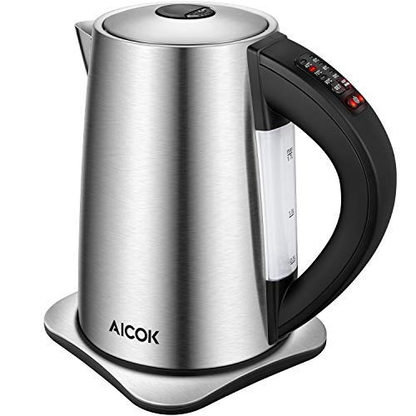
[5] [6]

  - Minimalistic design in computing
Minimalistic design can be applied to graphic design where people are employed to make logos or videos look minimalistic and sleek as possible. This is to create a professional approach and to not overload the user with information with what is on their screen. It can also be a key design point to consider when designing software, a minimalistic approach may be able to help people with learning difficulties or disabilities they may not be considered in the original design of a new system. The logo below is for a fast-food company called McDonald's it is a simplistic and minimalistic design that everyone recognises. The design on the right is for a sports company. The logo says golf but the images above display other sports making the user harder to understand what the company is about just by looking at the logo. [7]

[8] [7]

The design of the iPhone

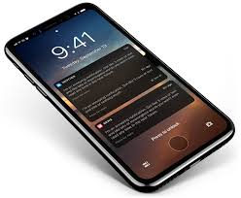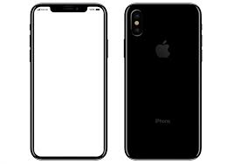[15]
The iPhone is a simplistic design for a phone that is in almost every hand on the planet. The iPhone has a screen and 5 buttons. The buttons include the action button which allows the user to exit apps and turn the screen on. This doubles up as a fingerprint scanner in later models and ion even later models again is completely removed for a small bar on the screen. The on and off button helps users close the phone for a short time and if held downturns off or restarts the phone. Volumes button which doubles up again for taking pictures and a switch that turns the alert tone off and on. Humans are only capable of holding 5 items in our short term memory at one time iPhones are designed to only have 4 icons on your main menu the rest of your icons in other menus are also in rows of 4 and can be contained in folders also with the same alignment. This is so people can recognise patterns and access applications quickly without the need to go searching for them. [2] [15]

Facebook and separating apps design

Facebook is one of the most populated apps in existence there is so much going on in the first screen you are not too sure where to look on first viewing. Since 2017 Facebook has developed another app dedicated to the messaging feature this, in turn, has helped Facebook become more minimal and the messenger app is also minimal on its own. In the screen captures below you can see that the screen is very full with lots of elements to consider.
This screen is showing every element that you can open on the main page Facebook without taking you t a different page, notifications and message chats are open and there are two huge lists down either sides of the web page. This makes the site hard to look at without no clear focus within the notifications tab there are highlighted and clear notifications the messenger. If this is the first time you are looking at a Facebook page it almost looks unappealing as it has no clear focus and if I wanted to just use Facebook for the messaging feature, I would have to deal with all the other tabs. They can be closed as you can see in the second picture on the right.
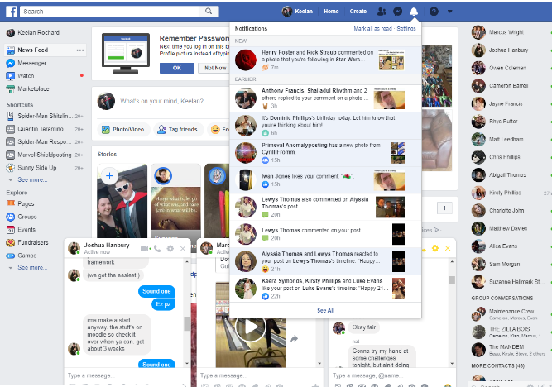
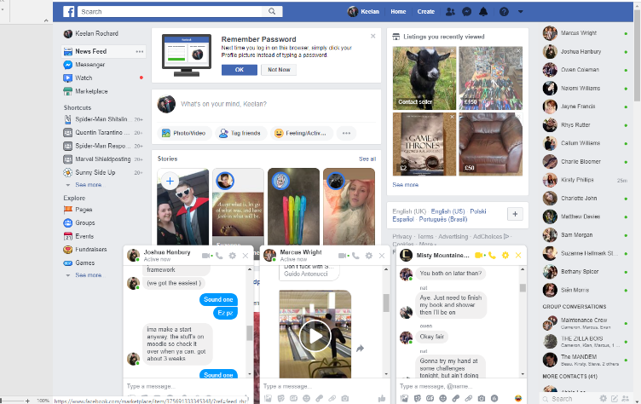
In 2011 Facebook released the messenger app and then on 2014 they cut the messenger function altogether from the original Facebook app. In the last picture below you can see what Facebook messenger looks like it has a very clear focus. The messages are on the right and the list of people to contact are on the left. This is a minimalised function separated to the original app and personally it works better as now the app is no longer attached with the busyness of Facebook and allows the user to message who they want straight away with no interruptions. [9]
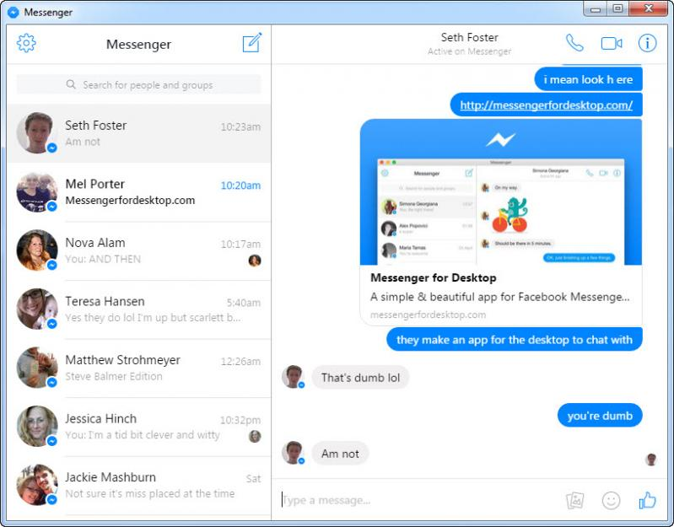

[9] [23]
How minimalism fits within design rules

With some design rules in usability engineering which is the study of how to improve user interfaces inside applications and hardware.

Here is a selection of rules from the list of Nielsen’s 10 golden rules these were established in 1970 and some of these rules are essential for minimalistic user interface design:

Visibility of system status
This is the design rule that allows user to be informed on how the system is currently coping throughout the day. If there are any issues, then the system should inform the user. For example, a connecting scanner or receipt printer should have a system status that tells the user if it is disconnected or not functioning properly. Systems built on VB tell the user the current running of the program but not every day users will know what it means. Minimalistic design would include this but as a title towards the bottom of the screen and flash red if there is an issue to indicate to the user of a problem. [10] [22]

Match between system and the real world
When designing a system, it is essential that you make connections from the real world into the system company logos and home buttons that allow the user the recognise features from their real-world experience to give them an idea of how the system will work. When incorporating minimalistic design into these icons and pictures will be more efficient than text in some cases. With an EPOS the user will recognise an item by picture better than looking for individual words. [10] [22]

User control and freedom
This is where there is space and room for users to navigate back and forth between various pages and click on images or features of a site that can take them to other addresses related to the company. In a till system there might be separate screens for how many products you sell or a screen for promotions. There may be a screen for the company’s website to read information. In minimalistic design there might be a need to have a separate screen for different readings and some space for users to explore but this will be limited. [10] [22]

Consistency and standards
This is where the designer is concerned on how the entire system looks screens will need to replicate elements of each other. In the design there should be no inconsistent colour schemes or naming conventions. In minimalistic design if the designer has made aware that the system will take this approach it is important the next screen is not cluttered with information and buttons and lose that consistency in the design. [10] [22]

Error prevention
This is where the user will take into account of the level of expertise of the users on the system and design the system in a way the user cannot make fatal errors in the system. There is no reason for a user to only complete a handful of tasks on a simple sales system to have access to the code of the system or the admin log in to then make other errors. In minimalistic design the system should be designed in a way where this information is not accessible and the level of user expertise is established and then defined by login in. [10] [22]

User Error recovery
This is where a user makes a mistake and needs clear direction on how to undo this error. For example, selling a product on a till and the user enter twice the amount of products that are present. A till system may require a manager login to fix this mistake or a simple button that rectifies the orders that have gone through and to start a new and to then move on from there. The minimalistic design might have a use of metaphor where a button with an exit or mistake symbol maybe in the colour red that says ‘cancel’ will be used in place here. [22] [10]

Help and documentation
When there is an issue or something is unclear the way to find out how to solve an issue is to look for help. This maybe a hyperlink that takes you to an FAQ page or a manual n the particular issue. In minimalistic design it is important to hide documentation like this until the user encounters an error. In visual basic programming software, the ability to hide label until certain criteria is met is common to use and is helpful to fill users in on information they are missing. [22] [10]

Recognition rather than recall.
This is where the designer will incorporate techniques that the user will recognise for example progress bars and alerts to let the user know when the system has done a task. This is so the user knows what is happening and to not think about what the system is doing. If you see a spinning wheel or two cogs you assume something is working or loading. Minimalistic design will use these but small versions in the bottom of screens to make the process seem timeless. [22] [10]

Flexibility and efficiency of use
With minimalism being used in this rule it is good practice that the system if flexible and is efficient when tasks are being requested. Messenger is a good example of this as if allows the use of GIFs and photos/videos to be shared within an instant by only showing small icons above the typing bar. When they are clicked the typing bar disappears and is replaced by a smaller search bar and then images from your device you wish to send. The design is flexible and efficient as the images you want to select should be within the recently added section of your device. [10] [22]

Aesthetic and minimalist design
With minimalist design, it needs to be aesthetic. It appears pleasing to the user and will be used frequently/ users will need to like and find the user interface attractive so that there are more likely to recommend to others. Finally, the aesthetic element will need to include the use of colours and icons rather than just cutting sections from design to make it minimal. [10] [22]

Here is a diagram from David McCandless’ Ted talk and they explained that this diagram is how user’s intake what is on a screen at any given time. Sight being the biggest sense used as users look at a screen then touch and hearing then taste being last because there is no taste of smell allocated to users except for a 4d viewing experience. This should be a primary focus for any designer when generating software. As sight is the key component to consider, as it is described as having “the same band width of a computer network” by David. So the designer should make sure to follow design principles to make sure the users sight is not distorted in any way. This can be to make sure colours do not contrast with each other and to make sure buttons are more clear and visible and commands or instructions are also very clear. [3]
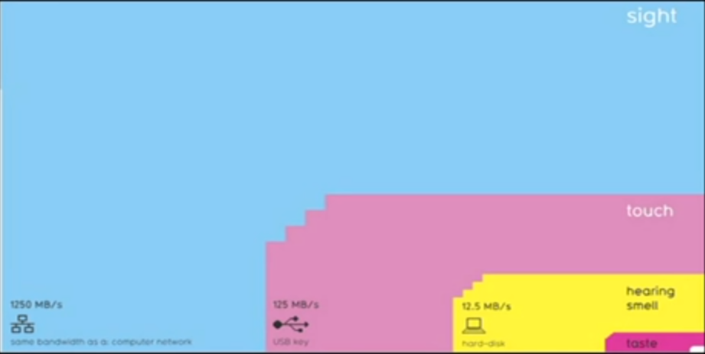[3]

  - How does minimalistic design help users of computer systems?
Minimalism allows the user to understand and take in information on the screen of a user interface easier as there is less information and interaction on the screen the user does not have to look through various potential buttons or tools in order to find what they need the most. Websites will include minimalism in the horizontal view a lot of features are cut here to make room for mobile users says Nielsen Norman group. Which helps users use the website on their phone otherwise the site would be too cluttered. Also the NNG suggests that Photoshop's UI is designed in a minimalistic way otherwise all the tools from the toolbar would cover a lot of the screen. That is why each tool will have separate sections for other features it has.
[4]

JoAnn T.Hackos, PHD has written a conference paper on the principles of minimalism applied to the design of human computer inter faces. In this paper is a breakdown of background information for what minimalistic design is and also a full break down of what minimalistic design principles are and how they can be applied to user interfaces. The four principles include:
♦ Principle 1: Choose an action-oriented approach
♦ Principle 2: Anchor the tool in the task domain
♦ Principle 3: Support error recognition and recovery
♦ Principle 4: Support reading to do, study, and locate
Although this source is not an academic research paper or add an investigation into this field it does however apply rules and guidelines the project desires and will take into account these principles in the final design and implementation of the system. [16]

Finally, in this section the project found, an applied theory the project has examined is by Colleen Mackenzie looks into minimalist, Performance-centred, and User-centred Design. This paper breaks down the previous design mentioned and found that all three design are key to perfect the “performance zone”. Their project found that each design methodology is so critical to the perfect UI design that all the overlapping features of each design should all be considered rather than the compare and discard features of one design and keep features of another. [17]
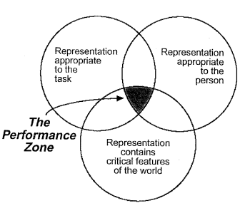

  - Advertising
A thesis written by Kostoula Margariti, Christina Boutsouki, Leonidas Hatzithomas, and Yorgos Zotos shows the use of minimalism in advertising. As advertising and apps are similar in the sense of they are both used to be seen by a potential customer and are also used to sell something or help convey a purpose of a company. The project desired some of the discoveries found in their literature review and research.
They looked into what minimalism was and stumbled on similar beats of the origins of minimalistic design and how it has progressed over the years from art to different lifestyles and housing. They then took multiple advertisements and looked at what colours they used and what made them appear minimalistic.
They found that a lot of advertisements were similar to each other in that they use the same techniques, these are a blank colour background with lots of space with large text taking up a portion of the advertisement space with a company logo taking up a corner of the space. This has benefited the project to use colours people are used to and to also take not of how much space to leave on certain forms and pages. [21]
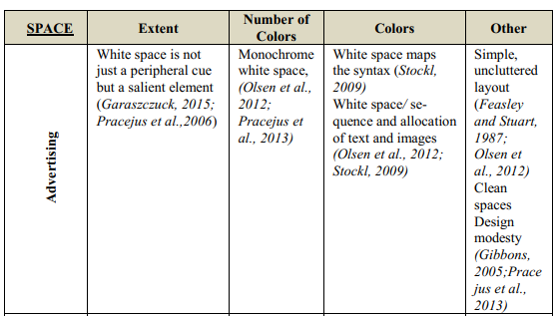[21]
  - Computer user documentation
Another assessment used to give user documentation minimalistic approach which has given the project desired features to look for as this is one of the only studies that directly includes both computer systems and minimalism designs found. The major principles to follow were that similar to design principles found by Nielsen’s and his 10 golden rules. These principles are: [20]
- action-oriented nature
This is when the designer is using concreate means of access such as menus navigation bars and hyperlinks. It also looks into alternative methods of using buttons for actions and to have less buttons on the screen at a time and to have other events that con take place if a singular button is pressed. It is also when the designer or programmer will indicate and focus only on the main tasks of building a system and designing the minimalism around that task with a lot of thought. If the sight of the main task Is lost, then the minimalism can be lost. Also with focusing on main tasks it is important to make sure that they are real and achievable task. You can do this by using SMART methodology for examining requirements and objectives. It will be hard to get a system with multiple criteria on it with many functions to become minimalistic. It is not impossible but it is a challenge to consider especially when working in the application development industry. [20]

- text-optimization
this is when a designer will think of where to place text efficiently on an application. A lot of text can be distracting to a user, with a lot of reading the application can take a while for the user to process what is happening on a page. The main points to consider when implementing this minimisation technique are to:
Replace unnecessary jargon. - This is to replace text or blocks of text that the user does not need this can clear space on a page an allows the user to think for themselves.
Do not spell out everything – this again allows the user to think for themselves and clears space if there are not instructions for everything. If there is a number pad on a contact form and a title saying ‘enter your mobile number’ this should be enough for the user to type in their number with the pad. It also eliminates a lot of time consuming activities.
Write in short simple sentences and use commands and questions instead of suggestible sentences- this is so the user has a very straight forward clear and concise command to follow. If it does not work, then there must be something wrong with the users understand rather than the long wording of a question. For example, ‘enter your number’ and ‘please give your contact details such as mobile number house number or a number of someone who has direct contact to you with a mobile phone’ accomplish the same task for the user whereas the first sentence is direct and easy to follow. [20]

- support of error recognition and recovery
this is when the designer will implement tools and techniques that allow the user to recover from errors they made or to prevent as many errors as possible before the user can make them. The techniques can be to display error information formally and promptly through message boxes or separate windows. That let the user know they need to stop. Give lots of information to certain errors on how to fix them but make sure it’s necessary information. Maybe provide a video that can show how to fix these errors or a tutorial when these problems occur. If you wish to include error recovery information, then the information must lead to a fast paced recovery for the user. The guidelines must be short so the user can grasp what is required of them to solve the issue. Make sure the error information is also ‘on the spot’ meaning if the error occurs the information must appear then and there so the user cannot move on from it and make further mistakes. For example, spellcheck is used so when the user types an incorrectly spelt word a red underlining I there to notify the user there is a spelling error and to fix it. The designer might also use signals in the final product to make sure the users are told about the error through symbols using “!” and red text or red colour blocks to display where the error is located on the page. [20]

- Modularity
Finally, this rule is where a designer will make sure the progress is notified to the user about where they are on the system or application. This can be as simple as highlighting what page the user is on in the navigation menu or to number each page on an enrolment form out of how many total pages there are to fill in so the user will know roughly how long using a system can take or to just keep them in the loop of where they are If they take a break and come back. To follow this rule there are tree simple steps which are: make chapters’ short – his allows the user to quickly get over a hurdle of a page if it is a logon page for example they need to be able to get to the app or site as quickly as possible, so the user can reach the main task and complete their goal. [20]

Provide closure of chapters – this is to let the user know when they have finished with a page or a task on an application. This is so the user has no sense of wondering what to do if the page is still and does not indicate any sign of change. This can be found in many sites and applications for example a site telling you that a payment you made has gone through successfully and the item you purchased is on the way or to simply tell you that you have logged in successfully is a good tactic to use to allow the user’s sense of mind to change about the page and wondering if anything is going to happen. [20]

No referencing between chapters-this is to not cause confusion between pages for the user. If the user is going through a step by step process for buying an item for the first time you do not want a step one with some information on it and then a ‘step one continued’ everything should be straight forward especially a function like buying a product online because people do not have a lot of trust with website security. There should also be no step which references another step to avoid confusion again for the user. If ‘step one’ is to enter personal details and step two s the enter bank account details tis step should not ask what the product is or information that was already made clear in the first step. This can through the user off their current task and will become more likely to quit the task than carry on with it. [20]

  - . Current systems

This section will look at 3 separate EPOS systems and judge how effective their UI’s are in terms of look, colour and effectiveness of design.
McDonald’s till system
In the picture below is the McDonalds till system. This can be found in many establishments across the franchise chain. This EPOS will be similar to the project's final design as it will include features made for staff users to enter into the system not the customer side of an epos system. There is a numbering function along the top which could be made into a small number pad along the side of one of these screens. [11]
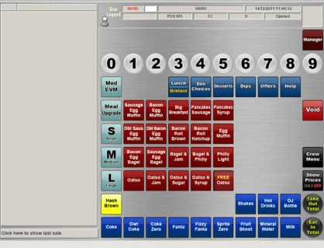[11]

Starbucks till system
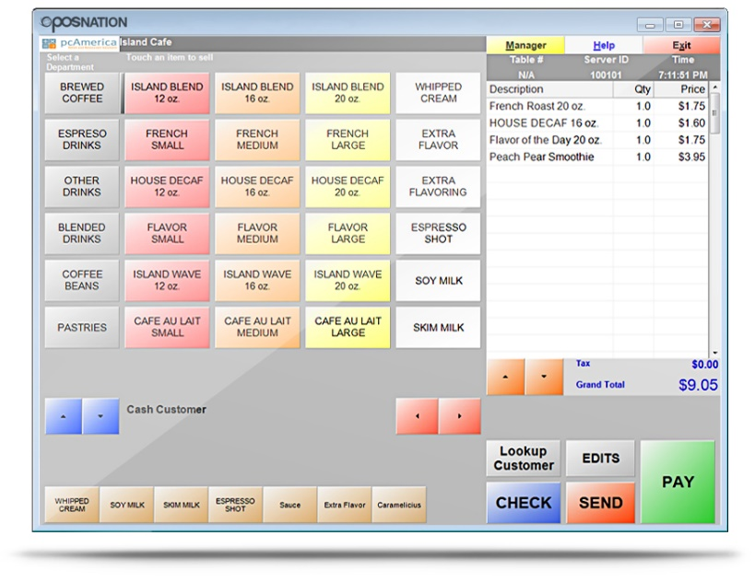
This Is a till system from Starbucks which is a mainstream coffee shop. as you can see in the image below there are similarities to the design of the previous till. This company is also a global chain with many EPOS systems in every establishment. The till system here also lacks a consistent colour scheme. The bland background of grey makes the system feel robotic and could use a better choice of colour as there are buttons in a lighter shade of grey present. Compared to the previous till system there is no numbering system or number pad this could suggest the till system is occupied by one user which can be harder to track down mistakes. [13]

Tesco till system
This till system below is from the supermarket Tesco found in the UK. Like the other examples is from a massive chain of establishments over the country. So again this till is designed for multiple employees in mid of all ages and disabilities. This till however is attached to a desk with other items connected such as bar code scanners and weighing scales.
These elements come into play to make the processing of products before purchase as easy as possible. This till design however makes the process slower depending on how fast the user can scan items there are certain buttons to duplicated the amount of items scanned but then they still need to be scanned through. The till design itself is straight forward but cluttered in the places where the user will have to draw their attention away from the main interaction on the screen. The buttons are also too close together and not big enough that also leaves room for error. [24]
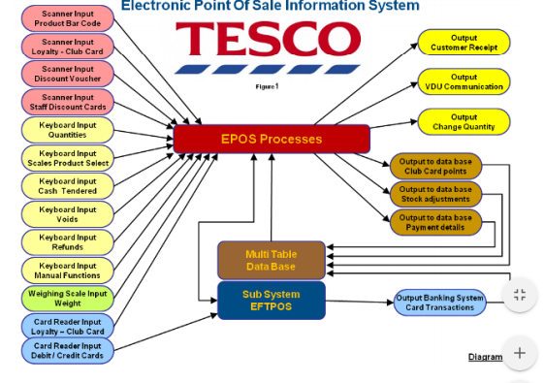
[24]
  - Conclusion
To conclude this section. The project will take into account of the above topics and make sure they are considered when implementing the project design, build and implementation. The topics above provide key elements to research further to gain a full acknowledged understanding of minimal design and will help the such as the research into making sure the design must be minimal but accomplish the same tasks as the kettles do from Leon Evans. Also to follow the guidelines set out by Nielsen with regards to minimalistic design and sticking to throughout and established design principles. The build of the project can take notes from the academic paper of looking at minimalism and rules to follow when writing computer user documentation in that of examining different aspects of action oriented approaches to building the till system and to make sure those actions satisfy the user allowing them chapter closure. The till systems section was a success the project now knows the direction It will take in regards to design and elements to include.

CHAPTER 3 - RESEARCH AND/OR DEVELOPMENT METHODOLOGY

Research methods
Research onion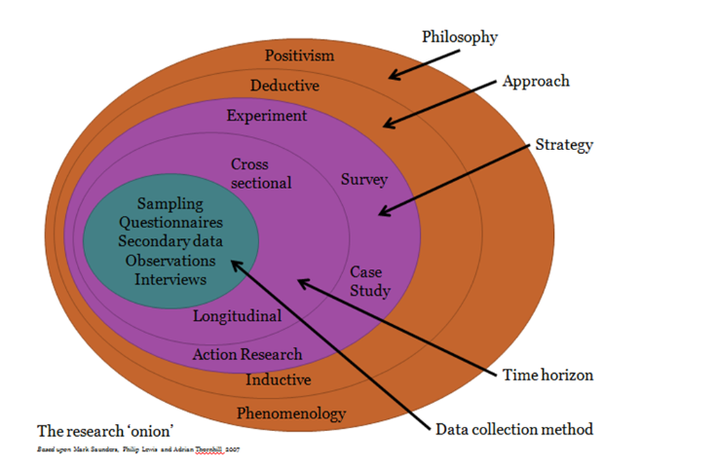
[14]
Philosophy - Positivism
This is the belief of static social fact in that if a group of people does not like something, therefore, the product needs to be redesigned or changed in some way to make it successful. As opposed to phenomenology which is the belief of 100s of instances. Positivism will be the better philosophy to follow as the project will require end-user testing and opinions of users to allow the final build to change and better itself through feedback and design. An advantage of this is that the project can rely of people and testing to make sure the hypothesis or question is correct or incorrect. So it is set in stone by however many people tested that the project is a success or not. A disadvantage of this is that this philosophy relies on people which can be a benefit and a disadvantage. As long as the purpose of the project is clearly explained to the participants involved the participant’s understanding of the project is clear then they should not be able to way the project on personal bias. For example, the project is to make a till system that shows whether or not the minimalistic approach is quicker or slower than the current system in place. If someone prefers the till system how it is they could cause the project a problem from not coming to its true conclusion. [14] [28]
Approach - Deductive
An investigation into the hypothesis to then develop a bigger understanding of the hypothesis or generate a new one from observations over time as the project progresses. This will be the approach to follow as the project will have secondary information gathered around the topic area and observation used to generate either an appropriate conclusion to the theory or a new theory altogether. An advantage of this is that the project is allowed a sense of freedom to be explored through user participation and allows the project a lot of time to gather as much information as possible to help come to a solid conclusion. A disadvantage of this is that the project can investigate too much and run out of time to come to a conclusion I will personally need to limit or find a limit to where the project will move on from certain sections such as primary research and design techniques. [14] [28]

Strategy - Experiment
Experiment to carry build a program with minimalistic design to see if the new system is preferred to the old. The new system will have the minimalistic design implemented inside of it that will follow the design rules listed above and will not interrupt the old systems functionality.
Advantage of this is that the project can conduct a primary research investigation to find out whether or not minimalistic approaches to UIs are good or bad. If the project proves either option to be true or else, then it is the project’s own fault and nothing can get in the way of the true conclusion. A disadvantage of this is that an experiment will need people and some cases facilities for the experiment to take place, it is important to try and use an experiment that has the most limited amount of people ad resources necessary so the project does not involve a budget.
[14] [28]
Time horizon - Longitudinal
Again this type of planning will be essential to the project as it is referred to as the data collection over an extended period of time to build upon a theory to then come to an appropriate conclusion. This is ideal as the project will need to be designed and developed for users which will take time. Then it will need to be tested against the theory whilst secondary research is being collected for the project. [14]

Advantage of this is that the type of planning will allow more time for the project to form and grow over time and allows for more time management skills to take place which is something a future project manager will need to learn. It also allows the theory to generate research and momentum before taking action to prove it and key areas of expertise can be studied here. A disadvantage of this is can be that the project will take up too much time ad not meet deadlines it is important to use techniques such as time boxing.

Data collection methods
To conduct the project, the collection methods that will be used are listed below. To use these methods will definitely be an advantage of gathering the best information and data to use in and generate a final conclusion.

Questionnaires
This will help the investigation by receiving answers that can be converted into numerical information to then place into statistical charts and graphs. This will be conducted through an offline process to gain more personal answers. It also allows the process to take quick action through a survey building website which can help generate statistics as people answer.

Observations
Will provide a more in-depth look into how people relate to minimalism and how they will use the system and draw a comparison from the use of their system. This will be carried out by watching test subjects who will use the proposed new system.

Documents, records and case studies.
This will be considered secondary research to gather the viewpoints of other people and companies to produce a literature review and help support the reasons as to why the project is a good aspect to research or worth considering. To also conduct research about others that have used similar research methods to find out a similar answer to the question that is being asked.

Advantage of these methods of collection is that the methods offer a wide range of different data types. Observations allow written knowledge and visual learning of what people can do with the new system and the questionnaires can apply numerical data to the project. The disadvantage of this is can be that people are involved again and if people are involved they may lie or not fully understand what is going on which can have negative impacts to the final conclusion.
Evaluation Criteria

1.1 End user satisfaction
This is where I will be looking back on test result to see if the end user is satisfied with the final result. The end user’s feedback is necessary for future reference if any other project teams what to incorporate the minimal approach to UI. The end user’s feedback is also necessary to a project if the client is not happy changes will need to be made to make them happy and to make sure the project is effective and worthwhile.

1.2 Basic till requirements
I will be evaluating the system against the other till examples mentioned earlier in the literature review and then to make sure the new system still meets the same requirements as the current till system. This is to make sure the practical aspect of the till hand basic functionality is a success.

1.3 Minimalistic design
I will be evaluating the till system against the design principles also listed in the literature review and the minimalistic design requirement found in the ‘computer user documentation’ to also make sure that the minimalistic design aspect of the system has worked well and to see if the project was a success and worthwhile.

Testing
Debugging – this is where the programming software will tell you where errors in code are and to eliminate those errors. This can be a very time consuming process so it is important to make sure that the code is right before running the debug. The debug also allows for unseen errors in code for example a line of could end up on the wrong form in VB and the debug could bring this up. [29]

End user test/questionnaire - I will be conducting a simple end user test. This is when requirements are tested against the new system by a user of the current system. They will be asked questions and observed as to how they feel about the system.

Development methods – Time boxing
The project has desired the use of time boxing which is the practice of time management skills of allocating certain amount of time for certain tasks within the projects lifespan. A quick example of time boxing will be that you have to program a form and to then work for 30 minutes – 1 hour then have a 5-minute break. This cycle is used until the task is complete. Time boxing can be used in the project for researching aspect found within the literature review as researching and reading around some topic areas can be energy consuming it is important to take breaks for fresh outcomes and to regroup about what you have learned before inserting it into the final report. This can be an advantage towards motivation. The only disadvantage time boxing can bring is that there are a lot of breaks which can all add up and might become a danger to the project deadline. A simple solution will be to cut down on breaks or have longer breaks after longer working periods to ensure workflow is consistent. I have chosen time boxing as I believe it allows the project to have the necessary breaks and workloads to ensure the completion on the deadline and to split the project up into steps and tasks to accomplish by certain dates allows the project to flow at a better rate.

Primary research

The practical primary research I have taken is to enter each department and to record sales at random to discover how long each sale takes with the current system. Each recording will be taken with a stopwatch and then to observe how many items are purchased, the price and payment type which can all contribute to the total time to be served with the current till system.

The other more specific recording the project could use is to only record how long the server takes to find each item the customer presents to them. This could be an advantage for the project to compare and contrast the time taken on the current till to find items compared to the new proposed system. This could also be a disadvantage due to the servers being over familiar with the current system disproving this theory.

Brook D – block
No. of items purchased | Total price | Payment type | Total time serving
1 | £0.80 | Card | 30 seconds
3 | £2.5 | Cash | 50 seconds
4 | £4.5 | Card | 56 seconds
4 | £5.7 | Card | 21 seconds
2 | £3.3 | Cash | 30 seconds
2 | £2.5 | Cash | 25 seconds
1 | £1.7 | Card | 30 seconds

Notes during research –
- Majority of people use card so functionality with other machines is a key requirement to include after the design of the till system but a cash and card buttons should be included.
- Time talking between purchases requesting of items builds up serving time.

Starbucks a/b – block
No. of items purchased | Total price | Payment type | Total time serving
1 | £0.80 | Cash | 10 seconds
3 | £2.1 | card | 25 seconds
4 | £4.5 | card | 20 seconds
2 | £2.2 | Cash | 30 seconds
4 | £5.3 | Cash | 50 seconds
4 | £4.9 | Card | 45 seconds
3 | £4.7 | Cash | 35 seconds
3 | £4.6 | cash | 20 seconds
Notes during research –

- Card purchases take longer due to the waiting of receipts or the entering of pin numbers for those that do not have contactless payments.
- Cash can take a while due to server or customer finding the right change.
- Group purchases of coffee are made by one person for a department maybe a button could be installed for a group purchase with a slight discount.

Refectory c – block
No. of items purchased | Total price | Payment type | Total time serving
2 | £1.80 | cash | 30 seconds
5 | £3.6 | card | 45 seconds
8 | £4.5 | Card | 1 min
2 | £1.7 | Cash | 30 seconds
3 | £2.5 | Cash | 40 seconds
3 | £2.4 | Card | 45 seconds
4 | £3.7 | Card | 25 seconds
2 | £2.2 | Cash | 30 seconds

- The 8 item was a group of coffees and teas with some snack type food for staff members this took a long time to insert into the till with a card payment this is the only anomaly I think the minimalistic design will not be proven to work much faster in as the amount of items was the defeat of the quickness of the current till server and system maybe a limit on items you can purchase at once could help speed the process up.

To conclude this section my till would need to beat these times. This might be hard to start off with in the experiment as the user will not be familiar with my till. I have decided to allocate an hour of experimenting time to the project for the user to gain some familiarity with the system then run a series of requests to which the user would be asked to achieve in a normal working day with the current system. The purpose of researching how long it took to sell products with the normal tills is so the project can then test again against these times in the implementation section to then come to a proven conclusion that minimalistic design is proven faster or slower.

Planning software
The planning software that will be used is Microsoft project as it is an actual project planning software that helps you plan out anything effectively. From naming the event to a time scale to naming the people involved in the project. It allows the allocation of days to each project step which creates a calendar of events and timestamps exactly when events occurred.
Project Plan
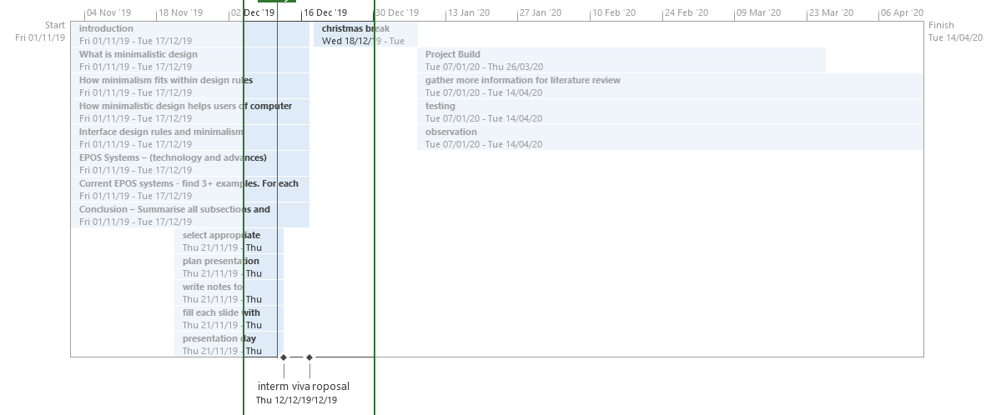
Here is a timeline of the project including holidays and weekends off the project is scheduled to be completed by the 14th of April when the final viva is due. The state of the project is currently in the highlighted section and the project Milestones are located below the timeline. A more detailed and final version of this will be shown in the final report. The timeline also allows room for weekends and days where the study ground is not open for breaks in the project. [26]

Word processing software
The software that will be used for documentation will be Microsoft word. This will help the generation of the project’s written reports such as questionnaires and documentation of the project’s programming build. The project also desires the ability to lay documents out formally with the use of underlines numbering and headings. It is also a good software to include images under text without getting in the way of paragraphs and text. Finally, the software also includes spellcheck software so the project documents will not have any spieling or grammatical errors. [25]

Programming software
The programming software that will be used in the project will be Microsoft’s Visual Basic 2017. This will be used because of the feature of adding design than programming the design elements separately. The code can be organised efficiently with helpful comments left behind for others to use. The design feature of VB is the most desirable aspect of the project as the design is what you can make. It is entirely up to the designer to implement the design they wish to include which gives the designer complete freedom and will finally allow the project to have its minimalistic user interface design. [27]

CHAPTER 4 - DESIGN & IMPLEMENTATION
Design
project requirements
- What are the project requirements? How did you discover them?
The project requirements are to build a functioning till system with minimalistic design techniques to make an effective till system. I discovered them through a small informal meeting with a current employee at NPTC Neath campus. After bringing light to the fact I am design a new system the employee explained more in-depth about the requirements and invited me to look at the system.

The requirement for the new system are:
- To build a till system that is useable
- To build a till system that reduces the amount of buttons on the screen
- To build a till system with a log on function
- To build a till system that has an appropriate colour scheme
- To build a till system with ease of use

system models
- What processes did you use?
The project used the following processes of application flow diagrams and site mapping. These processes allowed the project to get a clear planning of what software hopes to achieve. The site maps helped plan out the functionality as well as the design. The application flow diagram then allowed for the project to stay true to the core process of the system. The project also uses mock up and that is to design exactly how particular screens will play out. Before they are made this allows the designer.

Site map
The site map allowed the project to brainstorm and generate ideas for what can be included to the initial design for example maybe a report sheet at the end of every day to sum up the amount of totals can be used here. The site map also allows the project to think about who is the system for? The aims of the system, changes between the new and old system that need to take place. Any elements of the old system that could be useful or come into play within the new system. Usability as mentioned in the literature review above and the basic functionality of the system.
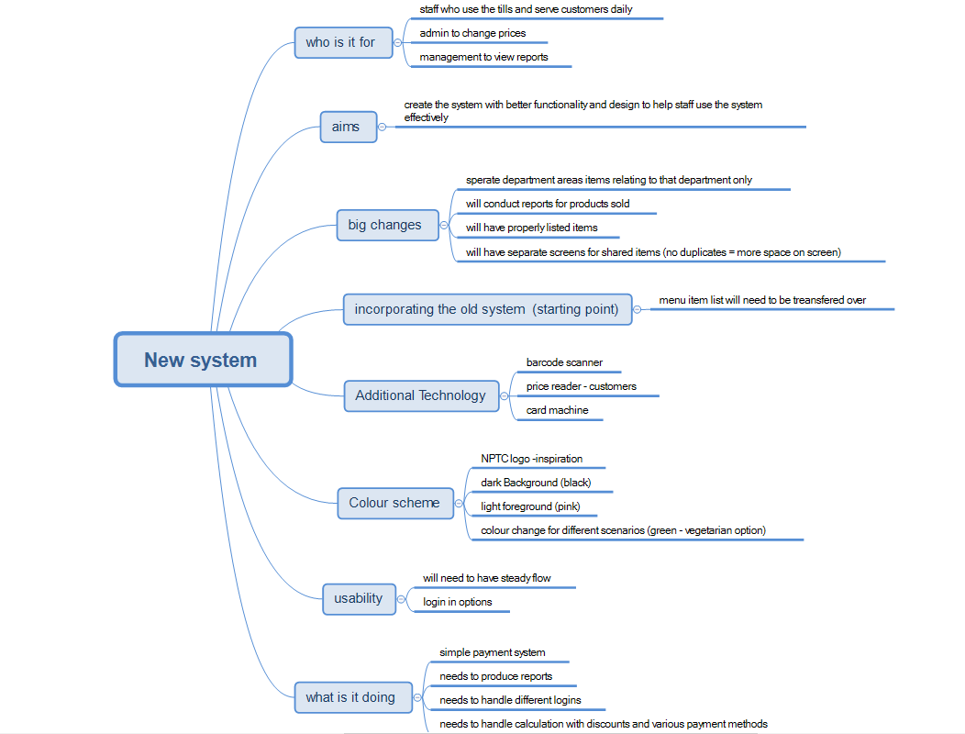

Application flow
As you can see the human interaction needs to be made for the employees to use the system. The employee enters into the system of what product the customer wants and then prepares the product. The till will then request payment which is retrieved from the customer and is then place into the till draw. This is the core business process that will be undertaken every day the system is used which is wat generated the need and sparked the idea for minimalism.
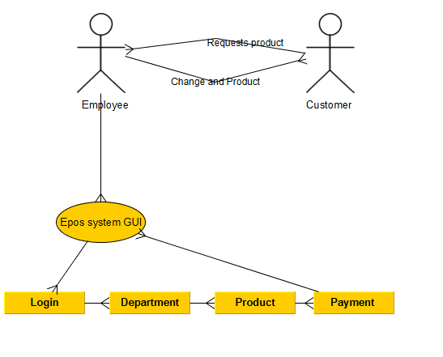
interface design
  - Mock ups of new system
This is what the original basic concept for the project. It is only a mock up so the colour schema and layout is how I want the project to look roughly accurate to the till systems found in the literature review. The first image you see below is the login screen this is not included in the till systems mentioned above. The login screen is so that a different user can use the system each day and if there are any issues it can be traced to that particular user.
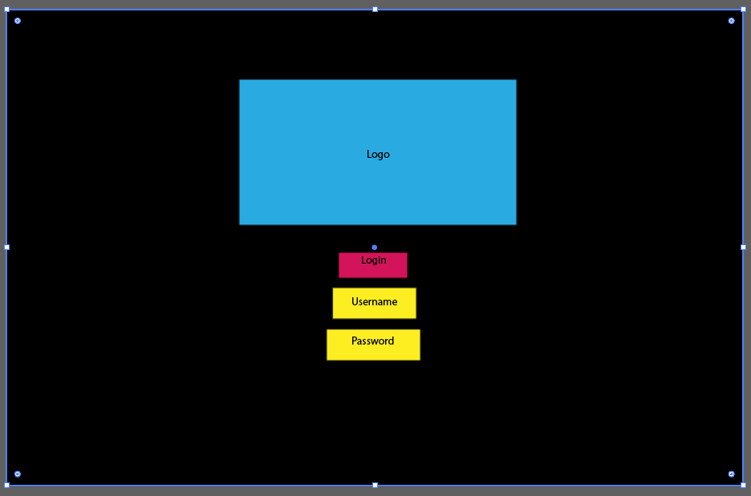
This screen is the menu screen where the main focus of the till system will take place. This is roughly what I would like the till system to look like as I believe this is how a person would like the layout of the system to be. Some of the design principles discussed in the literature review refer to design a system with how someone else’s mind-set works. The ’Z test’ and squint test work for this current screen. This means the screen is laid out in a Z shape which is how people would look at a screen normally and the elements of importance are laid out in a hierarchy with the most important being in the top left corner and somewhere in the middle of the screen where the eyes are naturally drawn to. The squint test is simply where you squint at the screen and the most important aspects are visible. [30]
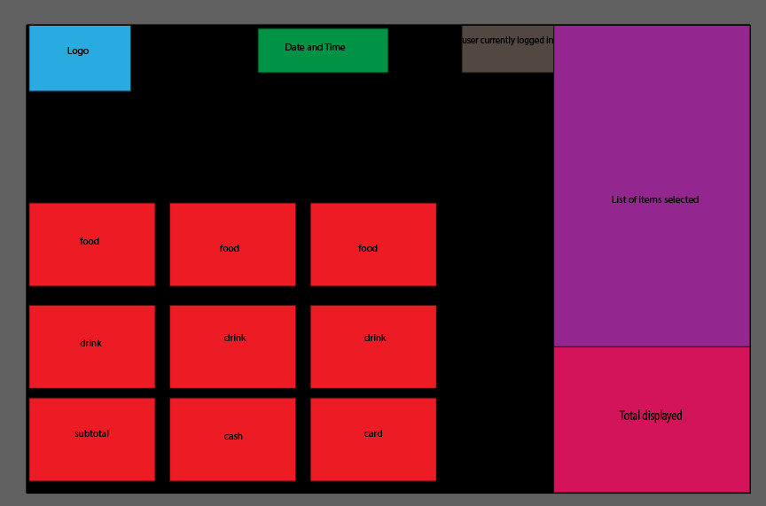
  - Final designs
These are the final system designs that I created using visual basic. This was so I could play out how screens would look before generating the code for the new system so I knew how many buttons to put on a screen at one time without the final product lacking in design. Using these design also allowed me to visualise the system before code was formed which gave me lots of time to decide where I wanted to place certain elements on each screen.

Login screen for users of the system. This includes the NPTC company logo and hen the button to begin the log on. Before generating this design, I did not know it was possible to include the use of the logo in the form. This has worked well and can be used in the final product of the system. The button to logon button also uses the colour from the logo and still looks like a button. I have chosen this because I feel as though it benefits the screen from jut having a blank background with a button on it.


This is the navigation menu after the log on screen. This will be included so the users will be able to gain access to the screens they require rather than making 3 separate systems for 3 separate departments in the Neath campus. The buttons again using the colour from the logo to give the system a recognisable feel to them as they are also navigation buttons this

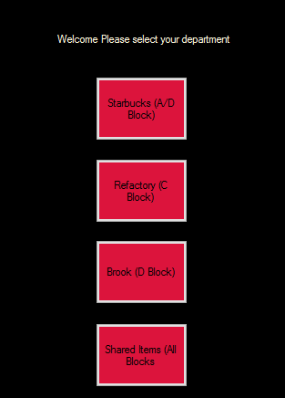

This is a final design of the system. The project will be close to mimicking this version of the designs. This has the minimalism included but every item on the screen is expanded to so the screen looks full only one section will be available to use at a time. The buttons are colour coordinated to represent iced drinks as blue and hot drinks as red. Each group box is its own section so it is organised into sections and highlights the section the user should be looking at.

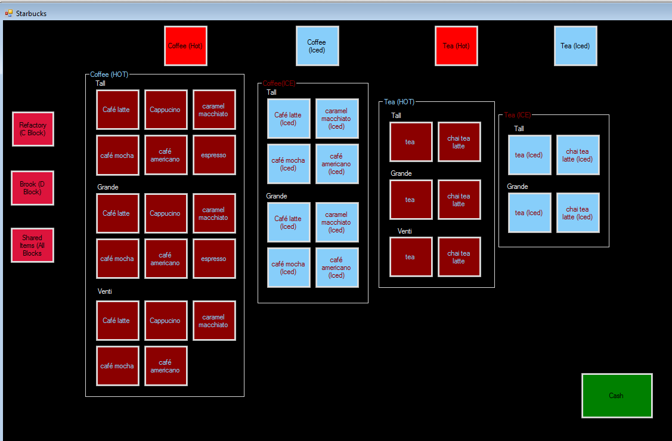

How did the previous till designs inspire the final design?
The till designs brought up in the literature report helped design the current system come together by evaluating the aspects used in them and what worked well and wat didn’t to then generate the system based on those facts. For example, each colour scheme of the till system does not look or work well which is why I have used black. I have also included the use of colour schemes with buttons effectively. Majority of the buttons found in the current till systems proved somewhat useless and uncoordinated. The final design was inspired by these systems as it will try to avoid what they have

Implementation
- Describe problems or successes you had in coding the software
The success of programming the software was that the project still managed to take the form of a till system and was not missing the functions of adding items to a list and then adding the totals up of the items and gave the user a total. An aspect I found particularly hard was the use of zones within a database that allowed for the program to take form. Each zone that was added created a ‘z’ like shape for the menus this was an aspect that I found hard to wrap my head around but soon understood the concept of where the next item was going to go and planned the menus accordingly to this function.

Testing of the software
  - Unit testing
As mentioned earlier one of the ways to test against the code was to debug it this is when you run code and the software will find errors in the code. There can also be errors in the code without running it through debugger that can be found. In the image below is a bar that appears that pops up from the bottom of the screen and tells you were errors have occurred within the code. [29]
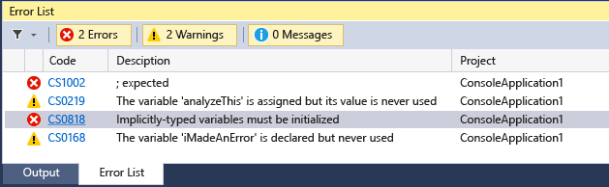[31]

  - System testing
The code is running and the system is working smoothly. You can tell this with the visibility of the system bar in visual basic. This allows the current running status of the system any problems or interruptions are displayed by a drop in the process memory section. [32]
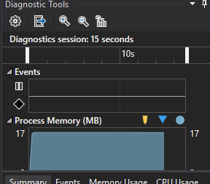[32]

  - Usability testing
Thankfully, the system does work this was tested through an observation held on the 20th of march where an employee of the college came to one of the computer labs and was requested items like they would be by customers in the real working world. This gave the user the chance to get familiar to the new system and to give their opinion of it. This was later recorded formally in a questionnaire. During the observation the project felt it was necessary to include the use of another data table to prove the agility of the new system. one of the data sheets was used again but timed with the use of the new system.
No. of items purchased | Total price | Payment type | Total time serving
2 | £1.80 | cash | 20 seconds
5 | £3.6 | card | 30 seconds
8 | £4.5 | Card | 50 seconds
2 | £1.7 | Cash | 25 seconds
3 | £2.5 | Cash | 45 seconds
3 | £2.4 | Card | 40 seconds
4 | £3.7 | Card | 15 seconds
2 | £2.2 | Cash | 20 seconds
This data table proved that the new system was indeed faster than the current working system.

  - Acceptance testing
The image below is of a questionnaire used at the end of the observation. The results read a score from 1-5 as a normal rating system would. This proved to be a perfect 5/5 when asked if the minimal aspect to the design was carried out well. It also proved to help the user work more efficiently as everything was organised and had a colour scheme to it compared to the current system.

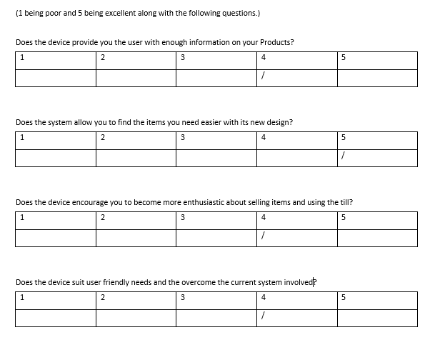

  - Time boxing
Time boxing allowed the project’s implementation to take place over two months. The generation of code was carried out over 4 weeks. Then the testing section happened over another month. The earlier sections testing took longer as the code encountered earlier unforeseen complications. The time boxing method used allowed me to program for 8 hours a day and take an hour break to separate the day to resemble working life. It also benefitted the project to work and section off parts of work to carry out because it is how I personally like to work.

CHAPTER 5 – EVALUATION

To evaluate the project was a success and the major finding of my data was that the minimalistic design proved to be faster and more efficient than the current system in place. The data did not back up the research found in the literature review but built from it and formed its own theory and conclusion based on the rules and design principles found. For example, the system is action and object orientated which was a finding from an assessment made about the different approaches and techniques to include in the design of a system. [20]
I believe that I met my aim and objectives. The aim I needed to meet was:
To test if a till with minimalistic approach to UI was more effective than a till without minimalistic design.
The objectives I needed to meet were:
- To build a till system that is useable
- To build a till system that reduces the amount of buttons on the screen
- To build a till system with a log on function
- To build a till system that has an appropriate colour scheme
- To build a till system with ease of use

I created a till system with minimalistic design techniques to satisfy a user and to be more efficient than a system without these techniques in place. This is how I believe I achieved my aim the till proved to be faster and more likeable than the original till system and was also requested to be installed immediately after use. The objectives were met by building a till system which I did, finding research to support why I made the design choices, to then design the system and finally show it to a user of the current system for positive feedback, which was put formally into an observation (experiment) and a questionnaire.
I also believe that I met my evaluation criteria. The first criteria I needed to meet was user satisfaction this was achieved through the colours scheme and organisation of the system. I believe the user would just be happy with a more organised system at the college but my project was to also meet a minimalistic design. I believe I did this though using design principles and theories of design and incorporating some elements into the final design of the system. This criterion was also met by simply including the user to come into the computer lab and test the system. Without the user’s opinion there would be no user satisfaction. The user as also kind and patient enough to complete the test without any incentive and to stay longer and give feedback on the system by filling in a questionnaire and to have their feelings recorded when using the system and after thoughts noted for the project’s conclusion. This was a good experience for the project and myself to have as people like this are hard to come by and majority of people would have said no before fully understanding what the project had in store for them.

Another criterion I needed to meet was to make the minimalistic design for system I used a questionnaire to gain feedback on the minimalistic design as mentioned earlier which received a 5/5 score. This allowed the project to gain the quantitative data it needed to come to the positive conclusion that the minimalistic design proved faster and more efficient than the current system. The questionnaire also included a ‘further comments’ section that allowed the user to express their feelings towards the project and allowed the project to gain its qualitative data also. This data expressed minor issues the user had with the system and that was to have a log on function this was cut out of the final product due to time constraints so it was a log on system with one user not the many other users and the switching of those user to keep track of who sold what item. This was one of the basic till functions I could not finish but did not affect the overall success of the system.
I believe I also met the minimalistic design by incorporating some design elements of the literature review. I included the action orientated nature and the use of space in the final product these are just some of the techniques I used to convey this approach. They worked through programming an action to every button with arrays this also classes as minimalism within the code and to leave lots of room ion the screens. when one button is pressed one lot of items will pop up and when time progresses throughout the day the different menu buttons will be selected hiding the current selected menu and replacing it with the new one in the same space so there is not a build-up of buttons which is the current problem with the system at the college.
My final criterion to meet was basic till function without this criterion the system would have no function and no purpose with the minimalistic design it would also appear unfinished. This was achieved through programming functions such as adding prices to each button in the menu and then adding those prices together and to include cash or card buttons that allowed the user to select either option. It was almost like a simulation of a till system. As mentioned above a login function was made but it was a brief version with only one user as the final product is a prototype. The project also suffered a loss of till function which was end of day reports. This again was not required but a function I wanted to include as it would benefit the system more if it worked like a real tll system with statistics of the best and worst selling items. This was let go for time constraint reasons and was not entirely missed. But when discussed with the user the idea was valued and was requested if the prototype becomes a full functioning system.

To conclude this section, the overall outcome is what I expected it but with small problems which I will discuss in the next section. If I were to do this project differently I would not use a database to control the menu items and just hard code every button I believe this route was more difficult and more time consuming as I did not know this skill before starting the project, however this is now a benefit as I do now know how to link visual basic to a database effectively. This database provided the program with another layer of depth, knowledge and understanding however I believe it was not necessary to include as the buttons could be coded in anyway and individually abled. The database could prove to be difficult to manage if this software was given to someone with no prior experience to using a system like this also if new items are added or taken away from the menu then will the staff be expected to go into the database or code and arrange the new items to be added? This will also cause problems compared to simply hard coding the buttons to work on the one software. It will also be more minimalistic to have one system running instead of the additional database but the same argument can also be made as the code will more than likely double as more elements will need to be programmed to each button.

CHAPTER 6 - CONCLUSIONS AND RECOMMENDATIONS

To conclude the project was a success through the introduction leading up to what the project will include. The project was also a success in the literature review section as I found many different resources of case studies and designs of tills to help convey the point that minimalistic design can be included in user interface design to provide productivity. The project was also a success in that he primary research taken before hand allowed for the use of comparing and contrasting times to prove the theory in the implementation section. The project was also a success in choosing the correct research methodology and following the certain sections of the research onion that created a steady path to follow throughout the projects life span.
This can also be said for the testing and evaluation criteria and also the development methodology time boxing. The project was also successful in the design and implementation stages of finding out requirements hen to build maps and flows of the application which then allowed mock ups of the design to take place and finally set the way for the code to be built and shown in front of an employee that had positive feedback on the system as a whole. Finally, the project was a success in that it accomplished that selling a certain amounts of products was faster using a minimalistic till than the current till system in place at NPTC group.
This project I believe sets further avenues for research as the project can be carried out again using the many other design principles I did not include in the final design and to use it in different areas of working environments. I personally chose a canteen in the college building I am studying at as this provided ease of communication and implementation with the test subject. This entire project could be carried out in a McDonalds or Tesco establishment as mentioned in the literature review to see how the minimalistic design performs in high intensity working environments where peak serving times over thousands of people in a day and not just over a couple of hundred people like in my chosen environment.
The project could also open up more room for research by actually making a till system that is fully functioning my till system had to cut sections such as making different users to log on and report sections as I had time constraints and they did not meet the basic requirements of the till system so they were easier to cut. I would like to see how someone could tackle these features with the minimalistic aesthetic in mind.
Another feature I would recommend using if the project were ever to arise again is to use more design techniques such as Entity relationship diagrams or ERDs and data flow diagrams. As I made a database for the project I would also include the use of these diagrams to successfully show how the tables are linked unfortunately I did not have enough time in the design stage for these diagrams and they were not that important compared to the site map and application flow diagram.

Another recommendation I would make is to switch up the pathways used in the research onion as I used:
- Philosophy - Positivism
- Approach - Deductive
- Strategy - Experiment
- Time horizon - Longitudinal

I would like to see how someone else would use phenomenology applied to this theory as it based on the belief that hundreds of instances will prove the theory this would mean that a lot more research into case studies of this field and more research into making different types of systems would help prove the theory in question and a lot more consideration and depth will be added to the design as many of the design will have certain adjustments made to them that could change how a user would view the system.
The approach could also take a different turn by using inductive research as that is the research of theories and case studies instead of conducting primary research to discover a conclusion. In my findings I could not find any relating case studies but in a couple of years my study along with some others may be available with time.
The strategy could be different as the one used in the project was an experiment which was also referred to as an observation and also used a questionnaire for more data gathering. There recommendations to explore could be to only use a survey or a different type of experiment with two or more systems with differences to find out which one was most appealing.
The time horizon could be cross sectional this is when someone will look at their finding at the same points in time for example in this study the experiment section and literature review section might be looked at during the same time period to draw the conclusion that applying different design principle’s will lead to different results. The project used longitudinal which allowed the collection of both quantitative and qualitative data where necessary over a short period of time that benefited the finding of the conclusion to the project.
The last change to be made in the research onion is the data collection methods used. The project could be done again through sampling and in-depth interviews after the user has had some time to use the system. These data collection methods will find more in-depth qualitative data which will need more time to be broken down and analysed to come to a conclusion which can be tricky but would also show more time and effort went into the project.

CHAPTER 7 – REFLECTION

For this final section of reflection, I am going to use the Gibbs cycle of reflection to fully display my thought process of the projects lifespan and what I was feeling during this time.

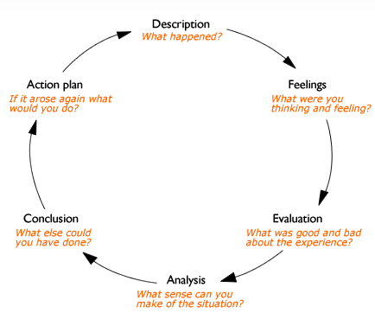[33]
Description
The project took place over several months. The project was manly to generate an original theory or question and to solve it. I chose minimalistic design as I have a passion for user interface design and hopefully would like to work in the field of it. The project then demanded research and to generate a piece of code to test against the theory. the project also included many meetings with a project supervisor that helped to generate certain aspects of the project through discussions in meetings almost every week of the project. This also allowed myself to keep on track of the project’s workload and make necessary choices which impacted the project’s outcome. The project also demanded the use of someone who worked at the college to come in and test the system. this helped the project collect primary data needed for the conclusion and was a very satisfactory promise.

Feelings
I felt pretty confident that I could complete these tasks with the timespan and with the support of the project supervisor. This was because I have prior knowledge and experience in visual basic programming language and the other software such as word and project to help move this project along to its completion. I only felt nervous towards the end of the project and getting the employee to use the system in fear that they would react poorly to it, this was then cleared when the positive feedback started to come through. my feelings also changed to becoming more relaxed as the project went along that the start I was very confused and subjective about the different routes I wanted to take the project but as I began the literature review I envisioned the project coming together the way it did and then the project became a ‘shopping list’ type of task to just do the next section and tick it off when it was finished and my confidence only grew during the duration of the project.

Evaluation
The project overall was a good experience and come to a positive conclusion. The project was a good experience because I have never carried a project of this scale out in this manor before which is a great experience to have and can also prepare me for a working career in possibly teaching r a research based job. A bad part about the experience of making the project was that I could not generate a fully working till system that the test subject is used to seeing having to tell them that it was a demonstration of sorts was quite disappointing as I believe they wanted to replace their current system almost immediately at the thought of a new one in place. Another bad experience I had with this project was trying to figure out where it would go all the way back at the beginning of the introduction. I was pondering over different ideas for a few weeks before settling on the idea of minimalistic design as I wanted to achieve something that had not been done before. However, this also brought upon more bad experiences of not being able to find reliable case studies as the project stands out. Majority of the findings when minimalistic design terms are searched are from artists and other artistic projects.

Analysis
To analyse the project as a whole I believe it was successful in achieving a goal with the minimal knowledge and resources to make a fully functioning till system. the project was conducted in a very formal manor when dealing with research methods and inquiring the user about what makes a good system in their eyes. I believe the project makes sense as a case study into the theory of minimalistic design bettering a typical UI design. I believe this because the project had a goal that was researched thoroughly with various different aspects to consider and where to apply the minimalistic design to. As I mentioned above I have a passion for UI design so this choice to incorporate this helped me give the project a well-rounded narrative. The project has background research then the incorporation of the techniques used then the design of the product I wanted to include and then the build, implementation and testing of that product that drew the project to a close. A further analysis would be that the project

Conclusion
To conclude the project as a whole I believe I have done the best that I can do with my programming abilities and resources to generate this till system. I would include the full functionality of a till system in addition to the screens I have made for the project to make the system feel complete. If I were to redo this project, I would complete my literature review a lot sooner to give me more time to program the system and to also include more employees to test the system this could not be done as there are three employees on each department and they could only spare one for the time allowed.

Action plan
If I were to carry out this project again I would personally choose different methods of the research onion to see how that would differ from the current project. If I used the different approaches as mentioned in the section above. I would do this to compare if the project came to a conclusion quicker or came to a conclusion with better depth and understanding of the theory. I would also change the software used to make the design. I would use PowerPoint instead as I believe the designs could be carried out much easier and faster. Especially with the mock ups and wireframes as it is just placing squares into a side rather than deciding the size of the paper and editing the size of each shape and colour in illustrator. I would finally recommend requiting a partner to conduct some research or carry out the programming in an actual till software to make the project feel more professional and efficient when the user tests the system.

CHAPTER 8 – REFERENCES

[1]

Tate. Minimalism – Art Term | Tate [Internet]. Tate. 2017 [cited 2020 Mar 5]. Available from: https://www.tate.org.uk/art/art-terms/m/minimalism
‌

[2]

Mcleod S. Short Term Memory | Simply Psychology [Internet]. Simplypsychology.org. 2020 [cited 2020 Feb 27]. Available from: https://www.simplypsychology.org/short-term-memory.html
‌
[3]
The beauty of data visualization - David McCandless [Internet]. TED-Ed. 2012 [cited 2020 Mar 5]. Available from: https://ed.ted.com/on/d4MJ7anJ#review

[4]
The Roots of Minimalism in Web Design [Internet]. Nielsen Norman Group. 2015 [cited 2020 Mar 5]. Available from: https://www.nngroup.com/articles/roots-minimalism-web-design/
‌
[5]
AICOK Electric Kettle Temperature Control, Stainless Steel Tea Kettle with Variable Temp, Cordless Electric Water Kettle with 1500W SpeedBoil, Auto Shut Off and Boil-Dry Protection, 1.7-Liter Boiler: Amazon.co.uk: Kitchen & Home [Internet]. Amazon.co.uk. 2020 [cited 2020 Mar 5]. Available from: https://www.amazon.co.uk/AICOK-Temperature-Stainless-SpeedBoil-Protection/dp/B07G27F4LP
‌
[6]
Leon Evans on Instagram: “Cheeky little teapot design before bed. Night . . . #productdesign #product #fusion360 #keyshot8 #render #3dsmax #industrialdesign…” [Internet]. Instagram.com. 2018 [cited 2020 Mar 5]. Available from: https://www.instagram.com/p/B2-I-ocFO8n/
‌
[7]
Great Lakes Golf Tour [Internet]. Great Lakes Golf Tour. 2020 [cited 2020 Mar 5]. Available from: https://www.greatlakestour.com/
‌
[8]
Inkbot Design. History Of The McDonald’s Logo Design [Internet]. Medium. Medium; 2018 [cited 2020 Mar 5]. Available from: https://medium.com/@inkbotdesign/history-of-the-mcdonalds-logo-design-abb29ef78741
‌
[9]
What is Facebook Messenger? - dummies [Internet]. dummies. 2016 [cited 2020 Mar 5]. Available from: https://www.dummies.com/social-media/facebook/what-is-facebook-messenger/
‌
[10]
Euphemia Wong. User Interface Design Guidelines: 10 Rules of Thumb [Internet]. The Interaction Design Foundation. UX courses; 2020 [cited 2020 Mar 5]. Available from: https://www.interaction-design.org/literature/article/user-interface-design-guidelines-10-rules-of-thumb
‌
[11]
Guinto S. Elearning Superstars [Internet]. Elearning Superstars. 2015 [cited 2020 Mar 5]. Available from: http://www.elearningsuperstars.com/project/till-training-game/
[12]
Sabrina Noelle Otero. 7 Starbucks Myths Debunked By A Former Barista [Internet]. The Odyssey Online. The Odyssey Online; 2016 [cited 2020 Mar 30]. Available from: https://www.theodysseyonline.com/starbucks-barista
‌
[13]
1Call4. Till Programming: Change/ Add a New Clerk - ICR Touch Point EPOS Software. [Internet]. YouTube. 2020 [cited 2020 Mar 5]. Available from: https://www.youtube.com/watch?v=EuOYYk9anPM
‌
[14]

Outside of the Onion [Internet]. 2012. Available from: https://onion.derby.ac.uk/onion.pdf
‌

[15]

Kelly G. iPhone 8 Leak Reveals Apple’s Design Secret. Forbes [Internet]. 2017 Aug 30 [cited 2020 Mar 5]; Available from: https://www.forbes.com/sites/gordonkelly/2017/08/30/apple-iphone-8-release-date-price-design-specs-ios-11/#42ab6c037fea
‌
[16]
Hackos JT. An Application of the Principles of Minimalism to the Design of Human-Computer Interfaces [Internet]. ResearchGate. ResearchGate; 1999 [cited 2020 Feb 6]. Available from: https://www.researchgate.net/publication/220756882_An_Application_of_the_Principles_of_Minimalism_to_the_Design_of_Human-Computer_Interfaces/link/5485a4b20cf24356db610927/download

[17]
Mackenzie C. APPLIED THEORY SUMMARY ᭜ Explores and compares three key design strategies that underlie the development of EPSSs: minimalism, performance-centered design, and user-centered design ᭜ Closes with observations on how the three strategies are converging The Need for a Design Lexicon: Examining Minimalist, Performance-centered, and User-centered Design [Internet]. [cited 2020 Feb 6]. Available from: http://core.ecu.edu/engl/southards/7746S10/ftp/0536.pdf

[18]
Allen M, Currie LM, Bakken S, Patel VL, Cimino JJ. Heuristic evaluation of paper-based Web pages: A simplified inspection usability methodology. Journal of Biomedical Informatics [Internet]. 2006 Aug [cited 2020 Feb 6];39(4):412–23. Available from: https://www.sciencedirect.com/science/article/pii/S1532046405001085

[19]
ULTIMATE GUIDE TO TIMEBOXING The Best Time-Saving Technique! [Internet]. Available from: https://productivityhackr.com/wp-content/uploads/2018/09/Ultimate-Guide-to-Timeboxing.pdf

[20]
van der Meij H, Lazonder AW. Assessment of the minimalist approach to computer user documentation. Interacting with Computers [Internet]. 1993 Dec;5(4):355–70. Available from: https://ris.utwente.nl/ws/files/6853553/Meij93assessment.pdf

[21]
Kostoula Margariti, Christina Boutsouki, Leonidas Hatzithomas, and Yorgos Zotos. A Τypology of Minimalism in Advertising Chapter · June 2017 DOI: 10.1007/978-3-658-18731-6_1
file:///N:/---AypologyofMinimalisminAdvertising---.pdf
‌
[22]
Ten Usability Heuristics by Jakob Nielsen [Internet]. Available from: https://tfa.stanford.edu/download/TenUsabilityHeuristics.pdf
‌
[23]
Facebook [Internet]. Facebook.com. 2018 [cited 2020 Mar 30]. Available from: https://www.facebook.com/
‌
[24]
Tesco updates EPoS cash drawers | News | Retail Technology [Internet]. Retailtechnology.co.uk. 2013 [cited 2020 Mar 30]. Available from: https://www.retailtechnology.co.uk/news/4764/tesco-updates-epos-cash-drawers/

[25]
Microsoft Word | Document & word processing software [Internet]. Office.com. 2019 [cited 2020 Mar 31]. Available from: https://products.office.com/en-gb/word
‌
[26]
Project Management Software | Microsoft Project [Internet]. Office.com. 2019 [cited 2020 Mar 31]. Available from: https://products.office.com/en-us/project/project-management-software

[27]
Visual Studio IDE, Code Editor, Azure DevOps, & App Center - Visual Studio [Internet]. Visual Studio. 2018 [cited 2020 Mar 31]. Available from: https://visualstudio.microsoft.com/
‌
[28]
RESEARCH METHODOLOGY [Internet]. [cited 2020 Mar 31]. Available from: https://shodhganga.inflibnet.ac.in/bitstream/10603/152574/8/12_chapter%205.pdf
‌
[29]
Mikejo5000. First look at the debugger - Visual Studio [Internet]. Microsoft.com. 2019 [cited 2020 Apr 1]. Available from: https://docs.microsoft.com/en-us/visualstudio/debugger/debugger-feature-tour?view=vs-2019
‌
[30]
Jeong Ryeji, Seung Bin Son, Hee Joo Lee, Kim H. On the robustification of the z-test statistic [Internet]. ResearchGate. unknown; 2018 [cited 2020 Apr 1]. Available from: https://www.researchgate.net/publication/324057531_On_the_robustification_of_the_z-test_statistic
‌
[31]
TerryGLee. Fix program errors and improve code - Visual Studio [Internet]. Microsoft.com. 2018 [cited 2020 Apr 1]. Available from: https://docs.microsoft.com/en-us/visualstudio/ide/find-and-fix-code-errors?view=vs-2019
‌
[32]
Tobias. How to switch process in Visual Studio Diagnostic Tools Window? [Internet]. Stack Overflow. 2018 [cited 2020 Apr 1]. Available from: https://stackoverflow.com/questions/48811188/how-to-switch-process-in-visual-studio-diagnostic-tools-window
‌[33]
Reflective writing: About Gibbs reflective cycle - Oxford Brookes University [Internet]. Brookes.ac.uk. 2020 [cited 2020 Mar 27]. Available from: https://www.brookes.ac.uk/students/upgrade/study-skills/reflective-writing-gibbs/

‌

‌CHAPTER 9 - APPENDICIES
Consent form

Do you…

Agree to the following terms listed below:

I agree to complete all questions listed before me.
I agree to answer truthfully and honestly to not cause any bias to the project.
I agree to express my opinions vocally to the developer of the system.
I agree to express any issues I find within the system.
I agree to thoroughly test the system to determine if the requirements are met.
I agree to express any further ideas or viewpoints that may help the development of the system.
I agree to keep the functions and fundamentals of the new system confidential within the workplace.

Signed:

Functionality
  - End user test
Please find below the end user tests I conducted on April 11th 2019.

Please mark the score 1-5

(1 being poor and 5 being excellent along with the following questions.)

Does the system provide you the user with enough information on your stock?
1 | 2 | 3 | 4 | 5

Does the system provide you with significant detail on the profit made?
1 | 2 | 3 | 4 | 5

Does the system encourage you to become more enthusiastic about working
1 | 2 | 3 | 4 | 5

Does the device suit user friendly needs
1 | 2 | 3 | 4 | 5

If you are unhappy about anything listed above do you have further feedback to add onto the development?

Design and usability

  - End user test
Please find below the end user tests I conducted on April 11th 2019.
Please mark the score 1-5
(1 being poor and 5 being excellent along with the following questions.)
Does the device provide you the user with enough information on your Products?
1 | 2 | 3 | 4 | 5
 |  |  | /

Does the system allow you to find the items you need easier with its new design?
1 | 2 | 3 | 4 | 5
 |  |  |  | /

Does the device encourage you to become more enthusiastic about selling items and using the till?
1 | 2 | 3 | 4 | 5
 |  |  | /

Does the device suit user friendly needs and the overcome the current system involved?
1 | 2 | 3 | 4 | 5
 |  |  | /

If you are unhappy about anything listed above do you have further feedback to add onto the development?
I am really happy with the overall design. I am also happy with the user friendly functionalities the current system does not have. My only personal flaw with the system is that the fact I can log on but have to close the system to log on as someone else. Maybe a potential inactive feature or timer to log me out automatically can be implemented into the system.

