Name of the report: BMIH6005 Organisational Consultancy
My name: Shakera Begum
Name of the company: Premier Inn
Report delivery date: 21/11/2022

Executive Summary
The problem or issue at stake
The Premier Inn is a venerable name in the hospitality industry considering its enormous market share and number of hotels (alex, 2014). the internal organizational challenges regarding management and innovation will be found while delineating the organization’s attempts to deal with the situation. The Premier has different management problems like skill-shortage of employees, market growth problems, supply chain problems, and service variety inadequacy. How the company has dealt with the issue and what steps have been taken are discussed in this consulting report (David, 1970).
Findings of the report
The Premier Inn's service was sluggish and of poor quality since many of the staff were not as competent as anticipated (back, 2016). Sixty-two percent of Premier Inn's 6373 survey respondents were unhappy with the hotel's sluggish service (Hicks, 2022). Once again, Premier Inn found that a lack of ancillary services was the primary reason for their high rate of customer churn. In 2020, Premier Inn had a significant drop in patronage due to a dearth of appealing entertainment and dining options. After doing extensive study, Premier Inn discovered that a lack of a variety of offerings was responsible for the loss of 34% of their clientele (Noordzy & Whitfield, 2014). The hotel's handling of its supply chain was another area of concern. Premier Inn is unable to obtain enough raw materials because of the disruption to importing and exporting caused by Brexit. The issue is exacerbated by the lack of coordination between logistics and information systems, which has led to a rise in waste. Seventy-three percent of Premier Inn's customers were unhappy because of the supply chain management problem (BLANKE) (Withvector.com, 2022). Finally, the Premier Inn has had trouble expanding its customer base since 42% of the UK's hotel and tourist companies have seen their expansion stymied because of Brexit (Finch, 2016).
Analysis of the findings
The Premier Inn as a whole has been declining due to management difficulties (jam). The organization has suffered as a result of their actions (jon, 2017), with negative effects on staff morale, earnings, market share, expenses, and more. The hotel has made several good decisions to remedy the situation (Peterson, 2022). To better serve its clients and address the talent gap, the Premier Inn Hotel, for instance, has used robots technology in the workplace and is teaching its workers via on-the-job training. Premier Inn's customer service increased by 25% in only 6 months thanks to the new management's strategies (jordan, 2001)

(Johnson & Whittington, 2020). However, in an effort to diversify its offerings and address the underlying problem, Premier Inn recently launched a spa and fitness center. In 2021, because to the success of new services, Premier Inn was able to increase its client base by 25% and gain 2% of the hotel industry's market (Hoerl & Snee, 2022).
Recommendations
Premier Inn has to take decisive measures to address the supply chain and market expansion issues it is facing. Since the UK is just a "associated member" of the European Union's trading bloc, it is up to British businesses to make contact with EU partner countries if they need to stock up on raw materials or other necessities (Kuzmin et al., 2017). To further address the supply chain problem, Premier Inn should address any lingering employee disagreements and work to improve communication between its Logistics and Information systems. Plus, to increase its market share and find a solution to the growth-related problem, the hotel has to expand into Asia (Godsiff, 2010).
Conclusion
Since it is a huge and international hotel chain, Premier Inn has certain management issues to deal with. The organization has room for improvement across the board, including product range, personnel competence (less, 2004), supply chain, and market expansion. The business has launched new offerings and boosted training in an effort to fix the problem. Yet the corporation may make more progress toward its objective by taking advantage of opportunities like expanding into the Asian market and sourcing supplies from cooperative nations.

Table of Contents
Introduction 1
Scope and analysis 2
Overview of the Premier Inn 2
External environmental analysis 3
Internal environmental analysis 5
Main body 7
Findings and results 14
Action Plan 17
Recommendations 19
Conclusion 20
References 22

Introduction
Consulting services in the field of organizational science include the analysis of internal corporate data by trained professionals in order to pinpoint areas for improvement and pinpoint voids in performance (Johnson, 2021). Given that the style of leadership and management that would fit a firm is determined via the consultation report, it is clear that consulting is essential for determining certain fundamental business elements. The goal of this document is to provide organizational consultant services to the Premier Inn, a hotel chain operating on a global scale (Burnett, 2022). The consultation report will reveal the management and innovation problems inside the firm and describe the steps taken to address them. This consultation report will address issues including organizational technology transformation, staff training, employee disputes, customer service (ros, 2013), social distance maintenance, insufficient service variety, supply chain problem, and so on (Traynor, 2022). The Premier Inn's interior and exterior will first be studied to help with this identification. The hotel's external and internal business environments will be examined via the lenses of the SWOT and PESTEL models of the business environment, respectively (Matthias & Campbell, 2019). The Premier Inn's potential for growth will be shown after an examination of the surrounding commercial landscape. Using change management theories and models, such as Kut Lewin's change management model (tell, 2015), we will examine how the organization is adapting to change, the challenges it is encountering (Investment, 2013), and its strategies for overcoming them. The analysis's results will be given subsequently, along with how they relate to the Premier Inn's ecosystem assessment. Finally, based on the issues that have been discussed, some suggestions will be made for the company to improve (Investment, 2013).

Scope and analysis

Overview of the Premier Inn
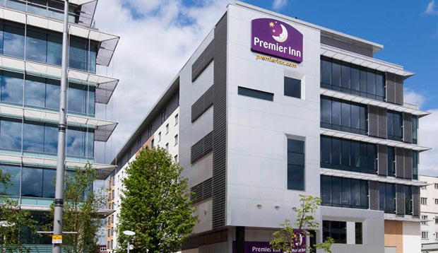
Figure 1: The Premier Inn.
Source: (O’Meara, 2021).
To the British, seeing new places is a kind of relaxation since it has deep cultural significance. The Premier Inn is only one of the numerous hotel chains that have sprung up to satisfy people's need for travel (Fernando, 2019). The Premier Inn was founded by Whitbread Plc, the parent firm of the biggest hotel chain in the UK (Iverson, 2009). The hotel opened in 1987 under the name Travel Inn; at this point in time, it is 35 years old. The hotel's founder opened it as a cutting-edge alternative to the dominant hotel brand at the time, Travelodge (Wood, 2022). In 2004, Whitbread Plc bought out Premier Lodge's remaining shareholders, and the hotel combined with Travel Inn to improve both companies' offerings to guests (Jhon, 2007). The new company was dubbed Premier Travel Inn. But in 2007, they changed the name to to "Premier Inn" (Jones, 2021). With over 800 locations and 72,000 guest rooms, Premier Inn is a massive hotel empire. Founded in 1994 and headquartered in Dunstable, United Kingdom, Premier Inn has expanded to over 800 facilities across four nations. As of 2021, Premier Inn's total sales was £520 million, while the company's net profit was £197 million. Seventy percent of Whitbread Plc's profits come from its hotel division. To date, Premier Inn has employed 112,822 people, all of whom are committed to providing excellent service to guests. 72% of Premier Hotel patrons in 2022 reported being pleased with their stay (Gorman, 2020). Given that Premier Inn controls 34% of the hotel market, this helps explain the company's enormous size (jojo). The firm has implemented various technology changes to enhance its service in order to capture 50% of the market over the next five years (Proctor, 2020). In addition, the corporation has a stellar reputation thanks to its huge wedding venues in the hotels, which have contributed to its notoriety as a high-end wedding destination. Its many offerings help maintain its stellar reputation. Its brand image has taken a hit, however, since the hotel was criticized for failing to keep a social distance during the COVID-19 epidemic (Vidal, 2022).

External environmental analysis
To the British, seeing new places is a kind of relaxation since it has deep cultural significance (Thorbeck, 2019). The Premier Inn is only one of the numerous hotel chains that have sprung up to satisfy people's need for travel (Fernando, 2019). The Premier Inn was founded by Whitbread Plc (Klosko, 2017), the parent firm of the biggest hotel chain in the UK (van, 2005). The hotel opened in 1987 under the name Travel Inn; at this point in time, it is 35 years old (Jon). The hotel's founder opened it as a cutting-edge alternative to the dominant hotel brand at the time, Travelodge (Wood, 2022). In 2004, Whitbread Plc bought out Premier Lodge's remaining shareholders, and the hotel combined with Travel Inn to improve both companies' offerings to guests (Klosko, 2017). The new company was dubbed Premier Travel Inn. But in 2007, they changed the name to to "Premier Inn" (Jones, 2021). With over 800 locations and 72,000 guest rooms, Premier Inn is a massive hotel empire. Founded in 1994 and headquartered in Dunstable, United Kingdom, Premier Inn has expanded to over 800 facilities across four nations. As of 2021, Premier Inn's total sales was £520 million, while the company's net profit was £197 million. Seventy percent of Whitbread Plc's profits come from its hotel division. To date, Premier Inn has employed 112,822 people, all of whom are committed to providing excellent service to guests. 72% of Premier Hotel patrons in 2022 reported being pleased with their stay (Gorman, 2020). Given that Premier Inn controls 34% of the hotel market, this helps explain the company's enormous size. The firm has implemented various technology changes to enhance its service in order to capture 50% of the market over the next five years (Proctor, 2020). In addition, the corporation has a stellar reputation thanks to its huge wedding venues in the hotels, which have contributed to its notoriety as a high-end wedding destination. Its many offerings help maintain its stellar reputation. Its brand image has taken a hit, however, since the hotel was criticized for failing to keep a social distance during the COVID-19 epidemic (Vidal, 2022)..
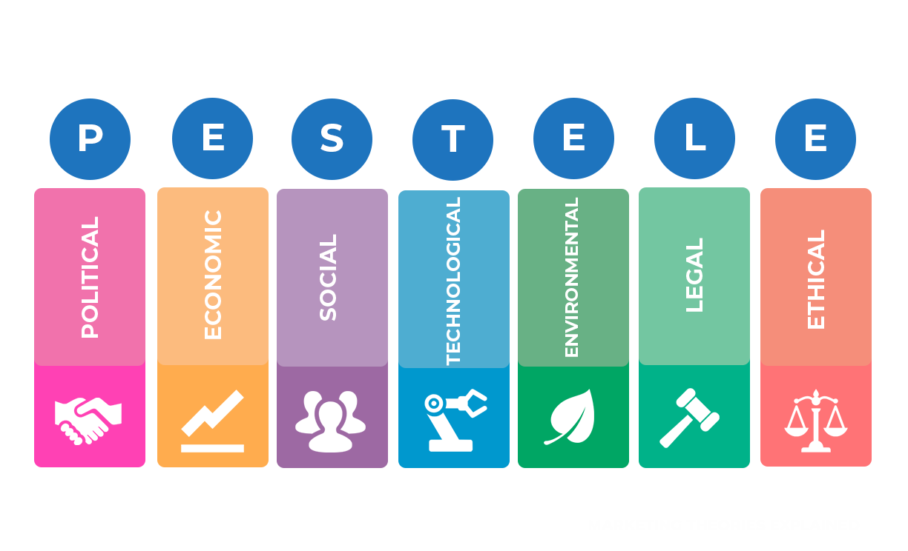
Figure 2: PESTEL analysis.
Source: (Mehmood, 2020).
Political: Due to the government of the United Kingdom's objective of fostering an open market for domestic and international enterprises, Premier Inn has certain advantages in expanding its chain of hotels and engaging in international trade. Furthermore, the UK's membership in the EU trade bloc demonstrates the Premier Inn's ability to obtain labor and commodities from other member states of the bloc (lipa, 2018) . As a result, the hotel's service quality and client base both improve, leading to more revenue and a more stable company. A high profit margin in the nation has led to a high tax rate, which has an adverse effect on Premier Inn's bottom line and future expansion plans (Smith, 2019).
Economic: People in the United Kingdom have a lot of disposable income thanks to the country's GDP per capita of $31,708 in the year 2021. Premier Inn bookings should increase as a result, since individuals are more likely to take vacations and spend money on fun activities when they have more cash. The corporate interest rate in the UK is low (Watson, 1976), too, at only 2.25 percent as of 2022, which has a beneficial effect on Premier Inn's revenue and guarantees the company's long-term success (Proctor, 2020). Nonetheless, the newest economic data states that the UK's inflation rate has risen to 10.1% as of September 2022, which has a detrimental impact on the Premier Inn's sales and operational expenses (Morey, 2018).
Social: Sales at Premier Inn are positively impacted by the UK population's inclination for travel (well). Moreover, employee dedication is high in the nation, which bodes well for the turnover rate; this bodes well for the Premier Inn's ability to attract and retain a sizable and loyal staff. The UK has a relatively small population of 68.7 million people, which has a detrimental effect on the hotel's ability to attract guests (Traynor, 2022).
Technological: Using cutting-edge technology like robots, AI, 5G, and so on, the Premier Inn has a significant influence on customer service and long-term development (Burnett, 2022). However, the hotel's lackluster cyber security results in inconsistently high client satisfaction (Perman, 2015).
Environmental: Since Premier Inn is a service provider rather than a manufacturer, it produces no carbon or other hazardous emissions; as a result, the public perceives it to be environmentally responsible, which is good for business (Wood, 2022). The hotel has high running costs since it doesn't engage in waste management and doesn't utilize renewable energy.
Legal: The Premier Inn is a caring employer because it complies with the Employment Act of 1996, the Health and Safety Act of 2010, and the Equal Remuneration Act of 1976. This method aids in maintaining the company's legitimacy and gives it a leg up on the competition (Matthias & Campbell, 2019). The hotel's inability to keep its distance from the public during the epidemic has resulted in consumer lawsuits and other legal concerns, and has hampered the hotel's ability to develop sustainably (Ponting, 2011).

Internal environmental analysis
The internal business environment is the sum of all the elements that are directly relevant to a company and have a major bearing on its operations. In this report, we use a SWOT analysis to examine Premier Inn's internal business environment (Robertson, 2020).
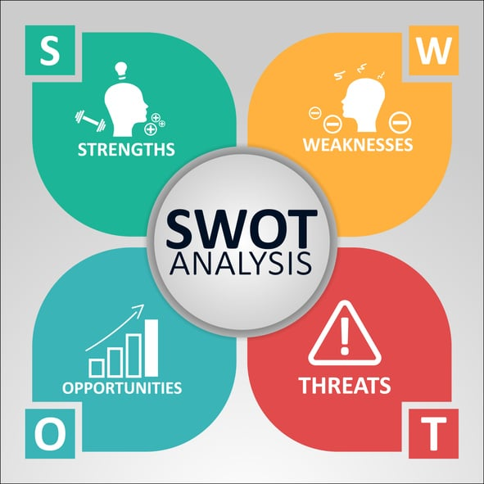
Figure 3: SWOT analysis.
Source: (Szende, 2021).
Strengths | Weaknesses
- As the biggest hotel chain in the United Kingdom, Premier Inn has an enormous brand value (Saunders, 2020).  - Over 112,822 people are employed by the hotel (Capocchi, 2019).  - With so many backers, the company has more than enough money to keep running smoothly. | - The services of the Premier Inn are fairly costly, due to the excellent quality of the services (Warner, 2020). (Warner, 2020).  - Disappointingly limited menu options plague the hotel's dining hall.  - Some guests leave because the hotel's marketing practices are subpar.
Opportunities | Threats
- Since the UK government has cut the corporate interest rate to help companies weather the epidemic, the corporation may readily obtain financing at a low rate of interest.  - With Britain's recent accession to the European Union, the hotel now has a better chance of expanding its international commerce, importing goods from other nations, and exporting services to them (Warner, 2020). | - Raw material prices in the hospitality business have risen sharply due to the high inflation rate in the UK, which might have a negative impact on Premier Inn's bottom line (Athiyaman, 2022).  - Since there aren't that many people living in the UK, it might hurt business if people don't feel like making the trip there.
Table 1: SWOT analysis.
Source: Own.
Premier Inn is the biggest hotel chain in the United Kingdom, giving it tremendous brand value. The large client base and varied set of sites are justification enough for the power. Premier also has enough workers and investors that are dedicated to the company's long-term success in order to provide excellent service to clients and run the massive enterprise smoothly (Kefalas, 2021). Premier Inn's services are pricey despite their high quality. However, the high cost is understandable given the high quality of the service provided and the expertise of the workers involved. The hotel also has a limited menu since it does not provide any Asian meals in addition to the usual American, British, Spanish, and Italian fare (Warner, 2020). One may also argue that the company's marketing practices have become antiquated since so little technology is used in them. The low interest rate and the United Kingdom's accession to the European Union trade bloc bode well for the firm since they will allow it to recruit enough human resources, buy enough raw materials, and raise enough money. However, rising inflation and a tiny population pose dangers for the Premier Inn by raising prices and decreasing sales (Athiyaman, 2022).

Main body
Premier Inn Hotel, the market leader, has several problems with its management and operations (Burnes, 2014). There are still certain shortcomings that need to be addressed, but the corporation has lately addressed some of them using effective management approaches. Those places where various models and ideas might be put to use to enhance the situation are outlined below.
Employees’ skill shortage
Premier Inn has an enormous workforce, yet many of its workers lack the necessary skills. Because of this severe lack of available talent, customer service suffered greatly. Because of this, the Premier Inn turned to a method of innovation management to address the issue. The following is a description of the method developed by managers using Kurt Lewin's theory of managing change.
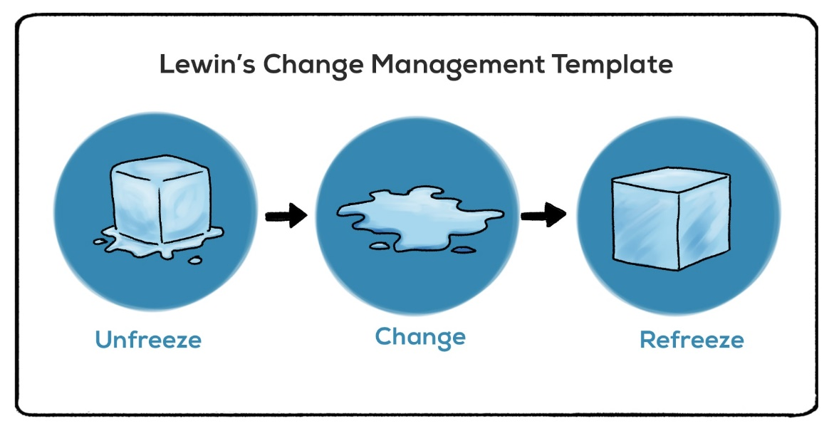
Figure 4: Kurt Lewin's change management model.
Source: (Muldoon, 2020).
Unfreeze: The Premier Inn was experiencing serious failures in terms of customer service as a result of the incompetence of a small number of its staff, who had caused service delays and widespread consumer discontent. Here's an example: Hicks (2022) surveyed 6,373 guests at Premier Inn and found that 62% of them were unhappy with the hotel's poor service. Thus, the hotel's management intended to implement a new management style in an effort to address the issue. It also convened a meeting with staff and vendors to get them ready for the transition (Slack, 2019).
Change: Premier Inn embraced the practice of transformation management in order to effect process change. Premier Inn intended to use new technology in the workplace to improve customer service, since these systems are able to process requests more quickly than human employees. In 2020, after implementing robots technology in the workplace, hotel management saw a 20% increase in the speed with which guests were attended to (Willamson, 2022). However, the hotel administration revised its training methods in an effort to improve staff performance. Premier Inn has shifted its focus from classroom instruction to on-the-job learning in an effort to better prepare its staff for the business world. Employees were able to learn in a practical setting with little time investment, making this approach very beneficial. Fifty-six percent of Premier Inn workers surveyed agreed that their abilities had improved thanks to on-the-job training (Godsiff, 2021).
Refreeze: However, it's never easy to completely execute a change, so the hotel had to tweak its management strategies. Premier Inn provided its staff with training in the usage of the new equipment. The hotel management also did a great job of inspiring its staff to make the most of their on-the-job training by outlining the long-term benefits of doing so. According to the findings of Slack's (2019) investigation, the Premier Inn's customer service improved by 25% within 6 months after these managerial improvements were implemented. The Premier Inn gained an edge over its rivals because it was able to attract and retain a more happy client base, which resulted in a 10% increase in the hotel's revenues (Noordzy & Whitfield, 2014).
Supply chain management problem
"supply chain" refers to the streamlined network of vendors that supplies a company with goods and services. Management of the supply chain is the process of directing this network of suppliers, warehouses, and retailers. A central authority regulates the flow of commodities and other resources. Burnes (2021) estimates that additional supply costs might be reduced by 26% with well-managed supply chains. For a company to run smoothly, the supply chain must be able to keep production from being interrupted by a lack of materials or components. However, Premier Inn is now experiencing supply chain problems. One of the most popular hotel chains in the United Kingdom, Premier Inn, goes through a lot of supplies on a regular basis (Johnson & Whittington, 2020). Premier Inn's primary needs are mineral water and water for beds, showers, food and drink, linens, pillows, and other products, transportation, tissues, furniture, and other things. Yet many clients worry that the firm's supply chain is dysfunctional. Premier Inn's supply chain problems may be traced back to the government's Brexit policies. Buttrick estimates that 55% of the hotel's supply chain has been negatively affected by Brexit (2009). The company was able to quickly and easily import items and supplies from other EU nations in the past. However, because the UK has left the EU, it is more difficult and time-consuming to get components from outside the UK. When the vast majority of Premier Inn's suppliers are based in countries other than the United Kingdom, it makes it more difficult to maintain a steady supply of goods and services. Dissatisfied customers and subsequent harm to the company's image are the direct outcome of a break in the supply chain. There was a supply chain issue, and as a result, 73% of the hotel's 9483 clients were unsatisfied with the service they received because of delays and poor quality (Noordzy & Whitfield, 2014).
While this is bad news for Premier Inn, it does provide the company with an opportunity to source from inside the United Kingdom. The company will boost output and reduce customer wait times if they accomplish this. Premier Inn will have the opportunity to build a reliable and long-lasting supply chain with the help of contracts with domestic suppliers.
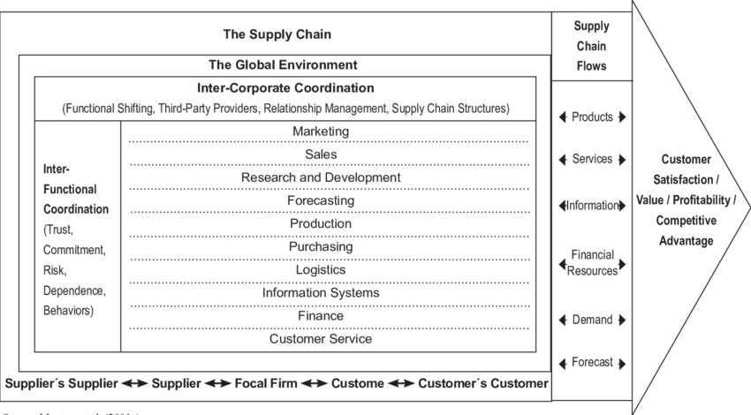
Figure 5: A model of Supply Chain Management.
Source: (Sari and Suslu, 2020).
Using the supply chain management model, the problem with Premier Inn's supply chain management may be identified and addressed. Both internal and external factors are given equal weight in the model. The approach calls for interdisciplinary cooperation across Premier Inn's different divisions. Sales, marketing, logistics, forecasting, finance, manufacturing, buying, information technology, and customer support all need to work closely together to achieve this (Karatepe, 2019). However, Premier Inn's IT and ops teams don't work well together. Some Premier Inns have been found to have inaccurate supply records due to poor information management. This prevents the logics team from knowing which portions need supplies and how much of each is required. Demand forecasting is also negatively affected by the branches' inappropriate disclosure of data in the information system related to customer demand and required resources. The global climate, in addition to these internally disjointed operations, hampered the Premier Inn supply chain. Because of Brexit rules, the Premier Inn's supply chain has been impacted (Chen, 2019). The delivery time has increased since the materials are coming from a different nation. Because of this, the Premier Inn supply chain is slowed down.
Service variety shortage
When 2020 rolled around, Premier Inn management noted a drop in clientele and investigated the cause, discovering that guests were seeking for more unique amenities than those offered by the hotel (Sari and Suslu, 2020). Premier Inn's approach to the problem was to make some changes in management that ended up helping the business. Below, the PDCA model is used to describe the administration shift..
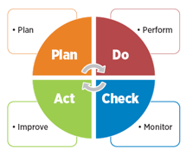
Figure 6: PDCA model.
Source: (Quartapelle, 2020).
Plan: Premier Inn foresaw the demand for opulent amenities and so planned the introduction of a spa and a gym. According to data gathered by Premier Inn, not providing these amenities led to the departure of 34% of the hotel's patrons (Sibanda and Pooe, 2022). Consequently, the deployment of these amenities was deliberate.
Do: In this phase, hotel management surveyed regulars on the new policy down an effort to zero in on the most effective method of management. The Premier Inn, for example, has installed a modest outdoor and interior gym to gauge guest interest. In addition, the company surveyed its clientele about their ideal spa experience before launching the service.
Check: At this point, the Premier Inn reflected on how well the preliminary test had gone. To give you an example, the hotel will evaluate the efficiency of the management strategy and determine whether adjustments are necessary. Additionally, the business keeps track of client feedback to enhance future efforts. Premier Inn discovered that 84% of reviewers preferred an outdoor gym, while 75% advocated for a professional spa service provider in order to get adequate treatment (Karatepe, 2019).
Act: In this phase, we take the feedback we received in the previous phase and make any necessary adjustments to the plan before putting it into action. Based on guest feedback, Premier Inn built fitness centers onto the ground floor of all of its hotels in 2021. The hotel's guests were able to continue enjoying unimpeded access as a result. In addition, in the second part of the same year, it launched its spa service and began hiring qualified individuals to run it. Premier Inn increased its client base by 25% in 2021 because to its more flexible service offerings. This represented a significant competitive advantage (Chen, 2019). The hotel was able to grow its market share by 2% thanks to its superior service and the fact that it attracted new clients at the expense of its competitors.
Market growth problem
Premier Inn's growth prospects have dimmed since Brexit. The hotel's market share and expansion issues are analyzed using the BCG matrix.
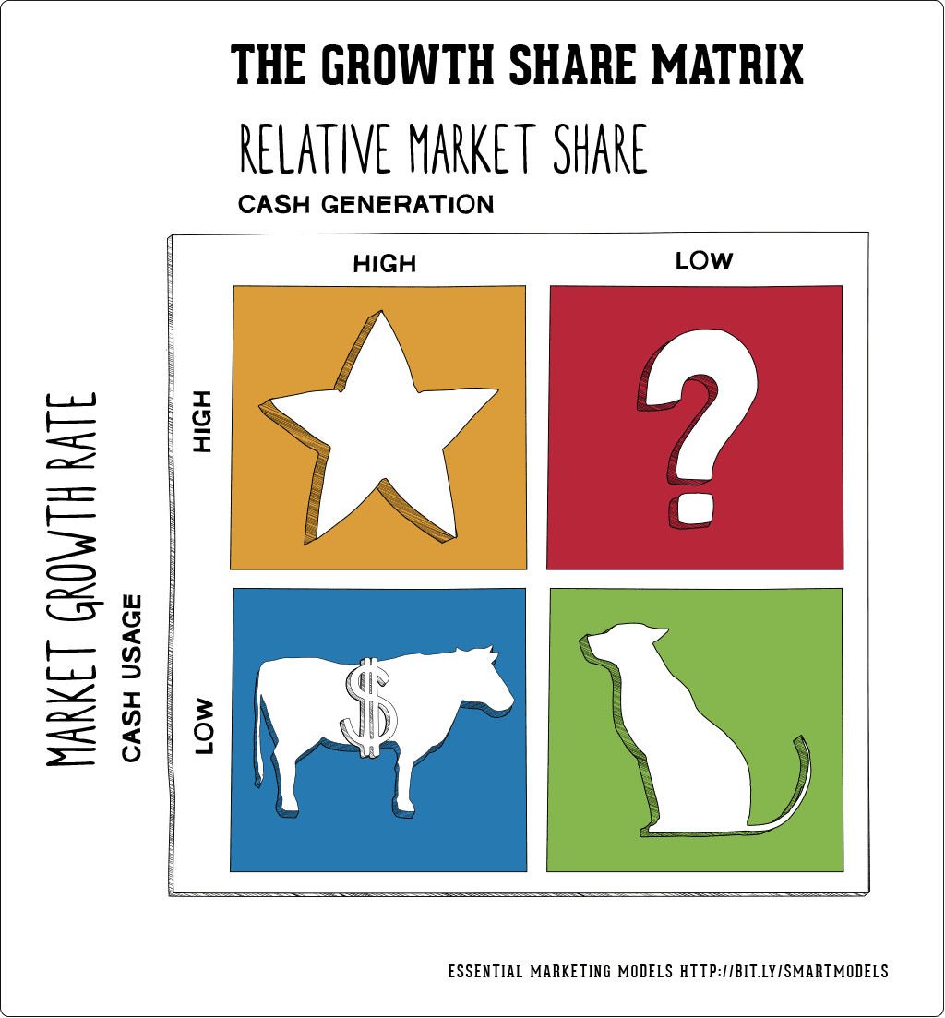
Figure 7: BCG matrix.
Source: (Jaya, Silva and Athauda, 2018).
The BCG matrix is divided into four categories, each representing a different perspective on market share and growth potential. Animals at this ages may be either dogs, stars, mysteries, or cash cows.
Dogs: Dog refers to a corporation that has a little share of the market and no room for expansion. These companies are certain to fail both now and in the future.
Stars: Successful businesses with high market share and bright prospects are called "stars" (Atanga, 2021). In this area, businesses may prosper and expand.
Question mark: Companies at this juncture have low market share but tremendous opportunity for growth. Companies should now focus on ongoing development.
Cash cow: When a company with a significant market share sees a drop in sales revenue, this is called "market share loss" (Tiawon and Supartha, 2021). However, there are no prospects for growth in the industry for the foreseeable future.
Premier Inn's chances of increasing its share of the UK hotel market are slim at present. Premier Inn, on the other hand, is seeing excellent results in the home market. The company runs a variety of sales and marketing campaigns, such as discount coupons, seasonal sales, and year-round sales. It has been found by Chakravarti (2017) that in order to increase their market share, domestic hotels have increased their usage of sales promotion by 16%. These marketing efforts are costly for the firm, but management does not believe there is opportunity for growth in the current market. Following the government's Brexit decision, Premier Inn is unable to expand into other European countries. According to Hadi and Wood) (2019), 42% of the hotel and tourist industry in the UK are suffering a growth hold-up as a consequence of Brexit. According to the BCG matrix, Premier Inn is in the Cash cow phase because of its high revenues, large market share, and little chances of expanding into new markets in the United Kingdom.

Findings and results
The following is the delineation of the findings and results got from the discussion above.
Issues identified (Developmental areas) | Results | The model used in the finding | Resources used in the identification
Skill shortage | The Premier Inn has noticed a scarcity of a certain kind of competence among its staff. Sixty-two percent of hotel guests were unhappy with the company's delayed service (Chakravarti, 2017). The hotel was able to recover once it installed robots technology and trained its staff on the job. | Kurt Lewin's change management model has been used to assess the talent gap and examine the transformational process. | Data analysis technologies like Sisense, Tableau, Microsoft Excel, and others have been employed with traditional resources like PCs and cellphones.
Supply chain problem | Recently, Premier Inn's supply chain has been a source of frustration. Brexit has affected 55% of the hotel's supply chain since export-import has become somewhat more difficult as a result of this policy Service delivery and quality are both negatively impacted by the time and effort required to import products from outside the United Kingdom. This problem has been made worse by the lack of coordination between the IT department and logistics. It has been revealed that 73% of Premier Inn's customers are unhappy because of the company's supply chain issue, which results in delayed and subpar service. | The problem has been correctly diagnosed thanks to the use of the Supply Chain management model. | Information has been gathered from business periodicals and related websites, and then analyzed using a variety of data analytic methods.
Service variety shortage | Premier Inn lost 34% of its clientele due to the absence of amenities like a fitness center and spa (Hadi and Wood, 2019). These were implemented in 2021, and that year the hotel saw a 25% increase in business (Kumar, 2020). | Using the PDCA paradigm, we were able to determine Premier Inn's approach to implementing innovation and change. | The team utilized collaboration software like Wrike and Zoom to compile evidence and make their identification.
Market growth problem | The Premier Inn is one of the 42% of British businesses struggling to expand their markets as a result of Brexit (Chakravarti, 2017). There is a problem with expanding into new markets since the corporation can no longer operate stores in European nations. | A stumbling block to the expansion of the market has been identified with the help of the BCG model. | This section draws on research from a variety of sources, including scholarly articles, books, websites, and data analysis programs like Talend..
Table 2: Findings and results.
Source: Own.
Premier Inn has a large staff, but many of them are incompetent. As a result of this ineptitude, customer service slowed down, which in turn increased consumer anger. Sixty-two percent of Premier Inn's 6373 survey respondents were unhappy with the hotel's sluggish service (Hicks, 2022). Premier Inn aimed to address the problem by introducing new technological systems into the workplace and providing improved training to staff. In 2020, after the hotel's management had implemented robots technology into daily operations, the hotel's service times improved by 20%. As a result, the hotel administration switched from classroom instruction to on-the-job training in order to efficiently address the scarcity of qualified workers (Kumar, 2020). It's clear that these management strategies worked, as Premier Inn's customer service increased by 25% in only 6 months. In 2020, Premier Inn had a significant drop in patronage due to a dearth of appealing entertainment and dining options. Premier Inn foresaw the need for opulent hotel amenities like a spa and a fitness center, and thus made preparations to provide them. In light of the fact that 34% of customer turnover was caused by a lack of these services, the installation clearly succeeded (Cunill and Forteza, 2021). Premier Inn introduced the features in 2021 after careful evaluation. The Premier Inn saw a 25 percent increase in its client base in 2021 thanks to the expansion of its range of available services, and it also increased its market share by 2 percent that year. As a result of the disruptions to the trade industry caused by Brexit, Premier Inn is having trouble importing necessities like Mineral water and water for beds, showers, linens, food and beverages, pillows, and other bedding, as well as transportation, tissues, furniture, and other products. Fifty-five percent of the hotel's supplies (Baron & Armstrong, 2007). Getting them from a vendor outside the UK is a risky and time-consuming proposition. The quality is not always able to be thoroughly inspected. The problem has been exacerbated by inadequate communication between various internal divisions, such as logistics and information systems. For this reason, 73% of Premier Inn's clientele are unhappy due to the supply chain management problem. Premier Inn is unable to expand into other European countries as a direct result of the government's Brexit decision. According to studies, 42% of the UK's hotel and tourist industry are seeing their expansion stymied as a direct effect of Brexit (Fisman & Sullivan, 2014). In addition, there is little room for it to enter the UK hotel industry. This prevents Premier Inn from expanding into new markets, putting it firmly in the cash cow category.

Action Plan
The following is an action plan for the aforementioned problems.
Number | Problem | Solution | Desired outcome | Time scale | Completion Date | Planned Budget
1 | Issues with the supply chain | The problem may be solved by developing new methods of sourcing resources. Since the United Kingdom is a part of the European Union, the Premier Inn may buy materials from the EU's other member states (Cunill and Forteza, 2021). When it comes to resolving problems between staff members, Premier Inn can improve by fostering better communication across its many divisions. | Faster service delivery and more customer satisfaction are possible because of the Premier's simplified and expedited access to raw materials.. | 4 months | 15.01.2023 | £30,000
2 | Market growth problem | In order to expand, Premier Inn should turn to the prosperous economies of Asia. Premier Inn can expand its business in Asia since there aren't very many five-star hotels there, despite the fact that demand is great (Puspita and Yuliawan, 2019). | Obviously, Premier Inn's market share will grow. Given the lack of hotels in the area, the hotel will have a relatively easy time making a profit in the new market. As a result, the company's sales and income will soar. | 6 months | 15.04.2023 | £70,000
Table 3: Action Plan.
Source: Own.

Recommendations
- Since the United Kingdom (UK) is a member of the European Union (EU), the Premier Inn should reach out to EU partner nations to acquire material resources. By doing so, the hotel will have access to raw materials quickly, easily, and affordably And there won't be any legal concerns with importing materials from those nations either.
- For the Premier Inn to resolve the supply chain problem, it must seek to reduce workplace tensions and improve cooperation across different parts of the company, such as the Logistics and Information Systems divisions. Because of the improved communication, the Supply Chain department's waste problem will be efficiently resolved.
- The hotel should expand its marketing efforts outside the European continent. The Premier Inn may increase its market share by capitalizing on the rising demand for opulent hotels in several Asian nations. Japan, Korea, Singapore, and other developed nations are all viable options for it to achieve its objectives.
- Premier Inn has to ramp up its marketing efforts to attract more international guests by using digital channels like social media. As a result, the firm will have a better chance of expanding into adjacent markets.

Conclusion
Recently, Premier Inn, an international hotel company, has been dealing with management challenges, mostly with transitions and new ideas. We have had concerns with a lack of qualified workers, sluggish market expansion, faulty supply chains, and unsatisfactory service selection. According to the Premier Inn's external environment study, the hotel is affected positively and negatively by the PESTEL model's five categories. In this regard, the low interest rate and the open market policy are examples of positive outcomes for business. Nonetheless, the high inflation rate and tax rate bode poorly for the company's operational expenses. The Premier Inn is the biggest hotel chain in the United Kingdom, and as such, its name is very valuable. The company also has a sizable workforce and investor base. But the Premier Inn's services are overpriced, and the restaurant's menu selection is limited at best. To emphasize the management problems, the Premier Inn was experiencing severe setbacks in terms of customer service as a result of the ineptitude of certain staff, since service had slowed and consumer unhappiness had become noticeable. The hotel intended to address the talent gap by equipping its staff with robots technology and providing them with training. The firm overcame the lack of service diversity by offering spa and gym memberships. However, there are still two issues that the business must address. These issues stem from the expansion of markets and the corresponding strain on supply chains. Premier Inn has to reach out to nations in the European Union's trading bloc and take risks in Asia to find solutions to these issues. Finally, I appreciate Premier Inn's management team for hiring me as a consultant. I have done my very best to provide the customer with excellent service. I have gathered all the relevant information and performed a careful analysis to arrive at this conclusion. On top of that, I've researched and recommended top-tier options to address the company's problems. As a result, I am hoping, and recommending, that the hotel hire me as a consultant if it ever has a need for one.

References
alex, les (2014) The Arbitration Act 1996, pp. 21–26. Available at: https://doi.org/10.1002/9781118853412.part2.
back, race (2016) “Nomenclature of Cyclitolsthese recommendations shall be known as the IUPAC-IUB 1973 recommendations for cyclitol.,” IUPAC Standards Online [Preprint]. Available at: https://doi.org/10.1515/iupac.37.0002.
BLANKE, J.A. (no date) “A household to be gathered: The annointing at bethany and the day of jesus' death in the gospel according to john.” Available at: https://doi.org/10.2986/tren.020-0258.
David, S. (1970) “Inn to infinity,” Cornell Hotel and Restaurant Administration Quarterly, 10(4), pp. 112–112. Available at: https://doi.org/10.1177/001088047001000423.
Finch, W. (2016) “Skill shortage in selected countries.” Available at: https://doi.org/10.1787/9789264252073-graph4-en.
Godsiff, P. (2010) “Service systems and requisite variety,” Service Science, 2(1-2), pp. 92–101. Available at: https://doi.org/10.1287/serv.2.1_2.92.
Holzer, J. (no date) “BCG growth-share matrix,” Encyclopedia of Management Theory [Preprint]. Available at: https://doi.org/10.4135/9781452276090.n21.
Investment, S. (2013) “Consulting Services - obtain the very best consulting for your home based business,” Radiopaedia.org [Preprint]. Available at: https://doi.org/10.53347/rid-21207.
Iverson, C. (2009) “Question mark,” AMA Manual of Style [Preprint]. Available at: https://doi.org/10.1093/jama/9780195176339.022.335.
jam, les (no date) “Environmental integration in external assistance,” Environmental Integration in the EU’s External Relations : Beyond Multilateral Dimensions [Preprint]. Available at: https://doi.org/10.5040/9781472565921.ch-004.
Jhon, R. (2007) “Vavasour, sir Henry Mervin, (17 June 1814–9 Dec. 1912), premier Baronet of United Kingdom,” Who Was Who [Preprint]. Available at: https://doi.org/10.1093/ww/9780199540884.013.u191808.
jojo, E. (no date) “Point to point,” SpringerReference [Preprint]. Available at: https://doi.org/10.1007/springerreference_21642.
Jon, D. (no date) “Technological imaginaire,” Understanding Technological Innovation [Preprint]. Available at: https://doi.org/10.4337/9781847208620.00013.
jon, ridas (2017) “Workplace Communities and workplace writing,” Workplace Writing, pp. 11–25. Available at: https://doi.org/10.4324/9781315104751-2.
jordan, air (2001) “Check,” Oxford Music Online [Preprint]. Available at: https://doi.org/10.1093/gmo/9781561592630.article.05502.
kane, H. (2013) “Freeze and UNFREEZE PANES.” Available at: https://doi.org/10.4135/9781526433862.
Kefalas, A.G. (2021) “Toward a sustainable growth strategy,” Business Horizons, 22(2), pp. 34–40. Available at: https://doi.org/10.1016/0007-6813(79)90049-1.
Kerdpitak, C. (2020). EFFECT OF DRIVERS PRESSURES ON SUPPLY CHAIN MANAGEMENT PERFORMANCE WITHIN THE HOTEL INDUSTRY. Polish Journal of Management Studies, 20(2), pp.290–299. doi:10.17512/pjms.2019.20.2.24.
Klosko, G. (2017) “Political obligation,” Political Science [Preprint]. Available at: https://doi.org/10.1093/obo/9780199756223-0121.
Kumar, T. (2020). Every Moment Matters: Study of Employee Engagement at Radisson Hotel Group, Nagpur. HELIX, 8(6), pp.4206–4209. doi:10.29042/2018-4206-4209.
Kuzmin, A. and Filey, P. (2017) “Use of PDCA-model in Government Procurement Management,” Administrative Consulting, pp. 121–128. Available at: https://doi.org/10.22394/1726-1139-2017-4-121-128.
Le, S., Wu, J. and Zhong, J. (2020). Supply chain quality performance: The effect of supply chain integration in hotel industry. Computational Intelligence, 1(1). doi:10.1111/coin.12379.
less, rod (2004) “Introduction: The environment and business,” Environment and Business, pp. 15–18. Available at: https://doi.org/10.4324/9780203005330-9.
lipa, dua (2018) “When company stakeholders get involved,” Balancing Green [Preprint]. Available at: https://doi.org/10.7551/mitpress/11596.003.0009.
Matthias, O. and Campbell, J. (2019) “Consultancy in management education,” Management Consultancy Insights and Real Consultancy Projects, pp. 108–116. Available at: https://doi.org/10.4324/9781315593425-10.
McFarlane, J. and Curran, R. (2021) “Business organizations the internal environment,” Enterprise and its Business Environment [Preprint]. Available at: https://doi.org/10.23912/978-1-910158-78-4-2923.
Mehmood, M. (2020) “Finance in the hospitality industry,” Contemporary Management Approaches to the Global Hospitality and Tourism Industry, pp. 185–212. Available at: https://doi.org/10.4018/978-1-7998-2204-2.ch011.
Morana, J. (2021) “Sustainable Supply Chain Management Balanced Scorecard,” Sustainable Supply Chain Management, pp. 139–165. Available at: https://doi.org/10.1002/9781118604069.ch4.
Morey, P. (2018) “Black British and British Asian fiction,” Oxford Scholarship Online [Preprint]. Available at: https://doi.org/10.1093/oso/9780198749394.003.0029.
Muldoon, J. (2020) “Kurt Lewin: Organizational change,” The Palgrave Handbook of Management History, pp. 615–632. Available at: https://doi.org/10.1007/978-3-319-62114-2_32.
Noordzy, G. and Whitfield, R. (2014) “Project Management of New Hotel openings,” Educational Strategies for the Next Generation Leaders in Hotel Management, pp. 140–163. Available at: https://doi.org/10.4018/978-1-4666-8565-9.ch006.
O’Meara, P. (2021) “Pestel and the Northern Society,” The Decembrist Pavel Pestel, pp. 114–123. Available at: https://doi.org/10.1057/9780230504608_8.
O'Neill, S. (2022) Premier inn sees upsides for itself with economic headwinds, Skift. Available at: https://skift.com/2022/10/25/premier-inn-sees-upsides-for-itself-with-economic-headwinds/ (Accessed: November 6, 2022).
Perman, R. (2015) “Environmental economics,” Environmental Science [Preprint]. Available at: https://doi.org/10.1093/obo/9780199363445-0033.
Peterson, D. (2022) “Skills shortage ‘will worsen,’” Education + Training, 43(2). Available at: https://doi.org/10.1108/et.2001.00443bab.003.
Ponting, R. (2011) “Market forces and the Continent’s growth problem,” Perspectives on the Performance of the Continental Economies [Preprint]. Available at: https://doi.org/10.7551/mitpress/8362.003.0012.
Proctor, A. (2020) “Internal Business Environment,” Encyclopedia of the UN Sustainable Development Goals, pp. 408–408. Available at: https://doi.org/10.1007/978-3-319-95726-5_300081.
Pugh, D.S. and Mayle, D. (2019) Change management. Los Angeles: SAGE.
Puspita, N.M.D. and Yuliawan, A.K. (2019). ROLE OF EMPLOYEE ENGAGEMENT ON WORK SATISFACTION REGARDING EMPLOYEE SERVICES QUALITY AT THE GRAND SANTHI HOTEL DENPASAR. Review of Management and Entrepreneurship, 2(1), pp.1–16. doi:10.37715/rme.v2i1.954.
Quartapelle, A. (2020) Customer satisfaction. Milano: McGraw-Hill.
Robertson, P.W. (2020) “Using supply chain analytics to enhance supply chain strategy processes,” Supply Chain Analytics, pp. 74–98. Available at: https://doi.org/10.4324/9781003084020-4.
ros, jak (2013) Premier Danseur [Preprint]. Available at: https://doi.org/10.5040/9781350977778.
Sari, K. and Suslu, M. (2020). A modeling approach for evaluating green performance of a hotel supply chain. Technological Forecasting and Social Change, 137(1), pp.53–60. doi:10.1016/j.techfore.2018.06.041.
Saunders, K.T. (2020) “The interest rate swap: Theory and evidence,” Journal of Corporate Finance, 5(1), pp. 55–78. Available at: https://doi.org/10.1016/s0929-1199(98)00017-0.
Sibanda, P. and Pooe, R.I.D. (2022). Enhancing supply chain performance through supply chain practices. Journal of Transport and Supply Chain Management, 12(1). doi:10.4102/jtscm.v12i0.400.
Slack, N. (2019) “PDCA cycle,” Wiley Encyclopedia of Management, pp. 1–1. Available at: https://doi.org/10.1002/9781118785317.weom100162.
Smith, W. (2019) “Business and the external environment,” Financial Services Management, pp. 130–145. Available at: https://doi.org/10.4324/9780203515532-10.
Szende, P. (2021) Hospitality Revenue Management: Concepts and Practices. Palm Bay, FL, USA ;: Apple Academic Press.
tell, less (2015) “Hewitt, Guy Arlington Kenneth, (born 1967), high commissioner for Barbados in the United Kingdom, since 2014,” Who's Who [Preprint]. Available at: https://doi.org/10.1093/ww/9780199540884.013.u282800.
Thorbeck, D. (2019) “GIAHS places,” Agricultural Landscapes, pp. 192–222. Available at: https://doi.org/10.4324/9781315142869-5.
Tiawon, H. and Supartha, I.W.G. (2021). Implementing a business strategy with supply chain management in a management system and management control to improve the performance of the hotel business. Uncertain Supply Chain Management, 9(3), pp.687–695. doi:10.5267/j.uscm.2021.4.010.
Traynor, S. (2022) Edinburgh Premier Inn evacuated as fire crews race to City Centre Hotel, edinburghlive. Available at: https://www.edinburghlive.co.uk/news/edinburgh-news/edinburgh-premier-inn-evacuated-fire-25372547 (Accessed: November 6, 2022).
van, hell (2005) “The problem of market bias in modern capitalist economies,” Technology, Institutions, and Economic Growth, pp. 213–239. Available at: https://doi.org/10.2307/j.ctv23dxd5h.15.
Vidal, M. (2022) “The management contradiction,” Management Divided, pp. 235–272. Available at: https://doi.org/10.1093/oso/9780198795278.003.0008.
Warner, S. (2020) “EU trade policy in practice,” Handbook on the EU and International Trade, pp. 169–170. Available at: https://doi.org/10.4337/9781785367472.00017.
Watson, R. (1976) “The Small Hotel/Motel Chain,” Cornell Hotel and Restaurant Administration Quarterly, 16(4), pp. 45–48. Available at: https://doi.org/10.1177/001088047601600410.
well, wax (no date) “Workplace violence and aggression,” Workplace Psychological Health [Preprint]. Available at: https://doi.org/10.4337/9781781952672.00015.
Whittington, R. and Molloy E. (2005) HR’s role in organisation: shaping change. Research report. London: Chartered Institute of Personnel and Development.
Willamson, D. (2022) “Cytokine production in primary BCG lesions,” Pathogenesis of Human Pulmonary Tuberculosis, pp. 299–311. Available at: https://doi.org/10.1128/9781555815684.ch19.
Withvector.com (2022) Types of supply chain management: 6 models to know, With Vector. Available at: https://www.withvector.com/types-of-supply-chain-management-6-models-to-know/ (Accessed: November 6, 2022).
Wood, Z. (2022) Premier Inn took £226 from me even though there was no booking, The Guardian. Guardian News and Media. Available at: https://www.theguardian.com/money/2022/oct/25/premier-inn-took-226-from-me-even-though-there-was-no-booking (Accessed: November 6, 2022).

