ACBA5017 –
Building Services 2 - Integration Assignment 2: Case study analysis - Low energy design
David Deeth (2223671)

Contents
Contents 1
List of Figures: 1
List of Abbreviations: 1
1. Introduction 2
1.1. EPC vs PHPP 2
2. Critical Appraisal of Scenario Building 3
2.1. Description of Building: 3
2.2. Understanding of Current AD: L Design: 4
2.3. LETI Variation 5
3. Comparison 6
3.1. HT 641 Operational outputs 10
3.2. Justifications: 10
3.4. HT 341 Operational Energy Losses & Gains 12
4. Conclusion 13
5. References 14
6. Appendix 15
6.1. Figures: 15

List of Figures:
Figure 1: Spring Designs_HT 641_ Floor Plan 4
Figure 2: aroTHERM plus (Vaillant.co.uk, 2025) 5
Figure 3: envirovent energiSava 200 (Envirovent.com, n.d.) 5
Figure 4: Mixergy cylinder (BEE - the smart heating merchants, 2026) 6
Figure 5: Total Annual Costs (www.passivhaustrust.org.uk, n.d.) 12
Figure 6: Spring Designs HT 641_Site Plan & Elevations 15
Figure 7: Spring Designs_HT 641_Floor Plans 16
Figure 8: Spring Designs_HT 641_Elevations 16
Figure 9: aroTHERM Specifications (Vaillant.co.uk, 2025) 18

List of Abbreviations:
ASHP | Air Source Heat Pump
AD: L | Approved Document L (Wales) 2025
EPC | Energy Performance Certificate
EUI | Energy Use Intensity
HWC | Hot Water Cylinder
LETI | Low Energy Transformation Initiative
M&E | Mechanical, Electrical and Ventilation Services
MVHR | Mechanical Ventilation Heat Recovery
SAP | Standard Assessment Procedure

Introduction

Residential buildings contribute towards a large percent of the UK’s greenhouse gas emissions and energy consumption and therefore is a major factor in achieving National and Welsh Government Net Zero carbon targets.
Approved Document L (Wales) 2025 [AD: L], which covers conservation of fuel and power, establishes the minimum required energy efficiency rates for new buildings.

The Low Energy Transformation Initiative [LETI] provides alternative, more ambitious guidance towards reducing energy demands, minimising dwelling occupational carbon emissions, and whole-life environmental impact considerations.
Achieving LETI standards requires making improvements to the building fabric through careful design, specification and commissioning of the mechanical, electrical and ventilation [M&E] services to maximise their efficiency.

This report aims to critically appraise the existing M&E design of the scenario building which has been designed to meet AD:L standards and, whilst keeping the building fabric as designed, utilise the Passive House Planning Package [PHPP] to identify design differences which could be made to achieve LETI standards.

EPC vs PHPP

Energy Performance Certificates [EPC] indicate the running costs of a building by providing a score between 1 and 100, divided into 7 bands, based on the Standard Assessment Procedure [SAP] set out by the UK Government.
However, SAPs are designed to be a compliance tool for AD: L, and the EPC methodology uses the overall cost-based ratings to drive energy efficiency.
As carbon emissions related to expensive electricity reduce, the EPC rating system could potentially show inaccurate results, with high EPC rated dwellings also producing a high rate of emissions.

PHPP is more rigorous and detailed assessment tool, providing in depth analysis of the building’s energy balance and specific component performance.

To improve building energy efficiency and lower emissions, energy efficiency should be measured using space heating as the primary metric, derived from PHPP or SAP calculations, assisted by EPC’s cost-based index.

Critical Appraisal of Scenario Building

Scenario building:  Designer: Spring Designs  Location: Vale of Glamorgan  Domestic dwelling  Gross Internal Area [GIA]: 110.0_{m}²  Stories: 2  6 Person 4 Bed House  Bathrooms: 2  Plant: MVHR, ASHP, HWC | 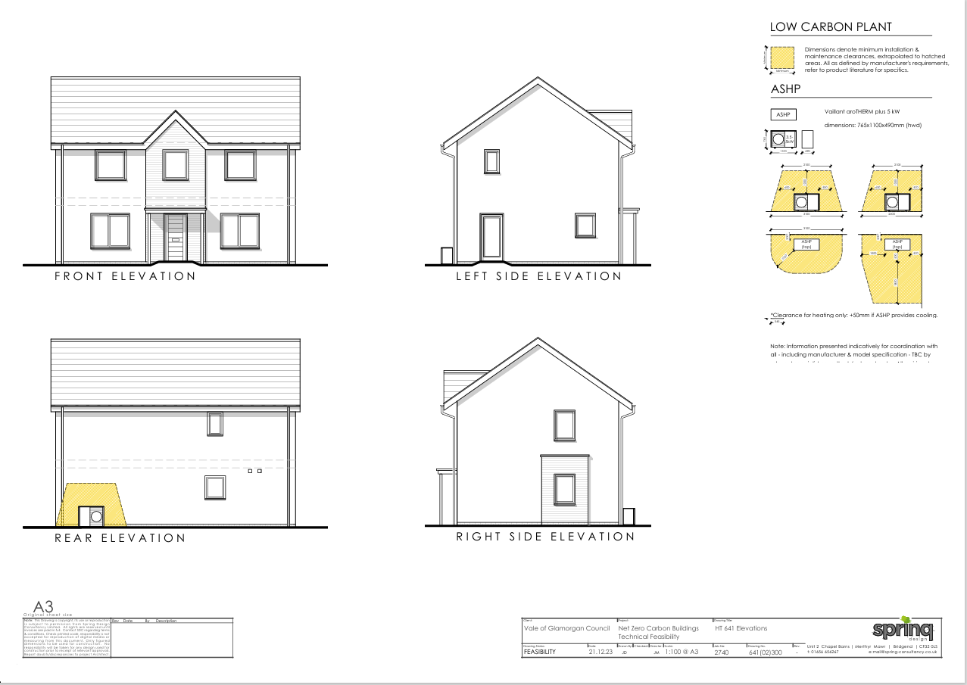  Spring Designs_HT 64 (Davis, 2025)

Property Location:
- Vale of Glamorgan (The Vale as it’s colloquially known): area of approximately 130 square miles between Bridgend, Rhondda Cynon Taf, Cardiff, and the Bristol Channel.
- Main towns: Barry, Penarth, Llantwit Major, and Cowbridge
- Population: approximately 130k
- Attractions: Barry Pleasure Park resort, Barry Tourist Railway.
- Proximity to: Cardiff, Newport, Swansea, and the A4.
- Transport: Cardiff Airport – domestic and international flights, Transport for Wales & Great Western Railway – services between Swansea, London Paddington, and Manchester Picadilly.

Description of Building:

- New build dwelling in wealthy rural area of Wales
- Two-story, Four-bedroom detached house with 110m2 internal floor area: presumed to allow occupancy of 4-5 people – typical family size home.
- Designed to comply with Approved Document L, Welsh Building Regulations
- Electricity: supplied from National Grid. No photovoltaic panels in current design
- Water: supplied from the mains water
- Standard UK climate data and building orientation
- House type: detached
- Floor area: 110m² internal floor area
- External wall thickness: 550mm
- Internal wall thickness: 100mm
- Floors: 400mm
- Existing services: ASHP, MVHR, DHW

Understanding of Current AD: L Design:

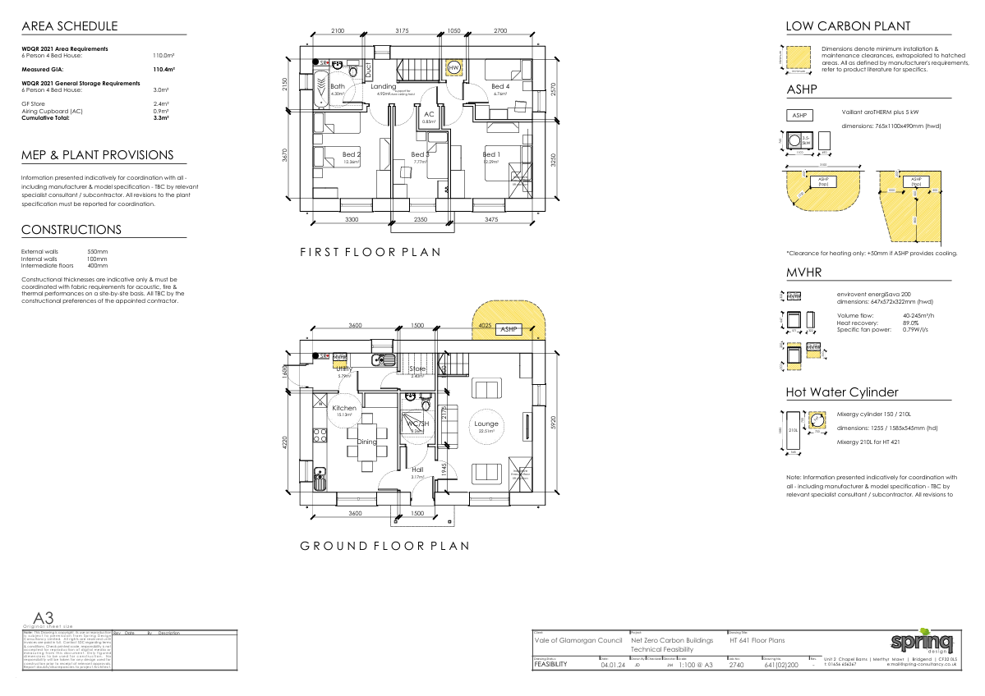
Figure 1: Spring Designs_HT 641_ Floor Plan

Building Fabric
Air permeability  Thermal bridges | 5.00 m³/m²/hr  0.200 W/mK
Doors & Windows
Frames U_{f}  Installation thermal bridging  Glazing U_{g}  Glazing g-value  Glazing edge | 1.400 W/m²K uPVC  0.040 W/mK  1.120 W/m²K double low-e glazing 16mm Ar  0.64  0.040 W/mK
Ventilation Strategy
Ventilation rate  Ventilation unit  Heat recovery efficiency  Ducting  Duct insulation (inlet/ exhaust) | 30m³ per person per hour via MEV  MEV  N/A (extract only)
Heating
ASHP  SCOP  Controls | Generic  3.30  On/off
AD: L Variation (www.passivhaustrust.org.uk, n.d.)

This design utilises the fabric u-value parameters from AD: L with the ventilation strategy changed to MEV to align with Future Homes and Buildings Standard: 2023 consultation for England.

LETI Variation

Building Fabric
Air permeability  Thermal bridges | 0.50 m³/m²/hr  -0.050 W/mK
Doors & Windows
Frames U_{f}  Installation thermal bridging  Glazing U_{g}  Glazing g-value  Glazing edge | 0.810-0.088 W/m²K Rehau Artevo uPVC  0.009-0.023  0.55 W/m²K triple glazing (4-18Ar-4-18Ar-4)  0.63  0.025 W/mK
Ventilation Strategy
Ventilation rate  Ventilation unit  Heat recovery efficiency  Ducting  Duct insulation (inlet/ exhaust) | 30m³ per person per hour via MVHR  Zehnder ComfoAir 225  92%  Semi-rigid radial  50mm closed cell Armaflex
Heating
ASHP  SCOP  Controls | Vaillant aroTHERM plus  4.01  Acc. to ambient temperature
LETI Variation (www.passivhaustrust.org.uk, n.d.)

These values were developed to ensure that even with the least favourable building topology, the HT 641 dwelling design could still comply with LETI standards.

ASHP:  Unit: Vaillant aroTHERM plus 5 kW  Location: external, to the rear of the property  (see appendix for full specifications) | 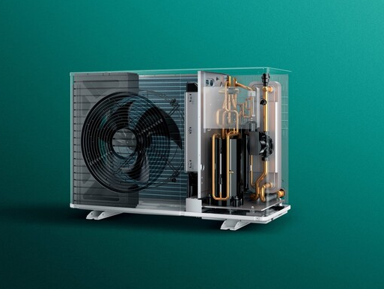  Figure 2: aroTHERM plus (Vaillant.co.uk, 2025)

MVHR:  Unit: envirovent energiSava 200  Location: ground floor utility room.  Volume flow: 40-245m³/h  Heat recovery: 89.0%  Specific fan power: 0.79W/l/s  Maximum Airflow: 241m3/h (67l/s) | 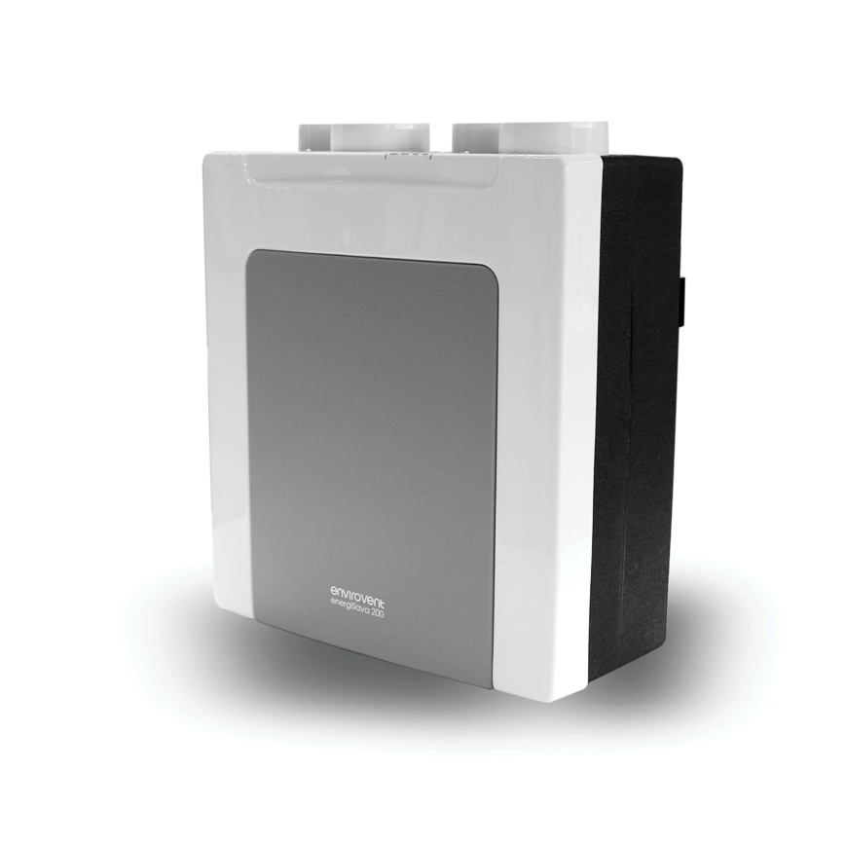  Figure 3: envirovent energiSava 200 (Envirovent.com, n.d.)
Provides fresh air and extracts stale air utilising a heat recovery system to reduce energy costs.
Baffle filters and designed ducting reduce operation noise and noise transfer between rooms.

HWC:  Unit: Mixergy cylinder 150 / 210L  Location: first floor boiler cupboard  Mixergy 210L for HT 421 | 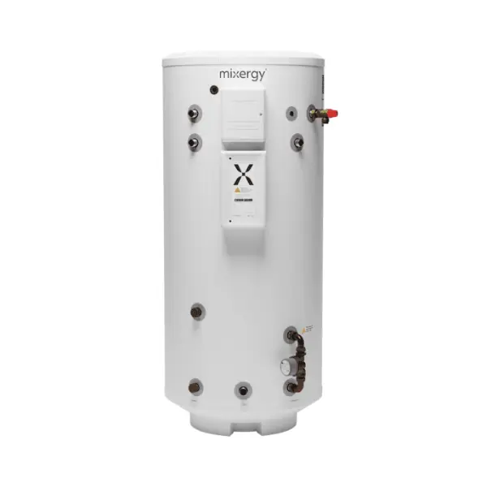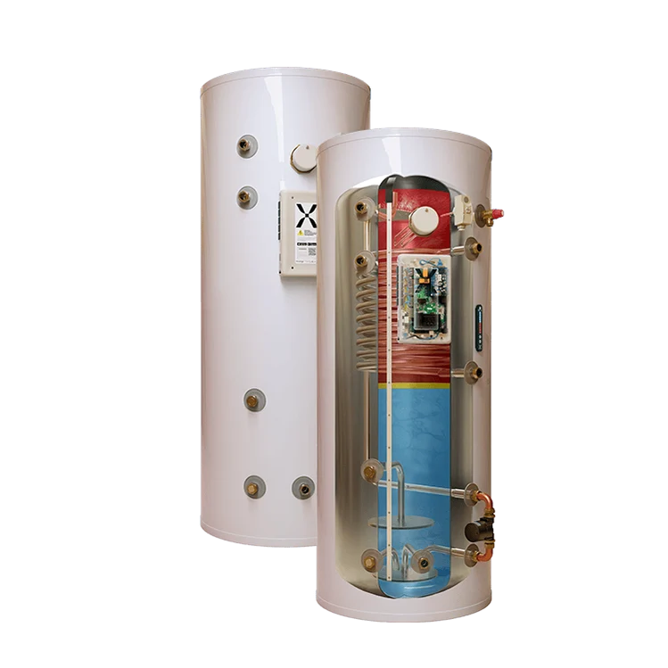  Figure 4: Mixergy cylinder (BEE - the smart heating merchants, 2026)

Comparison

As AD: L already requires high-quality building fabric, the LETI variation will use the same fabric with identical u-values to the AD: L variant.
This allows the LETI variant to demonstrate potential upfront carbon reductions without changing the operational performance of the dwelling.
Both variants use readily available materials which comply with building regulations.
Internal finishes, fixtures and fittings are not included in the analysis due to the high variance in carbon density.
The main differences come from: improved airtightness, mitigating thermal bridging, external doors and window quality, and the efficiency and optimisation of installed technologies.

Element | AD: L | LETI | Difference
Building Fabric
Air permeability | 5.00 m³/m²/hr | 0.50 m³/m²/hr | 4.50 m³/m²/hr
Thermal bridges | 0.200 W/mK | -0.050 W/mK | 0.250 W/mK
Doors & Windows
Frames U_{f} | 1.400 W/m²K uPVC | 0.810-0.088 W/m²K  Rehau Artevo uPVC | 0.590-1.312 W/m²K
Installation thermal bridging | 0.040 W/mK | 0.009-0.023 W/mK | 0.031-0.017 W/mK
Glazing U_{g} | 1.120 W/m²K double low-e glazing 16mm Ar | 0.55 W/m²K triple glazing (4-18Ar-4-18Ar-4) | 0.57 W/m²K
Glazing g-value | 0.64 | 0.63 | 0.01
Glazing edge | 0.040 W/mK | 0.025 W/mK | 0.015 W/mK
Ventilation Strategy | Extract Air Unit | Balanced PH ventilation with HR | High heat recovery,  Continuous supply of filtered air,  Better controls
Ventilation rate | 30m³ per person per hour via MEV | 30m³ per person per hour via MVHR
Ventilation unit | MEV | Zehnder ComfoAir 225 | Higher indoor air quality, comfort, and long-term performance
Heat recovery efficiency | N/A (extract only) | 92% | 92%
Ducting | N/A | Semi-rigid radial | Dedicated ducting to each room,  reduced noise transfer
Duct insulation (inlet/ exhaust) | N/A | 50mm closed cell Armaflex | Prevents condensation,  Minimises heat loss,  Improved acoustic dampening
Heating
ASHP | Standard air/water heat pump | Vaillant aroTHERM plus
SCOP | 3.30 | 4.01 | 0.71
Controls | On/off | Acc. to ambient temperature | Higher seasonal efficiency with lower electricity costs

Element | AD: L | LETI
Foundations | Trench Fill | Trench Fill
Identical foundation  Pros | - Strong, load-bearing foundation | Quick construction time
Cons | - High embodied carbon in concrete | - High material cost
Ground Floor | Screed, PIR, slab on grade | Steico joist w/ Warmcel
Pros | - Large thermal mass, stores solar gains  - Long lifespan  - Straightforward construction process | - Very low embodied carbon  - Easy to install / run services through floor  - Timber floor provides a more natural feel
Cons | - High embodied carbon  - PIR insulation is petrochemical-based  - Slow heating and cooling times  - Difficult to alter after construction | - Low thermal mass / heat retention  - High level of detailing required to achieve airtightness  - Higher material cost
External Walls  Brickwork finish externally | Plasterboard on dabs, masonry cavity w/ PIR | Plasterboard w/ service zone, SMARTPLY OSB, 292mm twin stud w/ Warmcel
Pros | - Traditional & familiar construction method  - High durability  - Good thermal mass  - Thin wall width due to PIR’s high insulation value | - Low embodied carbon  - Excellent thermal efficiency  - Twin-stud design reduces thermal bridging  - Easier to achieve Passive House level of fabric performance  - Good airtightness levels
Cons | - Thermal bridging issues  - Low embodied carbon  - Variable airtightness – requires skilled workmanship | - Thicker walls  - Less familiar construction process  - Careful design of moisture details to avoid interstitial condensation  - High upfront cost
Party Walls  All to Robust Details | Wet plaster, blockwork, ROCKWOOL filled cavity, blockwork, wet plaster | Plasterboard, SMARTPLY OSB, timber w/ Warmcel, cavity w/ Warmcel, timber w/ Warmcel, SMARTPLY OSB, plasterboard
Pros | - Traditional, well-established construction  - High fire resistance  - Good acoustic insulation  - Adaptable to occupancy changes | - Low embodied carbon  - Excellent acoustic performance  - Lightweight construction  - Good thermal continuity between INT and EXT wall elements  - Easier adaptability for services / routing
Cons | - Requires high weight bearing foundations  - Highly labour intensive  - Higher embodied carbon  - Difficult to alter services / routing once constructed | - High levels of detail design  - High-quality control and workmanship levels required  - Less familiar construction process-  - Lower fire resistance
Internal Walls | Wet plaster, blockwork, wet plaster | Plasterboard, stud w/ Warmcel, plasterboard
Pros | - High durability  - Long lifespan  - Good thermal mass  - Good fire resistance | - Fast and simple construction  - Lower embodied carbon  - Lightweight construction  - Services can be routed through the stud cavity
Cons | - High embodied carbon  - Longer construction and drying times  - Skilled labour required  - Difficult to alter services / routing once constructed | - Lower durability  - Lower thermal mass  - Harder to mount wall furnishings  - Prone to moisture and impact damage
Intermediate Floor | Chipboard, Posi-joist w/ ROCKWOOL, plasterboard | Chipboard, Posi-joist w/ Warmcel, plasterboard
Pros | - Excellent acoustic insulation between floors  - Durable insulation with high fire and moisture resistance  - Well established construction method | - Low embodied carbon in recycled cellulose insulation  - Excellent acoustic insulation between floors  - Blown insulation efficiently fills gaps to increase performance
Cons | - Higher embodied carbon vs cellulose-based insulation  - High energy usage manufacturing  - Insulation fibres can cause skin irritation | - Specialist equipment required for blown insulation  - Insulation density and settlement can affect performance  - Susceptible to moisture damage  - Requires fire-resistant treatment
Separating Floor  All to Robust Details | Screed, resilient layer, beam & block, suspended ceiling w/ ROCKWOOL & plasterboard | Screedboard, OSB deck, resilient layer, Posi-joist w/ ROCKWOOL, resilient bar w/ plasterboard, suspended ceiling w/ plasterboard
Pros | - Good thermal and acoustic insulation  - Fire and moisture resistant insulation  - Posi-joist construction allows for easy routing of services | - Low embodied carbon in recycled cellulose insulation  - Good thermal and acoustic insulation  - Blown insulation efficiently fills the cavity providing better performance  - Posi-joist construction allows for easy routing of services
Cons | - Higher embodied carbon compared to cellulose  - Energy intensive insulation production  - Insulation fibres can cause skin irritation | - Specialist equipment required for blown insulation  - Insulation density and settlement can affect performance  - Susceptible to moisture damage  - Requires fire-resistant treatment
Roof | Plasterboard, polythene VCL, ROCKWOOL, concrete tiles | Plasterboard, SMARTPLY OSB, Warmcel, Welsh slate
Pros | - High durability and longevity  - Good thermal and acoustic insulation  - Lower cost compared to slate | - Lower embodied carbon  - Higher rigidity and airtightness  - Very long lifespan with lower maintenance  - Good thermal and acoustic insulation  - Natural aesthetics
Cons | - High embodied carbon  - Heavy materials, requires a strong roof structure  - Polythene prone to damage | - Higher upfront material costs  - Heavy materials, requires a strong roof structure  - Higher skill requirement and labour time  - Warmcel requires specialist installation equiptment
(Davis, 2025, p.20)

HT 641 Operational outputs
Operational scenarios | Space heating demand | Energy use intensity (EUI) | Annual energy use per dwelling | CO2e emissions  ex. PV (60 yrs) | kWp of PV to Net Zero per dwelling
AD: L | 79.5 kWh/m²/yr | 65.6 kWh/m²/yr | 7,242 kWh | 27.20 tonnes | 10.0 kWp
LETI | 15.1 kWh/m²/yr | 44.5 kWh/m²/yr | 4,913 kWh | 18.50 tonnes | 6.8 kWp
Difference | 64.4 kWh/m²/yr | 21.1 kWh/m²/yr | 2,329 kWh | 8.7 tonnes | 3.2 kWp
(Davis, 2025, p.27)

Justifications:

Performance comparison between buildings with identical building fabric and u-values shows significant improvements can be made through detailed airtightness, thermal bridging, and ventilation strategies.
Reduced space heating demand from higher quality development allows the ASHP requirements to be reduced from 7kW to 3.5 kW.

Efficient operation and installation of MVHR system reduce the EUI and CO2e emissions to 32%, allowing for fewer PV panels required to reach Net Zero targets and reduce capital costs.

  - Costs

AD L (Wales) 2025 upgrade to LETI
Building Element
Fabric | Double glazing to triple glazing | additional cost | + £623.63
 | ASHP reducing in size | cost saving | - £6,000.00
 | MVHR addition | additional cost | + £4,000.00
 | MEV omission | cost saving | - £900.00
Generation | PV array decreasing in size | cost saving | - £1,200.00
TOTAL | Cost per unit |  | - £3,476.37
 | Cost per m² of GIA |  | - £31.49
(Davis, 2025, p.29)

Cost Analysis
Element | AD: L | LETI | Difference
Foundations | £8,750.00 | £8,750.00 | £0.00
Ground Floor | £19,345.00 | £19,345.00 | £0.00
External Walls | £54,230.00 | £54,230.00 | £0.00
Party Walls | N/A | N/A | N/A
Internal Walls | £9,435.00 | £9,435.00 | £0.00
Internal Floor | £5,225.00 | £5,225.00 | £0.00
Separating Floor | N/A | N/A | £0.00
Roof | £15,958.00 | £15,958.00 | £0.00
Doors / Windows | £7,018.76 | £7,642.39 | + £623.63
M&E | £31,200.00 | £26,800.00 | - £4,100.00
TOTAL | £150,861.76 | £147,385.39 | - £3,476.37
Cost per m² | £1,366.50 | £1,335.01 | - £31.49

Projected Annual Electricity Bills:
AD: L £1,774.29
LETI £1,203.69

Topic | AD:L | LETI
Operational Energy | meets minimum standards | minimises demand, uses high efficiency systems
Embodied Carbon | Limited considerations | Considered from the design stage
Controls | Basic compliance | Intelligent optimisation and monitoring
Renewable energy | Optional | Strongly encouraged where appropriate
Whole-life cost | Lower upfront cost, higher lifetime cost | High upfront cost, lower lifetime cost

HT 341 Operational Energy Losses & Gains

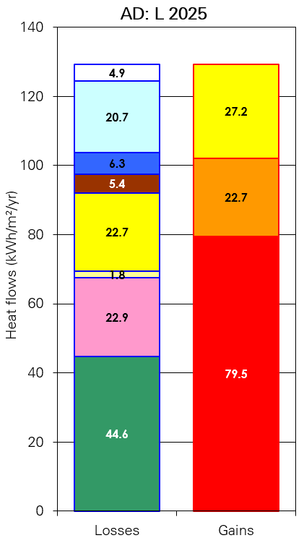 | 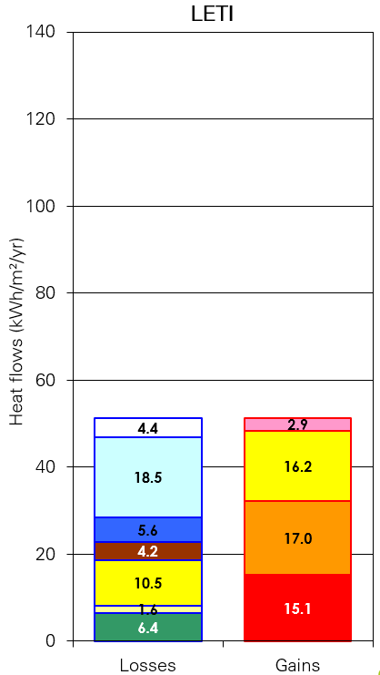 | 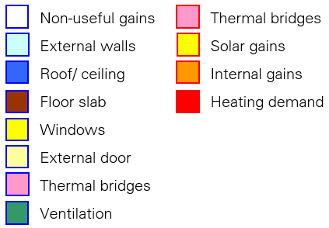

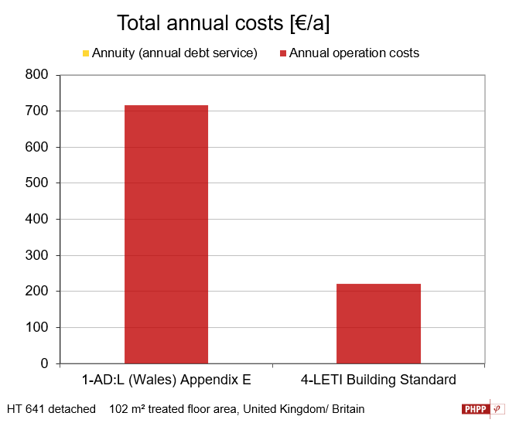
Figure 5: Total Annual Costs (www.passivhaustrust.org.uk, n.d.)

Conclusion

This report has critically appraised the M&E design for the scenario building and evaluated improvements which would bring the design closer to reaching LETI’s low-energy performance targets.
The current AD: L design complies with Building Regulations and incorporates low carbon heating and heat recovery ventilation which support the transition towards renewable energy.
If they are correctly designed and installed, these systems can deliver good levels of occupant comfort and indoor air quality.

However, this design only achieves the minimum AD: L standards which could lead to higher operational energy usage, higher heat loss through thermal bridging, and lower airtightness thresholds affecting the efficiency of the installed services, reducing the dwelling’s overall lifetime operational performance.

This appraisal hopes to demonstrate that adopting a ‘fabric-first’ approach through careful selection of the building materials, improvements to airtightness, continuous insulation, and reducing thermal bridging would greatly reduce the building’s heating and energy demands and allow the MVHR and ASHP units to operate at a higher efficiency level.

Integrating the building fabric, services, and construction methods together in the design stage and focusing on higher quality installation, commissioning, and maintenance of the services greatly improves the energy performance levels and life-time emissions.

For further improvements, installation of PV panels and battery storage would allow for future electrical infrastructure and reduce reliance on Grid electricity.

The suggested improvements reduce operational carbon emissions, lower annual energy consumption, and decrease operational energy costs whilst keeping high occupant comfort and indoor air quality.

In summary, this report aims to highlight the benefits of adopting LETI performance principles whilst still complying with AD: L and support the UK’s Net Zero objectives.

References

Approved Document F (2021). Approved Document F: Volume 1 applies to dwellings. [online] Available at: https://assets.publishing.service.gov.uk/media/61deba42d3bf7f054fcc243d/ADF1.pdf.

BEE - the smart heating merchants. (2026). Mixergy x slimline indirect unvented cylinder 120l - 210l. [online] Available at: https://beetbg.com/products/mixergy-210l-indirect-unvented-cylinder-485mm-dia.

Davis, J. (2025). Net Zero Carbon Buildings​ Feasibility Study & Cost Assessment.
Envirovent.com. (n.d.). energiSava® 200 | envirovent. [online] Available at: https://www.envirovent.com/product-details/energisava-200/.

EPCs as Efficiency Targets. (n.d.). [online] Available at: https://www.passivhaustrust.org.uk/UserFiles/File/research%20papers/EPCs/2020.04.17-
EPCs%20as%20efficiency%20targets-v9.pdf.

HM Government (2023). L Conservation of Fuel and Power the Building Regulations 2010 Volume 1: Dwellings Requirement L1: Conservation of Fuel and Power Requirement L2: On-site Generation of Electricity Regulations. [online] Available at: https://assets.publishing.service.gov.uk/media/662a2e3e55e1582b6ca7e592/Approved_Document_L__Conservation_of_fuel_and_power__Volume_1_Dwellings__2021_edition_incorporating_2023_amendments.pdf.

Mixergy. (2025a). Mixergy X. [online] Available at: https://www.mixergy.co.uk/solutions/hot-water/mixergy-x/.

Spring-Consultancy. (2025b). Spring-Consultancy. [online] Available at: https://www.spring-consultancy.co.uk/.

Vaillant.co.uk. (2025c). aroTHERM plus air source heat pump 5kW. [online] Available at: https://professional.vaillant.co.uk/for-installers/products/arotherm-plus-air-source-heat-pump-5kw-146560.html.

www.passivhaustrust.org.uk. (n.d.). Design Support. [online] Available at: https://www.passivhaustrust.org.uk/design_support.php.

‌

Appendix

Heating demand = Amount of energy required to heat a space annually
Energy / area (TFA) / annum
kWh / m²TFA / yr

Energy use intensity (EUI) = All energy consumed by a building annually*
Energy / area (GIA) / annum
kWh / m²GIA / yr
*excludes EV charging

Net Zero (operational) = Balancing annual consumption with on-site generation

Figures:

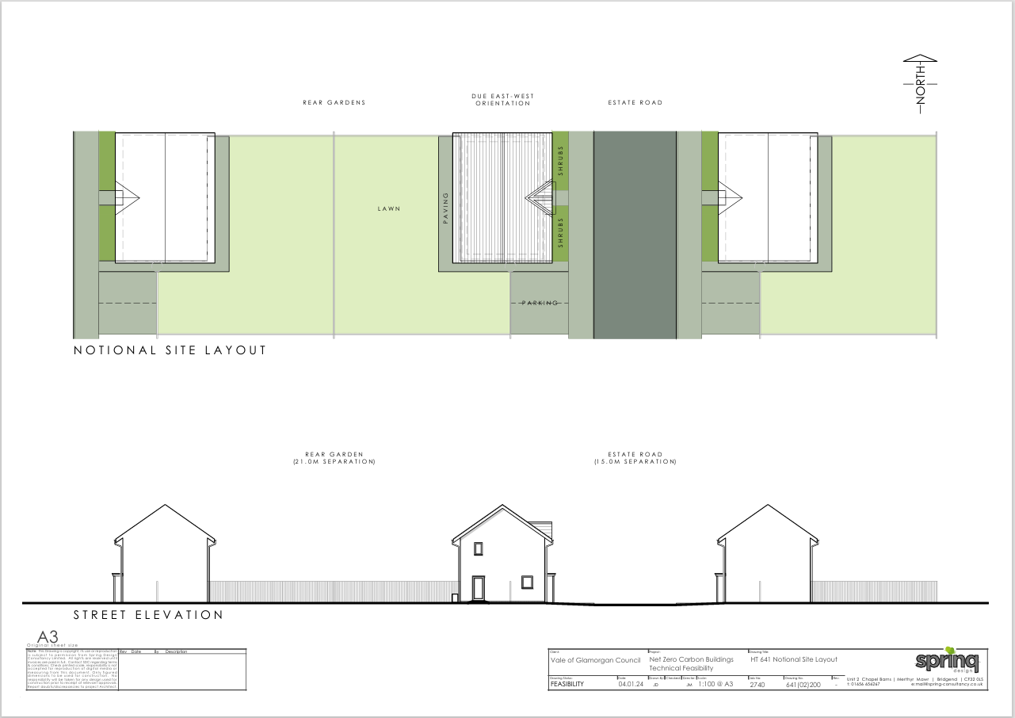
Figure 6: Spring Designs HT 641_Site Plan & Elevations

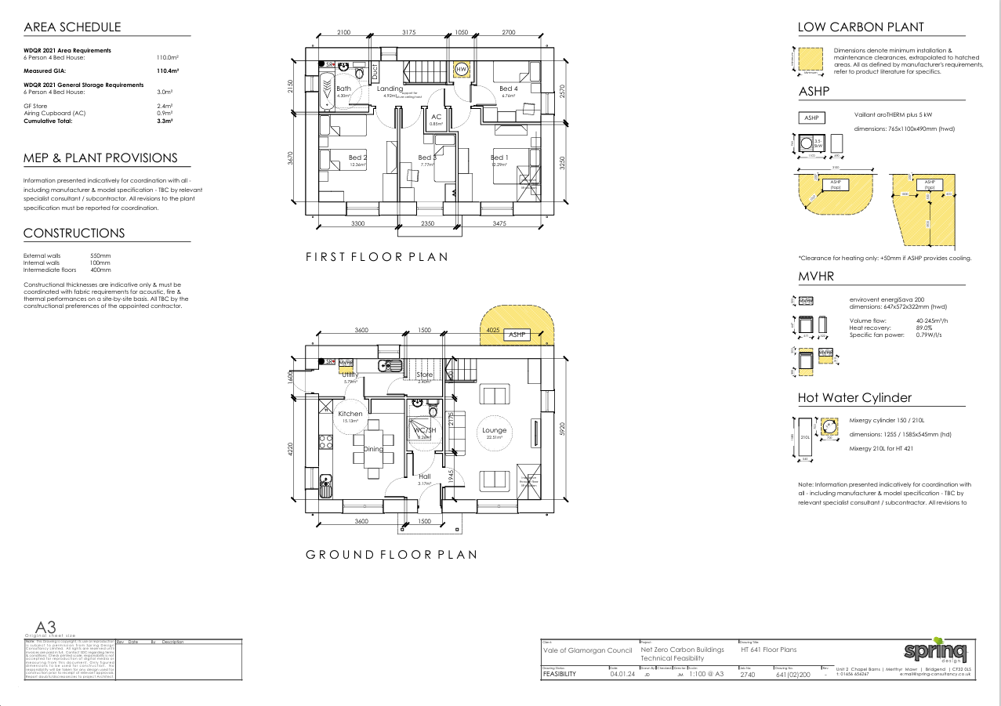
Figure 7: Spring Designs_HT 641_Floor Plans

Figure 8: Spring Designs_HT 641_Elevations

aroTHERM plus air source heat pump 5kW Specifications
 | Unit | 5kW VWL 55 / 6
General information
Width | mm | 1,100
Height | mm | 765
Depth | mm | 450
Weight, ready for operation | kg | 114
Connection, heating circuit |  | G 1 1/4"
Rated voltage | V | 230 V (+10%/- 15%), 50 Hz,  1~/N/PE
Rated current, maximum | A | 14.3
Fuse size | A | 16
Fuse Type |  | Characteristic C, slow-blow, singlepole switching
RCD type |  | Type B rated to 20kHz or greater and with a minimum trigger point of 150mA above 1kHz.
eBUS (2-core communication cable) | mm2 | 0.75
Maximum length eBUS cable (polarity sensitive) | m | 50
IP rating | m | IP 15 B
Fan, power consumption | W | 40
Fan quantity |  | 1
Fan, air flow, maximum | m3/h | 2,300
Heating pump, power consumption | W | 2 - 50
Heating circuit
Heating water temperature, minimum/maximum | °C | 20 - 75
Operating pressure, minimum | bar | 0.5
Operating pressure, maximum | bar | 3.0
Volume flow, minimum | l/h | 400
Volume flow, maximum | l/h | 860
Water volume, in the outdoor unit | l | 1.5
Minimum open water volume | l | 15
Refrigerant circuit
Fluid type |  | R290
Fluid fill quantity | kg | 0.6
Refrigerant, Global Warming Potential (GWP) |  | 3
Noise emissions, heating mode
Sound power, EN 12102, EN 14511 LWA, A7/W35 | dB(A) | 48
Sound power, EN 12102, EN 14511 LWA, A7/W55 | dB(A) | 48
Efficiency
Energy efficiency class 35°C | (A+++ to F) | A++
Energy efficiency class 55°C | (A+++ to F) | A
Combination with uniTOWER
Energy efficiency class | (A+++ to F) | A+++
Energy efficiency class for hot water supply | (A+ to F) | A++

Figure 9: aroTHERM Specifications (Vaillant.co.uk, 2025)

