

LEVEL/ LEfEL 4

SEMESTER 1/2

MODULE CODE/ Cod Y modIwl: PDSE4005 - Programmable Logic Controllers

aSSESSMENT TYPE/ mATH O ASESU: aSSIGNMENT
Assessment/Component/ AsESIAD/CYDRAN: 3 of 3

COMPONENT WEIGHTING/ PWYSAU’R CYDRAN: 40%

WORD COUNT/ NIFER Y GEIRIAU: 2000 WORDS/O EIRIAU

MODULE TUTOR / TIWTOR Y MODIWL: Richard Wray

SUBMISSION DETAILS/ MANYLION CYFLWYNO:

- Make sure that Your Name , Your Student P Number, Your Module Title, Assignment Title and Your Module Lecturer’s Name are clearly shown on the front page of your assignment
- All assignments must be submitted electronically to Turnitin unless indicated by the module lecturer here: …………………………………………...
- If a paper submission is required then it will be indicated here: ………………….
you will then be required to submit the assignment parts in a suitable report folder– not in poly-pockets - to the library.
- For paper submissions this form (ALL PAGES) MUST be printed out, signed, attached to the front of your assignment and submitted to the library separately from your electronic assignment submission.
- Assignments will not be accepted without this form as it is a requirement that you sign the disclosure regarding the referencing convention.
- DO NOT put this form into Turnitin or it will match many similarities with other students’ submissions.

RESULT

School of Applied Computing ASSIGNMENT SPECIFICATION

Student name: |  | Student P number:
Programme: | HND/HNC Electrical & Electronic Engineering, HNC Instrumentation Engineering, HNC Power Systems Engineering.
Lecturer: | Richard Wray | Internal Verifier: | Jason Pointer
Assignment Title: | PLC Program design and simulation
Hand Out Date: | 21/03/18 | Submission deadline: | 16/05/18
Referencing: | In the main body of your submission you must give credit to authors on whose research your work is based. Append to your submission a reference list that indicates the books, articles, etc. that you have read or quoted in order to complete this assignment (e.g. for books: surname of author and initials, year of publication, title of book, edition, publisher: place of publication).
Disclosure: | I declare that this assignment is all my own work and that I have acknowledged all materials used from the published or unpublished works of other people. All references have been duly cited.
Student’s Signature: | Hardcopy assignments will not be accepted without a signature here | Date:
Late submission will result in a late penalty mark, as follows:
Up to one week late, maximum mark of 40% for first attempts and 0% for resubmissions.
(Academic Quality Handbook 2017/18 7.5 (5))

Learning Outcomes tested
(from module syllabus)
LO1, LO2

TASK DESCRIPTION

Part A. Introduction
Programmable Logic Controllers are capable of accepting both discrete and analogue inputs. They are also capable of operating a range of equipment through the output interface. For this part of the assignment you are required to examine these aspects in detail.

Task 1. PLC Analogue and discrete I/O
- Identify and describe five different devices that could be connected to the PLC with respect to input circuits.

- Where an analogue input is to be used then an analogue to digital conversion (ADC) process will take place. Describe this process, including in your answer issues associated with quantization interval quantization error and the part binary plays in this process.

- Identify and describe five different devices that could be connected to the PLC with respect to output circuits.

- PLCs will use either relays or transistor to carry out the output switching process. Compare and contrast the characteristics of these two types of output switching devices.

Task 2. PLC maintenance and reliability

- Briefly describe the types of maintenance that would be applicable to a general PLC system. Include in your answer any specific examples of manufacturers’ recommendations or Good Automated Manufacturing Practice (GAMP).

- In developing PLC programs we may include subroutines that monitor, maintain or support fault diagnosis within external field devices or the program operation. Describe strategies or program routines that could be adopted to ensure this is the case.

Part B

Task 3. Process Alarm Panel

For this programming task you are required to use the Mitsubishi PLC analogue input functionality to design and simulate a process alarm system. The system should monitor an analogue input (typically 0 to 10 volts) and initiate an alarm if this signal drops below 20% or above 80% of the analogue input span. At all other times (i.e. between 20% to 80%) a ‘system healthy’ light should be illuminated. When the alarm is initiated an audible and flashing visual alarm should be activated.

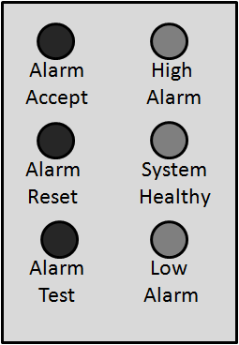
The system should have the following controls (see figure 1):
- A momentary ‘alarm accept’ button that should cancel the audible alarm and set the visual alarm from flashing to a steady state condition.
- A momentary ‘alarm reset’ button that that will turn off the visual alarm once the process has returned to a safe condition, this will be indicated by the ‘system healthy’ lamp.
- A momentary ‘alarm test’ button that allows the user to check the lamps and audible alarm are functioning correctly.

Figure 1. Alarm Panel

In addition, construct a Human Machine Interface (HMI) panel to demonstrate the operation of your program. You may use the Mitsubishi Alpha program development system ‘sketch window’ to construct the HMI.

To complete the task you are required to demonstrate the operation of your program to your Tutor and include a copy of the program in your report.

Task 4.

- For this task you are required to develop a program to control the fruit beverage blending operation shown in figure 2. You may use either the Mitsubishi Alpha AL2 PLC (function block) or the Mitsubishi FX PLC (ladder logic) to control the process. Both are supported by the process simulator. Assess the design specification before making your choice.

Design Specification

Initial conditions: Prior to operating the blending process, all valves should be closed and the transfer pump (PU203) should be off. Level switches LS201-2 and LS202-2 should be active to indicate a low level condition exists in holding tanks TA201 and TA202. Refer to figure 2 for tank system configuration.

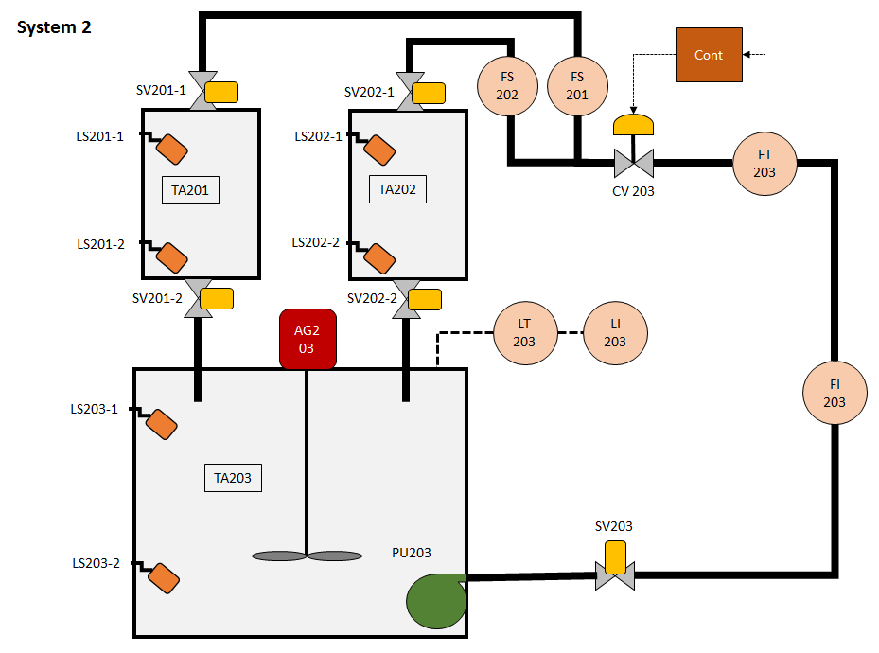
Figure 2. Fruit beverage blending system

Process operation: On pressing and releasing the start button the following automated sequence should be initiated:
Step 1. Fill tank TA201 with syrup.
Step 2. Fill tank TA202 with water.
Step 3. Start TA203 agitator.
Step 4. Hold contents in TA202 for 30 seconds.
Step 5. Transfer the contents of TA202 to TA203.
Step 6. Hold contents in TA201 for 60 seconds.
Step 7. Transfer the contents of TA201 to TA203.
Step 8. Blend contents in TA203 for a further 30 seconds.
Step 9. Stop agitator AG203.
Operation complete.

Note: Please incorporate the following safety precautions in your program:

- At no point should a dead head pumping condition exist for PU203. Flow switches FS201 and FS202 should be incorporated into the program design to detect a low flow condition.
- At no point should the contents of TA201 or TA202 exceed the high level setting or drop below the low level setting.
- To ensure an appropriate mixing operation takes place the contents of TA203 should be agitated when the contents of TA201 or TA202 are being added.
- The Alpha and FX PLCs are prewired into the blending system simulator, consequently specific input and output addresses must be used. For the Alpha PLC refer to table 1 and for the FX PLC refer to table 2.
Table 1. Mitsubishi Alpha PLC input and output configuration

Input |  | Output
1 | Filling process start switch (NO) | 1 | Pump (PU203) run + Mimic panel light
2 | Process emergency stop switch (NC) | 2 | Agitator (AG203) run + Mimic panel light
3 | Spare | 3 | SV203 + Mimic panel light
4 | TA201 high level switch (LS201-1) | 4 | SV201-1 + Mimic panel light
5 | TA201 low level switch (LS201-2) | 5 | SV201-2 + Mimic panel light
6 | TA202 high level switch (LS202-1) | 6 | SV202-1 + Mimic panel light
7 | TA202 low level switch (LS202-2) | 7 | SV202-2 + Mimic panel light
8 | Spare | 8 | Spare
9 | Spare | 9 | Spare
10 | Flow switch (FS201)
11 | Flow switch (FS202)
12 | Spare

Table 2. Mitsubishi FX PLC input and output configuration

Input |  | Output
0 | Filling process start switch (NO) | 0 | Pump (PU203) run + Mimic panel light
1 | Process emergency stop switch (NC) | 1 | Agitator (AG203) run + Mimic panel light
2 | TA201 high level switch (LS201-1) | 2 | SV203 + Mimic panel light
3 | TA201 low level switch (LS201-2) | 3 | SV201-1 + Mimic panel light
4 | TA202 high level switch (LS202-1) | 4 | SV201-2 + Mimic panel light
5 | TA202 low level switch (LS202-2) | 5 | SV202-1 + Mimic panel light
6 | Flow switch (FS201) | 6 | SV202-2 + Mimic panel light
7 | Flow switch (FS202) | 7 | Spare
8 | Spare
9 | Spare
10 | Spare
11 | Spare

On completion of this task you are required to demonstrate the operation of your program to your Tutor using the process simulator. Include a printed copy of your program in your report and briefly discuss the program operation. Evaluate the operation of the program and compare it against the design specification. Comment on any additional functionality that could have been incorporated into your program to ensure the blending process operated efficiently and safely.

GUIDANCE FOR Students IN THE COMPLETION OF TASKS

1. Research-informed Literature: You must provide evidence of individual research with respect to PLC and systems theory and operation, and provide relevant referencing.

2. Knowledge and Understanding of Subject: Your report should show you gained knowledge of the PLCs and associated systems used in this assignment.

3. Analysis: The report should show analysis of the research and experimental programming work.

4. Practical Application and Deployment: Verify program design and operation against expected theoretical and calculated outcomes. Although the practical exercises may be completed as part of a group exercise the resulting report and analysis of data must be an independent piece of work. You will need a verified copy of your program design (screen shot) to confirm the PLC program has been demonstrated and witnessed.

5. Skills for Professional Practice: Your work should be well organised and presented in a professional manner.

marking criteria and Student FEEDBACK

This section details the assessment criteria. The extent to which these are demonstrated by you determines your mark. The marks available for each criterion are shown. Lecturers will use the space provided to comment on the achievement of the task(s), including those areas in which you have performed well and areas that would benefit from development/improvement.

Common Assessment Criteria Applied | Marks available | Marks  awarded
1. Research-informed Literature  Extent of research and/or own reading, selection of credible sources, application of appropriate referencing conventions. | 10
2. Knowledge and Understanding of Subject  Extent of knowledge and understanding of concepts and underlying principles associated with the discipline. | 25
3. Analysis  Analysis, evaluation and synthesis; logic, argument and judgement; analytical reflection; organisation of ideas and evidence | 25
4. Practical Application and Deployment  Deployment of methods, materials, tools and techniques; application of concepts; formulation of innovative and creative solutions to solve problems. | 30
5. Skills for Professional Practice  Attributes in professional practice: individual and collaborative working; deployment of appropriate media; presentation and organisation. | 10

Assignment Mark (Assessment marks are subject to ratification at the Exam Board. These comments and marks are to give feedback on module work and are for guidance only until they are confirmed. ) | Late Submission Penalties (tick if appropriate) |  | %
 | Up to one week late (capped at 40%) |  | %
 | First Attempt? |  | %

FdSc & HN COMMON ASSESSMENT AND MARKING CRITERIA

 | OUTRIGHT FAIL | UNSATISFACTORY | SATISFACTORY | GOOD | VERY GOOD | EXCELLENT | EXCEPTIONAL
Assessment Criteria | REFER (equivalent to 0-29% | REFER (equivalent to 30-39%* | PASS (equivalent to 40-49%) | PASS (equivalent to 50-59%) | MERIT (equivalent to 60-69% | DISTINCTION (equivalent to 70-79% | DISTINCTION (equivalent to 80-100%
1. Research-informed Literature  Extent of research and/or own reading, selection of credible sources, application of appropriate referencing conventions | Little or no evidence of reading.  Views and findings unsupported and non-authoritative.  Referencing conventions largely ignored. | Poor evidence of reading and/or of reliance on inappropriate sources, and/or indiscriminate use of sources.  Referencing conventions used inconsistently. | References to a limited range of mostly relevant sources. Some omissions and minor errors.  Referencing conventions evident though not always applied consistently. | Inclusion of a range of research-informed literature, including sources retrieved independently. Referencing conventions mostly consistently applied. | Inclusion of a wide range of research-informed literature, including sources retrieved independently.  Selection of relevant and credible sources. Very good use of referencing conventions, consistently applied. | A comprehensive range of research informed literature embedded in the work. Excellent selection of relevant and credible sources. High-level referencing skills, consistently applied. | Outstanding knowledge of research-informed literature embedded in the work. Outstanding selection of relevant and credible sources. High-level referencing skills consistently and professionally applied.
2. Knowledge and Understanding of Subject  Extent of knowledge and understanding of concepts and underlying principles associated with the discipline. | Major gaps in knowledge and understanding of material at this level. Substantial inaccuracies. | Gaps in knowledge, with only superficial understanding. Some significant inaccuracies. | Evidence of basic knowledge and understanding of the relevant concepts and underlying principles. | Knowledge is accurate with a good understanding of the field of study. | Knowledge is extensive. Exhibits understanding of the breadth and depth of established views. | Excellent knowledge and understanding of the main concepts and key theories. Clear awareness of challenges to established views and the limitations of the knowledge base. | Highly detailed knowledge and understanding of the main theories/concepts, and a critical awareness of the ambiguities and limitations of knowledge.
3. Analysis  Analysis, evaluation and synthesis; logic, argument and judgement; analytical reflection; organisation of ideas and evidence | Unsubstantiated generalisations, made without use of any credible evidence. Lack of logic, leading to unsupportable/ missing conclusions. Lack of any attempt to analyse, synthesise or evaluate. | Some evidence of analytical intellectual skills, but for the most part descriptive. Ideas/findings sometimes illogical and contradictory. Generalised statements made with scant evidence. Conclusions lack relevance. | Evidence of some logical, analytical thinking and some attempts to synthesise, albeit with some weaknesses.  Some evidence to support findings/ views, but evidence not consistently interpreted.  Some relevant conclusions and recommendations, where relevant | Evidence of some logical, analytical thinking and synthesis. Can analyse new and/or abstract data and situations without guidance.  An emerging awareness of different stances and ability to use evidence to support the argument.  Valid conclusions and recommendations, where relevant | Sound, logical, analytical thinking; synthesis and evaluation. Ability to devise and sustain persuasive arguments, and to review the reliability, validity & significance of evidence. Ability to communicate ideas and evidence accurately and convincingly.  Sound, convincing conclusions / recommendations. | Thoroughly logical work, supported by evaluated evidence. High quality analysis, developed independently or through effective collaboration.  Ability to investigate contradictory information and identify reasons for contradictions.  Strong, persuasive, conclusions, justifiable recommendations. | Exceptional work; judiciously selected and evaluated evidence. Very high quality analysis, developed independently or through effective collaboration.  Ability to investigate contradictory information and identify reasons for contradictions.  Highly persuasive conclusions
4. Practical Application and Deployment  Effective deployment of appropriate methods, materials, tools and techniques; extent of skill demonstrated in the application of concepts to a variety of processes and/or contexts; formulation of innovative and creative solutions to solve problems. | Limited or no use of methods, materials, tools and/or techniques.  Little or no appreciation of the context of the application. | Rudimentary application of methods, materials, tools and/or techniques but without consideration and competence. Flawed appreciation of the context of the application. | An adequate awareness and mostly appropriate application of well-established methods, materials, tools and/or techniques.  Basic appreciation of the context of the application. | A good and appropriate application of standard methods, materials, tools and/or techniques.  Good appreciation of the context of the application, with some use of examples, where relevant. | A very good application of a range of methods, materials, tools and/or techniques.  Very good consideration of the context of the application, with perceptive use of examples, where relevant.  Evidence of some innovation and creativity. | An advanced application of a range of methods, materials, tools and/or techniques.  The context of the application is well considered, with extensive use of relevant examples.  Application and deployment extend beyond established conventions. Innovation and creativity evident throughout. | Outstanding levels of application and deployment skills. Assimilation and development of cutting edge processes and techniques.
5. Skills for Professional Practice  Demonstrates attributes expected in professional practice including: individual initiative and collaborative working; deployment of appropriate media to communicate (including written and oral); clarity and effectiveness in presentation and organisation. | Communication media is inappropriate or misapplied.  Little or no evidence of autonomy in the completion of tasks.  Work is poorly structured and/or largely incoherent. | Media is poorly designed and/or not suitable for the audience.  Poor independent or collaborative initiative.  Work lacks structure, organisation, and/or coherence | Can communicate in a suitable format but with some room for improvement.  Can work as part of a team, but with limited involvement in group activities.  Work lacks coherence in places and could be better structured. | Can communicate effectively in a suitable format, but may have minor errors.  Can work effectively as part of a team, with clear contribution to group activities.  Mostly coherent work and is in a suitable structure. | Can communicate well, confidently and consistently in a suitable format.  Can work very well as part of a team, with very good contribution to group activities.  Work is coherent and fluent and is well structured and organised. | Can communicate professionally and, confidently in a suitable format.  Can work professionally within a team, showing leadership skills as appropriate, managing conflict and meeting obligations.  Work is coherent, very fluent and is presented professionally. | Can communicate with an exceptionally high level of professionalism.  Can work exceptionally well and professionally within a team, showing advanced leadership skills.  Work is exceptionally coherent, very fluent and is presented professionally.


Cyfadran Dylunio Cymhwysol a Pheirianneg
Faculty of Applied Design and Engineering

Taflen Cyflwyno Aseiniad
Assignment Hand in Sheet

MANYLION Y MYFYRIWR
STUDENT’S DETAILS
ENW:  NAME: |  | RHIF  P Y MYFYRIWR:  STUDENT  P NUMBER: | P
CWRS:  COURSE: | Foundation Year/HNC/HND/FdSc/BEng/BSc/MEng/MComp/MSc * dileer fel y bo'n berthnasol / delete as appropriate |  | LEFEL Y CWRS:  LEVEL OF COURSE:
MODIWL:
MODULE:
TEITL YR ASEINIAD:
ASSIGNMENT
TITLE:
DARLITHIWR/WYR:  LECTURER/S: |  |  | DYDDIAD: DATE:
Staff Llyfrgell YN UNIG / Library Staff ONLY

Derbyniwyd gan / Accepted by: _______ Dyddiad Cyflwyno: Date Submitted: ________________________ Amser / Time: _____

----------------------------------------------------------------------------------------------------------------------------------------------------------

DERBYNNEB / RECEIPT
ENW / NAME: |  | RHIF  P Y MYFYRIWR: STUDENT  P NUMBER: |  | P
CWRS / COURSE: | Foundation Year/HNC/HND/FdSc/BEng/BSc/MEng/MComp/MSc * dileer fel y bo'n berthnasol / delete as appropriate |  | LEFEL Y CWRS / LEVEL OF COURSE:
MODIWL /
MODULE:
TEITL YR ASEINIAD/
ASSIGNMENT
TITLE:

DARLITHIWR/WYR:  LECTURER/S: |  |  | DYDDIAD /  DATE:
Staff Llyfrgell YN UNIG / Library Staff ONLY

Derbyniwyd gan / Accepted by: _______ Dyddiad Cyflwyno: Date Submitted: ________________________ Amser / Time: _____

