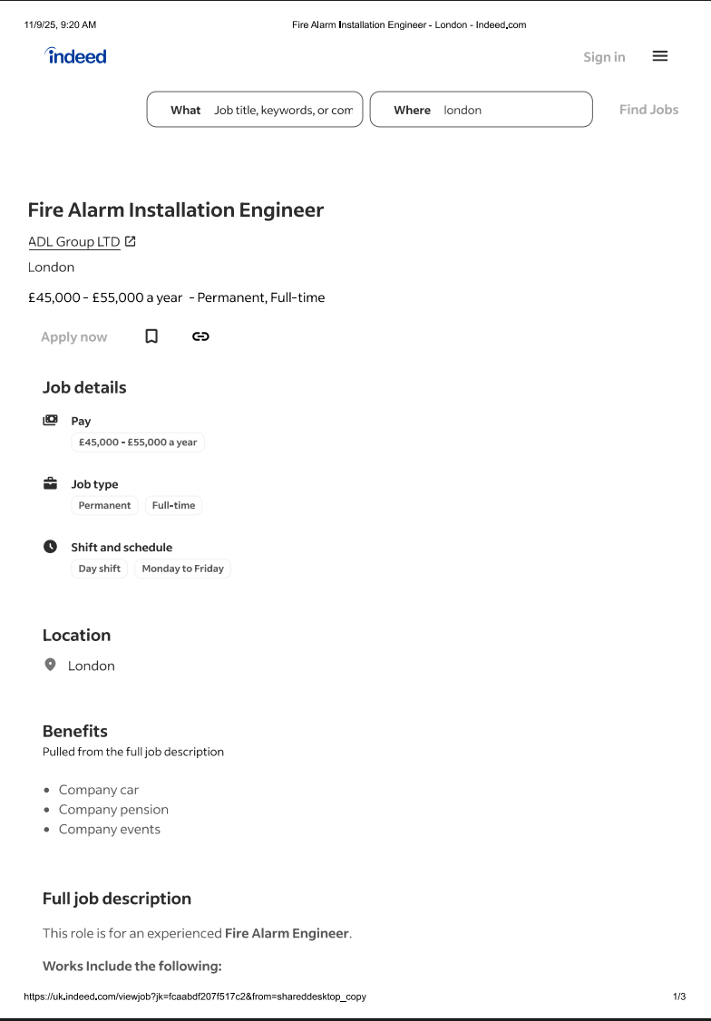

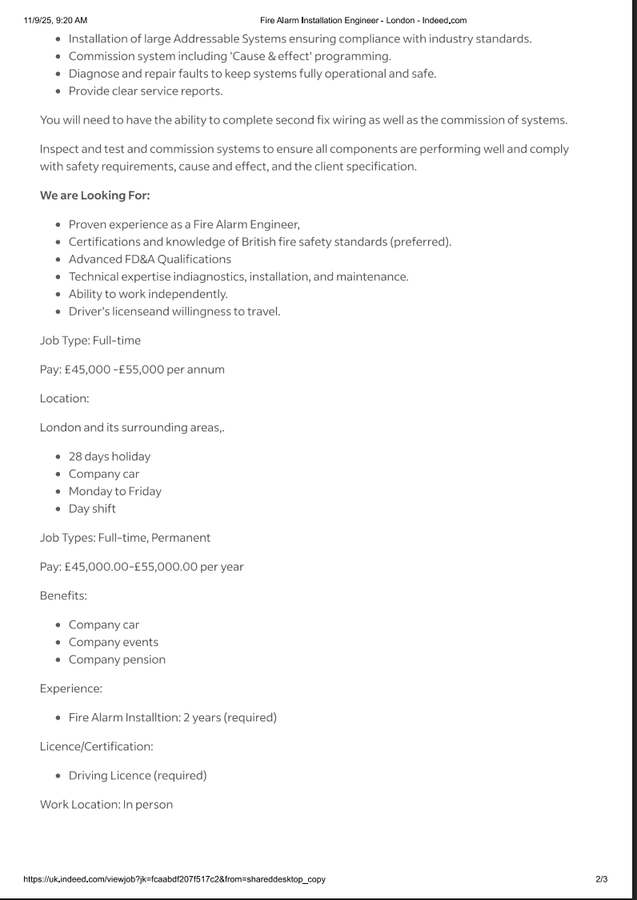

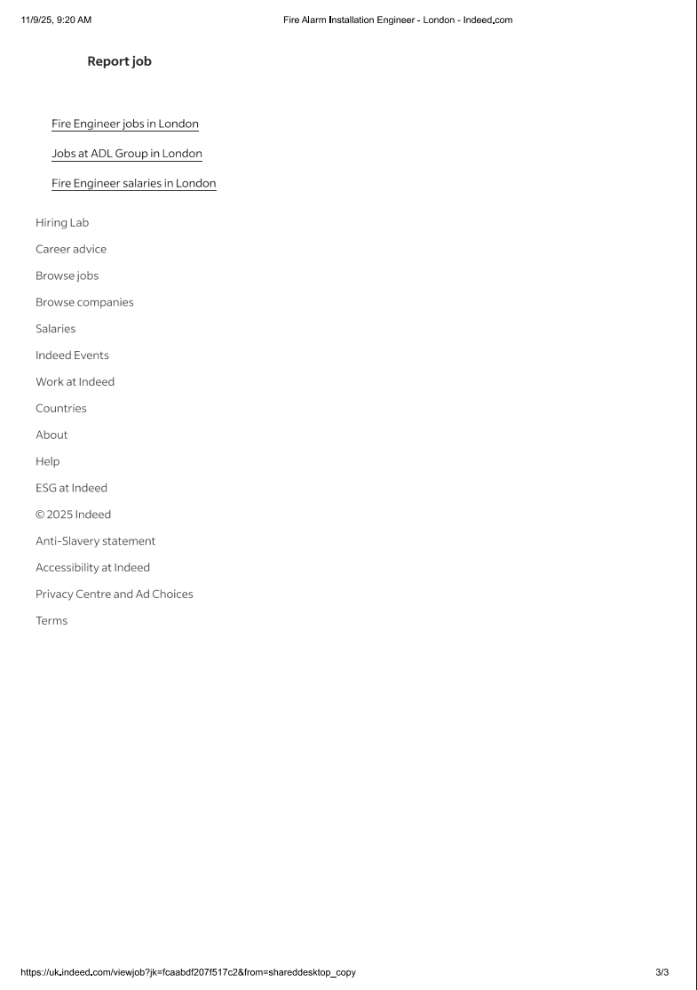
COVER LETTER RAY GRAND
124 FOREST STREET
LONDON
E70RT

(for this ex please leave blank)
PETER CARRINGTON
PRO ACTIVE F&S LTD
10 BRIDGE ROAD RE23RDS
09/11/2025

Dear Mr/Mrs/Miss/Ms Peter Carrington,
I wish to apply for the role of Fire Alarm Engineer, currently being advertised on Indeed.
Please find enclosed my CV for your consideration.
As you can see from my attached CV, I have over 4 Years of experience in the
Fire Alarm industry, and I believe I will be a great fit for job upon the required skill set you are demanding, during this time make me the right/perfect candidate for the role.
In my current role as a Fire Alarm Engineer at First class fire and security ltd, I have been responsible for Installing, Commissioning and Maintaining fire alarm panel to a high standard
All of this, coupled with my enthusiasm and dedication, 1st fixing (cable pulling) 2nd fixing devices such as I/O interfaces, bases, smoke/heat detectors, MCP’S and sounders
has helped gain the experience to be a fully stable engineer and to independent when working on my own. I am confident that I can bring this level of success with me to your organisation and help Pro Active F&S LTD build upon their reputation as [state their position in market – learned through your research]. With my previous experience and expertise, I believe my contribution will have a big impact on your company

Thank you for giving me the opportunity to apply for this job I look forward to be your right candidate

Yours sincerely/Yours faithfully,
RAY GRAND

CV

RAY GRAND
Fire and Security Engineer
Walthamstow, EN23RGT
Raygrand100@gmail.com
0742281108
Currently working for First class fire and security ltd
I'm familiar with the following Advanced, Hochiki, Kentec
I also hold a SSSTS (site supervision) Level3 Qualification in fire alarm industry with tavcom training
Holding a valid full uk driving licence
Willing to Relocate or travel Anywhere in the uk
Personal Details
Driver's License: B, Cars
Eligible to work in the UK: Yes
Total years of experience: 4
Skills
• Electrical engineering (4 years)

Languages
• English - Expert
Certifications and Licenses
Driving Licence
August 2020 to August 2030
Level 3 Qualification in Fire
SSSTS
2024 to 2029
ECS Card
January 2020 to January 2026

