Naomi Poole

Student No. 1713053

Title: Quantitative Data Analyis

Submission by: 7.08.26

Word Count: 2784

Quantitative Data Analysis
Introduction
Quantitative data is measurable information which has a numerical value associated with it for analysis. The numerical values are usually identifying how much, how many and how often.
There are many audiences and purposes for quantitative data, and it is collected throughout our daily lives, such as a census with key information for the government, information about how, when and what we shop through our loyalty or credit cards, weather temperatures and rainfall in localities, the amount of mileage through annual MOT checks and insurance renewals, the websites or social media sites we visit and shop on. This data is then collated by businesses, researchers, local government and weather stations to interpret and make predictions for future weather and contingency planning, business decisions relating to supply and demand or advertising, public policy and updates to legislation. Interpretation and analysis are affected by the researcher or customer’s purpose in gathering the data as well as their aims, prior knowledge and experiences as discussed in the first part of this module assignment. There are often nuances within the data analysis and it needs to be acknowledged that the same data set can be used by different groups to represent a different analysis as has been the case when information is used politically or by businesses with competing interests.

The data pack provided for this assignment outlines information on 20 customers of Gwalia Stores, a grocery and newsagent in a Welsh village. It shows how far the shop is from the customers’ homes, the average spends within a week, which newspaper they purchase regularly and their opinion of the local borough council. This data could have been collated using the following research methods:

- Telephone or face to face structured interview asking the questions with the researcher collating the information

It does not seem that this would be the most efficient method to collate this data as it would take extra time for the business when other methods would be more efficient so is unlikely to have been used.

- Document review and gathering information from a database

If the shop holds information on the newspapers chosen by customers regularly to keep and order accurate stock they may have customer names, gender and their addresses so could collate these from a database. The shop may also have accounts for local customers and be able to extrapolate an average spend if this is logged against customer names or a loyalty card system.

- Poll to gather opinion on the local borough council

This could have been created at the request of the local council or by another group to find out what the views of the village and other localities were. It may be in readiness for local election or another reason and could have been done in person or electronically at the store when customers shop.

- Survey using numerical text inputs for example, average money spent in a month and initials for the chosen newspaper and gender and a Likert scale with multiple choice for their opinion

It is worth noting that the business or researcher used a scale with only 4 choices so that participants were forced to make a decision either positive or negative on a scale and could not choose a middle neither contented nor discontented option which is good practice to be able to analyse opinions accurately. A survey seems to be the most efficient method to capture all this information in one place and is likely to have been the research method chosen by Gwalia Stores. This could have been done in paper format or digitally to gather the information for a variety of audiences.

Customer | Distance in m | Spend in £ | Gender | Newspaper | Opinion
a | 95 | 17 | m | W | 1
b | 5 | 24 | m | DE | 1
c | 7 | 23 | m | DE | 3
d | 200 | 14 | m | DE | 4
e | 270 | 12 | f | G | 2
f | 15 | 22 | m | W | 3
g | 340 | 11 | f | W | 4
h | 450 | 9 | f | G | 1
i | 16 | 21 | f | G | 1
j | 700 | 7 | m | DE | 1
k | 50 | 19 | f | G | 3
l | 1000 | 6 | m | W | 3
m | 50 | 19 | f | G | 2
n | 140 | 15 | m | W | 3
o | 300 | 11 | f | G | 3
p | 210 | 13 | m | T | 4
q | 12 | 23 | m | DE | 2
r | 180 | 15 | m | DE | 2
s | 50 | 18 | f | G | 1
t | 1100 | 6 | f | T | 4

Within this data set there are a range of variables including nominal, ordinal and scale.

- Nominal – gender and which brand of newspaper as these do not have quantifiable value, they have a category or label with no inherent order.

- Ordinal – the opinion on the local borough council as it is an ordered category, a ranking of personal views where the distance between numerical values is not precisely equal or measurable.

- Scale – distance in metres and the average weekly spend in £s as this data is collated in numerical value with equal intervals and a true zero point.

Analysis
To analyse the data, we will look at the most important and meaningful information for the owners of the business – Gwalia Stores and look at this in single variables or pairs of variables with can be analysed together to reveal patterns that can be used moving forward.

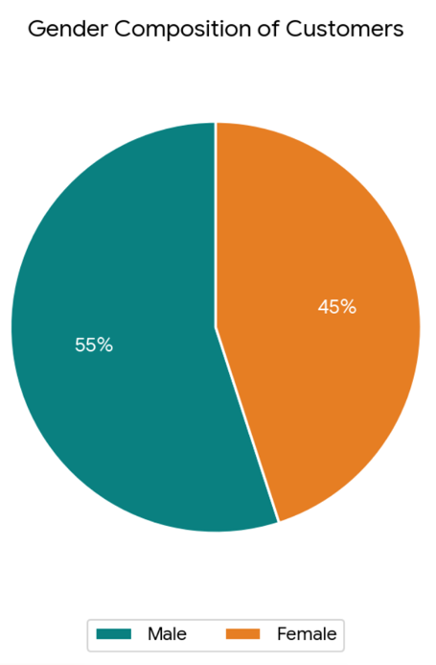
Gender Composition

Gender | Customers | Percentage
Male | 11 | 55%
Female | 9 | 45%

The gender composition is fairly evenly split with a slight majority of male customers within the sample of 20 customers.

Newspapers Purchased

 | Customers | Percentage
Guardian | 7 | 35%
Times | 2 | 10%
Daily Express | 6 | 30%
Western Mail | 5 | 25%

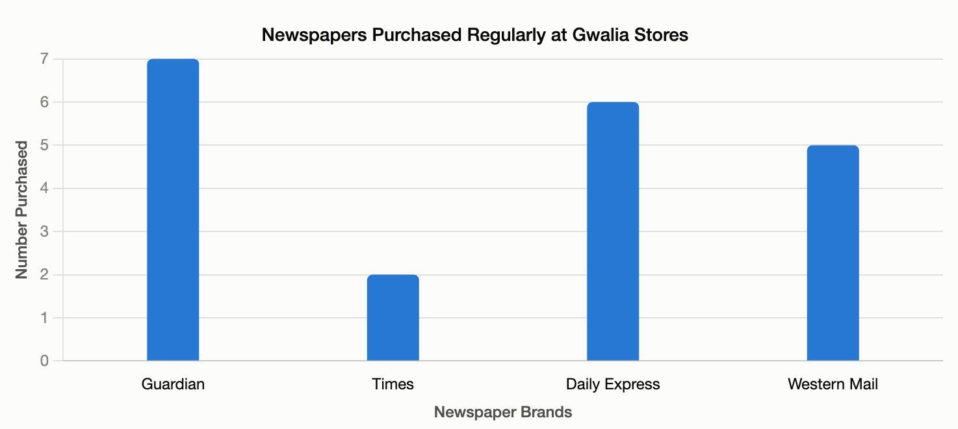

The Guardian newspaper is the most popular but is fairly evenly split with the Daily Express and the Western Mail having 6 and then 5 purchased. The Times is clearly the least popular choice of newspaper with customers, and this has an impact for the Gwalia Stores in terms of how many of each newspaper they should stock.

The data can also be further analysed from the data set to look at whether gender influences what newspaper is purchased.

Newspapers Purchased by Gender

Newspaper | Male Customers | Female Customers
Guardian |  | 7
Times | 1 | 1
Daily Express | 6
Western Mail | 4 | 1

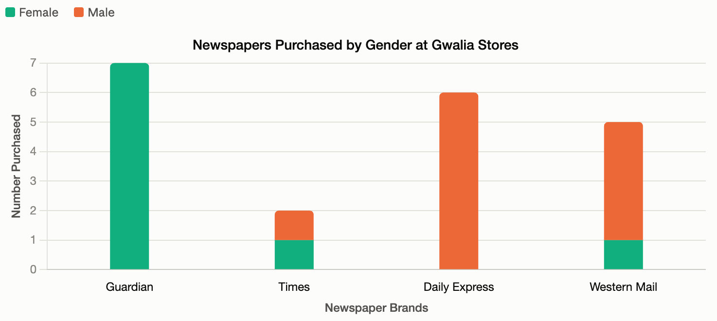

This shows a clear preference by female customers for the Guardian as well as one for the Western Mail. The Times readership is equally split male to female whilst the Western Mail is more heavily weighted to a male customer base. The Daily Express is entirely purchased from this store by male customers. It doesn’t of course mean that potentially the newspaper isn’t read by other potential members of the customer’s family, however it does show some clear gender preferences that could provide information on other magazines or print publications to stock. It could also identify some political preferences based on the editor’s viewpoints from the newspapers and would be interesting to see if there are any correlations with the opinion of the local council although this data set does not show what political party is running the borough council and would be more relevant for a different audience than Gwalia Stores.

Distance

Statistic | Value in Metres
Mean | 259.5 metres
Median | 160 metres
Minimum | 5 metres
Maximum | 1100 metres
Range | 1095 metres
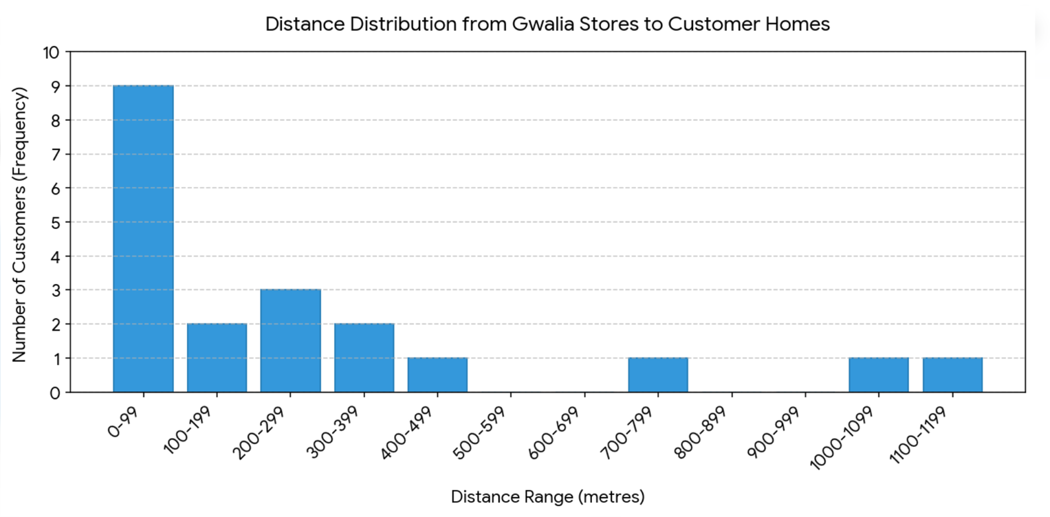
Almost half of the customers surveyed (9 out of 20) live very close to Gwalia Stores (under 100 metres away). A further 8 customers live between 100m to 499m from the shop. There is a significant gap in the data between 450m and 1000m with a few isolated customers living more than 1km away. As a result of these customers the mean at 259.5m is noticeably larger than the median at 160m and for the Gwalia Stores should use the median to have a realistic picture of where an average or typical customer of theirs lives from the shop. The sample size of 20 may need to be increased to give more of a picture of distance travelled by customers.

Average Weekly Spend

Statistic | Value in £s
Mean | £15.25
Median | £15
Minimum | £6
Maximum | £24
Range | £18

The total average weekly spend within this data for 20 customers was £305.

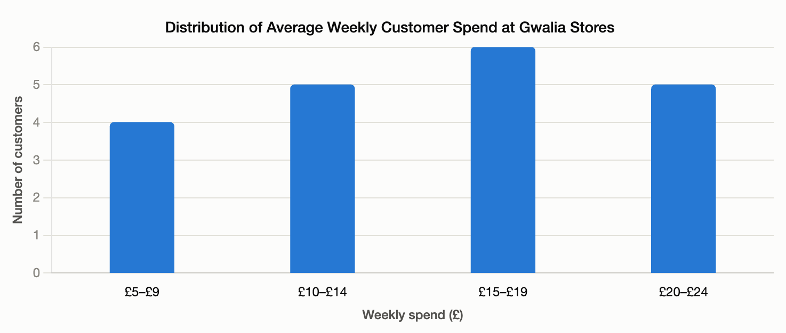

The distribution of average weekly spend follows the bell curve with a normal distribution amongst the values which can be seen in the original data set. The mean and median are accurate representations of the average amount being £15 by customers. This data identifies for Gwalia Stores how much they can expect most customers to spend which supports sales and profit forecasting and could be important to target their marketing of any new products or where to focus an increase of sales if they do further information about most popular products purchased weekly. It could also lead to initiating a loyalty or marketing/reward programme where customers get a certain number of points for each £1 or £5 spent and they can then claim a prize within a month to increase sales volume for some of those customers spending less than £10 a week.

Average Weekly Spend by Gender

Spend | Male Customers | Female Customers
£5 - £9 | 2 | 1
£10 - £14 | 2 | 4
£15 - £19 | 3 | 3
£20 - £24 | 4 | 1
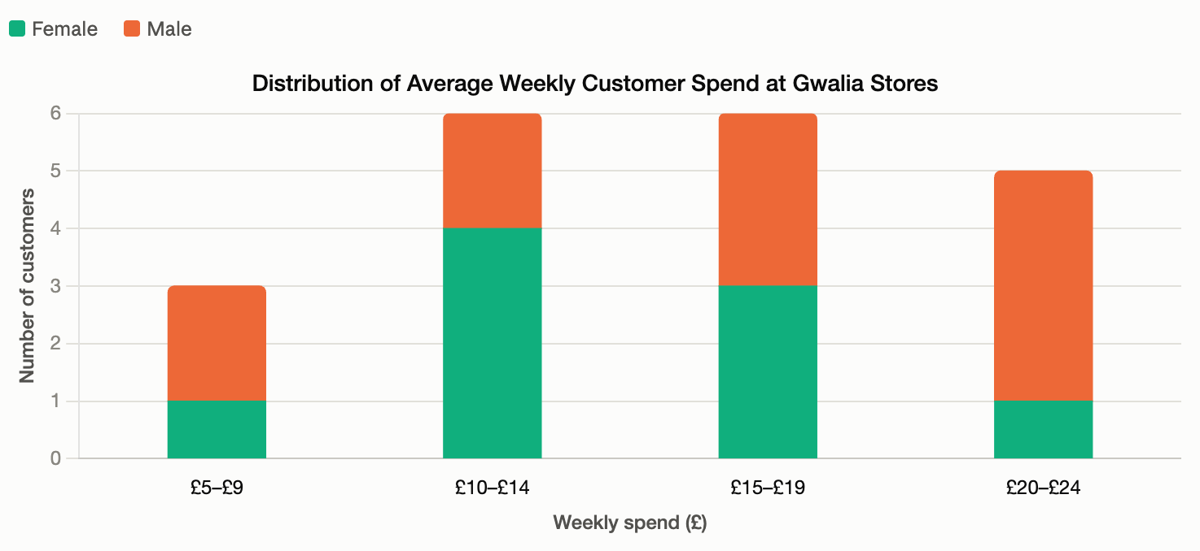
When analysing the gender average spend it is important to remember that there are 11 males and 9 females. However, it can be identified that 4 out of the 9 females are in the £10-£14 average band and only 1 in the £20-24 so female customers are clustered in the lower-middle range of spending weekly. Whereas male customers are more represented in the higher spending bands with 4 of the 11 in the £20-£24 section, compared to half that number in the £5-£9 band. This suggests that male customers tend to spend more per week on average at Gwalia Stores although the difference on the whole isn’t a large one. It may be helpful as part of identifying what products to market to increase sales figures or linked to the loyalty scheme potential already highlighted when analysing average weekly spend in the previous section.

Opinion of Local Borough Council

Opinion Scale | Customers
1 | 6
2 | 4
3 | 6
4 | 4

The opinion scale is identified on the y axis with 1 being low and 4 being high.
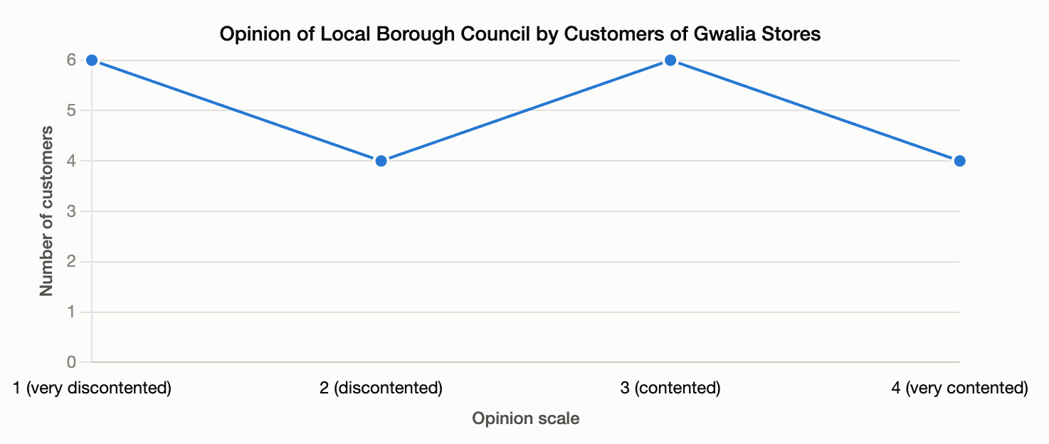
When analysing this data, it appears that customers tend to hold strong views with the most choosing very discontented (6) and contented (6). This has been encouraged by the researcher designing the survey using a 4 point Likert Scale so participants are forced into sharing their opinions as negative or positive responses. It also shows that more views are negative with 6 being very discontented and 4 very content.

Opinion of Local Borough Council by Gender

Opinion Scale | Male Customers | Female Customers
1 | 3 | 3
2 | 2 | 2
3 | 4 | 2
4 | 2 | 2
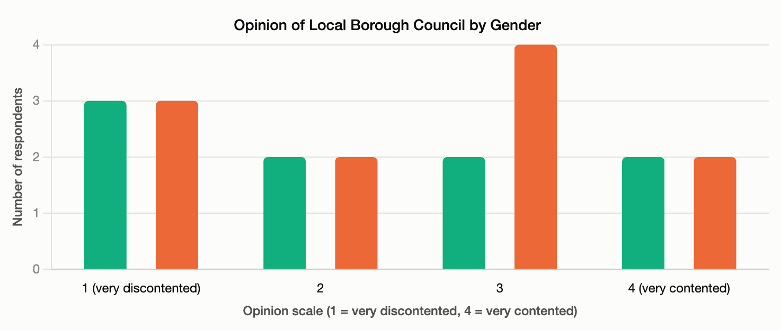
This shows that opinion is broadly similar amongst male and female customers of the local borough council with no pattern of one gender being more or less dissatisfied, with levels 1, 2 and 4 having the same number However, the one difference is at category 3 of being ‘contented’ which then changes the male average slightly but it should also be noted that there are 2 more male participants also in the data.

Opinion of Local Borough Council by Gender
As there is no other context about the local borough council within the data it is unknown why this data was collected or whether there are any particular issues within the locality or potential points of conflict with for example planning building works etc. We will also analyse the opinion of the customers with the distance they live from the stores to see if there are any patterns to interpret.

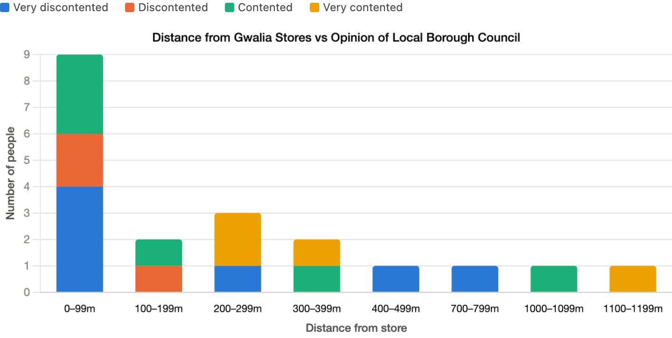

When comparing distance of customers’ homes from Gwalia Stores and their opinion of the local borough council there are some trends with a larger number of people closer to the store (6) being very discontented or discontented as opposed to the 2 customers who live 300 to 399 metres away being contented or very contented. However, for customers living 400 – 499 metres and 700 – 799 metres this changes to being very discontented before those at 1000 – 1099 metres and 1100 – 1199 metres being again contented and very contented. This suggests that there may be some issues closer for those customers who live closer to the shop which could possibly be linked to noise, traffic or footfall near the shop. Although as this survey sample is only 20 customers and this aspect is relating to personal opinion the trend and picture could change dramatically with a larger survey which would be needed to ensure a reliable statistical trend or pattern.

Conclusion
The data set relating to Gwalia Stores is limited as it relates to just 20 customers but provides a range of useful data to begin to analyse including average weekly spend, the distance customers live from the shop, what brand of newspaper they purchase regularly and their opinion of the local borough council. In analysing this it is vital to look at 2 single variables and then look at more than 2 variables to see what impact if any they may have on each other. This allows the owners to understand a little more detail about their customers and act on key messages.

Firstly, the customer base largely lives close to the store as nearly half the sample lives within 100 metres of the shop and the median distance of 160 metres confirms that Gwalia Stores is primarily a local, walk in convenience and village grocery shop rather than a destination store drawing custom from further afield. Understanding where the customer base lives can support the business in making decisions about opening hours and type of stock they should carry as the core customer base sampled are on average buying frequent, smaller top-up items rather than a large weekly grocery shop.

In addition, spending patterns are stable and predictable with the mean and median both close to £15 and a normal distribution curve. This provides the owners with a reliable figure to use for sales forecasting and stock ordering. The analysis about impact of gender on spending demonstrates that the gap shows male customers average higher weekly spends and they can use this knowledge to inform them which products they can promote to which gender of their customer base. It also gives the opportunity to initiate a loyalty scheme and plan for thresholds customers meet before being rewarded.

From reviewing newspaper brand purchasing there were clear trends with females exclusively purchasing the Guardian and the Daily Express bought by male customers actions and this can result in actions being taken within the shop. Product location and promotions can be carefully aligned with shelf placements for complementary product ranges for male or female customers next to the respective newspaper. For example, adjusting gender specific magazines or promotional items in-line of sight of these newspapers.

The clearest trend and relevant finding for the Gwalia Stores is the relationship between the distance from the store and the opinion of the local borough council. Customers living closest to the shop are both the largest single group in the sample and the most dissatisfied with the council, whereas satisfaction generally improves the further away customers live before the pattern becomes unreliable in the more sparsely populated distances. As this relates to the shop’s most frequent and largest customer group it is worth the owners investigating this situation further and conducting some more research. This could be through an extended focus group method by asking several open-ended questions or by informal conversations or a further wider survey to understand whether there are specific local issues in the village for those living closest to the shop. Is there an issue with traffic, young people, busy streets with footfall to the shop, parking or planning decisions being made about future developments the council are planning or services closing that are creating this discontent. As a vital village shop, they can where possible understand these further and be seen to engage with these concerns which could in turn strengthen the relationship between Gwalia Stores and it’s most loyal and closest geographic customers. There could also be the potential for leaflet drops to get information to the community or a community noticeboard to share important communications.

Overall, as this report shows the data and analysis report provides several practical steps for the owners of Gwalia Stores. It needs to continue to be noted that a larger and more representative survey would be needed to identify statistically robust trends and patterns. However, decisions can be made to test the hypotheses of this analysis and should make worthwhile improvements to the business as a community hub and financially.

