

CertHE Skills for the Workplace
Academic and Employability Skills
BMSW4001

Student: ITA RENA CHARLERY
ID: 2122358

Table of Contents
Introduction 2
Gibbs model of reflection 2
My reflection on time management 3
My reflection on organising study 5
My reflection on academic writing 6
My reflection on public speaking and giving presentations 8
Conclusion 9
References 11

Introduction
This reflective report will explain my overall reflection on four different skills that I learned during this module. The Gibbs model of reflection will be explained here, and the four different skills will be explained and reflected by me utilising this model of reflection. Finally, all these reflections will include specific action plans for me to improve on these skills.

Gibbs model of reflection
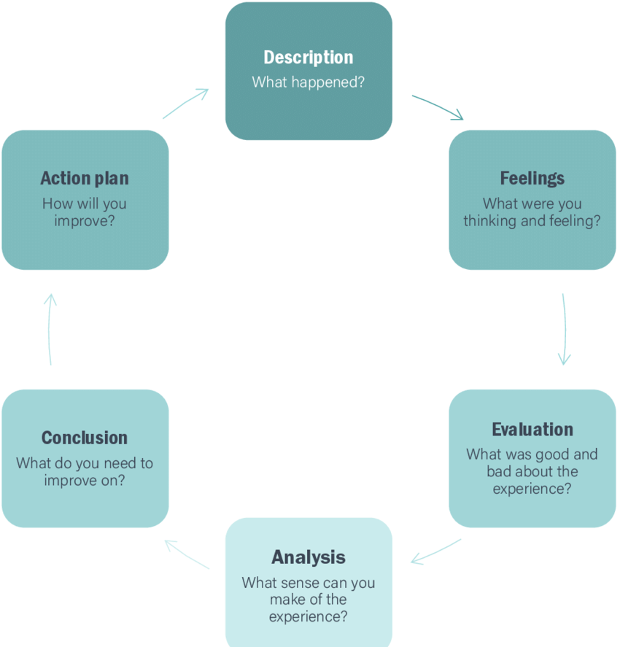
Figure 1: Gibbs reflective model
(Source: Strydom et al., 2020)
The Gibbs model of reflection is considered one of the major reflection models used in the learning environment. This model is comprised of six different stages, which are description, feelings, evaluation, analysis and conclusion, along with an action plan. The first stage of description involves describing the different aspects of the events or subject matter, on which the learner has to reflect (Strydom et al., 2020). The second stage involves explaining the different feelings that the learner had during the event or learning experience. The stage of evaluation involves determining the different positive and negative aspects of the feelings of the learner, and it involves determining the advantages and disadvantages that the learner had during the event. Adeani et al. (2020) stated that the stage of analysis involves analysing the strengths and weaknesses of the learner that were identified from the evaluation. The stage of conclusion involves depicting the possible alternative activities that the learner could have done to gain more from the learning event. The stage of the action plan involves developing a plan for the learner to cover the identified weaknesses.

My reflection on time management
Description
During the progress of this module, I learned about the topic of time management, I already knew about it from my earlier studies, but this time, I learned about it in more detail. I came to realise the impacts of time management in the business environment, and I learned about the different ways to improve the time management skills of a person. During the course of this module, our Tutor provided us with different tasks and assignments that required time management skills. I managed to complete some of them within my set deadline by managing my time perfectly, but I also failed to do the same for some of them.
Feelings
During the course of this module, I felt that time management is essential for business management activities. I felt that time management can help to finish jobs perfectly, and for complex tasks, managing time is essential by breaking the work down into smaller tasks and doing them on time. I felt that designing the schedule before starting work helps, as it allows focusing more on short deadlines of segmented tasks, ensuring the meeting of the final deadline.

Evaluation
This experience has granted me several benefits, as I have managed to learn more about time management, and practice managing time for assigned projects. Managing time is not easy, especially for complex tasks that have to be broken down into smaller tasks (Adams and Blair, 2019). However, I have realised that focusing excessively on managing time might shift concentration from the actual work, thus hampering it. Thus, I have realised that there must be a balance between time management and work management for success.
Analysis
During this module, I realised that my time management is not always perfect. At times, I failed to manage my time for the assignment allotted to me, and at times, I managed to develop and maintain my schedule perfectly. Thus, I think that I still need to develop my time management skills further to become successful in my future career.
Conclusion
During my learning in this module, I could have studied more about time management. I could have taken more advice about managing time in both my professional and personal life, which would have helped me to carry out my time management more efficiently.
Action plan
Objective | Actions | Resources | Deadline
To improve my time management skill | - Practising managing time of academic assignments  - Studying more about time management | - Books  - Journals  - Tutorial videos from the internet | 3 months
Table 1: Action Plan
(Source: Learner)

My reflection on organising study
Description
During my course of this module, I learned about the techniques and strategies of organising study. During this module, our Tutor provided us with different assignments, which required extensive study of different books, journal articles and websites. However, while preparing for some of these assignments, I had to change my study locations several times. Due to urgent personal work, I had to change my study timings in several instances. I took help from some of my peers by developing sturdy relationships with them, and one of my acquaintances helped me to organise my files and study notes for the module assignments. Overall, this resulted in me being successful in completing some of my assignments with perfect success, but I also failed to meet my own set standard for some of them due to failure in organising my study.
Feelings
I felt during my experience in this module that organising study is a complex task with many factors to keep in mind. I feel that carrying out an organised study requires me to consider my optimal time, location, materials and guidance for that study. I have felt that keeping my study notes and materials organised saves time greatly, especially when I am writing a material that requires a considerable level of research from different books, journals and online information sources. I also feel that asking for guidance without hesitation is also a key to the organised study.
Evaluation
During this module, I have learnt that organising study is highly beneficial, especially when it involves important courses that affect my future career. I have realised that carrying out an organised study might seem like it would require unnecessary efforts, but in reality, it increases the success chances of the study greatly (Asikainen et al., 2020). Furthermore, I believe that focusing on only organising my study can shift my focus from the study itself, which indicates that there must be a balance between study and organising to deliver the result optimally.
Analysis
I have also learnt that the overall chances for me to be able to organise my study and deliver my assignments are moderate, as I have not been able to organise my study appropriately in some cases, which has led me to be unable to deliver the quality of work that I want to deliver. Thus, I believe that I require improvements in my organising skills, especially regarding my study sessions.
Conclusion
I believe that I could have organised my study differently by focusing on the important aspects of my future career. For instance, I could have developed my organising plan by focusing more on my study timings in a week, rather than my study locations. This would have allowed me to study in more locations, thus giving me more time for other work. I could have organised my study according to the subjects, which would be more efficient.
Action plan
Objective | Actions | Resources | Deadline
To improve my study organising skill | - Practising to organise my study process in future studies  - Studying more about the organised learning process | - Books  - Journals  - Tutorial videos from the internet | 2 months
Table 2: Action Plan
(Source: Learner)

My reflection on academic writing
Description
During my learning of this module, I had to write academic content several times. For instance, I have learnt that each of the different academic content has different aspects, but there are some general guidelines, which have to be followed in academic writing. During my course, our Tutor provided us with several sections of academic writing and then asked us to write assignments in the academic writing style. I managed to write many of them properly. However, I could not write all of them in a perfect academic writing style, as I had some technical errors in my writing. My Tutor managed to help me out by identifying and pointing my errors out, after which I corrected those errors. I learned about academic writing this way.
Feelings
I felt during this experience that the concept of academic writing is fundamentally different from other forms of casual writing, in the sense that academic writing is highly formal, and is extremely evidence-based. I feel that academic writing is highly dependent on the credibility of the data used in the work, as no data were used there without citations. Furthermore, I also feel that some words, especially jargon and colloquial languages are not used in academic writing. The structure of any work in academic writing is also developed with a certain process, which made me feel that academic writing is very systematic, and requires discipline to write properly.
Evaluation
I realised from this module that the skills needed for academic writing are a good level of knowledge in formal English or any educational language that is applicable. Academic writing also requires a good sense of logic and information organising skills (Dorji, 2021). This was a positive experience for me, as I believe that academic writing skills would help me to gain a much better prospect in terms of my career, especially if I move toward the field of academic research works. However, I also learned that in some professional fields, academic writing might not be accepted, which I have to consider.
Analysis
I think that during this experience of academic writing, I managed to carry out an assessment of my skills regarding academic writing. I believe that even though I showed very good performance in some of my assignments that required academic writing, I have to improve my academic writing skills more. This is because I can write content while researching information from academic texts, but analysing all of them critically and perfectly is still not possible for me to do easily.
Conclusion
I believe that I could have carried out academic writing in a better way, For instance, I believe that I could have done academic writing by researching more on the information available, and I could have made the citations properly by following the proper referencing styles. I could have focused more on the quality of the language and writing style, which would have enhanced my skills.

Action plan
Objective | Actions | Resources | Deadline
To improve my academic writing skill | - Practising academic writing through writing academic assignment works  - Studying more about academic writing | - Books  - Journals  - Tutorial videos from the internet | 2 months
Table 3: Action Plan
(Source: Learner)

My reflection on public speaking and giving presentations
Description
During this module, I learned about the skills of public speaking and the skill of giving presentations to many audiences. I gained this experience through the presentation I delivered in week 9, and this was mostly a success. I managed to speak before many people, and I managed to learn more about this skill from the feedback from the Tutor.
Feelings
During this experience, I felt that the skill of public speaking and presentation requires a lot of confidence. This is because I believe that this requires projecting my thoughts among many different people, and I feel that this skill requires a good level of design skills and communication skills as well, along with time management skills.
Evaluation
I believe that during this experience, I gained insight into the various positive and negative aspects of public speaking and presentation skills. I realised that a good level of presentation skill help to reach out to many people and project my ideas toward them. However, too much focus on it may hamper the quality of the work itself, indicating the need for a balance (LeFebvre et al., 2018).
Analysis
I have realised that my skills in public speaking and presentation are mostly good, as I managed to present my content before my audiences in week 9 with a moderate level of efficiency. However, I believe that the design of my presentation could have been better, and I could have talked more confidently.
Conclusion
I think that I could have designed my presentation after consulting more with my tutor and the different online video tutorials about orientation. Furthermore, I could have developed public speaking skills better by practising public speech before groups of my acquaintances and peers.
Action plan
Objective | Actions | Resources | Deadline
To improve my public speaking and presentation skill | - Practising public speech before groups of acquaintances and peers  - Practising to make better presentation designs  - Studying more about public speaking and presentations | - Books  - Journals  - A computer for presentation designs  - Tutorial videos from the internet | 6 months
Table 4: Action Plan
(Source: Learner)

Conclusion
The above reflection concludes that I gained a significant level of insight in all four different skills, which are time management skills, organising study skills, academic writing skills and public speaking & presentation skill, during this module. Even though I believe that I have a moderate level of these skills, they still have room for improvement. My action plans for them would help me to improve on these skills within the stipulated time, thus benefitting my future career greatly.

References
Adams, R.V. and Blair, E. (2019). Impact of time management behaviors on undergraduate engineering students’ performance. Sage Open, 9(1), p.2158244018824506.
Adeani, I.S., Febriani, R.B. and Syafryadin, S. (2020). Using Gibbs’reflective Cycle In Making Reflections Of Literary Analysis. Indonesian EFL Journal, 6(2), pp.139-148.
Asikainen, H., Salmela-Aro, K., Parpala, A. and Katajavuori, N. (2020). Learning profiles and their relation to study-related burnout and academic achievement among university students. Learning and Individual differences, 78, p.101781.
Dorji, J. (2021). Enhancing Academic Writing Skill Through Mini Lessons and Revision. JET (Journal of English Teaching), 7(1), pp.56-66.
LeFebvre, L., LeFebvre, L.E. and Allen, M. (2018). Training the butterflies to fly in formation: Cataloguing student fears about public speaking. Communication Education, 67(3), pp.348-362.
Strydom, S., Herman, N., Adendorff, H. and de Klerk, M. (2020). Responding to the necessity for change: Higher Education voices from the South during the COVID-19 crisis. ResearchGate, pp.1-105.

