

THE UNIVERSITY OF WALES TRINITY SAINT DAVID

School of Engineering

Application of Computer Aided Engineering Processes

By Milena Tomaszewska (1902366)
BEng Energy and Environmental Engineering
ACMA6012

Abstract
This report explores the complex world of computer-aided engineering (CAE) tools and explores their dualistic character as both potential enablers and impediments to the engineering design process. The study necessitates the development of a multi-component assembly and subsequent kinematic and static structural analysis since it incorporates a real-world system simulated in a computational environment. The focus of the study is on the component's optimisation, which considers things like structural loading, fatigue life, and thermal conditions. Examining the effect of mesh sizing on the accuracy of the results is an essential component of the study. This analysis leads to an iterative process of performance improvement, which serves as the foundation for a thorough report on the advantages and disadvantages of CAE tools. The study done demonstrates the inherent benefits and drawbacks of employing CAE technologies in the engineering design process.

Contents

1. Introduction 1
1.1 Background of CAE tools 1
1.1.1 CAD (Computer Aided Design) 1
1.1.2 ANSYS (Analysis System) 1
1.1.2 Industrial applications of CAE 2
1.2 Purpose of the report 2
1.3 Aims and Objectives 3
2. Theoretical Foundations 4
2.1 Key Terms 4
3. Validation assessment 5
3.1 Importance of validation testing 5
3.2 A simplified test case 5
3.2.1 The engineering problem for validation 5
3.2.2 Analytical Solution 6
3.2.3 Created model 7
3.2.4 Mesh 9
3.2.5 Analysis 9
4 CAE Process 13
5 Limitations of CAE 16
6. Conclusion 17
7. References 18

Introduction

1.1 Background of CAE tools

1.1.1 CAD (Computer Aided Design)
When the engineering world started evolving, researchers and designers used to physically draw and test components to evaluate their efficiency and behaviours. As technology developed, CAD made significant strides in efficiency and time savings.
Given the appropriate knowledge, the software enables the user to swiftly generate and test ideas that are mathematically exact. The ability to create both 2D and 3D geometries allows for extensive experimentation and research of a variety of mechanical testing topics, including stress, creep, thermal distribution, and others.
(Suzuki, 2021)
Additionally, CAD can generate assemblies using 3D geometry that the user has created. It is possible for multiple items to join and function as one cohesive system. Instead of manually assessing every component, a time-saving tool enables rapid testing.

1.1.2 ANSYS (Analysis System)
Ansys Workbench is the integration and workflow platform that connects Ansys products. The project schematic enables users to configure their simulation processes, optimize exploration through parametric management, submit jobs to solver both locally and remote, and add APIs that allow for third-party software.
(ANSYS)
Ansys acts for the purpose of conducting engineering simulations and analysis across several disciplines, it functions as an integrated environment. Engineers and researchers may design, model, and assess large engineering systems using ANSYS Workbench, which unifies a variety of ANSYS tools and solvers into a single interface. For example, mechanical, fluent, heat transfer analysis etc. Components are usually first designed using CAD (Section 1.1.1) and the geometry gets imported on to the Ansys user interface to perform analyses. Furthermore, ANSYS has multiple mathematical CAE capabilities such as DEA (Finite Element Analysis) and CFD (Computational Fluid Dynamics) which allow for a great exploration of material behaviour.

1.1.2 Industrial applications of CAE
- Automotive – For example, The Group Research of the Volkswagen AG had recently majorly updated their vehicle analysis techniques. With integration of CAE, they started to develop improvements in terms of vehicle weight, environmental and economic aspects, and safety. CAE allows the company to phase from theoretical ideas and concepts into applied computer aided system developments.
(Veronesi and Van Herreweghe, 2016)
CAD is used to geometrically design the structure of vehicles which allows for aerodynamic analysis and ANSYS is used for structural analysis and helps to optimise the vehicle performance e.g., vibrations.
- Aerospace – Through ANSYS, engineers can:
- Optimize engine designs with scalable combustion and turbulence models
- Use mosaic meshing technologies
- VR (Virtual reality) simulations
- Simulate additive manufacturing to print right the first time (saving time and waste)
(ANSYS)
- Manufacturing
- Energy

1.2 Purpose of the report
In-depth analysis of computer-aided engineering (CAE) technologies and their application to the engineering design process is the main goal of this paper. It seeks to critically analyse how these techniques are used in simulating component assembly, kinematic analysis, and static structural evaluation. The research also demonstrates how to optimise a component's structural performance while considering variables including structural loadings, fatigue life, and thermal conditions that affect material properties.

Aims and Objectives
Aims
- To critically explore and understand the role of Computer Aided Engineering (CAE) tools in the engineering design process.
- To conduct a detailed study of a real-world system modelled using CAE tools, focusing on kinematic analysis and static structural assessment.
- To evaluate the accuracy of CAE tools in relation to a simplified, analytically resolvable test case.
- To discuss and analyse the benefits and limitations of using CAE tools in the engineering design process.
Objectives
- Develop an assembly of components using CAE tools and perform a kinematic analysis under realistic operating conditions.
- Conduct a static structural assessment of one component within the assembly, with the goal of optimising the structural performance and mass of the component.
- Consider the thermal conditions that the component is subjected to, understanding the potential for material degradation.
- Conduct a validation testing of the CAE software, comparing its output with a simplified test case where an analytical solution can be obtained.
- Analyse the impact of mesh sizing on the accuracy of the results.

Theoretical Foundations

2.1 Key Terms
- Kinematic Analysis – ‘The kinematic analysis consists of position, velocity, and acceleration analysis. The position analysis solves the position-level constraints by using Newton’s method. The velocity and acceleration level constraints are then solved to get the velocities and accelerations’ (ANSYS).
- Static Structural Analysis – ‘Used to determine displacements, stresses, etc. under static loading conditions. Both linear and nonlinear static analyses. Nonlinearities can include plasticity, stress stiffening, large deflection, large strain, hyper elasticity, contact surfaces, and creep’ (ANSYS, 2004)
- Optimisation – A ‘process of finding a better or more suitable design instance among the possible design variations’ (ANSYS, 2015). In Ansys, a system could get optimised by changing a design aspect such as, geometry layout, dimensions; or adding a feature e.g., springs.
- Thermal conditions – ‘A temperature boundary condition can be used to define a constant temperature at a simulation boundary and is most commonly used to set a surface or boundary such as the bottom of a device or substrate to room temperature’ (ANSYS). In simulations, the thermal boundaries set prior to solving the system, do not change and are the base point e.g., a room ambient temperature (22C) could be the thermal boundary of a tested object.
- Validation Testing – ‘Establishing the performance specifications of a new diagnostic tool such as a new test, laboratory developed test or modified method’ (Pearson, 2020). In ANSYS, there are several simple case studies (e.g., a thermal study on a bimetallic strip) which provide all the necessary data as well as study results. Such validation studies help inform the user if the system is performing correctly, in preparation for more complex case studies.
- Mesh Sizing – ‘A mesh is made up of elements which contain nodes (coordinate locations in space that can vary by element type) that represent the shape of the geometry’ (ANSYS, 2021). Mesh is implemented on geometrical objects to perform analysis on every node which provides more accurate results than evaluating the whole object.

Validation assessment

Importance of validation testing
Validation testing allows a user to assess a component while knowing what results to expect from the solver. If the presented results do not match the expectations, it is indicative of a fault in the system that must be revised and corrected. Sometimes, it is hard or almost impossible to find the fault which proves that the problem may be with the imported geometry, or elsewhere, and it should get analysed before evaluating a new component (the process could also uncover a previously underseen error). Conclusively, validation testing allows for accuracy verification and a reliability check, giving the user a chance to refine their model.

A simplified test case

3.2.1 The engineering problem for validation
To validate the performance of ANSYS a verification example of stress testing on a cantilever beam was used. The component was a bimetallic strip made up of Invar and copper, fixed to one edge only. Table 1 shows the material properties for validation. Since this is a real world applied component (used for temperature sensing) it is suitable to use for validation.
Table 1. Material properties for validation
Material | Invar | Modulus of Elasticity | E_{i} | 137 000.00 | MPa
Material | Invar | Poisson’s Ratio | V_{i} | 0.280
Material | Invar | Coefficient of Thermal Expansion | α_{i} | 1.2 x 10⁻⁶ | C⁻¹
Material | Copper | Modulus of Elasticity | E_{c} | 130 000.00 | MPa
Material | Copper | Poisson’s Ratio | V_{c} | 0.354
Material | Copper | Coefficient of Thermal Expansion | α_{c} | 2 x 10⁻⁵ | C⁻¹
Geometry |  | Cross-section width | W | 5 | mm
 |  | Layer thickness | t_{i} = t_{c} = t | 1 | mm
 |  | Length | L | 100 | mm
Load |  | Thermal loading | T_{c} | 100 | C

3.2.2 Analytical Solution
To find the dimensionless coefficient K1, equation 1 was used.
$K_{1}=4+6\frac{t_{c}}{t_{i}}+4{(\frac{t_{c}}{t_{i}})}^{2}+\frac{E_{c}}{E_{i}}{(\frac{t_{c}}{t_{i}})}^{3}+\frac{E_{i}t_{i}}{E_{c}t_{c}}$ [1]
Calculations:

$K_{1}=4+6\frac{1}{1}+4{(\frac{1}{1})}^{2}+\frac{130 000}{137 000}{(\frac{1}{1})}^{3}+\frac{137 000 × 1}{130 0001}$
$$K_{1}=16.05$$

To calculate the maximum deflection of the bimetallic strip, equation 2 was used.
$u_{z_{1}max}=\frac{6(∝_{i}-∝_{c})(t_{i}+t_{c})T_{c}}{t_{s}^{2}K_{1}}$ [2]
$$u_{z_{1}max}=\frac{6(0.0000012-0.00002)(1+1)}{1^{2}×16.05}$$
$u_{z_{1}max}=$- 0.00001405

3.2.3 Created model

Firstly, as shown on Figure 1&2 two separate strips of length 100mm, height 0.5mm and width of 5mm were created and then assembled using the ‘Mate’ function in CAD.
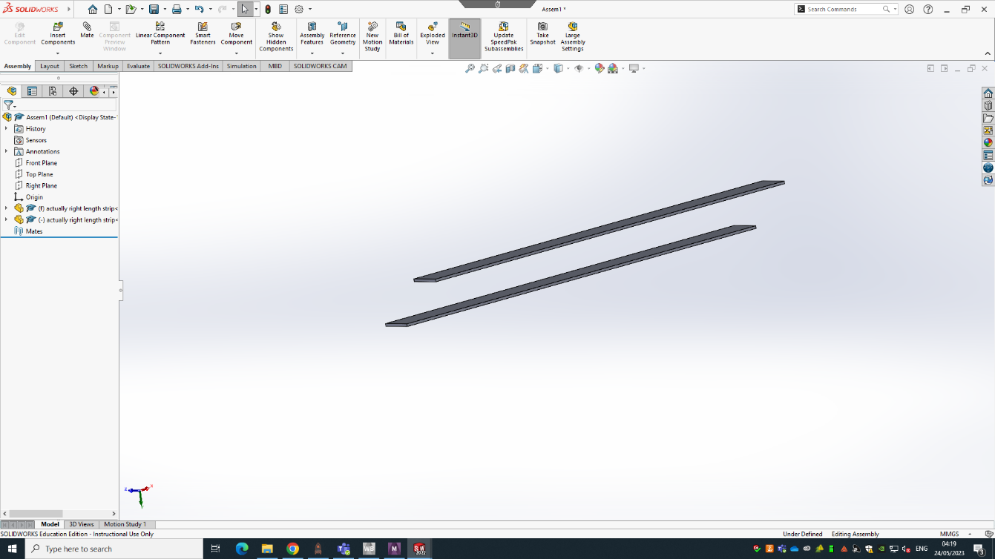
Figure 1. Bimetallic strips prior to assembling.
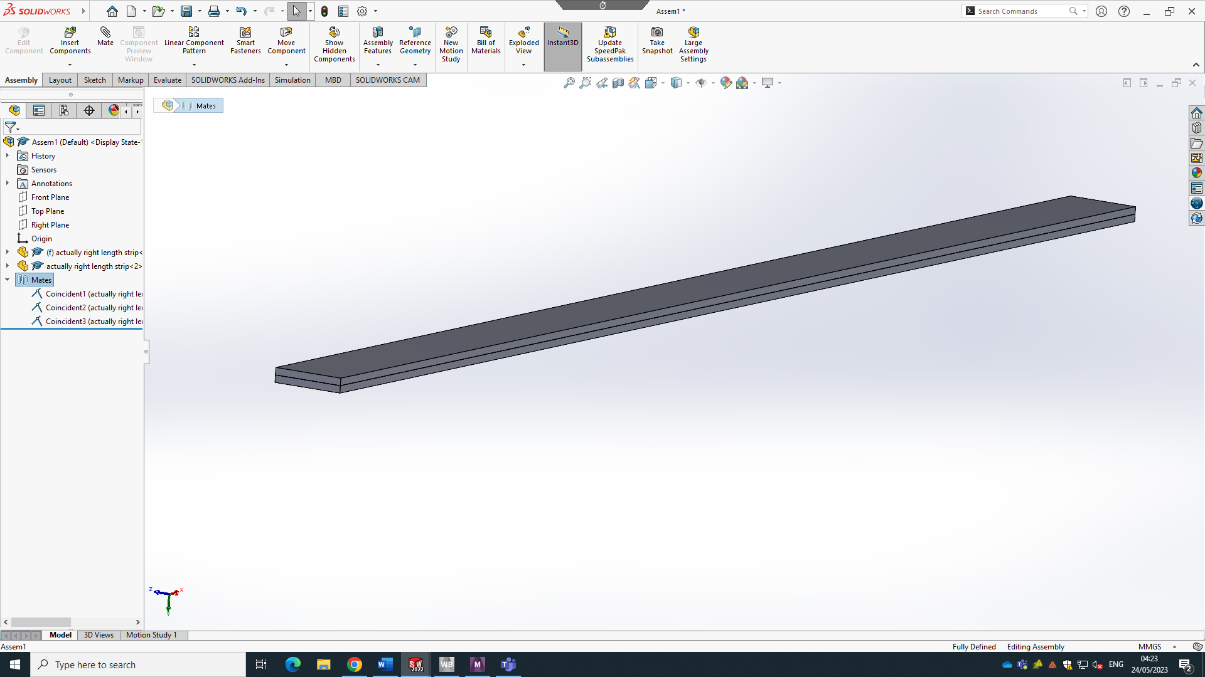
Figure 2. Bimetallic strip assembled.
Next, a static structural study was set up as shown in Figure 3 and the CAD file was imported into the ANSYS workbench as a STEP. file using the DesignModeler.
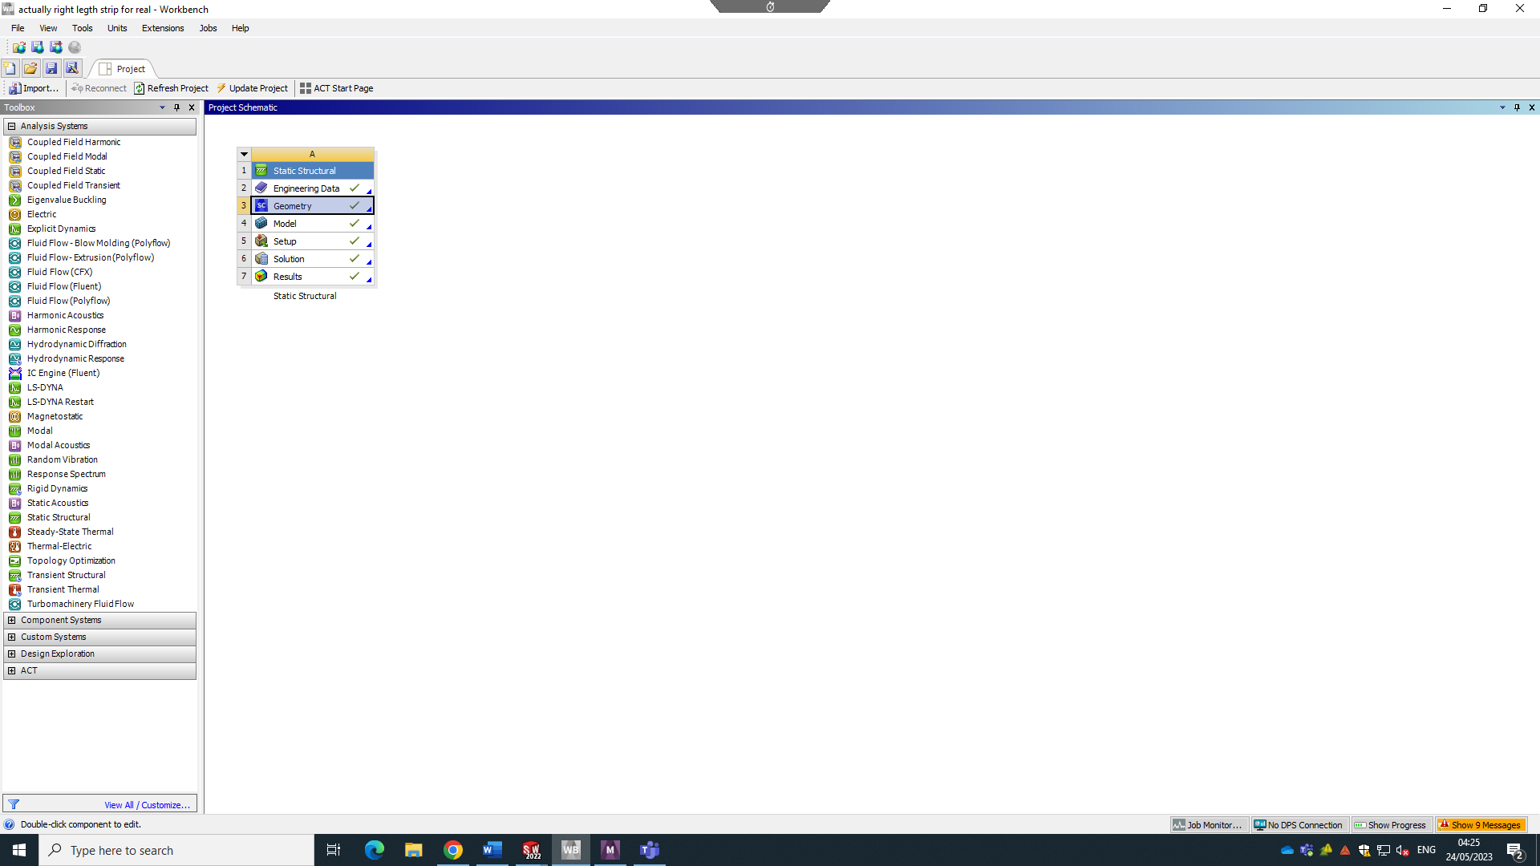
Figure 3. Workbench user interface - static structural setup.

To start modelling the component, one of the strips was set to be a Copper material and the other strip was set up as Invar, as shown under ‘Materials’ on the left-hand side of Figure 4.
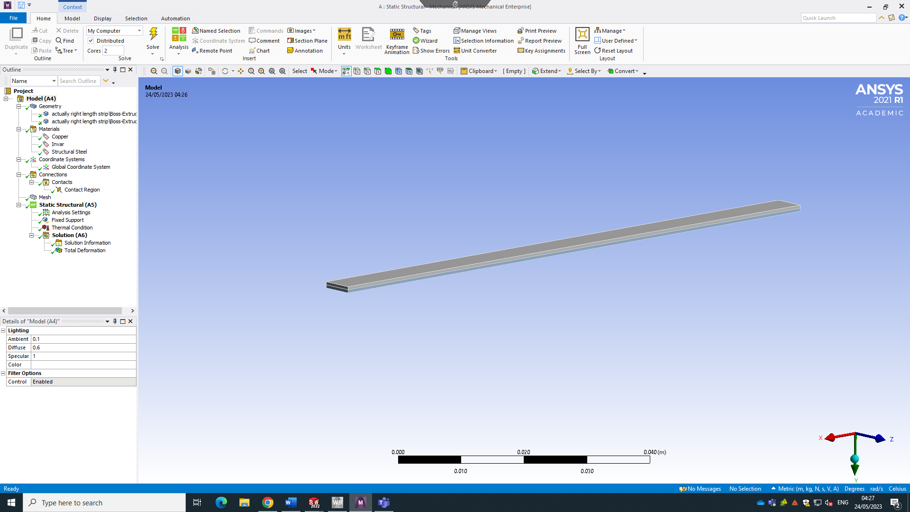
Figure 4. Model component of the static structural study.

3.2.4 Mesh
Figure 5 shows what the component looked like with 0.0005 element size mesh applied.
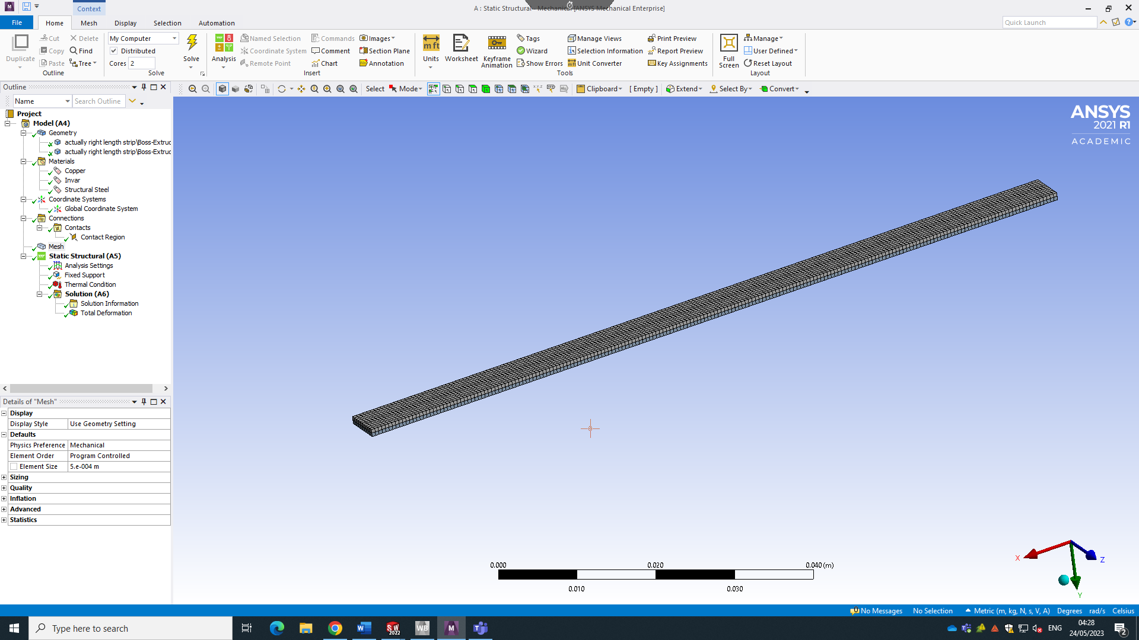
Figure 5. Bimetallic strip - mesh applied.

3.2.5 Analysis
For the analysis purposes, as seen on the left-hand side of Figure 6, a Fixed Support was added. Since the component for validation is considered a cantilever beam, two faces (one side) of the bimetallic strip were chosen.
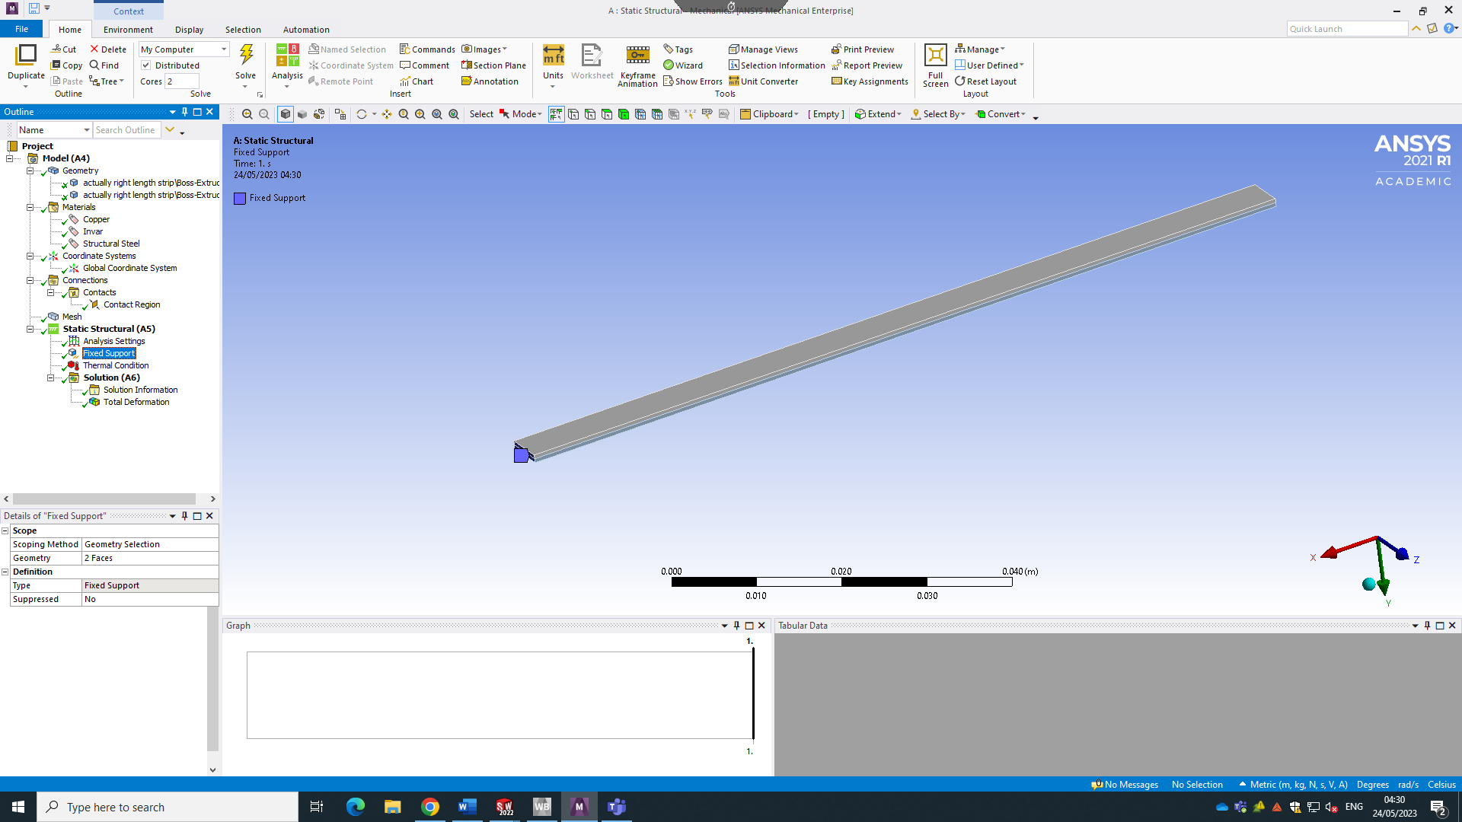
Figure 6. Analysis boundaries for the bimetallic strip - a fixed support on one side.

Lastly, a thermal condition, as seen on Figure 7 of 122C was allocated. The reason Table 1 states a thermal load of 100C and a chosen thermal condition was 22C more is because this is an ambient room temperature, the material is not being tested at a 0C and what the validation example calculates is how the product changes when it is heated by 100C not when it is heated from 0-100C.
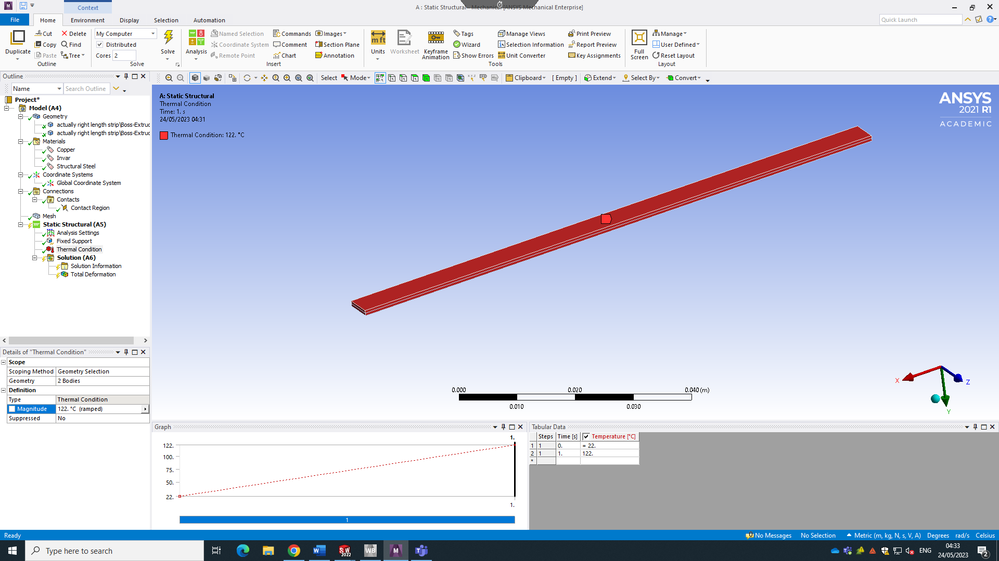
Figure 7.Analysis boundaries for the bimetallic strip - a thermal load

Results for solving the component for thermal deformation can be seen on Figure 8. The validation example expects an answer of 7.049 Max, and the results returned a 14.259 Max, which is almost double as high as it is supposed to be.
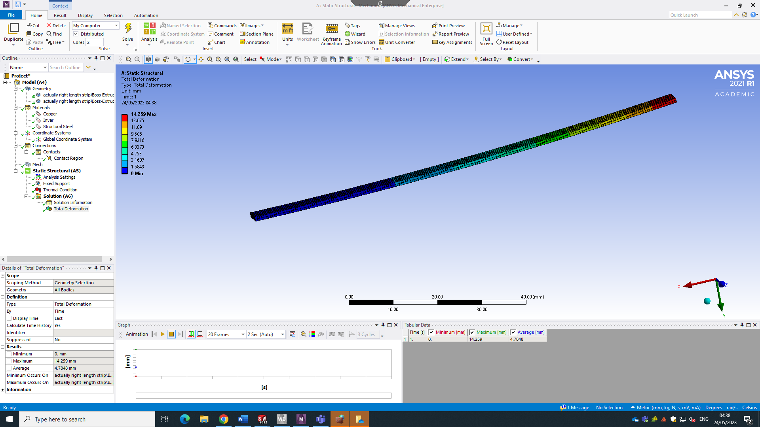
Figure 8. Deformation analysis results at a 100C thermal load.

After reviewing all the boundary conditions, it had been found that if the thermal load is set to 75C then the thermal deformation results are remarkably like what the validation returns (Figure 9). The solution for K₁ was like the analytical method results, suggesting that millimetres and meters could have been wrongly chosen somewhere within the simulation. Thus, error proves that ANSYS is extremely sensitive to user input, and it is a drawback of it that checking all parameters may be time consuming and results are very prone to human-error and assumptions.
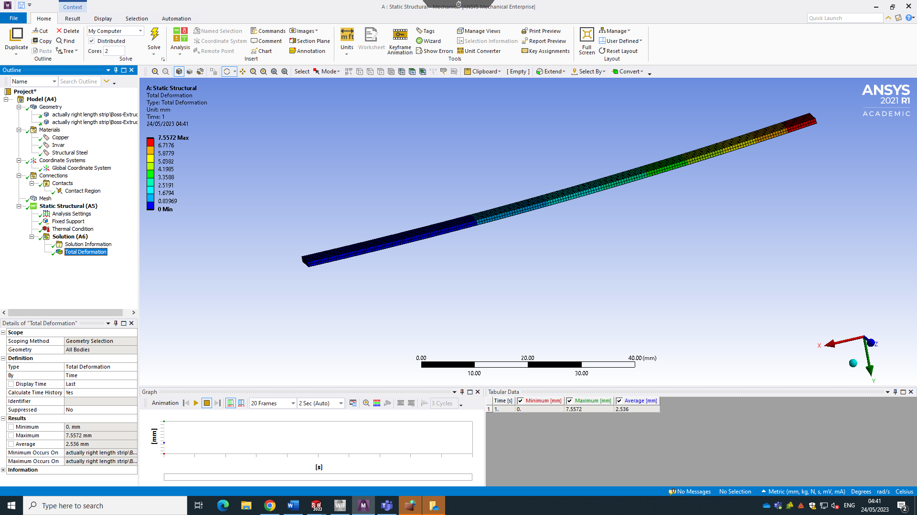
Figure 9. Deformation analysis results at a 75C thermal load.

CAE Process

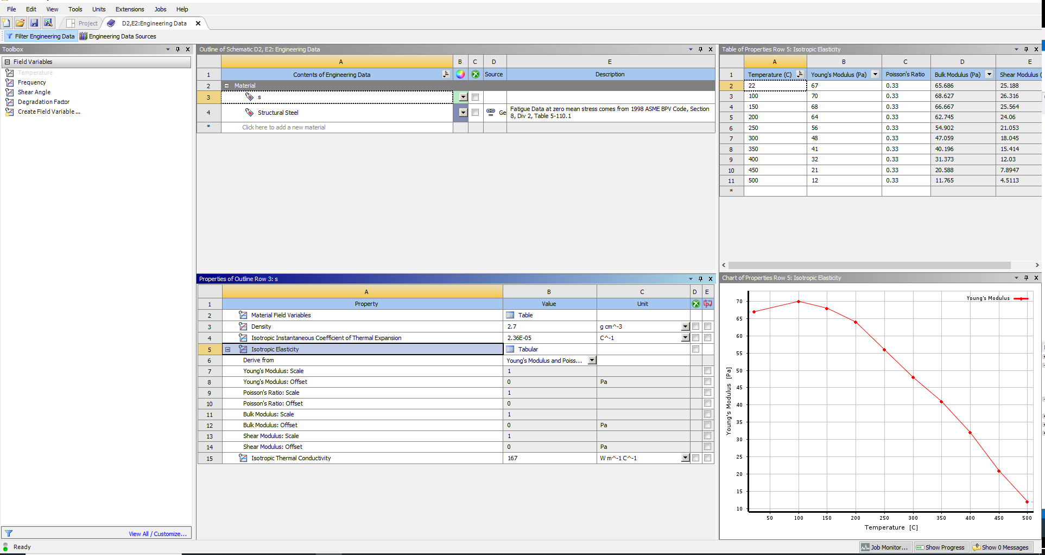
Figure 10. CAE process - Engineering Data.

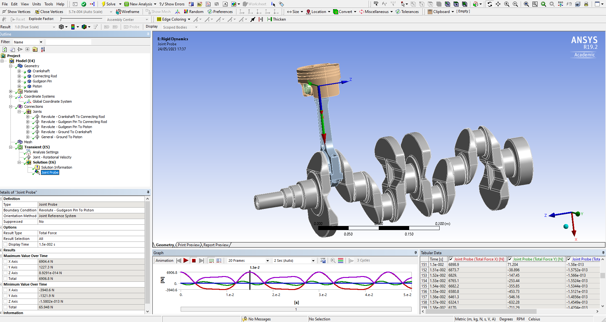
Figure 11. CAE Process - Rigid dynamics results.
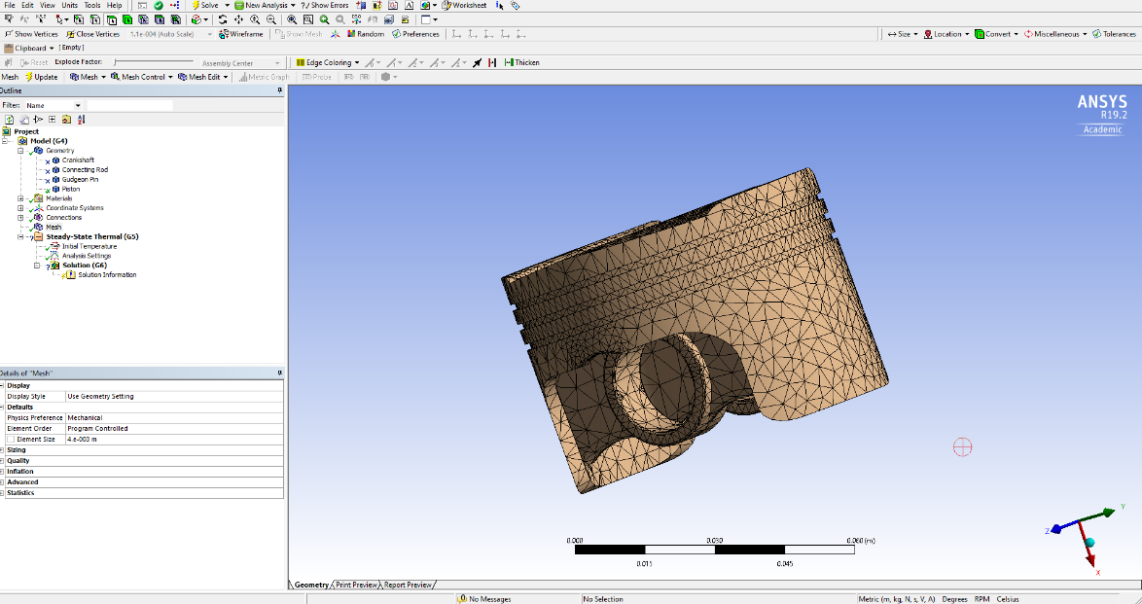
Figure 12. Steady-state Thermal - 0.004m mesh applied to the piston.
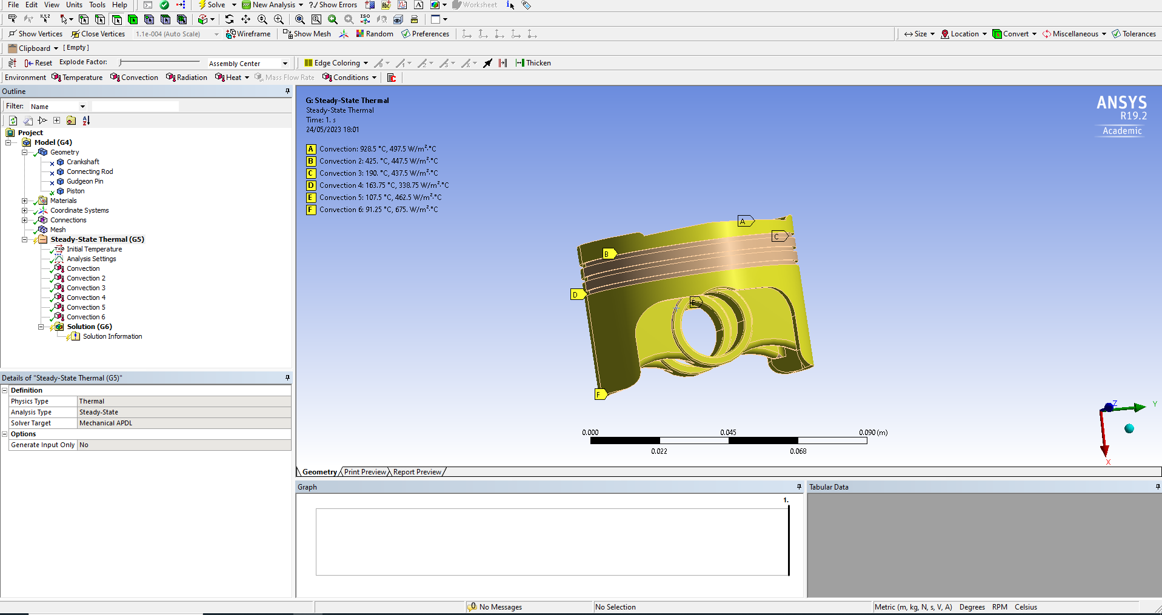
Figure 13. Steady-State Thermal - Boundary conditions (convection on piston).
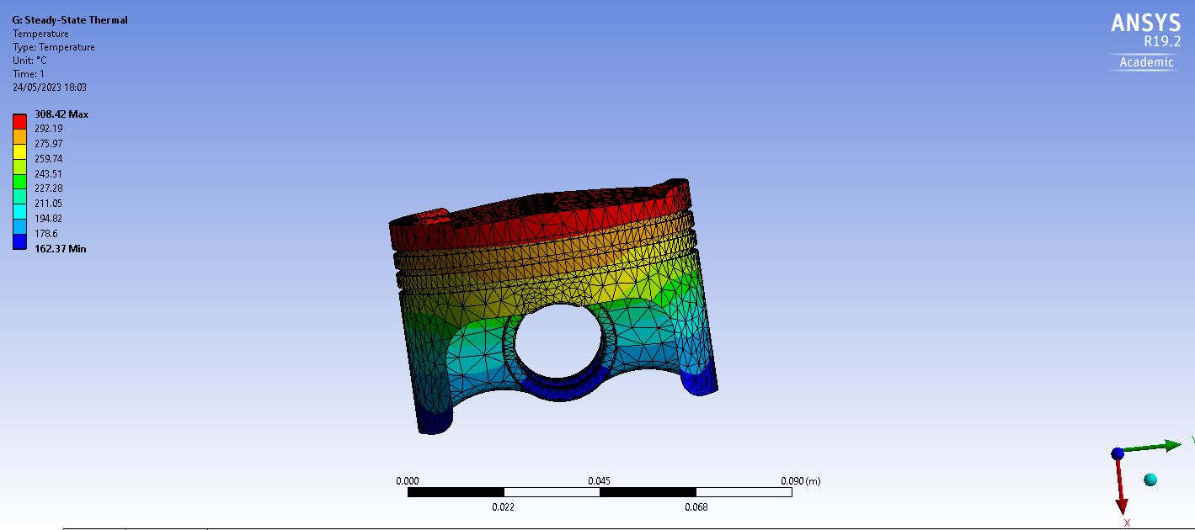
Figure 14. Steady-State Thermal results.

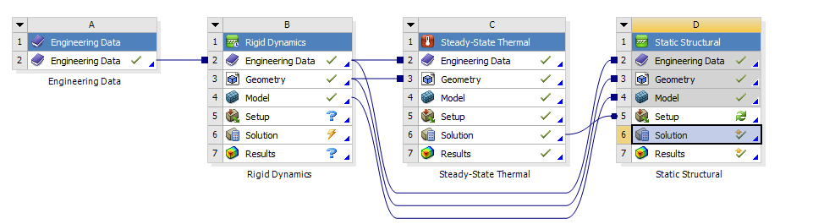
Figure 15. Final project schematic.
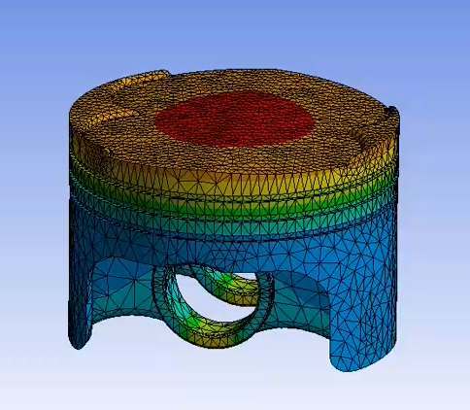
Figure 16. Final piston results.

Limitations of CAE
CAE analysis results heavily rely on user input, which introduces user assumptions that may not align with the behaviour of real components being analysed. Users sometimes resort to data simplification or shortcuts to save time, but it is important to acknowledge that CAE software can only operate based on the instructions it receives and cannot independently identify inconsistencies in the data. To address this, conducting mesh independence studies is crucial.
Mesh independence studies help mitigate this limitation by examining the influence of mesh density on the accuracy of results. Generally, finer meshes tend to yield more accurate results since the software performs more calculations. Adapting the mesh shape to suit the geometry of the component being analysed can also enhance accuracy. For instance, using a square-shaped mesh may be acceptable for a simple bi-metallic strip due to its straightforward geometry. Conversely, when analysing a wheel-shaped object, a triangular-shaped mesh would be more appropriate as it better captures the curves and crevices. Adjusting and refining the mesh facilitates the identification of optimal options.
The computational requirements of CAE tools can impose demands on the available computer resources. Analyses often consume considerable time and necessitate powerful computers to efficiently process the extensive amount of data involved, particularly for complex models. Mitigation of this limitation is possible but entails investment in high-performance computers and user expertise.
In summary, the limitations associated with CAE analysis, such as user assumptions and computational demands, should be acknowledged. Conducting mesh independence studies aids in addressing user assumptions, allowing for more accurate results. Additionally, allocating adequate computational resources and acquiring the necessary expertise can mitigate the challenges posed by computational demands.

Conclusion
This report's goal was to explore the complex world of computer-aided engineering (CAE) technologies and consider both of their possible benefits and drawbacks for the engineering design process. In order to represent the real-world system in a computer context, the research delved into the development of a multi-component assembly and subsequent kinematic and static structural analysis. It also investigated how mesh sizing affected the accuracy of the results and the ensuing iterative performance improvement process.
The investigation showed that CAE tools have enormous potential for helping engineers with big engineering system design, modelling, and evaluation. In the design and testing of engineering components, tools like CAD and ANSYS have been shown to provide previously unheard-of prospects for efficiency, time savings, and increased accuracy. Additionally useful in the automotive, aerospace, manufacturing, and energy sectors, these tools functioned as key agents in the enhancement of performance, safety, and environmental effects.
The study, however, also highlighted the delicate balance between the advantages and restrictions of CAE tools. Although these tools can increase effectiveness and accuracy, they are extremely sensitive to user input and prone to mistakes caused by suppositions or oversimplification of the facts. The validation evaluation illustrated the need for thorough verification and improvement by showing how differences can appear when comparing the software's output with a condensed test case.
In conclusion, the study offers a thorough grasp of the function of CAE tools in engineering design. It emphasises the importance of using these technologies carefully and methodically while appreciating both their inherent benefits and potential drawbacks.

References
ANSYS (n.d.). 6 Simulation Technologies Aerospace Engineers Don’t Want to Miss in 2019. [online] www.ansys.com. Available at: https://www.ansys.com/blog/simulation-techonogy-aerospace-engineers-aiaa [Accessed 23 May 2023].
ANSYS (2004). Ansys Structural Analysis Guide. [online] Available at: https://vdocument.in/ansys-structural-analysis-guide-558460aeb22b5.html?page=1 [Accessed 23 May 2023].
ANSYS (n.d.). Ansys Workbench | Simulation Integration Platform. [online] www.ansys.com. Available at: https://www.ansys.com/products/ansys-workbench [Accessed 23 May 2023].
ANSYS (n.d.). Kinematic Analysis of a Mechanical System. [online] ANSYS Innovation Courses. Available at: https://courses.ansys.com/index.php/courses/multibody-dynamics-theory-ansys-innovation-courses/lessons/kinematic-analysis-of-a-mechanical-system-lesson-3/#:~:text=The%20kinematic%20analysis%20consists%20of%20position%2C%20velocity%2C%20and [Accessed 23 May 2023].
ANSYS (2015). Lecture 6: Introduction to Optimetrics. [online] Available at: https://ece.uprm.edu/~rafaelr/inel6068/HFSS/HFSS_Antenna_v2015_v1/lectures_trainee/ANSYS_HFSS_Antenna_L06_0_Optimetrics.pdf#:~:text=Optimization%20A%20process%20of%20finding%20a%20better%20or,suitable%20design%20instance%20among%20the%20possible%20design%20variations [Accessed 23 May 2023].
ANSYS (n.d.). Materials and Simulation Objects - Boundary Conditions. [online] www.optics.ansys.com. Available at: https://optics.ansys.com/hc/en-us/articles/360044943714-Materials-and-Simulation-Objects-Boundary-Conditions#:~:text=A%20Temperature%20boundary%20condition%20can%20be%20used%20to,of%20a%20device%20or%20substrate%20to%20room%20temperature. [Accessed 23 May 2023].
ANSYS (2021). The Fundamentals of FEA Meshing for Structural Analysis. [online] www.ansys.com. Available at: https://www.ansys.com/blog/fundamentals-of-fea-meshing-for-structural-analysis [Accessed 23 May 2023].
Pearson, L. (2020). Method Validation and Verification. [online] Available at: https://arup.utah.edu/media/pearson-method-2020/lecture-slides.pdf [Accessed 23 May 2023].
Suzuki, E. (2021). What is CAD (Computer-Aided Design)? [online] Available at: https://www.autodesk.com/products/fusion-360/blog/what-is-cad-computer-aided-design/ [Accessed 23 May 2023].
Veronesi, L. and Van Herreweghe, M. (2016). Technology Spotlight CAD / CAE Integration: Opportunities in the Automotive Industry Sponsored by: Dassault Systèmes. [online] Available at: https://www.3ds.com/fileadmin/PRODUCTS-SERVICES/CATIA/SFE/PDF/VW_SFE_CONCEPT_IDC_Technology_Spotlight_Final.pdf [Accessed 23 May 2023].

