Module Title: Design Thinking and Innovation
Module Code: LCLM 6002
Assignment Title: Innovation & Customer Journey

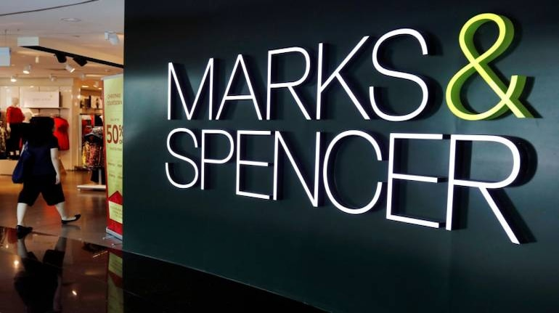

Student Name: MADALINA ALIU
Student ID: 2310477
Date of Submission: 17/11/2025
Table of Contents
1. Introduction 3
2. Consumer and Industry Trends 3
2.1. Retail Industry Trends in the UK 3
2.2. Consumer Behaviour Shifts 5
2.3. Impact on M&S 5
3. Part 1: Analysis of M&S’s Current Approach to Innovation 6
3.1 Innovation Strategy Overview 6
3.2 Application of the Innovation Ambition Matrix 7
3.3 Customer Journey Mapping 9
3.4. Identification of Innovation Opportunities 10
4. Part 2: Proposed New Digital Transformation Initiative 11
4.1 Overview of the Proposed Digital Initiative 11
4.2 Justification and Strategic Fit 12
4.3 Proposed Features and Functionality 13
4.4 Enhanced Customer Journey Map 14
4.5 Feasibility and Implementation Plan 15
4.6 Performance Measurement and Evaluation 17
4.7 Critical Evaluation of the Proposal 18
5. Conclusion 18
Reference List 20

1. Introduction
Marks and Spencer (M&S) is a major British retailer, established in 1884 by Michael Marks and Thomas Spencer, conducting its business in the food, clothing and home sectors with physical outlets and also with a well-established online base (Morrison, 2025). It showed revenues of approximately 13.1 billion pounds during the year ending in March 2024 due to a 13% increase in food sales and a 5.3% increase in clothing and home (Davey, 2024). It has more than 74,297 with 68,905 employees in the UK, a market share in clothing and home of approximately 10% and consistent returns in its food activities (Retail Week, 2024). This assignment will focus on the role of design thinking and innovation in creating the customer experience of M&S and suggest new avenues of digital transformation that could potentially be used to add more value to it. Part 1 of this report evaluates the existing innovation strategy at M&S and maps its current customer journey and Part 2 is a suggested digital initiative, including a customer journey map and indicators to measure the effect.

Figure 1: Marks & Spencer
(Source: denimsandjeans.com, 2025)

2. Consumer and Industry Trends

2.1. Retail Industry Trends in the UK
Growth in Online Shopping and Omnichannel
In the UK, the proportion of online sales has been developing steadily at around 26.5% of the aggregate retail sales in the 2022 (Centre for Retail Research, 2022). However, the rate of growth of the digital medium is higher than that of the brick-and-mortar medium. Customers are also driving towards smooth online, mobile and in-store engagements. The e-commerce penetration rate on the British Isles is nearing the 85% mark in 2025 (Watty, 2025). Retailers are committing to single systems that combine inventory, checkout and customer information to facilitate real-time consistency across the channels.
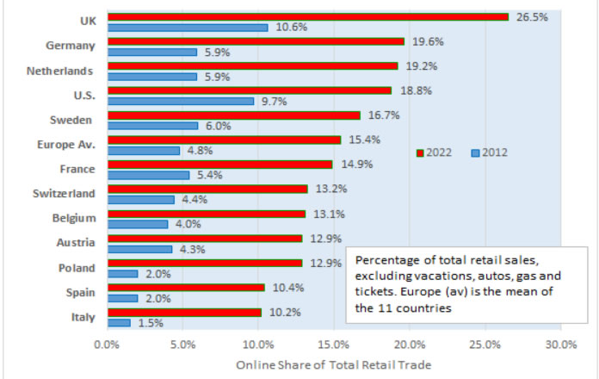
Figure 2: Online Shares of Retail Trade in 2012 to 2022
(Source: Centre for Retail Research, 2022)
Sustainability and Ethical Sourcing Pressures
Sustainability has not only been turned into a core expectation but also a point of sale. The consumers in the UK are increasingly preferring brands that are openly operating in their environment, are sourcing responsibly and have a circular model (Boyani Mogire, 2024). Retailers have pressure to decrease the carbon emissions, waste and supply-chain risk. An example is M&S, which has made the pledge of becoming net zero in its entire value chain by the year 2040 and is integrating sustainability as one of the major pillars of its ‘Reshape for Growth’ agenda (M&S, 2025).
AI and Data-Driven Personalisation
AI and predictive analytics are changing the customer interaction between retailers. Personalisation is no longer limited to product recommendations but to dynamic pricing, customised promotions and custom in-store experiences. Customer data platforms (CDPs) help retailers to harmonise profiles and apply real-time insights on a channel-wide basis (ADA Global, 2025). Chatbots, computer vision and shelf monitoring, AI forecasting, are some of the innovations that are becoming prevalent in the UK retailing operations.
Digital Payments and App-Based Engagement
Digital wallets, buy-now-pay-later and app-based checkout are payment technologies that simplify the process of purchase. Consumers demand easy, safe, frictionless payment transactions (Vlaicu, 2025). Retail applications become engagement centres, including loyalty programs, push notifications, AR try-ons and built-in shopping (Johnson, 2022).

2.2. Consumer Behaviour Shifts
Convenience, Local Sourcing and Hybrid Experiences
The speed, immediacy and proximity are becoming more and more important to the consumers. Micro-fulfilment hubs and dark stores are emerging to facilitate fast delivery. Halfway retail models, where Shoppers shop online, collect in-store or have delivered, are now becoming the norm (Sutinen, 2021). Shorter supply chains and sourcing locally are considered an aspect of sustainability and genuineness.
Post-COVID Recovery and Inflation Impacts
Consumers have become more cost-sensitive, value-focused and discriminatory after the multiple disruptions by the pandemic. Higher living costs and inflation have heightened price, deals and value ratios (Verbrugge and Zaman, 2024). There is some discretionary spending that has moved or decreased and this has exerted pressure on retailers to either prove premium positioning or to reinforce the value proposition.

2.3. Impact on M&S
‘Reshape for Growth’ Strategy (2022–2025)
In October 2022, M&S introduced its programme of redesign, ‘Reshape M&S for Growth’, to accelerate growth, improve margins and become digital (Marks and Spencer, 2025). The strategy is based on sustainability, simplicity and customer-focused digital transformation.
Investments in Technology and Digital Platforms
M&S has made significant investments in its online systems. Its online store, mobile application and loyalty program are called ‘Sparks’. It has also invested £340 million in modernisation of its food supply chain, distribution automation and enhancement of logistics (Derrick, 2025). The Plan A Accelerator Fund is used to advance environmental innovation in its value chain (M&S, 2023).
Comparison with Competitors
Next has been differentiated through efficient ‘bricks and clicks’ logistics and good online performance by using its physical presence as local fulfilment centres (Ward, 2025). Sainsbury and John Lewis also lead in investing in omnichannel and digital apps, particularly in grocery click & collect, delivery and loyalty (Savisaari, 2016). The quality and brand trust, combined with digital-physical experiences, allow M&S to compete, but it is imperative to maintain constant innovations.

3. Part 1: Analysis of M&S’s Current Approach to Innovation

3.1 Innovation Strategy Overview
Innovation and Design Thinking in M&S’s Context
In the M&S case, innovation can be defined as both incremental (product, process, service) and more radical (digital, model) transformation (Watson, Wilson and Macdonald, 2025). Design thinking is applicable in the human-centred approach to investigating customer needs, brainstorming solutions and testing prototypes. M&S has positioned innovation as a key to the provision of quality, value and service in a new manner (M&S, 2024).
Innovation Culture and ‘Never the Same Again’ Transformation
M&S also intends to incorporate innovation as ‘the new normal’, whereby the staff will be encouraged to present ideas and collaborate with outside innovators (M&S, 2025). Their Big Innovation Pitch programme has both internal and external ideas generated in line with sustainability, quality and digital ambitions. The change program ‘Never the Same Again’ emphasises the point that processes, services and operations should continue to change (no complacency) (Abdelazim, 2022). This spirit is not always explicitly mentioned according to that name in published documents, but can be seen in the M&S formula of ‘Reshape for Growth’ (2022-2025), the focus of which is on agility, digital investment and sustainability.
Examples of Current Innovations
- AI-driven Stock Management and Online Visual Search: M&S uses machine learning models in loyalty and e-commerce to interpolate purchase history, deliver targeted offers and products (Nguyen, 2025). Their shift to machine learning pipelines of manual data workflows speeds up the creation of insights and personalisation. They have also tested visual search options, where customers take pictures or upload them to locate similar products.
- Sustainability innovations (Plan A / Plan A 2.0): The long-term sustainability programme Plan A, developed by M&S, forms the core of its innovation agenda. It has become Plan A 2.0 and has a £50 million innovation fund to fund supplier innovations (e.g. lower-carbon materials, regenerative agriculture) and aims to reach net zero in the entire value chain by 2040 (Food, 2017). Examples of projects are the suppression of methane in dairy provision, a supply chain that is optimised and textile recycling.
- Automation in Supply Chain Logistics: M&S is undertaking the modernisation of its distribution and logistics systems. The ICT expenditure projected by it is above US$300 million (in hardware, software and services) to assist in automation, real-time visibility and integrated systems (GlobalData, 2023). Its retailer also stated that it was planning to invest heavily in a fully automated distribution centre (to be opened by 2029) to facilitate the growth of its food business. Another aspect where M&S is gaining more and more is the process of forecasting, route optimisation and waste minimisation in logistics through the application of robotics, sensors and AI.

3.2 Application of the Innovation Ambition Matrix
Innovation Ambition Matrix separates innovation into core, adjacent and transformational layers. The resource allocation and the recent investments in M&S can be categorised in this manner.
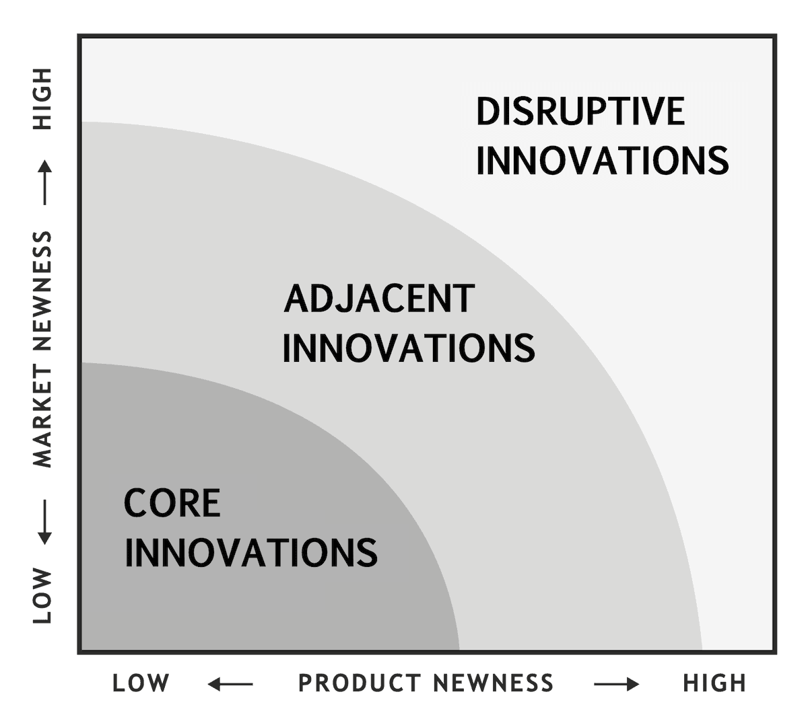
Figure 3: Innovation Ambition Matrix
(Source: romanpichler.com, 2025)
Core Innovations (Approx. 70 % Focus)
- Enhancing the Sparks Loyalty Program: M&S applies machine learning and data processes to target each Sparks member with offers, messages and retention strategies (Nguyen, 2025).
- Digitisation of In-Store Experience: Digital kiosks, store applications and inventory-check, click and collect application, as well as digital indicators (e.g. LED signage) are used to make physical retail more interesting (Ledingham, 2024). These, although less obvious to particular public projects, are in line with its plan of having its digitally-enabled stores.
Adjacent Innovations (Approx. 20 % Focus)
- Online grocery expansion and improvement of click & collect services. M&S is driving its food business with additional stores and digital order-up features, with the combination of online and offline flow (Newing et al., 2022).
- Granting alliances and logistics innovation to accommodate the resulting categories. For example, linkages in the supply chain with third-party technology providers, a pilot distribution model between food and general merchandise.
Transformational Innovations (Approx. 10 % Focus)
- AI-Assisted Personalisation and Predictive Shopping Algorithms: Deep learning systems that are predictive of future shopping behaviour and suggest a personalised assortment of products (Srivastava, Sarma and Nagavalli, 2021).
- Digital Dressing Rooms / Virtual Trials / AR: Provide customers with the opportunity to test clothes on the computer or view mix-and-match outfits in augmented reality (Idrees, 2023).
- New Business Model Experiments: Subscription model, circular fashion (e.g. subscription leases, resale), or marketplace model.
Critical Evaluation
- Exploitation vs. Exploration Balance (Govindarajan and Trimble): M&S relies greatly on core/exploitation to generate consistent revenue and brand equity, with a lesser percentage on exploration. Nonetheless, the threat is also not investing in transformational ventures sufficiently, which would expose M&S to disruptive competitors.
- Viability, Desirability, Feasibility
  - Viability: Costs (tech, staff, integration) need to be worth the money. Transformational bets can take longer to pay back and they are riskier, particularly where the retail market is volatile (Banks, 2024).
  - Desirability: Most of the customers want to be more personalised and convenient. AI or virtual try-on may address latent requirements.
  - Feasibility: M&S possesses effective digital and data infrastructure (ICT budget, data strategy pillars) to facilitate advanced innovations (Le Thuy Linh, 2020).

3.3 Customer Journey Mapping
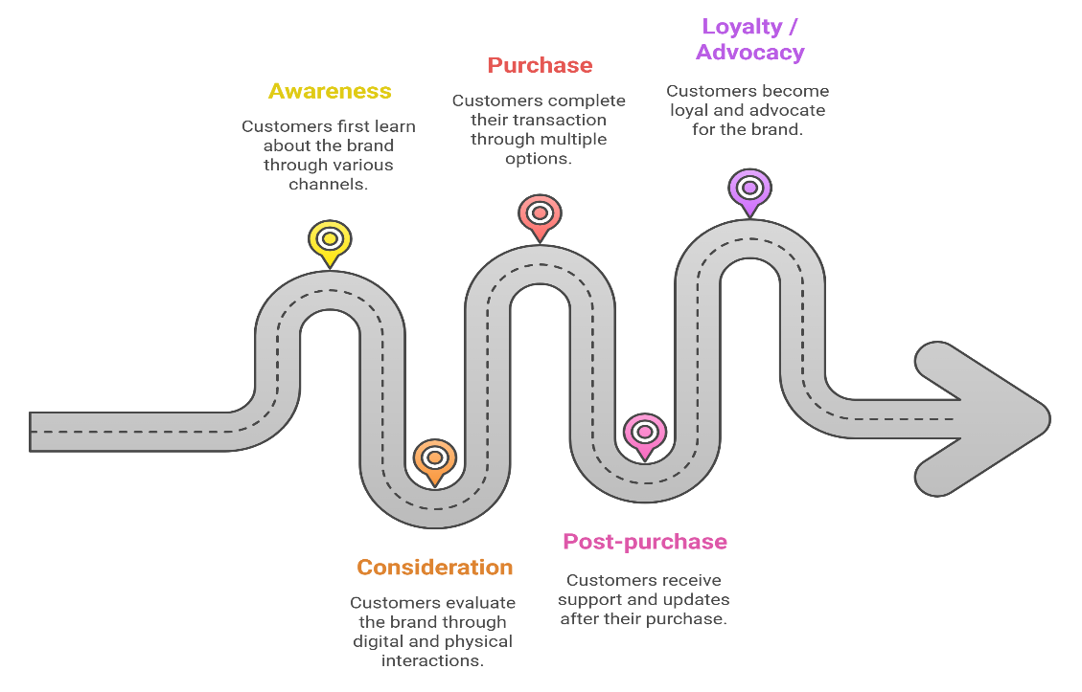
Figure 4: Customer Journey Map
(Source: Created by Author)
Stages | Channels / Touchpoints | Customer Actions and Emotions | Pain Points / Frictions | Gains / Strengths
Awareness | Social media ads, search, catalogues, word-of-mouth | Customer becomes aware of M&S offers, seasonal campaigns | Brand messaging may diffuse across clothing, food and home segments | Strong brand recognition and heritage
Consideration | M&S.com, Sparks app, influencer content, store visits | Browsing, comparing, filtering | Inconsistent information between online and store, lack of virtual try-on | Wide product selection, quality perception
Purchase | Website checkout, app, in-store, click & collect | Customer completes purchase | Checkout delays, cart abandonment, stockouts and click & collect fulfilment inconsistencies. | Flexible options, including in-store or online
Post-purchase | Delivery updates, email support, returns, Sparks follow-up | Customer awaits delivery, may request support or returns | Lack of real-time visibility, delays and return friction | Trust in M&S quality, clear return policies
Loyalty / Advocacy | Sparks rewards, exclusive offers, newsletters and social media | Customer uses loyalty benefits, engages again | Generic offers, low personalisation, loyalty fatigue | Emotional connection via Sparks, trust, perceived value
Table 1: Customer Journey Map
(Source: Created by Author)

3.4. Identification of Innovation Opportunities
Based on the analysis above, the following opportunity areas have arisen:
- Digital Integration and Omnichannel Integration: Inventory, promotion messages and customer data, consolidate in any channel to minimise disruptions and friction (Carvotta, 2022).
- AI-Driven Personalisation and Predictive Engagement: Implement more advanced analytics to predict customer needs, make personal offers and cross/upsell (Rajput, 2025).
- Sustainability Engagement: Open the customer service door, circularity, feedback on recycling (e.g. calculator of carbon impact, repair/resale services).
- In-Store Technology Enhancement: AR reflection, smart changing room, mobile POS and interactivity (Carvotta, 2022).
Under the design thinking stages, it was discovered that:
- Empathise: Interview, observe, shadow customers and understand their needs and feelings that have not been met (Cox, 2020).
- Define: What are the most important problem statements (e.g. disconnection with customers when switching apps and in-store)
- Ideate: Brainstorm some of the solutions (chatbots, predictive recommender, AR try-on) (Gupta and Madan, 2024).
- Prototype: Create the simplest ones (e.g. chatbot conversation, AR mockups) and introduce them in small groups to users first.
- Test: Receive feedback, pull out, repeat and choose the best prospect.

4. Part 2: Proposed New Digital Transformation Initiative

4.1 Overview of the Proposed Digital Initiative
Title: M&S Smart Companion – AI-Driven Personal Retail Assistant
The Smart Companion is a pioneering digital product of M&S, aimed to increase customer interaction with the help of AI and automation. The Smart Companion will be an individual shopping and lifestyle companion integrated into the existing M&S app and site. Based on Sharma (n.d) who notes a radical change in how AI is applied to retail personalisation and operational efficiency, this feature can utilise data-driven algorithms to recommend specific products in real time, based on individualised data across the M&S food, clothing, and home categories. Through state-of-the-art natural-language processing, customers are able to engage with the assistant through voice or chat, with customized recommendations, recipe ideas, outfit pairings and sustainability information like carbon-footprint information and recycling guidance. The Smart Companion is a secondary product that connects with the Sparks loyalty programme, where smart and behavioural rewards are provided dynamically and sustainable purchasing decisions are triggered.
This initiative is part of the Reshape to Growth strategy of M&S (M&S Strategic Report, 2025), which highlights the desire of the retailer to transform digitally, develop customer-focused innovations, and master omnichannel excellence. It solves major consumer discomfort points that had been recognised during the previous analyses, such as disjointed digital experience, lack of personalisation, and variations in click-and-collect services. The Smart Companion will help M&S stay in the realms of being a progressive and digitally empowered brand that places the customers, the environment, and convenience at the core of its priorities.

4.2 Justification and Strategic Fit
The Smart Companion is very much suited to the vision of M&S to become a data-driven, digital-first retailer. It increases customer interaction with its AI-based personalisation and encompasses sustainability transparency that underlines Plan A 2.0 objectives (M&S, 2022). The initiative will support both the ethical and digital transformation goals of M&S through combining the carbon-footprint information with behavioural nudges. The design of the platform reflects the sustainability system of Plan A (2025) of Planet Earth, which ultimately encourages responsible consumer behaviour. On the outside, its viability is supported by benchmarking to the Virtual Stylist of John Lewis, the ASOS Fit Assistant, and Amazon Alexa Shopping, which already feature availability of intelligent shopping in the market. Therefore, the Smart Companion will bring together M&S digital innovation and sustainability intentions, providing a competitive differentiation and strategic value over the long term.
Design-thinking Application:
The design-thinking approach will offer a systematic plan of designing the M&S Smart Companion, and the focus on the real customer requirements will be the basis of the innovation (Kenny et al., 2021).
Empathize:
Based on the results of Part 1, the customers usually feel frustrated by the impersonal and disjointed online communication experience. A lot of them are interested in more human-centred, personal, and ethically oriented shopping assistance.
Define:
The issue that was found to be core is the absence of personalised but sustainable shopping advice- customers are seeking balance in their digital experiences in terms of convenience, relevance, and responsibility.
Ideate:
To M&S innovation teams, the Smart Companion, an AI-based Digital Assistant, was co-created, aimed to provide real-time suggestions, sustainability information, and lifestyle services on all the categories of M&S.
Prototype/Test:
The assistant will be tested in the Sparks app to receive feedback on customers, optimize engagement and usability before being rolled out fully.
Strategic Value:
The initiative provides differentiation by way of a single and smart shopping companion that maximises personalisation and encourages sustainable decisions. Introducing AI into the current customer ecosystem, M&S improves the level of brand loyalty and establishes itself as a digital-first, responsible retailer.

4.3 Proposed Features and Functionality
The Smart Companion M&S product uses a multi-layered AI ecosystem, which is a combination of data analytics, conversation AI, sustainable insights, and omnichannel connectivity.
Personalisation Engine examines the data on the browsing, purchasing and loyalty and predicts it based on the specific preferences of the individual, suggesting intelligent choices, such as outfit matches or meal planners. The Voice and Chat Interface allows the customer to make natural-language queries like Find a sustainable cotton shirt under PS40 with adaptive technology and the NLP enhances the questions as the customer continues to use them (Pereira et al., 2022). Sustainability Dashboard is also founded on the principles of Plan A 2.0 and displays the carbon footprint of the purchases and promotes the green ones. The Omnicom Synchronisation enables the customer to scan products at the store to leave online feedback, styling information or wish lists and in the process, this helps to create a seamless flow between the real and the virtual retail area (Chundi, 2025). Finally, Smart Rewards have been evolving Sparks loyalty points dynamically based on the engagements and the sustainable behaviour of the users, to enhance responsible consumption. These factors would give a combined interactive customer experience that contributes to personalisation, transparency, and convenience and encourages customer loyalty.

4.4 Enhanced Customer Journey Map
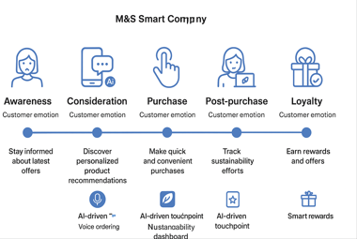
Figure 5: Enhanced Customer Journey Map
(Source: Created by Author)
Stages | Touchpoints and Digital Interactions | Customer Needs | Innovative Value Added
Awareness | Use of social media, app notifications, AI-targeted ads | Curious, innovative | Smart companion introduces customized campaigns
Consideration | App assistant, sustainability information | Maintained by transparency | Builds trust and friendship
Purchase | Unified checkout (in-store/app), voice ordering | Convenience, confidence | By clicking one secure payment, instant sparks and rewards.
Post-Purchase | Delivery tracking chatbot, feedback facilities | Empowered, satisfied | Real-time updates, instant returns management system.
Loyalty | Personal milestones, gamified Sparks rewards | Engaged, valued | Ongoing relationship through AI reminders and offers.
Table 2: A Redesigned Map
(Source: Created by Author)

4.5 Feasibility and Implementation Plan
Technology Feasibility:
M&S can apply the means of data infrastructure available to it and partner with one of the giant cloud/AI services providers, Microsoft Azure or Google Cloud, to apply scalable AI services. Retailers are moving towards hybrid or open cloud AI to enable them to scale their operations without the heavy load required by capital-intensive ones. According to KPMG (2025), it is recommended to start with the first data pipelines and introduce AI services on the top of it (e.g. personalization, recommendations).
Operational Feasibility:
Employees should be trained towards online interaction and AI supervision - such as the interpretation of AI outputs, the detection of anomalies, and exception handling. Upskilling of the workforce is vital in the process of adopting AI (Wilson, Johnson and Brown, 2024). To evaluate how to integrate the Smart Companion with app, retailer systems, and in-store processes, M&S should roll out the Smart Companion in a small area or one flagship store to test before it can be rolled out nationally. This pilot assists in streamlining interpersonal relations with the staff, customer relationships, and system trust.
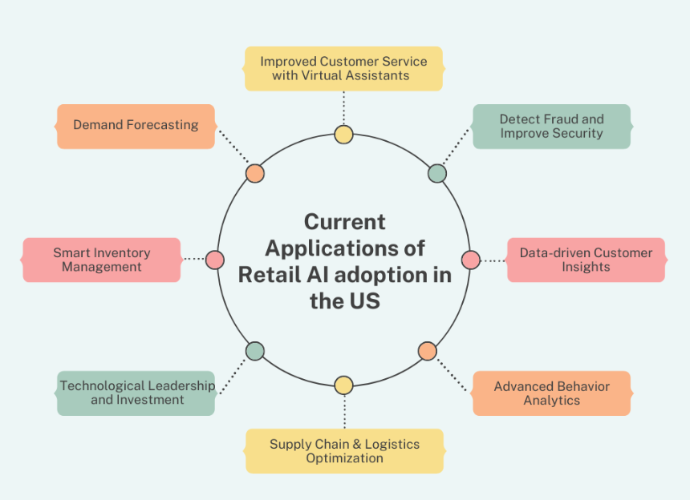
Figure 6: Meeting Customer Expectations
(Source: Wilson, Johnson and Brown, 2024)
Financial Feasibility:
£15 million initial investment could be sourced by Plan A Innovation Fund or digital transformation budget of M&S. As a result, numerous retail AI projects show ROI of more than 10 percent and some more than 30 percent returns to the company, as suggested by Anica-Popa et al. (2021). In this example, the 15-20 percent increase in online sales and 10 percent increase in app retention in the first year make the project financially viable with a payback period of 3-4 years.
Risk Assessment:
Data Privacy and Compliance: GDPR will also be followed, anonymisation and opt-in consent will be supplied and clear disclosures will be made. The ethical AI studies that ensure consumer trust are fairness, transparency and data protection (Adanyin, 2024).
Reliability Technical: Implement failures backup, back-up server system, frequent check of AI models, bias testing and performance measurement according to these AI deployment recommendations.
User adoption: No one can be guaranteed of high adoption since they are not familiar with the same (Kearey, 2024). The communication strategy that can be used to alleviate AI anxiety is through the use of marketing and education hybrid of online boarding tutorials, incentives, and early feedback loop.

4.6 Performance Measurement and Evaluation
Customer Experience Metrics:
These are the criteria used to assess the perception and interaction of users with the Smart Companion. The Net Promoter Score (NPS) determines the loyalty of the customers by measuring how likely they are to recommend M&S, while on the other hand, the Customer Satisfaction (CSAT) metric rates the level of satisfaction for various app features and AI recommendations (Van De Ven et al., 2023). The repeat purchase rate of customers is a metric through which the number of returning customers is tracked and subsequently trust and engagement with the personalized guidance of the company is reflected.
Digital Engagement Metrics:
Digital engagement, the metrics that indicate how users interact with the system. App dwell time is a metric that determines the duration of the customer's engagement with the app, chatbot interactions are the records of the AI query usage during communication, and Sparks activations indicate the users’ participation in the loyalty features prompted by the AI recommendations and thus linking the engagement to rewards (Enyejo et al., 2024).
Financial Performance Metrics:
Financial performances are the measures indicating the impact on business as the Conversion rate indicates which percentage of recommendations has turned into sales, Average Order Value (AOV) reflects the amount of money spent on each transaction, and ROI provides the calculation of the financial gain from the initiative (Islam and Ikbal, 2022).
Sustainability Outcomes:
Sustainability is the category of metrics that indicate the extent of eco-friendly behaviour. The proportion of sales for low-carbon products, the cut in returns, and the participation in circular-fashion activities are the three indicators showing the acceptance of environmentally-friendly product choices and good recommendations (Batista et al., 2022).
Innovation Metrics:
Innovation is the sign of how fast development is done as the time needed for prototype cycles, the feedback from users, and the number of staff giving ideas indicate the inverted progress and the engagement within the organization.
All these KPIs together form a holistic evaluation framework, which allows M&S to measure customer satisfaction, engagement, financial outcomes, sustainability impact, and continuous innovation.

4.7 Critical Evaluation of the Proposal
The M&S Smart Companion has a lot to offer, such as customer-first design, AI-driven customization, sustainability integration, and increased brand trust. It solves shopping experience fragmentation and supports the omnichannel concept. On the other hand, main drawbacks are the expensive initial investment, overreliance on precise data modelling, and possible privacy issues. The company can take advantage of the digital retail market's ethical leadership and AI and fashion tech partnerships across sectors because technology has made it possible (Farooq, Abbey and Onukwulu, 2024). The threats are the imitation of the competition, consumer technology saturation, and changing regulations that would affect the claims of data or sustainability. The project is on the line of being an adjacent and transformational innovation, which gives it the advantage of taking risks while also getting the rewards, hence the long-term digital and sustainable growth is already being driven.
M&S Smart Companion makes a strategic decision by placing itself in both the adjacent and transformational innovation zones of the Innovation Ambition Matrix. It primarily operates in the adjacent zone where it relies on the existing digital infrastructure and loyalty programmes of M&S and makes customer touchpoints more familiar with the incorporation of personalisation and convenience (M&S, 2022). At the same time, it operates in the transformational zone by bringing in AI-powered recommendations, sustainability tracking, and omnichannel intelligence that altogether create new experiences and alter the customers’ interaction with the brand.

5. Conclusion
The M&S Smart Companion is a perfect representation of the M&S retailer's customer-centric innovation and sustainability strategy, as it flawlessly brings together personalized recommendations, loyalty rewards, and environmental insights. It creates a smooth digital journey that connects online and offline purchases and experiences, thus boosting the convenience, engagement, and satisfaction of the customers in all product categories. The project not only strengthens M&S’s digital presence in the long run but also gives the retailer an edge over its competitors, thereby making it an AI-powered, ethical retail brand leader. Moreover, the application of iterative design thinking, which is complemented by well-defined KPIs and constant feedback from app metrics, surveys, and A/B tests, keeps the Smart Companion in sync with customer demands, operational intelligence, and sustainability goals. This methodical, data-informed approach ensures that there are regular improvements and that the impact is quantifiable.

Reference List
Abdelazim, Z., (2022). Sales Management–Enhance the Effective Selling of Items to Clients. Available at SSRN 4453466.
ADA Global (2025). How Customer Data Platforms (CDPs) Power Growth in the Retail Sector. [online] Adaglobal.com. Available at: https://www.adaglobal.com/resources/insights/how-customer-data-platforms-cdps-power-growth-in-the-retail-sector [Accessed 14 Oct. 2025].
Adanyin, A., (2024). Ethical AI in retail: Consumer privacy and fairness. arXiv preprint arXiv:2410.15369.
Anica-Popa, I., Anica-Popa, L., Rădulescu, C. and Vrîncianu, M., (2021). The integration of artificial intelligence in retail: benefits, challenges and a dedicated conceptual framework. Amfiteatru Economic, 23(56), pp.120-136.
Banks, O., (2024). Driving Retail Transformation: How to navigate disruption and change. Practical Inspiration Publishing.
Batista, L., Larsen, A.T., Davis-Peccoud, J. and Häuptli, M., (2022). Sustainability in Retail: Practical Ways to Make Progress. Bain & Company.
Boyani Mogire, R., (2024). Investigating Factors Influencing Changing Consumer Patterns and the Impact on Sales Revenue in the Clothes Department at Marks & Spencer in Dublin, Ireland.
Carvotta, D., (2022). Future window display: improving service through technology.
Centre for Retail Research (2022). Online Retail: UK, Europe & N. America : The Centre For Retail ResearchOnline Retail : UK, Europe & N. America : The Centre For Retail Research. [online] Retailresearch.org. Available at: https://www.retailresearch.org/online-retail.html [Accessed 14 Oct. 2025].
Chundi, V.R.K., (2025). AI-Powered Sustainability Integration: Transforming Retail and Manufacturing Through Enterprise Resource Planning Solutions. Journal of Computer Science and Technology Studies, 7(5), pp.881-887.
Cox, M., (2020). The business case for love: How companies get bragged about today. Springer Nature.
Davey, J. (2024). M&S’s profit soars 58% as a turnaround plan finally delivers. Reuters. [online] 22 May. Available at: https://www.reuters.com/markets/europe/mss-profit-soars-58-turnaround-plan-finally-delivers-2024-05-22 [Accessed 14 Oct. 2025].
Derrick, M. (2025). Behind M&S’ £340m Digital Supply Chain Transformation. [online] Technologymagazine.com. Available at: https://technologymagazine.com/news/m-s-340m-advanced-automated-food-distribution [Accessed 14 Oct. 2025].
Enyejo, J.O., Obani, O.Q., Afolabi, O., Igba, E. and Ibokette, A.I., (2024). Effect of Augmented Reality (AR) and Virtual Reality (VR) experiences on customer engagement and purchase behavior in retail stores. Magna Scientia Advanced Research and Reviews, 11(2), pp.132-150.
Farooq, A., Abbey, A.B.N. and Onukwulu, E.C., (2024). Inventory optimization and sustainability in retail: A conceptual approach to data-driven resource management. International Journal of Multidisciplinary Research and Growth Evaluation, 5(6), pp.1356-1363.
Food, S. (2017). Economics of Mutuality Alliance. [online] Economics of Mutuality Alliance. Available at: https://eom.org/knowledge-hub-content/marks-spencer-food [Accessed 14 Oct. 2025].
GlobalData (2023). Marks & Spencer - Digital Transformation Strategies. [online] Market Research Reports & Consulting | GlobalData UK Ltd. Available at: https://www.globaldata.com/store/report/marks-and-spencer-enterprise-tech-analysis [Accessed 14 Oct. 2025].
Gupta, R. and Madan, S., (2024). Digital Marketing: The science and magic of digital marketing can help you become a successful marketing professional. BPB Publications.
Idrees, S., (2023). Enhancing Apparel Size and Fit Prediction for E-Commerce: A Mixed Methods Approach with 3D Body Scanning (Doctoral dissertation, The University of Manchester (United Kingdom)).
Islam, M.R. and Ikbal, M.Z., (2022). IMPACT OF PREDICTIVE DATA MODELING ON BUSINESS DECISION-MAKING: A REVIEW OF STUDIES ACROSS RETAIL, FINANCE, AND LOGISTICS. American Journal of Advanced Technology and Engineering Solutions, 2(02), pp.33-62.
Johnson, S., (2022). CREATING SEAMLESS OMNICHANNEL EXPERIENCES IN ECOMMERCE: BRIDGING ONLINE AND OFFLINE RETAIL.
Kearey, (2024). Dealing with “AInxiety” in retail: why retailers must deploy AI solutions now to remain competitive. [Online] Available at https://www.kearney.com/service/digital-analytics/article/dealing-with-ainxiety-in-retail-why-retailers-must-deploy-ai-solutions-now-to-remain-competitive [Accessed 14 Oct. 2025].
Kenny, U., Regan, Á., Hearne, D. and O'Meara, C., (2021). Empathising, defining and ideating with the farming community to develop a geotagged photo app for smart devices: A design thinking approach. Agricultural Systems, 194, p.103248.
KPMG, (2025). Intelligent retail. A blueprint for creating value through AI- driven transformation. [Online] Available at https://kpmg.com/kpmg-us/content/dam/kpmg/pdf/2025/kpmg-intelligent-retail.pdf [Accessed 14 Oct. 2025].
Le Thuy Linh, H.O., (2020)An Exploratory Discussion of a British Apparel Brand in Relation to New Markets: Developing Actionable Recommendations Based on Network, Relationship, and Collaboration Perspectives.
Ledingham, D. (2024). Marks and Spencer: Reshaping a Strategy. [online] Substack.com. Available at: https://dledingham.substack.com/p/marks-and-spencer-reshaping-a-strategy [Accessed 14 Oct. 2025].
M&S (2023). Reshaping M&S. [online] M&S. Available at: https://corporate.marksandspencer.com/sites/marksandspencer/files/marks-spencer/investor/Annual%20Report%202023/M%26S_AR23_Strategic_report.pdf [Accessed 14 Oct. 2025].
M&S (2024). Marks and Spencer Group plc Annual Report & Financial Statements 2024. [online] Marks & Spencer. Available at: https://corporate.marksandspencer.com/sites/marksandspencer/files/2024-06/M-and-S-2024-Annual-Report.pdf [Accessed 14 Oct. 2025].
M&S (2025). Our pitch to make innovation the ‘new normal’. [online] Marks & Spencer. Available at: https://corporate.marksandspencer.com/our-pitch-make-innovation-new-normal [Accessed 14 Oct. 2025].
M&S (2025). Sustainability. [online] Sustainability. Available at: https://corporate.marksandspencer.com/sustainability [Accessed 14 Oct. 2025].
M&S Strategic Report, (2025). Strong financial and strategic progress in 2024/25 as M&S continues to Reshape for Growth. [Online] Available at https://corporate.marksandspencer.com/sites/marksandspencer/files/2025-05/M-and-S-Strategic-Report-2025.pdf [Accessed 14 Oct. 2025].
M&S, (2022). Shaping the FUTURE. [Online] Available at https://corporate.marksandspencer.com/sites/marksandspencer/files/Annual%20reports/m-and-s_ar22_full-ar.pdf [Accessed 14 Oct. 2025].
Marks and Spencer (2025). HIGHLIGHTS OF THE YEAR Financial Strategic Marks and Spencer Group plc Annual Report and Financial Statements 2025 2 STRATEGIC REPORT GOVERNANCE FINANCIAL STATEMENTS. [online] Available at: https://corporate.marksandspencer.com/sites/marksandspencer/files/2025-05/M-and-S-Strategic-Report-2025.pdf [Accessed 14 Oct. 2025].
Morrison, K.A., (2025). Chain Stores in the Golden Age of the British High Street. Liverpool University Press.
Newing, A., Hood, N., Videira, F. and Lewis, J., (2022). ‘Sorry we do not deliver to your area’: geographical inequalities in online groceries provision. The International Review of Retail, Distribution and Consumer Research, 32(1), pp.80-99.
Nguyen, H.S., (2025). A study of AI-powered tools in enhancing customer engagement within the fashion industry.
Pereira, A.M., Moura, J.A.B., Costa, E.D.B., Vieira, T., Landim, A.R., Bazaki, E. and Wanick, V., (2022). Customer models for artificial intelligence-based decision support in fashion online retail supply chains. Decision Support Systems, 158, p.113795.
Plan A, (2025). our Sustainability Initiative. [Online] Available at https://plana.earth/sustainability-initiative [Accessed 14 Oct .2025].
Rajput, A.A., (2025). The Influence of Digital Marketing Strategies on Consumer Buying Behavior:“A Comprehensive Analysis of Marks and Spencer’s Retail in the UK” (Doctoral dissertation, University of Wales Trinity Saint David).
Retail Week (2024). Marks & Spencer (Financials). [online] Retail Week. Available at: https://www.retail-week.com/retailnavigator/marks-and-spencer/marks-and-spencer-financials/7038337.supplierarticle [Accessed 14 Oct. 2025].
Savisaari, A., (2016). Supply chain effects in creation of omnichannel customer experience in grocery retail.
Sharma, V., AI-Driven Automation in Retail: Delivering Personalized Customer Experiences at Scale. integration, 10(1).
Srivastava, A., Sarma, W. and Nagavalli, S.P., (2021). Enhancing Personalized Shopping Experiences in E-Commerce through Artificial Intelligence: Models, Algorithms, and Applications.
Sutinen, A., (2021). Improving the efficiency of fulfilment operations in omnichannel grocery retailing.
Van De Ven, M., Lara Machado, P., Athanasopoulou, A., Aysolmaz, B. and Turetken, O., (2023). Key performance indicators for business models: a systematic review and catalog. Information Systems and e-Business Management, 21(3), pp.753-794.
Verbrugge, R. and Zaman, S., (2024). Post‐COVID inflation dynamics: Higher for longer. Journal of Forecasting, 43(4), pp.871-893.
Vlaicu, R., (2025). Digital Payments Adoption by Consumers and Firms: Implications for Financial Inclusion.
Ward, J. (2025). How Next defied the odds and positioned itself as a British high-street staple. [online] MoneyWeek. Available at: https://moneyweek.com/investments/retail-stocks/how-next-defied-the-odds-british-high-street-staple [Accessed 14 Oct. 2025].
Watson, R., Wilson, H.N. and Macdonald, E.K., (2025). Engagement logics: How partners for sustainability‐oriented innovation manage differences between organizational logics. Journal of Product Innovation Management, 42(2), pp.310-337.
Watty, F. (2025). Topic: Online shopping behavior in the UK. [online] Statista. Available at: https://www.statista.com/topics/7887/online-shopping-behavior-in-the-uk [Accessed 14 Oct. 2025].
Wilson, G., Johnson, O. and Brown, W., (2024). Exploring the integration of artificial intelligence in retail operations.

