

How I can use the DIKW and CRAAP frameworks to confirm or refute my collected Academic GRIT test result (Primary Data) compared to the UWTSD GRIT Result (secondary Data) based on the work of Angela Duckworth TED Talk lecture”.

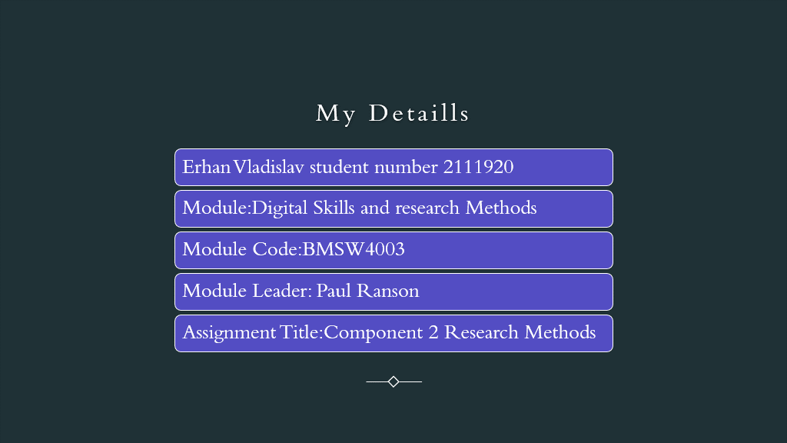

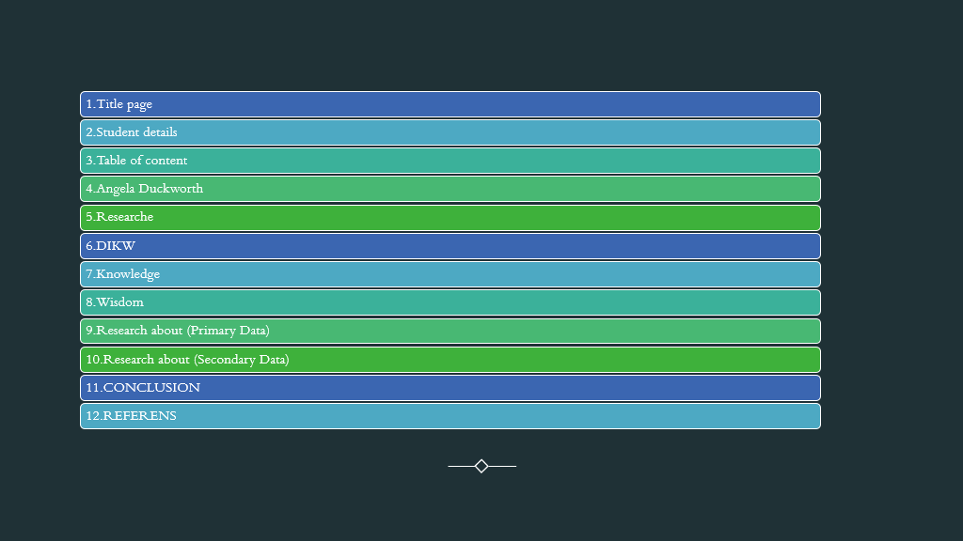

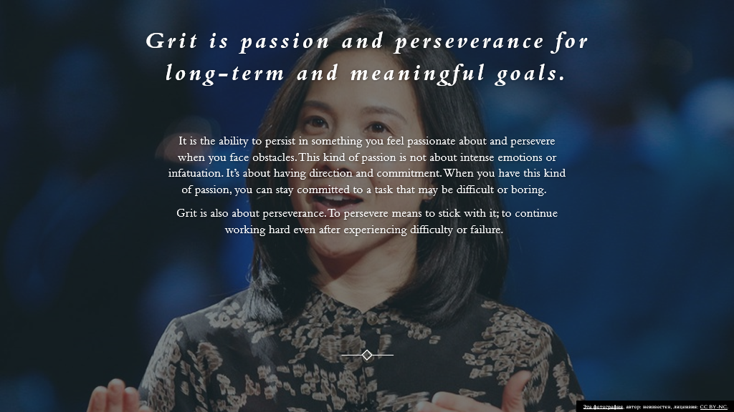

Angela Lee Duckworth graduated from Harvard University with a BA in Neuroscience and a Ph.D. in Psychology from the University of Pennsylvania. She won a MacArthur Foundation scholarship in 2013.At the age of 27, Angela decided to leave a rather difficult and responsible job in management consulting in order to switch to an even more difficult area - teaching. Duckworth began working in New York public schools.
Everything went according to a predetermined program. However, over time, Angela clearly realized that it is not only the IQ that distinguishes the successful and the lagging students. Those who performed better on assignments did not at all have exorbitant IQ levels. At the same time, some of the smartest schoolchildren could not master Duckworth's problems. After several years of teaching and observing, Angela was convinced that at the school desk, in addition to being able to quickly and easily learn, students need to have some other qualities. Not wanting to leave the research she had begin, Duckworth left school and went to graduate school to study psychology. She became interested in the study of the behavior of adults and children in various difficult situations. On a case-by-case basis, Duckworth tried to determine who was successful and how, and in the end, Duckworth came to a startling conclusion. The main component of success is not at all IQ level, not developed social skills, not external attractiveness and not health. Duckworth said the main key to success in all areas is strength of character. This trait implies passionate and persistent actions aimed at achieving even the most long-term goals.[WebSite].

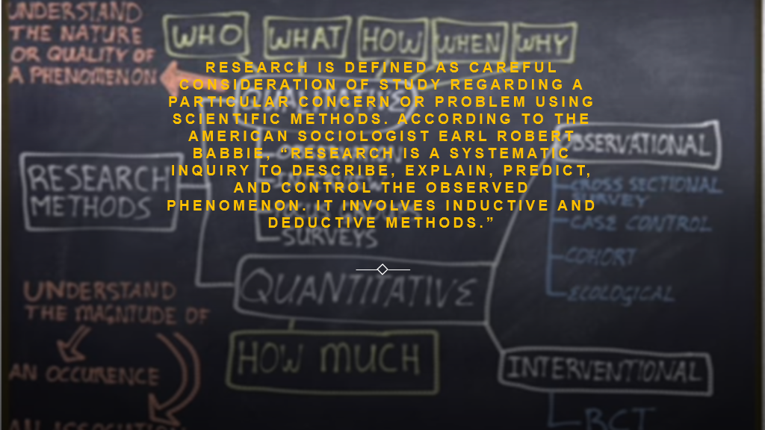

A well-defined research methodology guides your research in the correct direction, confirms your discoveries, and guarantee that the study you're completing answers the research questions.
The prime objective of this text is to explain what these different kinds of research methods contain and how to choose which option is suitable for you.
The practical, personal, and academic factors for selecting a specific research approach are also examined. Regardless of your field of study, our description of experimental, descriptive, historical, quantitative, qualitative, and mixed research methodologies will be useful.
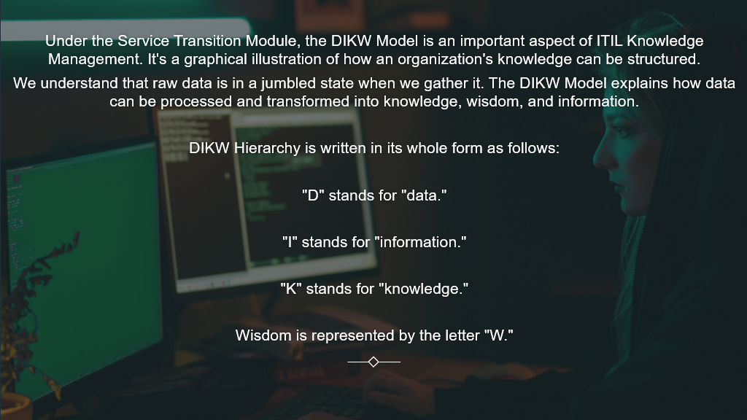

DIKW (data, information, knowledge, wisdom). It is not a technology, but a theoretical basis for understanding what steps must be taken to get value from the available data.
Even before the use of the model in knowledge management, its essence was expressed by the writer TS Eliot in the poem "The Rock", where he argues that information is not yet knowledge, and knowledge is not wisdom. With the onset of the information age, the amount of data began to grow rapidly. Quantitative and qualitative variables in a large volume open up great opportunities, but in themselves they are not valuable. To use them for your own purposes, you need to understand what to do with them.
The DIKW model is one of the possible, which helps to get something valuable out of the chaos of data. The wisdom gained from applying this model benefits organizations that provide IT services. Naked data says nothing about users, their behavior and interaction with services. Only after going through all the stages and reaching the top of the pyramid, you can use user data to create an innovative product that will be in demand.

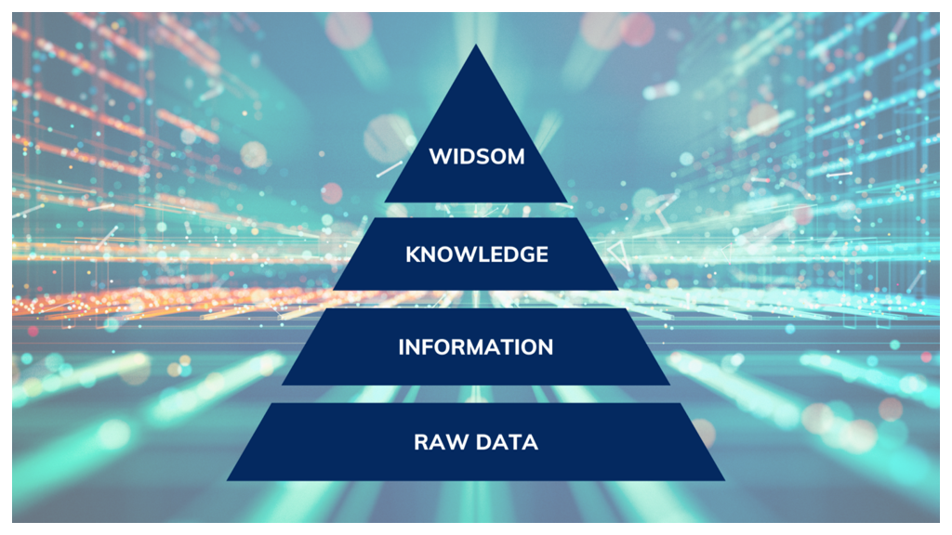
The DIKW pyramid, also known variously as the DIKW hierarchy, wisdom hierarchy, knowledge hierarchy, information hierarchy, information pyramid, and the data pyramid,^{[1]} refers loosely to a class of models^{[2]} for representing purported structural and/or functional relationships between data, information, knowledge, and wisdom. "Typically information is defined in terms of data, knowledge in terms of information, and wisdom in terms of knowledge".^{[1]}
Not all versions of the DIKW model reference all four components (earlier versions not including data, later versions omitting or downplaying wisdom), and some include additional components.^{[3]} In addition to a hierarchy and a pyramid, the DIKW model has also been characterized as a chain,^{[4][5]} as a framework,^{[6]} as a series of graphs,^{[7]} and as a continuum.^{[8]}



A theoretical or practical understanding of a subject is called to as "knowledge." This might be implicit (as in practical skill or ability) or explicit (as in theoretical subject understanding); formal or informal; systematic or individual. [1] In the Theaetetus, the philosopher Plato argued that knowledge and sincere belief are distinct, causing many to attribute to him a definition of knowledge as "justified true belief." [2] [3] For more than half a century, epistemologists have been debating the problems with this formulation presented by the Gettier dispute. [2]
A person's understanding of their own sensations, feelings, beliefs, and other mental processes is described to as "self-knowledge." [9] The nature of our acquaintance with ourselves has been the subject of extensive intellectual discussions, including whether self-knowledge differs from other types of knowledge, whether we have privileged self-knowledge over knowledge of other minds, and whether we have privileged self-knowledge over knowledge of other minds. [9] David Hume, as part of his overall scepticism personal identity, expressed doubts about whether we could ever attain self-knowledge beyond our immediate awareness of a "bundle of perceptions." [9]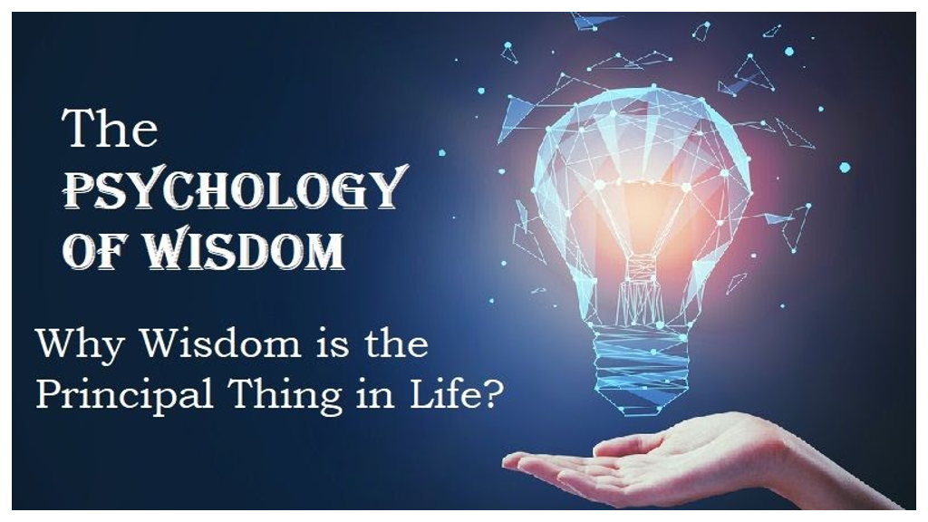

The [Wisdom is the DIKW Hierarchy's fourth and final phase]. It's a way for generalising knowledge to approximate the end result. It gathers data from all of the various levels of the DIKW Model and processes it using human coding skills (such as the moral, ethical codes, etc.).
Wisdom is the ultimate context and frame of reference; it is a state of awareness, a paradigm, or a combination of principles. Wisdom is the skill to use info to create rational decisions in a particular scenario without dependent on facts. Wisdom is knowing why something is the way it is, an objective understanding, acceptance, and acceptance of why something is the way it is, and it is seeing the overall picture. Knowing the appropriate things to do for the make more rational decisions is part of wisdom. It involves a feeling of right and wrong, ethical and unethical behaviour. It has a very human quality about it. [wisdom citation]

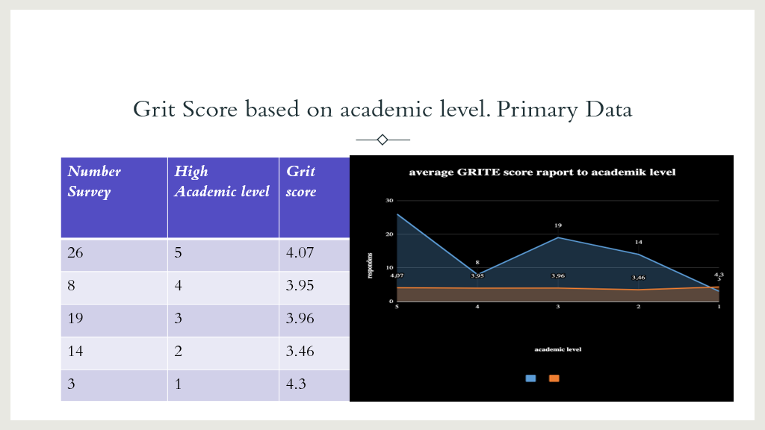

The total number of respondents in the above-mentioned class survey is 70, according to the survey. From the grafics we can see that 19 individuals have a highest academic level of 3 and average grite score is 3.96 evan when academic level became 4 grite score didn’t change to mach its 3.95. On another hands we have 26 participants, that work hard and achive level of 5. As a result of survey, the table and graph above provide reliable information about respondents' Grit scores. Its clear that academic level 5 show more perseverens in respondent live 3 grite score is 3.95 and the highest grite score is 4.07.

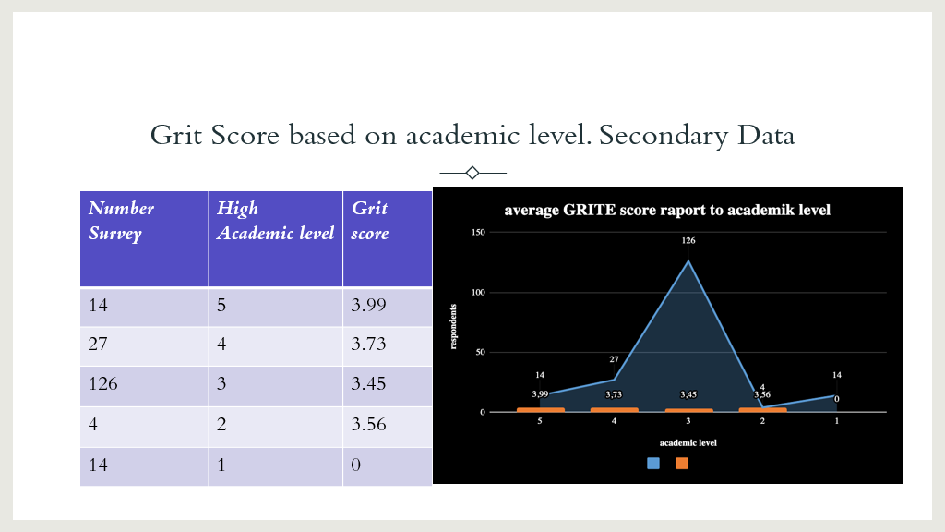

The grid score is extremely advantageous for determining a person's interest in and plan for achieving long-term goals.
The graphical representations that accompany this report show how grid score compare to other classes and how they are explained.
The above graph of academic advising grid generating that class responses are mostly focused on their interests and objectives, as well as their revolutionary digital skills. A high grid score indicates that a person is dedicated to attaining their objectives. The key reason for the students' outstanding achievement is their high level of skillsets.
The highest academic level of 123 respondents in the class survey is 3 with an average grite score 3.45. To compare ich academic level and participants grite score let see the graphics. How we can see major participants in quantity 123 have grite score 3.45 the next step of academic level is 4 and grite score is already 3.73 and the last and not most important academic level 5 with 14 participants have grite score 3.99.
This demonstrates that most students who work hard and have high grite scores can have at the end fantastic results and a good high academic level.
One is the highest academic level, and 4.8 is the grit score. The remaining 14 respondents, on the other hand, had a grit score of 4.8 and a top academic level of 5. They are all in the average category, showing a lack of excitement and commitment on the students' part in accomplishing personal and academic goals.

conclusion:

Angela Duckworth's work on "grit" has been widely accepted in recent years in public education circles as a worldview about how to provided adequate' "non-cognitive abilities," which seems to be essential for later in life success. Today, I'd like to show a better form of study, something that has practical implications for grit task education. And the reason for this is that concentrating on grit leads to a misleading context of human motivation; in the end, most people persist because they value the things they invest in, not because they are talented at persevering. The conclusion for schools is that they should focus less effort improving students' grit and more time thinking about how their programmes may help students feel confident and passion. Many of these schools appear to be most alive in their extra - curricular activities, like plays, musical performances, and student newspapers, where students could indeed connect to a real domain, where there are opportunities for repetition and exercise, but where it is linked to an adult world that students want to emulate and join. Students learn how to be historians, think like mathematicians, and work on real-world projects in the best disciplinary courses, but these are few and few between. There are two ways to look at this situation: 1) students in most modern classrooms need to boost their grit and perseverance; or 2) many classes need to be made more entertaining and engaging places with more authentic missions. While some may believe in the eat-your-broccoli approach to school reform, I believe that the school will be more effective and useful if they are places where students love to go.
While grit gets a lot of attention in school reform circles, it isn't the most popular motivation theory among psychologists. Edward Deci and Richard Ryan's "self-determination theory," which consolidated decades of research to say people are basically seeking autonomy, competence, and relatedness, and that they grow in these circumstances, is the most well-known scholarship on motivation. Trying to push grit is the easy way out. It helps us to avoid not only more uncomfortable talks about social inequalities, but also debating whether main aspects of schooling's "grammar" need to be changed. Young people show determination on a regular basis: they come back on the field after losses, comeback to the stage after flubbing their lines, and keep hunting for love after their hearts have been crushed. What these gatherings have in common is that they're all looking for something, hoping to achieve something. Our goal should be to structure education in a really way that students hold the same sense of purpose and meaning even when things get tough.

About Angela

https://angeladuckworth.com/
"knowledge: definition of knowledge in Oxford dictionary (American English) (US)". oxforddictionaries.com. Archived from the original on 14 July 2010.

"The Analysis of Knowledge". Stanford Encyclopedia of Philosophy. Retrieved 13 June 2020.

Fear of Knowledge: Against relativism and constructivism, Oxford: Clarendon Press, ISBN 978-0199230419, Chapter 7, pp. 95–101.

Wisdom reference https://www.systemsinnovation.io/post/dikw-pyramid

Wisdom is the fourth and the last step of the DIKW Hierarchy
https://www.certguidance.com/explaining-dikw-hierarchy/

Rowley, Jennifer (2007). "The wisdom hierarchy: representations of the DIKW hierarchy". Journal of Information and Communication Science. 33 (2): 163–180.

Zins, Chaim (22 January 2007). "Conceptual Approaches for Defining Data, Information, and Knowledge" (PDF). Journal of the American Society for Information Science and Technology. 58 (4): 479–493.

Baskarada, Sasa; Koronios, Andy (2013). "Data, Information, Knowledge, Wisdom (DIKW): A Semiotic Theoretical and Empirical Exploration of the Hierarchy and its Quality Dimension". Australasian Journal of Information Systems. 18: 5–24.

"Self-Knowledge". Stanford Encyclopedia of Philosophy. Retrieved 16 July 2020.

Zeleny, Milan (2005). Human Systems Management: Integrating Knowledge, Management and Systems. World Scientific. pp. 15–16.

