
DEVELOPING EMOTIONAL INTELLIGENCE SKILLS
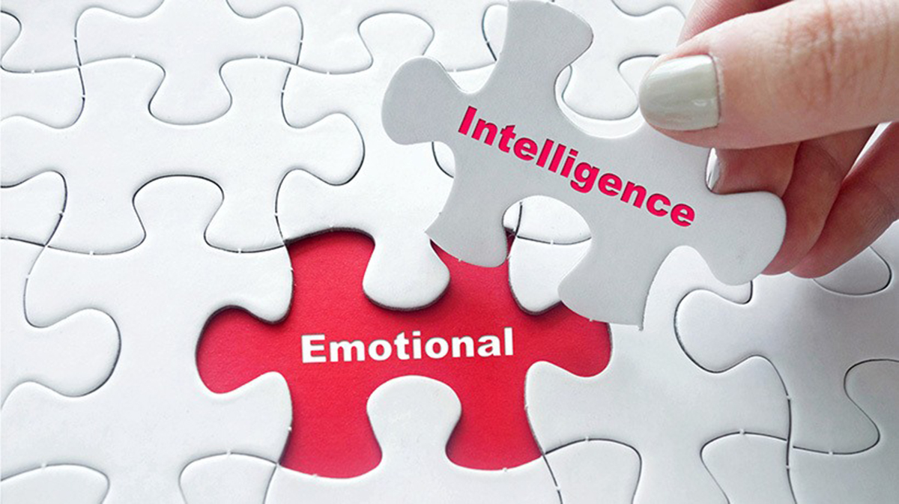
LECTURER: DR NASHI RAMSURRUN
STUDENT: CIPRIAN BANUC
ID: 2119748

Table of Contents
INTRODUCTION 2
I. CRITICAL EVALUATION OF HOW EMPLOYEES USE EMOTIONAL INTELLIGENCE COMPONENTS IN THE WORKPLACE 3
Relevant Emotional Intelligence Models 4
Goleman Theory 4
The Bar-On Model 5
Mayer-Salovey-Caruso Ability Model 6
The Trait EI Model 7
Mindfulness-Based Stress Reduction 8
II. UNIQUE EMMOTIONAL INTELLIGENCE CHARACTERISTICS MANAGERS SHOULD CONSIDER WHEN RECRUITING ACROSS GENERATIONS (Gen X, Y, Z) 8
Self-Awareness Across Generations 9
Self-regulation 10
Empathy 10
Social Skills 11
Motivation 11
III. CONCLUSION 12
IV. RECCOMENDATIONS 12
V. REFERENCES 14

INTRODUCTION
In today's companies, emotional intelligence (EI) has become recognised as a critical skill that affects teamwork, communication, leadership, and worker satisfaction. Numerous studies have demonstrated the importance of emotional intelligence in personal and professional success. The model put out by Peter Salovey and John Mayer (1990), who defined emotional intelligence (EI) as a pair of skills that includes the ability to deal with emotional information, is one of the first and most significant models created in the subject. The four characteristics of emotional intelligence that the researchers particularly defined are perception, utilisation, understanding, and emotion control (Gkintoni et al., 2016). Since then, a number of academics have developed different theoretical frameworks and expanded on emotional intelligence (Antonopoulou, 2024).
When investigating how employees identify, comprehend, and react to emotions to themselves and others, Goleman's Emotional Intelligence Framework which contains self-awareness, self-management, social awareness, and relationship management is especially important. These skills encourage better decision-making, improved teamwork, and less tension at work. Emotional Intelligence continues to be combined with mindfulness techniques like Mindfulness-Based Stress Reduction, which support workers in being more emotionally present and stabilised. EI and mindfulness work together to improve individual performance and develop a more positive workplace atmosphere.

CRITICAL EVALUATION OF HOW EMPLOYEES USE EMOTIONAL INTELLIGENCE COMPONENTS IN THE WORKPLACE
Employees use emotional intelligence in a variety of methods that have a direct impact on productivity, society, and attitude at work. Multiple theoretical frameworks, such as Goleman's EI Performance Framework, The Bar-On’s EI Competencies Model, the Mayer-Salovey-Caruso Ability Model, The Trait EI Model, and MBSR (Mindfulness-Based Stress Reduction), are used in this area to critically assess Emotional Intelligence.

Relevant Emotional Intelligence Models

Goleman Theory
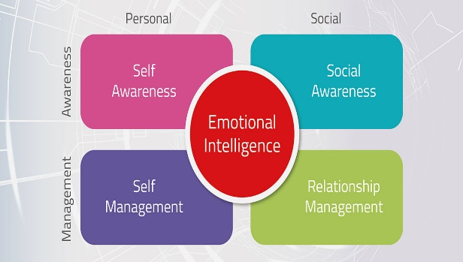
“Goleman’s concept develops EI above talents by including competences and leadership behaviours in all four areas: self-awareness, self-management, social awareness, and relationship management.
Self-awareness allows individuals to better understand how emotions impact perceptions, communication, and work performance. Strong self-awareness allows workers to identify tiredness, frustration, or insecurity before it affects their ability to make decisions (Fripp, 2023). Employees who lack self-awareness may accidentally project negative emotions onto others or fail to recognise the emotional consequences of their actions.
Employees with social awareness are better able to recognise the social and personal needs of other workers. Supportive staff members improve customer connections, encourage inclusivity, and modify communication methods. Poor interaction with customers, inappropriate managerial choices, and unsolved conflicts between employees are frequently the outcomes of a lack of empathy.
Self-management, according to NeuroLaunch (2024), is the ability to handle feelings and keep emotional self-control. Workers who demonstrate this ability maintain calmness under pressure, take a positive attitude to obstacles, and come back fast from losses. This is especially useful in organisations that are unstable or undergoing a lot of change. On the other hand, poor emotional control might manifest as impulsivity, rejection, or frustration actions that damage cooperation and trust.
Relationship management incorporates social efficiency with emotional intelligence. These skills are used by workers to collaborate, motivate, settle disputes, and create beneficial networks. no matter their position, employees with high EI frequently act as unofficial leaders. On the other hand, a lack of relationship management abilities may lead to fragmented work practices, ongoing conflicts, and problematic team dynamics.”

According to Goleman's framework, emotional intelligence (EI) is critical for management influence, organisational culture development, and personal administration.

The Bar-On Model
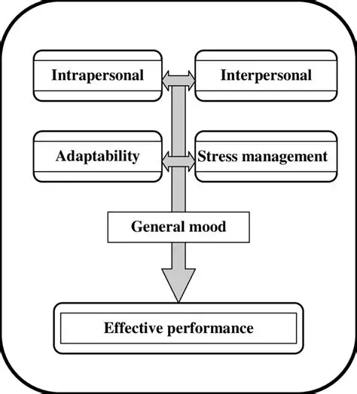
According to the Bar-On Model, emotional intelligence (EI) includes five components: intrapersonal abilities, interpersonal skills, adaptation, stress management, and general mood (Team, 2025).
“Intrapersonal talents facilitate emotional communication and confidence. Workers utilise these to communicate openly, create limits, and respectfully voice their worries. Poor intrapersonal skills are frequently manifested by indifferent conduct or denied feelings, which can lead to dissatisfaction and tiredness.
Interpersonal skills are essential for working in teams and collaborating. Employees who value confidence, understanding, and social responsibility have a greater ability to offer information, give help, and handle differences. High personal EI promotes work connections, while inadequate interpersonal ability leads to separation or miscommunication.
Adaptability helps people deal with workplace change by problem-solving and managing emotions. People that are emotionally adaptive accept changes in the organisation with interest instead of rejection. Hard feelings have been associated to lower mood and discomfort.
Stress management is crucial in extremely busy workplaces. Employees who can manage stress sustain performance and prevent emotional conflicts in team relationships. People who lack stress management skills are more likely to experience depression, disinterest, and emotional tiredness.
General mood, which represents optimism and determination, according to Iacono (2025), has a direct impact on working atmosphere. Positive emotions improve confidence and participation, but a bad attitude behaviours discourage teams and promote absence.”

Mayer-Salovey-Caruso Ability Model
According to the Mayer-Salovey model, emotional intelligence (EI) consists of four fundamental skills: Perceiving Emotions, Facilitating Thought Using Emotions, Understanding Emotions, and Managing Emotions (Team, 2025). This concept considers Emotional Intelligence as a collection of transferable thinking skills instead of behavioural characteristics.
“Perceiving emotions is the fundamental aspect of professional emotional intelligence. Staff are continuously understanding feelings that come from facial expressions, tone of voice, and written communications. Identifying emotions correctly enables employees to modify their reactions properly. For example, noticing worry in someone else may motivate encouraging communication, which improves collaboration. However, poor understanding, such as misunderstanding impartial emails as aggressive, can lead to unwanted conflict or defensive behaviour, proving the necessity of emotional perception abilities.
Depending on mental conditions to improve thinking and creativity is known as "using emotions to facilitate thinking." In reality, workers use their passion to push for activity, control their tension to stay focused on due dates, or use their emotional curiosity to stimulate creativity. With this skill, employees may see emotions as important sources of information that help set objectives compared to distracting factors. Workers who do not have this ability may completely control their feelings or experience emotional pressure, which affects their ability to solve problems (Laura K. Schenck, 2012).
EI
Understanding emotions requires changes and complexity is necessary for fully understanding feelings. Workers who possess this skill anticipate how people or groups will respond to criticism, organisational change, or discomfort from an excessive amount of work. This knowledge facilitates making emotionally informed decisions, such as scheduling delicate talks for times of calm rather than tension. Inadequate emotional intelligence can result in ineffective organisational communication that lowers participation or confidence.”
The most important EI skill is managing emotions, which means controlling the way one feels as well as assisting others in doing the same. Workers express this ability by rephrasing negative ideas, remaining calm in the face of provocations, and encouraging workers during disagreement. Productivity can be impacted by emotional expansion, which may be avoided with effective emotion management. In situations when this ability is missing, behaviours like violent emotions, resignation, or inactivity become more frequent, which contributes to team conflict and reduces emotional security (Laura K. Schenck, 2012).

The Trait EI Model

“Introduced by Petrides in 2001, trait emotional intelligence theory views emotional intelligence not as a simple mental capacity but also a collection of feelings, perspectives and emotional qualities that are part of an individual's character (Juan-Carlos Pérez-González, 2020). According to this theory, emotional intelligence (EI) shapes consistent behavioural habits in an assortment of contexts by reflecting how people generally interpret and handle emotions in daily life. Psychological confidence, flexibility, emotional control, social ability, empathy, independence, motivation, and wellness are examples of primary aspects.
Employees with high traits such as EI often show optimism, mental strength, and personal confidence at job. They easily participate in productive social relationships, manage stress more efficiently and keep optimistic attitudes in trying situations. Their emotional confidence improves teamwork stability, efficiency of communication, and leadership impact. For instance, these workers are more confident asking for help when they are stressed out or handling conflicts with solid confidence.
Employees who have reduced characteristics EI, on the other hand, might think of them as emotionally inefficient, resulting in a rejection of mental interactions, a lack of confidence in dealing with social challenges, and an increased sensitivity to workplace stress or anxiety. Trait EI, which is part of personality, appears stronger over time than competitive EI. However, emotional viewpoints may progressively improve via reflective practice, supervision, and mindfulness instruction (Hasan et al., 2023).”

Mindfulness-Based Stress Reduction
“Jon Kabat-Zinn created the Mindfulness-Based Stress Reduction (MBSR) approach, in 1970’s, which improves self-awareness, emotional regulation, attentional control, and empathy. The Mindfulness-Based Stress Relief encourages mindfulness activities such as meditation, breathing lessons, body examination, and paying attention in the moment in order to help people notice emotional trends without judging and respond appropriately instead of reacting inappropriately (Chiesa & Serretti, 2009).
Employees who use Mindfulness-Based Stress Reduction practices at work show increased emotional clarity and stress tolerance. Workers may avoid bad feelings by recognising emotional signals in real time. However, a critical review shows that the success of Mindfulness-Based Stress Reduction, is totally dependent on the organisational setting. Without systems that promote emotional discussion, coaching, and supportive leadership, mindfulness benefits may be limited to personal stress reduction instead of increased personal productivity. Employees might find themselves more organised in themselves, but they remain without the abilities needed to implement emotionally intelligent communication practices or relationship management tactics.”

UNIQUE EMMOTIONAL INTELLIGENCE CHARACTERISTICS MANAGERS SHOULD CONSIDER WHEN RECRUITING ACROSS GENERATIONS (Gen X, Y, Z)
“In today's changing work environment, managers are constantly employing from three key generations: Generation X (born between 1965 and 1980), Generation Y or Millennials (1981-1996), and Generation Z (1997-2012). Each generation has been influenced by different economic circumstances, technical settings, stories about culture, and educational opportunities. While technical skills are critical, emotional intelligence (EI) has become known as a key aspect in organisational success, impacting collaboration, leadership capacity, flexibility, and long-term engagement. When hiring across generations, managers must recognise that emotional intelligence does not look the same in every group. Instead, it frequently shows as different attitudes towards social skills, self- regulation, motivation, empathy, and self- awareness.
Recognising these generational variations enables managers to prevent judgements while recognising general patterns that might benefit recruiting decisions and workplace acceptance.
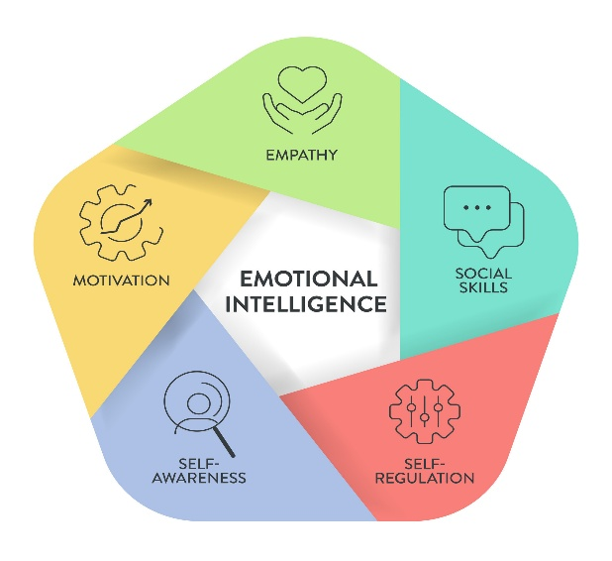
Source Image: (Vecteezy.com, 2024).

Self-Awareness Across Generations
“Self-awareness is the ability to comprehend a person's feelings, strengths, weaknesses, and influence on others which is a fundamental EI competence. Generation X's demand for freedom and private responsibility reflects their self-awareness. Many Gen X workers are used to managing their job on their own since they grew up in a less organised atmosphere. They have great independence and a practical awareness of their talents, and they often favour employment with clear performance goals and favourable evaluations. In interviews, they may prioritise dependability, direct communication, and personal responsibilities above collective dialogue (Lyons and Kuron,2014).
Millennials (Gen Y) have a strong sense of self-awareness that has been influenced by regular feedback through their educational experience and early careers. Many actively identify areas for improvement and professional goals, demonstrating their comfort with reflective discussions. Their EI may manifest as emotional sensitivity and connection with personal opinions. Employers may notice talks about goals, enthusiasm, and development possibilities. Millennials frequently want professions where emotional expression and self-improvement are encouraged and not discouraged.
Born in a time of social media and increased awareness of mental health problems, Generation Z frequently demonstrates effective emotional monitoring behaviours. They could have an excellent understanding of personal expression, stress management, and emotional limits. However, this can occasionally lead to careful self-expression during hiring procedures, as applicants hide their emotional weakness. Instead of being externally expressed, Gen Z self-awareness may be more reserved and reserved, which managers should acknowledge.”

Self-regulation
“Emotional management, or the capacity to control emotions under stress or conflict, vary significantly among generations due to occupational training and societal standards. Employees from Generation X are known for their strong emotional control. They are used to organisational structures where emotional expression is restricted. This frequently results in calm professionalism and consistent productivity under stress, but it can also minimise emotional excess or depression. Recruiters should examine stress tolerance while also investigating if applicants value emotional openness or prefer emotional repression.
In general, millennials seem more relaxed about expressing stress and promoting balance between work and life. They could talk honestly about tiredness and look for settings that promote wellness and adaptability. For this age, controlling emotions is more about cooperative solving issues and interacting than strong tolerance. Emotional availability frequently indicates great emotional intelligence and capacity to speak up; therefore, interviewers should avoid misunderstanding as emotional weakness.
Generation Z candidates have developed in a psychologically healthy language that recognises emotional well-being as crucial opposed to superficial. Their emotional management focusses on creating limitations, such as reducing excessive workloads or establishing regular timetables. While older generations may view this as a limited tolerance for stress, it really demonstrates mental strength in recognising sustainable production limitations (Engel, 2024).

Empathy
Management and collaboration depend heavily on empathy, which is the capacity to identify and react to the emotions of others. Professionals from Generation X usually demonstrate practical empathy; instead of expressing their emotions directly, they show concern by addressing problems. For example, providing support or teaching might take the place of vocal affirmation. Recruiters should be aware that this generation might have behavioural more than vocal empathy.
Generally speaking, millennials show greater expressive empathy. They prefer to use inclusive vocabulary to acknowledge colleagues' perspectives and provide emotional support. Group mentorship and teamwork are frequently facilitated by their comfort with emotional communication. This generation may demonstrate empathy in interviews by sharing stories regarding legislation, leadership growth, and partnership.”
“High concern to diversity, mental health awareness, and equality concerns is demonstrated by Generation Z. At the social level, many people have a great deal of empathy, showing concern for the good of the community and moral responsibility. However, some Gen Z candidates may find it difficult to communicate emotionally in person—not because they lack empathy, but rather because they have less verbal confidence from their initial internet contacts (Talent, 2024).

Social Skills
Because efficient communication differs from age to generation, it is a clear sign of emotional intelligence. Generally speaking, Gen X candidates prefer direct and clear engagement. Their social skills highlight precision and transparency, which might be helpful for leadership positions that need for determination.
Millennials frequently appreciate regular, cooperative communication that offers chances for criticism and discussion. Emotional transparency and interaction style flexibility are examples of their emotional intelligence. Instead, then confusing conversational excitement for oversharing, employers should evaluate how well Millennials handle feelings in group discussions.
The use of technology is reflected in Gen Z's communication style, which is comfortable with emoticons, multimedia expressiveness, and brief written interactions. While many people show high emotional intelligence online, face-to-face emotional communication may initially be less secure. Gen Z's real interpersonal skills may be undervalued by hiring procedures that place too much value on traditional interview performance (Lancioni, 2025).

Motivation
According to Team, (2025), motivation has a direct connection to emotional intelligence, which explains how people connect their emotions with their goals. Stability, competency skill, and specific acknowledgement are frequently motivating factors for Generation X employees. Their emotional fulfilment depends on independence and outcomes-driven success.
Millennials are motivated by their emotions and values. They look for jobs that reflect their own values, have a positive influence on society, and provide professional satisfaction. Appreciation, supervision, and participation have a big effect on their emotional involvement.”
Credibility and safety are major motivations for Generation Z. In a very unstable economic situation, people prioritise job security and mental security while going after identity
expression and improvement of skills. Their emotional durability is directly related to whether organisational cultures are open and helpful.

CONCLUSION
“In conclusion a fundamental skill that promotes worker productivity, teamwork, leadership excellence, and organisational well-being is emotional intelligence. When the Mayer–Salovey, Goleman, Bar-On, Trait EI, and MBSR frameworks are critically examined, it becomes clear that a mix of emotional capacity, social competences, personality characteristics, behavioural skills, and reflective awareness of emotions leads to workplace EI. Through understanding communication, stress management, conflict resolution, adaptive leadership, and emotionally responsible decision-making, employees use these talents during everyday activities.
Managers can hire for emotional balance instead of emotional equality by acknowledging generational emotional variation. Organisations create inclusive emotional environments that tolerate change while maintaining productivity and involvement by appreciating the emotional durability of Generation X, the relational capabilities of Millennials, and the authenticity of Generation Z.”

RECCOMENDATIONS
“In order to improve recruitment and retention companies should:
- Implement meditation-based wellness initiatives, such mindfulness-based stress reduction training, to improve staff adaptability and emotional control.
- Create multilingual coaching programs to encourage generations to share EI skills and minimise communication gaps.
- Incorporate emotional interviews that are in line with Goleman and Mayer-Salovey skills and, when necessary, emotional intelligence assessments into hiring procedures.
- Give management instruction that is in line with EI models, encouraging ethical decision-making, empathy-based leadership, and emotional self-regulation.
- Develop continuous EI learning cultures that include emotional security, mentoring, and reflective learning to stimulate progress based on emotions.”
By putting these strategies into practice, companies create emotionally intelligent employees that are flexible, motivated, mentally sound, and able to maintain high performance in changing work contexts. Successful cooperation, teamwork, and leadership now depend on emotional intelligence and mindfulness. Employees with emotional intelligence are better able to handle difficulties, establish connections with others, and favourably impact company culture.

REFERENCES
“Salovey, P., & Mayer, J. D. (1990). Emotional intelligence. Imagination, cognition and personality, 9(3), 185-211. https://doi.org/10.2190/DUGG-P24E-52WK-6CDG
Gkintoni, E., Halkiopoulos, C., Antonopoulou, H., & Togias, P. (2016). Emotional intelligence in social network consumers. SSRN Journal. https://doi.org/10.2139/ssrn.4312266
Antonopoulou, Hera. (2024). The Value of Emotional Intelligence: Self-Awareness, Self-Regulation, Motivation, and Empathy as Key Components. Technium Education and Humanities. 8. 78-92. 10.47577/teh.v8i.9719.
Fripp, G., (2023). Goleman’s Emotional Intelligence Framework‍- Organizational Behaviour. [Online] Available at: https://www.myorganisationalbehaviour.com/golemans-emotional-intelligence-framework/ [Accessed 10 December 2025].
Image: Disruptive Leadership Institute. (n.d.). Disruptive Leadership Institute. https://www.disruptiveleadership.institute/goleman_emotional_social_intelligence/ .
Team, F. C., (2025). Bar-On Model- Cognitive Psychology Key Term. [Online]
Available at: https://fiveable.me/key-terms/cognitive-psychology/bar-on-model
[Accessed 03 December 2025].
Iacono, D. V. L., (2025). 6 Strategies to Apply Bar-On’s EI Model in the Workplace for Success. [Online] Available at: Team, F. C., 2025. Bar-On Model- Cognitive Psychology Key Term. [Online] [Accessed 03 December 2025].
Team, N. E., (2025). Salovey and Mayer Emotional Intelligence: Exploring the Pioneering Ability Model. [Online] Available at: https://neurolaunch.com/salovey-and-mayer-emotional-intelligence/ [Accessed 28 November 2025].
Laura K. Schenck, P. L., (2012). What is Ability Emotional Intelligence? [Online] Available at: https://mindfulnessmuse.com/emotional-intelligence/what-is-ability-emotional-intelligence [Accessed 16 November 2025].”
“Juan-Carlos Pérez-González, D. H. S. S. M., (2020). Editorial: Trait Emotional Intelligence: Foundations, Assessment, and Education. [Online]
Available at: https://pmc.ncbi.nlm.nih.gov/articles/PMC7180316/
[Accessed 04 December 2025].
Hasan, N.N., Petrides, K.V., Hull, L. & Hadi, F. (2023) ‘Trait emotional intelligence profiles of professionals in Kuwait’, Frontiers in Psychology. Available at: https://www.frontiersin.org/articles/10.3389/fpsyg.2023.1051558/full. [Accessed 03 December 2025].
Chiesa, A., & Serretti, A. (2009). Mindfulness-based stress reduction for psychiatric disorders: A systematic review. Psychological Medicine, 39(4), 593-600. Available at: https://transpersonal-psychology.iresearchnet.com/mindfulness-and-contemplative-practices/mindfulness-based-stress-reduction-mbsr/.
IMAGE: Vecteezy.com, (2024). Emotional Intelligence, Framework, diagram. [Online]
Available at: https://www.bing.com/images/search?view=detailV2&ccid=jAiDprBw&id=FB1E4722392D408A2907E8A3497A338324E8B7AC&thid=OIP.jAiDprBw0vjdulVFG8YpIQHaHa&mediaurl=https%3A%2F%2Fstatic.vecteezy.com%2Fsystem%2Fresources%2Fpreviews%2F038%2F107%2F888%2Foriginal%2Femotio [Accessed 16 December 2025].
Lyons, S.T. and Kuron, L.K.J. (2014) ‘Generational differences in the workplace: A review of the evidence and directions for future research’, Journal of Organizational Behavior, 35(S1), pp. S139–S157.
Engel, H., (2024). Building a high-performing multigenerational workforce with emotional intelligence. [Online] Available at: https://www.lepaya.com/blog/build-a-high-performing-multigenerational-workforce [Accessed 16 December 2025]."
Talent, T., (2024). The Empathy Revolution: Navigating Gen Z Emotions in the Workplace. [Online] Available at: https://talking-talent.com/insights/latest-thinking/the-empathy-revolution-navigating-gen-z-emotions-in-the-workplace/?utm_source=chatgpt.com [Accessed 16 December 2025].
"Lancioni, K., (2025). Talking Across Time: How Generational Communication Styles Shape—And Challenge—The Modern Workplace. [Online] Available at: https://www.forbes.com/councils/forbescoachescouncil/2025/06/05/talking-across-time-how-generational-communication-styles-shape-and-challenge-the-modern-workplace/ [Accessed 17 December 2025].
Team, R. C., (2025). How Motivation and Emotional Intelligence Work Together. [Online] Available at: https://www.joinreframeapp.com/blog-post/what-is-emotional-intelligence-and-why-is-it-important [Accessed 17 December 2025]."

