

Strategic Management Analysis of BP plc: Evaluating Competitive Position in the Global Energy Industry

Master of Business Administration (MBA)
Module: Strategic Management (LCMB7003)
Assessment: Individual Report – British Petroleum

Student’s Name: Md Faysal Mia
Student’s ID: 2434754
Lecturer's Name: Dr Hoang Nguyen
Word Count: 5355

AI Acknowledgement

I acknowledge the use of ChatGPT (https://chatgpt.com/) on 02 April 2026 to write my
notes into submission format using the prompt(s):
- Please give me recent statistical data about BP at the university level.

I acknowledge the use of Grammarly (https://www.grammarly.com/) on 26 April
2026 to check my work using the prompt(s):
1. Please check the following text for readability, grammar and syntax.

I confirm that I have not presented any AI-generated text as my own work. I confirm I
have copies of my drafts, notes, and other resources I used before and after the use of
AI tools which I may be asked to provide in evidence.

Table of Contents
AI Acknowledgement 1
Section 1 – Strategic Analysis of BP plc 4
1. Introduction 4
2. Organisational Context and Company Overview 4
2.1 Background of BP plc 4
2.2 Vision, Mission and Strategic Direction 4
2.3 Business Model 5
2.4 Industry Context 6
3. External and Internal Environment Analysis 6
3.1 External Environment Analysis (PESTEL) 6
3.2 Critical Success Factors and Strategic Challenges 9
3.3 Internal Environment Analysis Using Value Chain 10
3.5 Internal Strengths and Competitive Advantage 12
4. CSR and Sustainability Strategy 13
5. Balanced Scorecard Analysis 14
5.1 Financial Perspective 14
5.2 Customer Perspective 15
5.3 Internal Process Perspective 16
5.4 Learning and Growth Perspective 16
6. Strategic Choices and Implementation 17
6.1 Business-Level Strategy: Cost Leadership 17
6.2 Corporate-Level Strategy: International Expansion 17
6.3 Recommended Strategy: Cost Leadership Focus 18
6.4 Change Management and Strategic Implementation 18
7. Strategic Evaluation and Recommendations 19
7.1 BCG Matrix 19
7.2 Critical Evaluation of Current Strategy 20
7.3 Strategic Recommendations 20
Section 2 - Reflective Account 21
Concrete Experience 22
Reflective Observation 22
Evaluation 23
Abstract Conceptualisation 24
Active Experimentation 24
Conclusion 25
Reference 26

Section 1 – Strategic Analysis of BP plc

1. Introduction
Strategic management helps organisations to make long-term decisions which determine competitive advantage and organisational performance. Evaluating the external environmental pressures and internal organisational capabilities is important to understanding how firms maintain a position of remaining competitive in complex industries. BP plc is a large UK-based multinational energy company in a rapidly changing world energy market. This report uses the analysis methods of PESTEL analysis, value chain framework, VRIO, Balanced Scorecard and BCG Matrix. These frameworks are applied in a critical light to discuss how BP is tweaking its strategy in response to industry change, specifically, the global shift to lower carbon energy systems.

2. Organisational Context and Company Overview

2.1 Background of BP plc
BP plc is a multinational energy company which was created in 1909 and is headquartered in London, United Kingdom. Over a period of over one hundred years, the organisation has evolved from a regional oil producer to a global energy corporation. BP currently operates in more than 70 countries with an employed workforce of around 90,000 people worldwide (BP, 2025). The company plays an important role in the global energy supply through its activities in exploration, production and fuel distribution. Given the extent of BP's generation of international revenue, BP reported revenues in excess of $200 billion in 2023 (BP plc, 2026). Its historical growth has been aided by technological capability, large-scale infrastructure and long-term investment in energy production and distribution networks across multiple markets around the world.

2.2 Vision, Mission and Strategic Direction
BP's strategic direction is evidence of a major overhaul in the face of global climate pressures as well as regulatory change. BP's mission is to deliver energy to the world, today and tomorrow, while acting on sustainability. BP's vision is to transition away from being solely an oil-focused company to become an integrated energy company, focusing on: net zero ambition, transformation and lower-carbon solutions. BP is committed to emission net zero by 2050 (BP plc, 2026). This goal is associated with large-scale investment in alternative energy sources (for example, wind, solar and hydrogen). The strategy is also driven by growing environmental legislation and growing societal demand for environmentally friendly energy sources (Edser, 2026). BP's shift towards low-carbon energy is an attempt to successfully marry its business needs for future security in a rapidly changing energy environment that requires sustainable energy consumption and carbon mitigation.

2.3 Business Model
BP's business model is geared towards creating value through energy production on a large scale, infrastructure and global distribution systems.
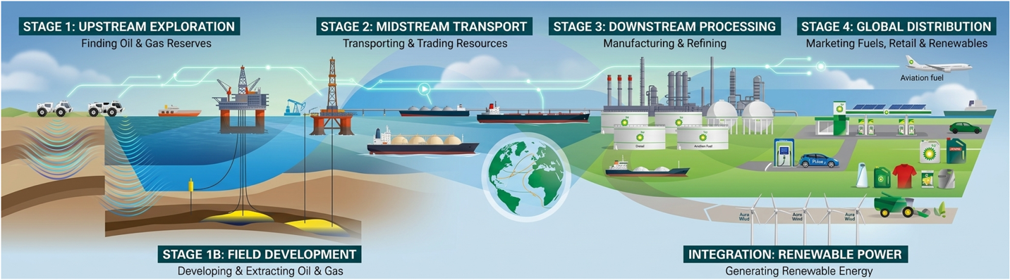
Figure 1: BP's Business Model
Source: (BP, 2025)
It has established three primary lines of business, upstream oil exploration, refining and marketing and is increasingly committed to new energy sources. Such business is underpinned by expert knowledge of exploration and trade routes. BP also has one of the largest energy trading operations in the world which enables it to manage fluctuations and changes in price (BP, 2025) . By undertaking the above activities the company aims to combine its conventional energy business and opportunities in the low-carbon energy markets.

2.4 Industry Context
BP plays in the very competitive world energy business. Major rivals include Shell, ExxonMobil, Chevron and TotalEnergies. The sector is characterised by high levels of capital investment, technological complexity and high levels of regulatory oversight. Energy prices are also subject to a lot of volatility and are based on geopolitical developments, global demand and production levels. At the same time, environmental regulation is getting more stringent, with carbon reduction targets being implemented by governments (Edser, 2026). These pressures are providing the impetus for the transition to renewable energy systems. For BP, long-term competitiveness has come to depend increasingly on being able to strike a successful balancing act between traditional energy production and investment in sustainable energy solutions.

3. External and Internal Environment Analysis

3.1 External Environment Analysis (PESTEL)
Strategic decisions are business objectives and mission statements, as well as marketing and customer-service strategies. Therefore, they are long-term kinds of decisions made over one or more years (Hashmi, Khan and Ajmal, 2020). A PESTEL analysis is an acronym for a tool used to identify the macro (external) forces facing an organisation. The letters stand for Political, Economic, Social, Technological, Environmental and Legal (Hashmi, Khan and Ajmal, 2020).
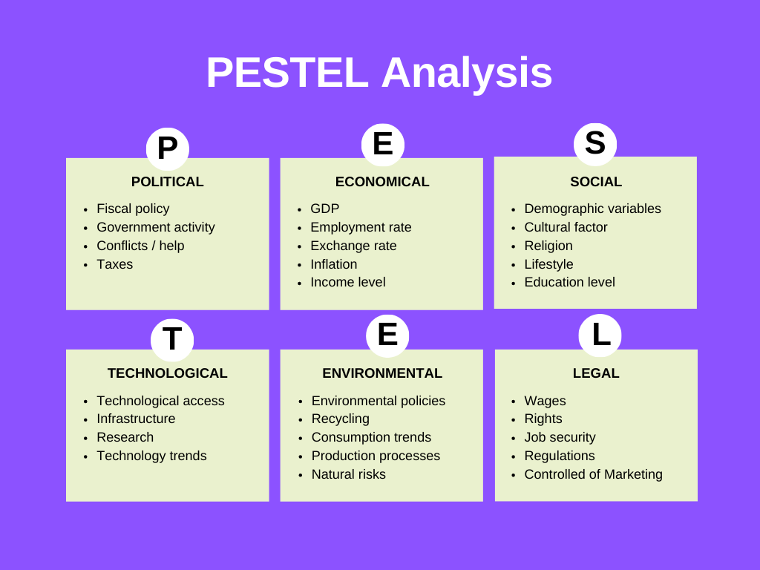
Figure 2: PESTEL Analysis
Source: (Bulgakov and Makarenko, 2022)
Political Factors
Oil upstream operations by BP are very sensitive to the political environment in resource-rich countries in the Middle East, Africa and Russia. Governments control access to oil resources through licensing, taxation and production-sharing contracts. For example, over 70% of global oil reserves are owned by nation states, making it difficult for multinational players to develop their oil businesses (Reuters, 2026). Geopolitical risks (including the conflict in Ukraine and geopolitical tensions in the Middle East) also impact oil markets. These interactions impact BP's investment approaches to diversify and manage risks. So BP invests in stable political environments, or forms joint ventures with government oil companies, to avoid political risks. However, investment in politically sensitive regions exposes uncertainties for petroleum upstream investments.
Economic Factors
The upstream industry is significantly influenced by oil prices. Oil prices in 2024-2025 have fluctuated between $70 and $95 per barrel (Brent crude), impacting BP's profits and investments between less than $40 to more than $100 a barrel in short periods of time. Capital expenditure on wells and drilling begins when prices are high, but is pushed back when prices are low. Increases in costs (inflation and interest rates) also impact investment in offshore wells and offshore facilities. Further, a weak global economy or recession negatively affects the energy demand and supply (Tharuniyaa Lakshmi, 2026). Therefore, BP requires a flexible investment approach, which combines a responsiveness to short term return to a policy of exploitation. And so financial and production planning resources are important.
Social Factors
Climate change concerns are driving a social transformation in the upstream industry. There is a shift away from fossil fuels as society looks for cleaner energy sources - more than 70% of investors factor environmental, social and governance (ESG) criteria in their investment. This leaves fossil fuel producers exposed to reputational damages (Bulgakov and Makarenko, 2022). This places pressure on BP to consider its upstream operations, such as greenhouse emissions and destruction of the natural environment. BP still has a strong demand for its product, but pressure from the public is forcing BP to be more transparent and less disruptive. This challenges BP: how to continue operating to generate profits while meeting social pressures for sustainability.
Technological Factors
Competition is won through technology. Seismic exploration, artificial intelligence (AI) and smart drilling technologies have improved prospects and reduced costs. Digital technologies have been pivotal for BP to enhance reservoir management and production. For instance, analytics can enhance recovery of oil by 10-15% (Hashmi, Khan and Ajmal, 2020). But with technology investment comes an increase in the bar across the oil value chain; the only solution is to continue investing. This can create an incentive for BP to continually invest in new technologies, albeit with high up-front costs.
Environmental Factors
Environmental regulation limits oil production. Emissions restraints are also coming into place in line with global climate change commitments. Oil account for 40% of global emissions and so is a target of these regulations (Bulgakov and Makarenko, 2022). BP will be impacted by increasing costs associated with carbon prices, environmental standards and sustainability initiatives. Secondly, it can face losses from environmental spillovers such as oil spills. Therefore, BP should include environmental concerns in its upstream approach, balancing efficiency and sustainability.
Legal Factors
Upstream is increasingly regulated. There are increasing safety, environmental and GHG emissions standards. For example, offshore exploration is subject to strict international standards and can also require large capital investment (billions of dollars) (Bulgakov and Makarenko, 2022). Also, if there is litigation or liability, particularly following an environmental incident, this will also affect costs. Thus, BP must have cost-effective and compliant operations. This regulatory aspect highlights the need for governance and risk mitigation strategies in upstream activities.

3.2 Critical Success Factors and Strategic Challenges
In our external analysis, we list a number of critical success factors for BP's upstream operations. First, control of reservoirs is critical, with long-term production rights based on strong reservoir control. Second, technology is critical to improve recovery and exploration, particularly in difficult circumstances such as deepwater wells (Hashmi, Khan and Ajmal, 2020). Third, cost control is essential to success, with success dependent on high operating and capital costs. Fourth, geopolitical risk management is important because of the political and regulatory risks faced by markets.
But BP has strategic problems. The biggest are the long-term changes in fossil fuel use due to decarbonisation programs. The upstream sector is threatened by increasing regulations and carbon costs (Bulgakov and Makarenko, 2022). Volatile oil prices also hit investments, creating uncertainty. Social and cultural concerns and investor calls for sustainability are also complicating factors. These all effectively force BP to periodically revalue its upstream strategy, in response to short-term financial objectives as well as long-term environmental and regulatory constraints.

3.3 Internal Environment Analysis Using Value Chain
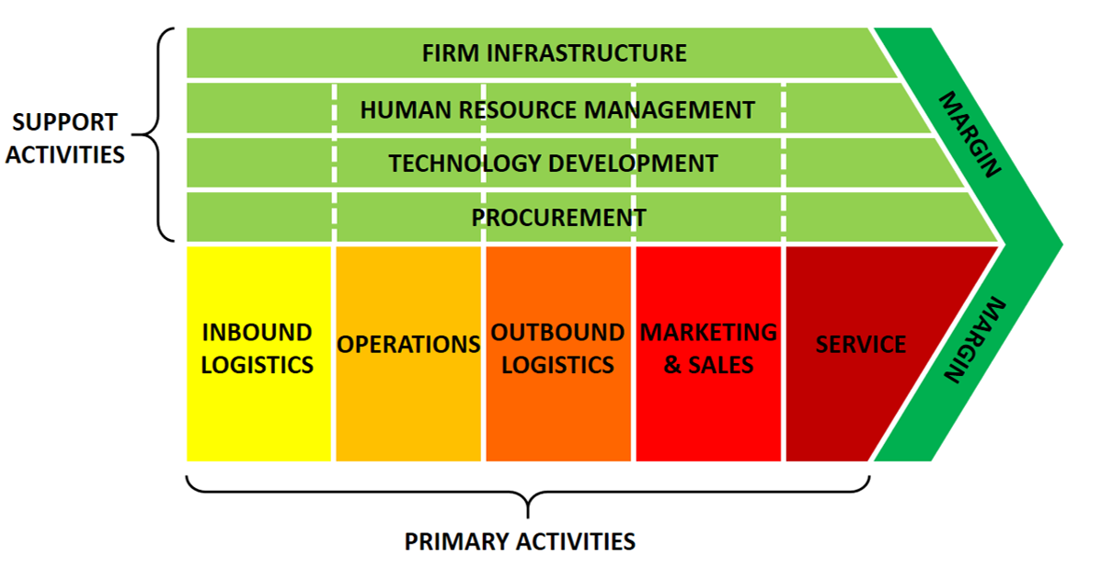
Figure 3: Value Chain Framework
Source: (Antràs and Chor, 2022)
Exploration: BP's upstream value chain is built up of several activities that create a competitive advantage. The key activities include exploration in which BP uses advanced geological mapping and seismic technologies to identify potential oil reserves (Önören, Arar and Yurdakul, 2017). This is a key activity as it creates opportunities for production. BP's experience and technical expertise enable it to be more successful at identifying reserves (Antràs and Chor, 2022).
Drilling and Production: The second activity is exploration and production, which is both costly and technologically intensive (Silvestre et al., 2018). BP uses advanced offshore and onshore drilling and production platforms staffed with skilled engineers. Exploration during this phase impacts production and profits. BP's large project management capabilities boost its efficiency (Antràs and Chor, 2022).
Transportation: Next is the transportation phase, where the crude oil is extracted and prepared for transport. BP has high-capacity plants and constant production. This ensures production costs are minimised and high profit margins, particularly during low prices. An essential component of the value chain is logistics (Önören, Arar and Yurdakul, 2017). BP uses pipelines, vessels and storage to transport crude oil. Logistics are crucial for availability and reach.
Support Activities: Support activities (R&D, procurement and human resource management) add to the value of BP's value chain (Silvestre et al., 2018). Innovation and development enhance the skills base, and human resource management achieves economies of operation.
BP's value chain is important to managing upstream activities. These technologies, scale and logistics are crucial to developments in the upstream petroleum industry.

3.4 VRIO Analysis of Strategic Capabilities
The VRIO framework evaluates BP’s key resources and capabilities in determining sustainable competitive advantage.
Resource/Capability | Valuable | Rare | Imitable | Organised | Competitive Implication
Global oil reserves | Yes | Yes | Yes (costly) | Yes | Sustained advantage
Advanced drilling technology | Yes | Moderately | Difficult | Yes | Temporary advantage
Integrated supply chain | Yes | Yes | Difficult | Yes | Sustained advantage
Industry expertise and experience | Yes | Yes | Difficult | Yes | Sustained advantage
Financial resources | Yes | No | Easy | Yes | Competitive parity

BP has valuable and rare global reserves of oil as a source of sustainability. Reserves can be purchased but are costly and heavily regulated, making them difficult to imitate and a source of sustainable advantage. BP has clever drilling systems which make the process more efficient and lower costs, but they are easy to copy, giving a temporary advantage. BP's supply chain is very effective as a means to integrate the exploration, production and distribution processes (Silvestre et al., 2018). This is difficult to replicate due to the complexities, providing a competitive advantage. In addition, BP's technical expertise, learned over many years, enables it to make and execute decisions and projects in a harsh environment. BP has the financial capability to undertake large projects, but this is common among all the large oil companies. So this results in competitive parity rather than competitive advantage (Silvestre et al., 2018). Ultimately, we've found through the VRIO analysis that BP's competitive advantage primarily resides in its reserves, supply chain and knowledge.

3.5 Internal Strengths and Competitive Advantage
BP's strength has positioned the company to obtain a competitive advantage in the upstream oil industry. BP's large oil reserves give it a safe and secure production, and allow it to secure a consistent flow of revenue. This, in turn, helps to maintain its market presence and secure demand. BP also excels in technology (Bergh et al., 2016). BP can build on further technology developments in exploration and production to enhance productivity and lower costs. This allows BP to participate in exploration and production activities in a hostile environment, such as offshore and deepwater production.
Furthermore, BP's integrated supply chain also aids in its competitiveness, by optimising the extraction, production and supply of fuel products. This enhances efficiency and agility. BP's expertise is also a critical attribute in its strategy and execution (A. Kassem, Khoiry and Hamzah, 2020). BP's expertise in global oil markets and regulation will allow for good management, but whilst these characteristics offer a competitive advantage, they are challenged by external drivers such as regulatory and renewable energy (RE) drivers. So, BP will be assessed on how it can capitalise on these attributes and respond to a shifting landscape.

4. CSR and Sustainability Strategy
Strategic Commitment to Sustainability: Corporate social responsibility is a strategic issue in the global energy industry that has been central to the companies. BP is increasingly lobbied by both its governments, investors and society to reduce its environmental impact and contribute to the global shift towards cleaner energy systems. In response, the company has added sustainability goals to its long-term corporate strategy (A. Kassem, Khoiry and Hamzah, 2020). BP has said it will aim to become zero carbon by 2050. This is a rising target of international efforts to reduce global temperature rises and minimise greenhouse gas emissions. The company has also recognised the fact that environmental responsibility is no longer a matter of reputation, but of strategic requirements for maintaining long-term competitiveness.
Key Sustainability Initiatives: BP has put forward a number of initiatives to help its sustainability goals. One of the major focuses is on the reduction of operational carbon emissions through production and refining activities. The company has set itself targets to reduce emissions from its operations while improving the energy efficiency of its facilities (Wan Ahmad et al., 2016). BP has also increased investment in renewable energy projects such as offshore wind and solar power. The company has a goal to build renewable generation capacity at the rate of roughly 50 gigawatts by 2030. In addition, environmental responsibility programmes include issues such as protection of biodiversity, responsible resource management and reducing environmental risk. These initiatives are undertaken to ensure good environmental performance while ensuring energy security.
Strategic Importance of Sustainability: From a strategic perspective, sustainability initiatives are now a consideration in investor confidence, regulatory approval and corporate reputation. Energy companies that fail to comply with environmental issues risk increasing regulations and loss of the public's trust. Integrating sustainability into corporate strategy, therefore, helps BP to manage long-term risks arising from climate change and environmental regulation (Akhtar and Sushil, 2018). At the same time, renewable investments provide the company with the chance to participate in the development of the clean energy markets. Consequently, sustainability has become a strategic mechanism in order to remain competitive in the context of an energy industry in a state of structural transformation.

5. Balanced Scorecard Analysis
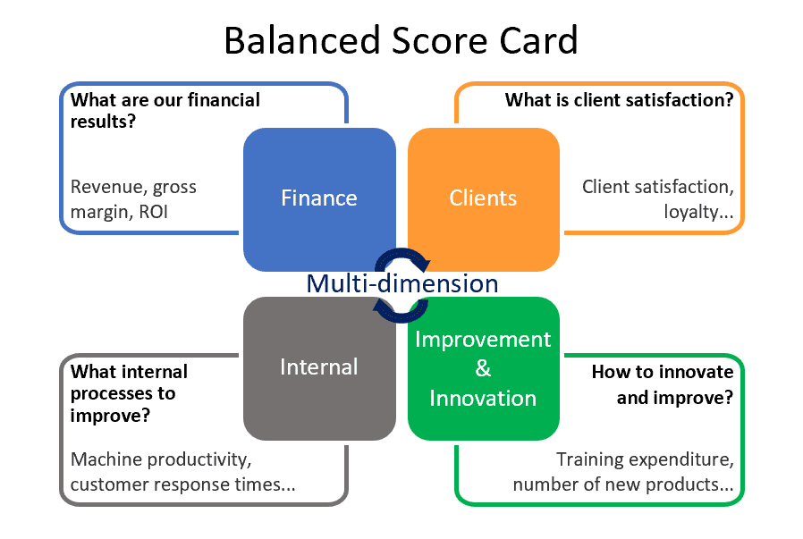
Figure 4: Balanced Scorecard
Source: (Zakaria, Nawawi and Salin, 2016)

5.1 Financial Perspective
Objective: Maximise profitability from upstream oil operations.
KPI: Upstream profit, production volume, unit production cost, return on capital employed. (Reuters, 2026)
Target: Maintain production at 2.3–2.5 million boe/day by 2030. (Reuters, 2026)
Initiative: Invest in high-margin projects and optimise cost efficiency in upstream operations. (Reuters, 2026)
The financial perspective measures the effectiveness of BP's creation of economic value amid the financial risk of the energy industry. BP has been reporting revenues over $200 billion in recent years, and it demonstrates its powerful presence in the global energy market. However, the profitability is very much affected by the ups and downs in the oil prices. Strategic investments in renewable energy require a lot of capital expenditure also (Al-Mana et al., 2020). BP has plans for spending billions of dollars on low-carbon energy technologies by the end of this decade. From a strategic point of view, financial performance is thus a balance between the short-term benefits from burning fossil fuels and investment in longer-term cleaner energy systems.

5.2 Customer Perspective
Objective: Ensure reliable crude oil supply to key stakeholders.
KPI: Supply reliability, contract fulfilment rate, stakeholder satisfaction, ESG ratings (Al-Mana et al., 2020).
Target: Maintain stable supply and strengthen long-term stakeholder relationships (Al-Mana et al., 2020).
Initiative: Improve supply chain reliability and enhance transparency with stakeholders (Al-Mana et al., 2020).
The customer perspective is concerned with the effectiveness of BP's performance with respect to the expectations of energy consumers and key stakeholders. Reliability of energy supply is still a key aspect to ensuring trust between governments, industries and retail fuel consumers. BP delivers energy products to millions of customers via thousands of fuel stations across the world (Al-Mana et al., 2020). Maintaining a constant supply while improving environmental performance has become more important to ensure that stakeholder confidence is maintained. Public perception is also an important level of the energy industry from a strategic point of view. Companies that have responsible environmental practices are more likely to gain support from investors and have better relationships with their customers in the long run.

5.3 Internal Process Perspective
Objective: Improve efficiency and safety in exploration and production (Akhtar and Sushil, 2018).
KPI: Plant reliability, production efficiency, reserve replacement ratio, safety incident rate (Reuters, 2026).
Target: Maintain plant reliability above 95% and reduce operational risks (Reuters, 2026).
Initiative: Implement advanced drilling technologies and digital monitoring systems.
Internal processes are involved in determining the efficiency with which BP manages exploration, production and distribution activities. Energy production involves a complex set of technical operations which require strict safety management. The company operates large-scale offshore platforms, refineries and transportation networks that have to perform reliably to keep global supplies functioning (Akhtar and Sushil, 2018). Operational efficiency, hence, demands effective risk management and technological monitoring systems. Improvements in efficiency in production can save operational costs and save the environment simultaneously. For this reason, optimisation of internal processes is a key to competitiveness in the international energy sector.

5.4 Learning and Growth Perspective
Objective: Enhance workforce capability and technological expertise.
KPI: Employee training, digital adoption, emissions reduction, innovation capability (Silvestre et al., 2018).
Target: Improve workforce skills and reduce operational emissions (Silvestre et al., 2018).
Initiative: Invest in training, digital oilfield technologies, and emission reduction systems (Silvestre et al., 2018).
The learning and growth perspective places an emphasis on the importance of innovation and organisational capability development. The energy transition requires the development of new technologies and skills by companies. BP is investing more in renewable energy research and low-carbon energy technology, such as hydrogen and carbon capture (Silvestre et al., 2018). These initiatives support the adaptability of the organisation in the long-term. Developing technological expertise and supporting continued learning in the workforce to help BP react well to changing industry conditions and new energy technologies

6. Strategic Choices and Implementation

6.1 Business-Level Strategy: Cost Leadership
BP's oil upstream operation mainly adopts a cost leadership strategy. The upstream industry is capital-intensive, and operators strive for cost efficiency to remain competitive and profitable in the face of varying oil prices (Bulgakov and Makarenko, 2022). BP strive for a reduction in the cost of production per unit, cost-efficiency and technology. For instance, BP produced 2.3 million barrels of oil equivalent per day from its upstream in 2025, focusing on scale production to reap the rewards of economies of scale (BP plc, 2026). BP leverages cost leadership to compete with its peers (ExxonMobil, Shell), but cost leadership is short-lived as the competition strategy is similar to its competitors, thus commodifying the industry.

6.2 Corporate-Level Strategy: International Expansion
BP's corporate-level strategy for its upstream business is globalisation. BP is active in several areas, including the Gulf of Mexico, the North Sea and the Middle East (BP plc, 2026). BP needs international geography diversification to avoid geopolitical risk and to achieve high-quality production. Yet, it exposes BP to political and regulatory risk and fluctuating tax regimes. But geographical collective ownership is essential to sustain long-term production.

6.3 Recommended Strategy: Cost Leadership Focus
Cost leadership is the best strategy for BP in the upstream oil industry. This is because competition for the upstream oil industry is price-based, with oil products being a commodity. And maintaining a low-cost structure allows BP to remain profitable even at low prices. BP can also achieve its corporate goals as it generates good cash flows through its competitive cost leadership strategy (Tharuniyaa Lakshmi, 2026). However, for BP not to become a low-end player, it needs to adopt a strategy that is cost-efficient but also includes some technological differentiation, such as in its complex offshore operations.

6.4 Change Management and Strategic Implementation
BP has made significant adjustments to its strategy, particularly in response to the transition and uncertainty. It has improved its efficiency and plant reliability above 95% in recent years. It has adopted technological improvements in exploration and production, such as automation and data analytics (Tharuniyaa Lakshmi, 2026). However, it has been inconsistent with change management. BP has said it will be sustainable, but its upstream business remains heavily dependent on fossil fuels. This is a trade-off for it to decarbonise and make profits.
The impact of change management on implementation has been mixed. Some have achieved cost efficiencies and productivity. But it has been affected by external factors, such as investor and regulatory concerns (Hansen, 2020). Operational efficiency, regulatory and sustainability requirements needed for successful implementation. Overall, BP has succeeded in operational changes, but has not kept up with upstream strategic changes in the industry.

7. Strategic Evaluation and Recommendations

7.1 BCG Matrix
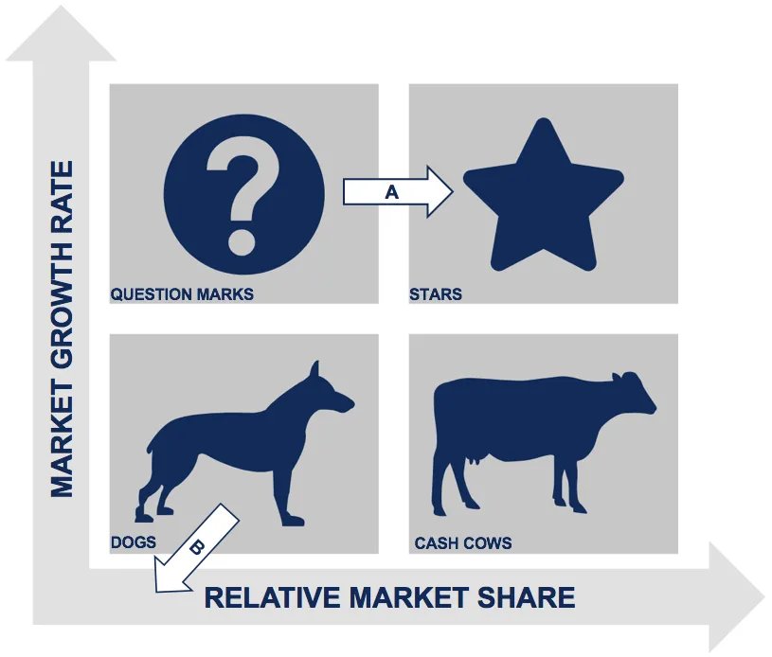
Figure 5: BCG Matrix
Source: (Hansen, 2020)
Strategic Portfolio Perspective
The BCG Matrix is a useful analytical tool when analysing BP's diversified energy portfolio. It evaluates the business segments in the market based on the growing market and the relative market position (Hansen, 2020). This way, one can understand which activities should be invested in in the future and which ones need to be restructured. In a changing energy market, portfolio analysis is relevant to strike a balance between short-term profitability and long-term strategic transition.
Stars – Renewable Energy Projects
The investments in renewable energy, particularly offshore wind and solar energy, can be considered as emerging "Stars" in BP's portfolio (Lakshman, Lakshman and Estay, 2017). These sectors have experienced rapid growth in the market due to the increasing demand for clean energy in the world. Strategic investment in these areas allows BP to strengthen its position in growth low-carbon energy markets.
Cash Cows – Oil Operations
Traditional oil operations remain BP's primary "Cash Cows." These activities yield high revenue and help in the financial stability of the company (Sen, 2024). Profits from mature fossil fuels are used to invest in renewable energy and strategic transformation programs.
Question Marks and Dogs
Emerging low-carbon technologies, like hydrogen and carbon capture, are "Question Marks." These are areas that need high investment, and the future of the market position is in doubt (Sen, 2024). By opposition, certain of the declining fossil fuel assets could bit by bit become "Dogs." Portfolio analysis is therefore useful to BP in deciding which investments to prioritise and allocate resources to sustainable energy opportunities.

7.2 Critical Evaluation of Current Strategy
BP's upstream strategy is to maintain production and improve efficiency. This approach provides for efficiency and profitability, but also neglects longer-term industry dynamics. Its fossil-fuel production exposes it to regulatory and product life cycle risks. Finally, ensuring little differentiation in upstream activities protects against downstream advantage because of the large number of firms a cost leadership strategy. In his generic strategies, Porter suggests cost leadership can be advantageous in commodity industries. However, to sustain advantage, there is a need to continue to manage costs and drive efficiencies. This is what BP has done, but it's limited by other factors.

7.3 Strategic Recommendations
Strengthen Cost Efficiency: BP should continue to enhance cost efficiency through production efficiency measures to reduce costs. New technology, such as automation, predictive maintenance and digital oilfield, are a part of this. This will allow BP to remain profitable in a low oil price environment.
Focus on High-Value Assets: BP should expand high value oil fields and refurbishing or divesting low value assets. This is in line with asset management where the portfolio strategy is to invest in assets with required return on investment. Prioritising high-value assets will boost profits and decline losses from low value assets.
Enhance Risk Management: BP can improve its geopolitical and regulatory risk management by diversifying into several regions which it can manage the risks. This helps to avoid political/regulatory risks. steadily increases production and revenues.
Integrate Sustainability into Upstream Operations: Upstream activities are carbon-intensive, but BP needs to work toward carbon-cutting technology, such as methane recovery and carbon management. This will help in regulatory and ESG rating. Upstream must be sustainable for resilience
Invest in Technological Differentiation: BP needs to invest in exploration and drilling technology for differentiation. While cost leadership is critical, technology differentiation helps increase efficiency and sustainability. This is effective because it is consistent with the resource based view of the firm, which holds that uniqueness of resources of the firm provides competitive advantage.

Section 2 - Reflective Account
This reflective section uses Kolb's cycle of reflective practice, which focuses on the elements of experience, reflection, conceptual understanding and future application. The framework allows a critical assessment of the learning process involved in analysing BP's strategic position inside the world energy industry.
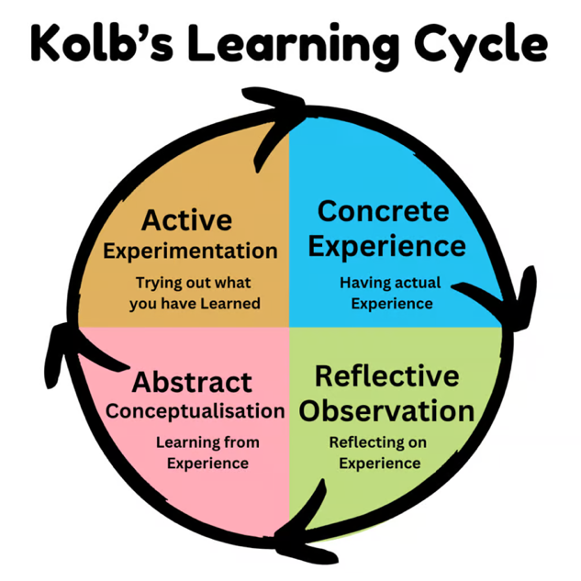
Figure 6: Kolb's cycle of reflective practice
Source: (Barker, Lencucha and Anderson, 2016)

Concrete Experience
The study was focused on the implementation of strategic management tools in the BP upstream oil business. Secondary data collected from company reports, industry data and journals for the study consisted of indicators of financial, production and operational efficiency (Barker, Lencucha and Anderson, 2016). The nature of the study, being focused on a business unit rather than the entire organisation, meant the focus was on upstream business units such as exploration, drilling and production. Analytical tools of PESTEL, Value Chain, VRIO and BCG Matrix were applied to external and internal factors. Except for SWOT and Porter's Five Forces analysis, upstream analysis was more inclined towards the Value Chain and resource-based analysis (Barker, Lencucha and Anderson, 2016). This included analytical rigour in linking activities to advantage. The experience brought up the complexities of how one analyses a capital-intensive and political industry in which decisions are highly related to external uncertainty and internal efficiency.

Reflective Observation
Clarifying BP's upstream business illustrated the challenges in analysing the relationships between external and internal elements. There are very dynamic factors present in the global oil industry, such as geopolitical and oil price risk, and regulation (Kleinheksel et al., 2023). This kind of understanding was to be gained by moving from a descriptive to an evaluative approach to gain insights into how those factors inform investment decisions for the upstream business. An important factor was recognition of the strategic dilemma between being profitable by producing crude and future decarbonisation requirements. A further shift - from industry analysis using Porter's Five Forces, to organisation analysis using Value Chain analysis - also involved a move from outward to inward focused analysis (external vs. internal competition) (Kleinheksel et al., 2023). That is, a change in focus from external to internal competition, and a focus on value creation. This exercise indicated that it's helpful to take a systemic approach to strategy during change.

Evaluation
The use of several strategic frameworks aided analysis. The PESTEL framework enabled attention to be given to an external environment (Political, Economic, Social, Technological, Environmental, and Legal), and the Value Chain framework enabled attention to be given to value creation for BP’s Upstream segment (Exploration, Production and Logistics (Meijer et al., 2022). The VRIO framework also helped in identifying resources and capabilities that are sources of advantage. The BCG Matrix then helped make an assessment of the upstream segment as a cash cow of a mature industry. However, there were issues with the research. Secondary data could have affected results, as corporate reports can be, in case of positive reporting bias, overly positive in terms of financials and strategy. In addition, the ever-changing energy sector means that the data might not be current, so it limits the ability to make inferences in relation to strategy (Meijer et al., 2022). Primary data is absent to contrast results. Such limitations highlighted the need for critical interpretative and critical evaluation of information, as well as trust towards the information.

Abstract Conceptualisation
Through the adoption of strategic management analysis, the research gave an overview of how the organisation responds to threats related to the environment and operations. The study indicated that the integrated strategy of BP is responding to the external environment, but also influenced by internal factors (Ryder and Downs, 2022). PESTEL analysis added to the understanding of the impact of political, environmental and economic changes on the strategy of multinational oil companies. Value Chain analysis showed the part of efficiency in cost leadership in exploration and production operations. The VRIO analysis reminded us that sources of competitive advantage are resources such as oil and technology and synergistic businesses (Ryder and Downs, 2022). The BCG Matrix provided a portfolio perspective and the upstream business was a cash cow with limited potential. This two-part model nodded to the need to look inwards, as well as outwards. And it highlighted both the importance and value of applying models rather simplistically or in a vacuum.

Active Experimentation
The results of our analysis will inform future research in many ways. Firstly, there will be an increased emphasis on the use of multiple frameworks that will seek to holistically understand strategy. The combination of PESTEL, Value Chain, VRIO and BCG matrix effectively mapped out both external and internal elements. Second, future work will try to incorporate quantitative data as well as qualitative data for further analysis (Kleinheksel et al., 2023). Third, future research will make critical assessments of data sources to avoid biases and improve the quality of the results. Finally, this process has highlighted the importance of future work needing to include sustainability and technological development in strategy. An integration of these learnings will result in a deeper understanding of the complex nature of organisations and provide a better strategy in the future.

Conclusion
This report examined the effectiveness of BP's upstream business in the competitive and ever-evolving global oil market. Findings demonstrate that the key source of BP's competitive advantage is its enormous reserves, vertical integration and technical know-how, enabling it to be a cost leader in a commodity industry (Bulgakov and Makarenko, 2022). However, the increasing regulatory environment, geopolitical instability and global warming policies will have a negative impact on its future performance. However, despite the upstream industry being a cash machine, it can be very fragile. Hence, for sustained competitiveness, BP needs to enhance its cost management, risk management and optimise its upstream business based on the changing regulatory and market environment.

Reference
Akhtar, M. and Sushil (2018) ‘Managing strategic performance in a dynamic business environment: A study of two Indian oil companies’, Global Business and Organizational Excellence, 37(5), pp. 47–62. Available at: https://doi.org/10.1002/joe.21876.
Al-Mana, A.A., Nawaz, W., Kamal, A. and Koҫ, M. (2020) ‘Financial and operational efficiencies of national and international oil companies: An empirical investigation’, Resources Policy, 68, p. 101701. Available at: https://doi.org/10.1016/j.resourpol.2020.101701.
Antràs, P. and Chor, D. (2022) ‘Global Value Chains’, Handbook of International Economics: International Trade, Volume 5, 5, pp. 297–376. Available at: https://doi.org/10.1016/bs.hesint.2022.02.005.
Barker, D.J., Lencucha, J. and Anderson, R. (2016) ‘Kolb’s learning cycle as a framework for early fieldwork learning’, World Federation of Occupational Therapists Bulletin, 72(1), pp. 28–34. Available at: https://doi.org/10.1080/14473828.2016.1162373.
Bergh, L.I.V., Hinna, S., Leka, S. and Zwetsloot, G.I.J.M. (2016) ‘Developing and testing an internal audit tool of the psychosocial work environment in the oil and gas industry’, Safety Science, 88, pp. 232–241. Available at: https://doi.org/10.1016/j.ssci.2015.06.003.
BP (2025) Our history | Who we are | Home, BP global. BP global. Available at: https://www.bp.com/en/global/corporate/who-we-are/our-history.html (Accessed: 20 March 2026).
BP plc (2026) BP Annual Report and Form 20-F 2025, https://www.bp.com. BP plc. Available at: https://www.bp.com/content/dam/bp/business-sites/en/global/corporate/pdfs/investors/bp-annual-report-and-form-20f-2025.pdf (Accessed: 20 March 2026).
Bulgakov, S. and Makarenko, E. (2022) ‘The Development of an Integrated External Environment Monitoring Framework Aimed at the Internal Control of the Procurement Process of Fat and Oil Companies’, Journal of Risk and Financial Management, 15(2), p. 50. Available at: https://doi.org/10.3390/jrfm15020050.
Edser, N. (2026) ‘BP steps up cost cutting as profits slide’, BBC News, 10 February. Available at: https://www.bbc.com/news/articles/cz0g4dkm77zo (Accessed: 10 March 2026).
Hansen, M.W. (2020) ‘Toward a strategic management perspective on local content in African extractives: MNC procurement strategies between local responsiveness and global integration’, Africa Journal of Management, 6(1), pp. 1–19. Available at: https://doi.org/10.1080/23322373.2020.1717283.
Hashmi, M.H.A., Khan, M. and Ajmal, M.M. (2020) ‘The impact of internal and external factors on sustainable procurement: a case study of oil and gas companies’, International Journal of Procurement Management, 13(1), p. 42. Available at: https://doi.org/10.1504/ijpm.2020.105189.
Kassem, M., Khoiry, M.A. and Hamzah, N. (2020) ‘Structural modelling of internal risk factors for oil and gas construction projects’, International Journal of Energy Sector Management, 14(5). Available at: https://doi.org/10.1108/ijesm-11-2019-0022.
Kleinheksel, A.J., Chen, W., Rudd, M.J., Drowos, J., Gupta, S., Minor, S. and Bailey, J.M. (2023) ‘Putting reflection back into practice: Kolb’s theory of experiential learning as a theoretical framework for just-in-time faculty development’, SN Social Sciences, 3(3). Available at: https://doi.org/10.1007/s43545-023-00649-z.
Lakshman, S., Lakshman, C. and Estay, C. (2017) ‘The relationship between MNCs’ strategies and executive staffing’, International Journal of Organizational Analysis, 25(2), pp. 233–250. Available at: https://doi.org/10.1108/ijoa-10-2015-0913.
Meijer, M.W., Brandhuber, T., Schneider, A. and Berberat, P.O. (2022) ‘Implementing Kolb´s Experiential Learning Cycle by Linking Real Experience, Case-Based Discussion and Simulation’, Journal of Medical Education and Curricular Development, 9, pp. 1–5. Available at: https://journals.sagepub.com/doi/full/10.1177/23821205221091511.
Önören, M., Arar, T. and Yurdakul, G. (2017) ‘Developing Competitive Strategies Based on SWOT Analysis in Porter s Five Forces Model by DANP ’, Journal of Business Research - Turk, 9(2), pp. 511–528. Available at: https://doi.org/10.20491/isarder.2017.282.
Reuters (2026) ‘FTSE 100 rises as oil price retreat lifts market sentiment’, Reuters, 16 March. Available at: https://www.reuters.com/world/uk/ftse-100-flat-energy-gains-offset-broader-weakness-2026-03-16/ (Accessed: 17 March 2026).
Ryder, M. and Downs, C. (2022) ‘Rethinking Reflective practice: John Boyd’s OODA Loop as an Alternative to Kolb’, The International Journal of Management Education, 20(3), p. 100703. Available at: https://doi.org/10.1016/j.ijme.2022.100703.
Sen, S. (2024) ‘Strategic Management Practices in Multinational Corporations: A Comparative Study’, Journal of Advanced Management Studies, 1(3), pp. 36–39. Available at: https://doi.org/10.36676/jams.v1.i3.18.
Silvestre, H.C., Gomes, R.C., Lamba, J.R. and Correia, A.M. (2018) ‘Implementation of Brazil’s energy policy through the national oil company: From institutional chaos to strategic order’, Energy Policy, 119, pp. 87–96. Available at: https://doi.org/10.1016/j.enpol.2018.04.028.
Tharuniyaa Lakshmi (2026) ‘UK’s FTSE 100 closes at 2-month low as investors weigh BoE rate decision and Iran war’, Reuters, 19 March. Available at: https://www.reuters.com/world/uk/uk-equities-slide-mideast-war-escalates-boe-decision-focus-2026-03-19/ (Accessed: 19 March 2026).
Wan Ahmad, W.N.K., Rezaei, J., de Brito, M.P. and Tavasszy, L.A. (2016) ‘The influence of external factors on supply chain sustainability goals of the oil and gas industry’, Resources Policy, 49, pp. 302–314. Available at: https://doi.org/10.1016/j.resourpol.2016.06.006.
Zakaria, K.M., Nawawi, A. and Salin, A.S.A.P. (2016) ‘Internal controls and fraud – empirical evidence from oil and gas company’, Journal of Financial Crime, 23(4), pp. 1154–1168. Available at: https://doi.org/10.1108/jfc-04-2016-0021.

