TASK 2: INDIVIDUAL REPORT

DIANA ARACELLY CASTANO GIRALDO (2207095)

ACADEMIC AND EMPLOYABILITY SKILLS (ACE BMSW4001)
Lecturer: Peter Allen

UNIVERSITY OF WALES TRINITY SAINT DAVID
(London Campus)

September 2022

Table of Contents

Introduction 3
1. Time Management 4
2. Academic Writing 5
3. Reflective writing. 6
4. Public Speaking and Giving Presentations………………………………………………………………...……….7
5. Conclusion…………………………………………………………………………9
6. References……………………………………………………………………….10

Introduction.

In my opinion, what is intended with this report is to guarantee learning by students through a reflective analysis of the individual cognitive experience and the feelings or emotions that were generated in each of them during it.
In accordance with the above and in order to study each topic related to this module, I will then make a brief tour of the topics that caught my attention and with which I somehow feel identified trying to transmit my perceptions and personal experiences throughout the process.

- Time Management.

Before studying at the University of Wales I thought that time management was related only to the duration of the execution of each task and the way to do everything in the shortest possible time; calendars and schedules had a different meaning for me which seems strange having previous studies. However, This is because I do not remember having received any lectures on this before.
Now, after discussing the topic in class and researching, I find that Time Management is the ability to organize your tasks and goals on a calendar. However, there are other definitions, raised by different experts who try to give a deeper meaning to this concept and that vary according to the approach that each of them considers relevant.
For example, according to author Carla Crutsinger (1994), time management is the ability to set goals, prioritize, allocate time to each task, and observe the results.
I think that this definition is quite in line with reality since it is not only about managing time, but this author also talks about being flexible with such management since, sometimes, our priorities vary, and we must adapt to those changes.
In my case, talking about time management is complicated since it is not exactly one of my skills. Actually, I didn't consider it a skill because as I said, before seeing the Academic and Employability Skills module taught by Peter Allen, I had not stopped to reflect on how important it is to know how to manage our time for the achievement of our objectives both personally and professionally and I think for that reason I never consider it a weakness within my personal SWOT analysis. Now, after everything discussed in class on the subject and other personal searches referred to in this report, I have understood that it is a very important aspect in my life and that I must work to improve it since, although to date I have achieved some of my purposes, it has not been easy to do so because I do not have enough knowledge to plan them, prioritize them and project them over time.
But since my goal is to be consistent with the learning obtained, I have started by preparing my weekly timetable in which I schedule the tasks to be done and I make sure that it is as realistic as possible, considering my SMART goals and that time must be distributed between study, work, family, chores and leisure.
Time management is important not only in the field of studies and work, but it is also essential for life in general since procrastination is a bad habit that leads us to make even the easiest tasks difficult and unrealizable. This happens due to the lack of organization and prioritization of our day to day.

- Academic writing.

In addition to time management, academic writing is another essential skill for the university student. In fact, I think that in all stages of study it is important to motivate and develop this skill in each person and in that way, when the students begin higher studies, have necessary tools such as: critical thinking, objectivity, precision, coherence and, above all, make a correct use of language to be able to build texts assertively.
"Learning to write academic texts is like learning a new language, the language of a community's academic discourse: becoming bilingual." (Ivanic and Roach, 1990: 106)
I identify with the previous statement since academic writing also requires specific knowledge on certain topics, it goes beyond just writing formally, it is also instructing the reader.
Reading and learning about this topic has been quite inspiring for me since during my academic processes I have faced the challenge of writing on several occasions and writing is something I like and enjoy a lot. However, this time the challenge will be even greater since now I do not do it in my mother language but in English, a language that until now I am learning but that has always interested me and of which I fall in love more the more I know it. Although I am clear that to achieve a good level of academic writing, I must read a lot about the topics to write and strive to enrich my vocabulary.
I must accept that at the beginning of this session I felt a little scared because I feared that it would be very difficult for me to understand the context of the class since I considered that my level of English was insufficient but contrary to that, and perhaps because of the pleasure I feel for this topic, I felt very comfortable, and I feel that I learned a lot. Something that I feel has helped me, and I think many of my classmates, is the methodology used by the professor since his explanations have been sufficiently clear and he has tried to clear all our doubts in a timely manner.
Now I think that with the learning obtained during the sessions at the university and researching more on the subject, I can obtain great results for my future both at the university level and in my professional life.

- Reflective writing.

Now I'm going to talk about reflective writing. Perhaps one of the topics that I found most exciting within this module. And I think that applying reflective thinking to learning processes leads us more than to learn, to apprehend since that is the best way to appropriate knowledge. It is about telling the learning process as a personal experience, talking about how we feel before and after of that learning.
Within reflective writing there are several models, which in their basic structure retain the same components but depending on their creator, present some variables.
Below, I present some graphic examples of these models in which it can be observed that they coincide in their cyclical form and that they start from an initial experience or event or that leads us to an analysis and later to a final action or conclusion after the experience or event:

ERA Cycle Borton’s Model
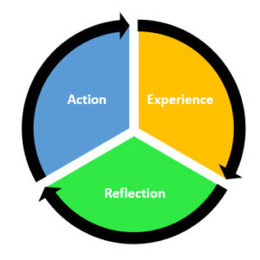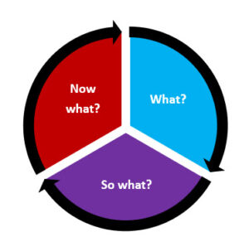
(Reflective writing tips, 2022) (Reflective writing tips, 2022)

Kolb’s Experiential Cycle Gibb’s Reflective Cycle
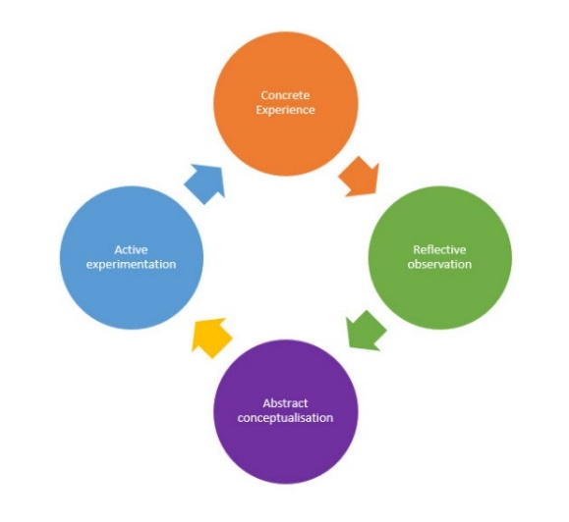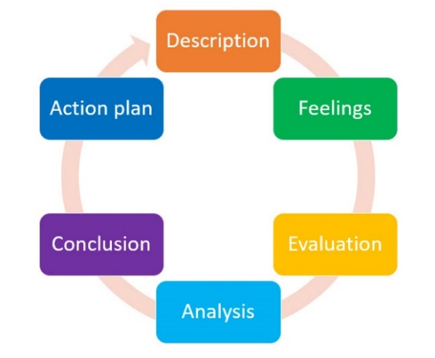
(Reflective writing tips, 2022) (Reflective writing tips, 2022)

After reading about every model and the way they are structured, I have tried to apply in this report The ERA Cycle developed by Professor Melanie Jasper (2013) which is built based on experience, reflection and action since being honest and considering that it is my first report in English, I thought it was the simplest while still being complete. I feel that applying this model has led me to resume what I learned in the sessions at the university and has generated in me the need to read more and deepen about the topics seen which in my opinion, guarantees the learning in a certain way.

- Public Speaking and Giving Presentations.

Finally, Public Speaking and Giving Presentations. An interesting topic, but at the same time intimidating for many people, including me.
Public speaking implies in addition to preparing very well and knowing widely the subject to be treated, following some parameters such as having good body language, showing self-confidence, having good management of the public and not losing their attention, being coherent, dressing appropriately and that the slides that are used as a support for what is being talked about, are clear, well elaborated and easy to understand. That way you can easily capture the attention of the receivers.
Even though in the past I had done it and I knew the basic guidelines for giving presentations, I am aware that we never stop learning and each new experience leads us to improve the previous ones. So, when I knew I had to make an individual presentation in front of my lecturer and classmates, I thought I was facing a big challenge and I was.
As I mentioned before, public speaking is not easy, but speaking in public in a language that is not your own, makes it much more difficult and even stressful; just thinking that you don't have enough lexicon and that surely your pronunciation isn't the best blocks you completely. No matter how much you prepare, how much you read about the topic you are going to expose or how much confidence in yourself you have, you feel like you are returning to your elementary school. At least that's exactly what I felt. However, when talking about it with many of my classmates I knew that they were feeling the same and that, although it seems selfish, relieved me a little.
To assimilate the situation a little I began to read and try to follow the steps I already knew, and the new indications received in class. I prepared myself for what I wanted to talk about in my presentation, I made the slides trying to follow the guidelines so that they did not look bland or saturated and thus attract the attention of the public. I also did some yoga exercises at home the morning of the presentation so that the nerves would not take over me and finally I was there in front of the teacher and the rest of the class talking to them about what I want to be in the future and for which I am preparing with this course: Becoming a Social Worker, because what I like most is being able to help others. The best thing about all this is that in the end I felt that I could do it and that it was not as difficult as I thought; I obviously made a lot of mistakes and my English wasn't the brightest, but I felt comfortable, calm, and I think that was a great start to what's coming forward. I know that there are many aspects to improve but at least my self-confidence flows and I do not remain paralyzed and without anything to say in front of my colleagues and a professor like Peter Allen who did everything and more than necessary to prepare us all for that moment. I thank him.

- Conclusion.

At the beginning of the Academic and Employability Skills module I knew that it was going to be an interesting learning process in which we were going to learn about the skills necessary for an adequate performance in our academic (current) and work (future) life. However, the module has exceeded my expectations since both what I saw in class and the preparation of this report have allowed me to understand that we can always go beyond the basics, it is necessary not only to memorize what we have learned, it is also necessary to deepen each topic and put it into practice to assimilate it properly.
Writing about each topic as a personal experience and remembering how I felt while writing this report turned out to be a very positive experience for me and I hope to make it a constant practice going forward.

- References.

- Castelló, M. (2009). Aprender a escribir textos académicos: ¿copistas, escribas, compiladores o escritores? En J.I. Pozo y Pérez Echeverría, M. P. (Coords.), La Psicología del aprendizaje universitario: de la adquisición de conocimientos a la formación en competencias (pp.120‐133). Madrid. Morata.
- Hellsten, L. (2012). What Do We Know About Time Management? A Review of the Literature and a Psychometric Critique of Instruments Assessing Time Management, Time Management, Prof. Todor Stoilov (Ed.), ISBN: 978-953-51-0335-6, InTech, Available at: http://www.intechopen.com/books/time management/what-do-we-know-about-time-management-a-review-of-the-literature-and-a-psychometric critique-of-inst. Accessed: (29/July/2022)
- Jones, G. (2022) Models of reflection you can use | Reflective Writing Tips (online) Available at: https://www.reflectivewriting.tips/models-of-reflection-you-can-use/ Accessed: (02/August/2022)
- University of Leeds, (2022) Academic Writing (online) Available at: https://library.leeds.ac.uk/info/14011/writing/106/academic_writing. Accessed: (25/July/2022)
- Zenker, P. (2018) Our Time Management Definition – From Tug Of War With Time. (July 30). Available at: https://pennyzenker360.com/time-management-definition/ Accessed: (01/August/2022)

