Environment Design
3D Diorama
Ashanti Taylor / 2304545
BA Games Design

Link to Presentation: https://youtu.be/1VM1riih6kk

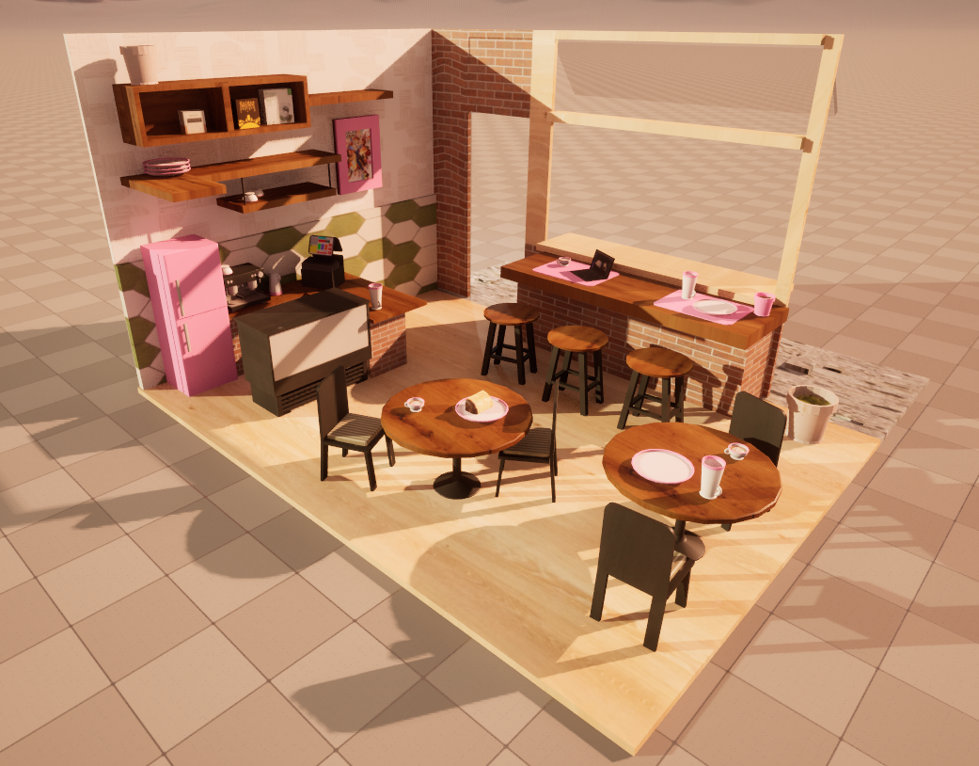
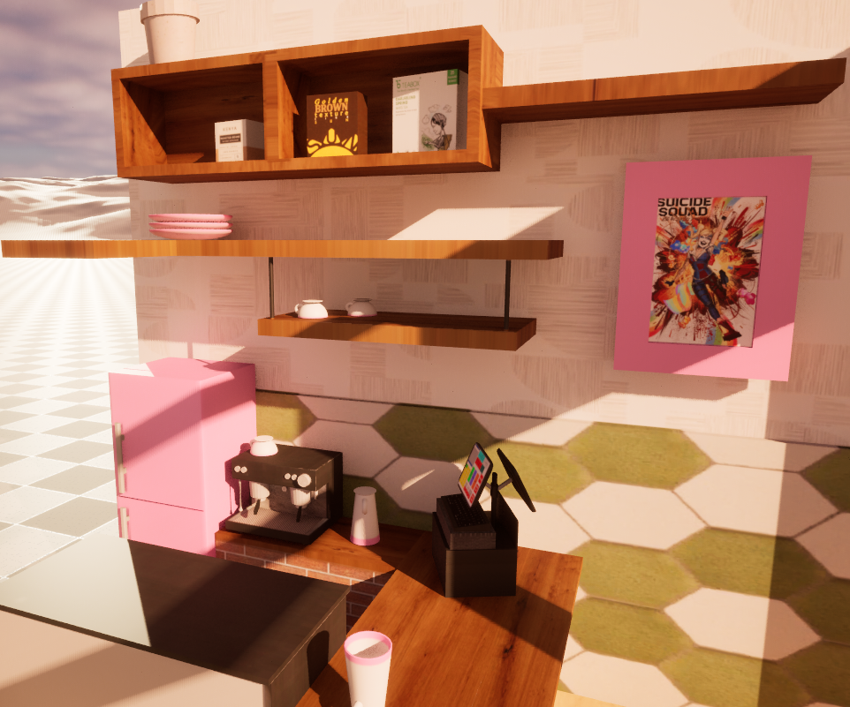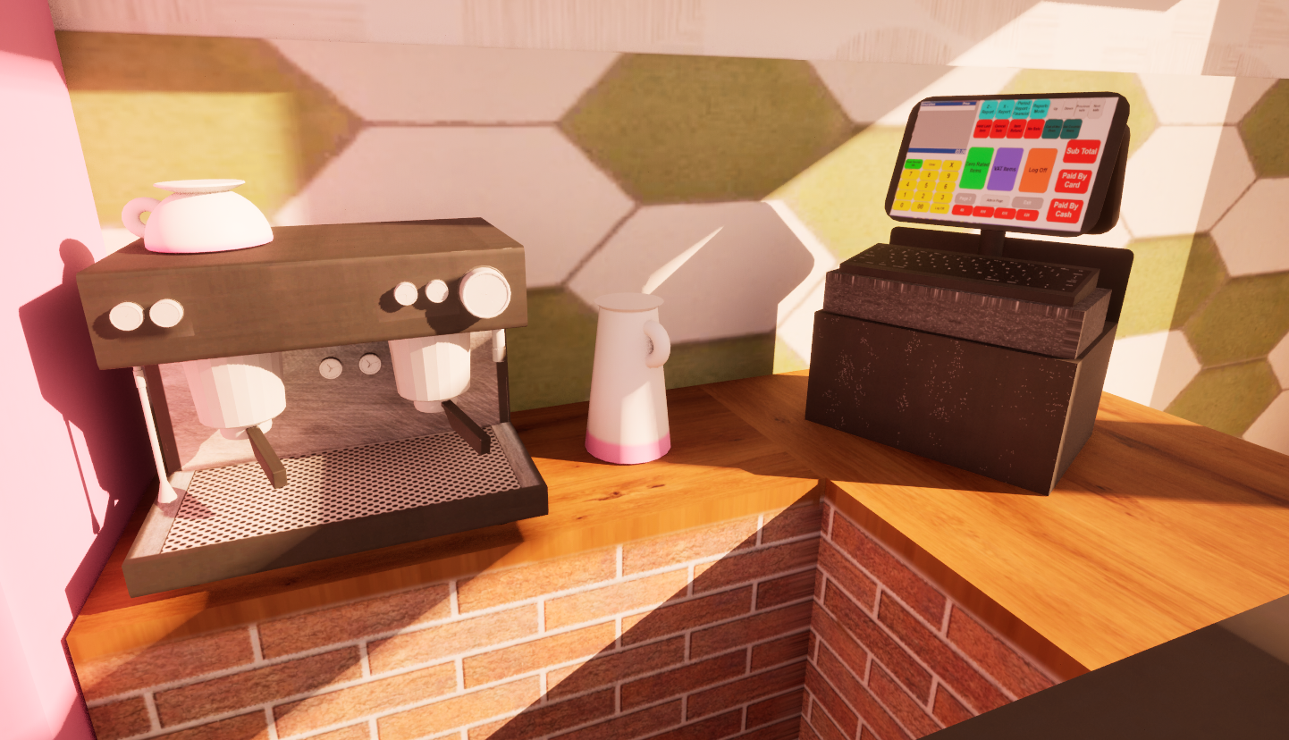

(putting this here just in case, there was a lot of small text on the PowerPoint so I want to make sure it’s readable)

Bibliography:

[1] ARTX, Architextures, https://architextures.org/ (accessed Apr. 27, 2024).
[2] Miro, “Miro,” https://miro.com/, https://miro.com/templates/mood-board/ (accessed Feb. 2, 2024).
[3] M. Aspland, “How to create a glass material - Unreal engine 4 tutorial,” YouTube, https://www.youtube.com/watch?v=a16EGZreJlM&t=272s&ab_channel=MattAspland (accessed May 6, 2024).
[4] James, How Do I?, “Basics of UV mapping introduction,” YouTube, https://www.youtube.com/watch?v=17iFakjVjZo&ab_channel=James%2CHowDoI%3F (accessed May 5, 2024).
[5] ProductionCrate, “Beginner tutorial - texturing in substance painter!,” YouTube, https://www.youtube.com/watch?v=JFGWe3G8uIo&t=61s&ab_channel=ProductionCrate (accessed May 6, 2024).
[6] James, How Do I?, “Substance 3D painter textures into Unreal engine 5 including emission,” YouTube, https://www.youtube.com/watch?v=wcpz9_stKgs&ab_channel=James%2CHowDoI%3F (accessed May 6, 2024).
[7] The RealTime Essentials, “4 ways to create copies of objects in Unreal Engine!,” YouTube, https://www.youtube.com/watch?v=nfbYPtc1z8o&t=24s&ab_channel=TheRealTimeEssentials (accessed May 6, 2024).
[8] ARTX, “Crazed tiles, hexagonal,” Architextures, https://architextures.org/textures/1606 (accessed May 6, 2024).
[9] ARTX, “Ash,” Architextures, https://architextures.org/textures/730 (accessed May 6, 2024).
[10] ARTX, “Haze wallpaper in Pink granite,” Architextures, https://architextures.org/textures/1543 (accessed May 6, 2024).
[11] ARTX, “Terrazzo,” Architextures, https://architextures.org/textures/739 (accessed May 6, 2024).
[12] ARTX, “Oak,” Architextures, https://architextures.org/textures/785 (accessed May 6, 2024).
[13] ARTX, “Speckled vinyl,” Architextures, https://architextures.org/textures/1000 (accessed May 6, 2024).
[14] ARTX, “Zinc,” Architextures, https://architextures.org/textures/799 (accessed May 6, 2024).
[15] ARTX, “Rusticated red brick stretcher,” Architextures, https://architextures.org/textures/1096 (accessed May 6, 2024).

[16] ARTX, “Stainless Steel,” Architextures, https://architextures.org/textures/2076 (accessed May 6, 2024).
[17] ARTX, “Moss,” Architextures, https://architextures.org/textures/2106 (accessed May 6, 2024).
[18] ARTX, “Terracotta,” Architextures, https://architextures.org/textures/951 (accessed May 6, 2024).
[19] ARTX, “Pink plastic,” Architextures, https://architextures.org/textures/2791 (accessed May 6, 2024).
[20] ARTX, “Olive green striped textile,” Architextures, https://architextures.org/textures/1758 (accessed May 6, 2024).
[21] ARTX, “Polycarbonate,” Architextures, https://architextures.org/textures/1202 (accessed May 6, 2024).
[22] holiday.photo.top, “Premium photo: White whipped cream texture. top view.,” Freepik, https://www.freepik.com/premium-photo/white-whipped-cream-texture-top-view_15013121.htm (accessed May 6, 2024).
[23] eBay, “Teabox fresh high grown Darjeeling Special Spring white tea 25bags free shipping,” eBay, https://www.ebay.co.uk/itm/115629330668?chn=ps&_ul=GB&mkevt=1&mkcid=28 (accessed May 6, 2024).
[24] J. Goodwin, “How to create a brushed aluminium sheet,” Aluminium Warehouse, https://www.aluminiumwarehouse.co.uk/blogs/news/how-to-create-a-brushed-aluminium-sheet (accessed May 6, 2024).
[25] Pwnage, “Ultra Custom Mechanical Keyboard,” Pwnage, https://pwnage.com/products/ultra-custom-mechanical-keyboard (accessed May 6, 2024).
[26] TextureX, “Aluminum hole texture silver metal circle steel greeting card by Texturex,” Fine Art America, https://fineartamerica.com/featured/aluminum-hole-texture-silver-metal-circle-steel-mark-texture.html?product=greeting-card (accessed May 6, 2024).
[27] K. G. D. Sarahekimbrey, “The stranglers- golden brown,” kimbrey Graphic Design, https://kimbreygraphicdesign.wordpress.com/tag/the-stranglers-golden-brown/ (accessed May 6, 2024).
[28] DenysHolovatiuk, “Vintage old label Template Coffee Vintage Stock Vector (royalty free) 1912391878,” Shutterstock, https://www.shutterstock.com/image-vector/vintage-old-label-template-coffee-packaging-1912391878 (accessed May 6, 2024).
[29] A. A. Muhammad, “Hot Coffee Latte with beautiful milk foam latte art texture isolated on transparent background AI generated,” Vecteezy, https://www.vecteezy.com/png/27187861-hot-coffee-latte-with-beautiful-milk-foam-latte-art-texture-isolated-on-transparent-background-ai-generated (accessed May 6, 2024).

[30] S. Nebhwani, “Coffee Shop Digital signage: Café Menu Boards to boost your sale,” DotSignage, https://www.dotsignage.com/solutions/cafe-and-coffee-shop-digital-signage (accessed May 6, 2024).
[31] Freepik, “Premium vector: Black and white vector illustration of vintage analog clock: Clock, Clock Icon, clock drawings,” Pinterest, https://www.pinterest.co.uk/pin/745486544556387594/ (accessed May 6, 2024).
[32] scubaluna, “Cappuccino milk foam spiral closeup stock photo 1976807609,” Shutterstock, https://www.shutterstock.com/image-photo/cappuccino-milk-foam-spiral-closeup-1976807609 (accessed May 6, 2024).
[33] Freepik, “Free photo: Cake frosting texture background vector with sprinkles on top: Cake frosting, cake frosting recipe, cake icing,” Pinterest, https://www.pinterest.com/pin/574560864971860523/ (accessed May 6, 2024).
[34] Adobe Stock, “Texture of chocolate icing close-up stock photo,” Adobe Stock, https://stock.adobe.com/uk/images/texture-of-chocolate-icing-close-up/74482116 (accessed May 6, 2024).
[35] Adobe Stock, “Lemon cake texture stock photo,” Adobe Stock, https://stock.adobe.com/images/lemon-cake-texture/113549604 (accessed May 6, 2024).
[36] Adobe Stock, “Close up texture of butter cake background stock photo,” Adobe Stock, https://stock.adobe.com/images/close-up-texture-of-butter-cake-background/122500230 (accessed May 6, 2024).
[37] Dunheved Golf Club, “Bistro,” Dunheved Golf Club, http://www.dunhevedgolfclub.com.au/bistro (accessed May 6, 2024).
[38] Dataweigh Systems Limited, “Cash register replacment,” Dslsystems.net, https://dslsystems-net.webnode.page/basic-till/ (accessed May 6, 2024).
[39] Autodesk, “Autodesk Maya.” Autodesk, San Francisco, CA, 1998
[40] Adobe, “Adobe Substance Painter.” Adobe, San Jose, CA, 1982
[41] Epic Games, “Unreal Engine 5.” Epic Games, Cary, North Carolina, 1991

