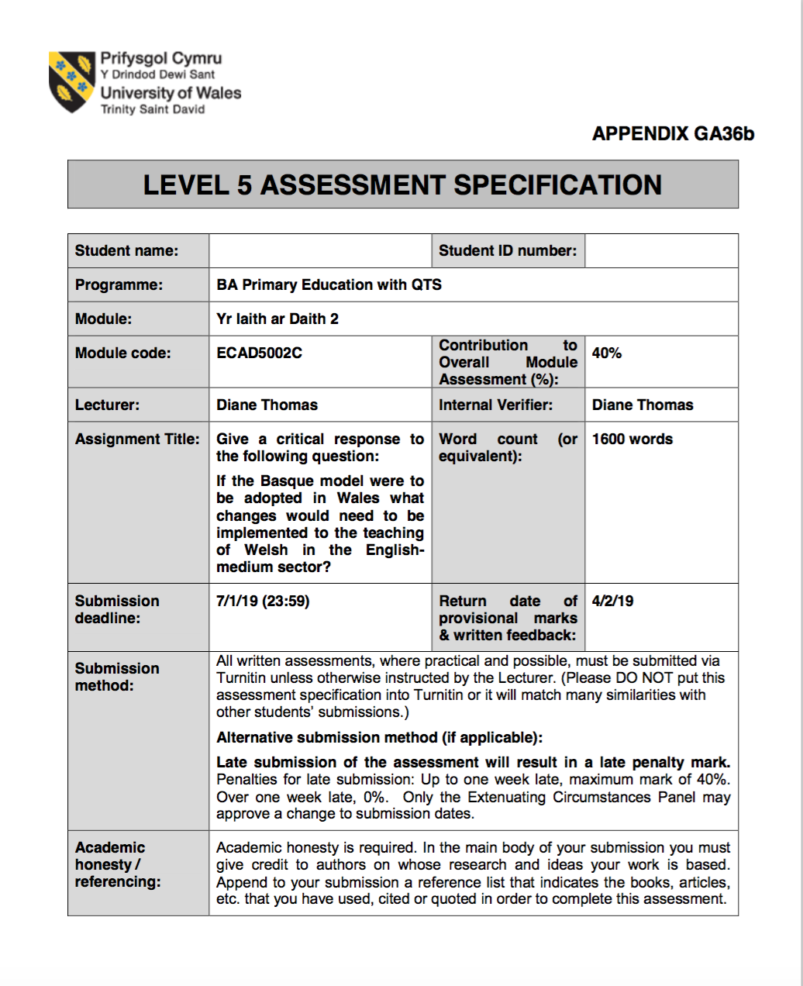
1700085
Emily Thomas
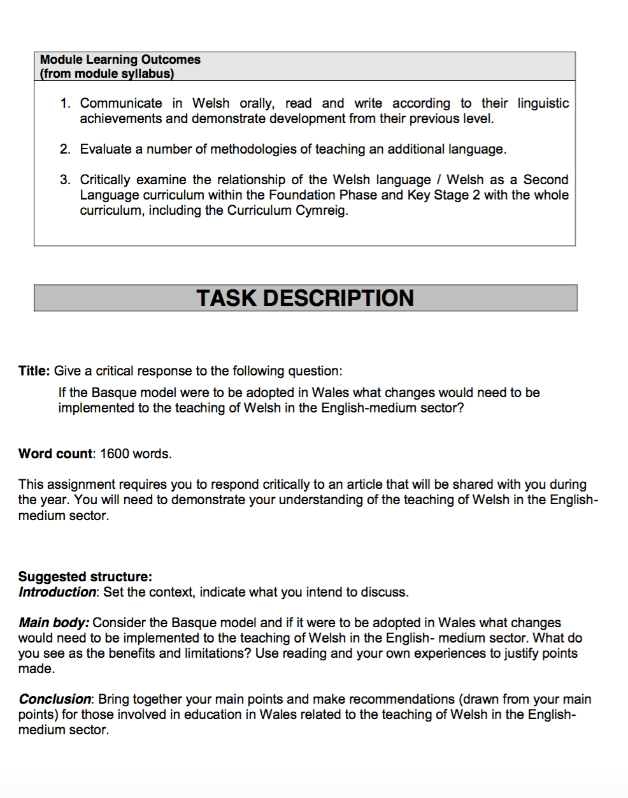
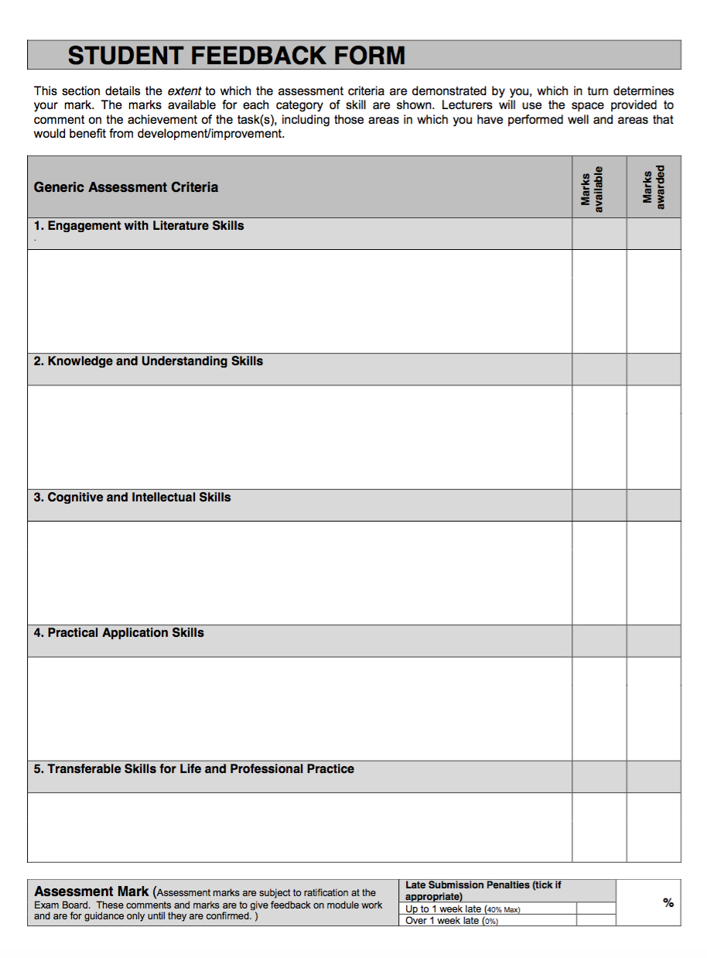

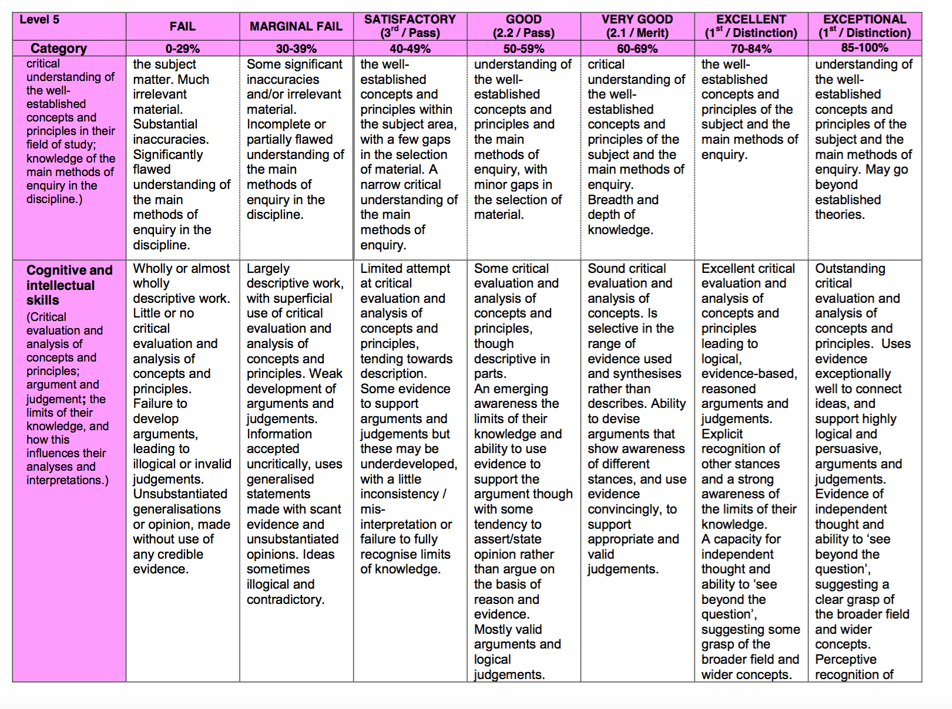

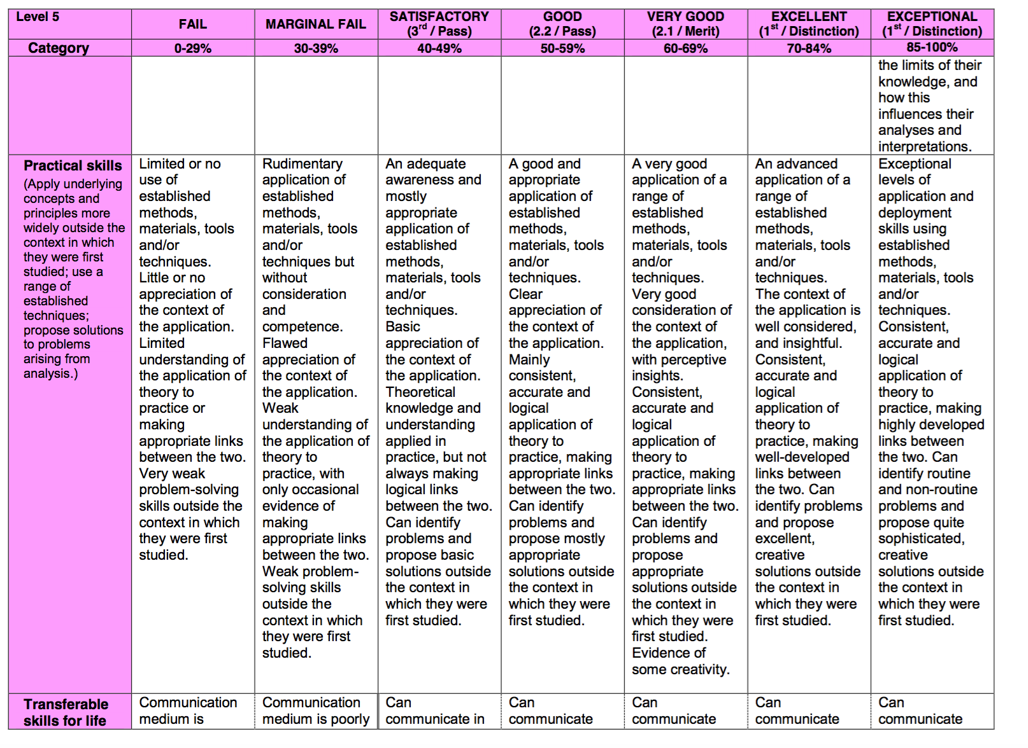

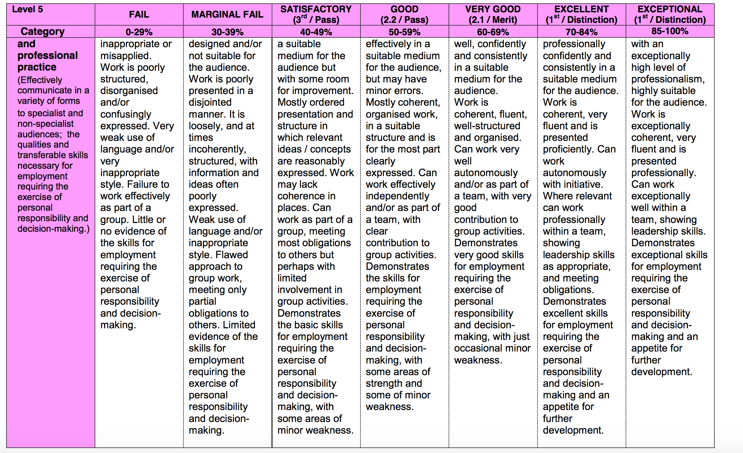

Give a critical response to the following question: If the Basque model were to be adopted in Wales what changes would need to be implemented to the teaching of Welsh in the English-medium sector?
Word Count: 1759. (1600 +-10%)

Basque is an autonomous community of Spain, possessing their own language of Basque. The curriculum teaches Basque, Spanish and English. (Hopwood et al.2018.)
The focus of Euskaltegiak’s curriculum is to create “independent speakers, equipped with strategies to communicate in the new language.”(Hopwood et al.2018.) This has succeeded creating multilingual learners; 2017 findings convey there are 223,000 more Basque speakers since 1992. The highest percentage of Basque speakers is within young-people from 16-24.(Katu,2017.) Basque has succeeded creating nearly fluent bilingual speakers, especially within young-people, conveying Basque teaches bilingualism successfully.

Wales shares a similar goal in creating independent fluent speakers. Wales’ goal is to produce one-million speakers by 2050 to “increase the number of people able to use Welsh within their families and workplace.”(WG,2016)
The Welsh language is not effectively used within English-medium schools, according to Estyn(2013a) one-in-ten schools make excellent progress in acquiring Welsh language skills, not a satisfying result if there is a need for one-million Welsh speakers. Wales could follow Basque’s model incorporating their ideas of good practice. Although within Basque, a population of 2.167 million, only 400,000-430,000 people speak Basque. (Katu,2017.) A small amount of fluent speakers, some may argue this does not seem vastly impressive. Although, it consists mostly of young-people suggesting Basque is successful creating young speakers who will pursue speaking Basque.

The article’s purpose is to explain how Basque achieves their goal creating fluent speakers. The article discusses how Basque utilises educational specialists whom are “employed to support teachers and schools”(Hopwood et al.2018) creating multilingual learners sharing similarities with Huw Lewis’ article. Lewis discusses the importance of educational specialists to aid the language learning highlighting how crucial the education department is in changing “and securing the future for the Welsh language.”(Lewis,2015.) Both articles share the importance of becoming multilingual. In-reality, the ability of Welsh spoken follows a system where “pupils make a good start speaking and listening to Welsh.”(Estyn,2013b.) By the time pupils enter KS2, they “lack skills”(Estyn,2013b) in oracy, reading and writing. Sioned Davies recognises the importance of change describing it as the “eleventh hour for the Welsh language,”(Davies,2013) proposing change needs to happen. It can be questioned, are we doing something correct in Wales if the majority of pupils are not already bilingual? Recommendations are proposed within Basque that may be executed to increase bilingualism.
The Basque model consists of A, B and D-model schools. The A-model school teaches through the medium of Spanish and teaches Basque for three hours a week, equating to an English medium school. The B-model schools teach 30%-40% in Basque and the D-model schools teach through Basque with Spanish as a compulsory subject. (Hopwood et al.2018.) Whereas Wales merely has two variations of schooling: English medium and Welsh medium. It highlights “parents and pupils increasingly choose B- and D-model schools” as Basque is more prominent thus more successful.”(Hopwood et al.2018.) This conveys parents and pupils desire becoming multilingual and suggests enjoyment learning various languages. Whereas, pupils in Wales do not understand the need for Welsh therefore want to avoid the language.(Williams,2015.) Some critics argue “forcing Welsh will make pupils educationally weaker”(Williams,2015) suggesting if pupils are forced to learn something, they may retaliate. When completing the Professional Teaching Experience, an interview was conducted with pupils regarding Welsh. The consensus was they did not desire to learn Welsh, see appendix one. This is concerning implying change is needed to increase motivation like Basque. If pupils are not motivated and do not desire to learn Welsh, how will parents?
Within Basque, parents and pupils are on-board with bilingualism; wanting their pupils to become multilingual as they “increasingly choose B and D model schools.”(Hopwood et al.2018.) Parents in Wales are uninformed to how much Welsh is realistically taught and have no input.(Evas et al.2017.)
If the Basque model were adopted in Wales, parents would need to be more involved in the teaching and learning process in order to motivate their children. Estyn(2018) suggest schools should explore the most effective ways to communicate with parents so they can be better involved in their child’s education. Colin Baker agrees suggesting, “One parent, one language…effectively raising a child bilingually is for each parent to speak a separate language to the child.”(Baker and Wright, 2017. p.101.) This conveys parents need an awareness of Welsh to increase bilingualism, similarly to Basque. Wales need to change the method of communication with parents, motivating them to speak Welsh outside of school with their children.
Wales recognises the need for family inclusion when teaching Welsh, aiming to create one million Welsh speakers using family language transmission. It is highlighted the government will “develop a national programme increasing understanding of bilingualism”(WG,2017a) suggesting parents and pupils will understand the need for Welsh by 2050. According to Megan Jones(2016) “many teachers in primary schools lack confidence teaching Welsh second-language” conveying if teachers lack confidence, how will this motivate parents to use Welsh?

Basque “established intensive Basque language courses for practising teachers” in 1980 expanding teacher-language competency to become confident teachers. (Hopwood et al.2018.) However, there are qualifications needed to progress onto courses consisting of “language-profile one”(Hopwood et al.2018) regarded as a high-standard within teaching implying a difficulty to advance onto the course. In Wales, any working practitioners can miss up to one year of teaching to learn Welsh on sabbatical-courses developing personal-language skills suggesting the focus is for any teacher to grasp the language.(WJEC, n.d.)
Basque does not allow this; teachers need specific qualifications, whereas Wales has created sabbatical-schemes involving every teacher implying the sole aim is to increase the supply of practitioners able to teach bilingually. This suggests implementing the Basque method would not assist Wales as sabbatical-schemes have been created to involve every teacher. Jane Jenkins, head-teacher at Moorlands Primary, states: "staff who have completed the courses are confident using Welsh and contribute to the Welsh ethos”(WG, 2017b) achieving the aim of the course. However, the Welsh scheme was launched in 2005 suggesting Wales did not recognise the weakness in teaching Welsh, whereas Basque launched in 1980 suggesting the sabbatical-schemes are long-term solutions as Basque have not fully achieved multilingual speakers. Concerns arise using sabbatical-schemes; practitioners absent up to a year of school can cause disruption, hindering pupils’ learning as different practitioners are transferred to teach. It costs the government a substantial amount of money to run courses and train practitioners. Having one or two practitioners leave annually means it will take a prolonged period of time to train a whole school therefore a long-term solution. However, it achieves the main goal of teachers gaining confidence in Welsh and sharing knowledge with their school. It accomplishes the 2050 goal of “increasing who can teach in Welsh from 2,900 to 3,900 by 2031 and 5,200 by 2050.”(WG, 2017a.) Wales has recognised a need to “establish strong links between initial teacher education and continuing professional development”(Furlong, 2015) to create the best possible teaching regardless of cost.
An aspect of Basque is to teach using CLIL, teaching subjects through a foreign language “producing trilingual speakers.”(Hopwood et al.2018.) The CLIL approach “promotes education through construction rather than instruction,”(Monteil, n.d.) a constructivist approach. Constructivist John Dewey states, “give pupils something to do, not something to learn…learning naturally results. (Dewey,1916.) Basque utilises CLIL to teach three languages, if this was adopted in Wales it could quicken the pace when solely learning two languages. The CLIL approach is similar to cross-curricular teaching as the language is utilised within a variety of subjects. John Barnes (2015) states cross-curricular approaches provide teachers with the best chance of including all children in successful learning proving CLIL is able to involve all pupils.
In Basque “timetabling, training and classroom resource implications are taken in to account”(Hopwood et al.2018) to increase language competence. This individualises each classroom to suffice both teacher and pupils’ needs in teaching and learning language. This is completed by “educational specialists developing materials, supporting teachers and schools” (Hopwood et al.2018) individualising resources further. Each school is different and possesses differing methods of teaching therefore in Wales; this would take a prolonged amount of time to satisfy each school therefore a long-term solution. When CLIL has been used to teach English, they become proficient after 5-7 years (Darn,2007) proving an extensive process to implement when Wales is struggling in the present. The need for outside assistance is expensive and may disrupt classroom life, especially if CLIL is adopted within a school term; the focus may become trying to create it rather than achieve it, hindering children’s bilingual learning. Using outside assistance could mean teachers and pupils will take it more seriously, as the information is derived from educational specialists.
The Basque method teaches English as a subject although English is strengthened by a range of subjects also taught through the medium of English. (Hopwood et al.2018.) Donaldson(2015) proposes areas of learning should include, where appropriate, a “Welsh dimension” incorporating Welsh into every area of learning, suggesting ‘Successful Futures’ is making good progress towards the CLIL approach.
When using CLIL, it expresses “individual interests are taken in to account when developing content for language learning”(Hopwood et al.2018) indicating pupils are the driving-force creating their learning. Steven Watson(2017) highlights children are happiest and show the most growth when freedom is given to lead learning. To adopt this within Wales, pupils would need to be the driving force for language learning in order to motivate them with their interests.

If Wales were to adopt the Basque method, many changes would need implementing. Firstly, all pupils should be made aware of the need for learning Welsh, like Basque. It can be argued this can be achieved with motivation from parents as well as schools. Parents should be made aware of different immersion services and encouraged to speak Welsh at home in order to create bilingual learners in a similar manner to Basque. Although, there is only so much Wales can do in order to motivate parents, it is their choice whether they want to learn Welsh.
Secondly, it would take a considerable amount of time to implement the CLIL approach. Teachers would need to get accustomed to the different teaching method, which could take a prolonged period of time, if it does not work it could be a waste of time, effort and cost. The Welsh curriculum is changing as Donaldson (2015) proposes including Welsh dimensions within subjects conveying changes in the curriculum attitude.
Thirdly, all teachers should have opportunities to attend a sabbatical-scheme to become confident in learning Welsh, regardless of the time it takes. The goal is to have bilingual speakers by 2050, therefore by continuing sabbatical-schemes, will aid the process.

Appendices

Appendix 1- An interview conducted regarding the use and importance of Welsh with pupils whilst on the Professional Teaching Experience. (8 Questions.) Conducted on Thursday November 29th before registration am.

- Can you see Welsh signs and displays around the school?

Child A: “I think there is a Welsh display in the class, but I do not look at it that much. I don’t see much around the school; some words are translated in to Welsh though.”
Child B: “Some objects are labelled in Welsh, like doors and tables but that’s all I can remember.”
Child C: “Yes, there are a some displays in the hall and there is a ‘wal graffiti’ in the playground.
- Is learning Welsh important to you?
Child A: “It is our language so it is important but I don’t use it in the house, only in school and in Welsh lessons.”
Child B: “Not really.”
Me: Why?
Child B: “I don’t think there is much need for Welsh, no one speaks in Welsh to me.”
Child C: “Me too. But it is important because we are Welsh, but I don’t use it a lot.”
- Do you speak Welsh in the classroom?
Child A: We say bore da before the register and then yma to answer. We have Welsh lessons sometimes.
Child B: We sing in Welsh in assembly sometimes.
Me: Do you ever read in Welsh?
Child A: No.
Child B: I think there are Welsh magazines somewhere in our classroom but I haven’t read them.
Child C: We say Prynhawn Da too after play. [In the afternoon.]
- Do you speak Welsh outside of school?
Child A, B and C: No.
Me: Why?
Child B: No one else speaks Welsh to me.
Me: With your family?
Child A, B and C: No.
- Do you take part in Welsh activities, such as Welsh after school clubs, Eisteddfodau and trips?
Child A: Not really no.
Child C: On St David’s Day we do! We sing.
Child A: Oh yeah.
Child B: No I don’t either. Only on St David’s Day I think.
- Do you use Welsh during other lessons, e.g. Geography, maths?
Child B: Only in Welsh lessons.
Child A: We learnt parts of the body in Welsh with you, and about the Welsh Florence Nightingale.
Child B: Betsi Cadwalder.
Me: What about before these lessons?
Child C: In Welsh lessons we learnt Welsh.
- Do you enjoy learning Welsh?
Child A: I don’t enjoy it that much; I like singing but not reading or writing in Welsh.
Child C: Me too.
Child B: I don’t enjoy it that much, I prefer it to maths but I don’t really understand the words sometimes.
- Is there a need for the Welsh language?
Child B: I don’t use it that much, so I’m not sure.
Child A: We are Welsh so we should speak Welsh but I only use it in Welsh lessons and assemblies and I only know some words in Welsh.
Child C: I’m not sure; we are Welsh so maybe there is. But I don’t mind not learning it in school.

Reference List

Baker, C. and Wright, W. (2017). Foundations of bilingual education and bilingualism. Bristol: Multilingual Matters.

Barnes, J. (2015). Cross-curricular learning 3-14. London: Sage publications.

Darn, S. (2007). Content and Language Integrated Learning. [online] TeachingEnglish | British Council | BBC. Available at: https://www.teachingenglish.org.uk/article/content-language-integrated-learning [Accessed 2 Jan. 2019].

Davies, S. (2013) One Language For All. Welsh Government: Caerphilly. [online] Available at: http://gov.wales/docs/dcells/publications/130926-review-of-welsh-second-lan-en.pdf (Accessed: January 2nd 2019).
Welsh Government. (2017). Cymraeg 2050: A Million Welsh Speakers. Cardiff: Welsh Government. [online]. Available at: https://gov.wales/docs/dcells/publications/170711-welsh-language-strategy-eng.pdf (Accessed 29th December 2018). A

Dewey, J. (1916). Democracy and Education. New York: Macmillan.

Donaldson, G. (2015). Successful Futures: Independent Review of Curriculum and Assessment Arrangements in Wales. Wales: Welsh Government.

Estyn (2013) The Annual Report of Her Majesty’s Chief Inspector of Education and Training in Wales. Cardiff: Estyn Available at: https://www.estyn.gov.wales/document/annual-report-her-majestys-chief-inspector-education-and-training-wales-2012-2013 B

Estyn, (2013). Welsh Language Development in the Foundation Phase. [online]. Estyn.gov.wales. Available at: https://www.estyn.gov.wales/sites/default/files/documents/Welsh%20Language%20Development%20in%20the%20Foundation%20Phase%20-%20January%202013.pdf (Accessed Janurary 2nd 2019). A

Estyn. (2018). Parental involvement with schools helps pupils achieve | Estyn. [online] Available at: https://www.estyn.gov.wales/news/parental-involvement-schools-helps-pupils-achieve [Accessed 29 Dec. 2018].

Furlong, J. (2015). Teaching Tomorrow’s Teachers: Options for the Future of Initial Teacher Education in Wales. Oxford: University of Oxford.

Hopwood, M et al. (2018). An overview Of The Assessment Of Language Proficiency in a Sample of Bilingual Jurisdictions: Qualifications Wales. [online]. Available at: https://www.qualificationswales.org/English/publications/bilingual-language-proficiency-2018/ (Accessed: 22nd December 2018).
J, Evas et al. (2017). Welsh Language Transmission and Use in Families: Research Into Conditions Influencing Welsh Language Transmission And Use In Families. Welsh Government: Cardiff. [online]. Available at: https://dera.ioe.ac.uk/30870/1/170612-welsh-language-transmission-use-in-families-en.pdf (Accessed: 29th December 2018).
Jones, M. (2016). Welsh Medium Education and Welsh as a Subject. Cardiff: National Assembly for Wales. [online]. Available at: http://www.assembly.wales/research%20documents/rs16-048/16-048-english-web.pdf (Accessed: January 2nd 2019).
Katu (2017). New figures just released on Basque-speaking population in the Basque Country. [online] Basque Books and More Blog. Available at: https://basquebooks.blogs.unr.edu/new-figures-just-released-on-basque-speaking-population-in-the-basque-country/ [Accessed 4 Jan. 2019].

Lewis, H. (2015). Welsh Second Language Within Our New Curriculum. Cardiff: Welsh Government.

Monteil, E. (n.d.). The CLIL Method of Teaching: 4 Ways to Implement This Method in Class. [online] General Educator Blog. Available at: https://www.fluentu.com/blog/educator/clil-method-of-teaching/ [Accessed 2 Jan. 2019].

Watson, S. (2017). Why Should Children Lead their Learning?. [online] Blog of Knowledge. Available at: https://treeof.com/blog/2017/10/25/why-should-children-lead-their-learning-by-mindstretchers/#.XDEErFKcab9 [Accessed 3 Jan. 2019].

Welsh Government (WG). (2016). Welsh Government|Vision for one million Welsh speakers launched. [online] Gov.wales. Available at: https://gov.wales/newsroom/welshlanguage/2016/160801cymraeg/?lang=en [Accessed 4 Jan. 2019].

Welsh Government. (WG). (2017). Sabbatical Scheme for teaching practitioners celebrates 10 years. [online] Cymraeg.gov.wales. Available at: http://cymraeg.gov.wales/Mwy/index/cynllun-sabathol?lang=en [Accessed 5 Jan. 2019]. B

Williams, K. (2015). Forcing pupils to learn Welsh will keep them weaker says private school head. [online] walesonline. Available at: https://www.walesonline.co.uk/news/wales-news/forcing-pupils-learn-welsh-keep-9256782 [Accessed 2 Jan. 2019].

WJEC. (n.d.). The Sabbatical Scheme. [online]. Available at: https://www.wjec.co.uk/teachers/support-team-for-the-welsh-language-in-education/the-sabbatical-scheme.html [Accessed 3 Jan. 2019].

