Student Name | Sheikh Md Abdul Halim
Student Number | 1605419
Module Title | Employability
Assignment Title | Employability
Module Tutor | Mary March

Table of Contents
Introduction 1
Task 1 Within recruitment and selection processes, explain the purpose of job description, a person specification 2
Task 2 Preparation of a CV for a specific job role 3
Task 3 From my personal experience and applying the STAR model, writing a statement of each competency that I selected: Team working, Problem solving 4
Conclusion 6
References 7

Introduction
Employability means the utilization of knowledge, learning of the people in work. People apply their practical knowledge and skill in order to get a work which is paid. Any voluntary work would not be counted as employability. People having an age range between 16-64 are known as having employability. For the purpose of being employable, a person has to know the job description, job roles, key duties, having the skill of writing CV in an attractive way is important. For this, one has to know certain characteristics of herself in which she is competent for.

Task 1 Within recruitment and selection processes, explain the purpose of job description, a person specification
The HR department is responsible for recruitment and selection process. It starts from the sourcing of the candidates and ends with the final viva of the selected candidates only. Once the employee needs for any period is faced by any department, then HR is responsible for making a list of the employees to be recruited, what educational background is needed by the company, the roles, responsibilities to be performed, the work environment needs, the mental and intellectual capabilities, the location of the job where work would be performed. Generally, recruitment is done after the proper analysis of job description and person specification (Compton, Morrissey and Nankervis, 2010).
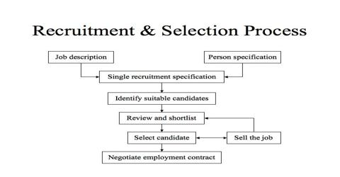
Figure 1 Recruitment and selection process
Source: (K, 2010)

Job Description
The job description is clarified form of the company’s culture, hierarchy, expectations and compulsory job roles from that specific job. This helps the employers to choose carefully from the CV and select the candidates properly. The job description is two types general purpose job description and specific purpose job description. Mainly in the advertisement for the recruitment process, two types of the job description are mentioned so that employees have a clear idea about what qualifications and ability are asked from a particular company. Job description varies for the banking sector, multinational companies etc.

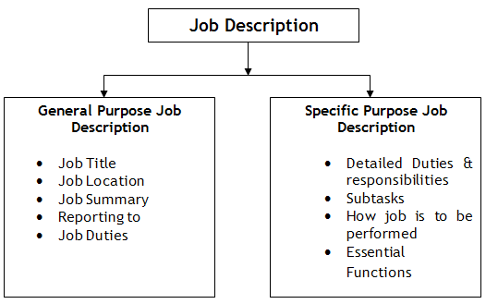
Figure 2 Types of Job Description
Source: (HR Daily Advisor, 2017)
The main purpose of the job description is that it helps both the employees and employers to understand what educational background is needed for the job, how many years of experience is needed and in which case it can be flexible for fresher’s. The potential candidates can get to know about the qualities that have been asking for from that particular organization so that he/she does not get puzzled when facing the written of interview board. He can also get the idea of the organization culture, environment, roles and responsibilities in a clarified manner which helps him to get prepared to appear on the interview board. Board of directors who would be taking the interview can also gain the idea about the competencies that are needed by the company so that they can frame their questions accordingly. It is helpful for the long-term benefit of the company so that if any confusions or indifference about work arise and employees excuse for not knowing the job, the employer can get the charge against him by showing the written document of the job description. It helps to establish reporting correctly to right person and assists in proper communication by the managers. Compensation and salary can be modified by the managers depending on the general purpose and specific purpose job description.
From the above discussion, it can be inferred that job description should be clarified to the candidates and the recruiters so that right person can be employed for the right job role.

Person Specification
The most challenging part of the recruitment process is person specification. It depends on the type of work the employee would be in and his/her inborn or practised qualities and abilities that make him able to perform any specific task effectively and efficiently. The person specification is not very much required for the low-level employees. It is required for the employees with high rank. Because they have the job roles which is basically decision-making capabilities from data analysis and reasoning. So, these types of jobs require some specific mental capabilities which can define the job roles and responsibilities clear to the potential applicant for the job.
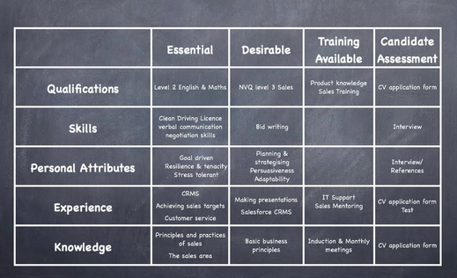
Figure 3 Person Specification
Source: (Grant, 1989)
The person specification is very important part of the recruitment process because the HR specialists have to lay out the plans and processes in order to choose the suitable employees. As person specification means qualification, skills, attributes, experience and knowledge, it helps the employees to set out the written examination in such a way where the person’s IQ can be tested, math and English proficiency can be judged. Through any case study process or teamwork, employers can identify the potential employee’s skills and experience in any organized situation. If it is not done properly, then the wrong person can be chosen for any challenging work environment and again any challenge loving people can be appointed to any job which may be seen boring to him. It not only helps employees to be neutral about judging the potential employees but also it helps the candidates to judge themselves in a situation that is done prior to the interview sessions. Thus, it makes communication easier for both of the parties. Organizations also do not have to suffer high job turnover where the person specification is done properly before the recruitment process.
From the above discussion, it is clear that the different quality people are suited in the different working environment. So, the HR department must specify the particular person specification in the prior advertisement process.

Task 2 Preparation of a CV for a specific job role
Here is CV to Washington Frank International for the post of a financial analyst.
Name: ABC
22 B, Road 32, London, UK.
Contact No: +44 2236 5555
Mail ID: abcd@gmail.com

Career Objective
Looking for challenging environment to employ the ERP system knowledge for the post of Finance Consultant in Washington Frank International, the leading ERP recruiters in the UK in a competitive environment where creativity is fostered along with ensuring secured work environment.

Educational Qualifications
Have done CFA from CFA Institute, the UK with 75% pass in each level.

Core competency & skills
- Time-bound
- Quick decision-making ability
- Language skill: Proficient and fluent in English and Spanish
- Computer Skill: Have good command over MS Office, Financial software SAP & Oracle E-business suite

Experience
Have been serving in Arrow Financial Services UK Ltd for 2 years.

Publications
Published equity reports for the retail companies in UK i.e. Asda, Tesco.

References available on request
Signature & Date

Task 3 From my personal experience and applying the STAR model, writing a statement of each competency that I selected: Team working, Problem solving.
The STAR model is the tool for shaping the employee behaviour and reaching the organizational performance that is expected of the managers of the company. The strategy chosen by the managers may vary depending on the goals and objectives of the company. Success and failure are also associated with this.
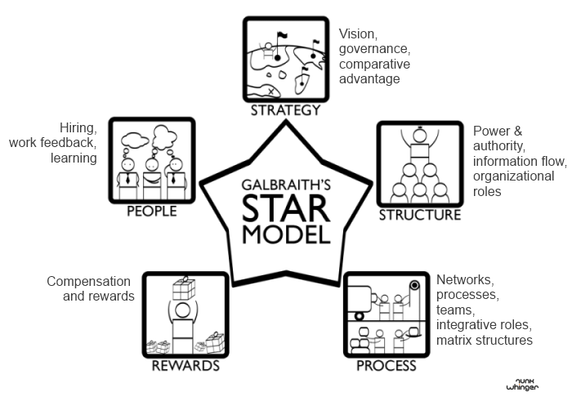
Figure 4 The STAR Model
Source: (User, 2017)

Elaboration of the competencies
There are some core competencies in a person which enables him to be successful in his employment life cycle. For the competencies, one can success and one can fail due to lack of competency required by any company.

Team working
While I was working in the largest retail company of the UK, which is Asda, I found that team working was a must for meeting the daily benchmark activities of the stuff. Because teamwork helps the staffs in a group to have an informal connection with them and share ideas. When I was newly recruited there, I noticed there was no cooperation among the managers and employees which resulted in a lack of understanding the direction and staffs were not able to share their unique ideas to improve the performance of Asda. But when managers turned the work environment into a friendly team working spirit, then the network got even stronger, communication became easier and as a result, there was consistency in the work environment. Besides, team working has strengthened the bonding among the group members. They could support each other while one was not available in the workplace. Responsibilities could be shared in the friendly environment. It was also noticeable that sometimes structure and process was followed from the STAR model which was the team leader communicated to the team members what the tasks would be and then each member was given with tasks with a specific matrix that works were mutually exclusive from each other so that there was no redundancy in the job roles.
So, the interview board should frame the process in such a way that the team working, coordination of the candidates can be judged by any case study or project implementation process being neutral.

Problem solving
Problem-solving skill is important while working in Asda. Because I was the customer service manager, I had to deal with customer complaints, needs and stuff which could be quite challenging some days. Many problems would arise during the daily tasks like one customer has bought any defected products, then the returning process from the stores. Customer care management for dealing with customers online, making sure that each customer has to face the least possible wait and convincing the customers in case of their POS time is longer for heavy rush in the stores as well as online. So, problems solving is important in every situation not only in customer service management but also a problem in dealing with suppliers if they are maintaining the quality products, checking the defected products, payment disbursement etc. In a retail store, many more problems arise from transportation to the inventory management system. Managers have to take decisions at the least possible time so that works can be run without any disruption in the daily process. Decision making capability is associated with intelligence. Managers should frame their questions accordingly so that candidates answer can be justified with their instant answers and their critical reasoning ability can be judged properly. So, managers should be focused on intelligence when they perform the recruitment process. Otherwise, the recruited employees would cause failure for the organization.
So, the HR department must include questions in the written examination as well as in viva board to judge the problem-solving skill of the candidates effectively without bias.

Conclusion
Employment process for any organization is important because both the employees and the employers should know about the defining the job roles, responsibilities, the qualities needed for each job roles. If the employees have the clear idea about the job roles and have the capabilities of writing the CV in an attractive manner, then his chances for getting interviewed increases. The HR department has to perform the task associated with the recruitment process after the overall organizational demands and needs. IF the recruitment process fails, job turnover would be high causing recruitment expenditure of the company to rise.

References
Compton, R., Morrissey, W. and Nankervis, A. (2009). Effective recruitment & selection practices. North Ryde, N.S.W: CCH Australia.
Grant, P. (1989). Multiple use job descriptions. New York: Quorum Books.
HR Daily Advisor. (2017). What is the Purpose of a Job Description? [online] Available at: http://hrdailyadvisor.blr.com/2013/11/04/what-is-the-purpose-of-a-job-description/ [Accessed 8 Dec. 2017].
K, R. (2010). Recruitment Management. Mumbai [India]: Himalaya Pub. House.
User, S. (2017). Jay Galbraith - Star Model. [online] Jaygalbraith.com. Available at: http://www.jaygalbraith.com/services/star-model [Accessed 9 Dec. 2017].

