BMSW4005
Professional Career Development-Portfolio of Work
Task 1 – Open Book Assessment case study on Diversity and Inclusion.

Student Name: Kushna Begum
Student ID: 1813048
Date of Submission: Thursday 11th February 2021

Introduction
Diversity is the characteristics that make people unique whereas inclusion is the behaviours and social norms that ensure people feel welcome and included within (bulletin.com). For the preparation of this assignment, the selected area I will be covering my views in terms of diversity and inclusion in the workplace.

Although I agree with all the point of views in the case study however, I do have a very unusual prospective ways of thinking and I will raise my own point of views. My personal views and research studies say that good people practice decisions benefit workers, wider society and organisations.
Three of the main business benefits of taking diversity and inclusion seriously are talent, market competitiveness, and corporate reputation.

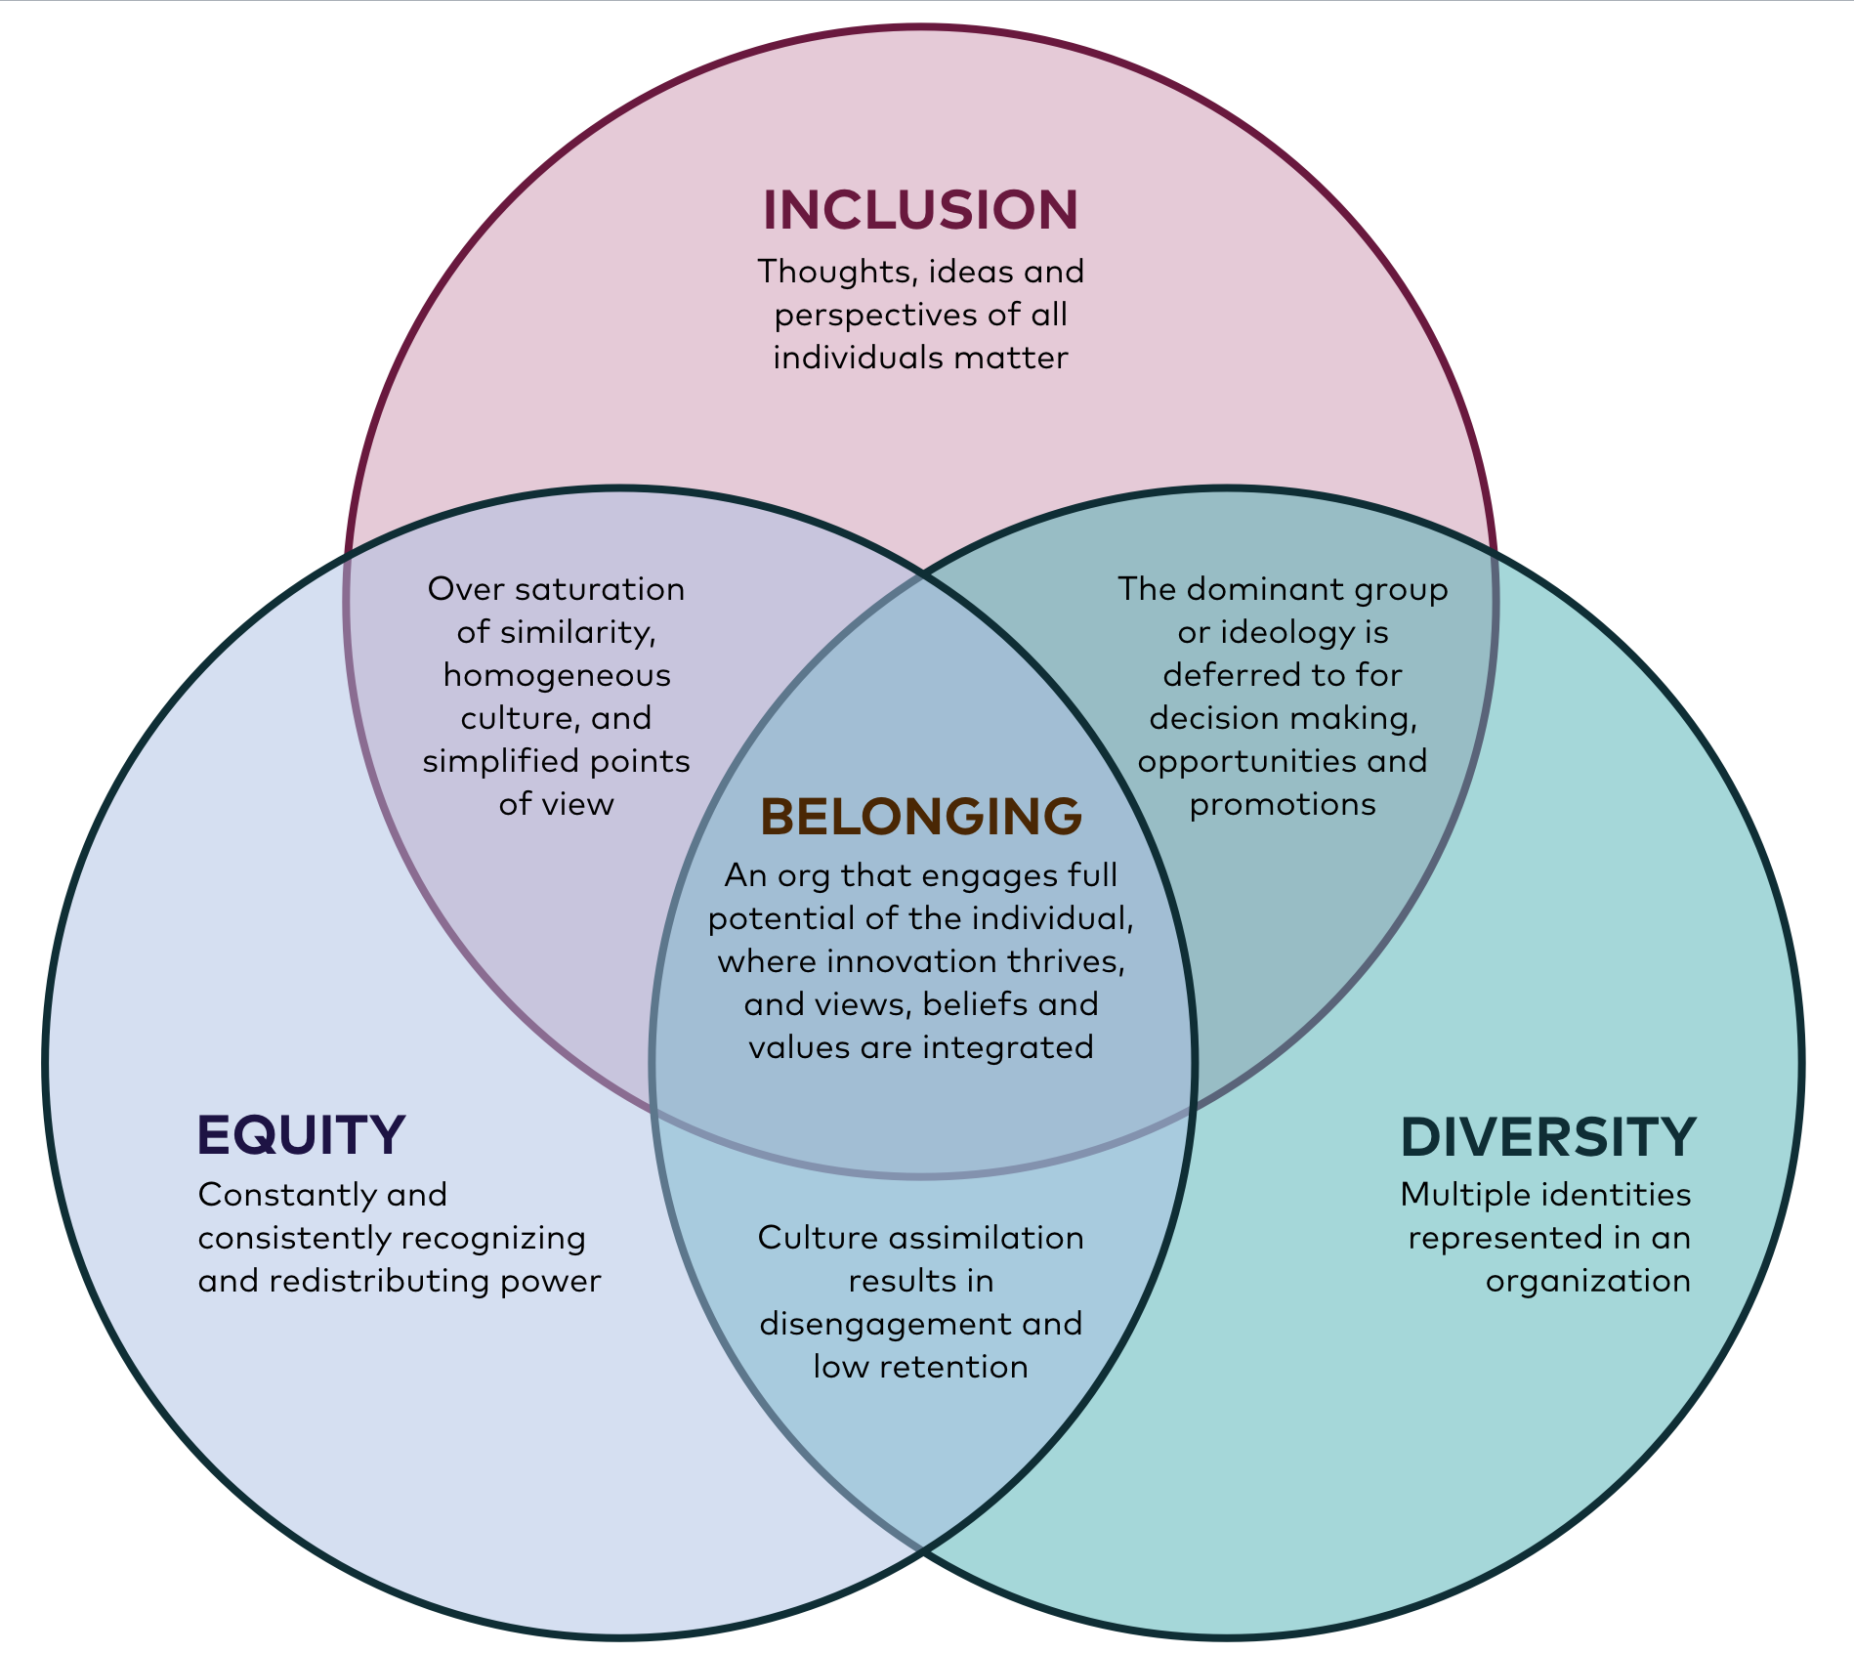
(Figure: medium)

Talent

[My personal views on this is the fact that I would like to feel valued for my talented contribution in the workplace, I have a very strong point of view on the trainings that take place at the workplace which ensures for the skilful talent not to go to waste and I would like to be treated fairly and respectfully.]

I am happy to see in my research that the employers are increasingly coming to recognise the strength of recruiting professionals from a range of backgrounds at all levels, as a result the business will gain access to a wide variety of point of views and different perspectives.
http://www.mckinsey.com/business-functions/organization/our-insights/why-diversity-matters
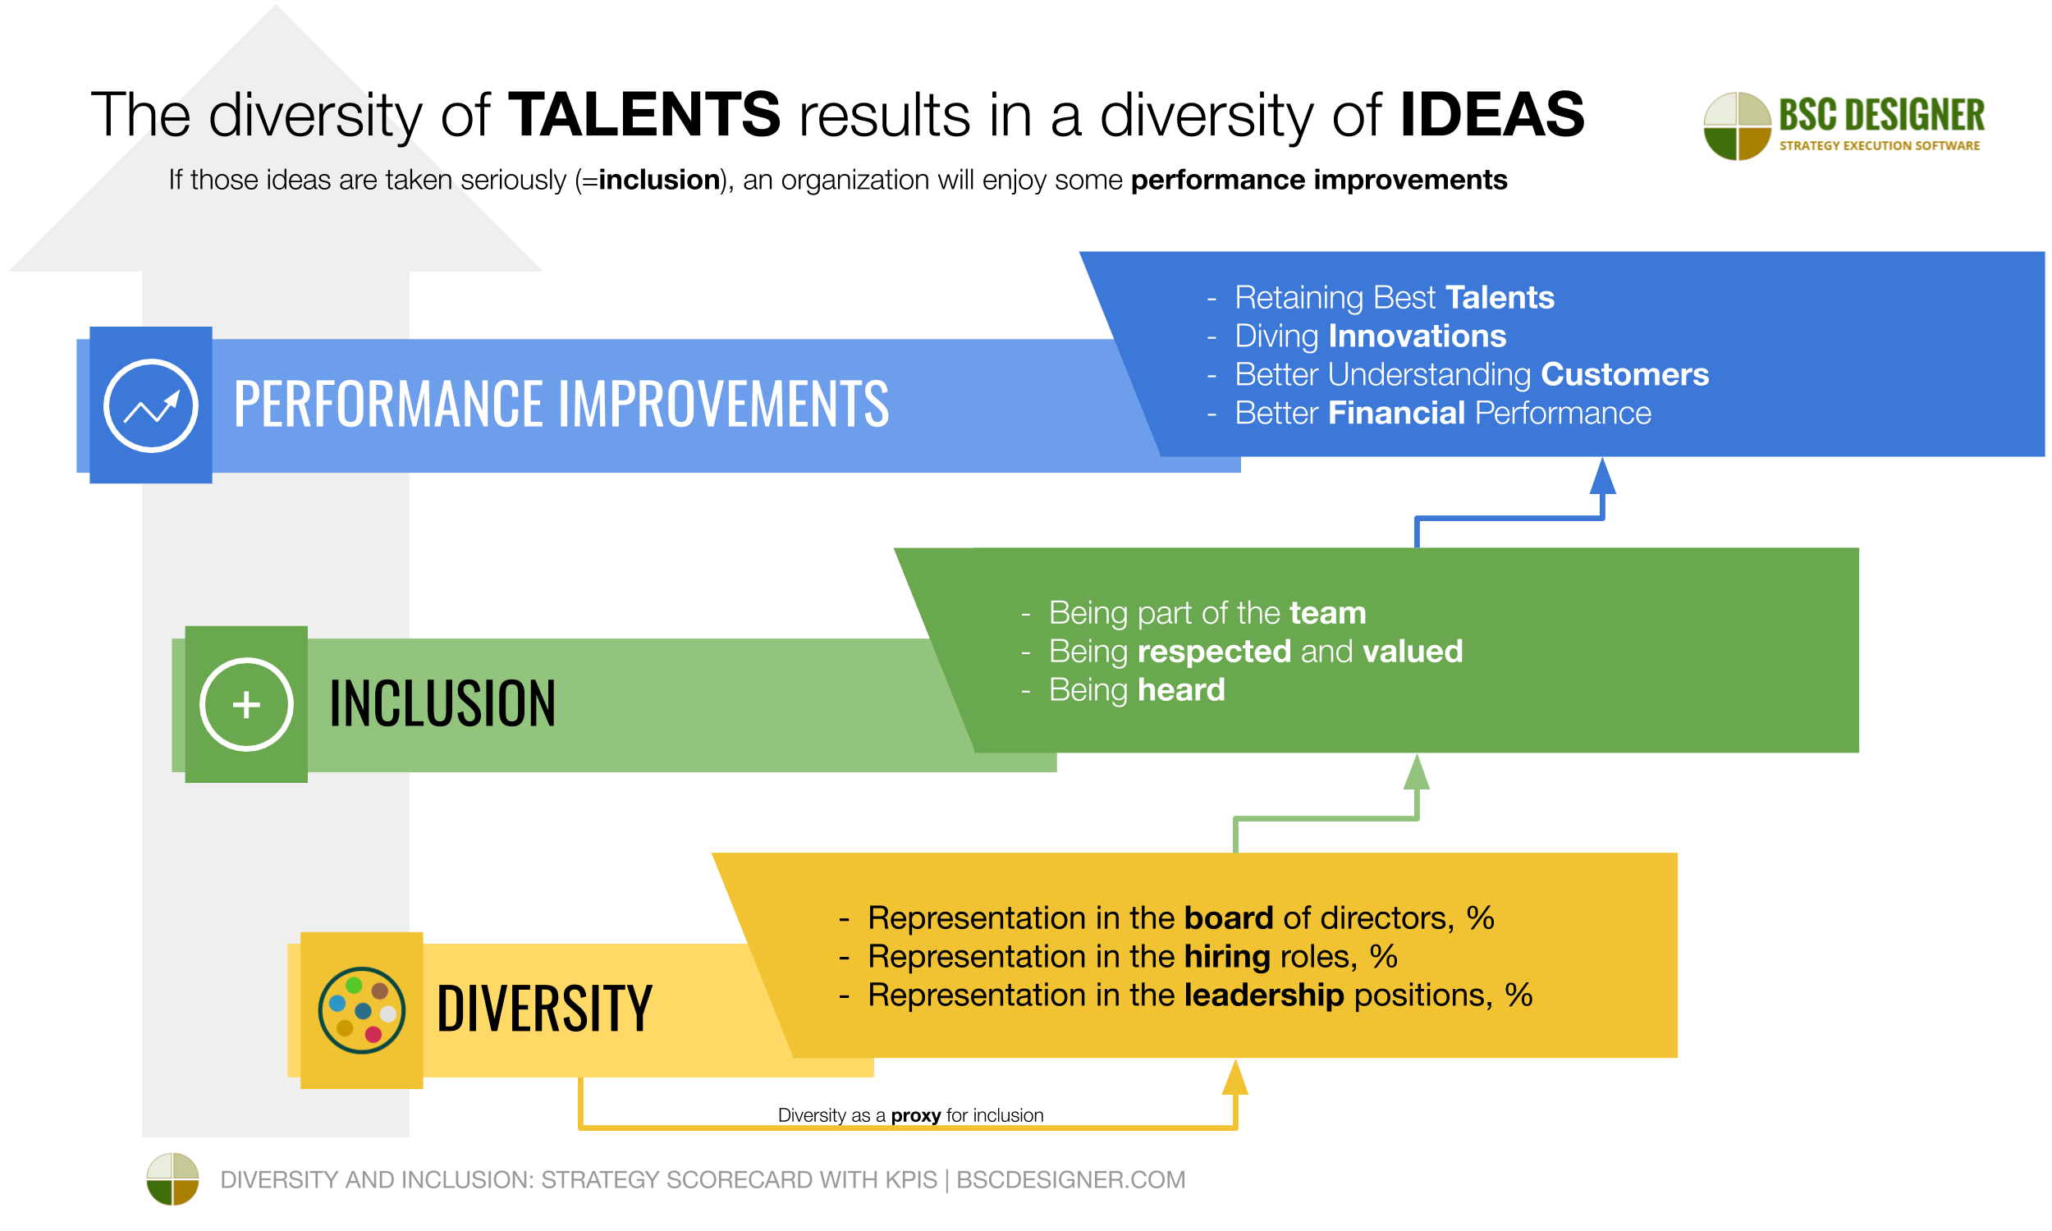

Market Competitiveness

[My personal views on this is that the organisation should hire a diverse range of different personalities and do a survey as the public views will be very diverse as the individuals, this will generate more profit and further appropriateness after listening to a diverse voice, as myself, I have always had a very different way of prospective thinking outside the box.]

3 further Diversity Perspective
(1) discrimination and justice, (2) access and legitimacy, and (3) integration and learning.
http://www.iaeme.com/IJMET/index.asp


https://blog.capterra.com/7-studies-that-prove-the-value-of-diversity-in-the-workplace/

Corporate Reputation

[My personal views on this is that the organisation should be responsible and hire a range of diverse employees as this will be a good growth on the business due to the multicultural world we live in, therefore overall your customers and employees will be satisfied which will be a good feedback for your company reputation.]

Research from Catalyst and around the world has found that diversity and inclusion benefit individuals, organisations, teams, and society.
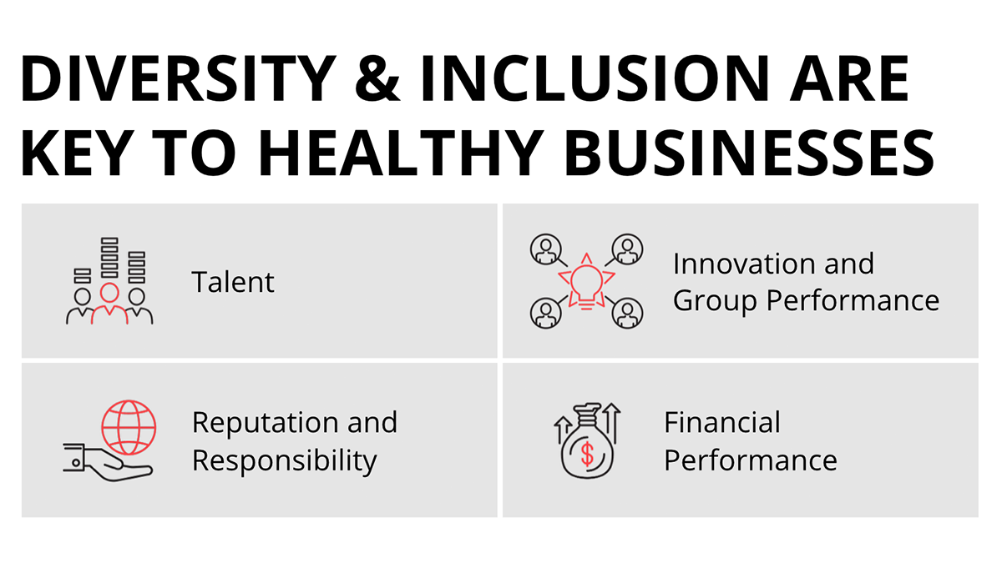

https://www.catalyst.org/research/why-diversity-and-inclusion-matter/

Conclusion
Diversity and inclusion is a key powerful device to make the organisation successful and effective. My personal findings to positively use of diversity and inclusion is to review the individual and analyse' roles for the betterment of the organisation that would meet profitability and productivity direction. Diversity considers positive results for individuals and customers, such as impact on well-being, and balanced working life. Which leaves enough time for your healthy social life and family time.

Reference
bulletin.com/Introduction
capterra.com/7-studies-that-prove-the-value-of-diversity-in-the-workplace/market competitiveness

catalyst.org/research/why-diversity-and-inclusion-matter/corporate reputation

iaeme.com/IJMET/index.asp/market competitiveness
mckinsey.com/business-functions/organization/our-insights/why-diversity-matters/talent
medium/figure
personal thoughts/:kb

