

BSc (Hons) Professional Police Practice

LEVEL 5 - 40 Credits

Workbook title: Competency Based Workbook 3 (PCDA)

(SOUTH WALES POLICE, GWENT POLICE AND UWTSD)

Learner name: Alice Franklin

Learner’s University Registration Number:
2029328

FACULTY OF BUSINESS AND MANAGEMENT
PUBLIC SERVICE PROGRAMME

Module title: Professional Police Practice 2 (PCDA) BMPP5000D

Workbook Guidance

Please read these notes carefully; they provide essential information.

What is the workbook for?

The purpose of this workbook is to enable learners to demonstrate and provide evidence of how they meet the learning outcomes set by the College of Policing, for the BSc programme. Essentially, you are being asked to outline your experiential learning based upon your theoretical understanding in a range of operational situations.

- Wellbeing and Resilience
- Decision-making and Discretion
- Vulnerability and Risk
- Public Protection
- Maintaining Professional Standards
- Leadership and Team-working
- Policing the roads
- Information and intelligence
- Conducting Investigations

You may wish to use the same incidents as you’ve outlined in the Occupational Competence Portfolio.

How should the workbook be presented?

Blank electronic copies can be found on Moodle of this workbook. You must submit this document electronically therefore it is important that you save your work regularly and upload the final typed version through Turnitin on Moodle.

Word count policy can be found in chapter 7 of the Academic Quality under section 7.7 (this applies to presenting work above and under the specified word count).
(https://www.uwtsd.ac.uk/media/uwtsd-website/content-assets/documents/academic-office/aqh-chapters/chapters---en/Chapter_07_Assessment_Taught_Programmes_Pages_72-79-UPDATED-05-11-2019.pdf)

Reflective practice is a core aspect for your workbooks and although there is a variety of useful resources on Moodle, there is one particular book, that is specifically based on reflective practice in policing, here is a link to one chapter from Selina Copley’s Reflective Practice for Policing Students:
https://moodle.uwtsd.ac.uk/pluginfile.php/298870/mod_resource/content/1/Reflective%20Practice%20for%20Policing%20Students%20-%20Selina%20Copley%20Chapter5.pdf

How is the workbook assessed?

Advice and support about the completion of this workbook will be provided by university staff as part of your initial training day. Your tutor constable and in-force training staff will not be involved in assessing or marking your workbook after it has been submitted.

Dates of workbook submission will be made available during the initial training day and posted on Moodle.

Once submitted your workbook will be assessed and marked independently.

Confidentiality

It is important that no individual can be identified either directly or indirectly from the information in the workbook. Therefore, you must:

- adhere to guidance in the Student Handbook about unfair practice and plagiarism.
- not identify individuals including witnesses, victims or offenders by name.
- not write information that enables any individual to be identified indirectly through the description you provide. This includes references to names, colleagues, places (including hospitals, schools, town, villages, streets) specific incidents which were high profile and could be identified due to past publicity, other professionals or any other personal information including medical or other conditions.
- take personal responsibility for adhering to confidentiality rules.
- not include any dates of any incidents or anything that specifically identifies an actual incident.

Please be aware that any content that is deemed to be inappropriate, disrespectful, or abusive will not be tolerated. Following review of any content of this nature the information will be shared with the employer of the student responsible.

Should any health and wellbeing concerns be raised because of disclosures made by the student within this workbook, the employer of the student will be informed.

NOTE

Your workbook will be submitted electronically via Turnitin on Moodle. Guidance on this is in the Student Handbook.

Remember that the workbook is YOUR responsibility you must not rely on the assessor or anyone else to pick up any confidentiality breaches as this is your work and you must accept full responsibility for confidentiality. Meeting all the confidentiality requirements is very important.

Dyslexia and other special circumstances

If you have any condition that you feel may affect your ability to deal with any part of the programme, please see the Student Handbook for further guidance. The University has a Student Services Unit that may be able to help but it is the learner’s individual responsibility to contact them.

Guidance:

- Your workbook must contain the items specified in the table below (clearly identified and in the order given);
- You should use this particular document to insert your text / answer within each section of this workbook;
- You should upload your completed document as a saved pdf file of this workbook; if this is not possible then a Worddoc file is acceptable. Do not send a scanned file from a photocopier, an apple.dot file or a Microsoft publisher file as Turnitin will not be able to assess them, despite you being able to upload them.

Contents

Workbook | Area of Professional Practice | Word count
Task 1 | Wellbeing and Resilience | 1250
Task 2 | Decision-making and Discretion  Vulnerability and Risk  Public Protection | 1750
Task 3 | Maintaining Professional Standards  Leadership and Team-working | 1750
Task 4 | Policing the roads  Information and intelligence  Conducting investigations | 1750
Task 5 | Individual Learning Plan | 1500 equivalent
 | Total | 8000
 | Bibliography

Task 1

Relevant areas of the National Policing Curriculum:
Wellbeing and Resilience

Having achieved Independent Patrol Status, reflect on the impact of organisation culture within policing on your wellbeing and resilience (organisation change, retaining personal values in a wider organisational culture).

Consider the risks of conforming to organisational culture.

Illustrate your strategies for maintaining wellbeing and resilience.

1250 words (+/- 10%: include your actual word count at the end of each section)

ANSWER:

Throughout this essay, I will aim to reflect on the impact of organisation culture within policing and how this effects my wellbeing and resilience. I will be considering the risks of conforming to organisational culture and try to illustrate my strategies for maintaining my wellbeing and resilience. I will also consider how I have retained my own personal values in the wider organisational culture.

Since achieving independent patrol status and having the comfort blanket of my tutor removed, organisational culture has become very apparent to me over the last 9 months. Organisational culture is defined as “the underlying beliefs, assumptions, values and ways of interacting that contribute to the unique social and psychological environment of an organisation." (GothamCulture, 2017)
In a large organisation such as the police, it is very easy to let the organisational culture have an unconscious impact on your well-being and resilience, whether it be a big or small impact and it is important to recognise this impact in order to maintain well-being and resilience.

As per (Luthar et al. 2000), resilience has been defined as a “dynamic process of maintaining positive adaptation and effective coping strategies in the face of adversity”.
A huge part of the organisational culture of the police that has the biggest effect on my well-being and resilience would be the traumatic incidents that us as police officers, attend most days of our working set which I would definitely refer to as adversity.
Police are always the first responders first on scene to every distressing incident and which therefore exposes them to witnessing the worst kinds of situations which more often than not, we are not used to before joining the job and can leave us feeling very traumatised.

(Cafasso, 2012) describes a traumatic event as “an incident that causes us as human beings, physical, emotional, mental or psychological harm.”
(Cafasso, 2012) also provides some examples of traumatic events and they include:
- physical pain or injury (e.g. severe car accident)
- Serious Illness
- Terrorism
- Witnessing a death
- Rape
- Domestic Abuse
All of which we as police officers attend on a daily basis. Now that I am 9 months into independent patrol status, I have spent time reflecting over these months and I have found that I find it hard to maintain a happy and positive attitude 24/7, even whilst at home, and I struggle sometimes to switch off from the incidents and trauma I have seen at work. Because of this, it is vital that I find suitable ways to maintain healthy well-being and keep building on my resilience. Before joining the police force, I was not very clued up on what well-being actually meant and therefore it has been an important part of my new role and new life to ensure that I understand why it matters so much. Through my exploration of well-being, I discovered that it is described as “Well-being is defined as a sense of health and vitality that arises from your thoughts, emotions, actions, and experiences. When we have well-being, we feel happy, healthy, socially connected, and purposeful most of the time.” By (Davis.T, 2022). They go on to say that there are different types of well-being and these are:
- Emotional well-being
- Physical well-being
- Social well-being
During these struggles on coming to terms with the incidents I am dealing with at work, it has been hard to find the motivation and energy levels to have as happy and care free life as I did before joining the police service. Police officers, and those that attend traumatic incidents in general, are at a higher risk of developing mental health concerns due to the nature of the incidents they are witnessing. (U.S. Department of Health & Human Services, 2022) defines mental health as “Mental health includes our emotional, psychological, and social well-being. It affects how we think, feel, and act. It also helps determine how we handle stress, relate to others, and make choices.” They go on to explain that Mental health is important at every stage of life, from childhood and adolescence through adulthood.
It has been therefore imperative that I find ways in my own time to be able to cope with this change and look after my mental health and therefore I have adopted strategies that assist me in maintaining and positively increasing well-being and resilience.
In this spare time, I aim to keep as active as possible through physical exercise and in particular, running.
Why is physical activity important? As per (American Heart Association, 2017), physical activity has a range of benefits and these include:
- It is a natural mood lifter
- It keeps you physically fit and able
- Boosts your energy levels
- Helps you sleep better
- Helps improve confidence
I go for a run in evening as much as I can and I maintain my attendance at the gym at least 5 times a week. Both of these activities help break up the day and give me the time and space away from work and my home environment to allow me to think and reflect on either the shift that has just passed or the shift I face that day.
A study by (Larcom, 2021), they found that out of 1,158 studies examined, 89% found a statistically significant, positive association between physical activity or exercise and mental health.
Another strategy I have implemented to my week is spending time outdoors. During my week, I will spend as much time as I possibly can outdoors. Reflecting on my last 9 months out of tutorship, I have realised how much time I spend in doors due to the nature of the role. I spend copious amounts of time in side peoples homes or businesses and the police station and therefore I make an effort on my rest days and spare time before shift to be outdoors in the fresh air. This can vary from taking the dog to the park, going to a beauty spot or simply going for a walk around the block before I go to sleep. I have seen an incredible difference in my mood and physical fitness since spending more time walking. (Gough, 2018) explores the benefits of spending time outdoors and these include:
- Fights off stress
- Reduces inflammation
- Helps eliminate fatigue
- Lowers blood pressure
- Improves memory
Finally, the last strategy I have put in place (which still requires some work) is talking to family and friends about the things that I am struggling with. Personally, I do not like or enjoy talking about my problems or what in particular I am struggling with. However, the role of a police officer is both physically and emotionally demanding and I have found over the last 9 months that without expression these emotions, the problems become heavier. Since talking to family and friends, I have seen a substantial change in my ability to cope with the trauma.
(Ghayas, 2019) investigates the benefits to discussing the problems you are facing. These benefits include but are not limited to:
- Sort through and solve the issue
- More clearly visualise the situation
- Consider the issue from a fresh or unique angle
- Release any stress that has built up; doing so can give you fresh perspective on the issue
- Discovering that you are not alone
- Find alternatives or fixes you hadn't considered previously.

In conclusion, I have discovered how important it is to adopt strategies to help maintain well-being and resilience. The strategies I have found have become a vital part of my life and allow me to become a better Police Officer because of it. I will continue to demonstrate these strategies during my everyday life in the hope that I can continue to improve my overall health.

Word count: 1303
Task 2

Relevant areas of the National Policing Curriculum:
Decision-making and Discretion, Vulnerability and Risk, Public Protection.

You must choose an incident, for example a domestic related incident, and reflect on how you made decisions in complex and unpredictable circumstances using dynamic risk assessment.

Give a brief description of the problem including social and legislative contexts and any relevant cultural, ethnicity and language issues.

Evaluate decisions made during the incident and your use (or otherwise) of the National Decision Model. Explain the rationale behind your decisions and your considerations when recording details of the incident. Consider your ethical approach to the decision. Outline the consequences of your decision making.

1750 words (+/- 10%: include your actual word count at the end of each section)

ANSWER:

In this essay I will be talking about a policing incident and how I made decisions in complex and unpredictable circumstances using a dynamic risk assessment. I will be talking about a domestic related incident that I attended and I will be including social and legislative contexts and I will aim to evaluate the decisions that I made throughout the incident including how I incorporated the national decision making model. In addition to this, I will include my explanation of my rationale behind each decision I made and the considerations I took into account when making them and my ethical approach towards these. With any decision comes consequence and I will also aim to detail these potential consequences.
A domestic related incident is described as “Any incident of threatening behaviour, violence or abuse (psychological, physical, sexual, financial or emotional) between adults who are or have been intimate partners or family members, regardless of gender or sexuality.” This includes issues of concern to black and minority ethnic (BME) communities such as so-called ‘honour killings’. Anyone can experience domestic abuse regardless of gender, race, ethnic or religious group, sexuality, disability or lifestyle. (LWA, 2022)
The incident that I will discuss throughout my essay was a domestic related incident involving a 16 year old boy who had been assaulted by his father. This incident did not have any cultural, ethnicity and language issues.
I was given information of a grade 1 emergency call from a female claiming that her 16 year old brother had been punched in the ribs and thrown on the bed and pinned down by their father leaving a visible bruise to the boys ribs.
Straight away, I am considering the decisions that I need to make in relation to this call. I immediately start using the National Decision Making Model.
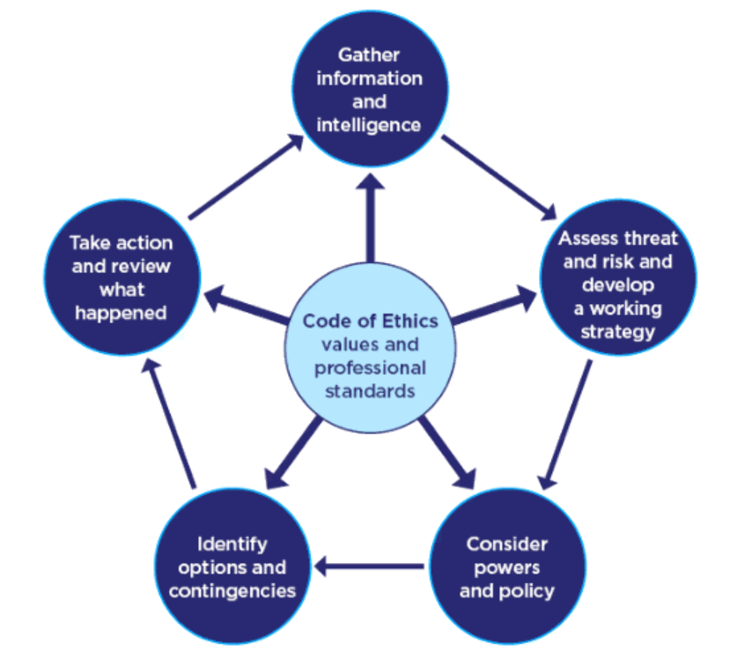
(College Of Policing, 2014)
The NDM has six vital elements to it and they are:
- Code of Ethics.
- Gather information and intelligence.
- Assess threat and risk and develop a working strategy.
- Consider powers and policy.
- Identify options and contingencies.
- Take action and review what happened.
At the very centre of the national decision making model is the code of ethics. This should continuously be applied to everything we do as police officers and it sets out the principles and standards of professional behaviour. The code of Ethics states that we should follow the 9 policing principles and the 10 standards of professional behaviour.

The 9 policing principles and their meanings:
- Fairness – you treat people fairly.
- Honesty – you are truthful and trustworthy.
- Integrity – you always do the right thing.
- Leadership – you lead by good example.
- Objectivity – you make choices on evidence and your best professional judgement.
- Openness – you are open and transparent in your actions and decisions.
- Respect – you treat everyone with respect.
- Selflessness – you act in the public interest.

The 10 standards of professional behaviour and their meanings:
- Honesty and integrity — I will be honest and act with integrity at all times, and will not compromise or abuse my position.
- Authority, respect and courtesy — I will act with self-control and tolerance, treating members of the public and colleagues with respect and courtesy. I will use my powers and authority lawfully and proportionately, and will respect the rights of all individuals.
- Equality and diversity — I will act with fairness and impartiality. I will not discriminate unlawfully or unfairly.
- Use of force — I will only use force as part of my role and responsibilities, and only to the extent that it is necessary, proportionate and reasonable in all the circumstances.
- Orders and instructions — I will, as a police officer, give and carry out lawful orders only, and will abide by police regulations. I will give reasonable instructions only, and will follow all reasonable instructions.
- Duties and responsibilities — I will be diligent in the exercise of my duties and responsibilities.
- Confidentiality — I will treat information with respect, and access or disclose it only in the proper course of my duties.
- Fitness for work — I will ensure, when on duty or at work, that I am fit to carry out my responsibilities.
- Conduct — I will behave in a manner, whether on or off duty, which does not bring discredit on the police service or undermine public confidence in policing.
- Challenging and reporting improper behaviour — I will report, challenge or take action against the conduct of colleagues which has fallen below the standards of professional behaviour.
Given the definitions behind each of these principles, it is obvious why they need to be integrated into our behaviour when dealing with members of the public at incidents.

When I got to the scene of the incident, I met with the boy and the female, which was his sister, outside of the address and both were very visibly upset and distressed by the incident. As the report had come in via a third party (his sister), I had to establish what had actually happened and if the original report was correct. I also had to ensure the details of the boy were correct and his age. Therefore, I started off by component one of the National Decision Making Model and I began gathering my information and intelligence. I spoke with the boy and asked him if he was ok and if he was injured in any way. The boy confirmed that he had been assaulted by his father following a verbal argument and that he had pain and a bruise to his ribs. I then conducted a person search of the father with the details obtained by the sister to gather further information and intelligence regarding him, to check for any warning markers that he may have, especially for being violent or carrying any weapons

I then established where the father was at present and both the boy and the sister advised that he was still inside the property and that he had been drinking alcohol. I have therefore moved to the second stage of the National Decision Making model and have begun to assess the threat and risk and thus develop a working strategy. As the sister was 18 and therefore an adult, I left the boy in the care of his sister a short walk down the road from the property as the sister had explained that the boy suffered from ADHD. While they waited there, myself and my colleague went into the address.
As the person search came back with a result for a violent warning marker, I made sure to announce my presence before entering the address to make the father aware that we were there. I have then met with the father and engaged in a calm conversation with him. The male was calm and non-violent and explained that due to his sons ADHD, he had to use force to restrain him which is where the bruise on his ribs had come from.
I then had to consider what powers and policies were available to me which is stage three of the National Decision Making Model. Although the account from the boy and the account from the father did not match, I went on the information that had been reported to us. South Wales Police policy states that positive action must be taken in relation to all domestic incidents and therefore I considered my powers under the Police and Criminal Evidence Act 1984. (South Wales Police, 2015) states that “South Wales Police has a positive action policy in relation to offences of this nature and robust action is taken to assist and safeguard vulnerable victims and their families at all stages of the police response”. I then confirmed with the father the details and date of birth of the boy and he confirmed that the boy was 16. This has then set in stone that an offence of domestic assault had taken place. I then moved to stage four of the National Decision Making Model which is to consider my options and contingencies. As I had established that a domestic related offence had taken place, I felt that my only appropriate and reasonable option was to arrest.

Domestic Abuse is defined as:
Behaviour of a person (“A”) towards another person (“B”) is “domestic abuse” if—
(a)A and B are each aged 16 or over and are personally connected to each other, and
(b)the behaviour is abusive.
(GOV.UK, 2021)
Subsequently, I have moved to the final stage of the National Decision Making Model and I have taken action by arresting the father to allow for the prompt and effective investigation into the allegation and to prevent any further harm to the boy, thus safeguarding him due to his age and vulnerability. ‘”A vulnerable victim is a person whose experience and/or effect of harm as a result of an incident is likely to be more significant because of their individual personal circumstances’”. (Law Insider, 2013)
I immediately asked another co-worker to take the father into custody so that I could stay behind with the victim, check on him, and put safety measures in place. I accomplished this by arranging for him to stay with a close relative until he was prepared to think about his long-term living arrangements. I took the required actions to make sure that his social worker was informed, and I completed a Public Protection Notification to make sure that I had done everything in my power to get him the best assistance that the police could offer.
Following all available measures being put into place, I have reviewed what I have done and what has happened and therefore in conclusion, the arrest of the father was absolutely necessary in order to ensure the safety of the victim and the wider community around him such as his sister. I was able to effectively make logical and rational decisions based on the information I had gathered and I was therefore able to successfully deal with the incident putting the victim first.

Word count: 1665

Task 3

Relevant areas of the National Policing Curriculum:
Maintaining Professional Standards, Leadership and Team-working

Evaluate theories of team dynamics as a means of developing team cohesion (reasons why some teams cannot function, theories and models relating to team dynamics, ways to improve team cohesion).

Consider why inter-personal conflict can occur within a team and outline what strategies can be adopted to enhance individual and team performance.

Consider how team dynamics within the police service can result in failing to comply with professional standards requirements (Code of Ethics, policies, procedures, protocols or legislation).

1750 words (+/- 10%: include your actual word count at the end of each section)

ANSWER:

Throughout this essay I will aim to evaluate the theories of team dynamics as a means of developing team cohesion and consider why inter-personal conflict can occur within a team. I will also aim to outline what strategies can be adopted to enhance individual and team performance. I will also consider how team dynamics within the police service can result in failing to comply with professional standards.

Team cohesion, as explain by (Nuclino, 2020), is “when a group of individuals in an organisation share a strong sense of common identity”. Ultimately, it is the way in which team members work together as one in an attempt to achieve a common goal that they all desire. In order to achieve team cohesion, effort and time needs to be put into building the relationship between team members and ensuring consistency and understanding throughout. There are many different ways of building team cohesion and some of these are:
- Communicating effectively with each other
- Being open and honest with one another
- Respecting everyone no matter their background or opinions
- Helping each other out and going to extra mile for each other
- Spend time getting to know each other, inside and outside of the work environment
Achieving team cohesions and adopting it into an everyday working life has its increased benefits, some of which are:
- Trust is built and maintained among team members
- Confidence in the work being produced
- Increased morale
- Achieve goals
Whilst in an ideal world, team cohesion would be strong and unbreakable, there are certain ways teams can’t function without this solidarity. One way that team cohesion can fail is when inter-personal conflict can occur within a team.
Inter-personal relationships is described as “The meaning of interpersonal relationships is how you connect with someone else—the way you communicate with them or understand them, and vice versa. It’s a two-way street that requires a free-flow of communication and a deep understanding of one another” by (Harappa, 2020). That being said, it is obvious that due to inter-personal relationships, conflict is inevitable at some point within a team. However, there are strategies that can aid in avoiding this conflict. One strategy that can be adopted is team building exercises. Team building exercises can enhance individual and team performance by helping to build trust and confidence in one another and as a result, help build inter-personal relationships too. (Guide, 2021) lists a range of benefits seen when team building exercises are incorporated into teams. Some of these benefits include increasing productivity and creativity, boosts motivation, improves confidence and trust and improves morale. (TeamStage, 2021) explores the effectiveness surrounding team building exercises and has discovered that nearly 75% of employees see teamwork and collaboration as essential. Also, 33% of employees believe fostering a collaborative culture leads to increased loyalty. Finally,
One theory that demonstrates ways in which you are able to increase team cohesion is the GRIP Model, which was developed in 1972. It outlines the core functions of effective teamwork.

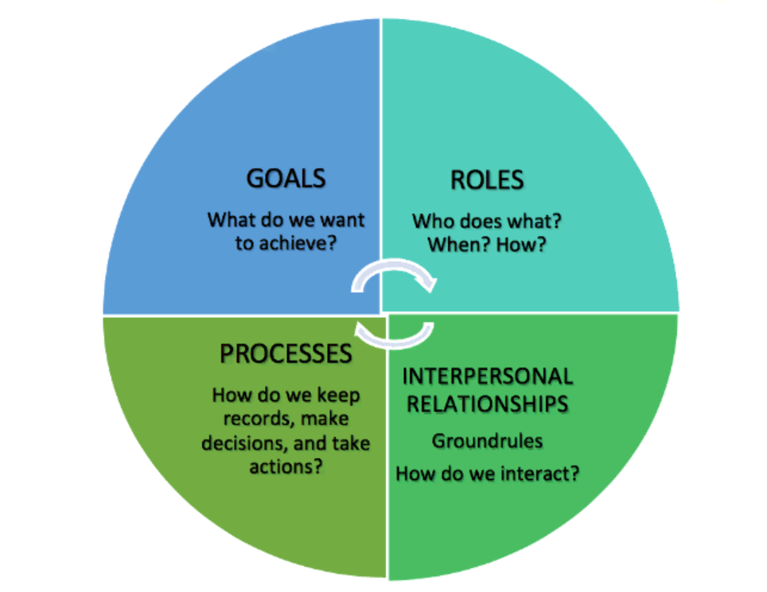
(Richard Beckhard, 1972)

The four interrelated sections that make up the GRIP Model are GOALS, ROLES, INTERPERSONAL and PROCESS which I have explained below:
- Goals: is the theory that everyone on the team must be entirely committed to the goals of the team and the wider organisation. This will result in trust being built, constant progress being made and actually achieving the outcome desired by all.
- Roles: There is a part to play by all individual team members in achieving goals and increasing team cohesion. Each team member should be knowledgeable on what their role is and how they can effectively manage their time to meet the expectations of the team
- Interpersonal: Effective communication and team work creating trust
- Processes: A way in which the team overcome problems and follow procedures to allow consistency

While it may be simple to look at these theories and try to incorporate the elements of these models into working team lives, there are obstacles that teams must overcome in order to improve their teamwork. The Lencioni Model is a hypothesis that examines these issues. The Lencioni model was created in 2005 with the intention of highlighting the issues affecting team dynamics.
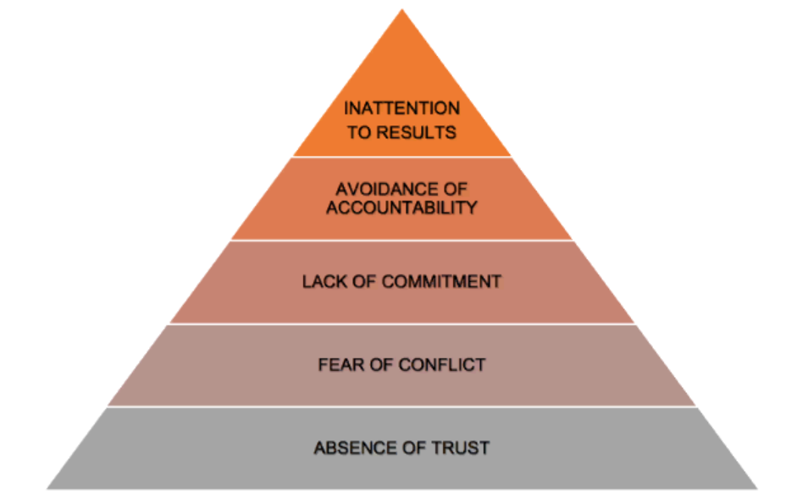
(Lencioni, 2005)

- Lack of trust: How can a team work if there is no trust among them? A lack of trust means that team members will not ask each other for help and therefore make it incredibly difficult to communication in any way whatsoever
- Fear of conflict: Team members often avoid approaching a problem in order to avoid conflict surrounding that problem and this then leads to a false peace among team members resulting in no progression. Lencioni states that conflict is a normal part of team work and can be managed if done effectively
- Lack of commitment: Team members lack in committing to doing the work in their role or do not follow through with promises or their decisions thus letting their team down and effecting the dynamics of the team
- Avoidance of accountability: Following on from point three, team members therefore avoid accountability of their failings and therefore create a bigger divide among the team
- Inattention to results: when team members focus on their own personal goals instead of the wider team, they lose the ability to be team players

After reviewing the Lencioni Model, it is critical to make sure that teams are taking the required and acceptable actions to integrate team cohesion into their day-to-day operations. Every organisation needs it, but the police service really needs it as it serves such a substantial amount of people that rely on professional and impeccable behaviour. All employees of South Wales Police must abide by the Code of Ethics established by the College of Policing which sets out the 9 policing principles and the 10 standards of professional behaviour. If the Lencioni Model's phases make up a larger portion of a team's culture than the Standards of professional behaviour then we will fail to comply with the Code of Ethics all together.
The 10 Standards of Professional behaviour, as per the College of Policing, are:
- Honesty and integrity – I will be honest and act with integrity at all times, and will not compromise or abuse my position.
- Authority, respect and courtesy – I will act with self-control and tolerance, treating members of the public and colleagues with respect and courtesy. I will use my powers and authority lawfully and proportionately, and will respect the rights of all individuals.
- Equality and diversity – I will act with fairness and impartiality and I will not discriminate unlawfully or unfairly.
- Use of force – I will only use force as part of my role and responsibilities, and only to the extent that it is necessary, proportionate and reasonable in all the circumstances
- Orders and instructions – I will, as a police officer, give and carry out lawful orders only, and will abide by Police Regulations
- Duties and responsibilities – I will be diligent in the exercise of my duties and responsibilities
- Confidentiality – I will treat information with respect, and access or disclose it only in the proper course of my duties
- Fitness for work – I will ensure, when on duty or at work, that I am fit to carry out my responsibilities.
- Conduct – I will behave in a manner, whether on or off duty, which does not bring discredit on the police service or undermine public confidence in policing
- Challenging and reporting improper behaviour – I will report, challenge or take action against the conduct of colleagues which has fallen below the standards of professional behaviour.
(College of policing, 2018)

The 9 Policing principles are:
- Accountability – You are answerable for your decisions, actions and omissions
- Fairness – You treat people fairly
- Honesty – You are truthful and trustworthy
- Integrity – You always do the right thing
- Leadership – You lead by good example
- Objectivity – You make choices on evidence and your best professional judgement
- Openness – You are open and transparent in your actions and decisions
- Respect – You treat everyone with respect
- Selflessness – You act in the public interest
(College of policing, 2018)

The Code of Ethics is in place the ensure that all members of the police service act in line with the behaviour principles set out and to ensure that the best service can be provided to the members of the public, doing “the right thing in the right way”.
As previously states, if we fail to comply with these standards and principles that are outline in the Code of Ethics then we will fail to comply with it, meaning that we as police officers are not acting with honesty and integrity which is the fundamental foundation of being a police officer.

In conclusion, I have evaluated the theories of team dynamics as a means of developing team cohesion and I have demonstrated this through explaining these theories including through their diagrams. These theories explain how in order to develop team cohesion, the team dynamic must eliminate certain behaviours and that there are several ways to help do this. It is clear that the Code of Ethics is vital to policing and it’s wider employees and I have demonstrated why it is paramount to adhere to them in order to ensure they are complied with and the police service and their individual, smaller teams can continue to serve their communities in the most professional and effective way possible.

Word count: 1587

Task 4
Relevant areas of the National Policing Curriculum:
Policing the roads, information and intelligence and conducting investigations.

Explain how information and intelligence can be used in the disruption of the more prevalent criminal activity (e.g. drug smuggling, human trafficking, child sexual exploitation, counterfeit goods, organised crime groups and ‘county lines’) by effective policing of the roads.

Outline how ANPR can be used as investigative resource when disrupting criminal activity.

1750 words (+/- 10%: include your actual word count at the end of each section)

ANSWER:

Throughout this essay I will aim to explain how information and intelligence can be used in the disruption of more prevalent criminal activity such as drug trafficking, human trafficking, child sexual exploitation and organised crime groups including county lines, by effective policing of the roads.
I will also include an attempt to outline how ANPR can be used as an investigative resource when disrupting said criminal activity. I will aim to focus on looking at drug trafficking in particular due to the relevance in today’s current society.

What is information and intelligence?
Intelligence, as explained in depth by (National Crime Agency, 2019), is “information that has been analysed to assess its relevance and reliability”. Intelligence is information concerning incidents, events or people which is subjected to a system of processing and is not necessarily evidence. Once the information has been processed, it can then be turned into usable intelligence. This process ensures ethical, accountable and transparent practice is taking place. Intelligence is used to build a picture of unlawful activities, to convert the information into evidence, which can be used to prosecute offenders.
There are many different ways to collect intelligence from a wide range of sources and these include:
- Open source – which (UpGuard, 2021) explains that open source intelligence is data obtained from publicly available sources such as social media or search engines.
- Security and intelligence agencies
- Private sector reporting
- Members of the public
- Undercover operations that undercover police officers operate
(National Crime Agency, 2018)

Information, as defined by (Differencebetween, 2014) is “Information is data or knowledge of something learned or gained from somewhere.” It is raw data that can be original and generated by police officers or it may come from the public or other officers, or be fed to police by partner agencies and other sources.
As police officers, we can gather information by:
- Information will only be forthcoming if the community has confidence in the police and officers themselves
- Building relationships with people will help information to be told
- Gratitude must be expressed to individuals providing information and intelligence so that the individuals feel it is being taken seriously
- Key source is initial gathering of information at the scene and the crime report

A way in which information can be processed into intelligence is by using the Grading system 3 x 5 x 2. In order for raw information to be evaluated it goes through the 3 x 5 x 2 grading system. The first part of the grading system is to sort the information into reliable, untested and not reliable information. There is a need to accurately evaluate this information because each piece of information can either be:
- Known directly
- Known indirectly to the source but corroborated
- Known indirectly to the source
- Not known
- Suspected to be false
The final part of this 3 x 5 x 2 grading system is called the handling code, as seen in the diagram bellow.
This final part then provides a risk assessment before making the decision to disperse the new found intelligence. The two handling codes are:
- Lawful sharing permitted
- Lawful sharing permitted with conditions

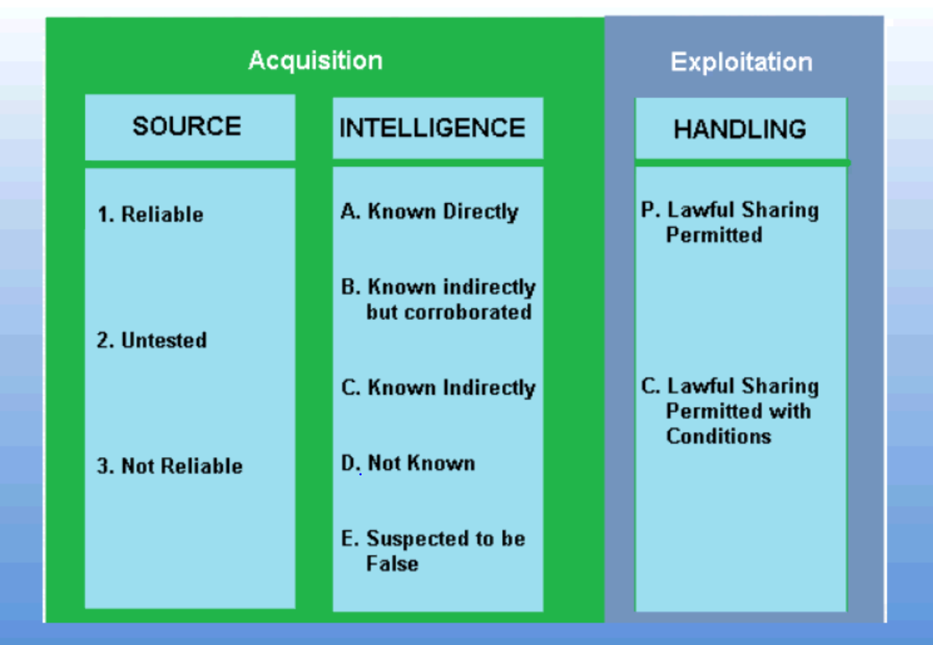

The 3 x 5 x 2 Grading System (NAFN, 2020)

Once it has been decided to disperse this intelligence, it should only be shared for a policing purpose only.

Information and intelligence can be vastly used when attempting to prevent prevalent crime. What is a crime? A crime is defined by (lawhandbook.sa.gov.au, 2017) as “an offence that merits community condemnation and punishment, usually by way of fine or imprisonment.” A prevalent crime are the crimes that far outweigh other crimes in terms of seriousness. An example of prevalent crime is drug trafficking which I will be referring to throughout this essay.
(Team, 2019) define drug trafficking as “Drug trafficking is the process by which individuals manufacture and distribute illegal drugs throughout the country.” Each individual component of the process involved in the making and distribution of illegal drugs, whether that be making them or passing them onto another person to sell them for you, falls under the umbrella of drug trafficking.
The creation and distribution of drugs is heavily operated by organised crime groups. As per, and under the Serious Crime Act 2015, an organised crime group explains:
“An OCG is defined (section 45(6)) as a group which:
- Has at its purpose, or one of its purposes, the carrying on of criminal activities, and
- Consists of three or more people who agree to act together to further that purpose. “
Drug trafficking can also lead to many other serious offences and circumstances and this includes to exploitation of children and vulnerable people. This exploitation often involves threating these groups of people with violence such as kidnapping and serious assaults and also involve weapons such as guns and knives.. In addition to this, where there is one organised crime group, another is not far away leaving many of these groups in violent rivalries and can often lead to deadly results. Due to the nature of the drug trade and it being a crime that is constantly on the move, it requires a massive use of the roads to assist them in carrying out their crimes and offences and this is where county lines comes into play. County lines is where Organised Crime Groups use networks to move illegal drugs into different areas around the country. More information on country lines can be found through (National Crime Agency, 2018). An example of a network Organised Crime Groups use to export drugs from one area to another is by using the roads.
As police constables there are a wide variety of options available to us when it comes to effectively policing the roads and this is where information and intelligence helps assist us.
ANPR (Automatic Number Plate Recognition) is a type of camera that scans a number plate and runs the details against the police database. The results will bring back any cars that are of particular interest or those that have been involved in crime and are outstanding. The point of Automatic number plate recognition is to help detect, deter and disrupt criminal activity and as per (Police.uk, 2022), this includes criminals who use the roads to travel and avoid getting caught, organised crime groups and terrorists.
Police Constables also have the legal power to stop vehicles under Section 163 of the Road Traffic Act 1988. Section 163 dictates “A person driving a mechanically propelled vehicle on a road must stop the vehicle on being required to do so by a constable in uniform or a traffic officer.” In addition to this and aside from Automatic Number Plate Recognition, police constables have the facility to check a number plate themselves using their force issued devices which accurately and quickly provides the police constables stopping the vehicle with access to any intelligence held on the vehicle or the person driving the vehicle. Under Section 164 of the Road Traffic Act 1988, the police constable can then request the driver to produce his license and under Section 165 of the road Traffic Act 1988, the police constable can then request the drivers insurance documents. This information and intelligence can then lead to the police constable potentially seizing the vehicle under Section 165 of the Road Traffic Act 1988 depending on if the Police Constable has reasonable grounds to suspect an offence has been committed. In addition to the Road Traffic Act 1988, another piece of legislation that assists police with deterring crime on the roads is the Misuse of Drugs Act 1971. Section 23(2) of the Misuse of Drugs Act 1971 gives police constables the permission to stop and search any person or vehicle if they have reasonable grounds to believe that they are carrying drugs or a vehicle is carrying drugs.
Section 23(2) of the Misuse of Drugs Act 1971 states:
“If a constable has reasonable grounds to suspect that any person is in possession of a controlled drug in contravention of this Act or of any regulations made thereunder, the constable may—
(a)search that person, and detain him for the purpose of searching him;
(b)search any vehicle or vessel in which the constable suspects that the drug may be found, and for that purpose require the person in control of the vehicle or vessel to stop it;
(c)seize and detain, for the purposes of proceedings under this Act, anything found in the course of the search which appears to the constable to be evidence of an offence under this Act.”
(legislation.co.uk, 2011)
To conclude my essay, it is apparent by my findings that there are multiple investigative resources available to police in order to disrupt prevalent crime by effectively policing the roads. Crime, especially prevalent, is becoming an increasing issue such as the drug and human trafficking trade which presents a massive threat to society and the welfare of the general public. Effective policing of the roads is assisted greatly by the use of ever-developing technology including the automatic number plate recognition cameras. The correct handling of information and intelligence is proving to be an invaluable source of being able to efficiently and safely deter, disrupt and detect criminal activity and bring criminals to justice.

Word count: 1576

Task 5
Individual Learning Plan

The second learning outcome identified in the accompanying module descriptor (BMPP 5000D) asks that you create an individual learning plan to meet your identified needs through reflection upon your continuing practice. This shows confidence in your ability to manage your own learning in response to evolving circumstances in the workplace.

This task differs from the PDPs that you have completed in your previous workbooks in that this learning plan allows you to assess what level you believe you are in key knowledge, skills and experience against where you believe you (and the force) consider you should be – now and in the coming 6 to 12 months of your placement. This should then be used to target future development need.

1500 words equivalent. Please note that this is not the actual number of words used in completing the table, the count reflects the thought and research behind it.

It will count towards the overall equivalent word count of 8000 words expected from this module.

ANSWER:

Knowledge, Skills and Experience Assessment

 | REQUIRED |  |  | RATING |  |  | DEVELOPMENT NEED
KNOWLEDGE | Low  1-4 | Med  5-7 | High  8-10 | Low  1-4 | Med  5-7 | High  8-10 | I have been able to use the last 9 months to develop my skills and knowledge in every aspect of policing but naturally, there are still areas I am struggling with and need further time to learn about.  I would like to build my knowledge further on legislation, especially surround traffic and the Road Traffic Act 1988.  Due to my role, being a response officer, I am out on mobile patrol constantly. This means that I spend a large majority of my shift out in the van and when it comes to stopping vehicles, searching vehicles and seizing vehicles in particular, while I am familiar with the legislation and what to do, I would like to further my knowledge so that I feel entirely confident in this process.  I am planning to email the Roads Policing Department to obtain an attachment from them so that I can spend a day or a few with the department furthering my knowledge in traffic offences. As the attachment is no longer mandatory for a response officer, I know that it is down to my own initiative to make this happen. In addition to this, I am trying to spend more spare time in the role (albeit extremely sparse) being proactive with stopping vehicles which is allowing me the consistency that I need to have this extra learning.
SKILLS | Low  1-4 | Med  5-7 | High  8-10 | Low  1-4 | Med  5-7 | High  8-10 | Over the last 9 months through my independent patrol status, I have come to the conclusion that I need to further my skills when it comes to interviewing prisoners.  I do not struggle with interviewing prisoners however I want to gain more confidence in this area and attempt to deal with them quicker. I aim to do this by practicing questions for popular offences and saving some interview questions as examples in my personal work folder. This will allow me to have a template and a go to document to help me when I am given a prisoner to always have the fundamental questions ready for interview. I appreciate that when I do my attachment to the Hub, will be the time I am greatly helped with this, I feel that I can help myself develop my interviewing skills by preparing more for interview with a logical approach.
EXPERIENCE | Low  1-4 | Med  5-7 | High  8-10 | Low  1-4 | Med  5-7 | High  8-10 | Over the last 9 months of my independent patrol status, I have discovered that I do not have much experience doing case files. While this is unavoidable due to the Hub department taking majority of prisoners, it is imperative I gain more experience in auctioning case files so that I can confidently and independently create and finish a case file from start to finish. I am familiar and confident with most documents on a case file but I do lack experience when it comes to the MG forms and therefore I plan to gain this experience when I go to my attachment in the hub and deal with case files every day. During my time in the hub I will be ensuring that I ask questions and aid my own development by being willing to learn and take from the experience.

Bibliography
The bibliography should only include sources referenced within the workbook using the Harvard referencing system. Information about referencing in written assignments and how to avoid plagiarism can be found on Moodle. It is important that you are aware of the importance of ensuring that the work submitted is your original work.

American Heart Association (2017). Why is physical activity so important for health and wellbeing? [online] www.heart.org. Available at: https://www.heart.org/en/healthy-living/fitness/fitness-basics/why-is-physical-activity-so-important-for-health-and-wellbeing.
Cafasso, J. (2012). Traumatic Events. [online] Healthline. Available at: https://www.healthline.com/health/traumatic-events.

College Of Policing (2014). National decision model. [online] College of Policing. Available at: https://www.college.police.uk/app/national-decision-model/national-decision-model.

Davis, T. (2022). ​What is Well-Being? Definition, Meaning, and Strategies. [online] The Berkeley Well-Being Institute. Available at: https://www.berkeleywellbeing.com/what-is-well-being.html.

Differencebetween (2014). Difference Between Information and Intelligence. [online] Compare the Difference Between Similar Terms. Available at: https://www.differencebetween.com/difference-between-information-and-vs-intelligence/#:~:text=%20Information%20is%20data%20or%20knowledge%20of%20something

Ghayas, B. (2019). Benefits Of Talking About Your Problems. [online] Crossroads / Path. Available at: https://carleplacecrossroadspath.net/693/opinion/benefits-of-talking-about-your-problems/

GothamCulture (2017). [online] Available at: read://https_gothamculture.com/?url=https%3A%2F%2Fgothamculture.com%2Fwhat-is-organizational-culture-definition%2F.

Gough, P. (2018). 5 Science-Backed Reasons Why You Should Spend More Time Outside - Paul Gough Physio Rooms. [online] www.paulgoughphysio.com. Available at: https://www.paulgoughphysio.com/5-science-backed-reasons-why-you-should-spend-more-time-outside/#:~:text=So%2C%20let%E2%80%99s%20take%20a%20look%20today%20at%20why

GOV.UK (2021). Domestic Abuse Act 2021. [online] Legislation.gov.uk. Available at: https://www.legislation.gov.uk/ukpga/2021/17/part/1/enacted.

Guide, C. (2021). 17 Benefits of Team Building for Your Organization. [online] Indeed Career Guide. Available at: https://www.indeed.com/career-advice/career-development/benefits-of-team-building.

Harappa (2020). The Importance Of Interpersonal Relationships At Work. [online] Harappa. Available at: https://harappa.education/harappa-diaries/interpersonal-relationship-its-meaning-and-definition/.

Keningale, P. (2020). The National Intelligence Model. [online] BSC Policing Network. Available at: https://bscpolicingnetwork.com/2020/05/26/the-national-intelligence-model/.

Larcom, A. black (2021). New Report: Exercise Plays Key Role in Mental Health & Well-being. [online] IHRSA. Available at: https://www.ihrsa.org/improve-your-club/new-report-exercise-plays-key-role-in-mental-health-well-being/#.

Last, S. (2019). 4.2 Five Models for Understanding Team Dynamics – Technical Writing Essentials. [online] Bccampus.ca. Available at: https://pressbooks.bccampus.ca/technicalwriting/chapter/understandingteamdynamics/.

Law Insider (2013). Vulnerable victims Definition. [online] Law Insider. Available at: https://www.lawinsider.com/dictionary/vulnerable-victims#:~:text=Vulnerable%20victims%20%E2%80%98A%20vulnerable%20victim%20is%20a%20person

Legal Services Commission of South Australia (2017). What Is a Crime? [online] Sa.gov.au. Available at: https://lawhandbook.sa.gov.au/ch12s01.php.

legislation.co.uk (2011). Misuse of Drugs Act 1971. [online] Legislation.gov.uk. Available at: https://www.legislation.gov.uk/ukpga/1971/38/section/23/enacted.

LWA (2022). Domestic Abuse Definition | lwa.org.uk. [online] LWA. Available at: https://lwa.org.uk/understanding-abuse/abusive-relationships/domestic-abuse-definition/.

NAFN (2020). Intelligence Management 3 x 5 x 2. [online] Available at: https://www.local.gov.uk/sites/default/files/documents/Intelligence%20Management%20Training.pdf.

National Crime Agency (2018). County Lines - National Crime Agency. [online] Nationalcrimeagency.gov.uk. Available at: https://www.nationalcrimeagency.gov.uk/what-we-do/crime-threats/drug-trafficking/county-lines.

National Crime Agency (2019). Intelligence: Enhancing the Picture of Serious Organised Crime Affecting the UK - National Crime Agency. [online] Nationalcrimeagency.gov.uk. Available at: https://www.nationalcrimeagency.gov.uk/what-we-do/how-we-work/intelligence-enhancing-the-picture-of-serious-organised-crime-affecting-the-uk.

National Institute on Aging (2020). Real-Life Benefits of Exercise and Physical Activity. [online] National Institute on Aging. Available at: https://www.nia.nih.gov/health/real-life-benefits-exercise-and-physical-activity.

NCIS (2000). The National Decision Model. [online] Available at: http://www.intelligenceanalysis.net/National%20Intelligence%20Model.pdf#:~:text=The%20National%20Intelligence%20Model%20gives%20such%20managers%2C%20individually,of%20the%20Model%20are%20the%20intelligence%20standards%20endorsed.

Nuclino (2020). Building Team Cohesion. [online] www.nuclino.com. Available at: https://www.nuclino.com/articles/building-team-cohesion.

Police.uk (2022). Police.uk. [online] Available at: https://www.police.uk/advice/advice-and-information/rs/road-safety/automatic-number-plate-recognition-anpr/.

Police.uk (2022). Police.uk. [online] Available at: https://www.police.uk/advice/advice-and-information/rs/road-safety/automatic-number-plate-recognition-anpr/.

South Wales Police (2015). [online] Available at: http://swplive.blob.core.windows.net/wordpress-uploads/Response-649_15.pdf#:~:text=South%20Wales%20Police%20have%20a%20positive%20action%20policy,of%20abuse%20thereby%20reducing%20the%20risk%20of%20harm..

Team, C. (2019). Drug Trafficking - Definition, Examples, Cases, Processes. [online] Legal Dictionary. Available at: https://legaldictionary.net/drug-trafficking/.

TeamStage (2021). Team Building Statistics 2022: Effectiveness and Engagement. [online] TeamStage. Available at: https://teamstage.io/team-building-statistics/.

U.S. Department of Health & Human Services (2022). What Is Mental Health? [online] Mentalhealth.gov. Available at: https://www.mentalhealth.gov/basics/what-is-mental-health.

UpGuard (2021). What is Open Source Intelligence? | A Definition by UpGuard. [online] www.upguard.com. Available at: https://www.upguard.com/glossary/open-source-intelligence

