‘Describe a learning event which has happened during your recent school experience. Reflect upon what took place, connecting events to theories of learning and teaching. Make recommendations about how you could improve your own practice in the light of this. Produce a poster to illustrate how you would develop the elements of an effective learning environment.’

Introduction

This assignment is going to look at and focus on key observations made within a primary school. It will contain detailed descriptions and evaluations of a learning event that has occurred within a classroom setting. This learning event will be critically analysed, compared and contrasted with current literature of learning and teaching.
My learning event took place in a primary school in the centre of Swansea. This was a two-form entry school with 26% free school meals (FSM) which in accordance to (Schoolguide.co.uk, 2018) the national average FSM is 18.9%. There are 417 pupils in the school, with 18% having additional learning needs (ALN). The school’s previous Estyn inspection in 2015 showed that the school’s current performance was good, as well as their learning experiences (Estyn.gov.wales, 2018).

My observation at the primary school, was focused on the ages 7-8 years in Key stage 2 (KS2). The KS2 class contained 25 pupils and 2 adults (1 teacher and 1 LSA). To ensure confidentiality, all ethical considerations were considered before my observation took place. The pupils, teachers and name of the school will remain anonymous and be highlighted in black. In regard to the schools safeguarding policy, no consent was needed to take pictures of the pupils’ work.

Over the past three years of working in a primary school, I had witnessed and observed a variety of key elements within everyday teaching and learning. There was one area in particular which took my interest, which was how children learn and how they are assessed using different strategies throughout the phases. This area took my interest because of the new vision of Professor Graham Donaldson’s curriculum (Donaldson, 2015).

Part 1- Observation

Following my previous experiences, it meant I was able to go into this primary school with an idea of a particular assessment for learning (AFL) strategy that I wanted to observe. Assessment for learning is a relaxed approach, that is implemented into all areas of teaching and learning. AFL is then carried out in a diverse way and delivered in a variety of different styles by the teacher (Wiliam, 2011). There are two types of assessment: Formative and Summative. (Wiliam, 2011.) defined formative assessment as “the process used by teachers and students to recognise and respond to student learning in order to enhance that learning, during the learning.” Formative assessment is a system that teachers use to measure student grasp of specific topics and skills they are teaching. It’s also used to recognise pupil misunderstandings and errors while the lesson is being taught (Wiliam, 2011). Summative assessment is an assessment of pupils at the end of topics, during mid-terms and at the end of the year. They are designed to assess the level of pupils’ learning of that topic and evaluate whether progress has been made (Wiliam, 2011.).

Within this area of teaching and learning I have chosen to focus on the process of how children learn through self-assessment which is an important component of formative assessment (Wiliam, 2011). Self-assessment is the process of an individual reflecting and assessing their learning through making decisions about an aspect of their performance (Faragher, 2014). To ensure I had sufficient and reliable evidence for my observation I used distinct analytical techniques to such as: written records of what was happening, asking the teacher and children questions, listening to conversations between the teacher and children, taking photographs and reading through children’s work books.

The learning event I had chosen, took place during a numeracy lesson as a whole class, focusing on addition. In order to portray aspects of the classroom, I used a note pad and pen to keep a written record of what was happening during my learning event. I thought this was an appropriate method to use, because It was subtle and put less pressure on the teacher, pupils and learning support assistant. The purpose of written records is to gather qualitative, detailed, descriptive and narrative information which can then help the observer summarise what occurred (Complexneeds.org.uk, 2018). Another option I found useful was using digital media techniques. I used audio recordings, because I thought this was an extremely beneficial technique to use when referring back to certain aspects of the learning event. To ensure consistency in my observations, I used a voice recorder to support my written records as well as dialogue between the teacher and pupils. This was used as a back-up source in case I missed any key verbal information needed. I found this as a useful method of observation because It meant I was able to write less notes and become more involved in the activity. I took photographs of numeracy books as evidence to give a more visual way of understanding what self-assessment looks like inside the pupil’s books (Complexneeds.org.uk, 2018). However, I would like to have chosen a video recording method to provide more clarity to my observations when capturing the event. Despite this, I chose not to use video recording because (Msu.edu, 2018) states that children being video recorded would result in a change of behaviour, which would then have an effect on my observations.

The teacher began the lesson using a quick practical warm up method by asking the class to form a human circle in the middle of the classroom. The aim of this task was to count to thirty using the two times table. The teacher requested the class to ‘slap’ their fists every time they added on two. I thought this was a useful way of learning the two times table, because the children used an action to trigger a response. However, there were disadvantages to using this method. Some children were mimicking what another child was saying, rather than thinking to add two on each time. This could have been that the teacher was moving at a fast pace and not taking lower abilities into consideration. Once the warm up activity finished, the teacher sat the whole class down in front of the white board. The teacher called this thinking time, where the children were asked to think back to the previous numeracy lesson and to discuss to the person sitting next to them what they did. I thought this was a fitting way for the teacher to use a formative assessment technique called ‘think, pair, share’. This method is for children to discuss and share what they have learnt with a partner, they then feedback to the teacher what they know (Strebe, 2015). This enabled the children to self-assess what they have learnt and tell the teacher what they remembered from the previous numeracy lesson. Figure 1.0 below shows the feedback pupil A gave in response to the teacher’s question.

Teacher | ‘who would like to share what we learnt in maths yesterday?’
Pupil A | ‘We had to pick different numbers from the board and add them to 100’.
Teacher | ‘That’s it we had to had them to 100. We also had different challenges, didn’t we? What else did we do?
Pupil A | ‘We had to add 1, 10 or 100 to a three-digit number’
Teacher | ‘Exactly, we are going to build on what we learnt yesterday, and partition three-digit numbers to help us add 1, 2- and 3-digit numbers to it.’
Figure 1.0 Dialogue of pupil reflecting back to previous numeracy lesson.

Once the teacher recognised the children recalled what they did in the previous lesson. The children were asked to show a ‘thumbs up’ or a ‘thumbs down’ if they were confident with the difficulty of work that had previously done on adding and partitioning. I saw this approach useful as it was a quick and easy way to for children to self-assess on whether they found it difficult, okay or easy and it enabled the teacher to identify what children would need more support with it. Although, this approach could also be seen as unreliable as certain children could be surrounded by other children who have their thumbs up, which could then lower their confidence resulting in the child being dishonest with how they feel about the activity (Wiliam, 2011). The activity then extended into a focused task called the ‘ADDITION CHALLENGE’ (figure 1.2) which had to be completed in the children’s work books. Their aim was to add two numbers together to make a total. During this activity, Pupil B had added two difficult numbers together and came up with the right answer. The teacher than asked Pupil B to explain the method they used to work it out. Pupil B then responded in the following dialogue (figure 1.1). Once the child had fed back to the teacher, the teacher then rewarded the child with praise. I noticed the child smiling with a sense of pride, I believe this was seen as a positive because the child’s self-esteem clearly had been lifted by the teacher. This could then lead onto the child being more motivated when dealing with future tasks. Malow’s Hierarchy of Needs exemplifies that motivation and self-esteem must be satisfied in order for pupils can attend needs higher up the pyramid (Taormina and Gao, 2013), see figure 1.4. This dialogue between the teacher and pupil is a great example of self-assessment, where the pupil is able to assess their own learning by reflecting back on the process they used to solve the sum.
This moment brought me to the decision, where I decided to focus my attention on this particular learning event. I was intrigued as to how self-assessment can impact children’s learning.

Teacher | ‘How did you add these two numbers together to get that answer?’
Pupil B | ‘I partitioned both numbers into place value columns. Next, I added the hundreds together, then the tens and then the units’

Figure 1.1 Dialogue of pupil B assessing their work, explaining how they came to that answer

I was extremely fortunate to be observing this age group, because during the numeracy lesson the children were also being trained on how to self-assess their work. According to (Black and Wiliam, 2010) if formative assessment is to be productive, pupils should be trained in self-assessment so that they can understand the main purposes of their learning and thereby relinquish what they need to do to achieve.
Through this AFL approach, children develop a strong cognitive attribute called metacognition. Metacognition is when learners must reflect on their learning and intentionally apply the results of reflection to further their learning (Pritchard, 2008). According to (Hacker, Dunlosky and Graesser, 2009), students who are educated about how they learn and acknowledging effective and ineffective learning strategies should not only enhance the accuracy of their metacognitive decisions but should also improve their self-regulated learning. The process of children developing their thinking can be viewed as a cycle (figure 1.2), this demonstrates the teacher can use the learning and feed it into the following lesson.
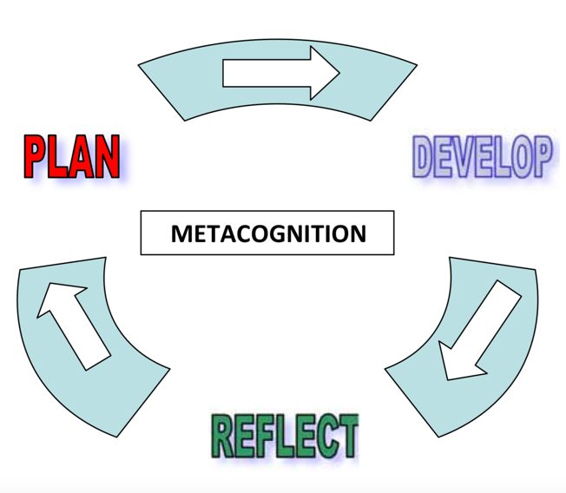

Figure 1.2 Metacognition cycle (Griffithjones.amdro.org.uk, 2018)

The teacher used a smiley face self-assessment technique (figure 1.3) where the child would colour in how difficult they found the task. However, I felt this wasn’t a reliable method to use as the children were unsure whether the smiley faces meant they enjoyed the activity or how difficult it was. At the end of the lesson the teacher asked the children to self-assess their work and indicate whether they received support. This was carried out by putting an ‘S’ or putting an ‘I’ for doing the work independently. It was important to do this at the end of the lesson while it was fresh in their memory. The teacher would then ask the children to place their books in either the green, yellow or red pile indicating what children found the activity difficult. The teacher then implied they would arrange to revisit the work and go through it with them. I found there were advantages and disadvantages to this method. The advantages were that it was an organised and systematic way of identifying what children needed differentiated work for future activities and they could then sort the child into ability groups. The disadvantages were, as mentioned earlier, the children may have self-assessed incorrectly and put their book in the pile on whether they enjoyed the activity, or they may have not understood what was asked by the teacher Also, a child may have felt embarrassed that their peers found the work easy and therefore put their book with their fellow peers’ books. To avoid any misjudgement by the children the teacher would then check the work to see if the child understood and had been sincere in their self-assessment. Once the work has been reviewed the they would then leave a comment for the child to sign to say they have read the feedback given.

Part 2: Connect to theory

The majority of teachers are proficient in offering opportunities in order to progress children’s learning. However, it is common for teachers not to understand the theory behind the pedagogy (Prtichard, 2008). Therefore, it is important to reflect upon my learning experience, understand and apply it, for my development as a future practitioner.

There has been a vast perspective on way in which humans learn. In spite of this, there are three main perspectives on how children learn that have made a huge impact within the practice of teaching over the past decade. These are the constructivist, Humanist and behaviourist approach (Prtichard, 2008). For children to be able to learn, the adult must be able to transfer their knowledge in an understandable way. However, the adult cannot get the best learning out of the children without knowing how they learn and knowing what they already do and don’t know (reference). Teachers need to know about their pupils’ progress and difficulties with learning, so they can adapt their work to meet their needs (Black and Wiliam, 2010). Teachers can find out what they need to know through observing, discussing and assessing pupils’ work. This therefore indicates that self-assessment is becoming ever more important within education.

A constructivists’ view learning as “the result of mental construction”. They believe learning occurs when “new information is built into and added onto an individual’s current structure of knowledge, understanding and skills”, (Prtichard, 2008).

Jean Piaget (1896-1980), was viewed as one of the most prominent people of a cognitive constructivist approach. According to Piaget, children are born with a very basic mental structure that has been inherited and evolved, where all learning and knowledge is constructed. Piaget believed children’s cognitive development happens through four developmental stages: Sensorimotor, Preoperational, Concrete operational and Formal operations. According to Piaget, the Sensorimotor stage is estimated to occur in children between 0-2 years. It is where simple reflexive behaviour gives way to ability to form knowledge and to create patterns and chains of behaviour (Pritchard, 2008). The Preoperational stage is estimated to occur between the ages of 2-7 years. It is where children are egocentric and are unable to consider events from another person’s point of view. It is also where children use a ‘symbolic’ thought process and imagination begins to develop. Referring back to the observations made, the Preoperational stage had been supported by the teacher creating a ‘symbolic’ self-assessment form, where the children used their knowledge and understanding of associating symbols with meanings to colour in the smiley faces that represented difficulty levels of the task. The Concrete operational stage is estimated to occur between the ages of 7-11 years. At this stage, children begin to use logical thought about physical operations. Also, they become more able to take another’s point of view and consider other perspectives. This stage is also interesting because when the teacher asked Pupil B (figure 1.1) to reflect on the work they produced, they were able to use a logical thought process to break down their learning and feed it back to the teacher using language skills. The final stage is the Formal operation estimated to occur from 11+ years, where the children are able to think logically and theoretically. This is considered the pinnacle stage of intellectual development, and it’s considered that even though children still have very little knowledge, their thought processes were as developed as they are ever likely to be. These stages feed into a child’s metacognition development, and therefore develops their thinking further to construct their own learning through self-assessment. Despite this perspective corresponding with self-assessment, it acknowledges children’s optimum learning occurs when they actively configure their own understanding of things.

In reference to Maslow’s Hierarchy of Needs (figure 1.3), motivation and self-esteem are things to consider when assessing pupils. As mentioned earlier, the teacher questioned Pupil B’s answer for the pupil to reflect on their knowledge and understanding, which then led to the teacher rewarding the pupil by responding with positive praise. This can be seen as a positive because increasing the pupil’s self-esteem can lead to the pupil taking on more difficult future tasks. When the classroom’s ethos is to focus on rewards such as praise, stickers, grades or class ranking. Then pupils look for ways to obtain the best marks rather than to improve their learning, by spending time and energy looking for clues to the right answer (Black et al., 2011). This approach can be linked with the behaviourist learning theory. Behaviourism is based around the central notion of a reaction being made to a particular stimulus, which in a classroom context is a teacher rewarding a pupil (Prtichard, 2008). In relation to the observation, this could have been seen as a negative, because when the teacher asked the children to self-assess their work and put their books into three difficulty piles. The pupils may have put their books in the ‘I understand’ pile because they seek some sort of reward from the teacher.

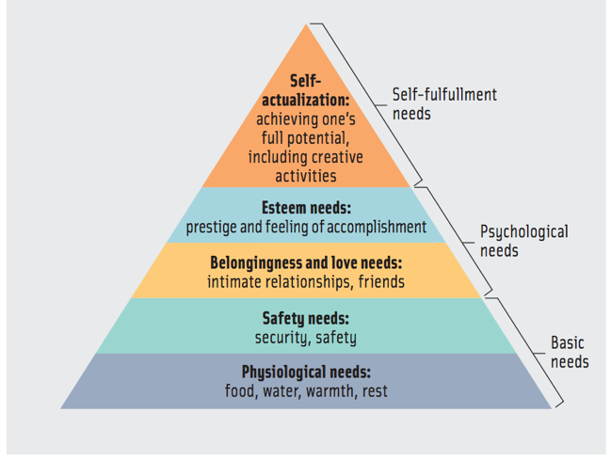

Figure 1.3 Maslow’s Hierarchy of Needs Accessed at: (Anon, 2018)

Another constructivist called Lev Vygotsky (1924), agreed with Piaget’s view that learning happens internally and that children learn through being active. However, he didn’t agree with children progress through specific stages of development at specific ages. Vygotsky also didn’t believe that children are “lone scientists”. Vygotsky was a social constructivist, who believed learning is a socially meditated activity, where children work with others socially to make meaning for themselves (Prtichard, 2008). He also believed that social learning tends to precede development. Whereas, Piaget believed development must inevitably precede their learning (Falchikov et al., n.d.). Social constructivism is concerned with the importance of collaboration with others, such as a group of fellow pupils, with just another pupil, learning support assistant or with the teacher. It views social interaction as the primary means by which learners construct new meanings, (Palincsar, 1998). Therefore, by children conversing, it becomes the vehicle by which ideas are considered, shared and developed (Prtichard, 2008). As mentioned earlier, Pupil A and Pupil B were able to converse and discuss ideas with the fellow pupils during the ‘think, pair, share’ method about what they had learnt in the previous lesson. Also, the teacher conversed with the pupils through questioning to help stimulate their self-assessment support their learning.
This shows that social constructivism is essential for the teacher to know how the children learn and knowing what knowledge they have to structure their teaching, but also for children construct their learning socially by using others around them. These social interactions are with what’s known as a more knowledgeable other (MKO). According to (Prtichard, 2008), the role of a more knowledgeable other within a school setting is usually the teacher. The teacher’s role is to engage individuals or groups in a dialogue and facilitate the development of learning and understanding.

Jerome Bruner was someone who also followed Vygotsky’s line of interest and used the concept of ‘Scaffolding’ to highlight the way that one person can become very intimately, and productively involved in someone else’s learning (Mercer, 1995). Vygotsky developed a concept known as the zone of proximal development (ZPD). The ZPD (figure 1.4) is used to describe the current or actual level of development of the learner, so the idea is that individuals learn best when working together with others during joint collaboration. The ZPD shows that with support of an MKO, could potentially be that extra push that learner needs to get into the ‘What I can do’ zone (Shabani, Khatib and Ebadi, 2010). Early in a learner’s learning process, a pupil will require much assistance (MKO) in accomplishing a task that is in the upper end of their zone. Through practice and experience, the pupil will be able to accomplish independently what they were able to accomplish before with much assistance (Doolittle, 1997). As mentioned earlier, during the learning event the teacher and LSA (MKO) would indicate whether that child received support ‘S’ or did the work independently ‘I’. This would benefit the child when self-assessing, by being able to review what work they could do with support (MKO) and acknowledge how they’ve progressed to doing work independently. This would lead to their psychological needs being satisfied with a feeling of accomplishment, in accordance to Maslow’s Hierarchy of Needs (Maslow, 2013).

(Learning.gov.wales, 2018) state, self-assessment will only work if the teacher (MKO) ‘coaches’ the learner in self-evaluation through: modelling questions, engagement and, processes and strategies. In a real context, during the observation the teacher (MKO) would ‘coach’ the children during the lesson on the correct self-assessment process. They would also feed questions to the pupils whether its 1:1, in a group or as a class to stimulate the children’s reflection on previous knowledge and assess the situation. However, this is only effective if children are taught the correct process and understand how to self-assess. (Black and Wiliam, 2010) states that the main problem with self-assessment is pupils can only assess themselves when they have a sufficiently clear picture of the targets such as a success-criteria or learning objective, that their learning is meant to attain. This was an issue in the classroom, because the children were unsure what the ‘smiley faces’ meant, therefore the self-assessment wasn’t completed truthfully by the children. Furthermore, in order for self-assessment to work efficiently and effectively, (Black and Wiliam, 2010) acknowledges when the learner is trying to learn, assessment feedback about the effort has three elements: recognition of the desired goal, evidence about present position, and some understanding of a way to close the gap on what they need to know. All three must be understood by the learner before he or she can act to improve learning.

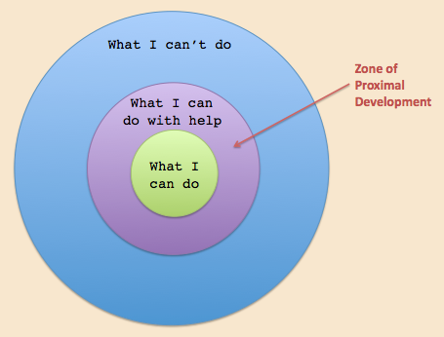

Figure 1.3 Zone of Proximal development (Accessed at: Innovativelearning.com, 2018)

Conclusion

To conclude, the learning event I observed has provided me with knowledge and understanding that will help improve my future teaching practice. I’ve acknowledged that self-assessment is becoming an essential component of classroom work and its development can raise standards of achievement (Black and Wiliam, 2010). For self-assessment to be effective, I will stimulate children’s metacognition to enable learners to critically reflect on their learning and intentionally apply what they have learnt to assess their own learning (Pritchard, 2008). As the adult, I will ensure children are taught on how to self-assess their learning through the scaffolding approach. Thus, once self-assessment becomes automatic the ‘scaffolding’ will be removed. This will be done through modelling questions, engaging the pupils and providing a clear picture of the processes and strategies in place. The pupils will then use this skill to understand the main purposes of their learning and grasp what they need to do to achieve (Black and Wiliam, 2010).
Whilst there are merits in both Piaget’s and Vygotsky’s theories on constructivism, for self-assessment to be effective, it cannot solely depend on one theorists view. As a future practitioner I will take on board certain aspects of constructivism as well as other learning theories.

Part 3: Reflect and Innovate

Children spend the majority of their school time within a school-based learning environment. The classroom environment is one of the most important factors affecting student learning. Students learn better when they view the learning environment as a positive and supportive (Gardner, 2013). A positive environment is one in which pupils feel a sense of belonging, trust others, take risks, build social skills, and ask questions (Gardner, 2013). The classroom environment shapes a great deal of teaching, learning and assessment (Gardner, 2013). Therefore, in order to create a positive, successful ethos within the classroom, Professor Graham Donaldson’s four purposes (figure 1.5) will be considered (Donaldson, 2015). My ideal learning environment is based on a year two classroom and covers many aspects that link with Donaldson’s four purposes, but in order to for these purposes to be implemented the classroom must first be adapted to suit these. Maslow’s Hierarchy of Needs acknowledges, humans’ basic needs are to feel safe and secure before they can develop. Therefore, my learning environment will consider the safety, security and well-being of the children (Maslow, 2017).
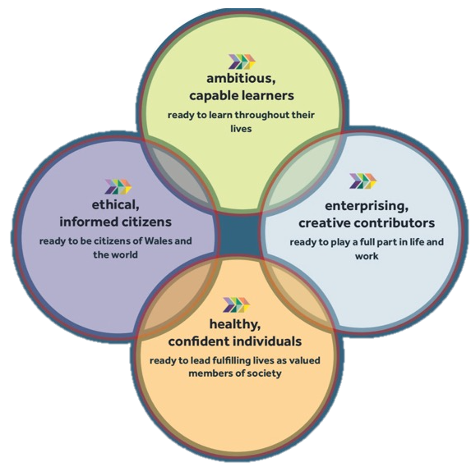

Figure 1.5 Professor Graham Donaldson’s four purposes (Donaldson, G. (2015). Successful Futures. [online].

A Humanistic theorist called Maria Montessori believed classrooms should be filled with readily available and well organised learning materials. She believed the ideal learning environment should be aesthetically pleasing, and only include things that the teacher wants the child to experience and engage with (Montessori, 2013). Maria Montessori created the Montessori Method, this approach emphasized individuality and independence in learning. She believed children are seen as inherently curious and learning driven and children should be allowed choices, therefore preparing them to become independent learners. Children are able to discover the world around them through a physical approach rather than information being ‘thrown’ at them in a classroom (Montessori, 2013). As a result, this approach links in with outdoor learning (Figure J).

Children in this current day tend to lead indoor, sedentary lives whilst at home and so, teachers taking learning outdoors is gaining significance (Learning.gov.wales, 2018). Learning outside the classroom is best seen not as a subject but as a tool for teaching and learning (Waite, 2011). Outdoor learning can be exploited through all subjects to improve engagement, building a repour with staff and pupils, and to improve pupils cultural and environmental awareness (Waite, 2011). This has been proven to benefit the pupil in the long term in their learning, development, health and well-being (Learning.gov.wales, 2018). However, in the majority of schools, outdoor learning isn’t considered as a priority with the pressure of the crowded curriculum and so teachers struggle to find time for learning outside the classroom (Waite, 2011). So, this begs the question, does there need to be an emphasis on learning outside the classroom?
Providentially, the foundation phase accommodates outdoor learning to enrich all attributes of children’s development socially, physically, creatively and culturally. If these attributes are developed, then children become better learners and retain that learning (Learning.gov.wales, 2018). Therefore, places a greater importance on the use of the outdoor learning environment throughout the school phases. Forest schools is an approach that accommodates the foundation phases pedagogy of outdoor learning (Knight, 2013). As supported by (Montessori, 2013,), the Forest Schools approach encourages children to explore their environment and challenge themselves. This also links in with Piaget’s theory of children being “lone scientists” where they can construct their own learning through exploring their environment and come to their own conclusions from what they learn (Pritchard, 2008). Therefore, in accordance with Maslow’s Hierarchy of Needs (figure 1.4), the concept of Forest Schools can lead to children strengthening their confidence and self-esteem, when tackling new situations and tasks (Knight, 2013). Other learning opportunities outdoors, can be carried out through play. Play has been defined as “freely chosen, self-determined and without adult intervention” (Whitehead, 2011). (Singer, Hirsh-Pasek and Golinkoff, 2006), recognises that play provides children to be creative and spontaneous. My ideal outdoor learning environment would include apparatus like a Timber trail (O) which facilitates children’s play, by enabling them to develop characteristics of a physically literate individual, including motivation, fine motor skills, confidence, environmental and interpersonal engagement, self-knowledge and self-expression (Johnston and Nahmad-Williams, 2014).

One of Donaldson’s four purposes is for children to be healthy, confident individuals (Donaldson, 2015). Therefore, ideally my learning environment would include a ‘Snack Shack’ (P) which would also endorse the healthy schools’ scheme. The focus of this would be for children to prepare healthy snacks and run the business of selling these snacks within the playground. As a result, children are able engage in real-life experiences where they are able to take risks, as expanding research is signifying the outdoors is the ideal learning environment for experimental learning by offering the children opportunities to be creative, to move around, be noisy, socialise and take risks (Learning.gov.wales, 2018).

The use of digital apparatus (B, D, N) in my learning environment, has become essential part to everyday teaching and learning (Learning.gov.wales, 2018). The use of ICT is a key aspect within the Digital Competence framework (DCF) that has been embedded into the new curriculum by Graham Donaldson. Professor Donaldson has argued that computer programming and ICT in all classes should be as in important and literacy and numeracy (Donaldson, 2015). “Digital competence is the set of skills, knowledge and attitudes to enable confident, creative and critical use of technologies and systems. It will enable pupils to be a digital confident citizen, to interact and collaborate digitally and help computational thinking” (Learning.gov.wales, 2018). Due to the way modern society is progressing and employers demand, digital skills are becoming increasingly imperative according to (Learning.gov.wales, 2018). In spite of this, there is an increased pressure on schools and teachers to integrate ICT in teaching and learning activities, which can be a challenge to some practitioner’s own knowledge (Olofsson, Lindberg and Fransson, 2018). I have chosen to include the use of digital tablets (D) because according to (Olofsson, Lindberg and Fransson, 2018), digital tablets are a flexible and multimodal ICT tool to support students’ learning. Research has shown that the use of digital tablets prepares students for life and work in the twenty-first century and that they have made a positive impact on students’ motivation for learning (Olofsson, Lindberg and Fransson, 2018). Research also states using these devices can help pupils develop their oracy skills. For example, in my learning environment digital tablets will be available to use with a green screen (N) which can be implemented into different subjects. These available resources can be used to support Professor Donaldson’s enterprising, creative, contributors’ purpose (Donaldson, 2015). A scenario where this could be used is when the teacher is delivering a welsh lesson focused on the weather, the teacher could then create a carousel cross-curricular task where children can independently create their own weather channel. The children can use the tablets to evidence their creative work by either videoing or photographing (Beauchamp, 2015). Therefore, this links to Jerome Bruner’s ‘scaffolding’ conception, where the teacher will set the activity and apply the scaffold (support) until the pupils can eventually independently carry out the task (Mercer, 1995). However, if the teacher isn’t competent on the use of digital tablets and apparatus, then the pupils cannot become digitally competent themselves. ICT can be also under-utilised and therefore teachers can miss out on the huger benefits that technology can bring as a tool to enhance all areas of education (Elston, 2007).
In order for these focused areas to be utilised, carousel learning will play the primary role of learning in the environment. The carousel learning system will accommodate all areas within the classroom. It is a communicative and interactive opportunity for participants/students to get up and move around a room in a circular fashion (Uticaschools.org, 2018). In a carousel, students work in small groups and move from station to station (areas in the classroom), discussing each task as they go. It is a useful tool to use to integrate practical learning into everyday teaching to give pupils a break from sitting on chairs and will also encourage and support group work (Nicurriculum.org.uk, 2018). A study carried out by (Yusmanto, Soetjipto and Djatmika, 2017) found carousel learning could increase pupils higher order thinking skills as well as social learning outcomes. The carousel system allowed pupils to have time to think, discuss and to receive scaffolding. This supports Vygotsky’s theory of social constructivism where pupils can work together collaboratively in order to develop their learning (Prtichard, 2008).
This system is particularly effective within the foundation phase through, continuous, enhanced and focused provisions. The focused provision is led by the teacher or LSA to work with either a group or individuals and involves high quality adult child interaction focusing on specific planned activities (Thomas and Lewis, 2016). The continuous and enhanced provisions allow the pupils to gain additional, enhanced, cross-curricular and enriched learning opportunities in relation to a specific topic (Thomas and Lewis, 2016). For example, the two focus groups are to practise number bonds to 10 with the adult, whilst the other provisions are independent (Thomas and Lewis, 2016) with one group using the computers practising number bonds on maths games to enhance their digital competence and another group focusing on physical literacy to improve their fine and motor skills in relation to the topic(reference). These grouped activities will then rotate like a carousel after a period of time (Thomas and Lewis, 2016). Carousel is used in its best practice, when the activities have a clear purpose (Assembly.wales, 2018). The content and level of support match children’s needs. However, even though children are being active from moving to each station, if the activities are poorly organised, these activities do not necessarily offer children possibilities to deepen their learning or explore their understandings thorough meaningful contexts (Arthur and Cremin, 2018). Thus, learning must be really well designed to be meaningful and in line with the goals, in accordance with what students need to prepare for their future (Yusmanto, Soetjipto and Djatmika, 2017).
5,600 words- needs to be maximum of 5,400

