University of Wales Trinity Saint David
Information Engineering
ACCC4004
Molner Thomas 1804565
8/15/2018

Pick Veggies is supplies and they are selling different types of groceries to their customer. They have more store located in Oval, Slough, Reading, Watford and Amersham. They want to record some information about they customer and invoice for making a system to be automatically send to them. They have a lot of customer which they make order for sales.
n the first part I want to talk about the entity relationship for this business. An Entity Relationship Diagram(ERD) modelling is a conceptual modelling technique to identify the entities and the relationship between the entities for relational database design . We have more relationship with customer, staff, branch, item, order, supplies, order line and item line. They have primary key and foreign key. In the figure bellow Figure 1 Entity Relationship Diagram (ERD) after you can see the connection where is many to many or one to many.

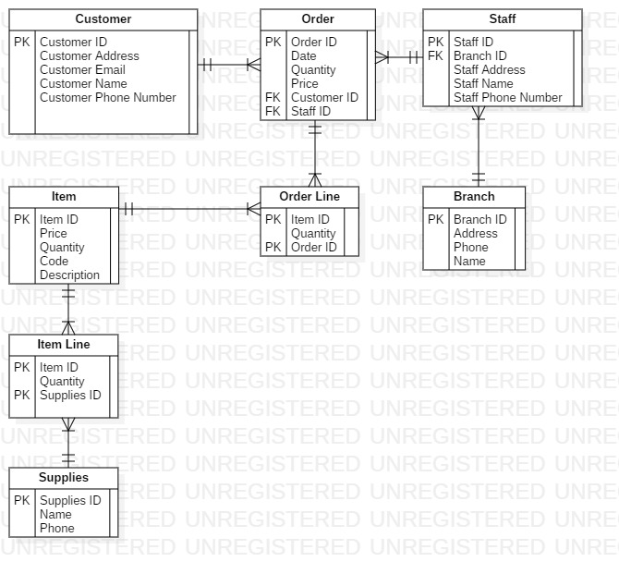Figure 1, Entity Relationship Diagram (ERD)
Customer: Customer ID; Customer Address; Customer Email; Customer Name; Customer Phone Number.
Order: Order ID; Date; Quantity; Price; Customer ID; Staff ID.
Staff: Staff ID; Branch ID; Staff Address; Staff Name; Staff Phone Number.
Item: Item ID; Price; Quantity; Code; Description.
Order Line: Item ID; Quantity; Order ID.
Branch: Branch ID; Address; Phone; Name.
Supplies: Supplies ID; Name; Phone
Item Line: Item ID; Name; Phones.

In the second part where I need to design for the Pick Veggies store a diagram. The definition for data flow diagram is a Data flow diagram is a graphical representation of movement through the organisation. Representation current system of the term in data flow. I attached Figure2,Data Flow Diagram (DFD) this case where you can see the Data Flow Diagram Level 0.
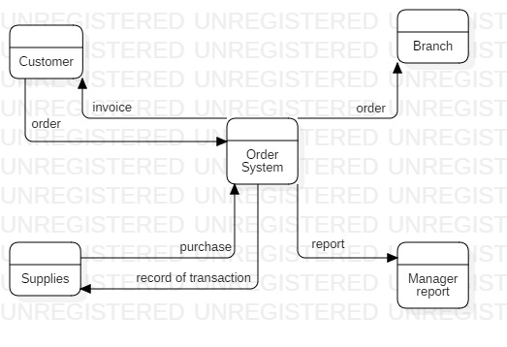Figure2,Data Flow Diagram (DFD)

In the last part I have a Use Case diagram. Use case diagrams are usually referred to as behavior diagrams used to describe a set of actions (use cases) that some system or systems (subject) should or can perform in collaboration with one or more external users of the system (actors). You can see in the Figure 3, Use Case Diagram (UCD) where I make the diagram.

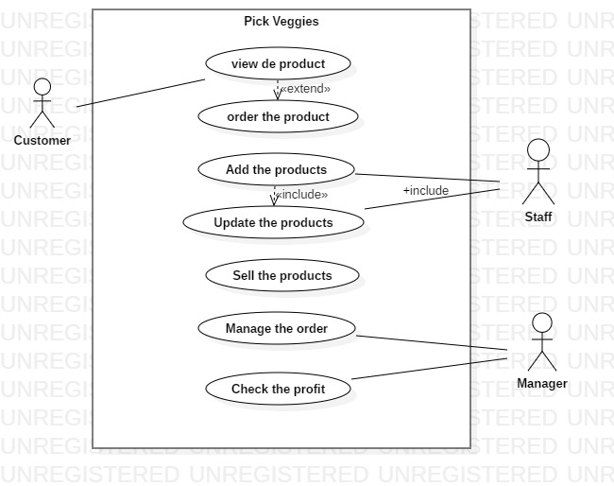
Figure 3, Use Case Diagram (UCD)

