DS 1 ASSIGNMENT.

My Screenshots/Photos
- Please add 4–6 screenshots or photos of your digital life.
- You can use your phone or laptop.
- For each screenshot, write one or two sentences explaining what it shows.

Screenshot/Photo 1
[Insert Photo/Screenshot below]
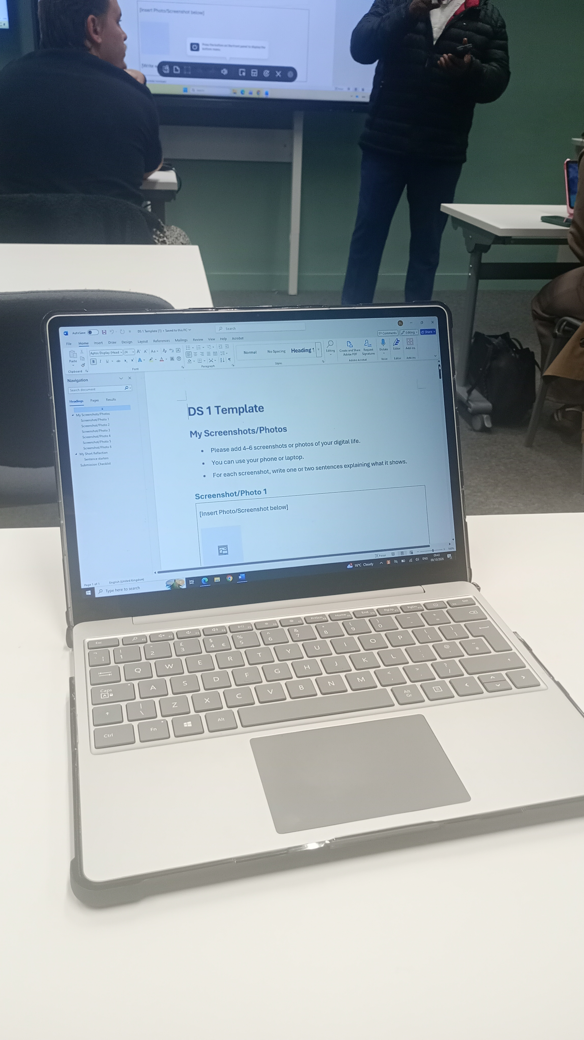
This is me using a laptop to do my assignment DS1
I have used my phone to take a picture and transferred it by email to my university email.
I would like to improve my knowledge of digital skills {DS}
I need {DS} so I can improve my computer or laptop use to better my abillities in the digital econemy.

Screenshot/Photo 2
[Insert Photo/Screenshot below]
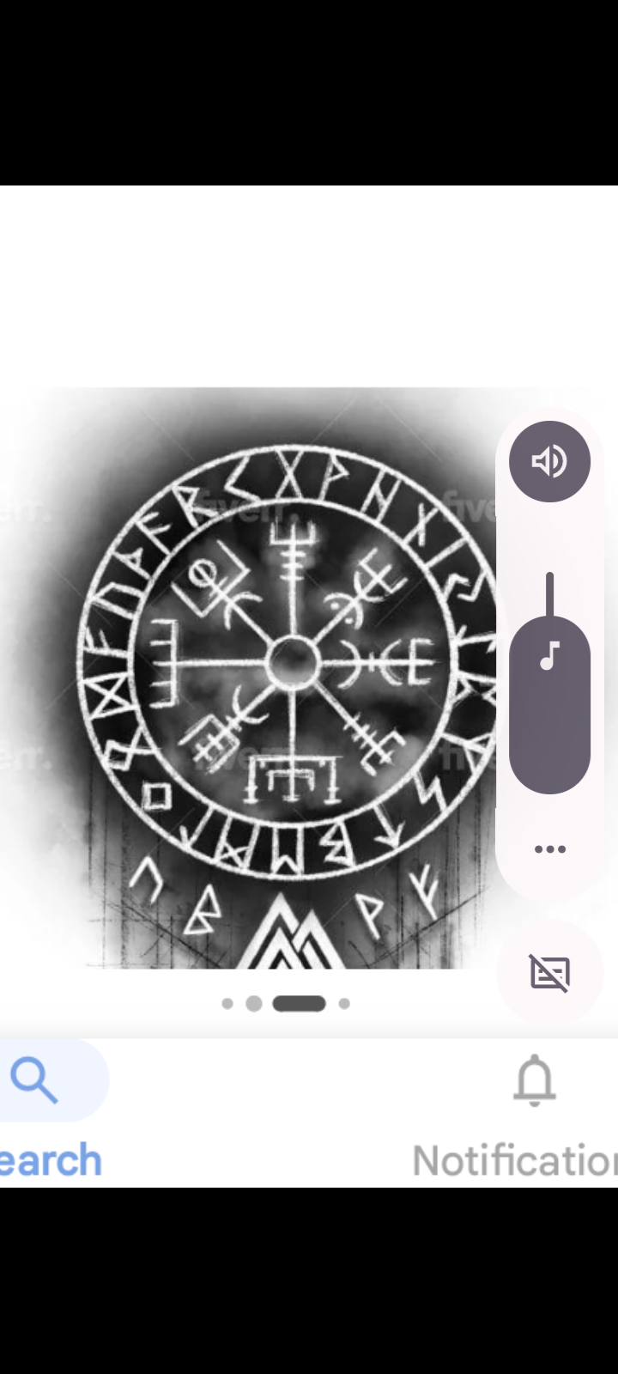
I took a screenshot from the internet while looking for viking runes
I saved,copied and transferred it to my studant email to better my{DS}
I will make msure to use the laptop to better{DS}
Repeating these actions are getting me use to the computer.

Screenshot/Photo 3
[Insert Photo/Screenshot below]
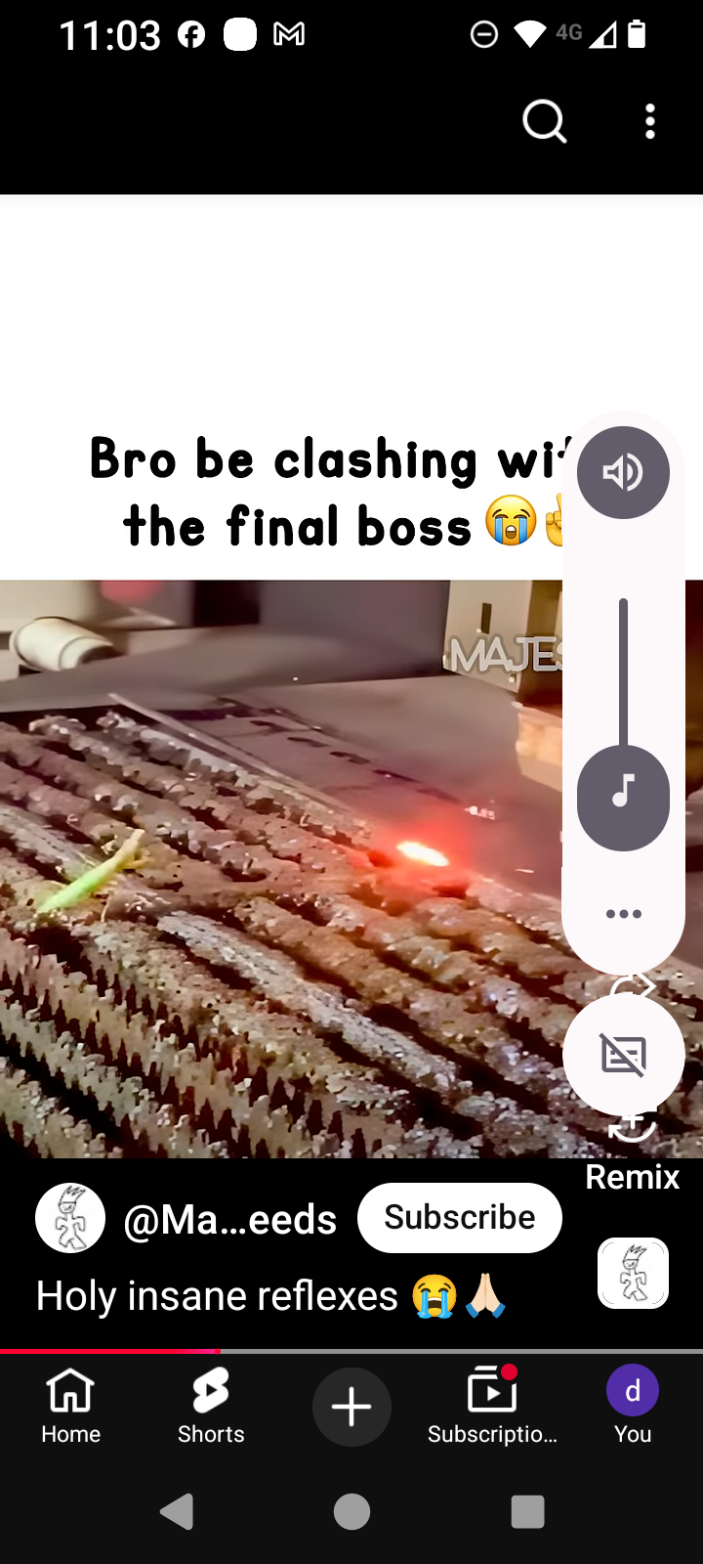
This is me using the internet to looking through youtube.
I screenshoted my use of youtube and uploaded it to my sudent email so that I could upload it to my DS1Assignment.
I am only just getting use to using my {DS} so I need to use my laptop more to get use to opening files and uploading subjects to my assignments.
I am repeating actions on the laptop to better my {DS} by saving and uploading data.

Screenshot/Photo 4
[Insert Photo/Screenshot below]
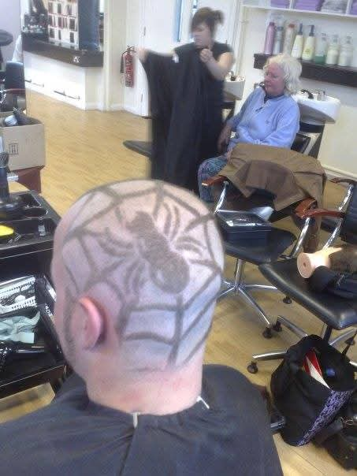
This is me capturing some work moments on my mobile phone.
I took the picture to capture and record some work that I hove done.
I am still stuggling with saving and downloading pictures so I need to use laptop to get use to the actoins I have to take to upload files.
I am continuing to learn about saving and uploading files. I have to use the laptop more to get use to using microsoft.

Screenshot/Photo 5
[Insert Photo/Screenshot below]

[Write what this shows of your digital life]

Screenshot/Photo 6
[Insert Photo/Screenshot below]
[Write what this shows of your digital life]

My Short Reflection
- Write 5–8 simple sentences about your digital life.
- You can use the sentence starters below if helpful.

Sentence starters
- I use digital tools to …
- I feel confident when I …
- I want to improve …
- I often use these tools: …
- I sometimes feel nervous about …
- I hope this module will help me …
- Digital skills are important for me because …
You can write more if you want.

Submission Checklist
Before you submit, please check:
​​​ ☐ I added 4–6 screenshots
☐ I wrote short sentences for each screenshot
☐ I wrote my short reflection
☐ My work is my own
☐ My file opens correctly
​​☐ My file opens correctly

