Alexander Apps (1806320)
BA Business and Management BMSP4005 Jessica Shore 15th May 2019
Distinctiveness & Regeneration Llanelli

Introduction – Llanelli’s economic anatomy past present and future

Llanelli was once a powerhouse. An economic hub that attracted many investors. She had a coveted secret beneath her soil. A secret that would make a few rich and become a working necessity for many.
Now, that industrial and economic revolution has evaporated completely. Llanelli is simply a used husk of little value to the pioneer. Are Llanelli’s best days behind her? Possibly! Llanelli requires a new economic direction for regeneration to begin.
Other counties thrive yet Llanelli is economically arrested. What secrets do they have for regeneration that Llanelli needs as well to be able to regenerate and thrive? She has been a tested miracle for economic focus. Yet what derivative do we need to kick-start her new economic future.
Historical Development

Area’s that have become industrially derelict, usually had a sparkling economic past. Mah surmises economic dereliction as “on places that had been 'left behind' [it’s] the context of an uneven geography of capitalist development” (Mah, 2014). When the area is no longer economically viable an area like Llanelli is abandoned. Not discovering another sustainable direction before the industrial boom ended. Llanelli benefitted from industrialisation but suffered from its demise.
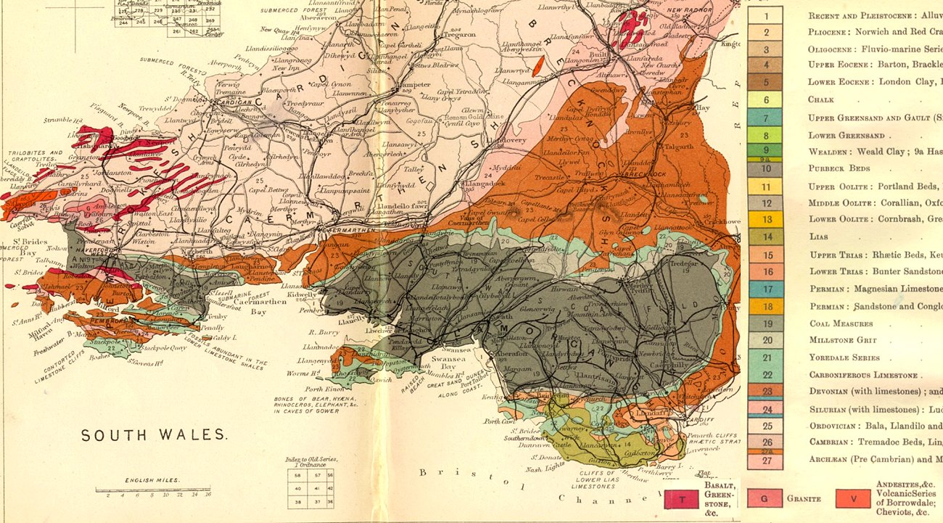
Llanelli before the eighteenth century was a small un-industrialised area of farming and fishing. The locals had a very small trading model of selling sea coal within the community. Llanelli was not invested in at this time. But elsewhere the prelude to the nineteenth century industrial revolution was beginning.
Above the length of the coal deposits under South Wales. The further west the richer the coal shelf becomes.
By 1700 Jethro Tull had invented a new seed drill capable of planting more crops. Greatly changing for manpower in the community, effectively changing farming. The first Steam Pump was invented in 1712 by Thomas Newcomen used to de-flood coal mines. Canals opened in 1761 (The Bridgewater Canal), allowing for an economic transport system. The Spinning Jenny (1764) and Mule (1774), Water Wheel Power (1769) improved production power and by 1771 the first factory was opened by Richard Arkwright at Cromford. By 1781 James Watt revised his steam engine for rotary motion contributing to the development of the steam train and by 1790 Arkwright had his factories powered by steam.
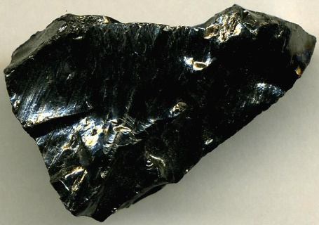
Llanelli’s industrial secret was locked deep within her soil. Large amounts of Anthracite ran under the soils of South Wales. With this vital resource the investments flowed in. Anthracite has a high carbon index of 97%. It creates great amounts of heat essential for steam powered machines (coalmerchantsfederation, 2019). Llanelli had a coal shelf that ran through the entirety of South Wales, a vast and highly exploitative potential for investment. Where there is coal there is money to be made.
Anthracite – an industrial catalyst (tech-faq, 2019)
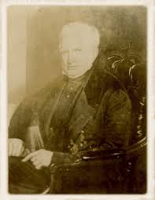
Alexander Raby (Pictured Left), Chauncey Townsend and Baronet Edward Vaughan the 3rd with Joseph Shewen and Robert Morgan to name a few, transformed Llanelli. Raby invested in 1797. Producing an industrial hub within 100 years. Raby is understood as the great engenderer of Llanelli’s economy. The eighteenth and nineteenth centuries were profitable times. During the nineteenth century a large industrial rail network was created in the South Wales region. Used for the transportation of coal. Docks were formed creating an international direction for Llanelli’s coal. By 1913 South Wales produced 57,000,000 tons of coal per year and employed 230,000 coal miners in more than 600 mines (Agor, 2019). During the coal boom (1880 to 1913), Llanelli experienced her greatest economic explosion. With the investment, resources and manpower she had a distinctive economic boom and the beginning of the twentieth century Llanelli’s future looked very bright.
Pictured above Alexander Raby (John, 2019)

y

Changing Fortunes

Unfortunately, these times didn’t last, and the twentieth century was the time of reckoning for this region as the very resource and industry that gave her these economic blessings was swiftly trounced and in only a few short decades. Regeneration is so important now that this industry has been vanquished. Inventions in the oil sector reduced the need for coal. The change to from coal to oil was something even anthracite couldn’t compete with. When the internal-combustion engine was invented and plane travel for the military, industrial and tourist sectors were developed; it spelled disaster for the South Wales Coal Industry.
Post First World War (1914 - 1918) the demand for coal had slowed. By the time of the Great Depression of 1929 a massive global downturn lasting approximately 10 years. Coal itself was becoming an industry that needed larger amounts of investment. Coal has a bad image to this day and the effects were acutely experienced.
New diseases were discovered related to coal mining. Black Lung or Pneumoconiosis (hse, 2008) a degenerative condition where the patient has no chance of. The cost that this illness places upon government and industry was large at this time in and drew a great arrestive stance to the national coal industry.
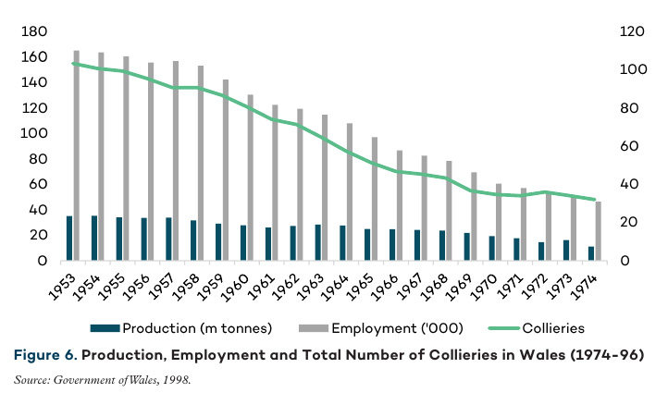
The smog that cities endured from the numerous coal fired power stations and domestic coal use. Contributing to lung related deaths. Attention was warranted and the price of coal usage within industry and home was increasing. Government and the coal industry had to confront this. By 1936, nearly 250 mines were closed and nearly 150,000 jobs were forfeited (Seaton, 2016). In the 1920’s the coal industry employed 1.2 million people but was forced to compensate the miners due to industrial dangers. But coal still had a large death toll even with better safety measures. This once great industrial power source was slowly becoming a damaged.
(Kitson, 2017)
By the end of the Second World War the South Wales coal industry had an outdated image. Synonymous with disease and death. It was an industry that couldn’t survive or change. In 1913 South Wales produced nearly 60 Million tons of coal per year by 1945 she produced roughly 750.000 tons per year (IBID). In 1947 the coal industry was nationalised to stave off the death of the industry. But it was a superficial cure.
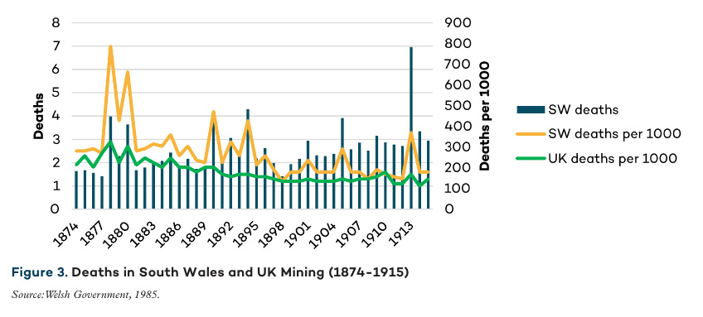
With other less developed countries wanting their own industrial revolution they invested in their own collieries. The forming of OPEC helped it later in the twentieth century, but coal is not oil. Oil has successfully powered the combustion engines of the oil revolution.
(Kitson, 2017)
After the 1984 miner’s strike the coal industry in Britain was dead. Llanelli had her greatest employer and economic development vanish within a generation and no contingent resurrections were planned for this lost industry. It simply vanished, what made Llanelli sent her in to decline.
Regeneration would have no better home than here where it is needed. But you can’t help to think what Llanelli would be like now, if she had oil.

Llanelli’s existing Assets, Structures and Economic character

Llanelli does have several assets. The TATA steel works the Wetlands, Trostre Park are just a few “Llanelli has no rival as the chief town in Carmarthenshire and excluding some great centres in Glamorganshire it is the most considerable and important town from, commercial and other standpoints in Wales.” (llanellich, 2019). With a developing Carmarthen and Swansea, Llanelli is on the downturn. So how does she change the diminutive character of her present self.
What are Llanelli’s current assets and social structures. Firstly, her population. Llanelli has a higher population than Carmarthen and personally as a Llanelli native, she has the great good will of her people. They defend the town always.
Yet Llanelli does possess dark areas to her character. Llanelli has an image problem. After coal she has never been able to break the idea that she is as outdated as coal itself. The abandonment pf projects like Delta-Lakes, caused more image problems.
But Llanelli has an even darker image. Llanelli suffers from a worsening Heroin problem. The local community and the council are tackling this to an extent. But bad word of mouth always follows Llanelli. Baltimore (Berger, 2007) is similar, it used to have a good economic character. But, being sandwiched between New-York, Philadelphia and Washington DC; people avoid the city due to its drug problem, as well as investors. The answer always given is why would you want to work or live there. This image must change through government or social means. Sadly, her economic character will remain in a downward spiral. Due to no or little regeneration, because all efforts are a band aid upon an open economic wound.
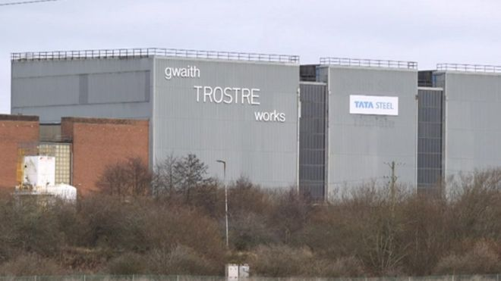
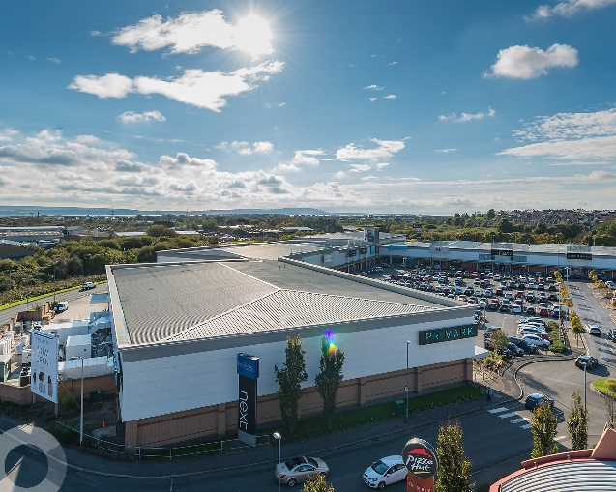
She’s haemorrhaging talent and capital just due to bad perception; she needs another Raby and another economic miracle.
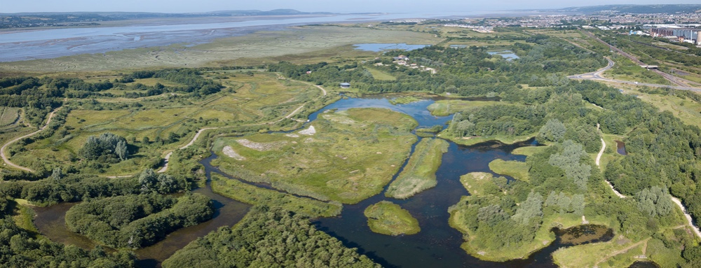
Above clockwise Trostre Retail Park, Tata Steel Works and The Llanelli Wetlands all unique features of Llanelli

Key Stakeholders and Groups

In the early twentieth century an economist Milton Friedman believed “that a company has no real “social responsibility” to the public, its only concern is to increase profits for the shareholders. The shareholders, would privately shoulder any social responsibility.” (McDonald, 2019). This shaped the corporate environment throughout the twentieth century.
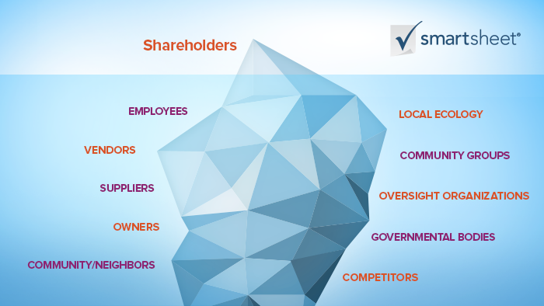
Contrastingly Dr. F. Edward Freeman in 1984 created the stakeholder theory. Paraphrased by Professor Craig McDonald as “shareholders are one of many stakeholders in a company. The stakeholder ecosystem, involves anyone invested and involved in, or affected by, the company: employees, environmentalists near the company’s plants, vendors, governmental agencies, and more.” (McDonald, 2019).
Above a visual description of Freeman’s Stakeholder Theory (Smartsheet, 2019)
Defining Stakeholders for a business domestic or international is a simple task. Kristen’s describes the idea of the stakeholders as “The prime sources for the business are stakeholders which taken together form [an] influence on the business” (Kristen, 2015). Kristen takes this idea further by defining a stakeholder matrix “The impact of stakeholders’ moves is something which can be described as to have Power [or] Interest. Stakeholders affect the business’s policy in two perspectives. When they [have] power and when they have interests.” (Kristen, 2015). What type of influence would they form what type of mercantile thrust would they employ?
When not within a company the same principles of Dr. Freeman can be applied to a community like Llanelli. A stake holder is anyone within Llanelli that has an economic value to lose or advance. Stakeholders are effectively a combination of the electorate, council, investors, potential investors and landlords.
All these groups have a stake within the future economy of Llanelli. Most can shape the economic landscape within Llanelli and have done so. By opening the Odeon and surrounding shops it has given employment to that area. Producing a nascent growth. But has effectively deprived the high street within Llanelli. Places like Vaughn Street have already lost several businesses due to high-rent or lack of footfall.
There’s more at stake here for regeneration to occur within Llanelli. A very concerted effort, and an observation of continued economic thwarting must be remedied before a prognosis can be delivered.
Above a picture of Kristen’s Stakeholder Matrix (Kristen, 2015)

Local/ Regional Development Strategies

The idea of regional development strategies began in the 1990’s by “identifying each region’s competitive advantages and then prioritizing public and private investments necessary to exploit those advantages. This period is seeing the blurring of lines between economic and workforce development, as innovation emerges as a key element around which economic development strategies are organizing.” (Administration, 2009) A great change of governmental direction from the polar “Era of Industrial Recruiting [which] were adopted during the Great Depression and after World War II.” (IBID)
Why is local development so crucial for Llanelli’s future? Local development is something that is seen by community and other potential investors. It has a great positive impact on communities creating jobs, investments and most important a big change in image. Llanelli has a perceived image problem. Any local redevelopment scheme being considered is a boost to this town. Helping to shackle off its image bad image problem.
Llanelli has already had a £60 regeneration programme including “a new theatre, arts and social enterprise complex call Y Ffwrnes, the refurbishments of Llanelly House and Llanelli Library, a new leisure, office and retail development called East Gate, with additional extensive new town centre improvements in Vaughan Street and Stepney Street including canopies and lighting.” (llanellitowncouncil.gov.uk, 2019)
So far Llanelli council has proposed the demolishment of certain derelict buildings within the Market Street and the town centre (carmarthenshire.gov.uk, n.d.). Key sites within the town centre are being offered up for development particularly the area near S4C on Market Street. His follows on from “a £4.5million investment to buy and renovate underutilised properties from the private sector, bringing them back in to use at an affordable rent.” (IBID) within Llanelli itself. Yet more investment is needed in the town itself. The council is creating “a Local Development Order, which will speed up the planning process for a range of developments, is also nearing completion.” (IBID).
Asbri Planning Ltd has won permission to develop a site near Millennium Coastal Park to create 210 new homes into the area. (Bannon, 2018). Encouraging new investment is crucial. But schemes like Highways, Transport, Property, Waste and Environmental, Planning, Education and Children's Services, Housing, Social Care, Culture and Leisure, Local Development and help for Corporate Services all being considered by Carmarthenshire council for development across the county. (Bannon, These are the 98 projects Carmarthenshire Council has promised to deliver in next five years, 2018). But what most people consulted on the field trip wanted was the return of the local council.
Let’s just hope they make sure to direct in all to Llanelli instead of the already profiting Carmarthen. A town that does not need regeneration currently.
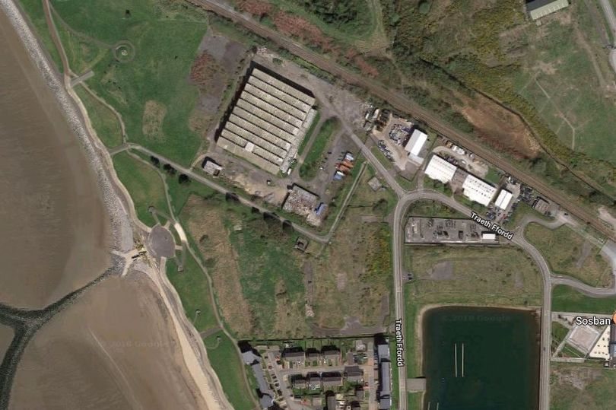

Above the Area for proposed housing Development, close to the Millennium Coastal Park

Considerations for Regeneration in Llanelli

Image is a very powerful weapon. A perceived bad image has a destructive effect on any future. Gaining a purer image of regeneration is not impossible. Yet it is uncommon and difficult to regain without a concerted effort from community, local government and the willing participation of investors.

What would potentially regenerate Llanelli?

Lowering Taxes to Encourage Investment

“A country with broad bases and low rates will be a relatively attractive place to locate capital for firms which expect to earn rents. This approach is therefore useful in attracting highly profitable multinationals” (Devereux et al.2002). Cardiff benefitted greatly from tax breaks for investors wanting to become part of her local economy Tax breaks for investors. Giving them a much lower threshold of tax to encourage their investment. Something that is being considered for the whole of Wales to encourage investment.
Alexander Klemm considers that “Empirical research on tax incentives shows that they sometimes work in attracting [investors]. In practice, however, it may be difficult to achieve such an outcome, because of the many disadvantages of existing tax incentives and difficulties in their administration.” (Klemm, 2010).
However, in Germany, Sascha Becker believes that “Overall, we find that the business tax rate levied by a municipality negatively affects the number of MNEs [Multinationals] it can attract as well as their employment and fixed assets invested. larger municipalities with an abundant workforce, especially of skilled workers, may attract foreign MNEs by much smaller changes in their tax rates. Implicitly, these results suggest that municipalities with generally favourable environments for far location should be able to use their tax rates more successfully to attract foreign MNEs than those with less favourable environments.” (Beckera, 2012)
Lowering tax for several years to encourage investment is something of a branding for a local community. It helps create an image of prosperity which encourages a greater sense of pride, in the area simply due to this branding of lower taxes. Switzerland is branded correctly for its lightness of touch when it comes to this type of benefit to business. This is something that could regenerate Llanelli since Llanelli suffers from an image problem associated with poverty, many residents on the field trip discussed this.

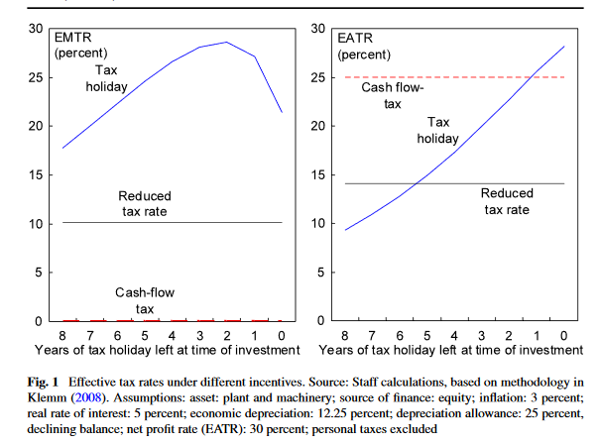
Below (Klemm, 2010)

Using Unoccupied Buildings and Lowering Rents

During the Field trip Llanelli residents were most unhappy with the amount of unoccupied buildings in the town.
Getting Stakeholders to help with regeneration would help Llanelli. There are many buildings in the centre of Llanelli that are sitting vacant because the rent is either too high or that they have chosen not to allow people into these buildings (Council C. , 2018) . Social Enterprises, Charities and Non-Profit organisations would all benefit from a change to the local laws. Currently due to ownership a landlord effectively can act like a dark age’s monarch with no outside oversite or accountability to the local populace. It’s legal but it’s not moral. It will not build a community in any sense or spark regeneration it has the opposite effect of avoidance.
Changing local laws and forcing landlords to take lower rents for a smaller time period, until a high paying client could be procured would break this cycle. Seeing unoccupied shops in a town is a ghastly sight and does not promote tourism or investment. “One great way to reduce rent is to share it. Begin by renting a larger space with one or two more rooms find one or two people who offer services complementary to yours and rent them a room.” (Dirubbo, 2006)
Children’s playgroups and local schools or rent-free business start-ups, could be set up which would be right alongside their parents who are at work. Again, another encouragement for community and social regeneration. The landlords would be receiving a steady income and the community and town would promote further employment. Seizing back the direction of town from the few individuals that have a strangle hold on it. Making it more palatable.

Image Reconstruction

Lamentably, Llanelli is associated with drug addiction, lack of investment, lack of jobs a vanishing talent base and economic decline. Aitchison and Evans categorise the decline of towns like Llanelli as” the 1970s and 1980s witnessed a period of unprecedented industrial decline in the UK. Cardiff turned to cultural industries and the production of consumer culture to reverse the industrial decline by diversifying local economies and rebuilding local communities.” (Evans, 2003)
How would you rebrand Llanelli?
Sociologists associate image as Zukin does by “in the post-industrial era, sense of place reflects geographical mobility, the social construction of landscape, and marketing strategies. Rural regions like Vermont are reborn through the social, cultural, and economic efforts of local entrepreneurs to create a distinctive and authentic sense of place.” (Zukin, 2011). Changing the perception of a place is crucial to regeneration, that is something that Llanelli needs, now. The above propositions will help with this image problem, more investment and jobs. Then a change of image for the positive is provoked.
Llanelli has a lot of vacant land. Again, an image problem, it looks as if nothing is being constructed after the building Trostre Park. All that is needed for this is a change of direction from the local council. But this won’t occur without social pressure for investment in this area
People take drugs to escape from boredom or a lack of perceived future. Building the communities ambitions back is something takes a lot of time. Finding that pride especially when you’ve been made redundant can come only from yourself. Having a loving family can break the viscous cycle of the addiction of poisonous self-doubt and alchemise a better sense of wellbeing. This would come from the individual more than government or community. But that individual must have knowledge of where to go. Thankfully there already are groups talking this.
The drug problem may be Llanelli’s worst image, but it can be changed by the goodwill of Llanelli’s people. It just must come from the said addict do I want to change Yes; I do. With a change of fortunes for the better her image will be regenerated.

Conclusion – Llanelli’s Future

Llanelli has a proud population, which does not want to be locked in a viscous cycle. Since the disappearance of her greatest employer the coal industry and the economic recessions of the 1980’s and 2000’s. Llanelli has languished in a perennial sense of economic stagnance. Few industries or companies wanted to invest due to Llanelli’s image problems and simply a lack of belief on part of company owners stopped investment. With the disappearance of the power of local council, something the electorate want returned. Llanelli lost her decision-making strength and relied on Carmarthen as the agent for her strategy.
Dumfries and Galloway council defined their strategy for regeneration as “build the local economy; provide the best start in life for young people; protect the most vulnerable people; and be an inclusive Council.” (Council, 2016). The direction is known now Llanelli needs the implementation. It could be an easy operation, just look at the benefit that Cardiff gained from tax breaks to encourage the further development of the local economy and Swansea bay with the inclusion on the UWSTD and other developments has turned old into new.
But is the Welsh assembly to Cardiff centric? Leaving little attention for a town like Llanelli. Llanelli does need attention for a positive economic change otherwise she may become the new Merthyr, sadly a Welsh town that shouldn’t be economically dispossessed. She is floundering but developments like Trostre have helped it’s the town centre regeneration that potentially will spread a good word of mouth for her image change. But there is enough academic though and cogent proof from other regenerating communities that action needs implementation immediately. She was a powerhouse and has the potential to become one again its just the choice of gathering will of people, council and investors that need the coalescent will for lascivious taste that local regeneration would give.

Bibliography

Administration, U. E. (2009). Crossing the Next Regional Frontier. U.S. Economic Development Administration. Retrieved from statsamerica: http://www.statsamerica.org/innovation/reports/sections2/2.pdf
Agor. (2019, February 5). Development of the Coal Industry. Retrieved from Agor: http://www.agor.org.uk/cwm/themes/life/economy/
Bannon, C. (2018, March 23). Plans for up to 210 new homes near town's coastal path. Retrieved from walesonline.co.uk: https://www.walesonline.co.uk/news/local-news/plans-up-210-new-homes-14451227
Bannon, C. (2018, January 11). These are the 98 projects Carmarthenshire Council has promised to deliver in next five years. Retrieved from walesonline.co.uk: https://www.walesonline.co.uk/news/local-news/98-projects-carmarthenshire-council-promised-14140399
Berger, J. (2007). "There Is Tragedy on Both Sides of the Layoffs:" Privatization and the Urban Crisis in Baltimore. International Labor and Working-Class History, (71), 29-49.
carmarthenshire.gov.uk. (n.d.). Bright future on horizon for Llanelli town centre. Retrieved from carmarthenshire.gov.uk: http://newsroom.carmarthenshire.gov.uk/2018/10/bright-future-on-horizon-for-llanelli-town-centre/
coalmerchantsfederation. (2019). Anthracite. Retrieved from coalmerchantsfederation: http://www.coalmerchantsfederation.co.uk/products/anthracite
Council, C. (2018). South West Wales Regional Plan for Regeneration. Carmarthenshire Council.
Council, D. a. (2016). Upper NithsdaleRegeneration Plan. Dumfries and Galloway: Dumfries and Galloway Council.
Devereux, M. P., Griffith, R., & Klemm, A. (2002). Corporate income tax reforms and international tax competition. Economic Policy,17(35), 451–492.
Dirubbo, N. (2006). Creative and Practical Ways to Reduce Rent. Nurse Practitioner, 50-50.
Evans, C. A. (2003). The cultural industries and a model ofsustainable regeneration: manufacturing ‘pop’ inthe Rhondda Valleys of South Wales. Managing Leisure 8, 133–144.
hse.gov.uk. (2008). Pneumoconiosis. Retrieved from hse.gov.uk: http://www.hse.gov.uk/lung-disease/pneumoconiosis.htm
John, L. (2019, January 26). Alexander Raby - Ironmaster and Coalmaster . Retrieved from Llanelli Community Heritage: https://www.llanellich.org.uk/files/395-alexander-raby-ironmaster-coalmaster
Kitson, T. M. (2017). The End of Coal Mining in South Wales. GSI, 1-33.
Klemm, A. (2010). Causes, benefits, and risks of business tax incentives. Int Tax Public Finance, 315 - 336.
Kristen, J. (2015). STAKEHOLDERS THEORY- HOW THEY INFLUENCE THE BUSINESS. International Journal of Business Policy & Governance, 14-17.
llanellich. (2019). A Short History of Llanelly 1897. Retrieved from Llanelli Community Heritage: https://www.llanellich.org.uk/files/288-a-short-history-of-llanelly-
llanellitowncouncil.gov.uk. (2019). About Llanelli. Retrieved from llanellitowncouncil.gov.uk: http://www.llanellitowncouncil.gov.uk/about-llanelli/
Mah, A. (2014, November 30). The Dereliction Tourist: Ethical Issues ofConducting Research in Areas of Industrial Ruination. Sociological Research Online, pp. 1 - 14.
McDonald, C. (2019). What Is Stakeholder Theory and How Does It Impact an Organization. Retrieved from smartsheet: https://www.smartsheet.com/what-stakeholder-theory-and-how-does-it-impact-organization
Moldenaes, T. (2016). Reinventing a Place through the Origin Myth. In T. Moldenaes, Place Reinvention (pp. 165 - 168). Ashgate Publishing.
Sascha O. Beckera, P. H. (2012). How low business tax rates attract MNE activity: Municipality-levelevidence from Germany. Journal of Public Economics, 698 - 711.
Seaton, A. (2016). Farewell King Coal. British Medical Journal, 364 - 366.
Smartsheet. (2019). What Is Stakeholder Theory and How Does It Impact an Organization? . Retrieved from Smartsheet: https://www.smartsheet.com/what-stakeholder-theory-and-how-does-it-impact-organization
tech-faq. (2019). What is Anthracite Coal? Retrieved from tech-faq: http://www.tech-faq.com/what-is-anthracite-coal.html
Zukin, S. (2011). Reconstructing the authenticity of place. Theor Soc, 161–165.

