Name: Mafuta Lilian MANZUMBA
Student Number: 1706306
Module Title: BMSK4004 Problem Solving and Decision Making
Assignment Title: Problem Solving and Decision Making
Word count: 4000 words
Module Lecturer Name: Molly Jack

Problem solving and decision Making in the work place
Euro car parks case study
Introduction:
This essay will aim to demonstrate the importance of problem solving and decision-making process in a chosen organisation and discuss the process of developing a fair and rational decision in a workplace as well as discuss the different ways of approaching the assignment problem. I will start by giving a brief definition of the term “problem solving and decision making” and identify problems in the workplace and come up with the best decision-making process to resolve this problem. I will make use of case studies, theories, statistics and first/secondary research to back up points made in this essay.
Challenges and issues in workplaces can arise in any job weather it is working in an office, a construction site or working in pressured environments with co-workers to complete daily tasks. Most problems faced can be determined as being big or small but nevertheless, they still they need to be dealt with constructively and fairly. It is beneficial that the employer managers and supervisors enhance their ability to affectively screen potential staff members in the early stages of recruitment to eliminate chances of future problems. Other ways that decision making problems could also be a misbalance of resources should the company not have had the correct resources in how they outsourced for the suitable candidates for their job positions, misbalance in the company’s opportunities and finally the companies/ employer’s inability to set out relative objectives.
Most managers must have the ability to solve problems effectively and make sound decisions in a work place as to show their employers that they have good leadership skills. Whilst having the correct level of assertiveness and ability to make good choices can benefit you career, bad decisions can however, slow down the progression an individual makes in their chosen job role because often bad decision can upset colleagues and perhaps alienate the individual prohibiting them from being a part of a fully functioning team; unless the role comes with minimal decision-making requirements.
What is problem solving?
Problem solving can be described as, a systematic process which defines a problematic situation (whereby gap builds up between the actual and expected or sometimes where there is something that is unsatisfactory) and the problem is identified as an opportunity for which a solution will need to be implemented by the individual or as part of a group.
These problems can be found in every aspect of the working life and these problems can range from, customer issues with some of the products/services offered, unresolved issues between departments or team members, cost related issues, introducing new products or sometimes finding new customers.
The Happy Manager (2018) states that problem solving, and decision-making is important in any given work place. And explains that problem solving can otherwise be defined as a mental process on a bigger scale that helps identify, understand and later establishing a suitable solution to resolve the issues. Decision making can sometimes be a mental process that help bring bout different scenarios before making a final decision. Problem solving refers to having the ability to make use of knowledge, facts and data to solve a problem. This does not always have to been that you have the answer to the problem immutably but instead shows that you have the capability to think on your feet to assess and solution to the problem at hand and shows. Resembling the general radiational decision making model (Figure 1) Tim Hicks in the business journals of Sonoma/ Marin emphasizes that decision-making processes be made up of a sequence of steps dedicated to rationally develop a desired solution. Typically, these steps involves the seven different steps to problem solving in a workplace as;
- Identifying the problem - understanding the problem
- Understanding everyone’s interest -separating interests from solutions
- List the possible solutions /options – separating options from evaluating problems
- Evaluate the options -
- Select an option
- Document the arguments
- Agree on contingencies, monitoring, and evaluating
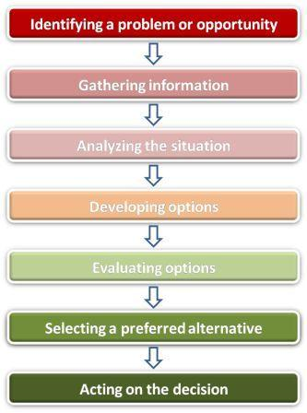
Figure1: General rational decision-making model

Issues affecting problem solving:
There are various models that can be used to help understand what is meant by the term “problem solving and decision making” one of which helps us understand Problems and they can be described as a misbalance of resources, opportunity and objectives. All three gives a sense of misguidedness and irrationality. Some implications of decision making is that it can cause complexity on some unintended outcomes whereby one unintended outcome can have other unpredictable effects. These relationships between the different variables can produce non-linear / unpredictable results on external environmental challenges and distinguishing between threats to be avoided and opportunities that can be seized.
The two types of decision categories can be described as structured or unstructured. Majority of the time, decisions made in a workplace can consist of both types of decisions making and on most occasion a decision that is unstructured can easily be turned into one that Is structured.
- Structured -
planned, routine decisions, the execution of policies or rules and non-consequential
- Unstructured -
Ad hoc, non-repetitive, non-programmed, consequential.
Political, lack of information - ambiguities and complexities
Ethical Issues
This research paper will not need to overcome ethical barriers. For this research study to than be ethical; the content of the study will need to disclose financial information about the company as means of backing up any brought forward. All the information that will be used in this essay will be collected from different channels, ranging from past/present statistics, peered and non- peered reviewed work, academic journals and books. The aim of this essay is to help get a better insight and understanding on problem solving and decision making in the work place.
Literature review
Euro car parks Case study:
The Euro car park is a limited company that operates with the legislations set by a greater association known as the British parking association (BPA). BPA is a large non-profiting organisation that works with 699 organizations other than euro car parks. As euro car parks operates under the BPA, there is assurance that procedures are taken very seriously, and should this not be done directly with euro car parks than customers have the choice to escalate matters further directly with the BPA. This is commonly done through training employees in their various departments and employees following these procedures when dealing with customers when there are issues. Customers normally would call in with different types of issues, these issues can range from their car being blocked by another driver and the customer will need to report this issue back to customer services department to find a solution in resolving this matter. At which point it becomes euro car park’s responsibility to track down that specific car to resolve the situation using the two different parking services they have available, for example, pay by phone or pay by machine. However, there are cases where the company would not always be able to solve the situation. Unlike paying for a ticket by phone where the persons details are logged in, euro car park does not have information from someone who would pay for a ticket using the ticket machine. This means that euro car park would not be able to track down the driver who is blocking the passage which leaves our customers feeling dissatisfied. However, euro car park always aspires to satisfy customers by providing customers such as giving a free ticket for the next time they would park at any location as a gesture of good will.
It than becomes apparent and highlights the importance in the company’s ability to overturn negative attitudes into positive attitude. Fishbien’s multiattrbute theory breaks down this importance of within a workplace or work setting. Fishbiens muliti- attribute theory and Azjen theory of reason and planned behavior (1975). Fishbien concludes that attitude (Robert Deshaies, Cuerrier, Pelletier, Mongeau, Claude, 1992) is an individual’s opinion in the way that they judge whether the behavior is positive or negative, whilst Ajzen subjective norm argues that an individual’s perception can arises can from social pressures.
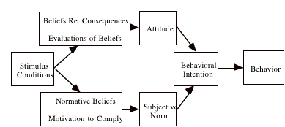
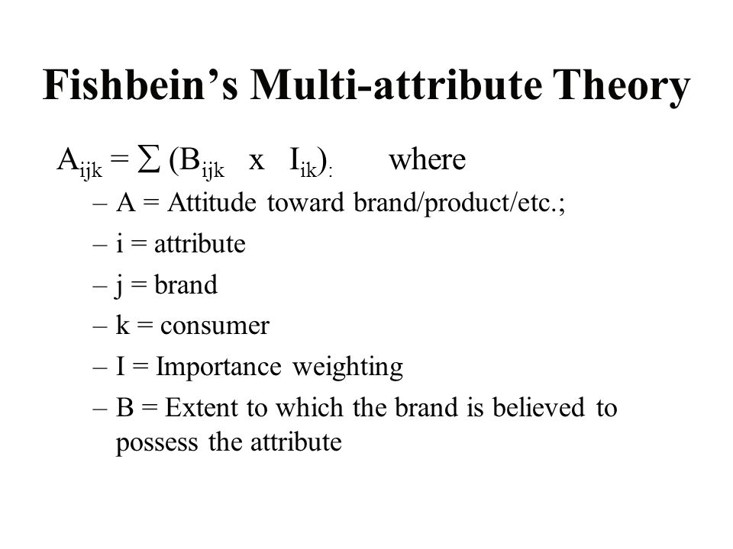

Vs

Figure 2: Azjen & Fishbien muliti-attrbute theory model (1975)

Figure 3: planed/behavioral theory

Figure 1: Azjen and Fishbien mulitiattrbute model, (1975)

Euro Car parks Case study
The Euro Car park is a limited company that operates with the legislations set by a greater association known as the British parking association (BPA). BPA is a large non-profiting organisation that works with 699 organizations other than euro car parks. As euro car parks operates under the BPA, there is assurance that procedures are taken very seriously, and should this not be done directly with euro car parks than customers have the choice to escalate matters further directly with the BPA. This is commonly done through training employees in their various departments and employees following these procedures when dealing with customers when there are issues. Customers normally would call in with different types of issues, these issues can range from their car being blocked by another driver and the customer will need to report this issue back to customer services department to find a solution in resolving this matter. At which point it becomes euro car park’s responsibility to track down that specific car to resolve the situation using the two different parking services they have available, for example, pay by phone or pay by machine. However, there are cases where the company would not always be able to solve the situation. Unlike paying for a ticket by phone where the persons details are logged in, euro car park does not have information from someone who would pay for a ticket using the ticket machine. This means that euro car park would not be able to track down the driver who is blocking the passage which leaves our customers feeling dissatisfied. However, euro car park always aspires to satisfy customers by providing customers such as giving a free ticket for the next time they would park at any location as a gesture of good will.
Figure 3: Theory of reasoned & planned behaviors (1980)
Swot analysis
The Oxford dictionary describes “swot analysis” as a study undertaken by an organization to identify its internal strengths and weaknesses, as well as its external opportunities and threats. The swot analysis will look at the factors surrounding Euro car parks as well as have a brief insight of their operating environment to better understand the market space of which they base their operations on.
Strengths:
* Euro car parks is one of the leading car parking and space management company within the UK and Ireland
* High company turnover
* Fast customer complaints turnover
* Euro car parks have owned car parks that can benefit from being leased to others
Weakness:
* Expensive car parking ticket prices
* Limited parking spaces in some managed car parks
* Staff members and customer may not understand the rules of some of the car park
Opportunity:
* Expand to other territories
* Threat of new entry in the market
* Some individual can use to walk/ride bicycles instead of driving
Threats:
*Expand to new territories
Political factors of the Euro Car Parks and the BPA;
The BPA which works above Euro Cars are responsibly held under greater companies such as the DVLA. When there would be issues such as retrieving information about a owner which a particular car they would need to request for information from the DVLA’s records. The use the scheme known as the Approved Operators Scheme.
* There are political factors highlighted under the BPA such as the parking charge notice (PCN) where if an acting of trespassing or breaching of a parking contract takes place, a notice charge which is also known as a parking ticket will be sent to the driver by the car park owner of the operator. * Any company that work under the BPA is required to sign a declaration in which they agree to comply to the rules and regulations provided by the BPA. * Another political factor highlighted under the BPA is that any organisation or company must pay appropriate fees set by the BPA council. * The BPA however, does not cover legislations such as the Road Traffic Act in 1984 or the Traffic Management Act in 2004.

Economical factors of Euro Car Parks;
Euro Car Parks as previously mentioned have branched out to different cities such as Manchester and London. They have also gone as far as branching out of the UK and into countries such as Ireland.
There are very rare cases where Euro Car Parks would have to deal with abandoned car situations where a driver is completely unable to move onto their destination as there is no one to collect the abandoned car. Therefore, if the car collectors were to go out and collect a car and supposedly someone else was to call in for the same issue, there is a possibility that there would be ineffective open communication as these circumstances are very much rare or expected. This would then result in an extremely angry customer who would possibly want to take the issue further if the waiting time was to be a very long time. Another small issue that may grow into a bigger one would be cases such as a customer losing the subscription cards that euro car parks sell usually costing £35 to £45. If a customer was to leave their car in the car park and then at the end of they day return to reclaim their car but they had lost their card, they would usually have a fee to pay which costs £100. Some customers are not willing to pay such large sums and would therefore become very aggressive towards the staff members working at the car park or staff members at the stores that are being managed by euro car parks. This is a situation that may cause ineffective communication between customers and the staff members as at this point customers would have the patience to listen and resolve the situation.
Some of the goals that we fail to achieve according to our customers reviews are issues such as CCTV screening. There have been cases where our customers may have not been happy with the way some situations may have occurred and so when they contact customer service to have their situation resolved and request a CCTV footage, our customer services fail to provide footage. It is however, euro car parks goals to get more CCTV’s all over our car parks in order for us to record every angle of our car parks for the safety and satisfaction of our customers. Our most frequent customers complaints would be the prices that come with our car parks. As Euro car parks we do try our best to leave our customers satisfied when they use our services by offering courtesies such as 2 hours of free parking however, after this we do charge prices such as £27 for the whole day. We believe that this price is suitable as we have a success rate of 89% when it comes to safety handling of every vehicle in our car parks, which is something that we could say not all car parks have as there are usually cases of theft and robbery. We however, go by the universal rule that what the customer says goes and so it is therefore our goal to reduce the prices of our car parks by April 2019 for the satisfaction of our customers.
Euro car parks could improve their quality by recruiting more people to work in sectors online customer services. This way we would be able to reach out to our customers as quickly as possible leaving them even more satisfied. Another sector that needs recruitment is the HR department. If there are any difficulties taking place with our employees’ salaries, this has an effect and their personal life which then has an effect on their professional lives. In order for our customers to be satisfied, it is important that our employees come into work pleased with the services that we also offer onto them so that they may be able to pass that service unto the customers and that way the cycle continues. Another way that we could improve the quality of our services is by having technicians that are able to head out a s frequently as possible to do frequent check ups on our ticket machines to make sure that they are working. Customers do believe that they are being cheated when they park in an area where the ticket machines are not working and when they are charged for not purchasing a parking ticket they also lose their trust for us and prefer to look out for alternative car parks.
The problems that euro car parks are usually able to avoid are issues such as space to hold many a multitude of cars. The majority of euro car parks are usually large which is one of the reasons why we have a lot of people favoring our company car parks instead of others. Customers do not have to roam around for over 20 minutes just to look for somewhere that they can park their cars because we usually always have more than enough space for everyone. In addition to this, in areas where there is a high rate of people such as Shoreditch. Euro car parks manage other parks such as Sainsburys just in case their own car parks fill out, this way customers are still able to benefit from deals or the way in which original euro car parks would run.
The National statistics from the DVLA shows that 854,000 cars were registered in the UK between January and March in 2018. This shows that there is going to be a rise in the number of vehicles parking in the euro car parks. Although we do have many car parks it is our responsibility to accommodate the increase in the number of cars that are to come by also opening more car parks. This also gives us an opportunity to increase in our finance and through this euro car parks will be able to provide the best services in the UK and potentially in other countries also.

Conclusion
To conclude, in order to have effective problem solving in a company it is very important to firstly take into consideration the issues that arise from the customers reviews. Many of the issues such as price rates were issues concerning customers because as much as Euro car parks thought that they would be profiting from charging expensive costs, it would most likely only be customers that regularly use their services that would be consistent as they have the knowledge that their vehicles are under strict surveillance at all times. However, if there is an individual that has never used Euro car parks’ services and they come across the prices that come with that payment. Instead, their initial judgement would be that the service is too expensive and that would lead them to find a different service.
However, regardless of some of the economical aspects that may not be the best in the eyes of the customers, Euro car parks are actively effective in their aim to always remain professional. Other than the fact that their services are highly rated for safety another benefit is how their services are branched out. This mean that other than they fact that they may have customers in different cities and countries. Customers that are possibly going on vacation would be pleased to find Euro car parks’ services elsewhere. They could then propose the services to their family and/or friends which allows Euro car parks to grow in numbers and also profit economically.
It is also very important to consider the BPA when looking into the services that come from Euro car parks. Although Euro car parks are a limited company they have a higher service that they are held accountable to. If Euro car parks are not going by the rules and regulations that they have been given there are consequences that they would suffer. This could either come in the form on prosecution or the company being shut down if that was to be the worst-case scenario. This therefore means that, if there are any problems that Euro car parks constantly ignore, if someone was to take the issue up to a higher company (such as the BPA) it would highly taken into consideration.

Appendix Page:
Grants Chart figure 4:


References:
- Tim Hick
http://www.connexusconflictmanagement.com/
- The happy manager
The Happy Manager. (2018). Definition of Problem Solving - The Happy Manager. [online] Available at: https://the-happy-manager.com/tips/definition-of-problem-solving [Accessed 01 August. 2018].
- By Vallerand, Robert J.,Deshaies, Paul,Cuerrier, Jean-Pierre,Pelletier, Luc G.,Mongeau, Claude, Journal of Personality and Social Psychology, Vol 62(1), Jan 1992, 98-109
- Euro Car parks Services: https://www.eurocarparks.com/services-we-offer/ecp-services : [Last assessed- 27th August 2018].
- Definition of Swot Analysis: https://en.oxforddictionaries.com/definition/analysis: [Last assessed- 27th August 2018].
- Euro Car Parks
Website title: Eurocarparks.com
URL: https://www.eurocarparks.com/

