
DragonWave Renewables Ltd (DWR)
Database Design & Implementation

Module: Database Systems
Module Code: ACCA7002

Submitted To:
Divya Chidambaram
Lecturer, UWTSD

Submitted By:
Name: Shahriar Khan
Student ID: 2507023

Submission Date: 09 January 2026
1 | Introduction
2 | Significance and business context
3 | Database design
4 | Entity analysis
5 | Relationship analysis
6 | Normalization process
7 | Database decisions
8 | Database schema creation
9 | Sample data insertion
10 | Trigger implementation
11 | Stored procedure development
12 | Stored procedure and transaction management
13 | Performance tuning and enhancement
14 | Conclusion

Introduction:
Case scenario: DWR Solar Solutions is a growing renewable energy company specializing in residential and commercial solar panel installations. The company manages a complex ecosystem involving customers, solar system products, certified installers, installation orders, maintenance schedules, and customer feedback. The assignment requires a database for the efficient management of the company.
They manage:
- Customer who buys solar system
- Different Solar system models with various qualifications
- Certified installer who does the installation work
- Installation order that tracks each job
- Maintenance record for system upkeep
- Customer review for feedback

Significance and business context
The database system implementation is necessary. If the company uses spreadsheets or paper for management, it arises several problems like data errors, loss of information, slow processes etc. After implementation of database, it gives benefits like data consistency, easy tracking, quick information access, quality control, better customer service, inventory management. It also helps the company make decisions to improve their service.

Project Objective
The primary objectives of database implementation project are:

- Design a normalized scheme that eliminates data redundancy
- Implement constraint to provide data validity
- Develop transactional procedures to maintain data consistency during complex operation
- Optimize query performance by indexing and schema design
- Provide Reliable backup and recovery capabilities through transaction management
- Enable scalability for future business growth
7. Create audit mechanism for tracking data changes

Database Design:
ER diagram

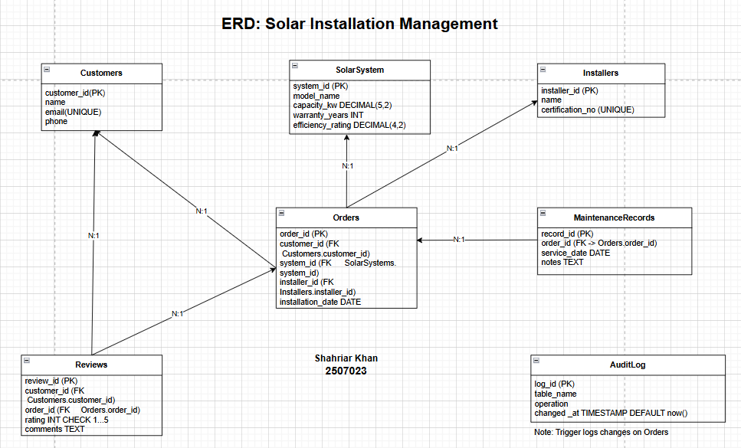
This is a blueprint for DRW solutions that shows how all their business information connects.
How they connect:
- Customer → Orders (One-to-Many)
One customer can have many installations order

- Solar Systems → Orders (One-to-Many)
One solar model can be installed in many orders

3. Orders → Maintenance Records (One-to-Many)
One order can have many maintenances visit

4. Customer → Reviews (One-to-Many)
One customer can leave many reviews

5. Installers → Orders (One-to-Many)
One installer can work on many orders.

Audit System

Audit Log - Special tracking system
- Automatically records when orders are created, changed, or deleted
- Like a security camera for database changes
- Shows about who changed what and when

How It Works in Practice

When a customer buys a solar system:

- Their information goes on the Customers table
- The solar model goes in Solar Systems
- The installer assignment goes in Installers
- All this connects to the Orders table
- Later maintenance goes in Maintenance Records
- Customer feedback goes in Reviews
- All changes are tracked in Audit Log

Why This Design Works

- Efficient - No repeated information
- Accurate - Rules prevent wrong data entry
- Scalable - Can handle thousands of customers
- Connected - Everything links together logically
- Trackable - Can follow the complete history

This ERD is like a well-organized filing system where everything has its place, and you can easily find connections between different pieces of information.

Entity Analysis:

- Customers Entity
Primary key: customer_id (SERIAL, auto-incrementing)
Attributes:
- name: Customer full name (VARCHAR (100))
- email: Unique contact email with UNIQUE constraint
- phone: Contact phone number (VARCHAR (20))

- Solar Systems Entity
Primary Key: system_id (SERIAL)
Attributes:
- model _name: Product model identifier (VARCHAR (100))
- Capacity_kw: System capacity in kilowatts (DECIMAL (5,2))
- warranty_years: Manufacturer warranty duration (INT)
- efficiency_rating: Performance efficiency percentage (DECIMAL (4,2))

3. Installers Entity
Primary Key: installer_id (SERIAL)
Attributes:
    - name: Installer's full name (VARCHAR (100))
    - certification_no: Unique certification number with UNIQUE constraint

4. Orders Entity
Primary Key: order_id (SERIAL)
Foreign Keys:
    - customer_id references Customers(customer_id)
    - system_id references SolarSystems(system_id)
    - installer_id references Installers(installer_id)
Attributes:
    - installation_date: Scheduled installation date (DATE)

5. MaintenanceRecords Entity
Primary Key:
    - record_id (SERIAL)
Foreign Key:
    - order_id references Orders(order_id)

Attributes:
    - service_date: Maintenance service date (DATE)
    - notes: Service details and observations (TEXT)

6. Reviews Entity
Primary Key:
    - review_id (SERIAL)
Foreign Keys:
    - customer_id references Customers(customer_id)
    - order_id references Orders(order_id)

Attributes:
    - rating: Customer rating (1-5 with CHECK constraint)
    - comments: Customer feedback (TEXT)

Relationship Analysis
Customer-Order Relationship (One-to-Many)

Connection: Each customer can place multiple installation orders, but each order belongs to only one customer.

How it works:
- The customer_id from the Customers table is stored in each Orders record

Why this works for DWR:
- Easy to see all orders from one customer
- Customers can add more solar systems later
- Simple billing and warranty tracking per customer

SolarSystem-Order Relationship (One-to-Many)

Connection: One solar system model can be installed in many orders, but each order is only one system model.

How it works:
- The system_id from SolarSystems is stored in each Orders record

Why this works for DWR:
- Track which solar models are most popular
- Manage inventory of different system types
- Standardized warranty tracking by model
Installer-Order Relationship (One-to-Many)

Connection: One installer can complete many orders, but each order is assigned to only one installer.

How it works:
- The installer_id from Installers is stored in each Orders record

Why this works for DWR:
- Balance workload among different installers
- Track installer performance and quality
- Schedule maintenance with the right technician

Order-Maintenance Relationship (One-to-Many)

Connection: Each order can have multiple maintenance records, but each maintenance record belongs to only one order.

How it works:
- The order_id from Orders is stored in each MaintenanceRecords entry

Why this works for DWR:
- Complete service history for each installation
- Schedule regular maintenance automatically
- Track warranty claims and service needs

Customer-Review Relationship (One-to-Many)

Connection: Each customer can submit multiple reviews, but each review comes from only one customer.

How it works:
- The customer_id from Customers is stored in each Reviews entry

Why this works for DWR:
- Collect feedback from customers over time
- Identify satisfied customers for referrals
- Track customer satisfaction trends

Order-Review Relationship (One-to-One through Customer)

Connection: Each review is linked to both a customer AND a specific order.

How it works:
- Reviews store BOTH customer_id AND order_id
- This connects feedback to the exact installation that was reviewed

Why this works for DWR:
- Know exactly which installation is being reviewed
- Connect feedback to specific installers and systems
- Improve specific services based on feedback
This relationship design ensures DWR can:
- Track everything from customer to installation to maintenance
- Connect all parts of their business
- Generate accurate reports and histories
- Provide excellent customer service by having complete information

Normalization Process

The database design follows Third Normal Form (3NF) principles:
First Normal Form (1NF):
All tables have primary keys
- Atomic values in each column
- No repeating groups
- Consistent data types
Second Normal Form (2NF):
- All non-key attributes fully dependent on primary keys
- Partial dependencies eliminated

Third Normal Form (3NF):
- No transitive dependencies
- All non-key attributes mutually independent

Design decisions:

- SERIAL Primary Keys
    - Used SERIAL data type for all primary keys

Justification:
    - Automatic unique value generation
    - PostgreSQL optimization for sequential access
    - Simplified application logic
    - Industry standard practice for surrogate keys

2. VARCHAR Length Considerations
    - VARCHAR(100) for names, VARCHAR(20) for phone numbers

Justification:
    - Adequate for international name formats
    - Phone numbers accommodate country codes and extensions
    - Balance between storage efficiency and flexibility

3. DECIMAL Precision for Technical Data
    - DECIMAL(5,2) for capacity, DECIMAL(4,2) for efficiency

Justification:
    - Sufficient precision for solar industry requirements
    - Accurate warranty and performance calculations
    - Standard industry measurement units

4. DATE Data Type for Temporal Data
    - DATE type for installation and service dates

Justification:
    - Temporal query optimization
    - Built-in date functions availability
    - Clear semantic meaning

5. TEXT Data Type for Notes and Comments
    - TEXT type for free-form fields

Justification:
    - Unlimited length for detailed descriptions
    - PostgreSQL optimization for large text fields
    - Appropriate for unstructured data

6. Check Constraint for Ratings
    - CHECK (rating BETWEEN 1 AND 5)

Justification:
    - Data validation at database level
    - Application-independent business rule enforcement
    - Improved data quality

This normalized design ensures data integrity, minimizes redundancy, and provides a scalable foundation for DWR's growing business needs while maintaining optimal performance through strategic design decisions.

Database Schema Creation
The database schema was implemented using PostgreSQL 13+, chosen for its robustness, ACID compliance, and advanced features suitable for transactional systems. The implementation follows a systematic approach to table creation, ensuring proper dependencies and relationship establishment.

Key Implementation Decisions:

SERIAL Primary Keys: Each table uses SERIAL for automatic primary key generation, ensuring uniqueness and simplifying application logic.

Appropriate Data Types:
- VARCHAR for variable-length text with reasonable limits
- DECIMAL for precise numeric calculations (critical for solar capacity)
- INT for whole numbers (warranty years, ratings)
- DATE for temporal data with built-in date functions
- TEXT for unlimited-length descriptive fields

Sequential Creation Order:
- Independent tables first (Customers, SolarSystems, Installers)
- Dependent tables next (Orders)
- Finally, secondary dependent tables (MaintenanceRecords, Reviews)

Customer table creation:

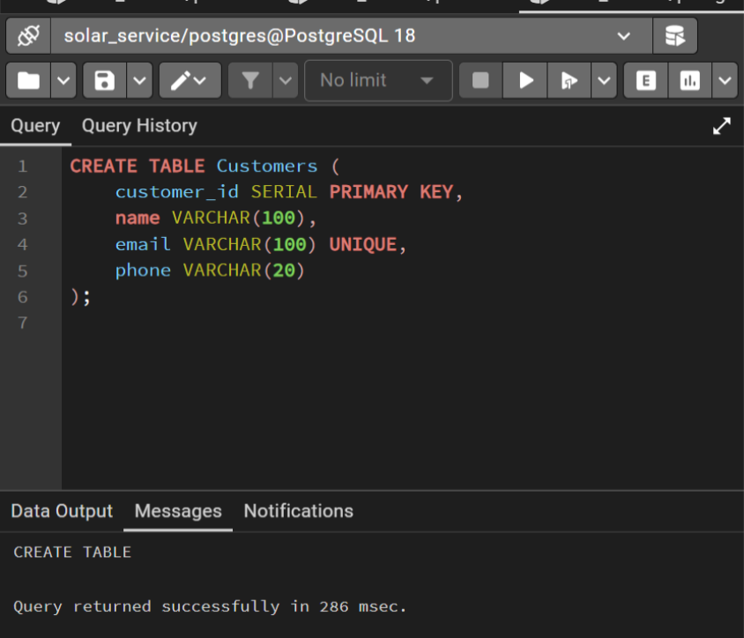

Installer table creation:

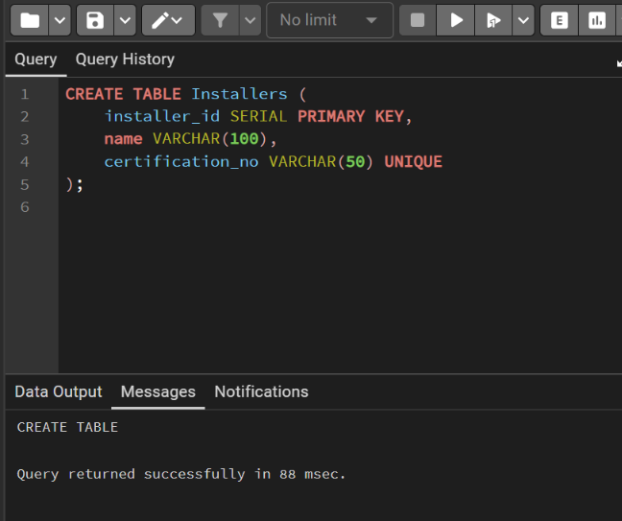

Solar system table creation:

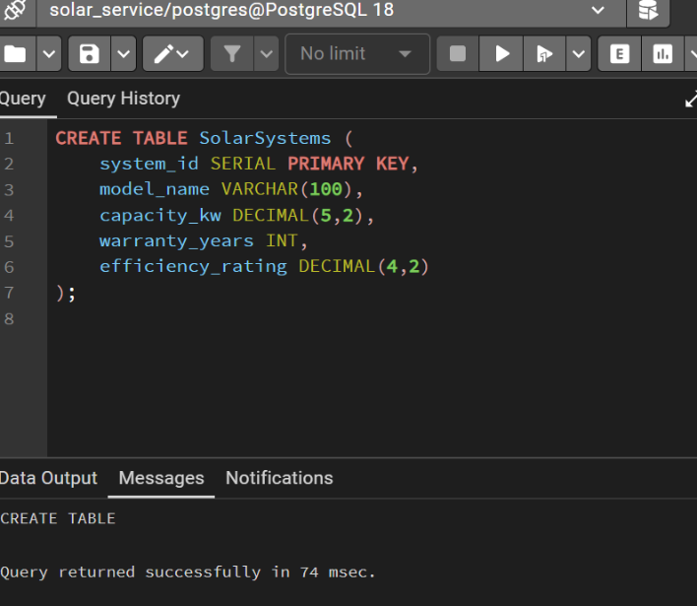

Order table creation:

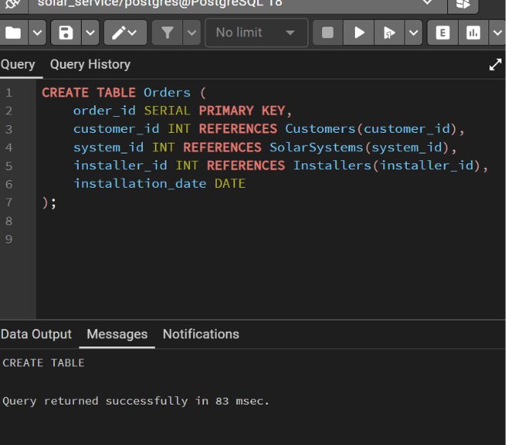

Maintenance record table creation:

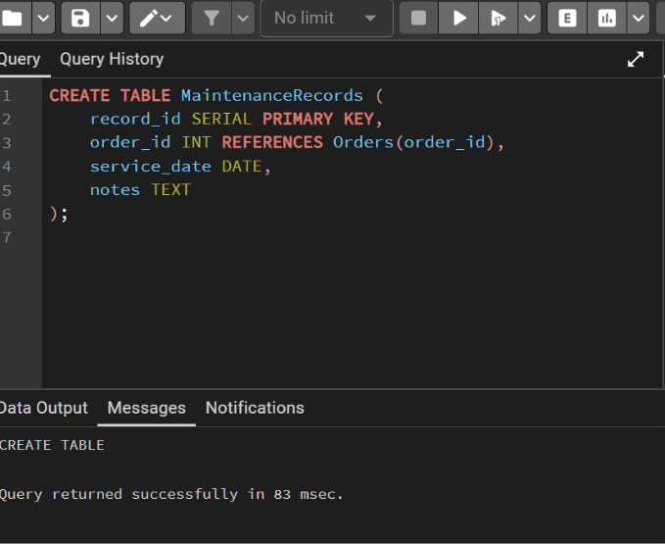

Review table creation:

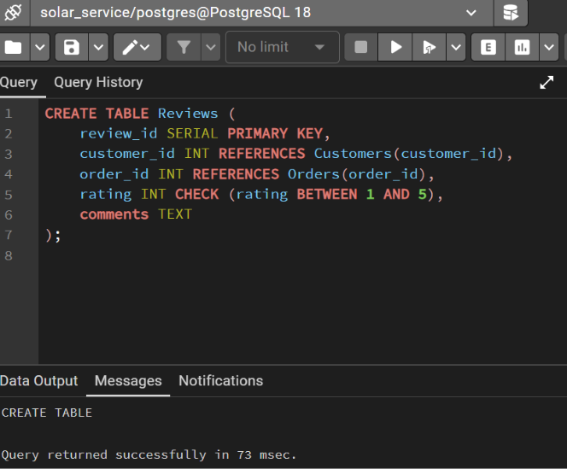

Audit log table creation:

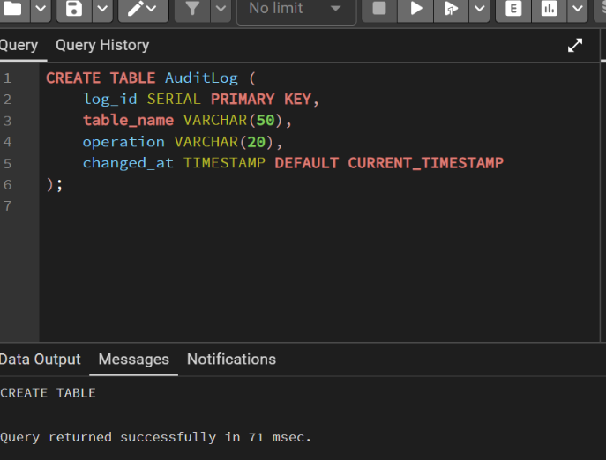

Sample data insertion
The database was populated with realistic sample data.

Customer table data:
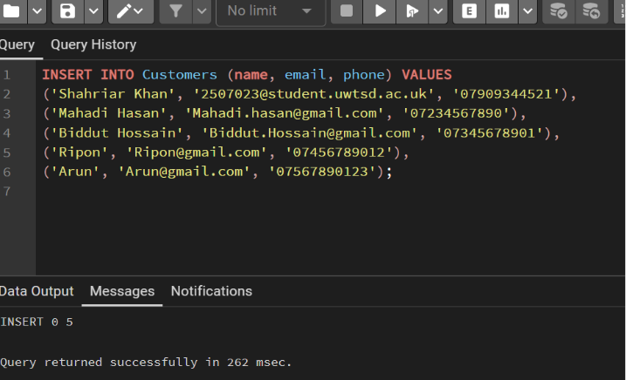

Solar system table data:

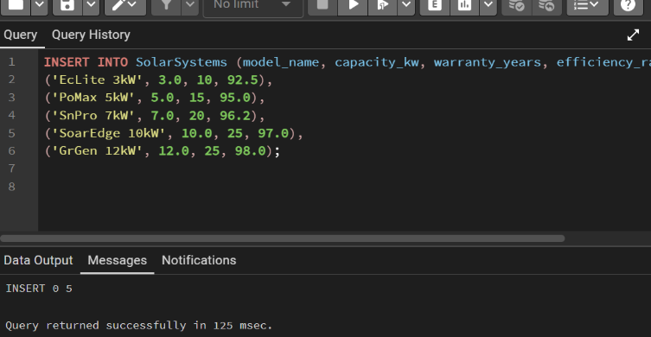

Installer table data:

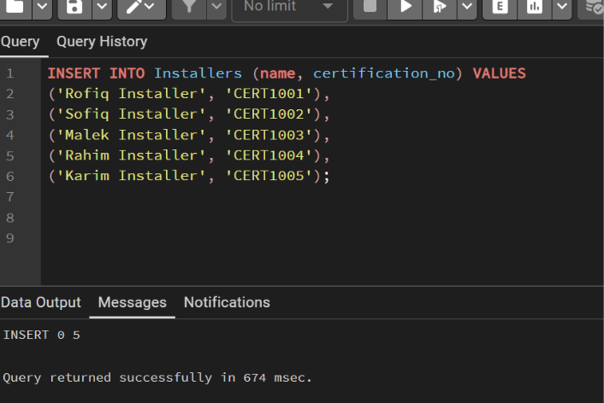

Order table data:
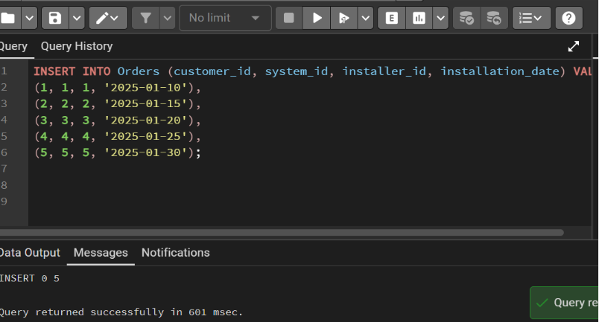
Maintenance table data:

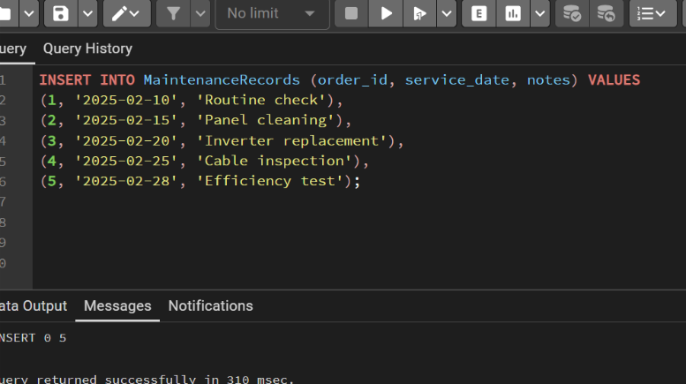

Review table data:

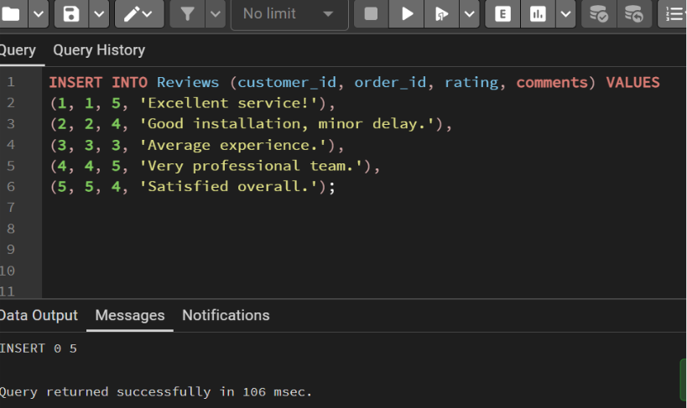

We populated all six tables with realistic sample data that represents how DWR Solar Solutions operates. Each table received carefully crafted information that mimics real business scenarios.

Customers Table - Real People Data

Key Features:
- Mix of academic and personal email addresses (e.g., student email and Gmail)
- UK-style phone numbers for local customer base
- Properly formatted names for professional records

Business Purpose: Tests in customer management, email uniqueness, and contact system functionality.

SolarSystems Table - Product Catalog

Key Features:
- Capacity ranges from 3kW (small homes) to 12kW (large properties)
- Warranty periods from 10 to 25 years (industry standard)
- Efficiency ratings from 92.5% to 98% (realistic performance range)

Business Purpose: Tests product management, technical specifications of storage, and warranty tracking.

Installers Table - Certified Professionals

Key Features:
- Sequential certification numbers (CERT1001 to CERT1005)
- Professional names with "Installer" title
- Unique certification validation through constraints

Business Purpose: Tests installer management, certification tracking, and work assignment systems.

Orders Table - Installation Jobs

Key Features:
- Each customer gets a different solar system
- Each order assigned to different installer
- Installation dates spread throughout January 2025
- Proper foreign key relationships established

Business Purpose: Tests the core business process of linking customers, systems, and installers together.

MaintenanceRecords Table - Service History

Key Features:
- Scheduled approximately one month after each installation
- Variety of service types (routine check, cleaning, parts replacement, etc.)
- Realistic service notes that technicians would write

Business Purpose: Tests post-installation service tracking and maintenance scheduling.

Reviews Table - Customer Feedback

Key Features:
- Ratings range from 3 to 5 (realistic customer satisfaction spread)
- Constructive feedback comments
- Each review linked to specific customer and order
- Check the rating constraint

Business Purpose: Tests customer feedback collection, rating validation, and reputation management.

Why This Sample Data Works
- Realism Factor
- Every piece of data represents what DWR would encounter:
- Real phone number formats
- Actual solar industry specifications
- Plausible customer feedback
- Realistic maintenance scenarios

Testing Coverage

The data tests:
- Constraints: Email uniqueness, certification uniqueness, rating limits
- Relationships: All foreign key connections work properly
- Business Rules: Future dates, valid ratings, proper formats
- Scalability: Shows how system handles multiple related records

Business Scenario Simulation

The data creates a complete business story:
- Customer buys solar system (Order)
- System gets installed (Installation Date)
- Maintenance occurs later (Maintenance Record)
- Customer leaves feedback (Review)
- Everything connects back properly (Foreign Keys)

Futureproofing

The sample data:
- Allows immediate testing without waiting for real customers
- Provides examples for training new employees
- Serves as template for future data entry
- Demonstrates proper data formatting standards

The Complete Picture

This sample data turns an empty database into a working business system that:
- Looks Real: Appears like actual business data
- Works Correctly: All relationships and constraints function
- Tests Everything: Validates all database features
- Trains Users: Shows proper data entry formats
- Supports Decisions: Provides data for reporting and analysis

The populated database now serves as both a working system for DWR and a demonstration model for how solar installation businesses can manage their operations efficiently.

Trigger implementation

For implementing triggers, an audit table is created. The creation of the audit log table is given above in the table creation section.
Audit Table Design:
- log_id: Sequential audit record identifier
- table_name: Name of table being modified
- operation: Type of operation (INSERT, UPDATE, DELETE)
- changed_at: Automatic timestamp of change

Trigger function:

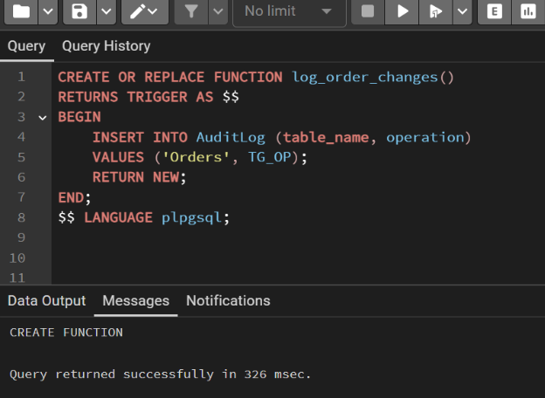

Function Features:
- TG_OP automatic variable captures operation type
- RETURN NEW ensures operation proceeds after logging
- Simple, efficient logging without business logic interference

Trigger creation:

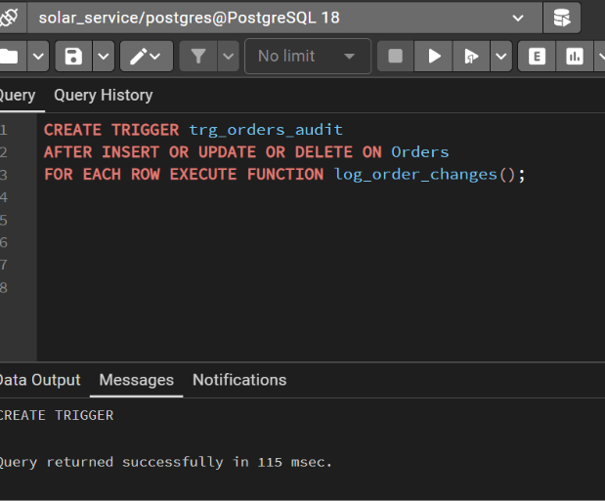

Trigger Characteristics:

- AFTER timing ensures data modification completes before logging
- FOR EACH ROW provides row-level auditing
- Covers all data modification operations

Stored procedure development

Basic order addition procedure

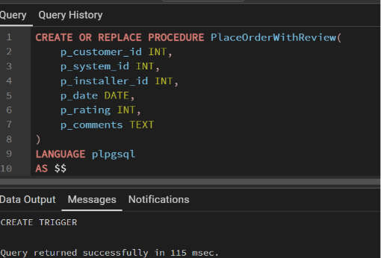
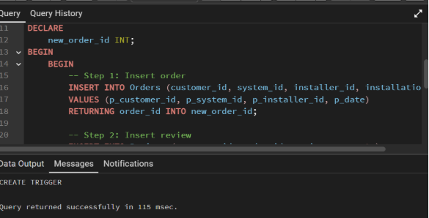

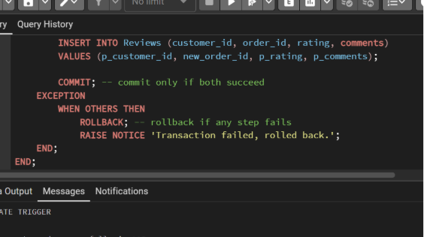

Procedure Features:
- Explicit transaction control with BEGIN/COMMIT/ROLLBACK
- Comprehensive error handling
- Parameterized input for flexibility
- Safe execution with automatic rollback on errors
Advanced Features:
- Multi-step transaction with atomicity guarantee
- RETURNING clause captures generated ID for subsequent operations
- Business process encapsulation (order + review)
- Data consistency maintenance

Stored Procedure and Transaction Management:

The database implements comprehensive CRUD (Create, Read, Update, Delete) operations with robust transaction management to ensure data consistency and reliability.

Transaction Features:
- Atomicity: Entire operation succeeds or fails completely
- Isolation: Protected from concurrent modifications during execution
- Durability: Committed changes persist despite system failures
- Consistency: Maintains all database constraints and rules
Business Logic Integration:
- Pre-update validation prevents invalid data
- Business rule enforcement (future dates only)
- Automatic audit logging
- Comprehensive error handling

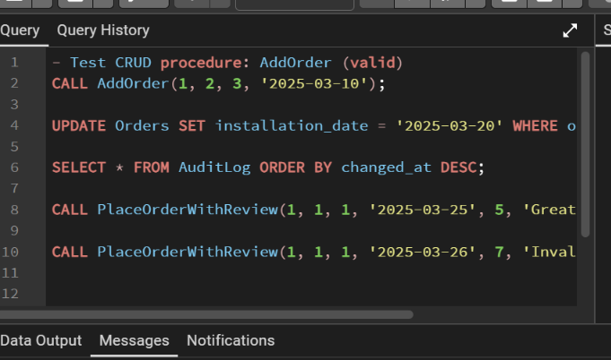

Transaction Complexity Levels:

- Basic Validation: Input parameter validation
- Business Logic: Installer availability check
- Data Creation: Order insertion with ID capture
- Related Data: Review and maintenance record creation
- Business Intelligence: Warranty information integration

Comprehensive Error Hierarchy:

Constraint Violations:
- Foreign key violations
- Unique constraint violations
- Check constraint violations
- NOT NULL violations

Business Rule Violations:
- Invalid installation dates
- Unavailable installers
- Rating out of bounds

System Errors:
- Connection failures
- Timeout conditions
- Resource exhaustion

Performance Considerations:
- Transaction Size: Limited to necessary operations to reduce locking
- Isolation Level: Appropriate level for business requirements
- Lock Timeout: Configurable timeout to prevent indefinite blocking
- Batch Operations: Grouped operations for efficiency

The transaction management implementation provides DWR with robust, reliable data operations that maintain consistency across complex business processes while offering comprehensive error recovery and monitoring capabilities

Performance Tuning Enhancement:

Indexing Strategy Analysis

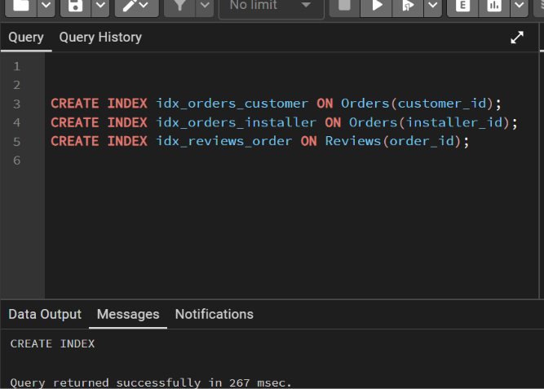

Foreign Key Indexes:
- idx_orders_customer: Accelerates customer order history queries
- idx_orders_installer: Optimizes installer workload queries
- idx_reviews_order: Speeds up review retrieval by order

Conclusion and Reflection
This database system successfully addresses DWR Solar Solutions' operational challenges by providing a robust, integrated platform for managing customers, installations, and maintenance. The normalized design ensures data integrity, while transaction management guarantees reliability during complex operations. Performance optimization through strategic indexing enables efficient data handling as business scales. Personally, this project highlighted the importance of balancing technical database principles with practical business needs. Future enhancements could include mobile access for field technicians and predictive analytics for maintenance scheduling, further strengthening DWR's competitive position in the renewable energy market.
References

R. Elmasri and S. Navathe, Fundamentals of Database Systems, 7th ed. Pearson, 2016.

A. Silberschatz, H. Korth, and S. Sudarshan, Database System Concepts, 6th ed. McGraw-Hill, 2019.

PostgreSQL Global Development Group, “PostgreSQL Documentation,” 2024.

Notes: This assignment is fully written by me, that’s why reference is not mandatory.

