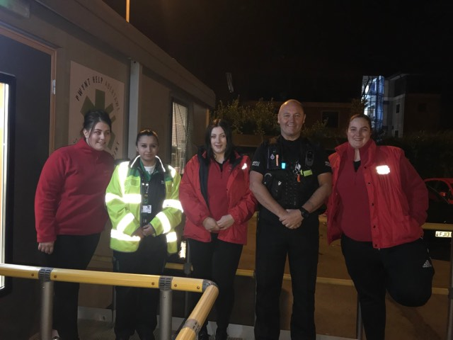
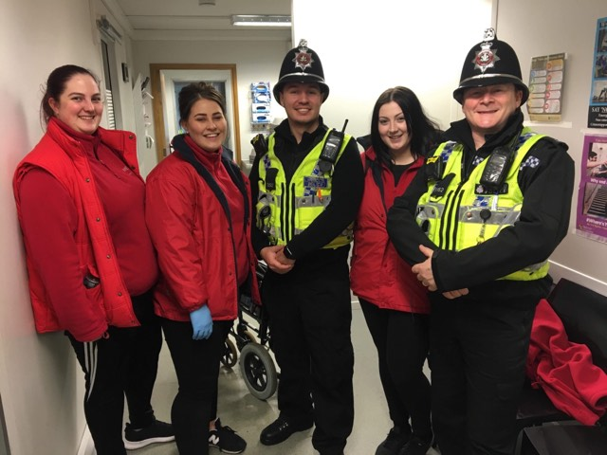

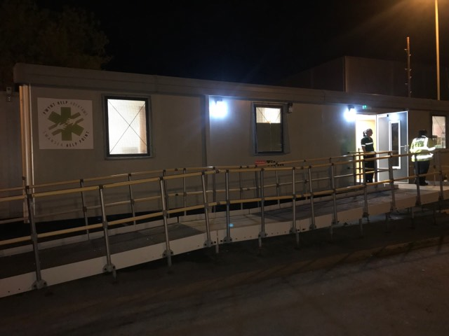
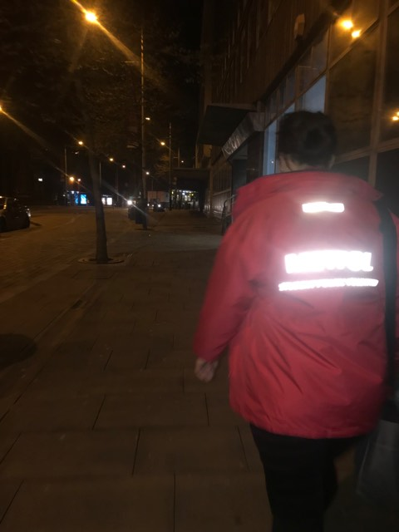
VOLUNTARY SECTOR
WORK EXPIRENCE
METPOL
STUDENT POLICE
VOLENTEERING
DEMI BEVAN P150912

I have undertaken a voluntary sector with Metpol, Metpol is a student police volunteering scheme which provides students who are studying a public service course the ability and knowledge of being a part of the public service environment. To be a part of Metpol I had to be vetted and given the training which I needed to be apart of the team. Metpol is a triage in Swansea city centre, it’s a large cabin which have all the facilities which A&E have just a little smaller. Metpol allows students to gain related professional work experience and the insight of the job which they are looking towards after their studies. Metpol takes the pressure off A&E and saves the NHS money as it takes in intoxicated individuals and provides them with the help they need to sober themselves up and get them home safe and sound.
Working with others
Within Metpol you work along side a variety of different people, many which you work alongside and others which are part of the community. I have had to work along side many people within Metpol, for example I have had to build new relationships with the new starters of Metpol, I have made sure that they feel comfortable in being as part of team. Many times, in Metpol I have had to work towards resolving a negative issue which was impacting on my team, this was when a team member was lacking within the team, I took on the leadership role and spoke to the individual asking them if they could carry out roles which was keep them occupied and be able to work alongside the time without being negative. I have acted with sensitivity to someone’s feeling when we had a call out to collect an intoxicated female, when we got to the female she wouldn’t leave any male help her only female, she was intoxicated with no phone and no friends around to help, me and my team needed to try and get to the Metpol to make sure she was safe. The female was very upset, we needed to try and gain the females trust and to let her know we were there to help, and that she would be taken care of in our hands. This is where you need to work with the patients and make them realise that we have their best interest at hold.
Commitment to excellence
There have been many incidents where individuals have lost all their friends on a night out and end up staying in Metpol all night, there was on incident where we brought an 18-year-old girl to the help point and she kept repeating that she was from Bridgend and she was meeting all her friends to get a minibus home. It was me and my team’s responsibility to help get in contact with her friends and make sure she made up with them before 1am when the minibus was picking them up. This was a hard task to be completed within the timeframe which we were given but we did manage to get in contact and be able to get the young girl reunited with her friends and home safely. I was unhappy with one shift on Metpol when I was feeling unwell so that effected my performance on the shift and affect my team members as they had to keep the vibe up and make sure everything was still on track and running smoothly. Within Metpol we need to make sure we meet the objectives which are given, if we don’t make sure the objectives and tasks are done then that may have an impact on the patient and an impact on the team which you are working with. Meeting the objectives which we have been given will provide us with knowledge on being part of the police force when someone who is higher than you give out objectives which you need to meet, in the police force you will be given tasks which will need to be completed by a deadline, this means you will need to manage your time efficiently and provide the best of your ability.
Commitment to Development and Communication
Within Metpol, it is being committed and being able to help people and developing on yourself. I have learnt that I am more patient with others after working at Metpol. You need a patient and sometimes sensitive approach. Also, I have learned that I am able to undertake a leadership role working within a team and work effectively with people within the community. I have an encouraging sense of humour, I like to give support and make people show their confidence within part of a team. Within Metpol we have many new starters who are very shy, I like to bring new starters out of their shell and make sure they are confident within the team. I had to encourage a young man who was part of my team to help the team and use the radio to contact comms to let them know that we were going on a walk, firstly he was against doing it he said he was to shy. I spoke to him and said that it would improve on his learning and experience to take part and use the radio. Metpol develops effective communication and you learn from one another, I have learnt from colleagues and they learn from me. For Example, my colleagues who is recently new she didn’t know where the equipment was to top up the bag which we take out on walks., I showed her where they were and provided her with them to carry out her tasks. There are many times where I have had to communicate to a large group of people for example, a group of people who are high up within St John’s ambulance came down to Metpol and wanted to know what we did there and how we did it. Me and my team provided them with the correct information, showed them around and what equipment we used to get the job done. I think it went well but I think I could have taken more of a leadership role with my team members and got more involved to speaking aloud. I love working as part of a team and being able to communicate within a team. Metpol is a team-based volunteering organisation scheme so without being able to work as part of a team. I work as part of a team every shift which I attend, we complete several different tasks which are set and listen to instruction which are needed within the team.
Commitment to Diversity and Integrity
When working in Metpol you need to think about other people’s difference and how you treat people fairly and ethically. We have several men and women who come in to Metpol different ages, different ethnicity and different religion. In Metpol we had a call out which involved to an elderly man who was badly intoxicated and under the influence of drugs, we needed to attend to him as soon as we could because he was causing havoc up the town. We brought him down to Metpol and me and my team had respect his age and take consideration that he had impartial hearing and his needs may be different to younger men and women. We needed to take on his needs and make sure we spoke to him with profession and investigate who to contact on his behalf, if he needed any treatment or if he was taking any medication which he needed to take. The time where I have taken responsibility for my own actions is when I’ve helped intoxicated individuals get treated if needed, by delivering them from wine street to Metpol, then when they have sobered up we make sure they have friends with them and then we call taxi’s and make sure they get home safely. I have had many tasks within Metpol where the patients have trusted me with their problems and sometimes they are sensitive about it. One lady was suffering from depression, she was very sensitive about suffering from depression and she told me and didn’t want me to tell my team members she was really upset and by drinking alcohol she got worse. I had to carry out the task to get her to Metpol and make sure she was safe, after this patient it made me realise that sometimes you got to have a trustworthy personality to make sure the patients can trust you with their problems. We promote Metpol within the Swansea area, we provide leaflets which are handed out to the public to show that we are helping the NHS by saving them money and that we are helping youngsters get home safely.
About yourself
After finishing all my studies, I am looking to go towards the police force, I have many family members who are part of the police force and I am really interested in being a part of a force. I want to be able to help within the community and be able to make people feel safe, also I like to make my presents aware and I will be there on times of their needs. I want to be able to help prevent crimes and improve the quality of life for all citizens. I want to be able to respond to emergency calls form the public and patrol the local area to make sure the public know the police are patrolling to make the community safer. There are many skills which I will need to get in to the police force, I think I have very good communication skills as I am able to communicate with others, this is used highly within the police force as you need to speak with the public to gather facts about a crime that has been committed. If you do not communicate within the police force it can contribute to becoming a life or death situation if some tasks aren’t done properly. I can work well as part of a team which you need to be able to work as a team to be in the police force as most of the work is team-based. The police force is one of the most efficient and effective teams within the public services, they must make sure they plan as part of a team to get the tasks and objectives complete on time. I think by being apart of the student police volunteering scheme I have had time to prepare for being apart of the police force, I think by being in the same situation as the police force and being around the police force when volunteering it has given me more experience and knowledge to be a police officer. Metpol is a very good way to get students to have the experience to go and be in charge, it provides us with more confidence and the ability to know the role of a police officers patrolling the streets. The volunteering scheme helps students like me get involved with the police and organisations to help give help back to the community which I live in, it offers and excellent insight into out work and is very useful to me to be able to pursue my career in the police force. In Metpol we work alongside several emergency services we work along side south wales police force and St John’s ambulance. I think I am the right person to be a part of the police force as I am happy to be able to help the community in which I would be working in, I work well within a team, I am able to communicate well with other induvial and I have wanted to be part of the force since a very young age. I enjoy doing fitness which that has a big impact when joining the police force and I look forward to being able to solve crimes which need solving.

