ENTREPRENEURSHIP

Assessment 2

LCBB5001

Submitted by: Irinel-Georgian Gheorghe

BUSINESS DESCRIPTION / MARKET OPPORTUNITY

The business venture that has been planned to be launched is an organization in the textile sector. This organization that will be launched will prepare fabric from algae. The name of the organization that has been decided is ‘Kaai Fabric’. Kaai in Sanskrit means algae. This is the organization that will target the UK market.

Figure 1: Logo of the Firm
(Source: Created by the learner)
It has been seen that after the outbreak of the Covid-19 pandemic, the people have been looking forward to ensure sustainability. A major shift in the buying behaviour of the people has been seen. The customers have only been shopping from the sustainable brands and have been investing highly in sustainable clothes. It has been seen that while producing fabric, a lot of pollutants are released in the air as well as water. This is the factor that will have a negative impact on the environment. Hence in order to reduce the impact on the environment, the idea has been generated.
There are a lot of growth opportunities. The main reason is the support of the government. It has been seen that the UK government has been supporting businesses and entrepreneurs. Not only this, but the government also been supporting sustainable organizations that are doing something good for the environment. In addition to this the Awareness of protecting the environment has also increased in the customers. This is the factor that will ensure profit.
About the product:
Special type of fibre will be created with the help of the sea cell. The material will be success by combining wood cellulose as well as Seaweed together. The fabric will be made from Seaweed. This material is generally found beneath the level of sea. This is like grass that grows within the sea. There are different types of Seaweed that are available. Hence this is the factor that will make it easy for the organization to source the raw material. In order to harvest the Seaweed the organization will implement sustainable practices. In addition to this it will be ensured that the seaweed does cut above the root. This will ensure that harvested process does not affect the regeneration process of the seaweed. In addition to this the ecological value of the raw material can also be retained effectively. The organization will not produce clothes but will also produce the fabric that can be used for various purposes.
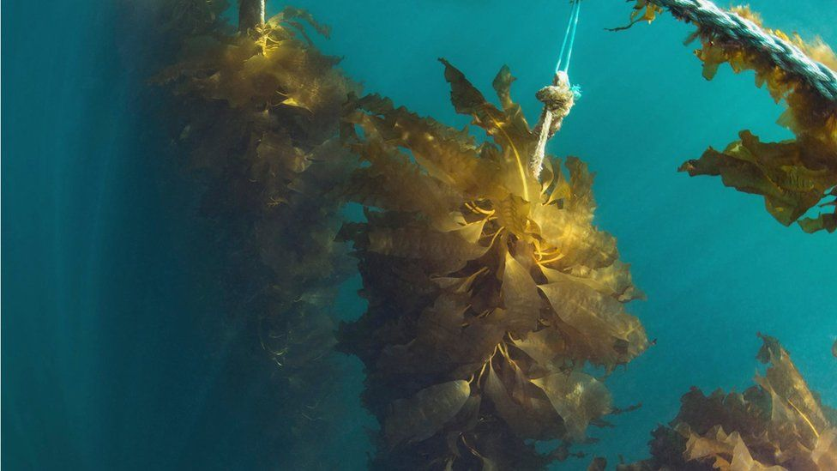
Figure 2: Seaweed
(Source: bbc.com, 2020)
Location:
Within the UK market. The main target of the organization will be Great Britain. The reason behind choosing this location is that it is very near to the north sea. Here finding the raw material for production of clothes will be quite easier. The clothes can be them transported to different parts of the United Kingdom as well as Europe. To generate yarns, the firm will use a closed-loop method to spin cellulose fibres with organic brown seaweed.

INDUSTRY ANALYSIS

Figure 3: Porter’s five forces
(Source: Created by the learner)
Threat of new entry
The idea that has been chosen in a quite unique yet. It has not been properly implemented in any of the firms. There are number of firms that have been trying to implement the new technology so that they can produce fabric with the help of algae (rochester.edu, 2022). In addition to this the procedure that will be involved is also quite difficult. The entry barriers in terms of establishing a new business is quite high. In addition to this, there are a number of challenges that need to be taken. The investment cost is also quite high. All these factors are contributing to the difficulties for the new entrants. Hence this force can be said to be a weak force.

Threat of substitutes
It has been seen that the technology has been advancing (Yadav et al., 2019). There are a number of organizations that have been working hard to produce sustainable products and reduce the overall impact that the mankind has on the environment. However finding alternatives of the raw material that are used in production of fabric is a difficult process. There are different organizations that have been using different sustainable products to produce clothes. Hence it can be said that the people have choices in terms of choosing clothes. This is the factor that can be said to be a moderate force.

Bargaining power of customers
The product that has been designed to be sold within the United Kingdom market is quite unique. There are not a lot of organizations that have been producing sustainable clothing. Hence the organization has an option of implementing the cost leadership strategy. The customers will not have a lot of bargaining power left with them. The customers will not have different alternatives in terms of shopping the sustainable clothes. In addition to this the organization will also focus on the quality of the fabric that they will produce. Hence they can charge premium prices for they are products. Based on these factors it can be said that the bargain power of customers is a weak force.

Bargaining power of suppliers
The organization will be connecting with unique suppliers that will provide unique raw material and Technology for the organization. This is the reason the organization will have to maintain the relationship with the suppliers. The suppliers here will be more superior as compared to the organization. Hence the bargain power of suppliers will be more and this factor will be a strong force that can have an impact on the organization.

Competitive Rivalry:

Name of competitor | Differentiation
Competitor 1  H&M | H&M has been looking forward to include algae. This is a non-profit organization that is funded by the founders as well as the owners of the H&M group (cnn.com, 2021). The organization has been creating awareness in terms of sustainability with in fashion. In addition to this it has also been attracting new investors. However are organization will also have a number of benefits over H&M. The cost of the fabric will be quite low as compared to the organization.
Competitor 2  Smart Fibre | Smart fiber is the organization that has been already implementing algaeing (smartfiber.de, 2022). This is an organization that is based in Germany. The scope that is available to the company is high as the Government of UK will support the local brands on a large scale as compared to the foreign brands.
Competitor 3  BEEN London | BEEN London is an organization that is based in London. The firm has been producing fabric from recycled material that includes leather outfits as well as plastic bottles (been.london, 2022). However Kaai fabrics will have an upper hand due to being suitable for a wide range of applications. SeaCell materials can be utilized for a variety of garments. It is particularly effective on everything from new-born apparel to loungewear. It can also be used to make yoga wear or other fitness garments.

OPERATIONS AND MANAGEMENT TEAM
OPERATIONS
SEACELL is a patented, environmentally material with endless textile uses. The fibres are appropriate for a wide range of applications in sports and recreation textiles, including underwear, loungewear, and soft furnishings. We can mix SEACELL fibres with virtually any other fibre using this technology, making it globally compatible.
The introduction of SEACELL fibres gives other textile products a delicate, silky feel and maximizes comfort. Making it a game-changing fibre in terms of meeting the needs of a new generation that leads an athletic and health-conscious lifestyle. This eco-friendly procedure is used to create SEACELL. A closed-loop production system that works with nature and generates no waste chemicals. The fibres are manufactured from natural elements that are eco-friendly, minimal in resources, and completely biodegradable.

Figure 4: Process involved
(Source: Created by the learner)

How would you generate revenue for your business?
The firm will introduce the products In order to prevent any type of losses the organization will firstly ensure that they do not wait any raw material. In addition to this try to implement cheaper options but will also look at the quality. If the organization maintains the quality then they will not have to waste time and resources on redoing the work. These are the factors that will help the firm to generate revenue.

MANAGEMENT TEAM
A staff will be required to efficiently handle Kaai Fabrics' company. There are several responsibilities that must be filled, and they will be assigned accordingly.
Name | Skills | What do they bring to the firm
Business Executive | Management and communication skills | This is the person who will be in charge of contacting clients and forming partnerships.
Manager | Leadership skills | The manager will be responsible for managing the personnel as well as communicating with the business executive to grasp the clients' expectations (Sacks et al., 2018).
Marketer | Digital marketing skills | The marketer will be in charge of the business's marketing functions and will investigate ways for the firm to grow.
Financial manager and controller | Financial planning and crisis management skills | The individual will be in charge of handling finance, including investment, bank operations, and insurance.
Team of labour/employees | Skilled in different areas | The team will be responsible for activities such as loading, production, packing, and delivery.

MARKETING: The Four P’s must be used to describe your marketing strategy

Figure 5: 4 P's of Marketing
(Source: Created by the learner)

Product
The main product that is going to be provided by the organization is the fabric that will be made by algae. The product will beprepared with the sea cell that will be available in the sea (algaeing.com, 2022). These seaweed textiles are quite comfortable for anyone who wears them. It feels smooth and pliable on the skin. Seaweeds provide the fabrics with skin-beneficial minerals and vitamins, as well as anti-oxidants. Most of the time, producer’s desire adaptability when combining several fibres together. It endows the fabric with unique qualities. SeaCell fibres combine easily with different types of fabrics, making them even better. This cloth is both breathable and lightweight. It also absorbs perspiration faster than cotton. Another excellent application for sportswear and active wear. SeaCell fabrics are completely biodegradable and vegan. It adheres to OEKO-TEX Class 1 sustainability practices. In the production process, no toxins are used or emitted as waste. As we covered before in this post, seaweed is a found naturally resource in all aquatic systems. It is harvested using specialized techniques and machinery to protect the habitat.

Price
The price in strategy that will be implemented by Kaai fabrics is the premium pricing strategy. This is a strategy that will help the organization to set a price of the product that will be higher in comparison to the similar products (Ali and Anwar, 2021). It has been seen that there are no similar type of product that are available in large quality within the United Kingdom market. Hence the organization can successfully implement the strategy. The organization will be providing the customers with unique products and services. In addition to this they will also ensure sustainability. Hence it is the best pricing strategy that can be implemented by the firm. This pricing strategy will help the organization to ensure maximum profit as well as maximize the economy.

Promotional Mix
The majority of the promotional activities will take place through online media. The social media outlets will be used efficiently. In addition to SEO marketing, Email marketing will be used. On the other hand the organization will also implement the traditional methods of promotion. The organization can make attractive advertisements on television. In addition to this they can also partner with famous celebrities in order to create awareness about the brand. They can partner with the organizations that aim to create awareness in terms of sustainability. In addition to this the organization can also sponsor fashion events so that models as well as the important people from the fashion sector come to know about the brand.

Place (Distribution strategy)
The main location of the organisation will be in Great Britain. Major reason of keeping the headquarters in Great Britain is that the organisation can effectively source the raw material from the Sea which is nearby. This will save the money of the organisation in terms of transportation. In addition to this the organisation will also target other places from United Kingdom and Europe. This can be done through the online channel. Hence the products of the organisation will be available on both the channels which are online and offline.

FINANCIALS

Sources of funds
In order to acquire financial support for the organization cluster Drop shipping, loans and overdrafts might be used. Taking out a bank loan is the finest approach to fund and organize a business because it is a long-term mode of financing. The overdraft facility, on the other hand, is only available for a limited time. When a company's bank balance falls below the minimum amount that must be maintained, a bank overdraft can help. In addition, the organization can borrow money from a bank at a hefty interest rate. As a result, this is a viable option. In addition to this organisation can also you is the strategy of venture capital (Block et al., 2019). It has been seen that the venture capitalists look forward for the businesses that are driven by technology. In addition to this they also expect the organisation to have high growth potential in it as well as biotechnology. This is the best strategy that can be implemented by the organisation to ensure funding. The venture capitalists have the potential to take equity position within the organisation so that they can keep funding the organisation.

Use of funds

 | Month 1 | Month 2 | Month 3 | Month 4 | Month 5 | Month 6
Revenue | £10000 | £15000 | £20000 | £25000 | £30000 | £35000
Fixed Costs  Transport cost  Harvest Cost  Electricity Cost  Maintenance Cost | £2000 | £2000 | £2000 | £2000 | £2000 | £2000
Variable Costs | £2000 | £3000 | £3000 | £3500 | £4000 | £4200
Profit | £6000 | £10000 | £15000 | £19500 | £24000 | £28800

REFERENCES
algaeing.com, 2022. [Online] Available at: <https://www.algaeing.com/> [Accessed on 17 November 2022].
Ali, B.J. and Anwar, G., 2021. Marketing Strategy: Pricing strategies and its influence on consumer purchasing decision. International journal of Rural Development, Environment and Health Research, 5(2), pp.26-39.
been.london, 2022. [Online] Available at: <https://been.london/pages/our-ethos> [Accessed on 17 November 2022].
Block, J., Fisch, C., Vismara, S. and Andres, R., 2019. Private equity investment criteria: An experimental conjoint analysis of venture capital, business angels, and family offices. Journal of corporate finance, 58, pp.329-352.
cnn.com, 2021. [Online] Available at: <https://edition.cnn.com/style/article/israel-algae-environment-textiles-spc-intl-hnk/index.html> [Accessed on 17 November 2022].
rochester.edu, 2022. [Online] Available at: <https://www.rochester.edu/newscenter/will-your-future-clothes-be-made-of-algae-476562/> [Accessed on 17 November 2022].
Sacks, R., Eastman, C., Lee, G. and Teicholz, P., 2018. BIM handbook: A guide to building information modeling for owners, designers, engineers, contractors, and facility managers. John Wiley & Sons.
smartfiber.de, 2022. [Online] Available at: <https://smartfiber.de/en/seacell> [Accessed on 17 November 2022].
Yadav, A.N., Singh, S., Mishra, S. and Gupta, A., 2019. Recent advancement in white biotechnology through fungi (p. 528). Cham: Springer International Publishing.

